Republic of the Philippines


CAVITE STATE UNIVERSITY
Imus Campus
Cavite Civic Center, Palico IV, City of Imus, Cavite
(046) 471-6607 / (046) 436-6584
www.cvsu-imus.edu.ph

ACTIVITY 5: BLOG PLATFORM API + UI

Group Members:
- Aguilon, Adriane
- Bunag, Percy S.
- Dela Cruz, John Mark C.
- Factor, Francis C.
- Fortaliza, Destine April D.
- Irenea, John Michael A.

A full-stack social blog platform built with NestJS and React. Users can create posts, comment, like/dislike content, receive real-time notifications, track edit history, manage profiles with avatar uploads, and switch between light/dark themes. Features include pagination, protected routes, and comprehensive social interactions.

Tech Stack
- Frontend: Vite (React + TypeScript), Tailwind CSS, Radix UI components, React Router DOM, Sonner toasts, next-themes, date-fns, lucide-react icons
- Backend: NestJS, TypeORM with SQLite, JWT authentication, Passport, bcrypt, Multer for file uploads, Swagger (OpenAPI), class-validator

Key Features
- Authentication: User registration/login with JWT, protected routes, password hashing, token stored in localStorage
- Post Management: Create/edit/delete posts with title (max 120 chars) and content (max 2000 chars), pagination support, author attribution
- Comments System: Add/edit/delete comments on posts, nested display, author-only editing, character limits
- Like/Dislike System: Toggle likes/dislikes on posts and comments, real-time count updates, visual feedback for user's like status
- Notifications: Real-time notifications for new comments on posts, likes on posts/comments, unread badge count, mark as read/unread, delete notifications
- Edit History Tracking: Complete edit history for posts (title + content changes) and comments, view who edited and when, compare previous/new versions
- User Profiles: Profile page with avatar upload (max 5MB), bio editing, join date, post count, stats display, account settings
- Theme Support: Light/dark mode toggle with persistence, smooth transitions, system preference detection
- UI Components: Radix UI primitives (dialogs, dropdowns, tooltips), responsive design, loading states, error handling, toast notifications
- API Documentation: Swagger UI with Bearer auth, endpoints for posts, comments, likes, users, notifications, auth

Screenshots of Working System
Authentication Page
Capture the `AuthPage.tsx` showing login/registration form with email, password fields, and mode toggle button.
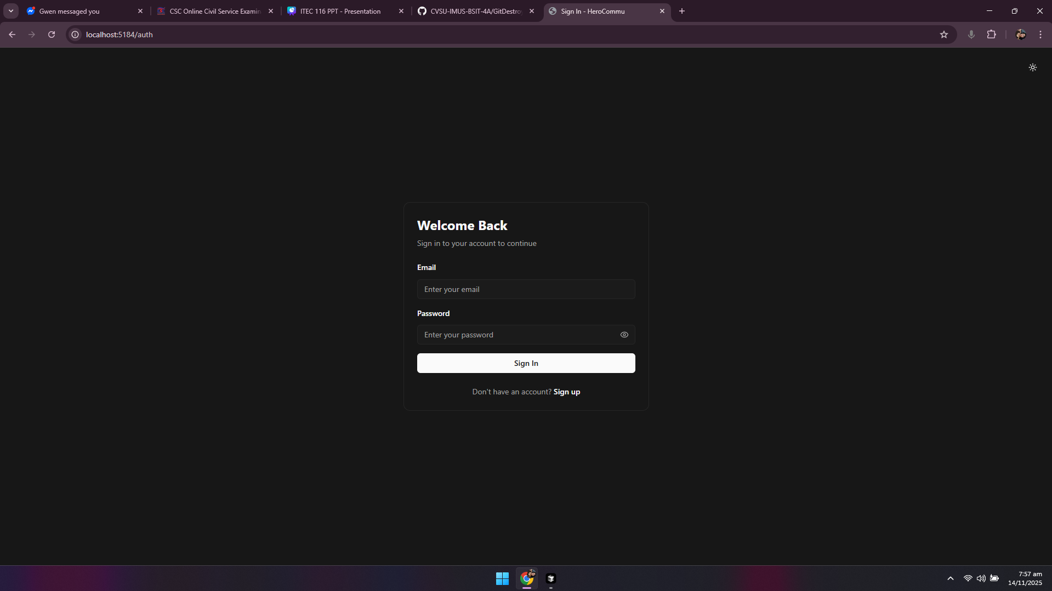
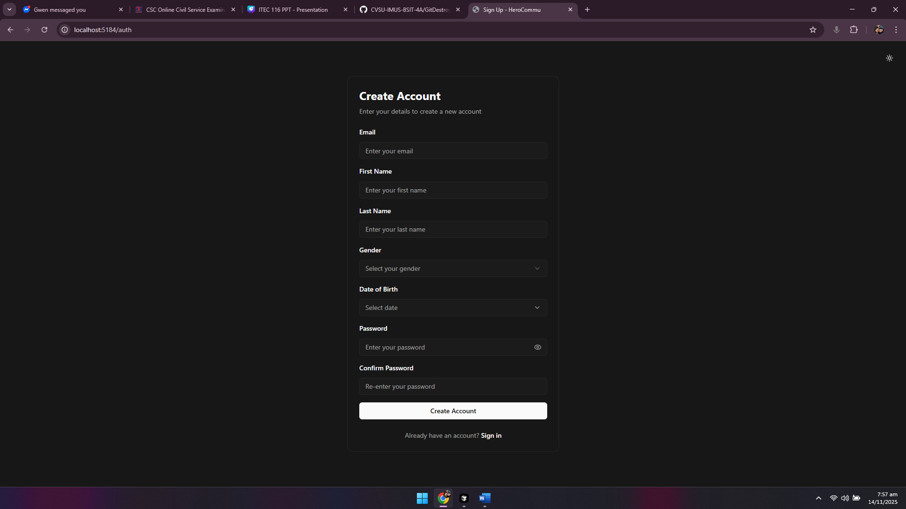

Main Feed (PostsPage)
Capture the `PostsPage.tsx` showing "HeroCommu" header, navigation bar with Add Post button (+), Home refresh button, Notifications bell with badge, Profile dropdown, and the feed of posts with pagination.
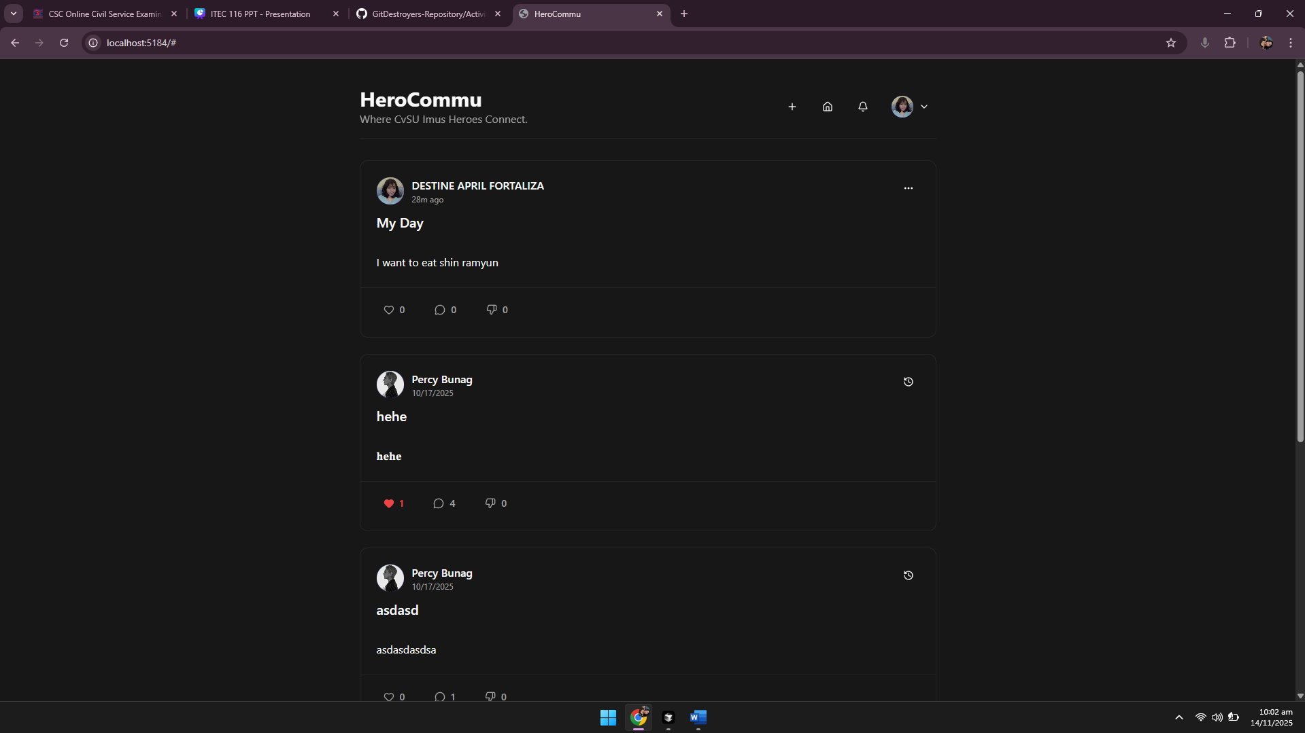
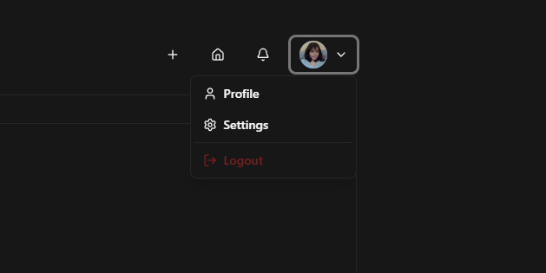

Create Post Dialog
Capture the "Create New Post" dialog showing title input with character counter (X/120), content textarea with counter (X/2000), and Create/Cancel buttons.
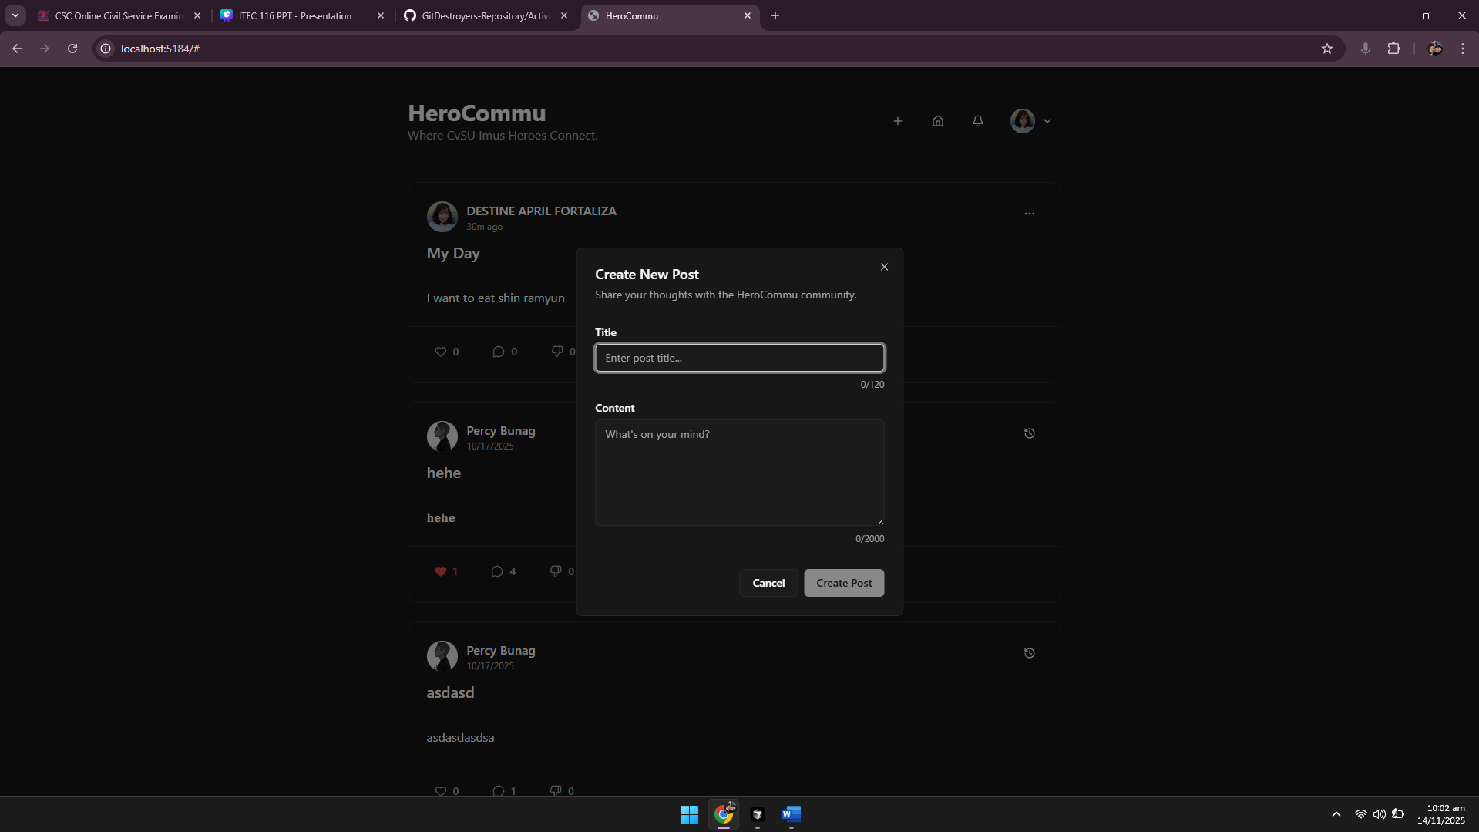

Post Card with Interactions
Capture a `PostCard` showing post title, author info with avatar, content preview, like/dislike buttons with counts, comment count, Edit/Delete buttons (if owner), and "View History" button if edited.
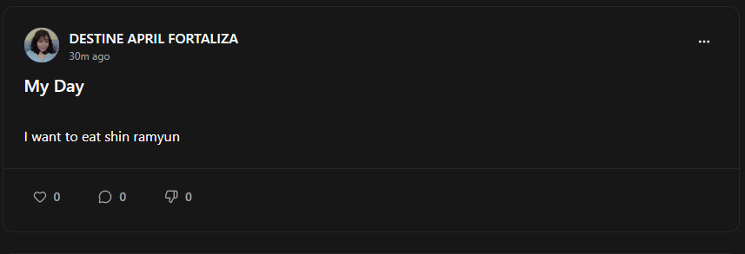
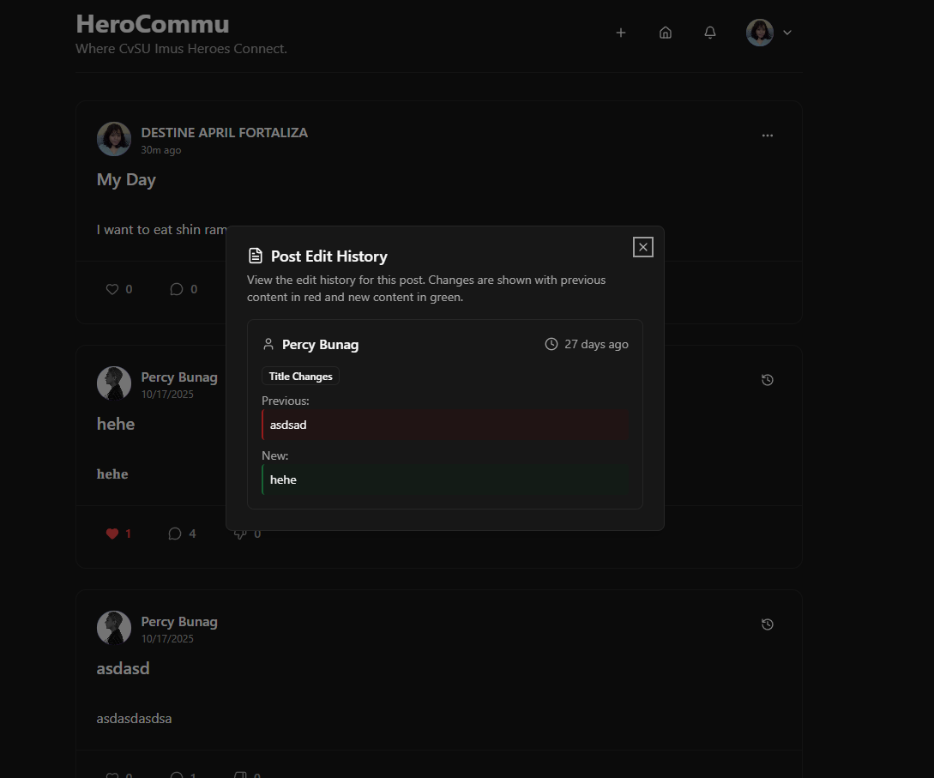

Individual Post View
Capture the `Post.tsx` page showing full post content, all comments with like/dislike buttons, comment edit/delete options, and the "Back to Posts" button.
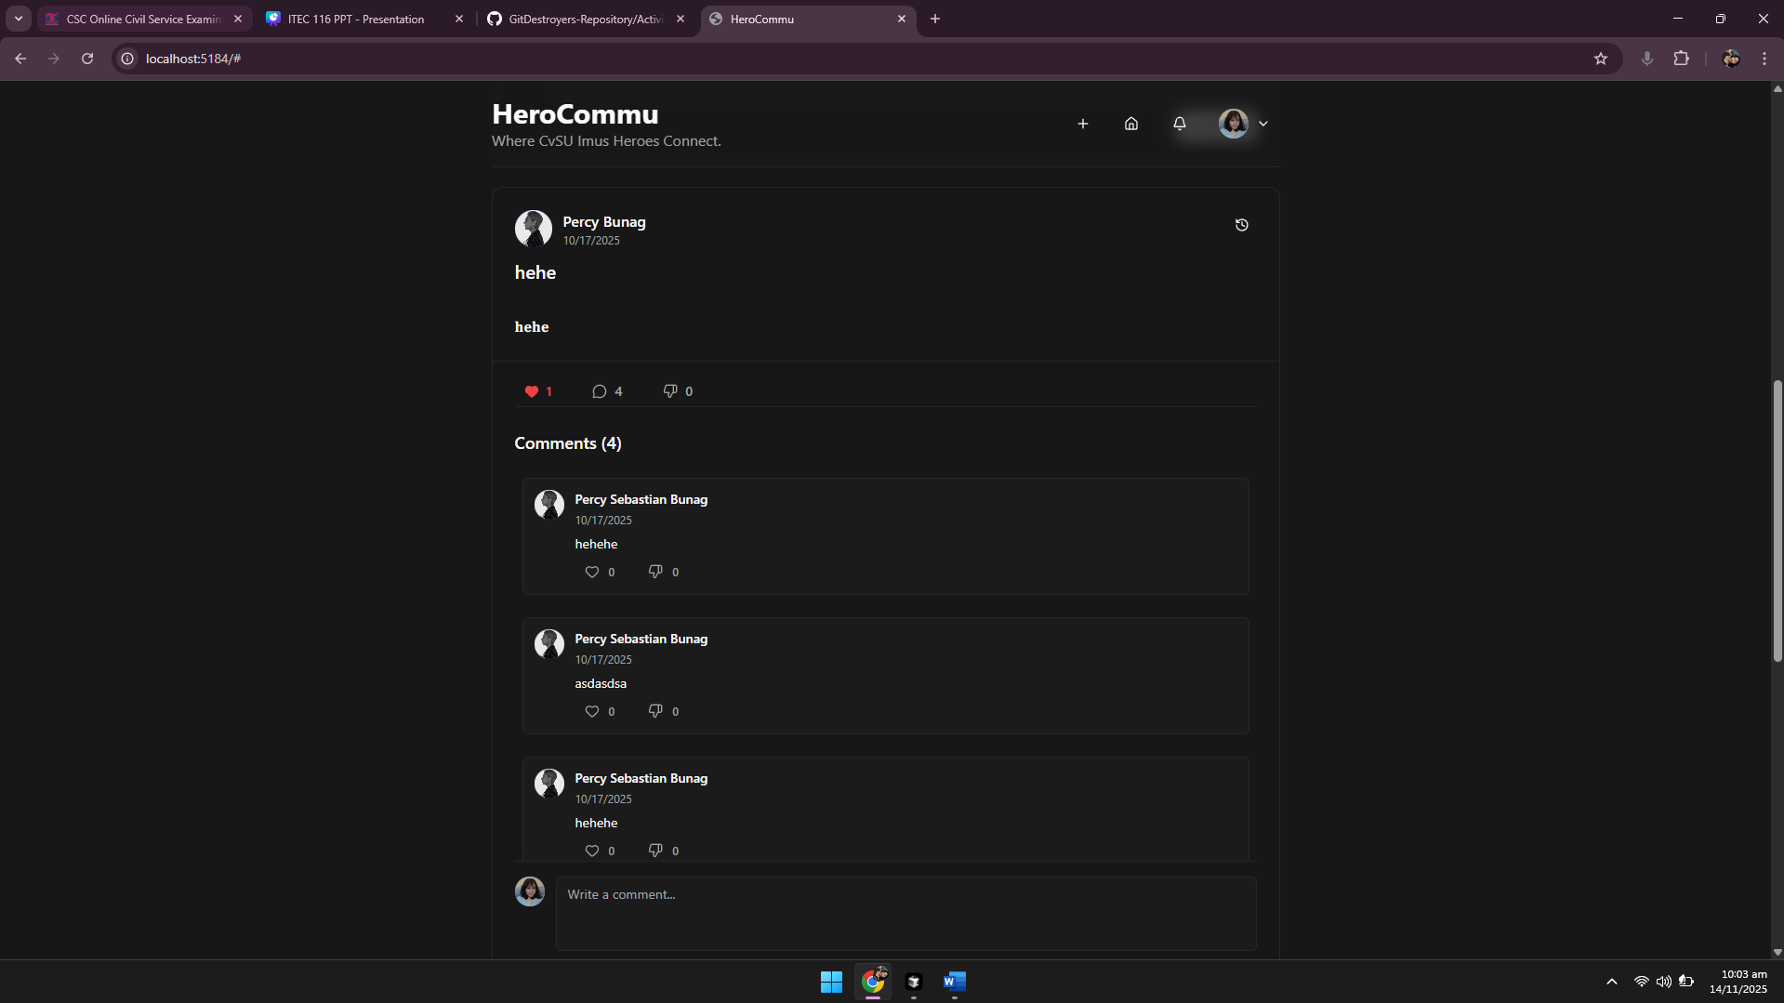

Notifications Dropdown
Capture the `NotificationButton` dropdown showing unread notification badge, list of notifications (new comment, like on post, etc.), "Mark all read" button, and individual notification actions (mark read/unread, delete).
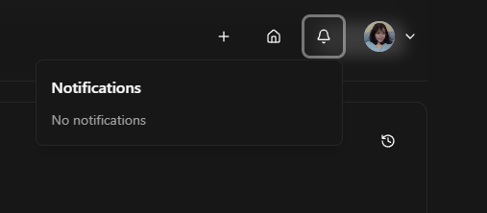

Profile Page
Capture the `Profile.tsx` showing user avatar (or initial letter), name, bio (editable), join date, profile stats (Total Posts, Total Comments, Total Interactions), and "My Posts" section with list of user's posts.
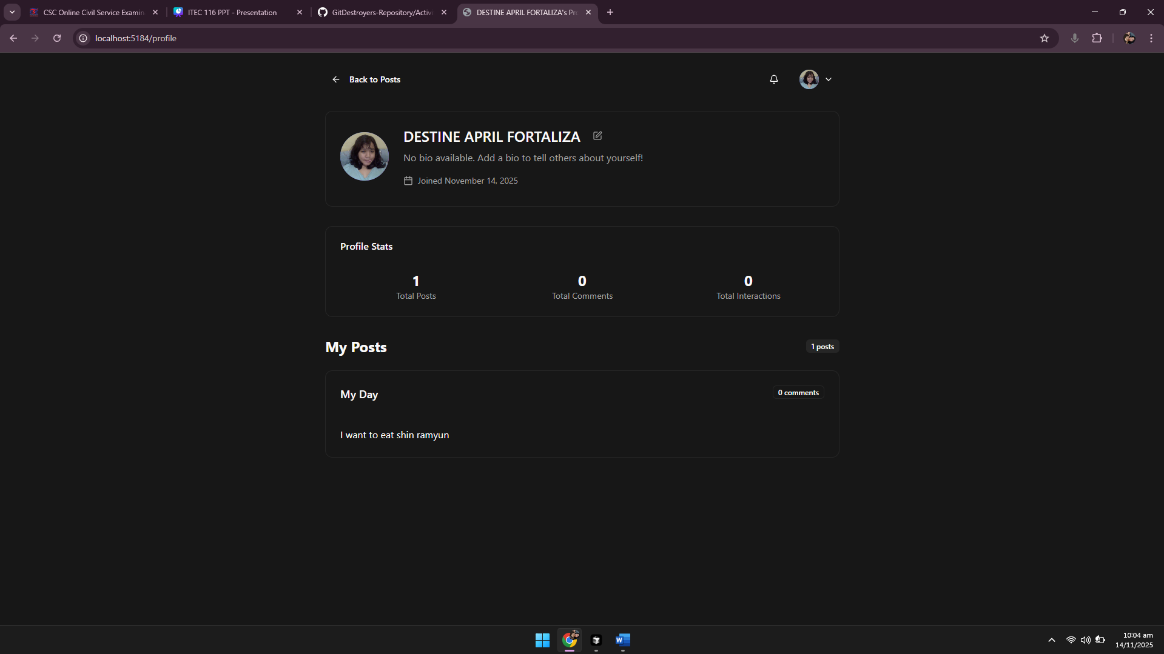

Profile Edit Mode
Capture the profile in edit mode showing editable bio textarea, camera icon button for avatar upload, Save/Cancel buttons, and avatar preview.
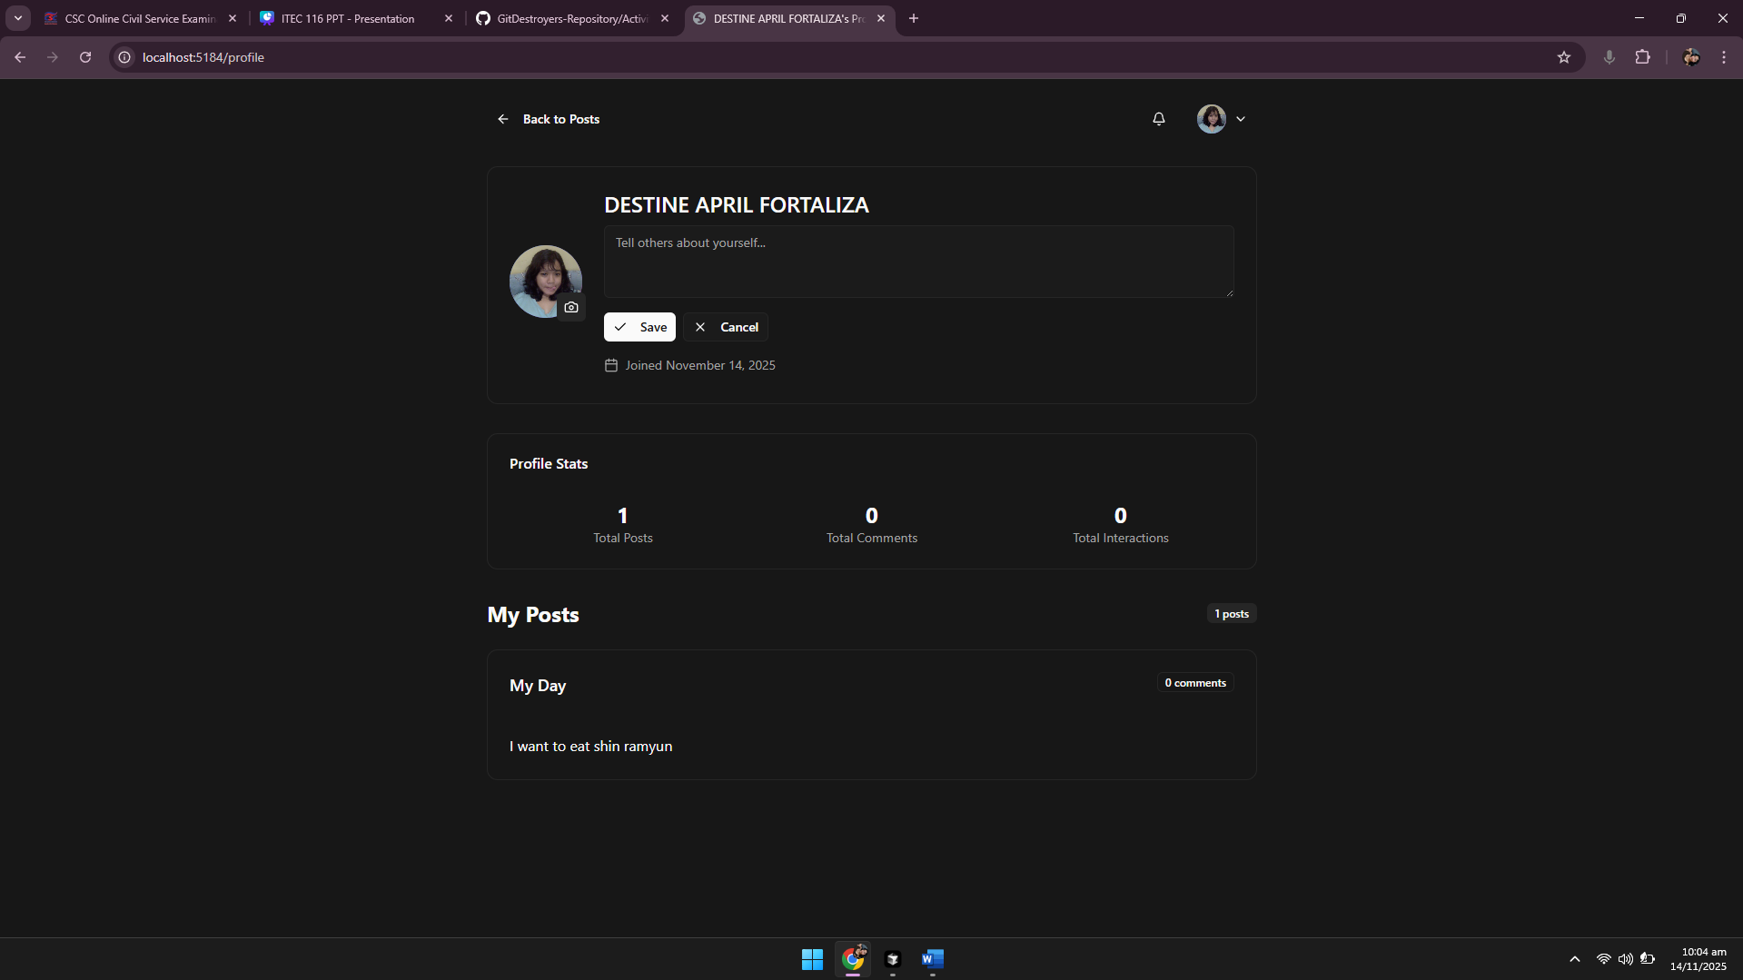

Settings Dialog
Capture the `SettingsDialog` showing theme toggle (Light/Dark), account settings, and other configuration options.
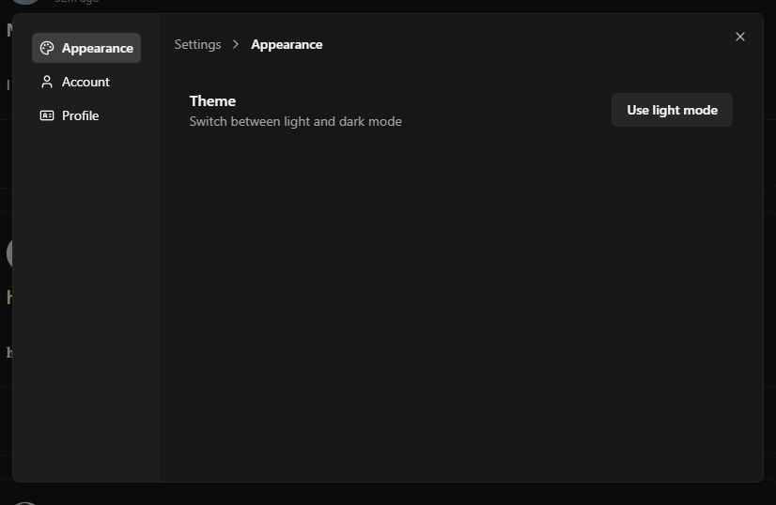
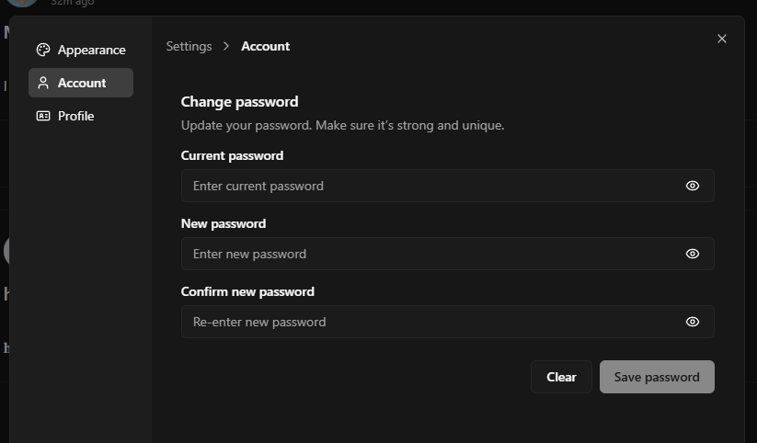
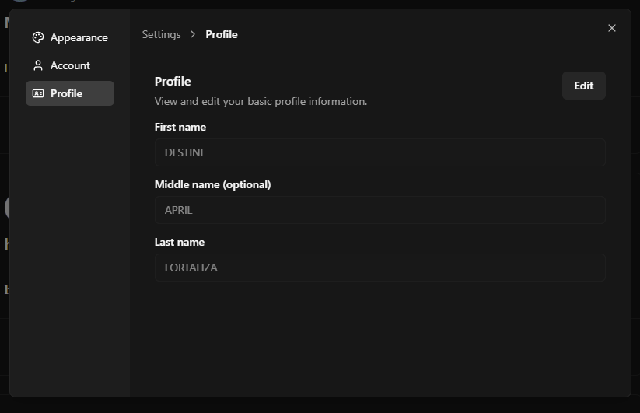

Swagger Auth Endpoints
Capture Swagger UI (`http://localhost:3005/docs`) with the `auth` tag expanded, showing `POST /auth/register` and `POST /auth/login` endpoints.
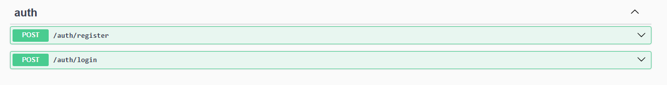

Swagger App & Users Endpoints
Capture Swagger UI with `users` tag expanded (show `POST /users`, `POST /users/{id}/avatar and `app` tag showing app status endpoints.
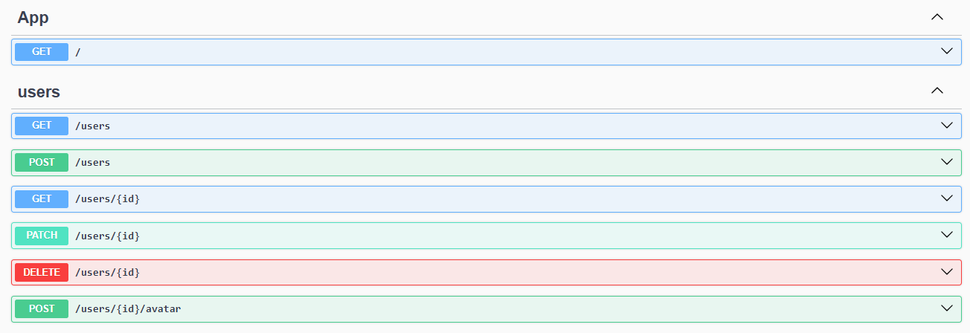

Swagger Posts & Comments Endpoints
Capture Swagger UI with `posts` tag expanded (show `GET /posts`, `POST /posts`, `PATCH /posts/{id}`, `DELETE /posts/{id}`, `GET /posts/{id}/history`) and `comments` tag showing CRUD endpoints.
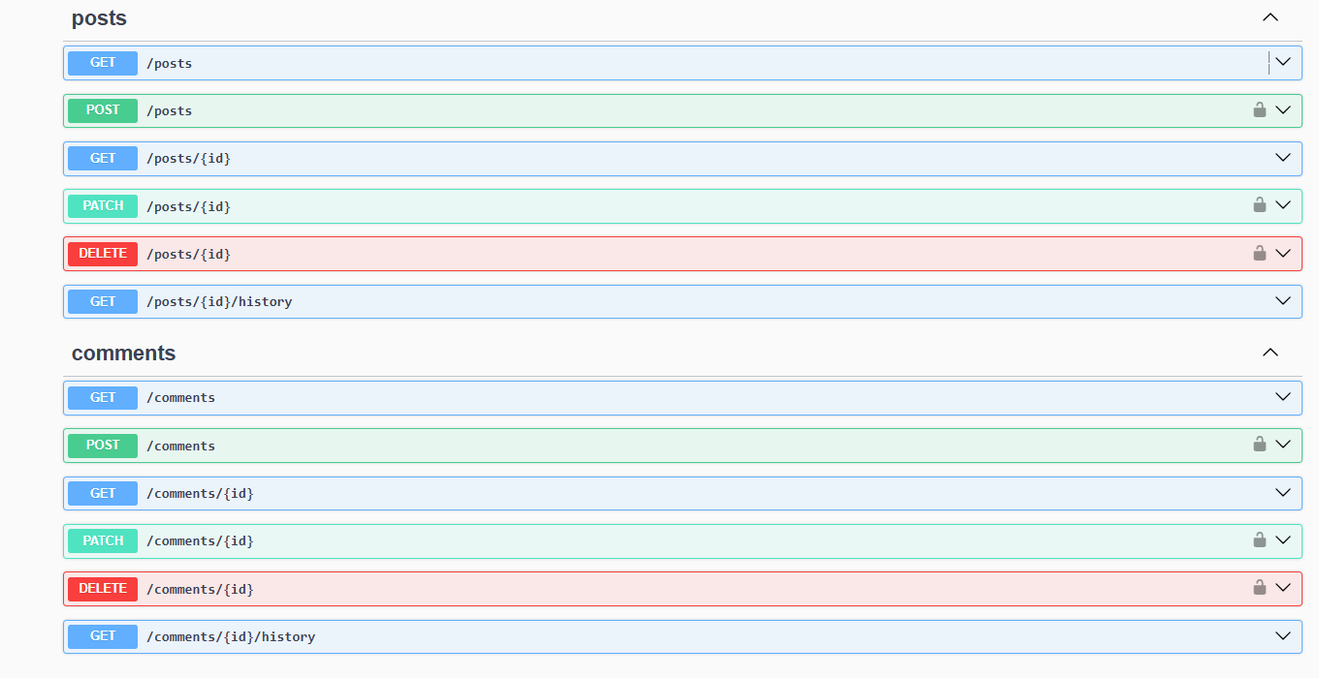

Swagger Likes & Notifications Endpoints
Capture Swagger UI with `likes` tag expanded (show `POST /likes/toggle`, `POST /likes/comment/toggle`) and `notifications` tag showing notification management endpoints.
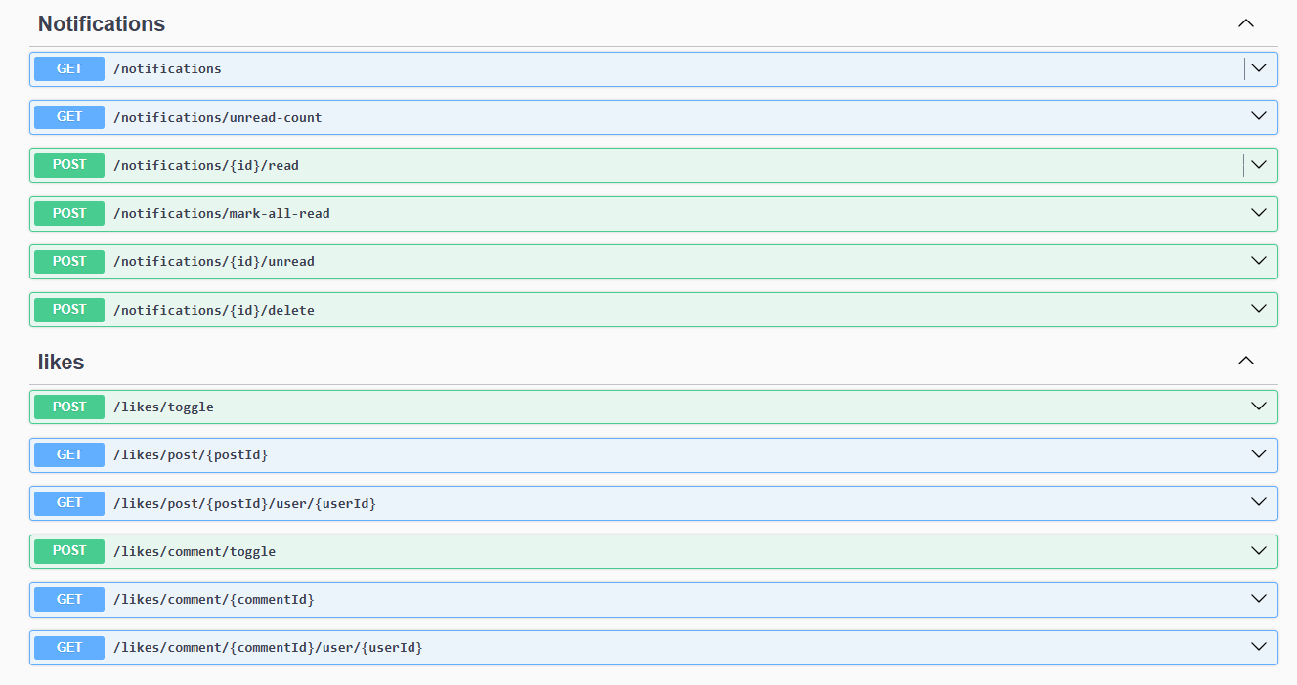

Instructions on How to Run the Project

Prerequisites:
• Node.js v18+ and npm v9+
• Git (if the repository hasn’t been cloned)

Clone and Install:
1. Clone the repository (skip if already cloned):
git clone https://github.com/CVSU-IMUS-BSIT-4A/GitDestroyers-Repository.git
cd Activity5
2. Install backend dependencies:
cd backend/blog-api
npm install
3. Install frontend dependencies:
cd ../../frontend/blog-ui
npm install

Run the Backend:
1. From `Activity5/backend/blog-api`:
npm run dev
2. Backend listens at http://localhost:3005
3. Swagger docs available at http://localhost:3005/docs

Run the Frontend:
1. From `Activity5/frontend/blog-ui`:
npm run dev
2. Open http://localhost:5184 in a browser

Optional Production Builds:
• Frontend:
cd Activity5/frontend/blog-ui
npm run build
npm run preview
• Backend (example with ts-node-dev -> Node):
cd Activity5/backend/blog-api
npx tsc
node dist/main.js # or host with your preferred process manager

