1. **Helices definition of target sequence.**

**Pairwise alignment using AlignME for helices definition of target sequence (*DM*OR59b used here as an example)**

* **Pairwise alignment of *Dm*OR59b with *Mh*OR5 (PDB ID:7LIG) using AlignMe 1.2**

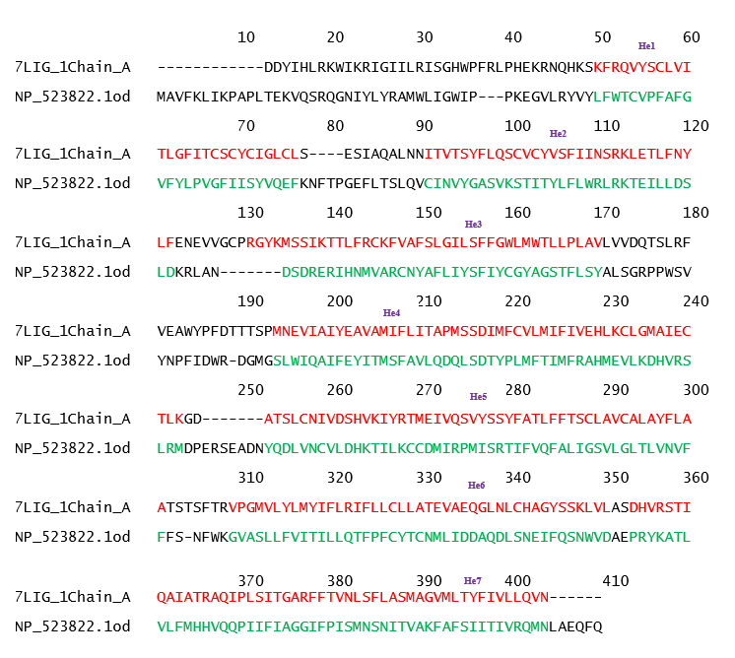

* **Manually edited alignment of *Dm*OR59b with *Mh*OR5 (PDB ID:7LIG)**

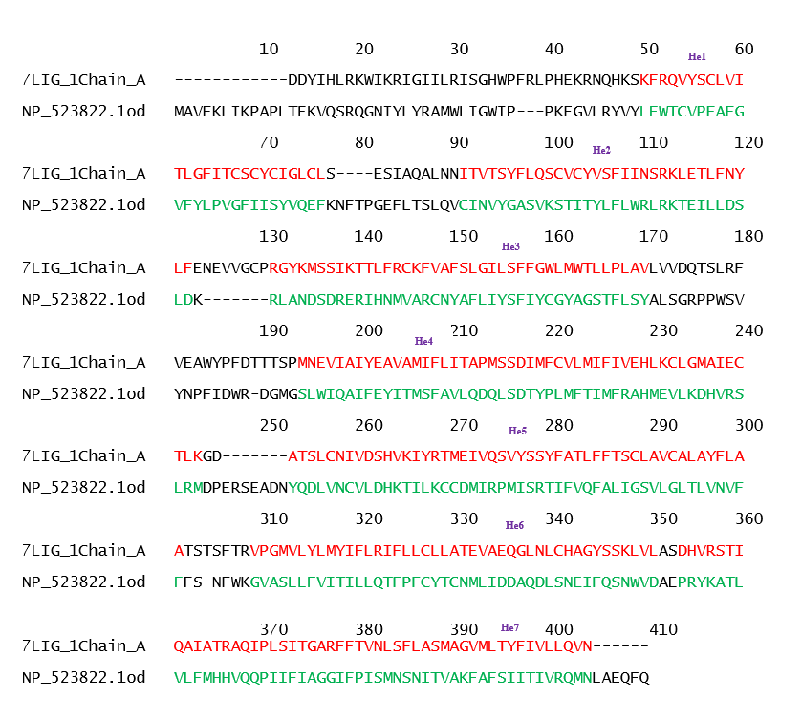

* **Pairwise alignment of *Dm*OR59b with *Ab*Orco (PDB ID:6C70) using AlignMe 1.2**

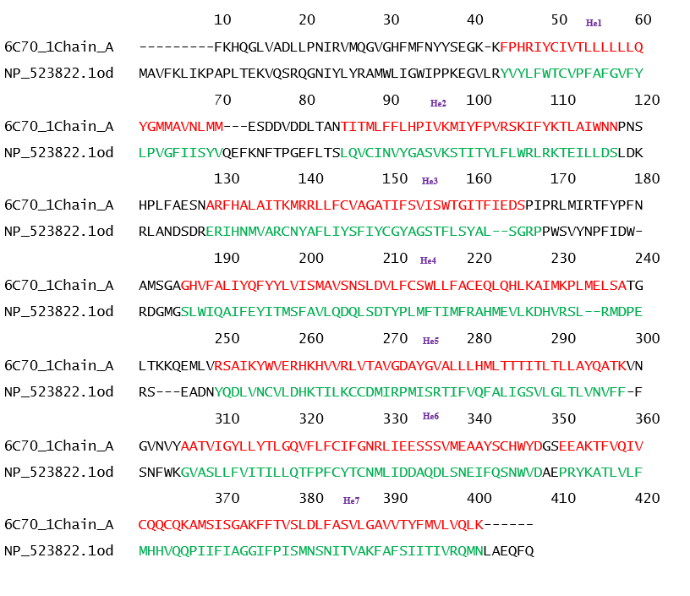

* **Manually edited alignment of *Dm*OR59b with *Ab*Orco (PDB ID:6C70)**

* **Alignment of template sequences of *Mh*OR5 and *Ab*Orco adapted from (Del Mármol et al., 2021)**

* **Helix definitions in *Dm*OR59b**

Analysing the alignment of both the structural templates given above and the consensus alignment of *Dm*OR59b with both the templates, the 7 helices and the centre residues are defined. The sequence, position of the helices is added in the OR datafile in iBio-GATS folder

Table 1. Helix definitions for *Dm*OR59b (UniProt ID: Q9W1P8)

|  |  |  |  |
| --- | --- | --- | --- |
| Helix | Helix start | Helix end | Centre residues |
| 1 | 47 | 73 | Y60 |
| 2 | 88 | 119 | F104 |
| 3 | 121 | 160 | S146 |
| 4 | 183 | 232 | D206 |
| 5 | 242 | 290 | S267 |
| 6 | 297 | 339 | L321 |
| 7 | 342 | 392 | F367 |

1. **Paste Insect OR sequence in FASTA or plain format in the sequence.txt file given in the iBio-GATS folder.**
2. **Run script file.**

The script checks the sequence file, process the given sequence, and shows the first- and second-best template. The alignment files and result summaries are stored in the iBio-GATS folder for user reference.

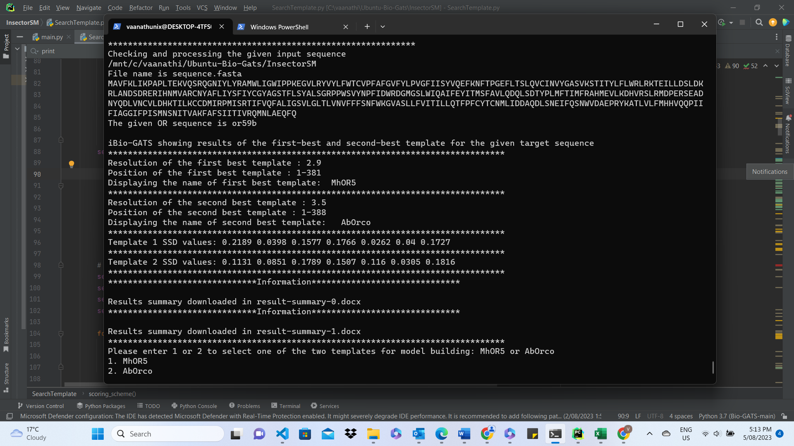

1. **Select the desired template**

The user is given an option to select the desired template. If MhOR5 is selected, the user is given an option to select any one of the *holo* structures of MhOR5(7LIG, 7LID).

1. **Manually edit the alignment if needed.**

The user is given an option to manually edit the alignment. If needed, the user can edit the specific alignment file in the Modeller folder and save it and proceed with the script. For *Dm*OR59b, the alignment is edited to remove gaps based on the final alignment given in section 1. This editing was done using MEGA sequence viewer. The final edited alignment for DmOR59b is given below

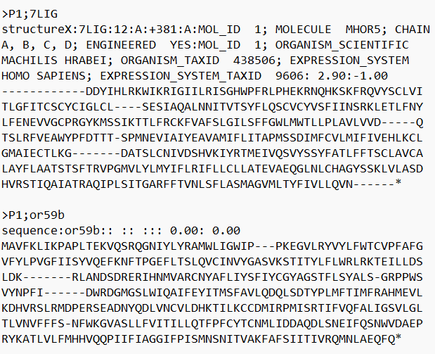

1. **The final output**

The summary of successfully produced models are given in the output and the models are stored in the Modeller folder. The user is advised to save the models in a specific output folder.

