# Output from 7LIG-or59b

Please cite: Jabeen A., Ranganathan, S. BIO-GATS: A tool for automated GPCR template selection through a biophysical approach. (unpublished)

>P1;7LIG  
structureX:7LIG:12:A:+381:A:MOL_ID 1; MOLECULE MHOR5; CHAIN A, B, C, D; ENGINEERED YES:MOL_ID 1; ORGANISM_SCIENTIFIC MACHILIS HRABEI; ORGANISM_TAXID 438506; EXPRESSION_SYSTEM HOMO SAPIENS; EXPRESSION_SYSTEM_TAXID 9606: 2.90:-1.00  
DDYI---HL-R------KWIK-RI-GI-I-L-R----ISGHW-PFRLPHEK---RNQHKS--KFRQVYSCLVITLGFITC  
SCYCIGLCL---S--E---SIAQALNN-ITVTSYFLQSCVCYVSFIINSRKLETLFNYLFENEVVGCPRGYKMSSIKTTL  
FRCKFVAFSLGILSFFGWLMWTLLPLAV-LVVDQTSL-RFVEA--W--Y-PF-DTT---T-SPMNEVIAIYEAVAMIFLI  
TAPMSSDIMFCVLMIFIVEHLKCLGMAIECTLK--G----D-ATSLCNIVDSHVKIYRTMEIVQSVYSSYFATLFFTSCL  
AVCALAYFLAATST-S-FT-RVPGMVLYLMYIFLRIFLLCLLATEVAEQGLNLCHAGYSSKLVLASDHVRSTIQAIATRA  
QIPLSITGARFFTVNLSFLASMAGVMLTYFIVLLQVN*  
>P1;or59b  
sequence:or59b:: :: ::: 0.00: 0.00  
---MAVFKLIKPAPLTEK-VQSR-QG-NIYLYRAMWLI-G-WIP---PKE-GVLR--Y--VYLFWTCVPFAFGVFYLPVG  
FIISYVQEFKNFTPGEFLTSL-Q----VCINVYGASVKSTITYLFLWRLRKTEILLDSLD--K-----RLANDSDRERIH  
NMVARCNYAFLIYSFIYCGYAGSTFLSYAL-----S-GR----PPWSVYNPFID--WRDGMG-SLWIQAIFEYITMSFAV  
LQDQLSDTYPLMFTIMFRAHMEVLKDHVRSLRMDPERSEADNYQDLVNCVLDHKTILKCCDMIRPMISRTIFVQFALIGS  
VLGLTLVNVFF---FSNF-WKGVASLLFVITILLQTFPFCYTCNMLIDDAQDLSNEIFQSNWVDAEPRYKATLVLFMHHV  
QQPIIFIAGGIFPISMNSNITVAKFAFSIITIVRQMNLAEQFQ*

## TM1

Template: KFRQVYSCLVITLGFITCSCYCIGLCL  
Target: LFWTCVPFAFGVFYLPVGFIISYVQEF

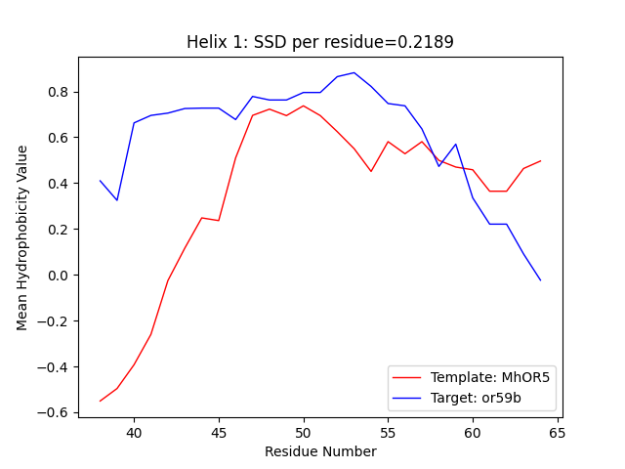

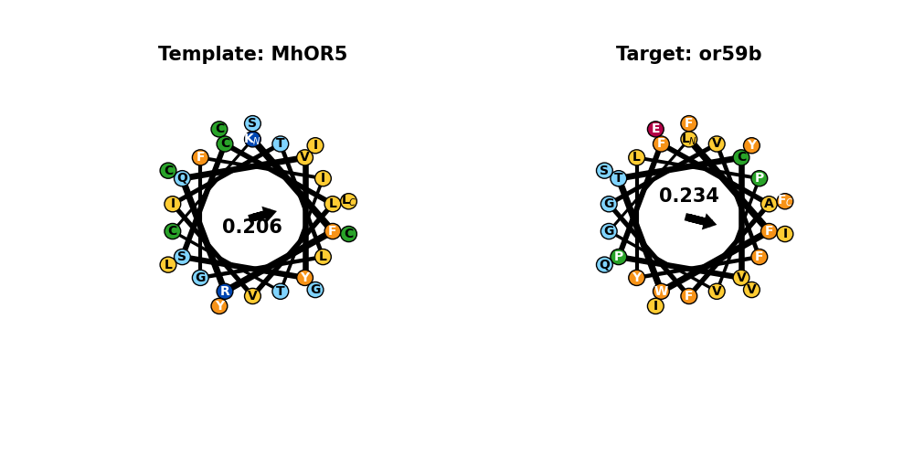

## TM2

Template: ITVTSYFLQSCVCYVSFIINSRKLETLFNYLF  
Target: CINVYGASVKSTITYLFLWRLRKTEILLDSLD

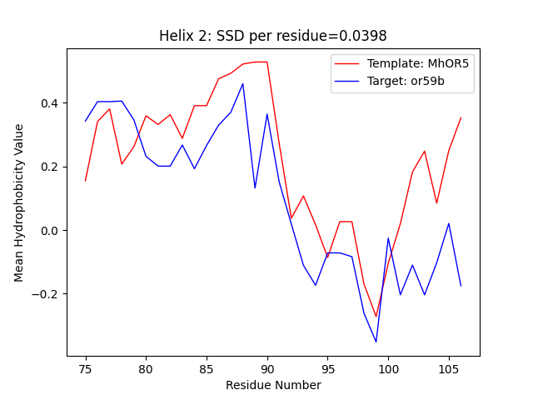

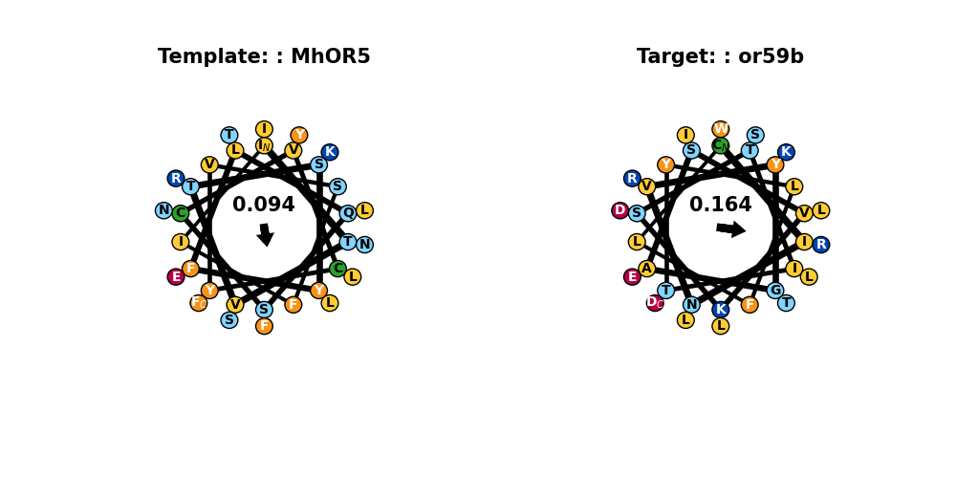

## TM3

Template: RGYKMSSIKTTLFRCKFVAFSLGILSFFGWLMWTLLPLAV  
Target: RLANDSDRERIHNMVARCNYAFLIYSFIYCGYAGSTFLSY

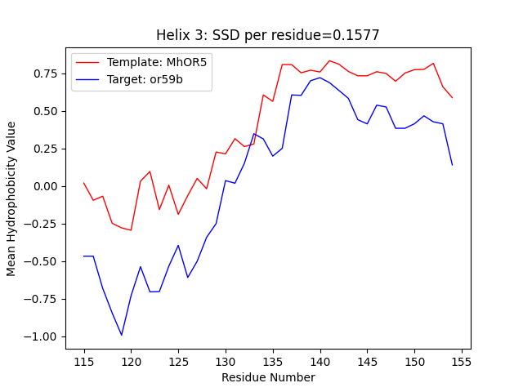

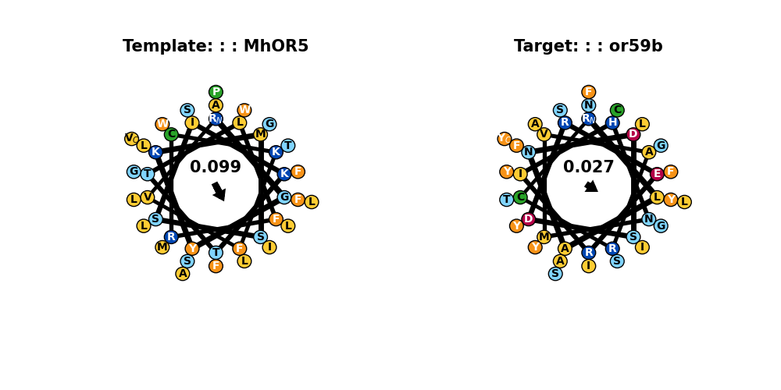

## TM4

Template: MNEVIAIYEAVAMIFLITAPMSSDIMFCVLMIFIVEHLKCLGMAIECTLK  
Target: SLWIQAIFEYITMSFAVLQDQLSDTYPLMFTIMFRAHMEVLKDHVRSLRM

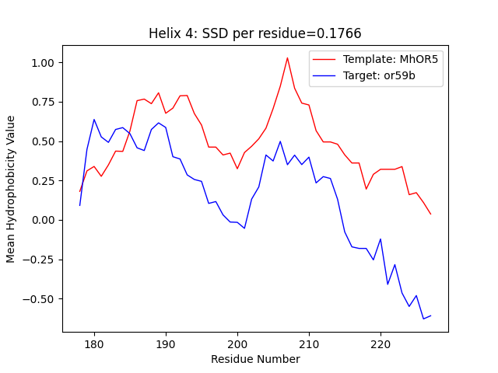

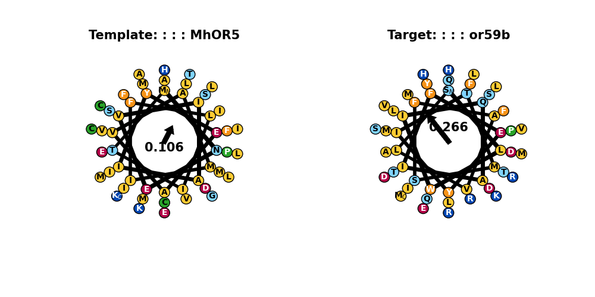

## TM5

Template: ATSLCNIVDSHVKIYRTMEIVQSVYSSYFATLFFTSCLAVCALAYFLAA  
Target: YQDLVNCVLDHKTILKCCDMIRPMISRTIFVQFALIGSVLGLTLVNVFF

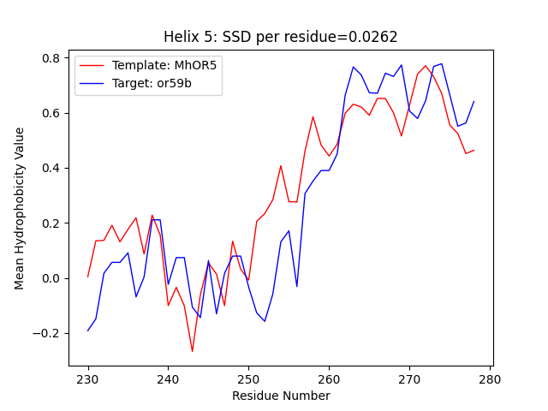

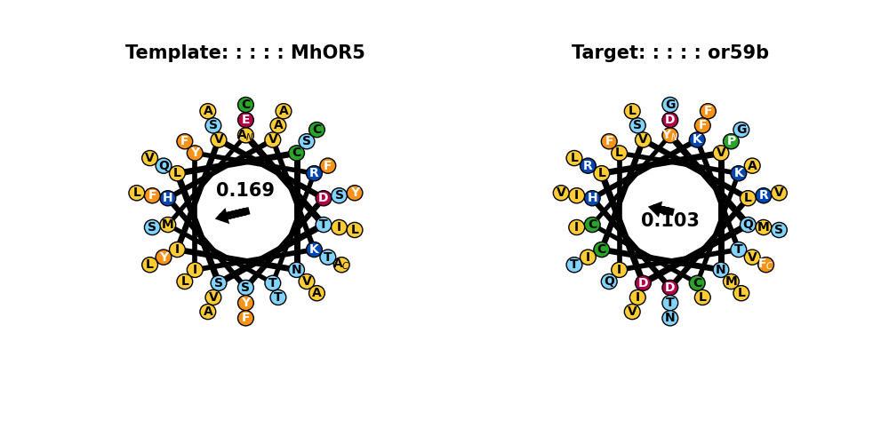

## TM6

Template: VPGMVLYLMYIFLRIFLLCLLATEVAEQGLNLCHAGYSSKLVL  
Target: GVASLLFVITILLQTFPFCYTCNMLIDDAQDLSNEIFQSNWVD

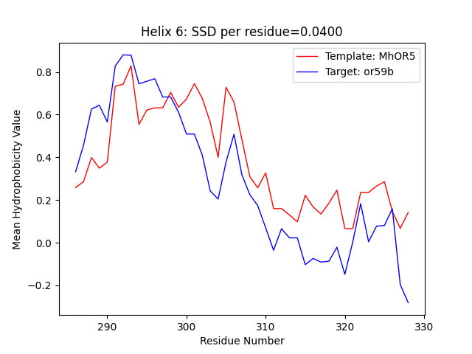

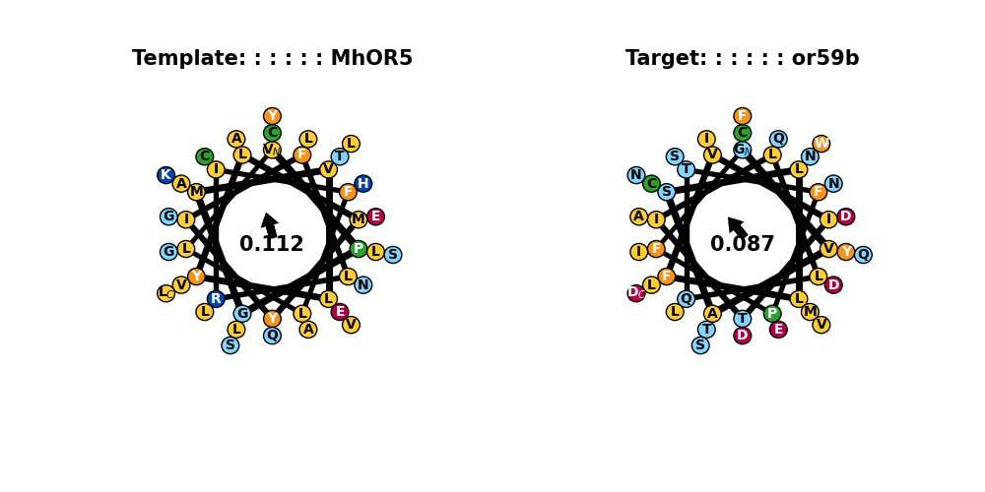

## TM7

Template: DHVRSTIQAIATRAQIPLSITGARFFTVNLSFLASMAGVMLTYFIVLLQVN  
Target: PRYKATLVLFMHHVQQPIIFIAGGIFPISMNSNITVAKFAFSIITIVRQMN

