# Output from 6C70-or59b

Please cite: Jabeen A., Ranganathan, S. BIO-GATS: A tool for automated GPCR template selection through a biophysical approach. (unpublished)

>P1;6C70  
structureX:6C70:3:A:+388:A:MOL_ID 1; MOLECULE ODORANT RECEPTOR; CHAIN A, B, C, D; ENGINEERED YES:MOL_ID 1; ORGANISM_SCIENTIFIC APOCRYPTA BAKERI; ORGANISM_TAXID 490712; GENE OR2; EXPRESSION_SYSTEM HOMO SAPIENS; EXPRESSION_SYSTEM_TAXID 9606: 3.50:-1.00  
---FKHQGLV--ADLLPNI------RVMQGVGHFMFN-Y-YSE-----G----K----K---FPHRIYCIVTLLLLLLQY  
GMMAVNLMMESDDVD----D-LTA-N-TITMLFFLHPIVKMIYFPVRSKIFYKTLAIWNNPNSHPLFAESN-ARFHALAI  
TKMRRLLFCVAGATIFSVISWTGITFIEDS------PIPRLMIR-TF-Y-PF-N---AMSGAGHVFALIYQFYYLVISMA  
VSNSLDVLFCSWLLFACEQLQHLKAIMKPLMELSATGLT--KK-Q-EMLV-RSAIKYWVERHKHVVRLVTAVGDAYGVAL  
LLHMLTTTITLTLLAYQATKVN-GVNV-Y-AATVIGYLLYTLGQVFLFCIFGNRLIEESSSVMEAAYSCHWYDGSEEAKT  
FVQIVCQQCQKAMSISGAKFFTVSLDLFASVLGAVVTYFMVLVQLK*  
>P1;or59b  
sequence:or59b:: :: ::: 0.00: 0.00  
MAVFK---LIKPA---P-LTEKVQSR--Q--G----NIYLY-RAMWLIGWIPPKEGVLRYVYLFWTCVPFAFGVFYLPVG  
FIISYVQEFK----NFTPGEFLTSLQVCINVYGASVKSTITYLFLWRLRKTEILLDSLD---------K--RLANDSDRE  
RIHNMVARCNYAFLIYSFIYCGYAGSTFLSYALSGRP-P-----WS-VYNPFIDWRDGM-G-SLWIQAIFEYITMSFAVL  
QDQLSDTYPLMFTIMFRAHMEVLKDHVRSLRM-------DPERSEAD---NYQDLVNCVLDHKTILKCCDMIRPMISRTI  
FVQFALIGSVLGLTLVNVFF--FS-N-FWKGVASLLFVITILLQTFPFCYTCNMLIDDAQDLSNEIFQSNWVDAEPRYKA  
TLVLFMHHVQQPIIFIAGGIFPISMNSNITVAKFAFSIITIVRQMNLAEQFQ*

## TM1

Template: FPHRIYCIVTLLLLLLQYGMMAVNLMM  
Target: LFWTCVPFAFGVFYLPVGFIISYVQEF

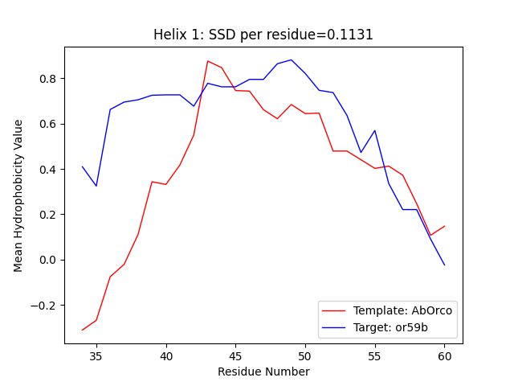

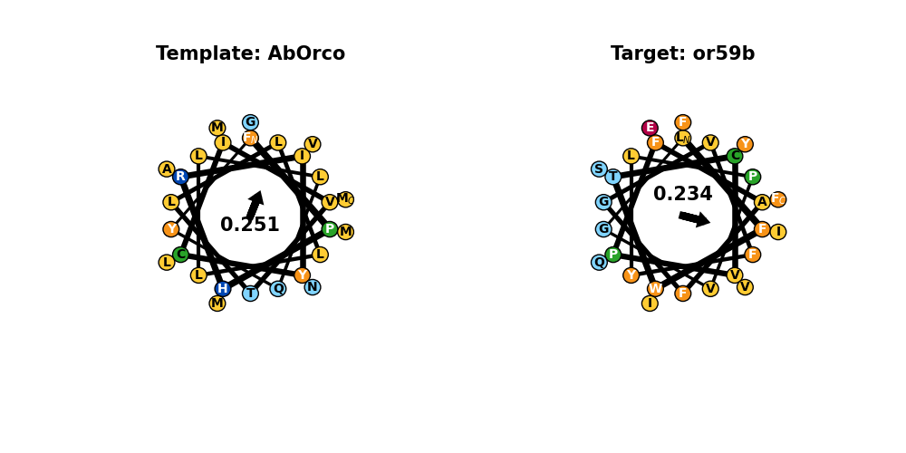

## TM2

Template: TITMLFFLHPIVKMIYFPVRSKIFYKTLAIWNN  
Target: CINVYGASVKSTITYLFLWRLRKTEILLDSLD-

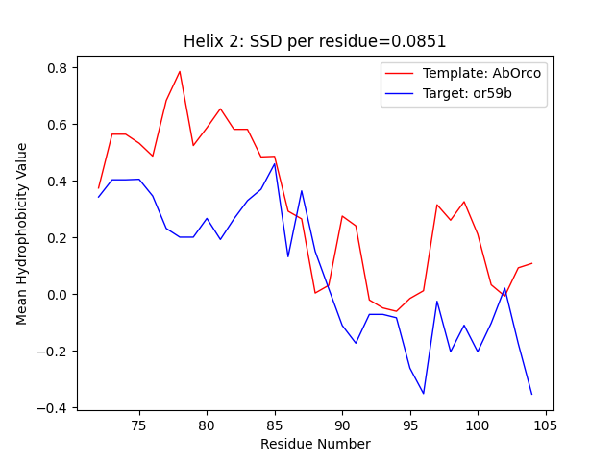

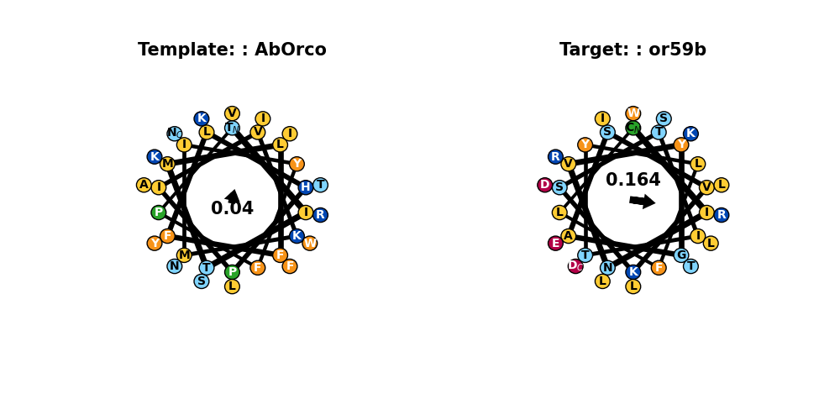

## TM3

Template: -ARFHALAITKMRRLLFCVAGATIFSVISWTGITFIEDS-  
Target: RLANDSDRERIHNMVARCNYAFLIYSFIYCGYAGSTFLSY

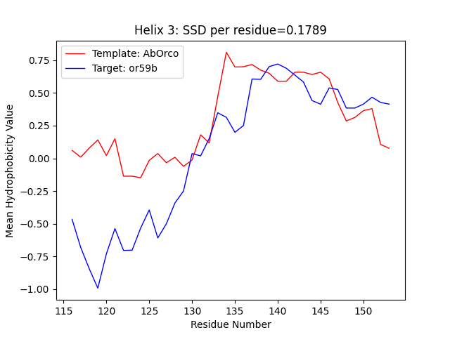

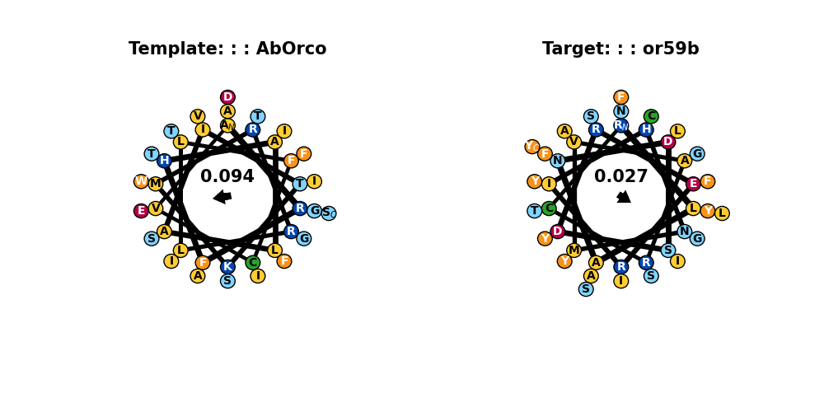

## TM4

Template: GHVFALIYQFYYLVISMAVSNSLDVLFCSWLLFACEQLQHLKAIMKPLMELSA  
Target: SLWIQAIFEYITMSFAVLQDQLSDTYPLMFTIMFRAHMEVLKDHVRSLRM---

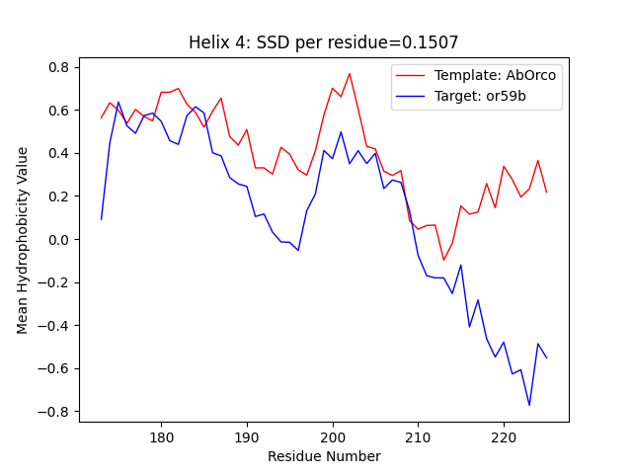

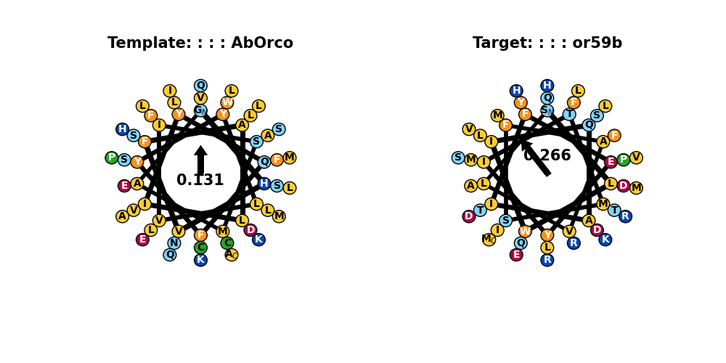

## TM5

Template: RSAIKYWVERHKHVVRLVTAVGDAYGVALLLHMLTTTITLTLLAYQATK  
Target: YQDLVNCVLDHKTILKCCDMIRPMISRTIFVQFALIGSVLGLTLVNVFF

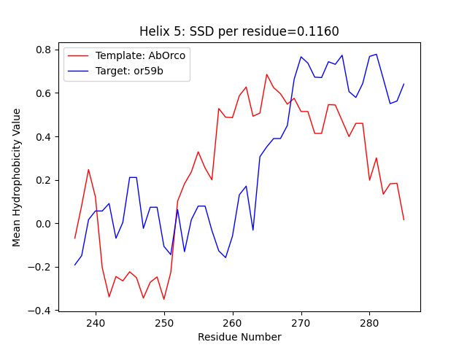

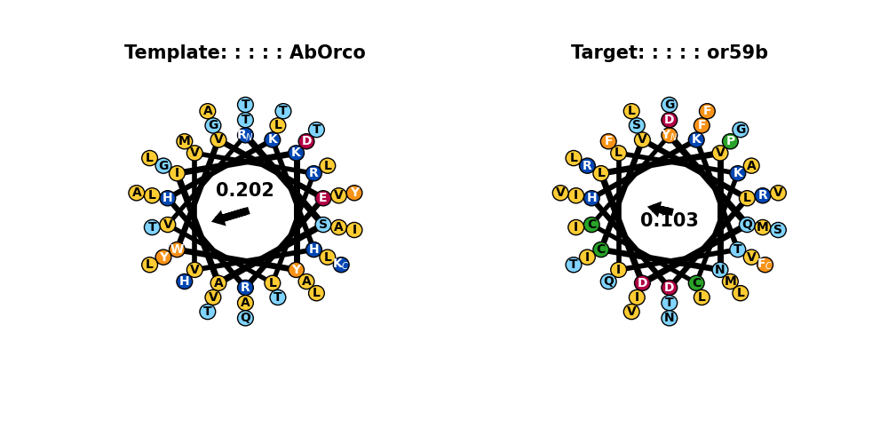

## TM6

Template: AATVIGYLLYTLGQVFLFCIFGNRLIEESSSVMEAAYSCHWYD  
Target: GVASLLFVITILLQTFPFCYTCNMLIDDAQDLSNEIFQSNWVD

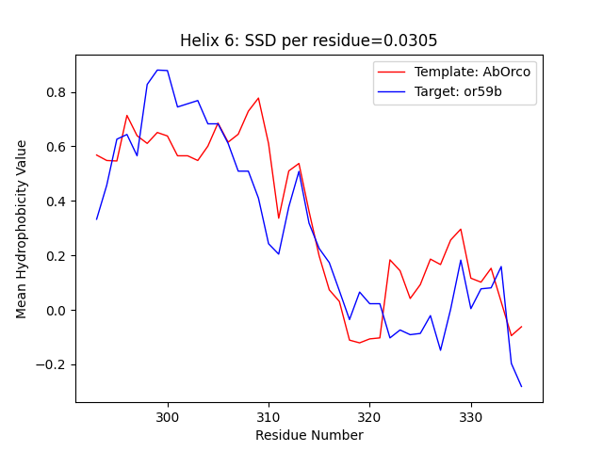

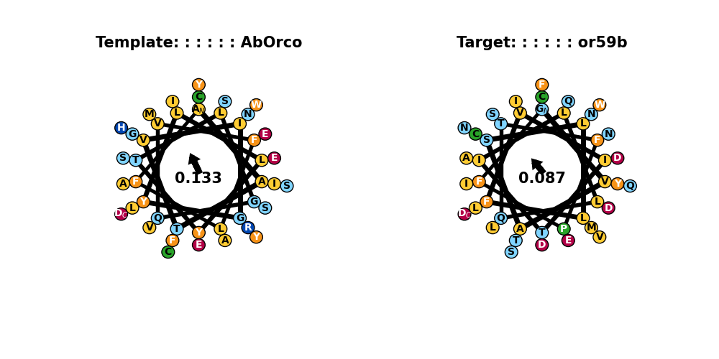

## TM7

Template: EEAKTFVQIVCQQCQKAMSISGAKFFTVSLDLFASVLGAVVTYFMVLVQLK  
Target: PRYKATLVLFMHHVQQPIIFIAGGIFPISMNSNITVAKFAFSIITIVRQMN

