TempleInnAndSuites.com

Site Plan

Clayton Vanfleet

WDD230-03

12/1/2022

Site Purpose

Temple Inn & Suites is an Inn located next to a few Temples from the Church of Jesus Christ of Latter-Day Saints and the goal is to build many more next to even more temples!

The purpose of this website is to help church members and non-church members to be able to book rooms at these inns when they want to travel and visit these beautiful temples.

Target Audience

The target audience for templeinnandsweets.com is as follows:

* **Who:** Investigators of the church, recent converts, member couples, church youth leaders, youth, any other members of the church
* **Age: 11 – 100+**
* **Scenarios:** Investigators wanting to see the temple, converts getting temple work done, member couples looking to get sealed, youth groups doing baptisms for the dead, etc..

**Personas**

Charles Augustus

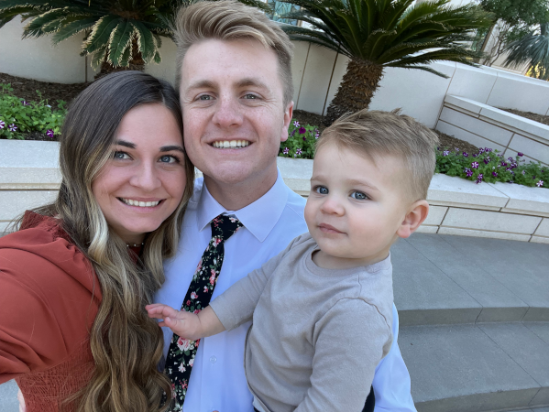

* Demographics and age: Charles Augustus, 24 years old, is from Frankfurt, Germany.
* Goals and Motivation for using the site: Mr. Augustus and his wife both got baptized a year ago, and now they would like to get sealed together along with their son. The temple they would like to be sealed in is quite a distance away and will need a place to stay. Temple Inn & Suites would be a perfect place!

Phil Edwards



* Demographics and age: Phil Edwards, 30 years old, is from Austin, TX.
* Goals and Motivation for using the site: Mr. Edwards is a young men’s leader in the church. He is currently planning a big trip with all the youth of the church to do baptisms for the dead. He appreciates how Temple Inn & Suites can accommodate all 30 of the youth of their ward.

Site Map

This section describes the site map of the website:

Color Scheme

|  |  |  |  |  |
| --- | --- | --- | --- | --- |
| Main background: | Header/footer: | Selected nav link: | Text: | Button: |
| #fcfcff | #153b50 | #429ea6 | #14010B | #931F1D |

Typography

The primary text fonts are Cinzel for the headers, and Source Sans Pro for the rest of the text.

|  |  |  |  |  |
| --- | --- | --- | --- | --- |
| Site header | Cinzel | 40px | #153b50 | Sample |
| Navigation | Source Sans Pro | 20px | #429ea6 | Sample |
| Heading 1 (h1) | Cinzel | 30px | #14010B | Sample |
| Heading 2 (h2) | Cinzel | 25px | #fcfcff | Sample |
| Heading 3 (h3) | Cinzel | 20px | #931F1D | Sample |
| Paragraph text (p) | Source Sans Pro | 16px | #fcfcff | Sample |

Wireframe Sketches

This section gives you a layout of large, medium, and small views of the main page. (Note that these wireframes are mostly to show layout and color scheme. So the typography will not match):

Large View

Small View

