# Appendices

## Appendix A: Requirements specification

|  |  |  |
| --- | --- | --- |
| **stt** | **Roles** | **Requirement** |
| 1 | All users | Can login to the web with provided account |
| 2 | guest | Can view all approved cmr of the faculty |
| 3 | guest | Can view statistical report |
| 4 | guest | Can view exception reports. |
| 5 | Admin | Can view/add/ edit all the courses |
| 6 | Admin | Can view/add/edit all faculties |
| 7 | Admin | Can view/add/edit all staffs |
| 8 | Admin | Can assign PVC,DLT to faculties |
| 9 | Admin | Can assign courses to faculties |
| 10 | Admin | Can assign CL,CM to courses |
| 11 | Course Leader | Can view assigned course |
| 12 | Course Leader | Can create the CMR |
| 13 | Course Leader | Can view/edit the CMR until it approved |
| 14 | Course Leader | Can view the commit of DLT in the cmr |
| 15 | Course Moderator | Can view assigned course |
| 16 | Course Moderator | Can approve the CMR submit by CL |
| 17 | Course Moderator | Can view the commit of DLT in the cmr |
| 18 | Course Moderator | Can view the CMR submitted |
| 19 | Director of Learning and Quality | Can view assigned faculty |
| 20 | Director of Learning and Quality | Can view the CMR submitted |
| 21 | Director of Learning and Quality | Can make the commit for CMR submitted |
| 22 | Director of Learning and Quality | Can view all approved cmr of the faculty |
| 23 | Pro-Vice Chancellor | Can view assigned faculty |
| 24 | Pro-Vice Chancellor | Can view the CMR submitted |
| 25 | Pro-Vice Chancellor | Can view all approved cmr of the faculty |

## Appendix B: Database design

This is the Data diagram of our project. It was Design by Chi and Truong. In our work, the process need some change and we change the database design to suitable with

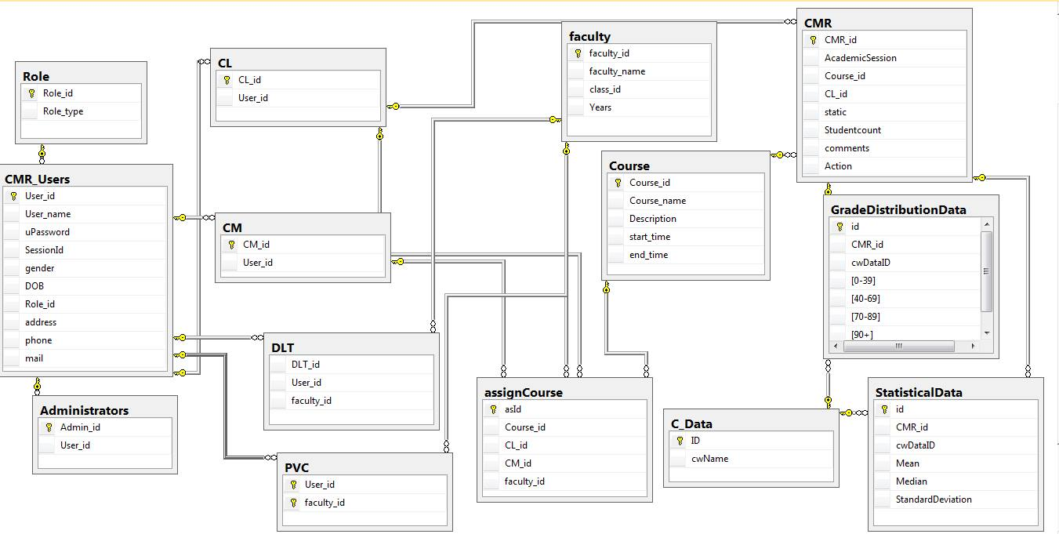

## Appendix C: Interface Design

The interface design already in description of the final built system and its functionality, including annotated screen shots. There are many picture that show our system’s process. It also show the design of interface.

## Appendix D: Role-based security system

The Role-based security of the system is very important. In the system, we use md5 to encrypt the users’s password.

This function below here is md5 encryption.

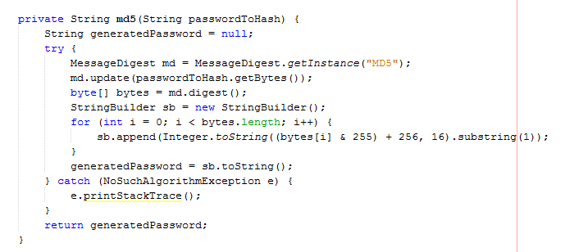

And how to call this this function for password encryption of users and check to the database.

C:\Users\Nguyen\AppData\Local\Microsoft\Windows\INetCache\Content.Word\callmd5.png

## Appendix E: Validations implemented

This is the example how we check the validation. Validation exist when login failed or user type wrong password.

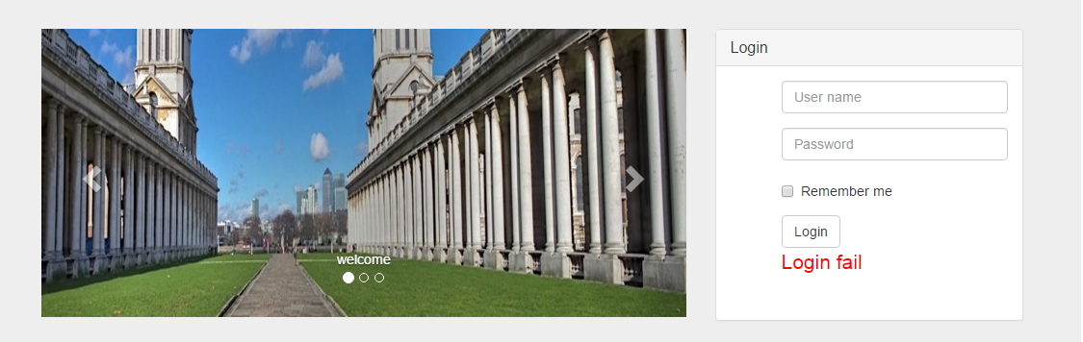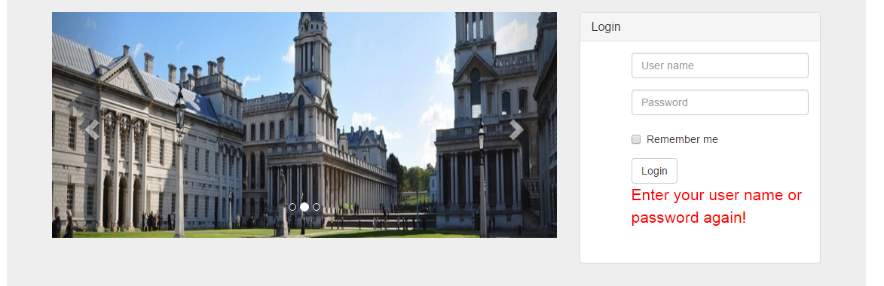

## Appendix F: Workflow implementation

This is ERD

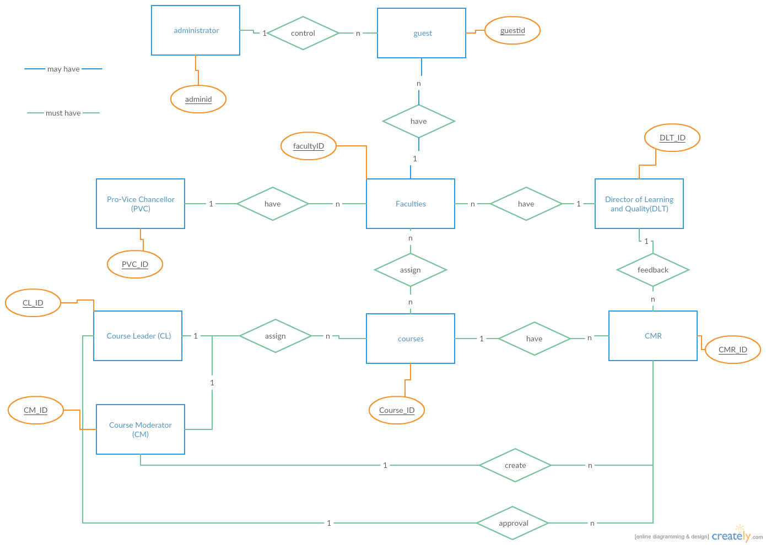

## Appendix G: Test plan and test log

|  |  |  |  |  |
| --- | --- | --- | --- | --- |
| **Test** | **What is being tested** | **How** | **Test data used** | **Expected Results** |
| 1 | Check Login | Enter account  Enter password | Data set 1 | Login successful, the account exists in the DB. |
| 2 | Check Add new course | Enter all information of course. | Data set 2 | Information of course entry is the same as that information on the information capture sheet. |
| 3 | Check validation of input | Enter typical values, boundary value, values that should be rejected. | Data set 3 | Good data accepted, bad data rejected. |
| 4 | Check Edit course | Enter information of course need edit. | Data set 4 | Information of course entry is the same as that information need edit. |
| 5 | Check Delete course | Delete all information of course. |  | Information of course need delete does not exist in the DB. |
| 6 | Check activity and status of the course |  |  | Information about activity and status of the course. |
| 7 | Check Search online course | Enter information of online course looking. | Data set 7 | List of the online course. |
| 8 | Check View information of course |  |  | All information of the course. |
| 9 | Check my grades | Enter name or my ID. | Data set 8 | All information about grades. |
| 10 | Check my course that I manage | Enter name or my ID. | Data set 10 | All information of my course that I manage. |
| 11 | Check register a new account | Enter information of a new account. | Data set 11 | New account exists in DB. |
| 12 | Check confirm new members to join the course |  |  | Members present in courses. |
| 13 | Check report about my course's status in CMR | Enter name or my ID. | Data set 13 | All information about report about my course's status in CMR. |
| 14 | Check the CMR create by the CL | Create new CMR | Data set 14 | All information in CMR. have taken and save to database |
| 15 | Check the approval of CM | Approval the new cmr | Data set 15 | The new cmr change status |
| 16 | Check the mail sent when CL create new CMR | Mail sent to DLT,CM,PVC | Data set 16 | The mail has been seen to the email address of other staffs |
| 17 | Check the DLT can list all the CMR not have feedback | Show all the cmr not have feedback and in the dlt control | Data set 17 | The list has been show |
| 18 | Check the DLT can update the feedback for CMR not have feedback | DLT make feedback for the cmr | Data set 18 | The DLT make feedback for the cmr and save to database |

## Appendix H: Minutes of meetings

We met and discuss ten minutes for each meeting at class and library. After that we did our mission and commit them to Github.

## Appendix I: Scrum documentation

We had product backlog file and sprint backlog file and zip them with report file to commit.