Name: Crystal Wolf

ID: X00512932

1. Prompt the user for a string
2. Count the number of letters, words, and sentences that the user has inputted.
3. Compute the users grade using the formula 0.0588*L(avg of num per 100 words)-0.296*S(avg num of sen per 100 words)-15.8
4. Print out the users grade as ‘Grade X’
5. Print out the number of letters, words, and sentences.
6. If the user’s grade is 16 or higher, print out ‘Grade 16+’
7. Else the user’s grade is less than one, print out ‘Before Grade 1’

**Summary of Tools**

* **Stdio.h:** Has the info to make input and output functions, i.e printf, scanf, etc.
* **String.**h: Has functions that can handle strings. i.e strlen (what I used, but didn’t end up in the final product)
* **Ctype.**h: Classifies (and can change) characters. i.e islower checks for lower case numbers. (used at the start, don’t think it made it into the final product)

**Testing**

**Input:** I like dogs.

**Expected Output**

**Letters: 9**

**Words: 3**

**Sentences: 1**

**Score: 1**

**Your grade is: Before grade 1**

**Output**

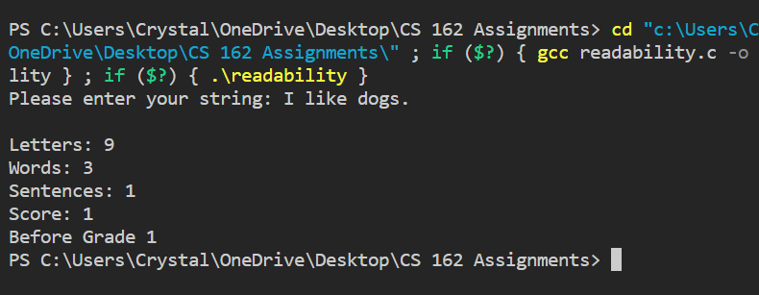

**Input:** Do you like dogs? I do.

**Expected Output**

**Letters: 45**

**Words: 12**

**Sentences: 3**

**Score: -1.15**

**Your grade is: Before grade 1.**

**Output**

**(It rounded down)**

**Input:**

**Expected Output**

**Letters: 86**

**Words: 20**

**Sentences: 4**

**Score: 2.38**

**Your grade is: 2**

**Output**

**Reflection**

I learned patience from this assignment. I also relearned math skills from elementary school.

**Other Comments/Questions**

Sometimes when I run the code, it gives huge numbers that are definitely wrong, but I couldn’t figure out why.