Charles “Warren” Hammock

CS530

HW2: Relational Schema for MOVIE Database

Company(Name, address) Name is primary key. No foreign keys.

Movie(Title, Year_of_release, Name, Length_in_minutes, Plot_outline, ID_genre) Title and YOR are primary keys. Name(from Company) and IDgenre(from Genre) are foreign keys.

Director(Name, Date_of_birth) Name and DOB are primary keys.

Actor(Name, Date_of_birth) Name and DOB are primary keys.

Directs(Title, Year_of_release, Name, Date_of_birth) All foreign keys that act as primary keys. Changes the (Director/Movie) many to many relationship to a many to one relationship for both.

Acts(Act_ID, Name, Date_of_birth, Title, Year_of_release, Role) ActID is a primary key created for this table. It will be used to reference tuples in this table.

Quotes(Act_ID, Quote) ActID will be a foreign key used as primary key. Created addition table for quote attribute due to partial participation.

Genre(ID_genre, Genre_Matrix) Each combination of Genre is represented in the Genre table and is given a value (ID_G

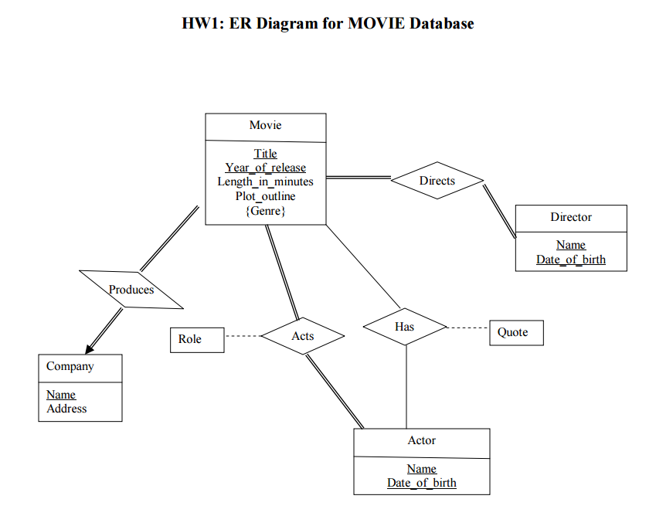enre).