- SiNGLE-PLOT, port. PNG
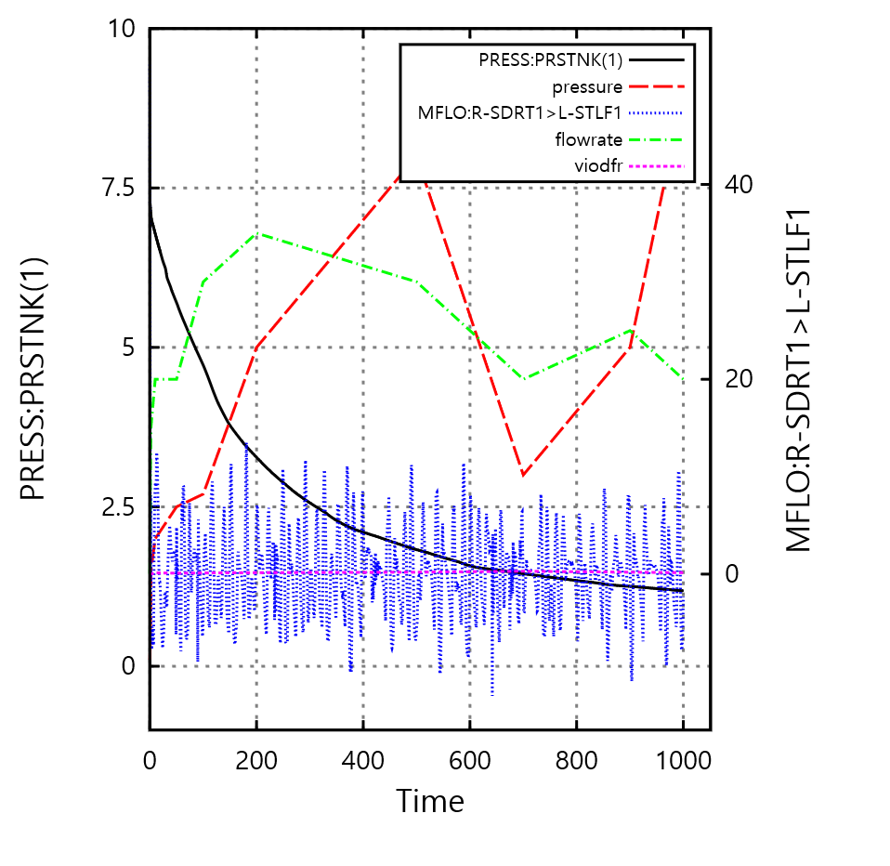
- SiNGLE-PLOT, Land. PNG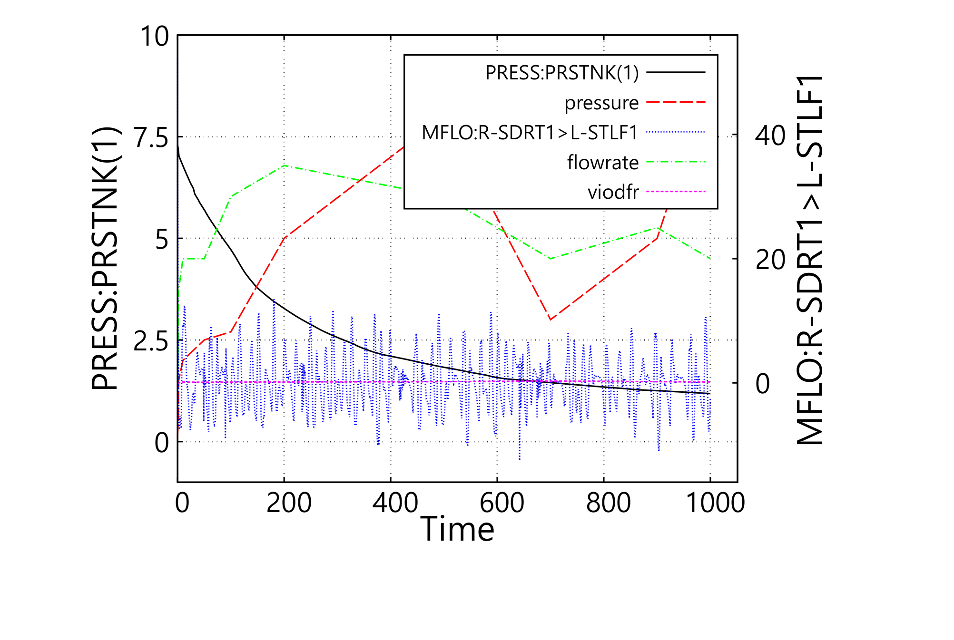

- SiNGLE-PLOT, Port. EMF

- SiNGLE-PLOT, Land. EMF

- SiNGLE-PLOT, Port. SVG

- SiNGLE-PLOT, Land SVG
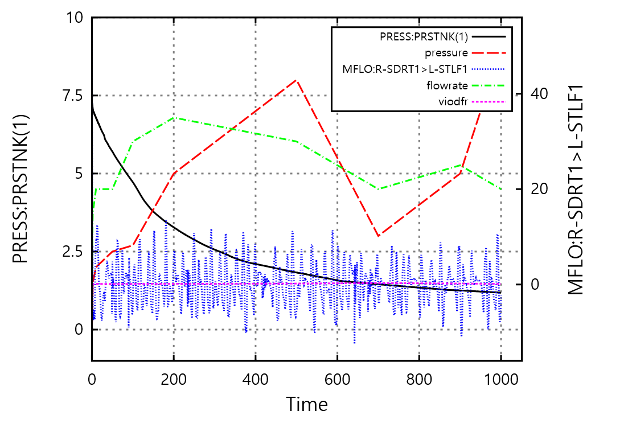

1.M-P, Auto, 1-p: port-PNG:out111(14), press(8), PRESS(9), PRESS(10), PRESS(11)
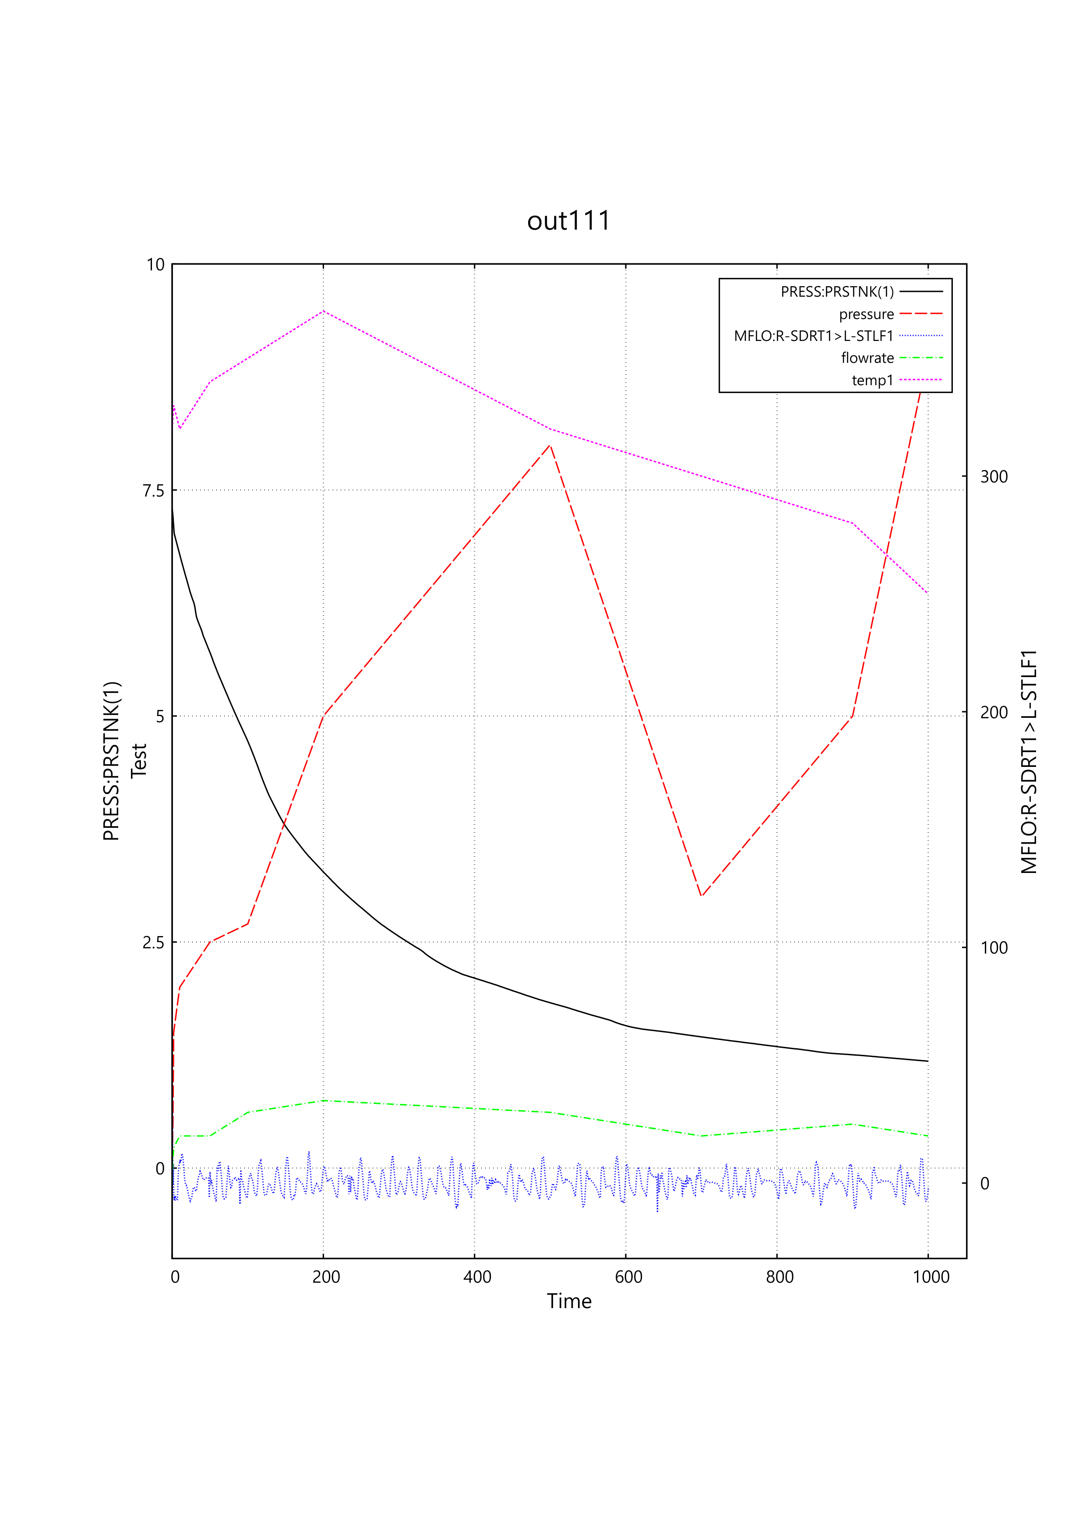
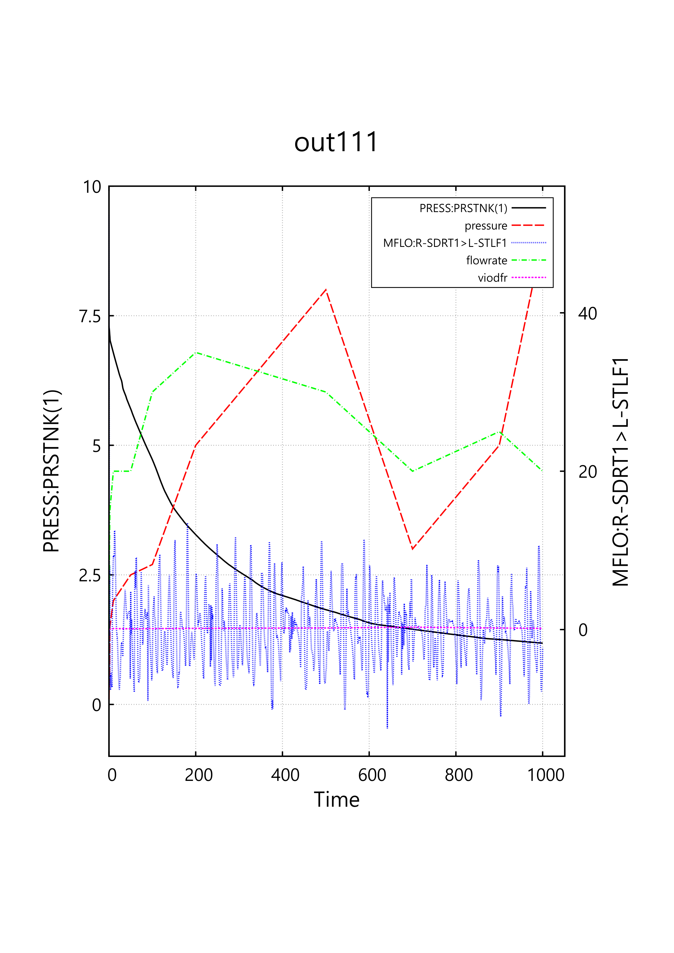
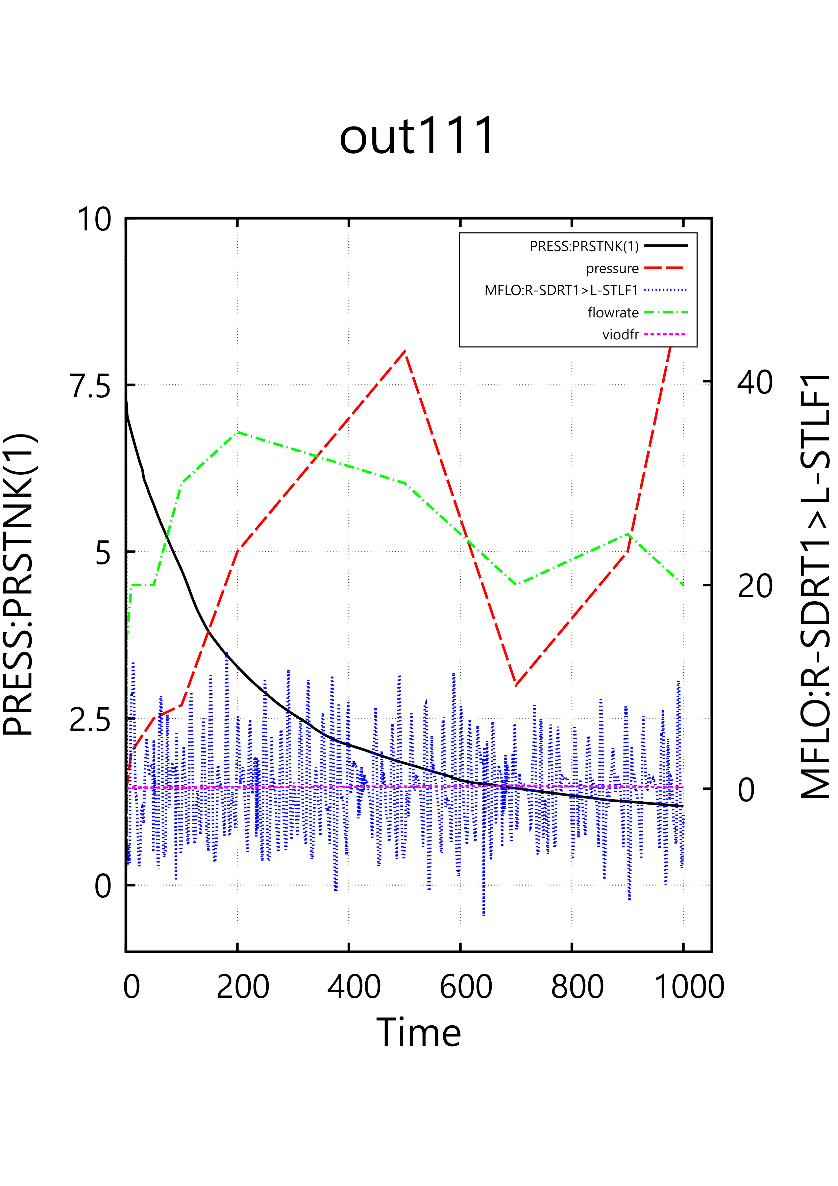
2. M-P, Auto, 1-p: Land-PNG: out111(14), press(8), PRESS(9), PRESS(10), PRESS(11)
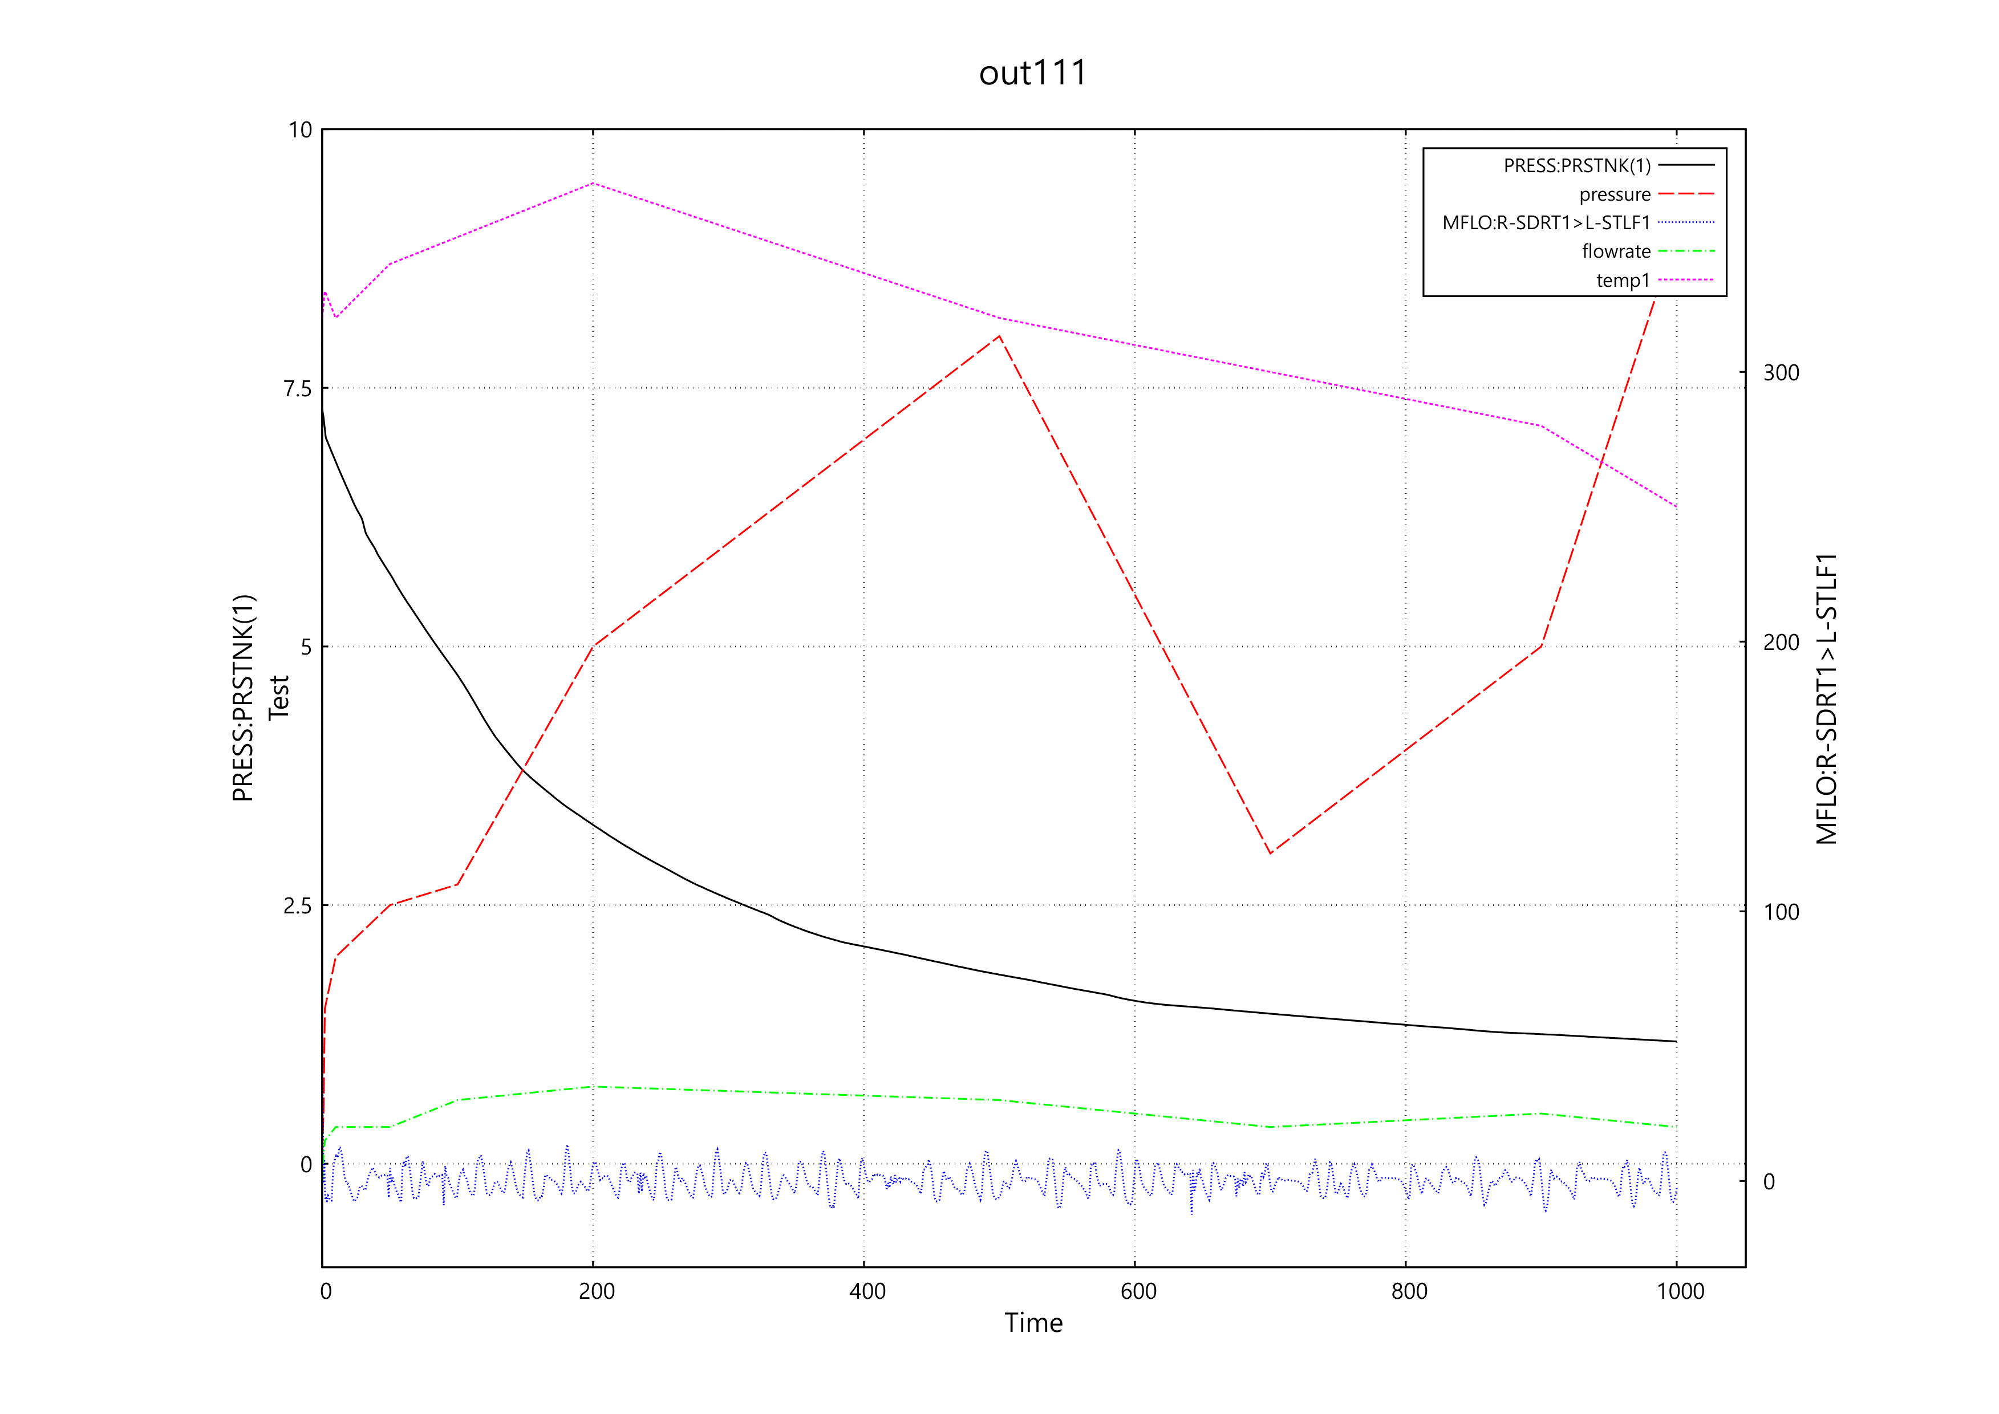
New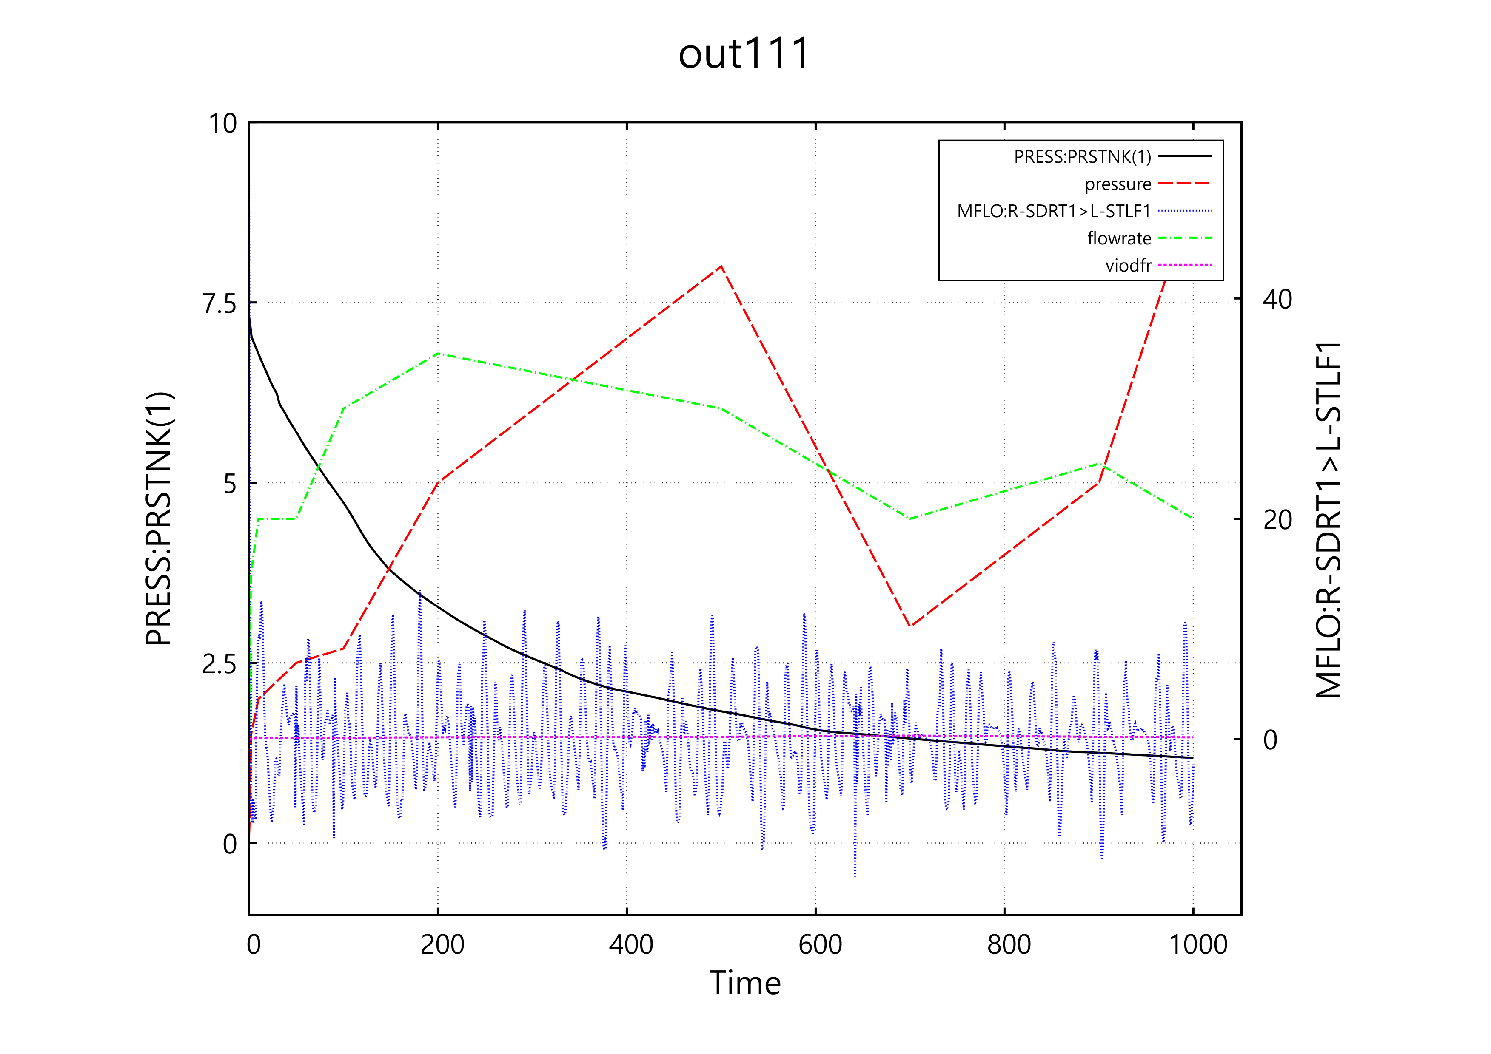
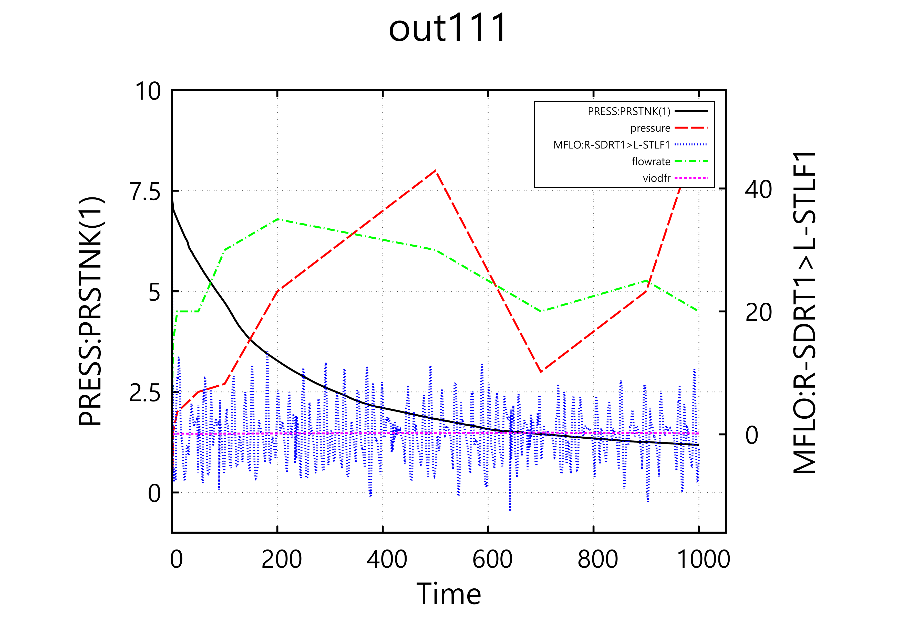
3. M-P, Auto, 1-p: Port-EMF: out111(14), press(8), PRESS(9), PRESS(10), PRESS(11)
new
4. M-P, Auto, 1-p: Land-EMF: out111(14), press(8), PRESS(9), PRESS(10), PRESS(11)

New
5. M-P, Auto, 1-p: Port-SVG: out111(14), press(8), PRESS(9), PRESS(10), PRESS(11)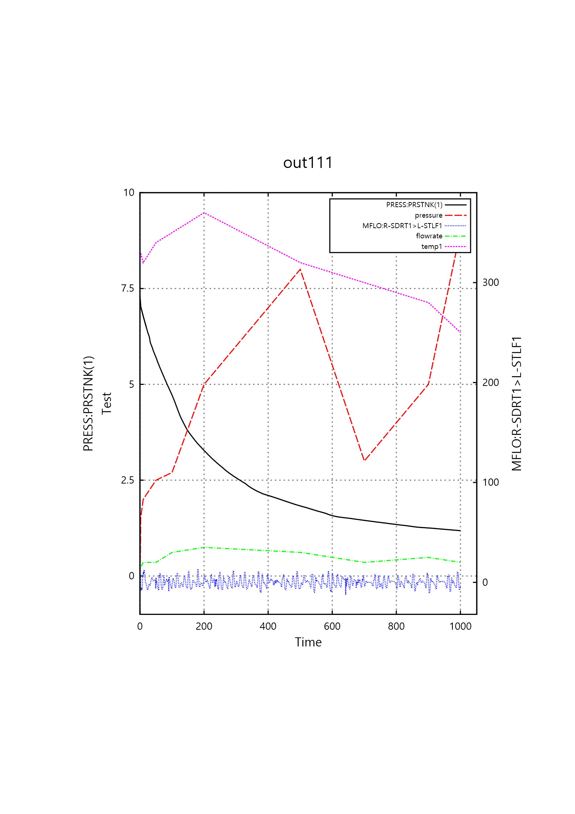
new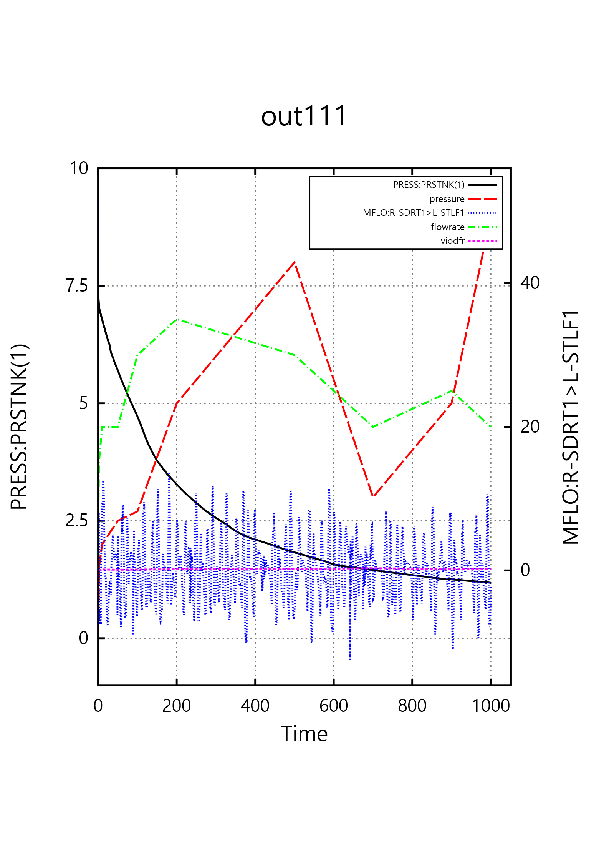
6. M-P, Auto, 1-p: Land-SVG: out111(14), press(8), PRESS(9), PRESS(10), PRESS(11)
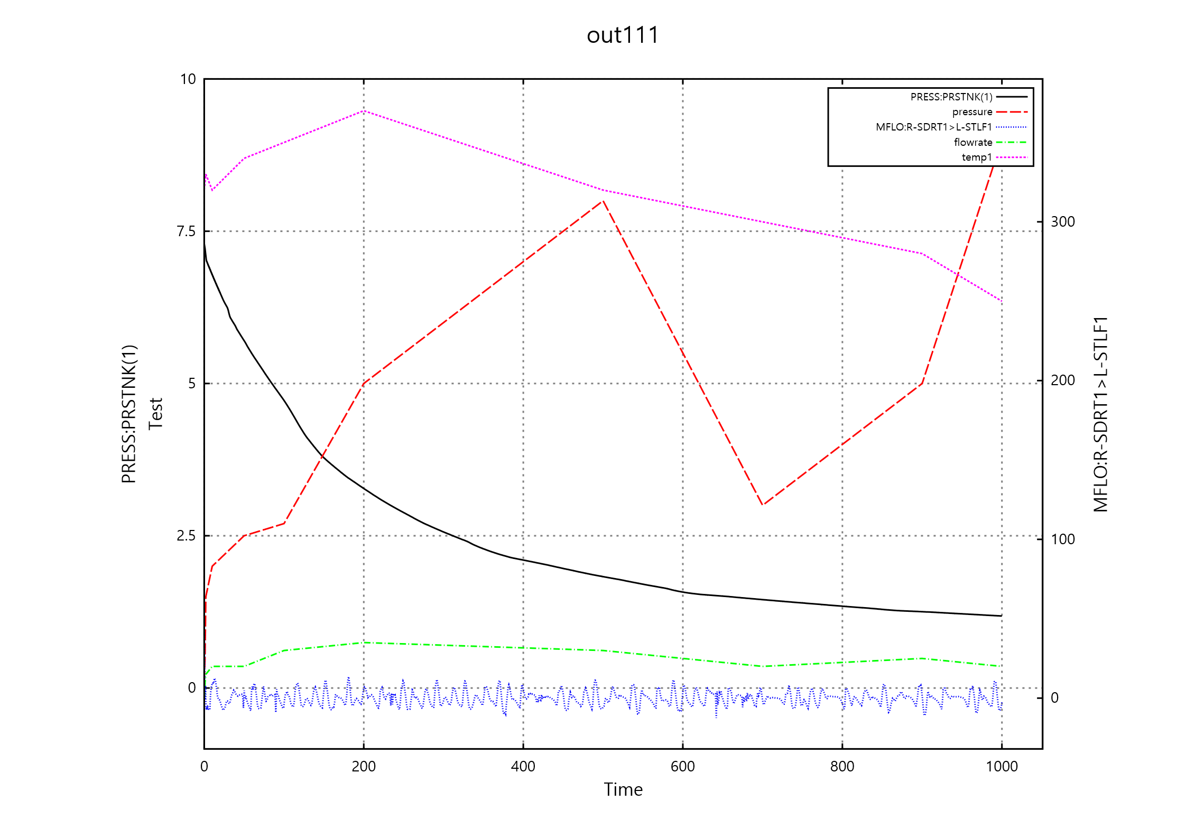
new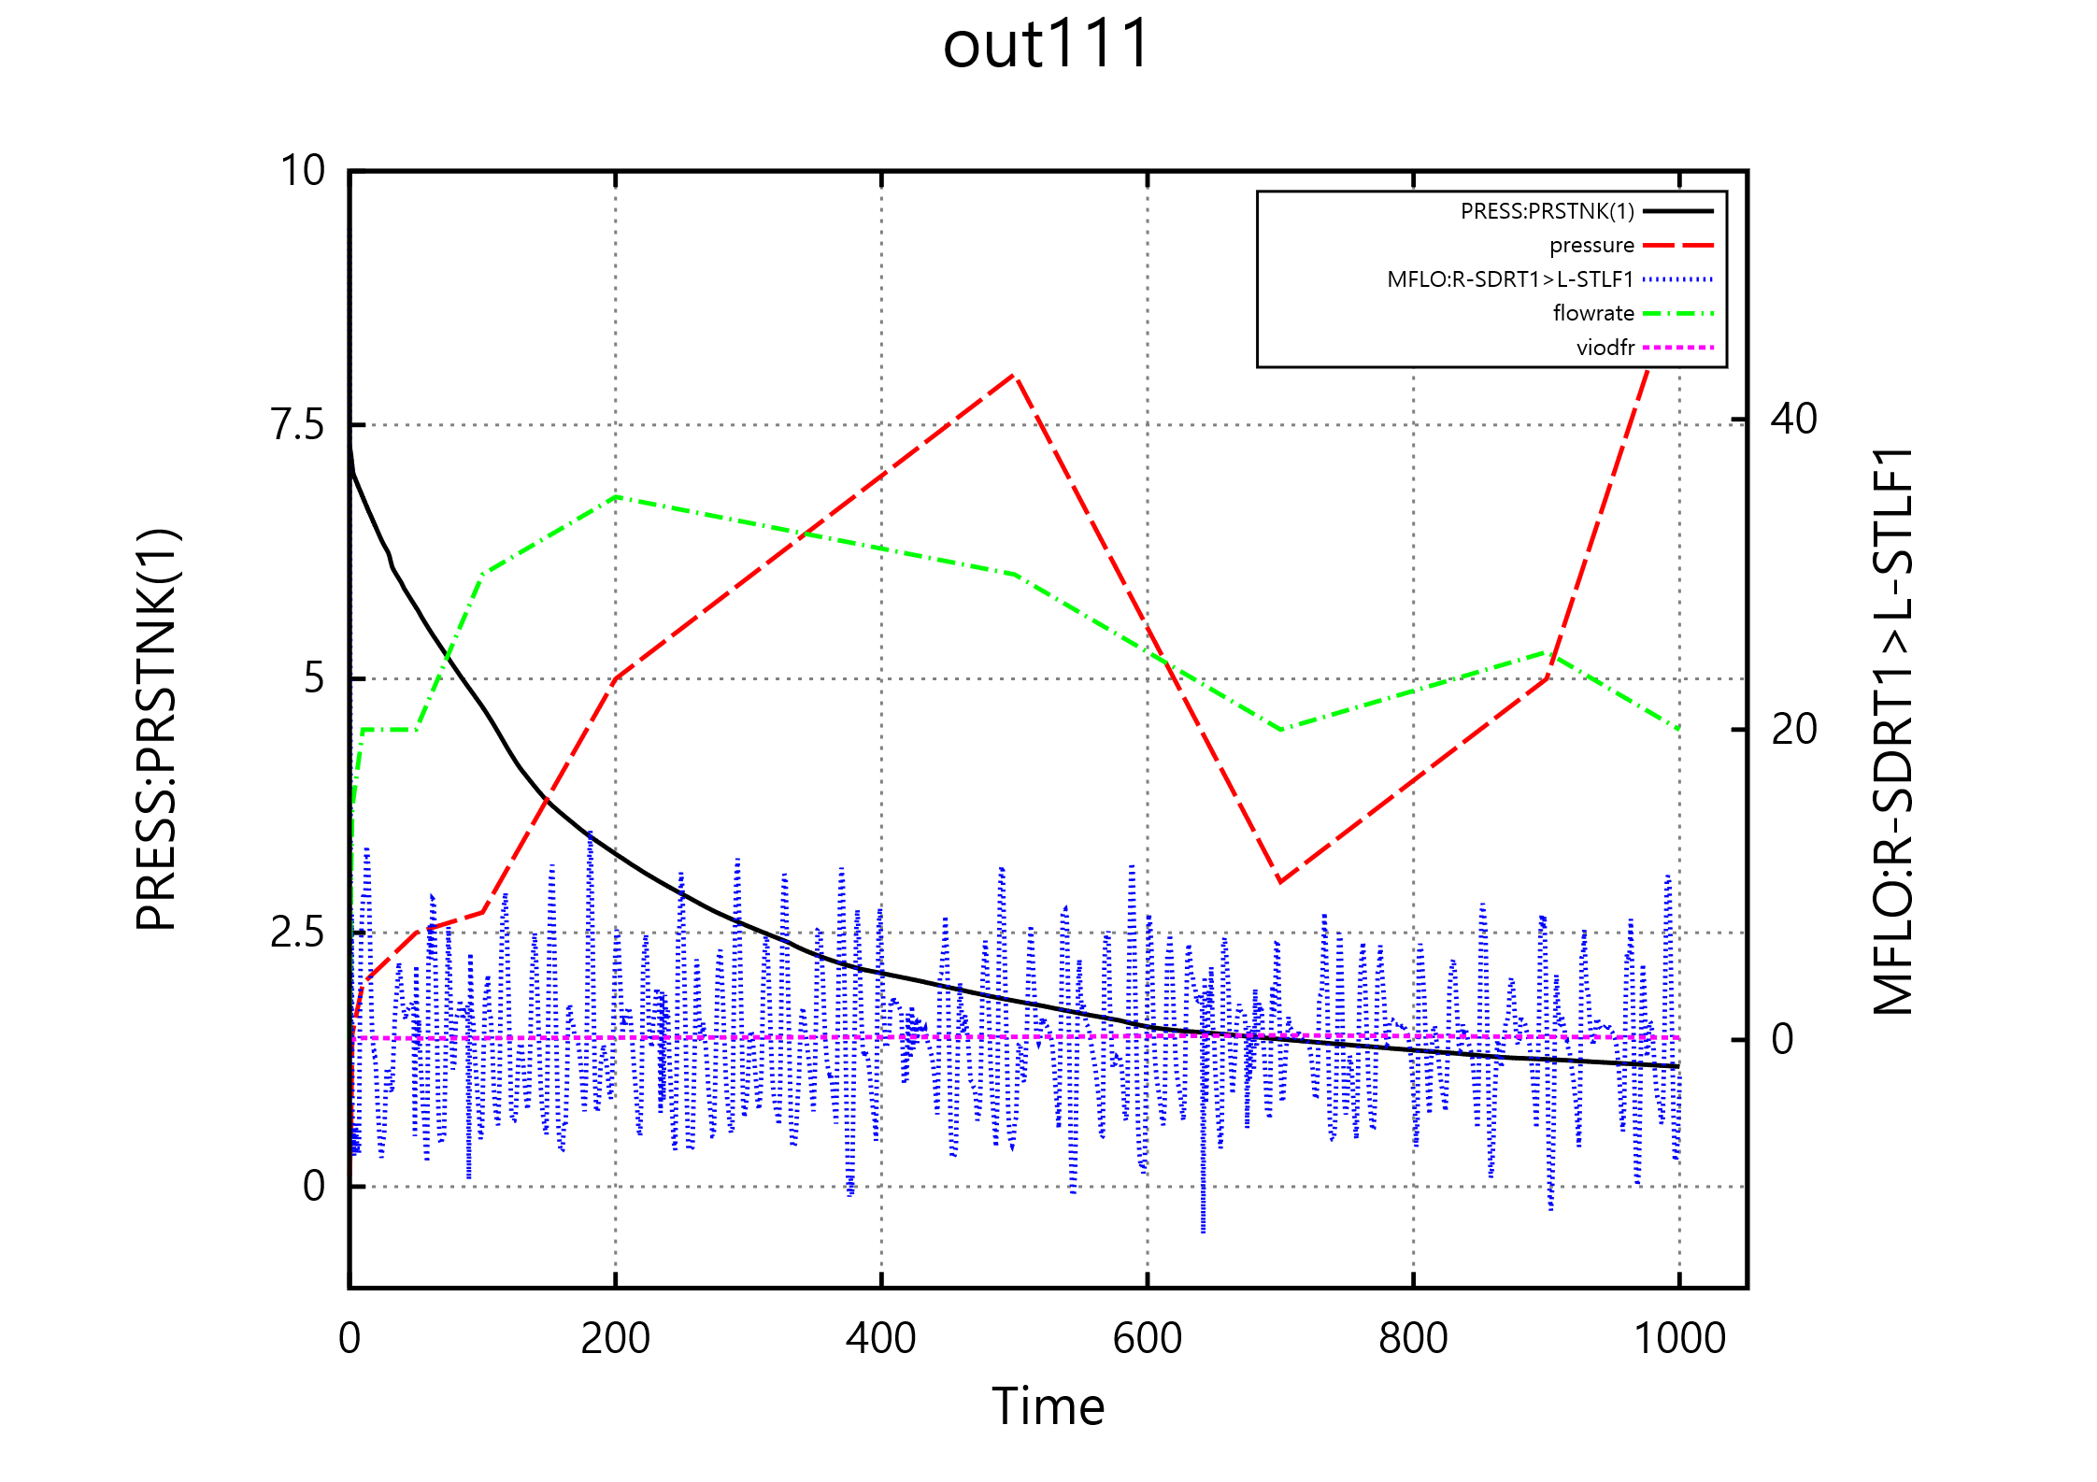
9. M-P, Auto, 2-p: port-PNG: out111(14), press(8), PRESS(9), PRESS(10), PRESS(11)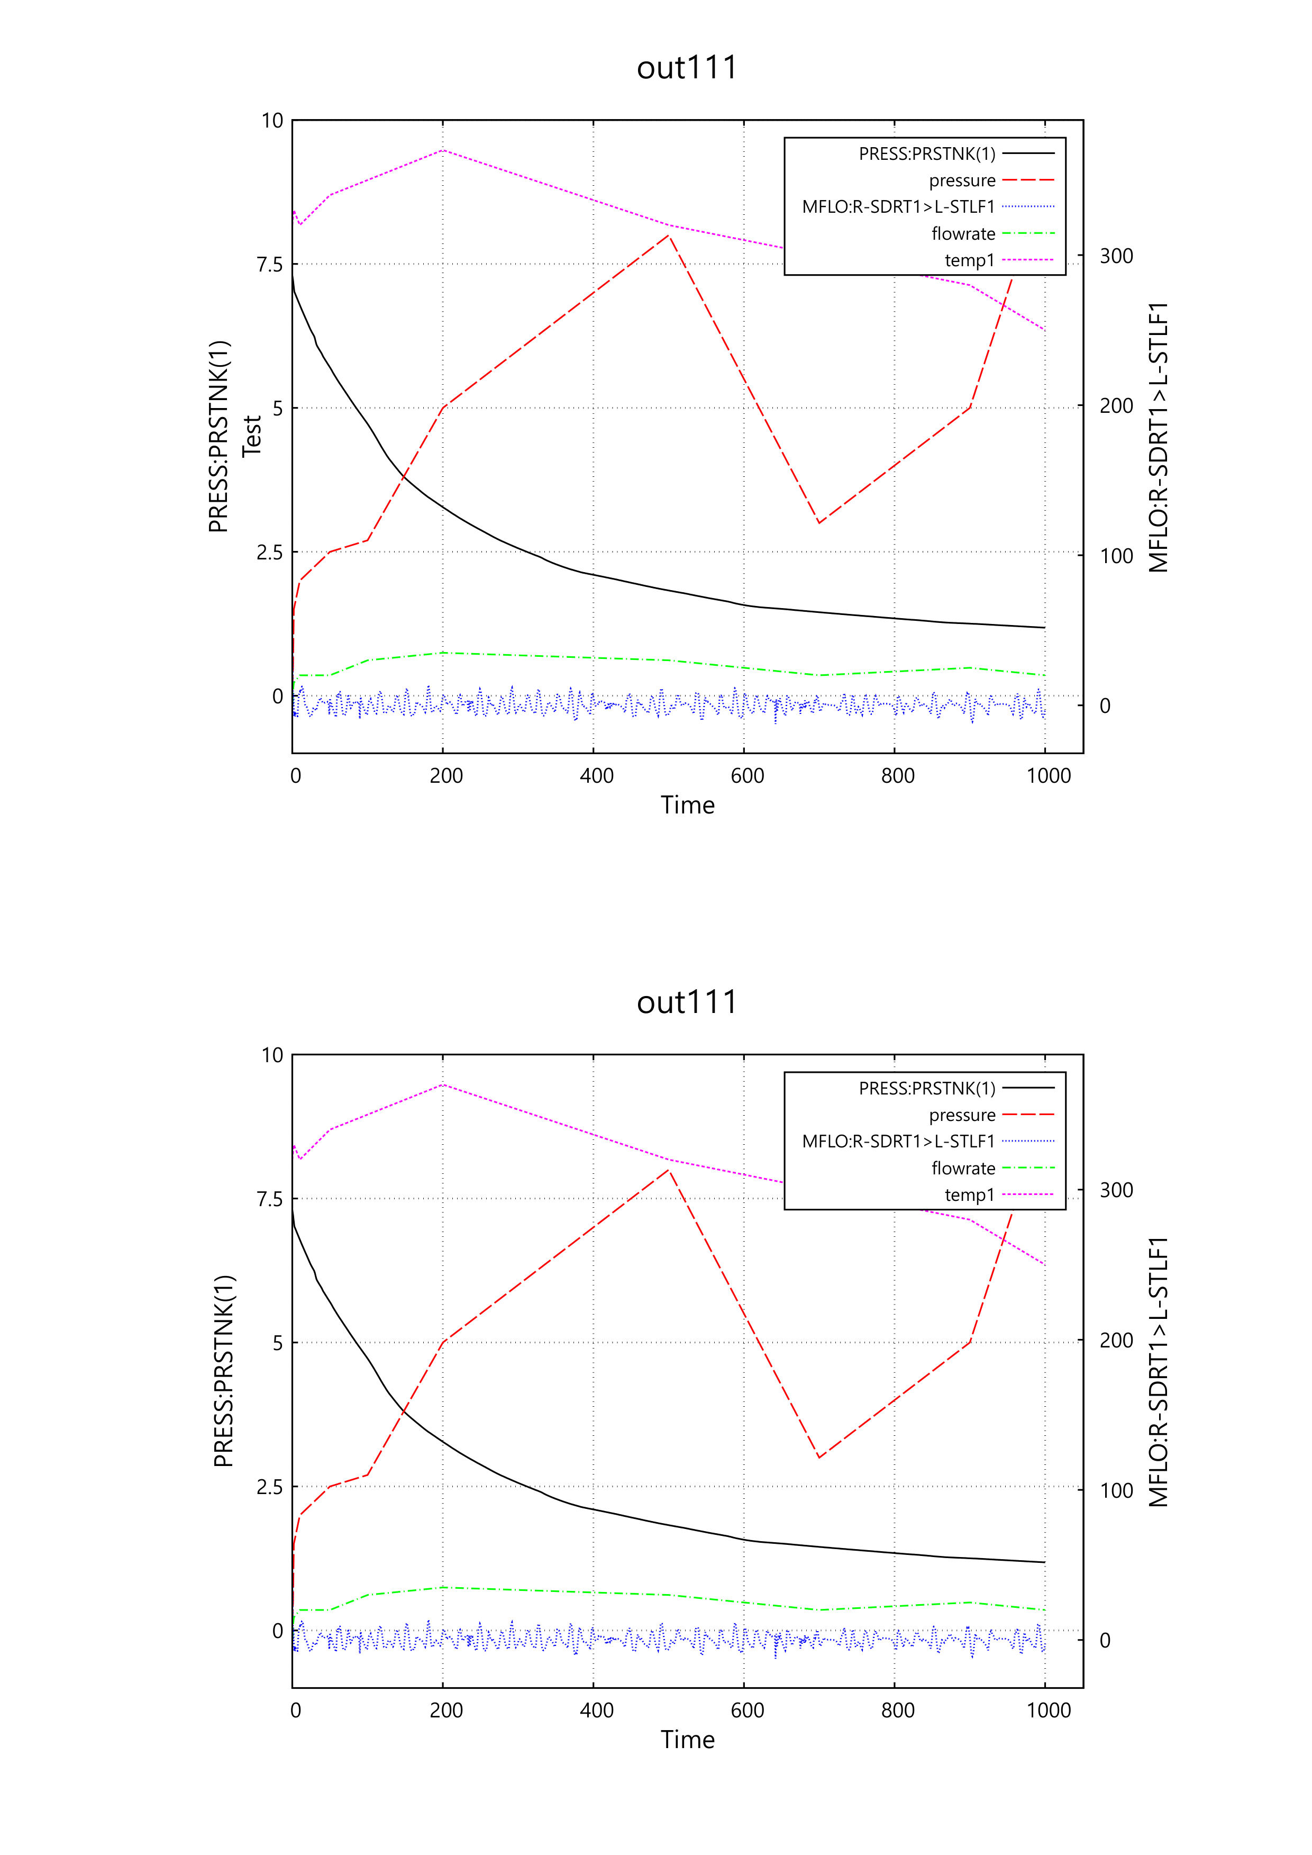
new
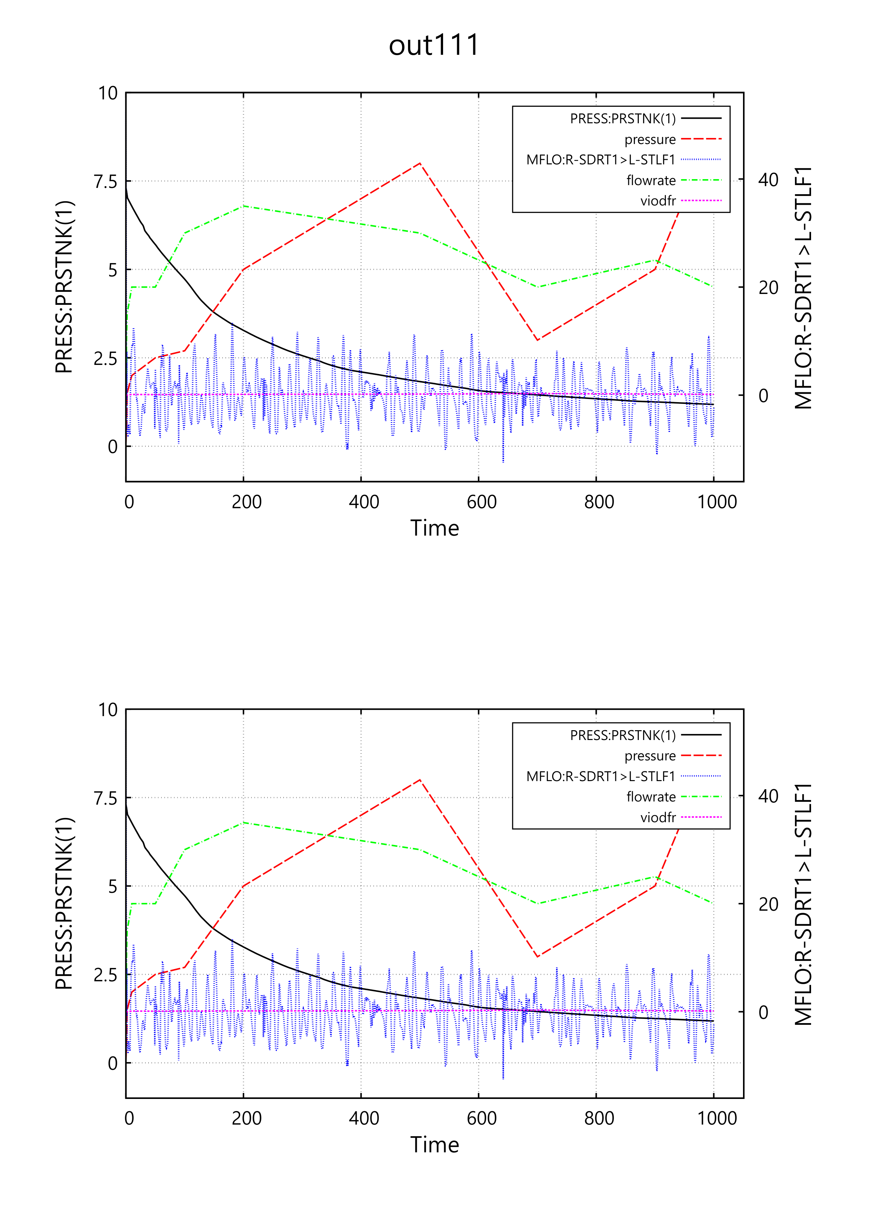
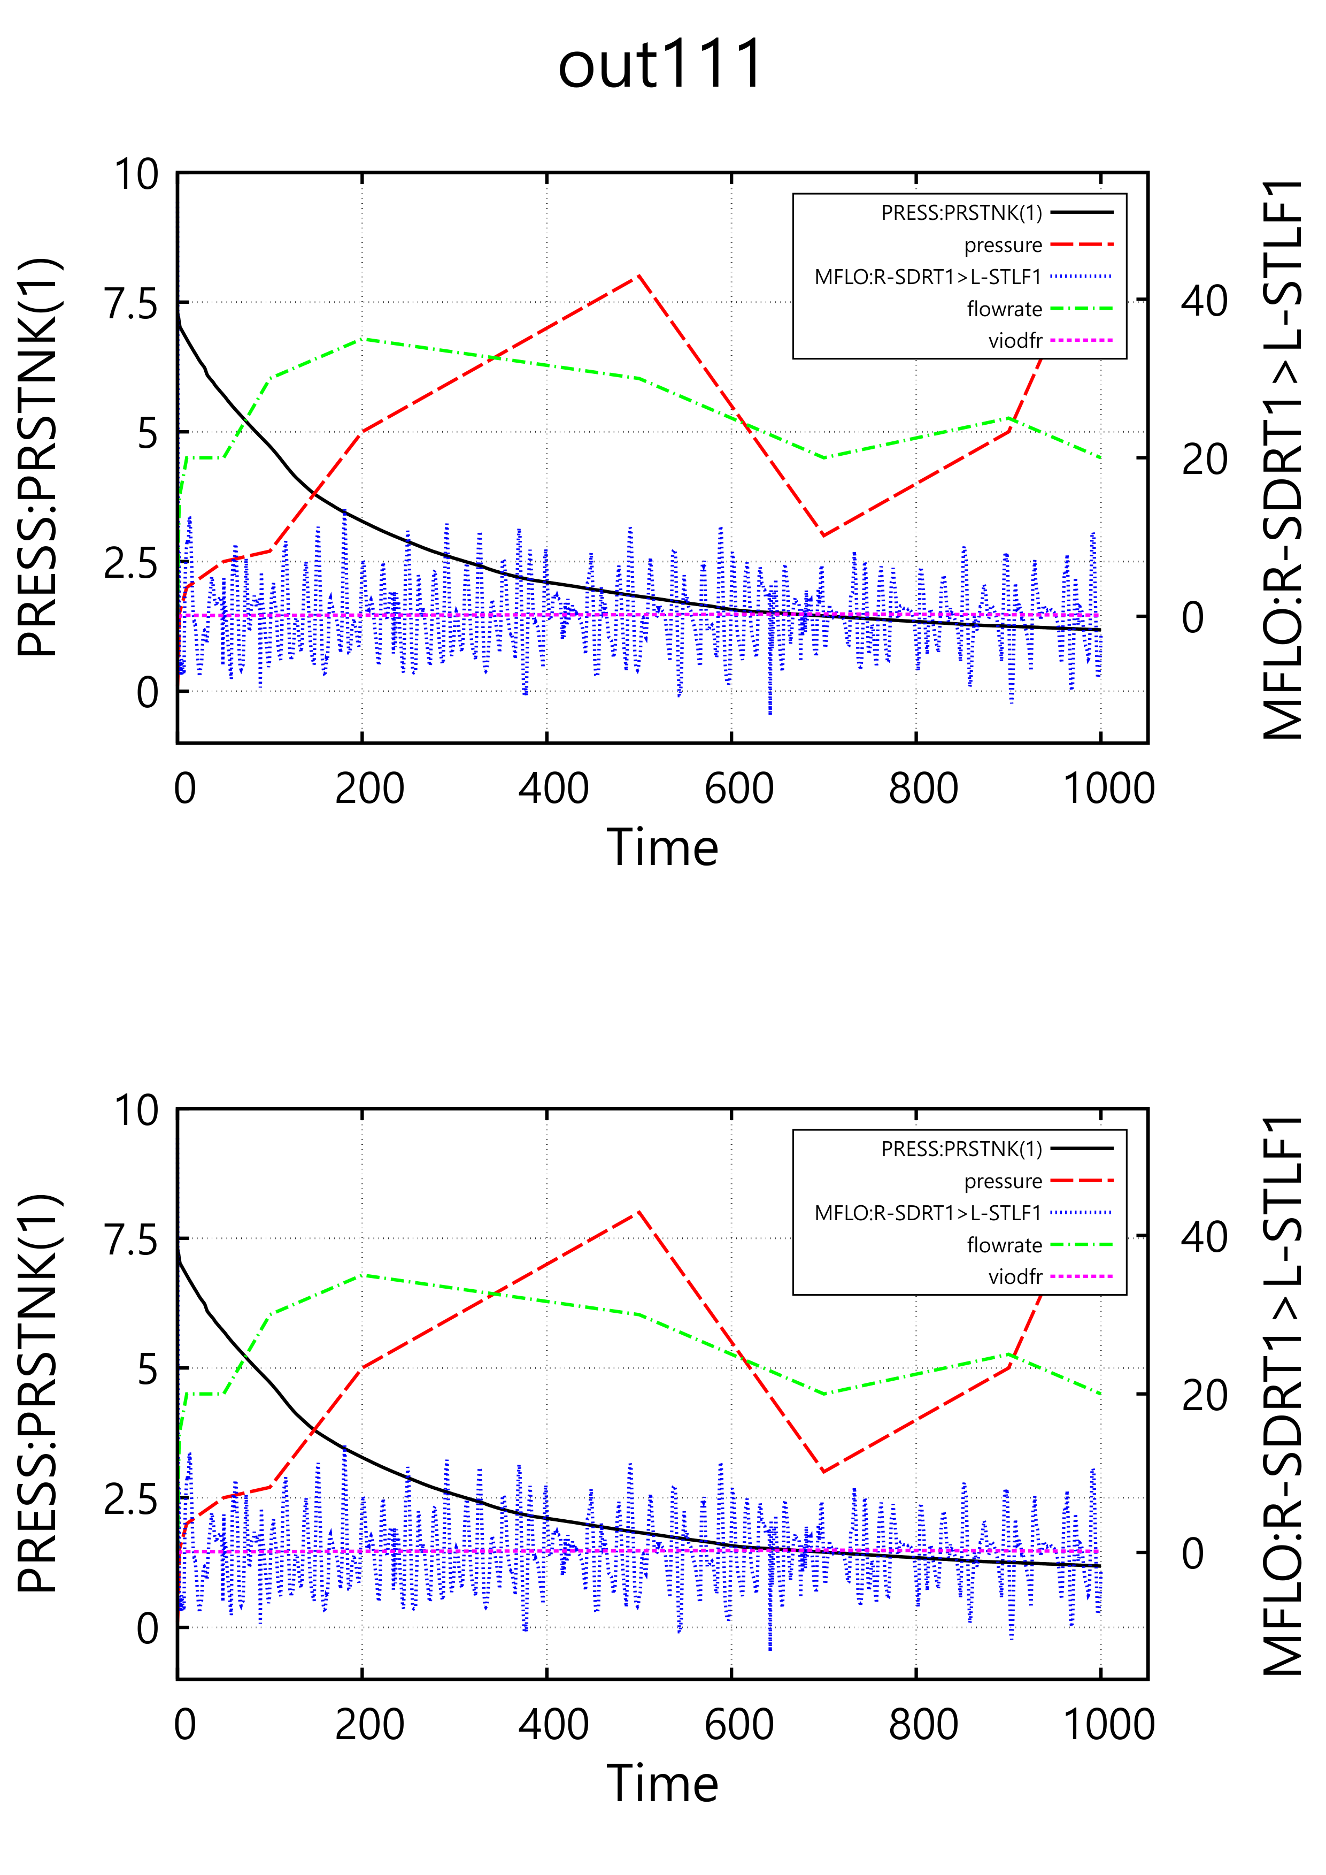

10. M-P, Auto, 2-p: Land-PNG: out111(14), press(8), PRESS(9), PRESS(10), PRESS(11)
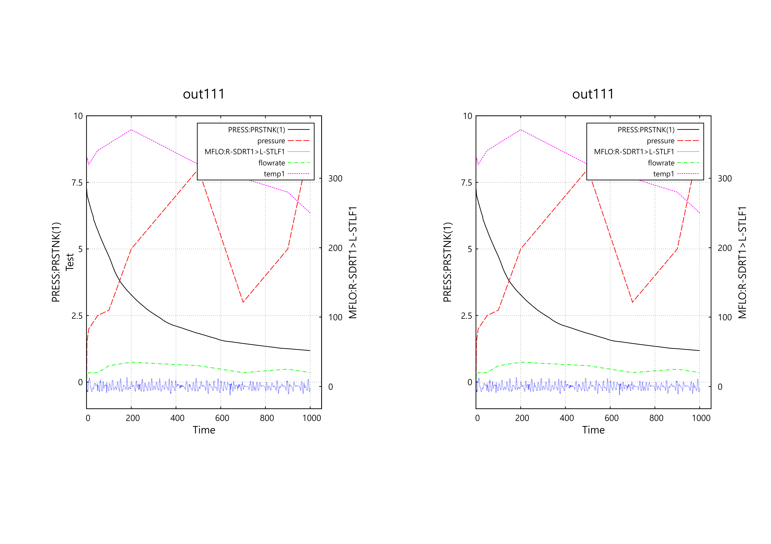
new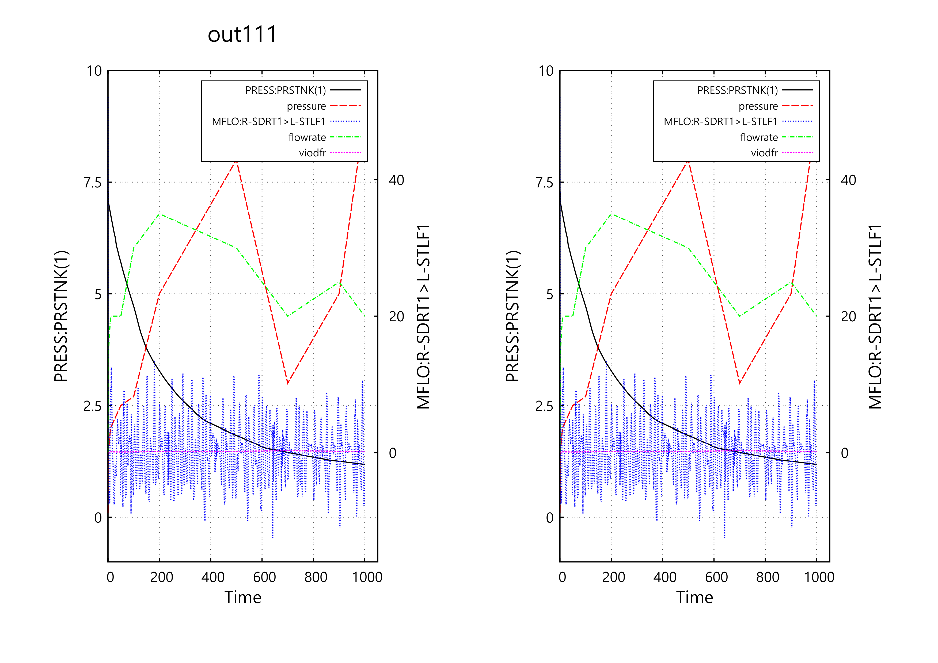
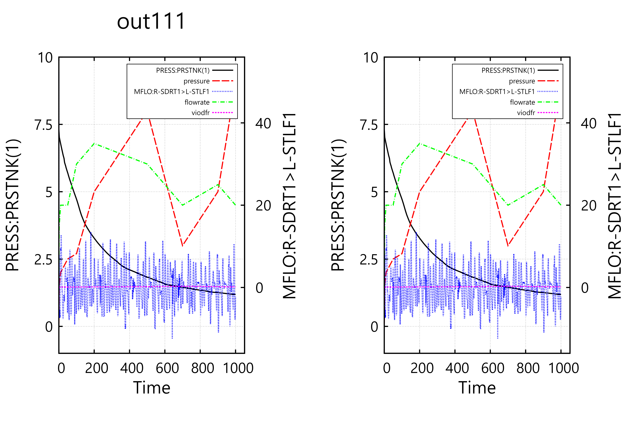
11. M-P, Auto, 2-p: port-EMF: out111(14), press(8), PRESS(9), PRESS(10), PRESS(11)
new
12. M-P, Auto, 2-p: Land-EMF: out111(14), press(8), PRESS(9), PRESS(10), PRESS(11)
new

13. M-P, Auto, 2-p: Port-SVG: out111(14), press(8), PRESS(9), PRESS(10), PRESS(11)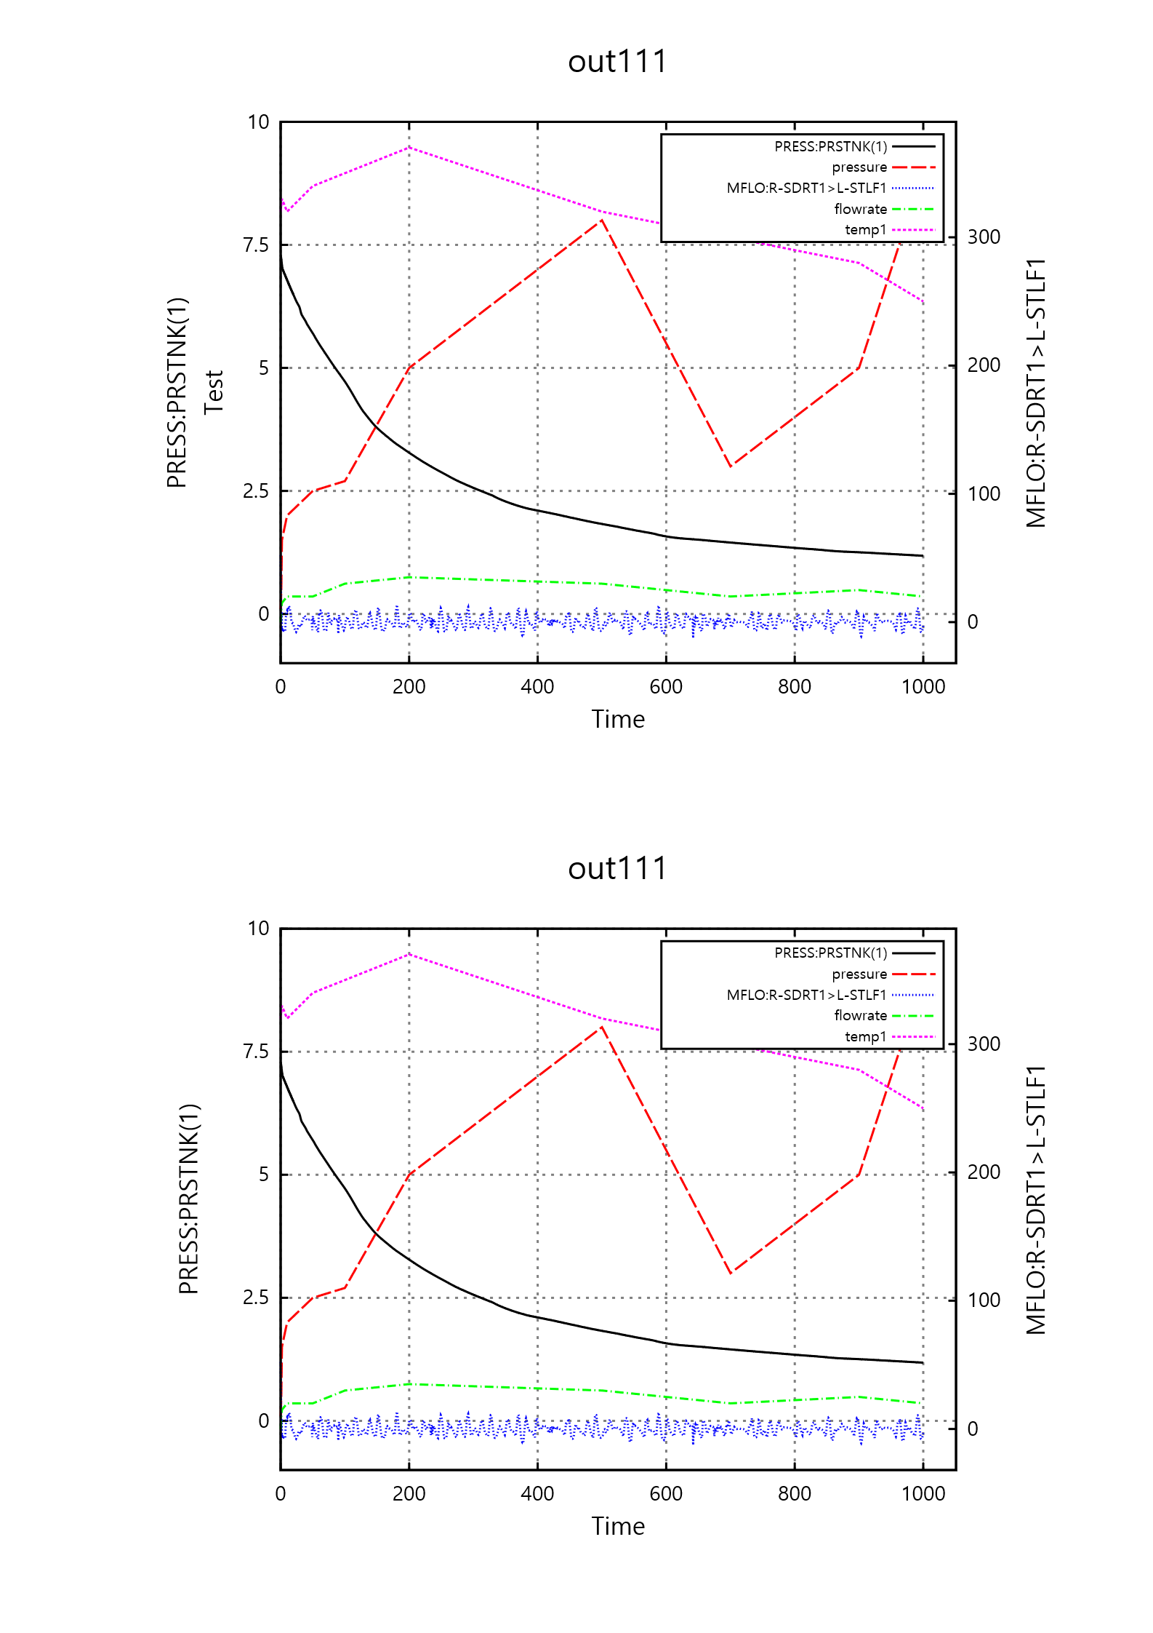
new
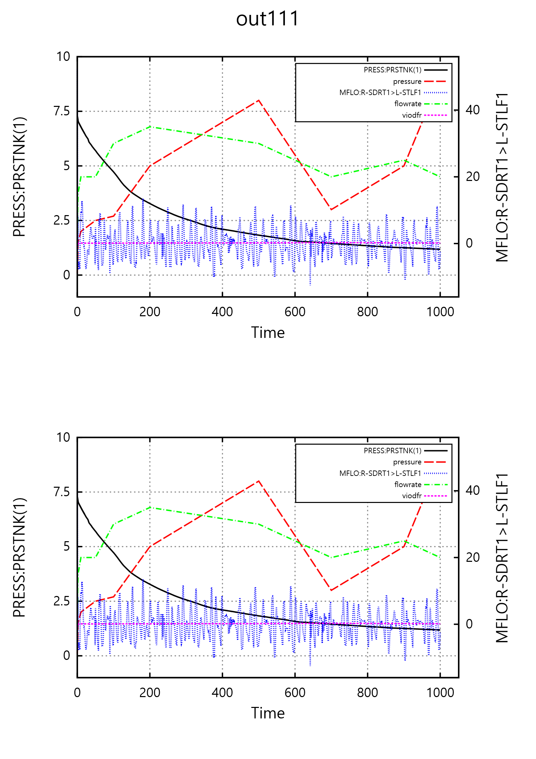
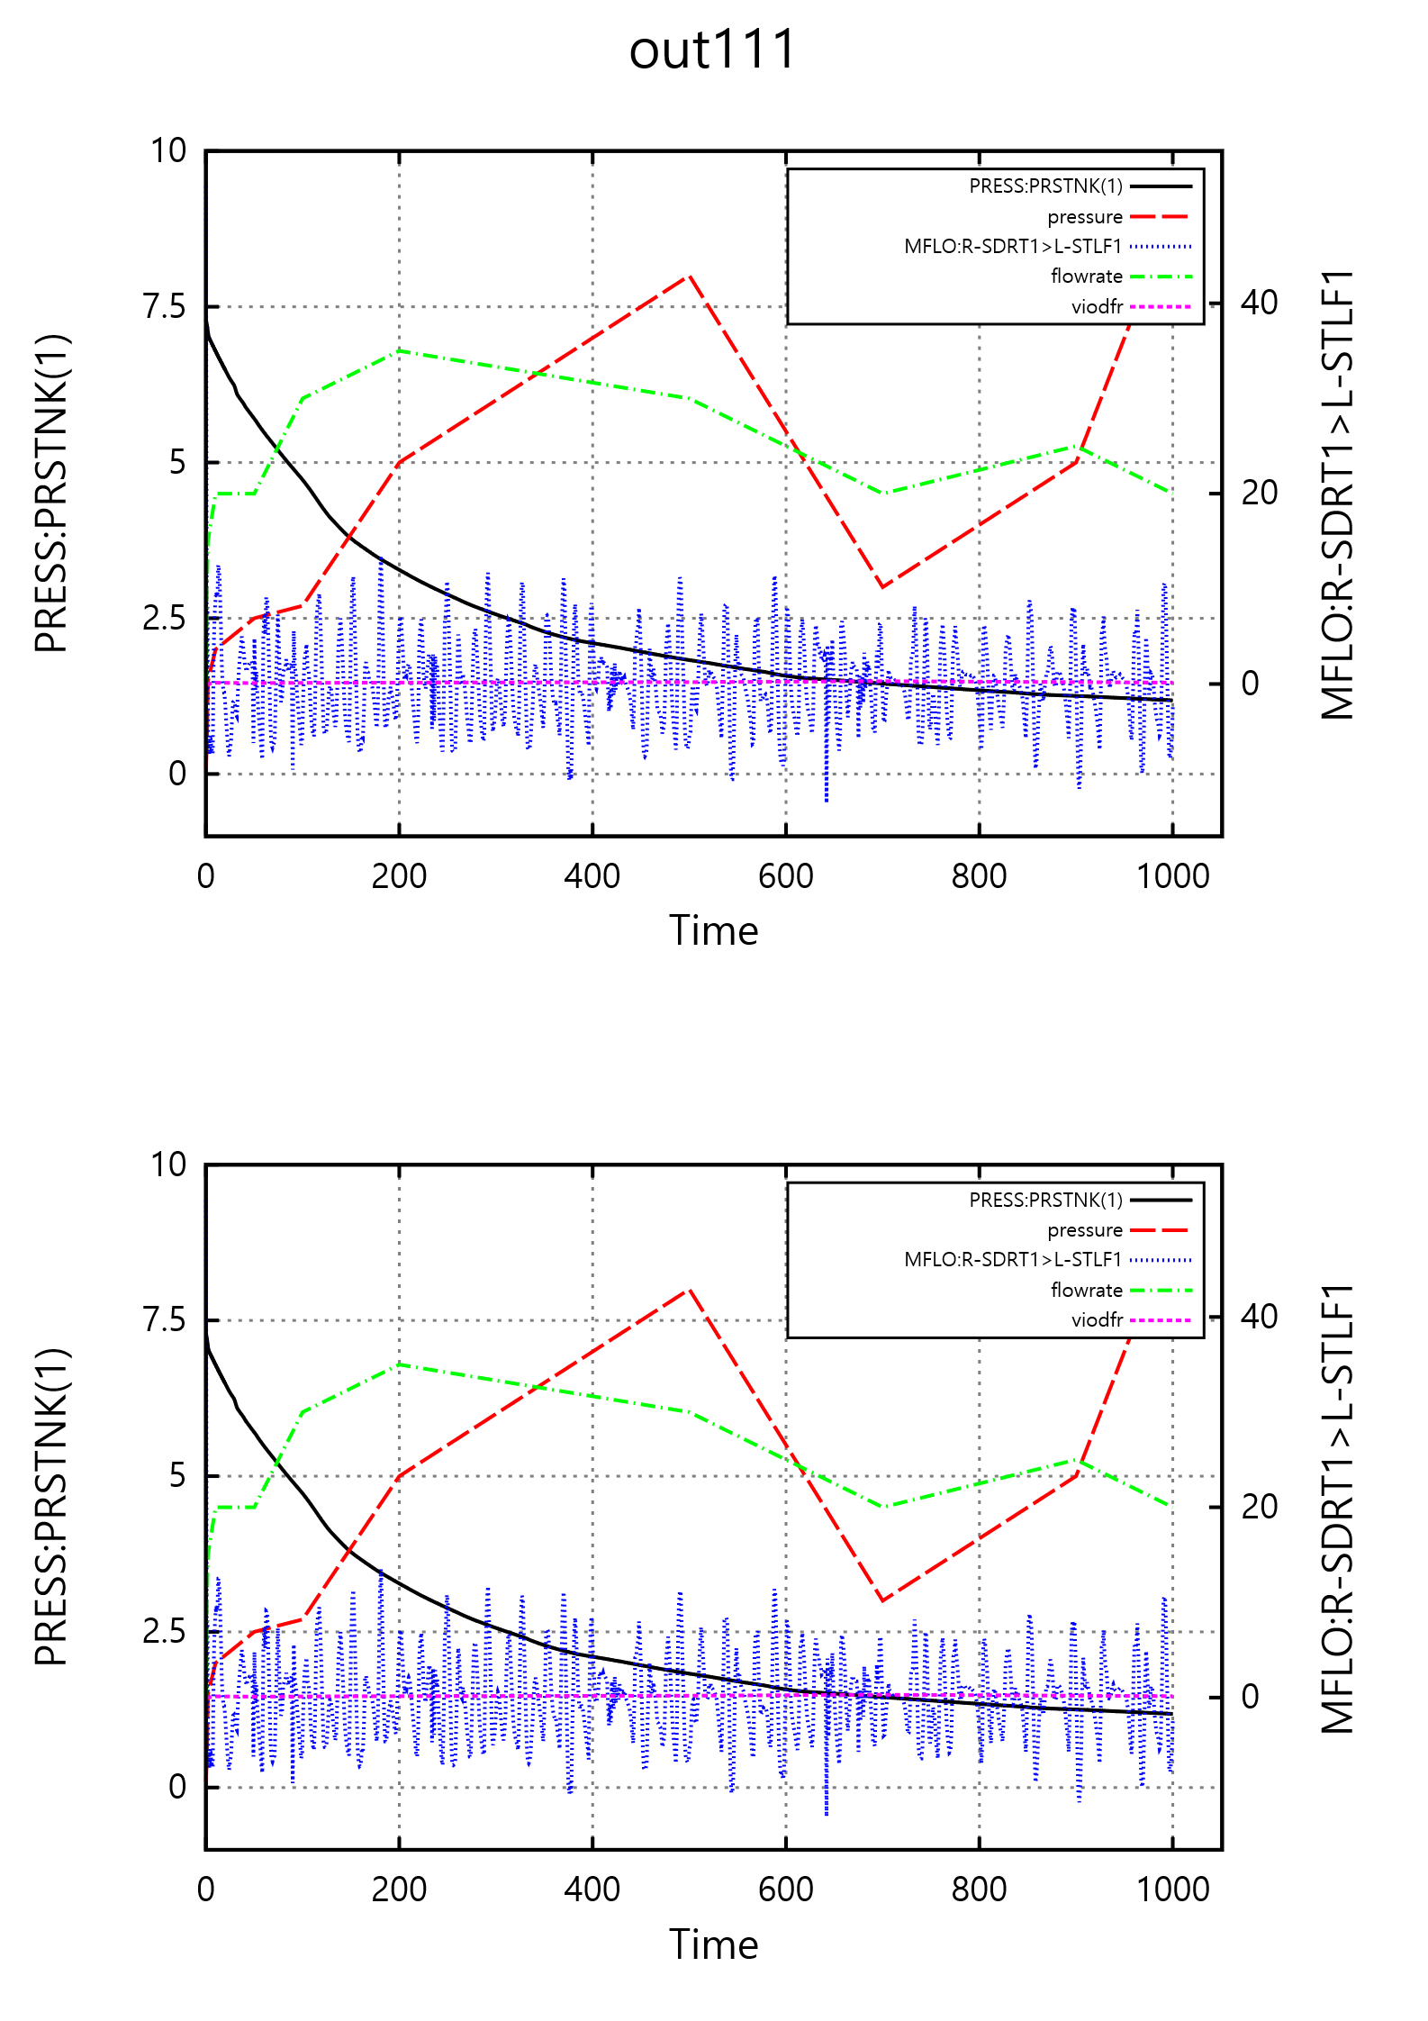
14. M-P, Auto, 2-p: Land-SVG: out111(14), press(8), PRESS(9), PRESS(10), PRESS(11)
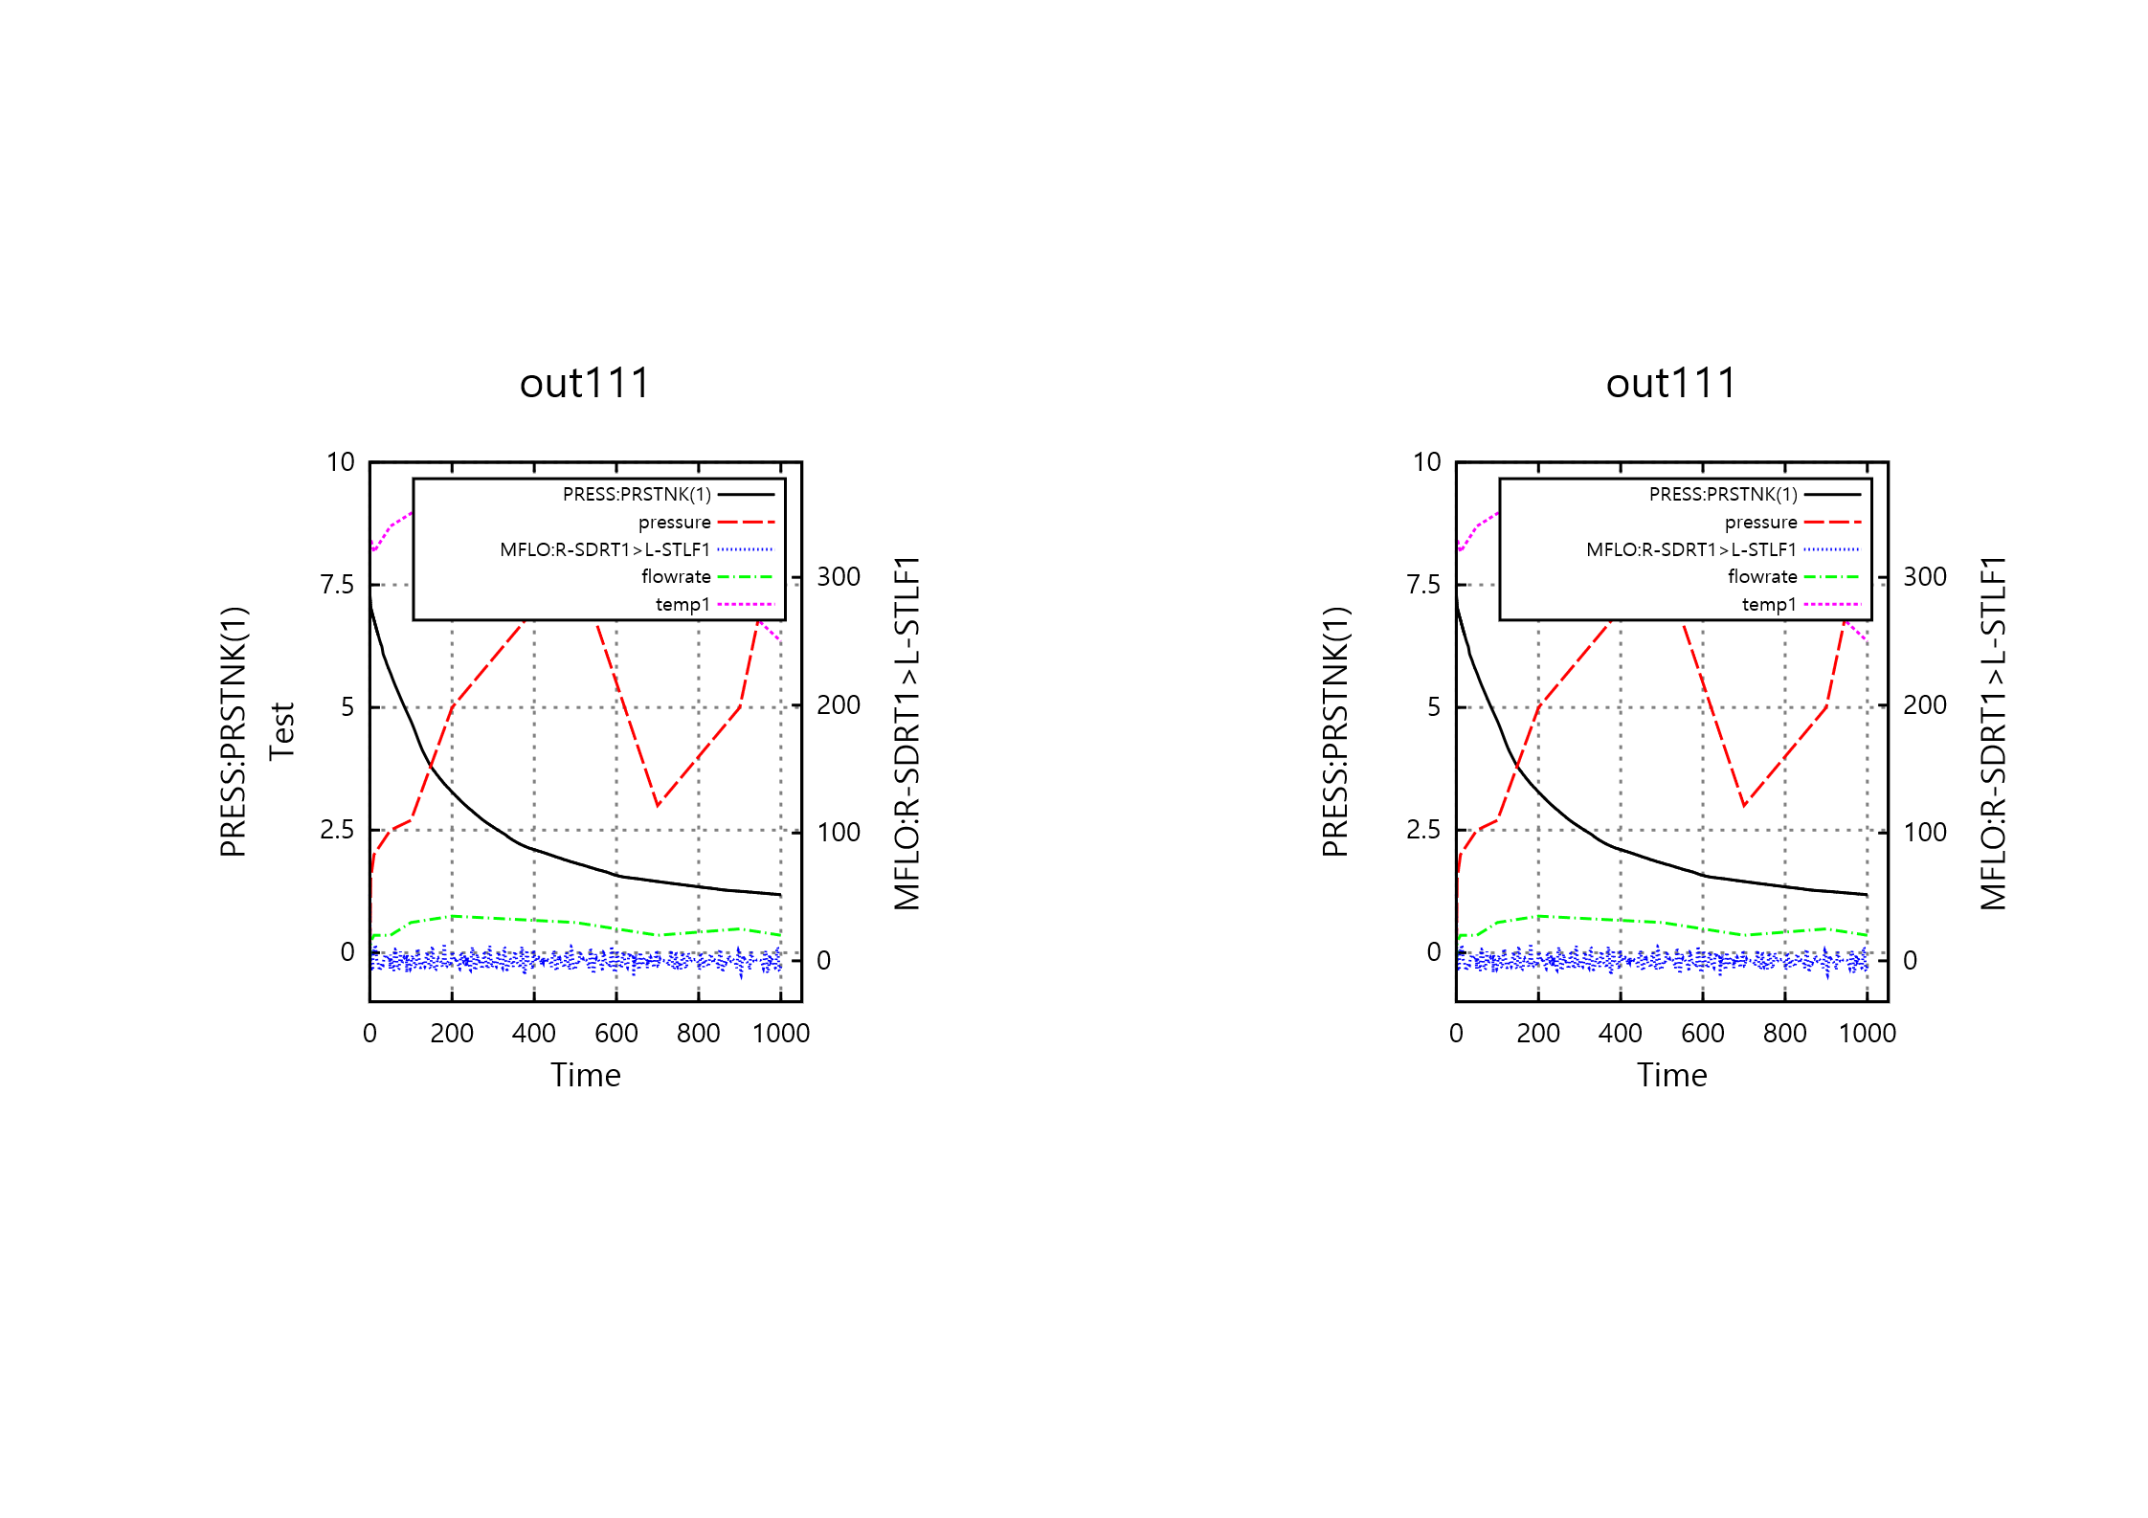
New 

