1.M-P, Manual, 1-p: port-PNG:out111(14), press(8), PRESS(9), PRESS(10), PRESS(11)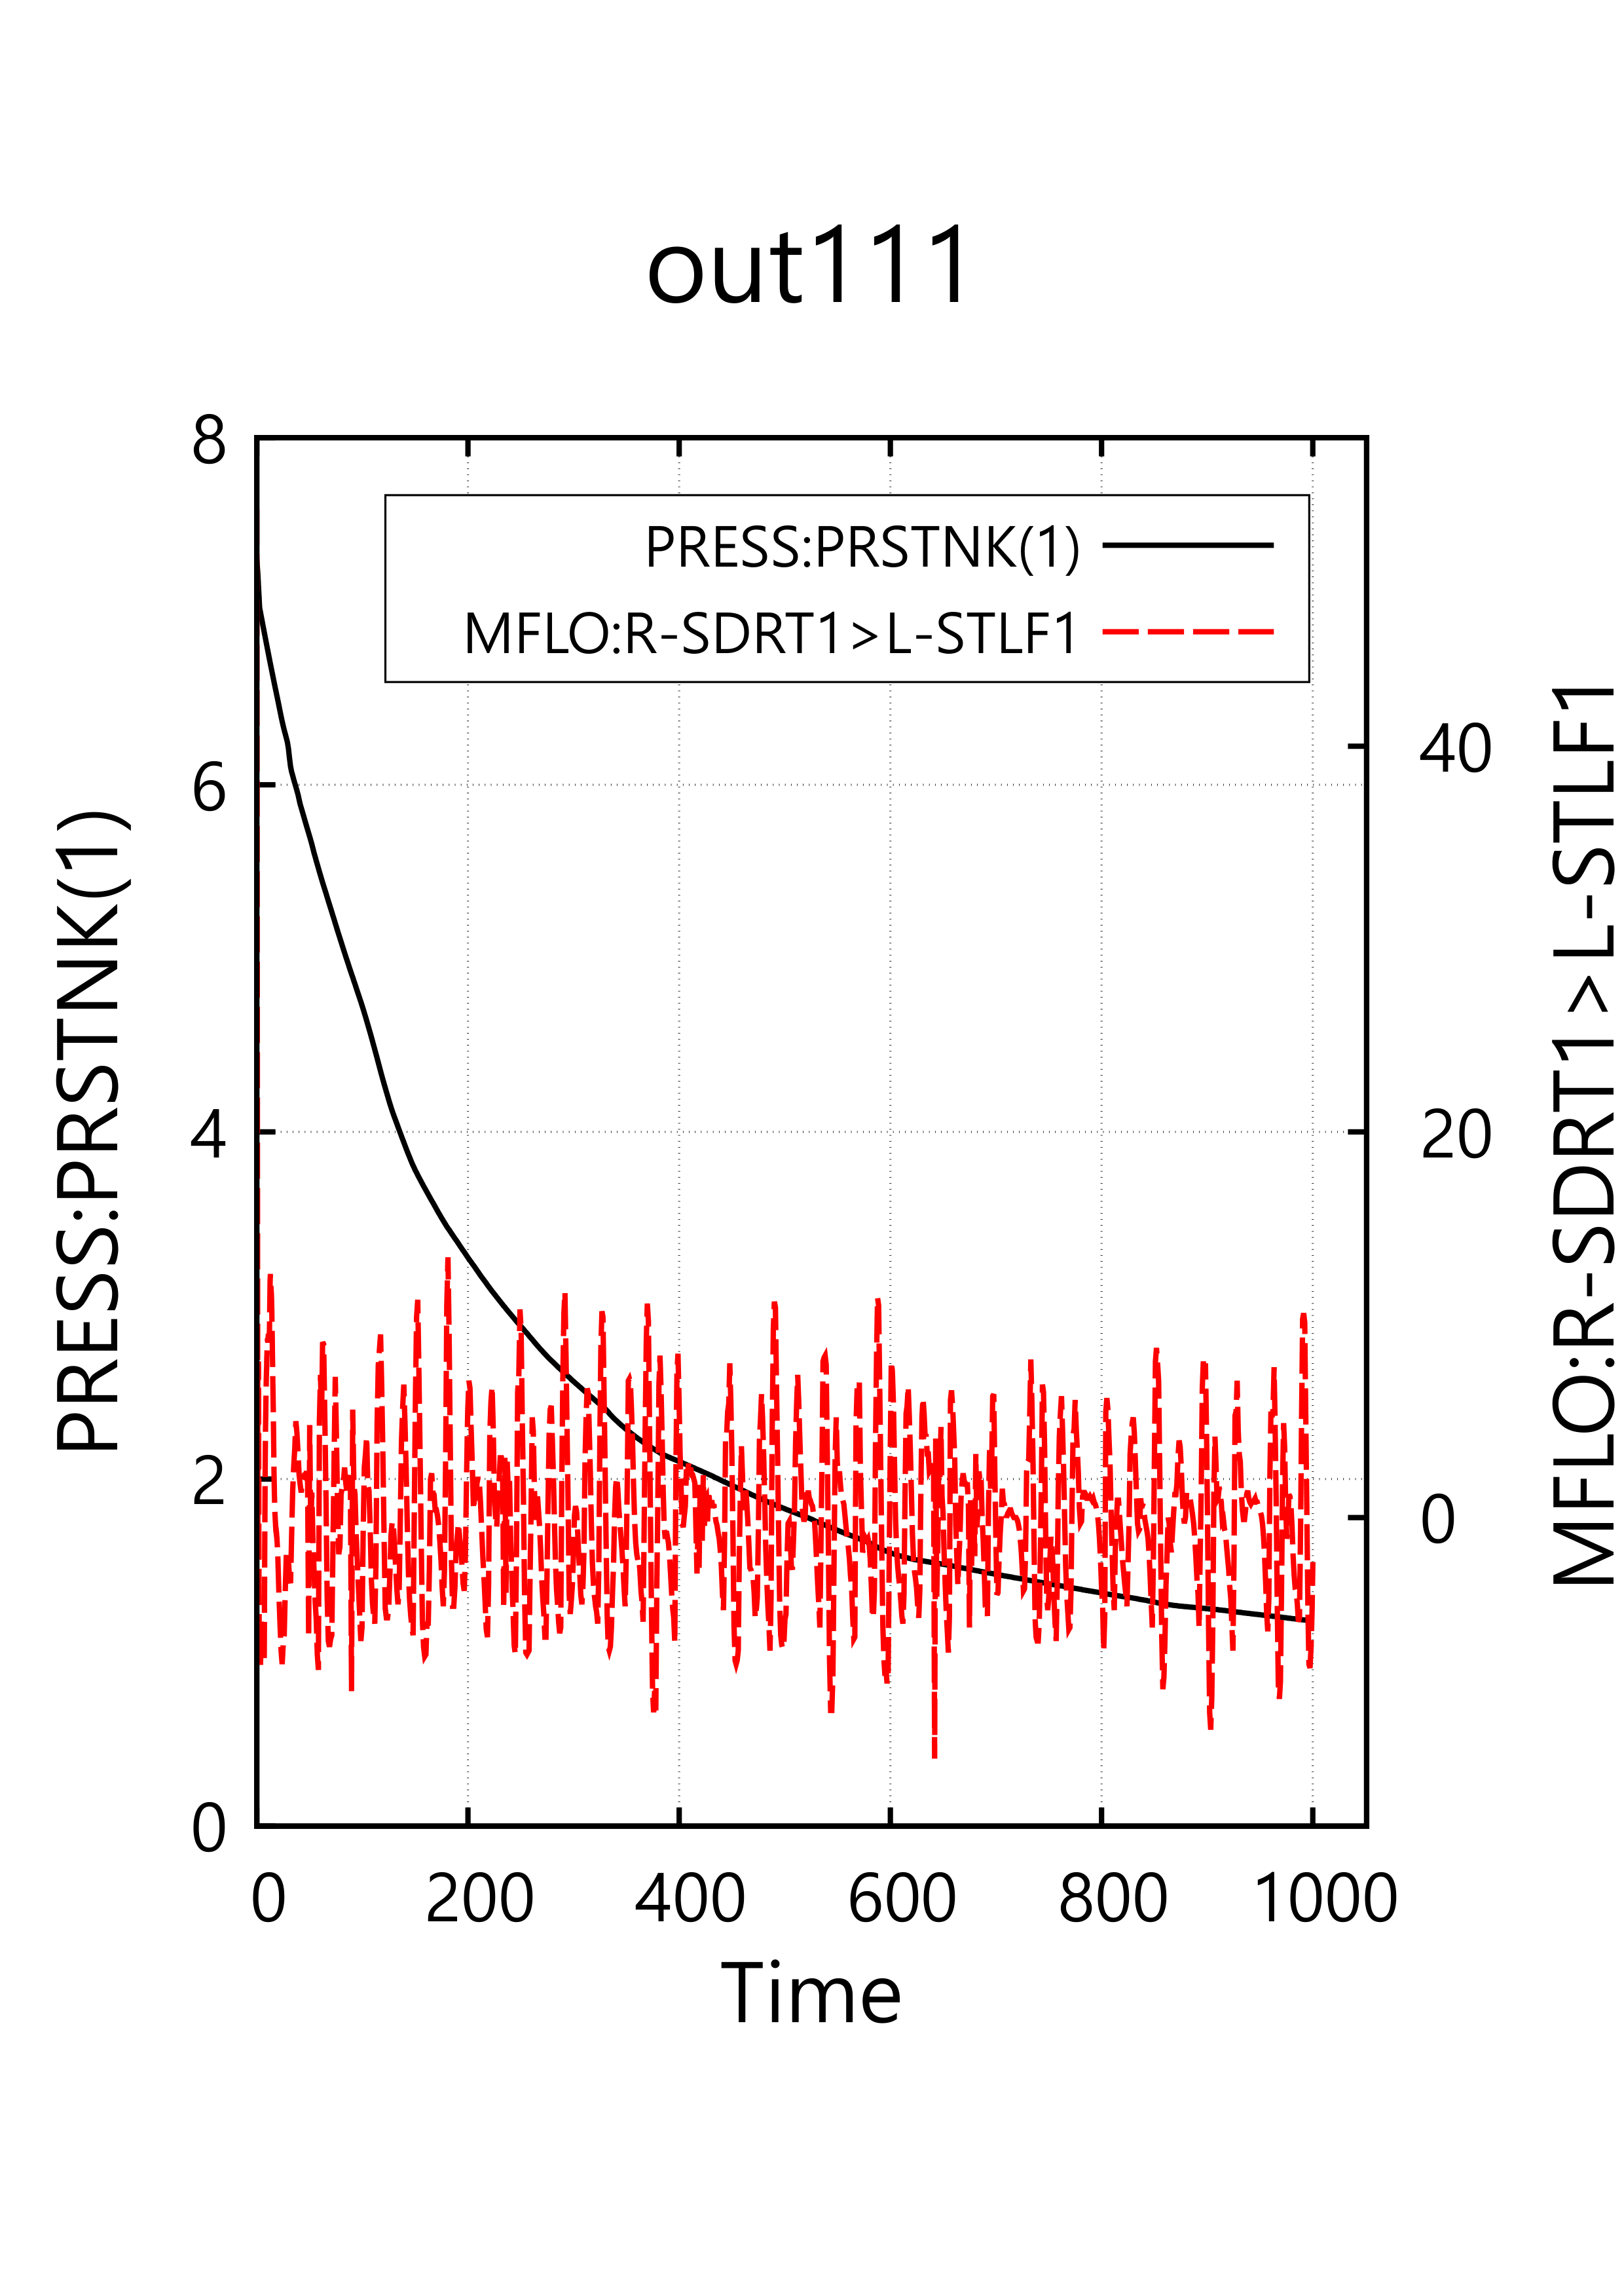
8/9: 14:35 이후
2. M-P, Manual, 1-p: Land-PNG: out111(14), press(8), PRESS(9), PRESS(10), PRESS(11)
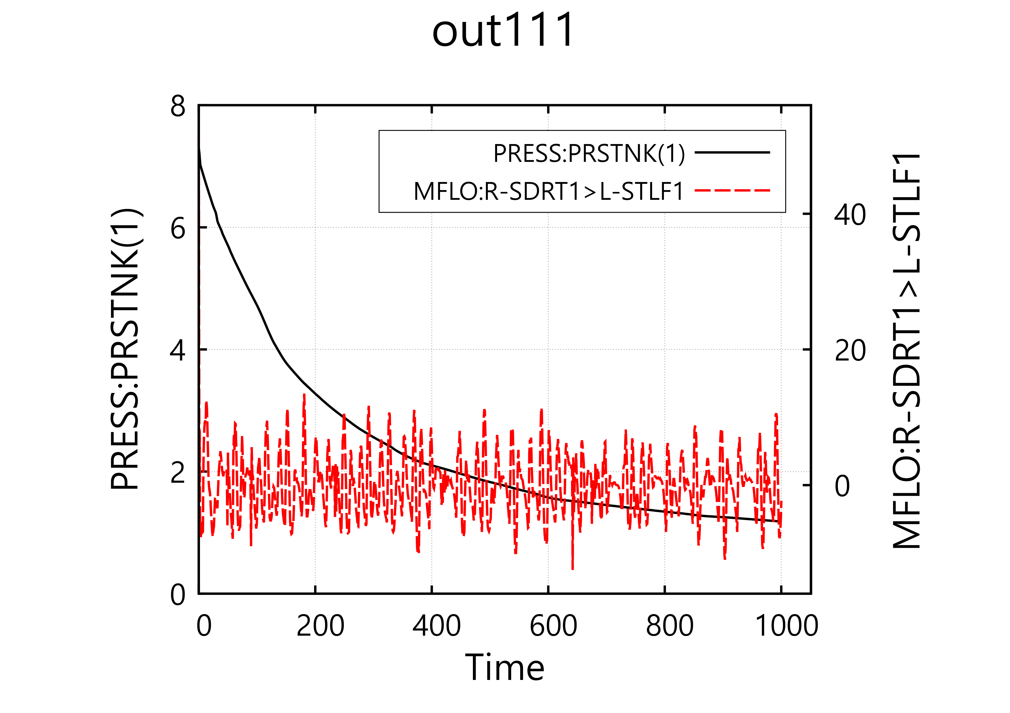
8/9: 14:35 이후

3. M-P, Manual, 1-p: Port-EMF: out111(14), press(8), PRESS(9), PRESS(10), PRESS(11)
8/9: 14:35 이후
4. M-P, Manual, 1-p: Land-EMF: out111(14), press(8), PRESS(9), PRESS(10), PRESS(11)8/9: 14:35 이후
5. M-P, Manual, 1-p: Port-SVG: out111(14), press(8), PRESS(9), PRESS(10), PRESS(11)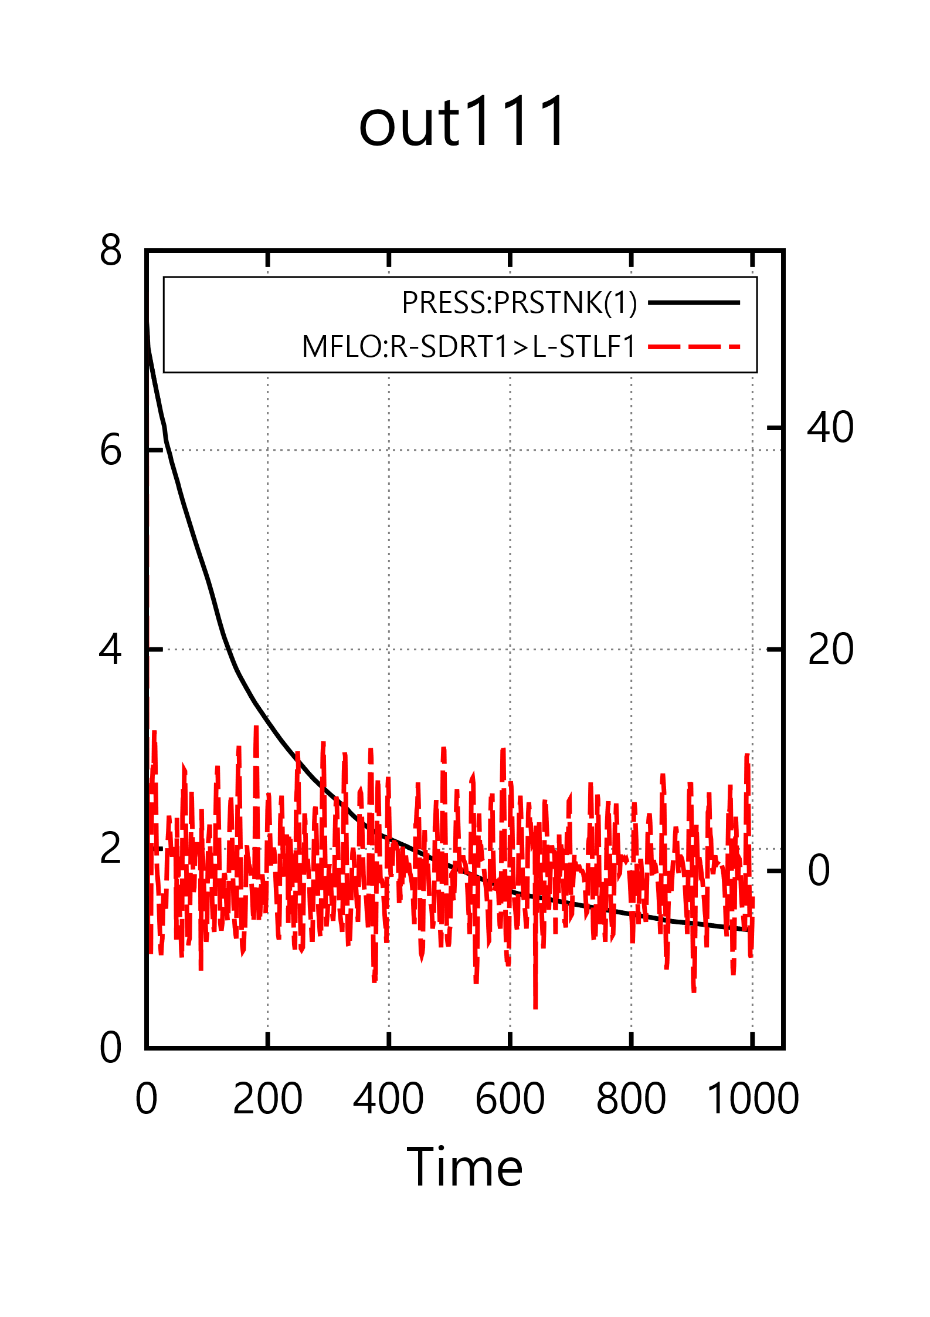
8/9: 14:35 이후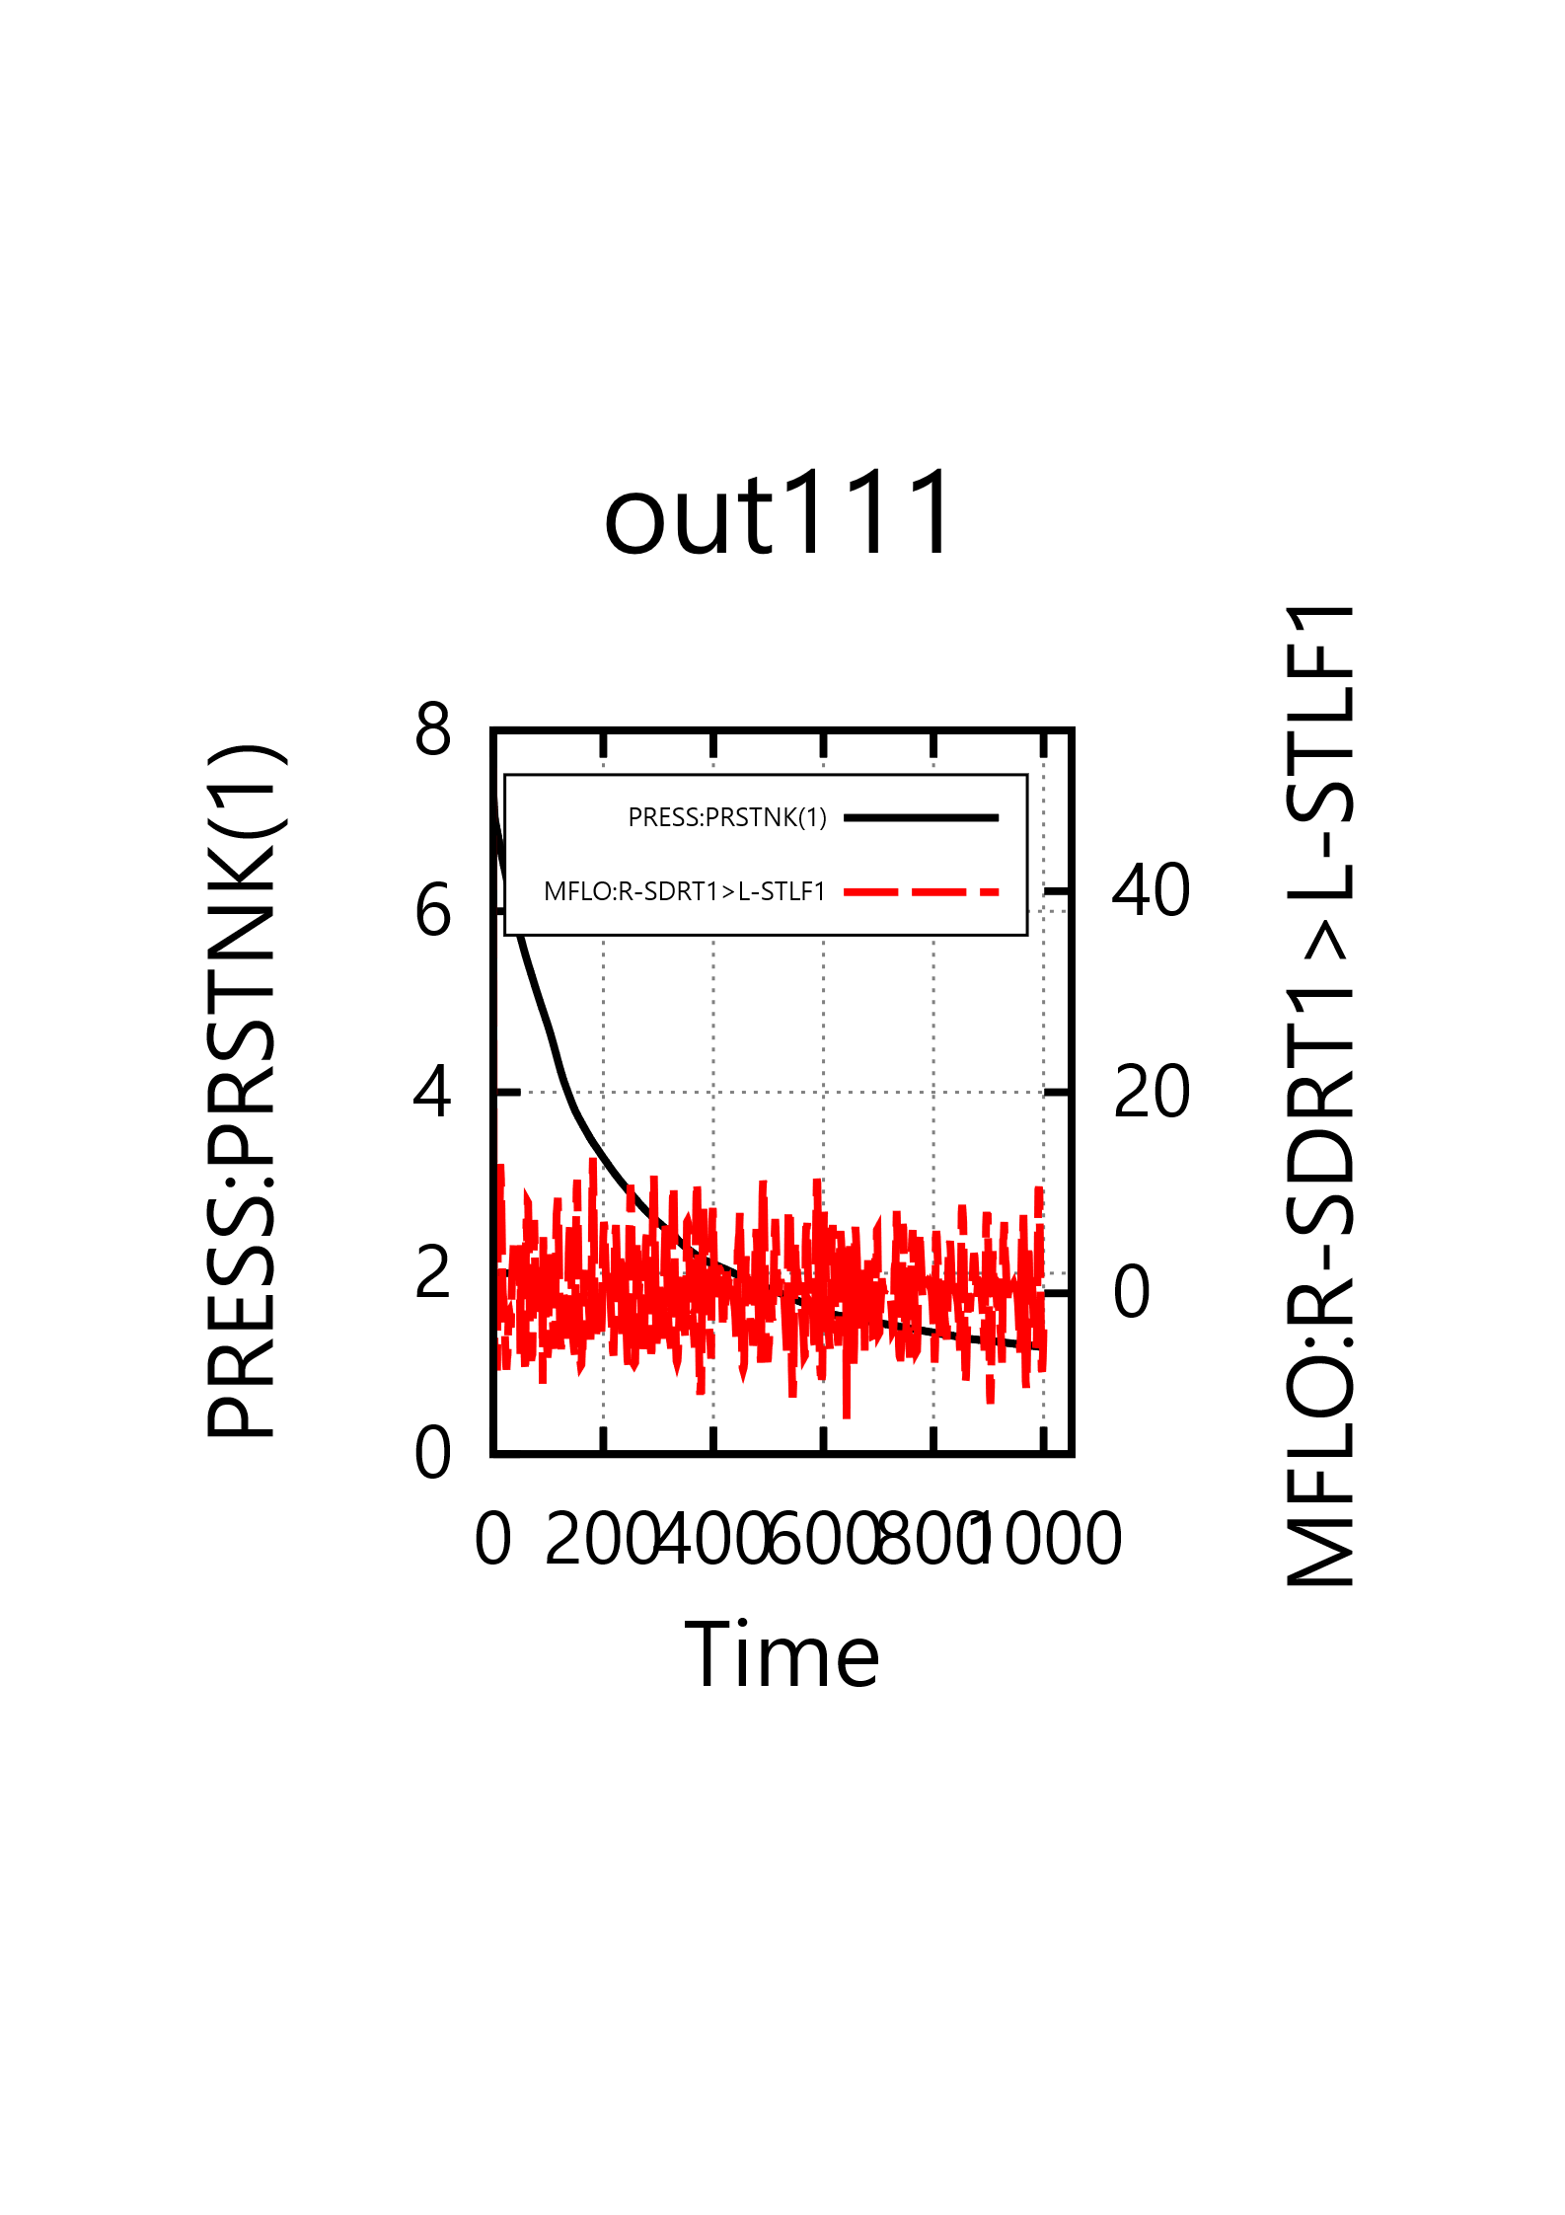
6. M-P, Manual, 1-p: Land-SVG: out111(14), press(8), PRESS(9), PRESS(10), PRESS(11)
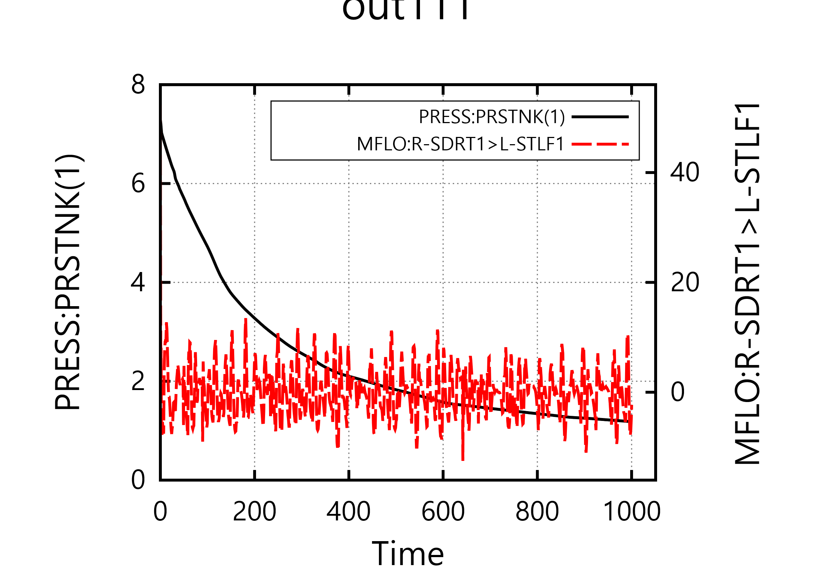
8/9: 14:35 이후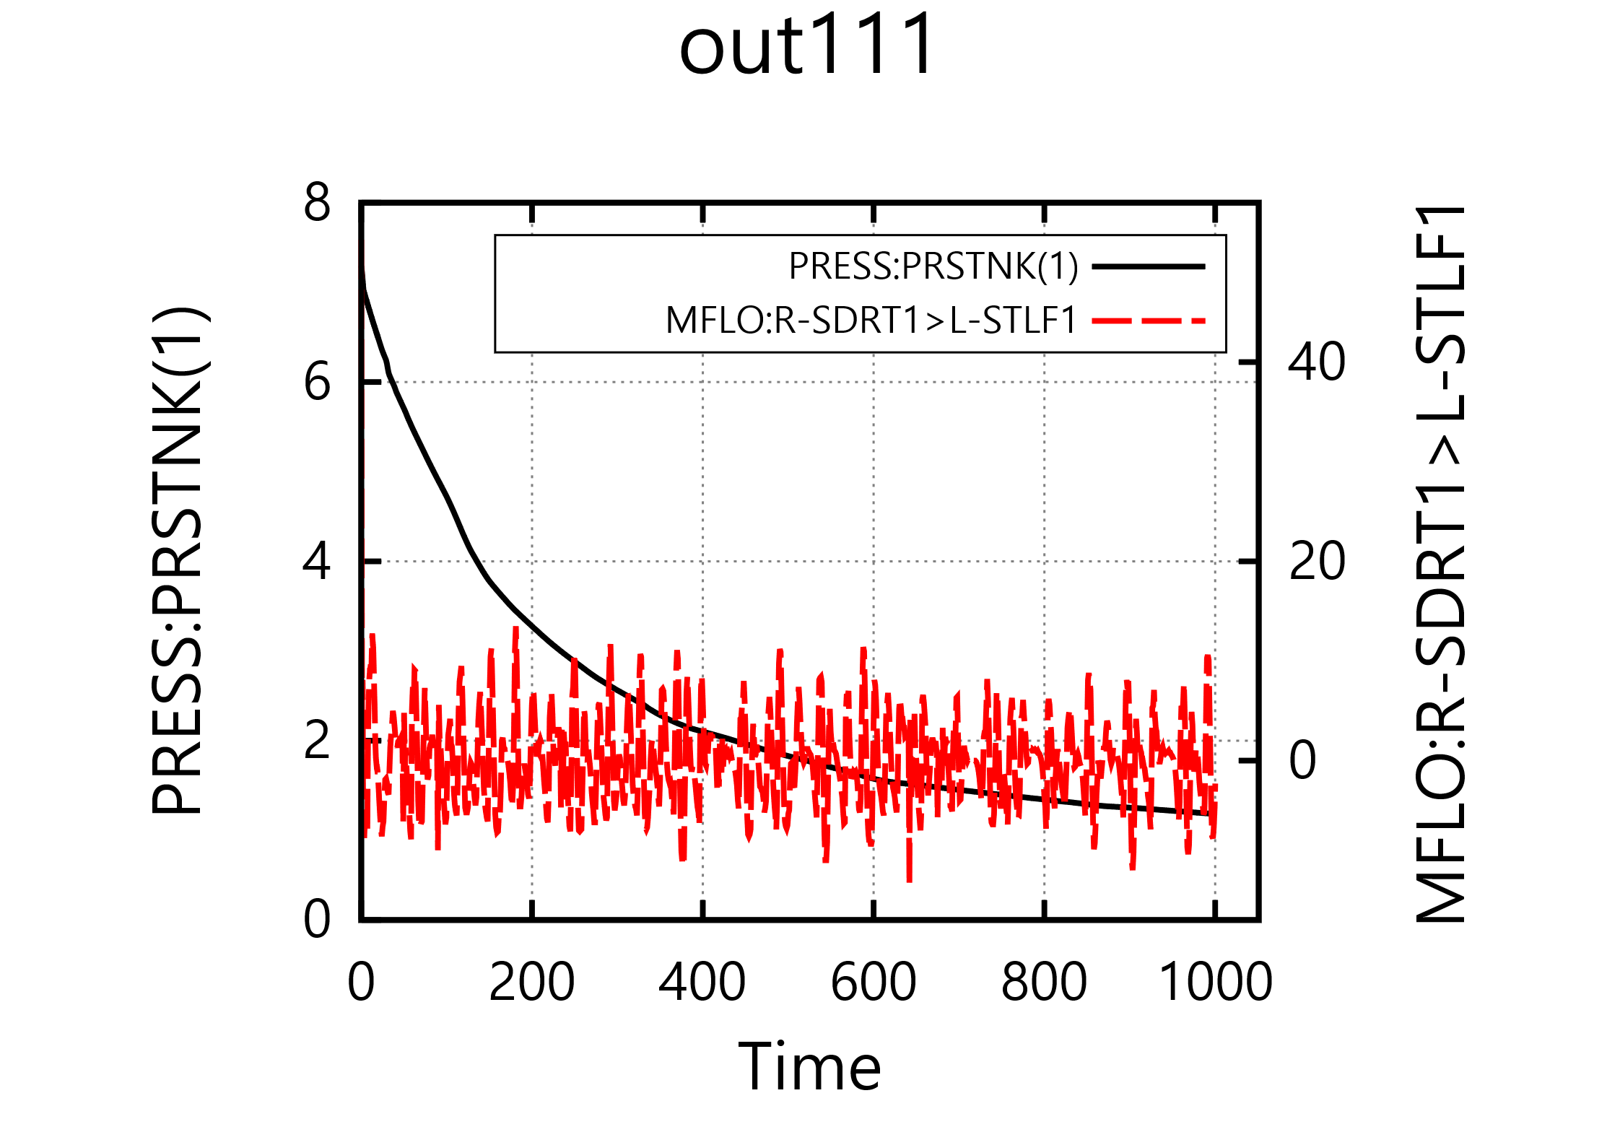

7. M-P, Manual, 2-p: port-PNG: out111(14), press(8), PRESS(9), PRESS(10), PRESS(11)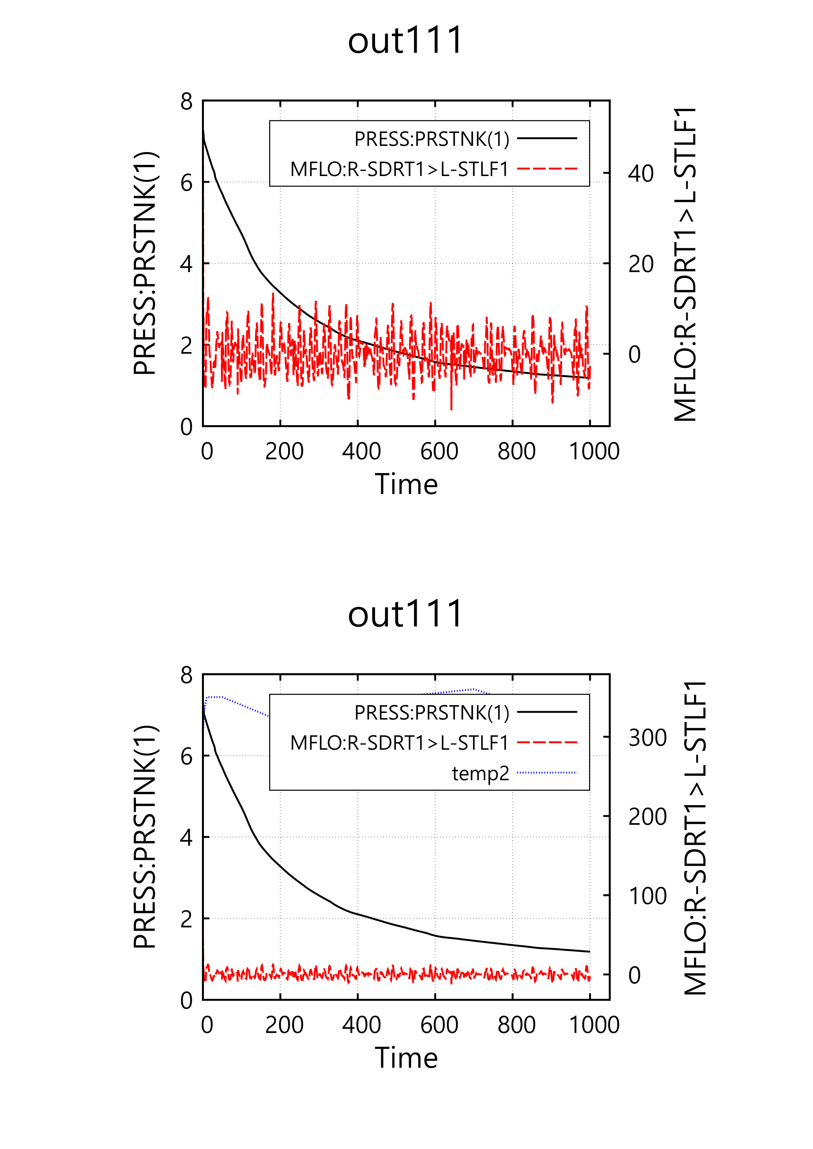
8/9: 14:35 이후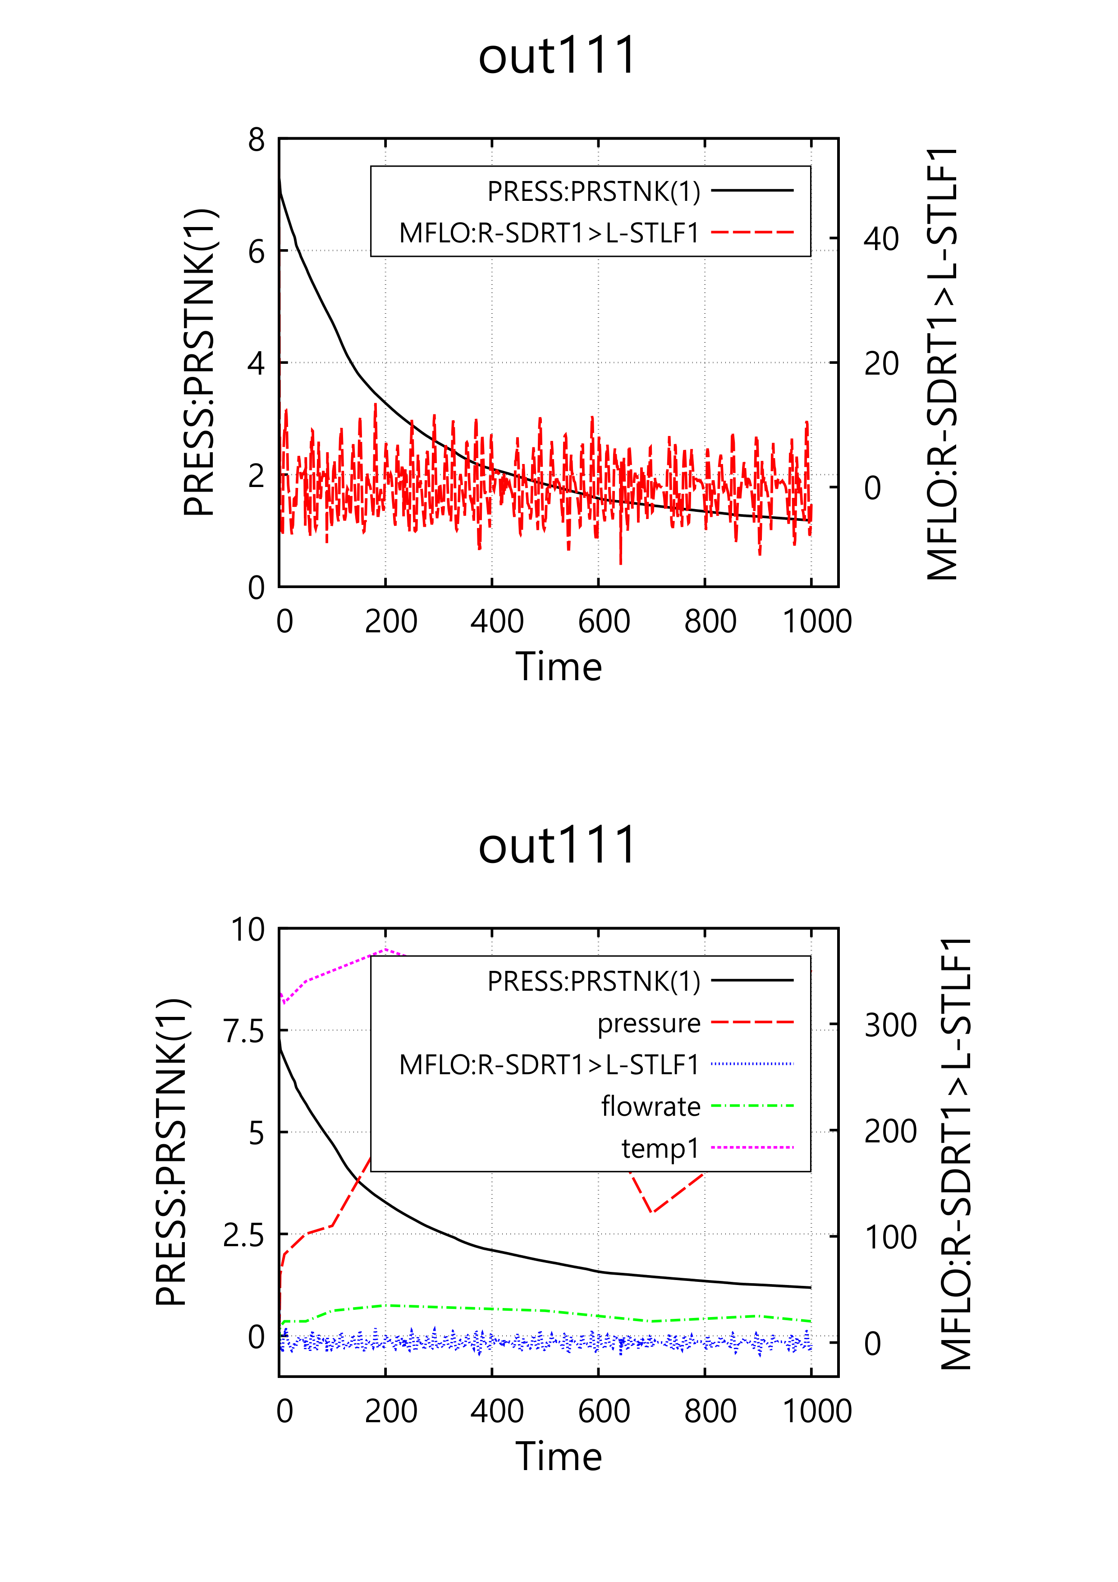
8. M-P, Manual, 2-p: Land-PNG: out111(14), press(8), PRESS(9), PRESS(10), PRESS(11)
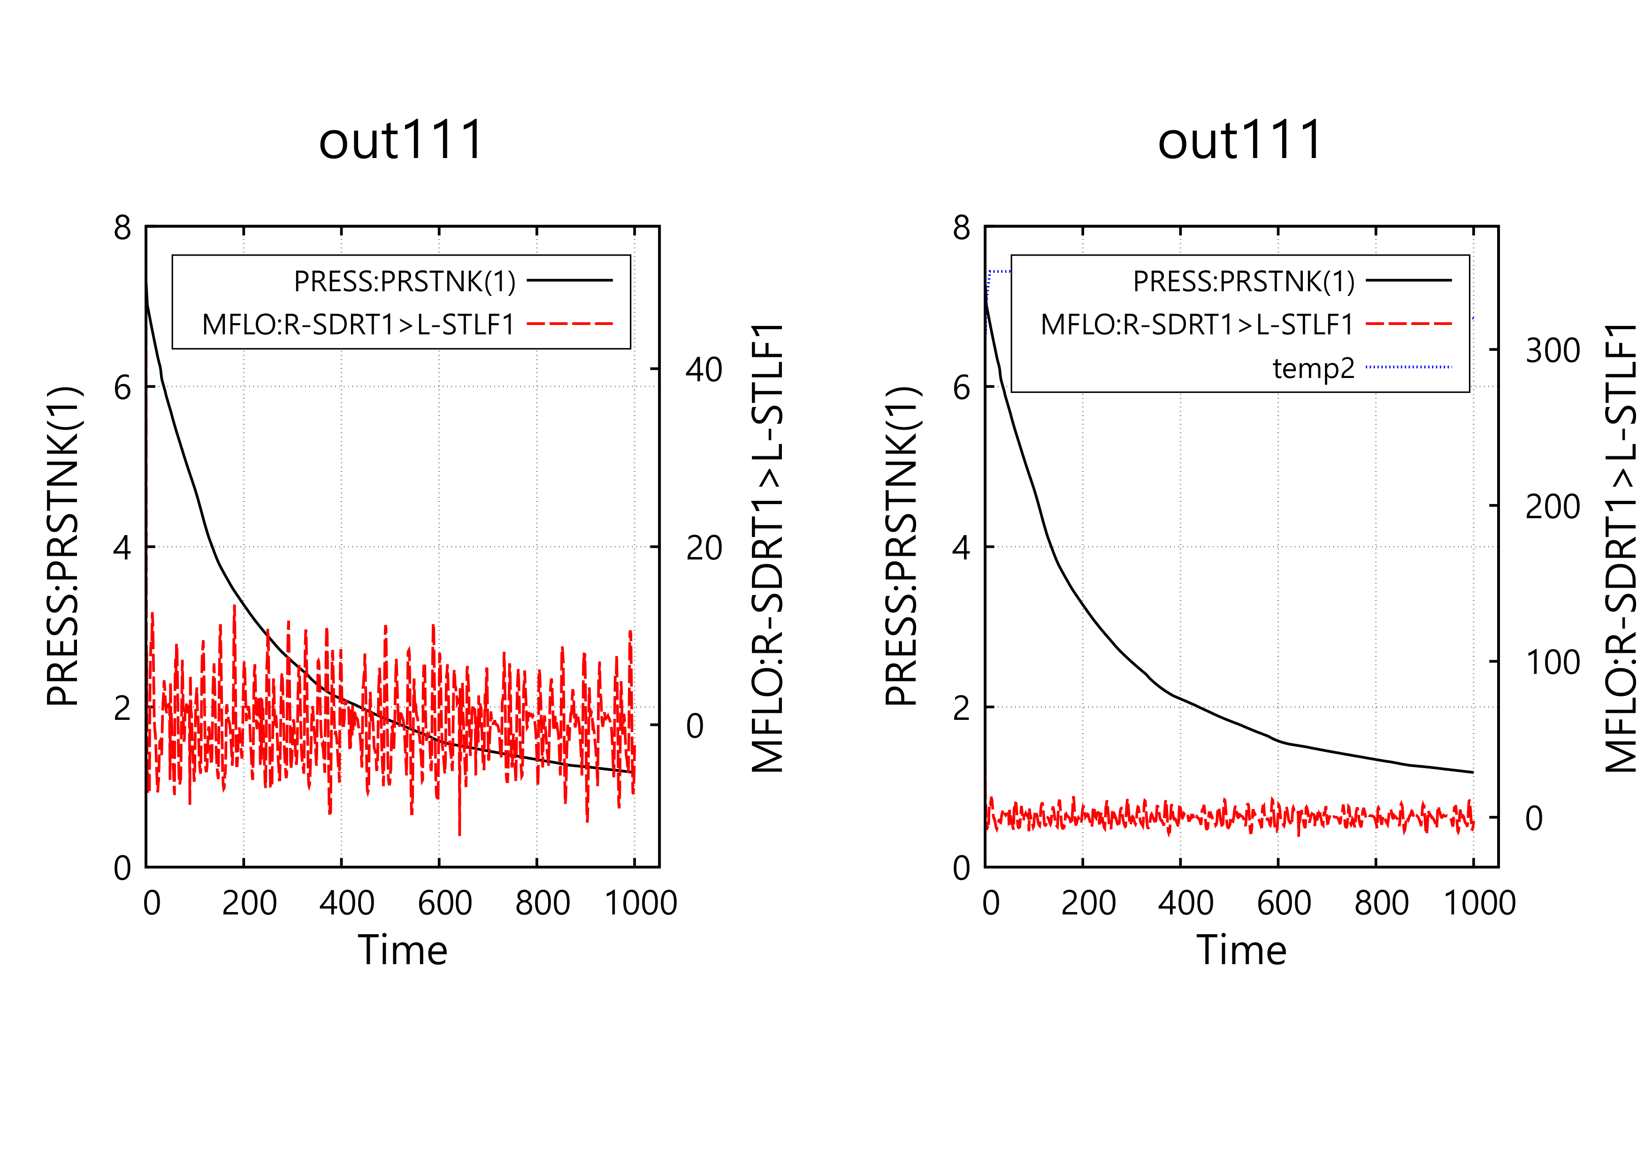
8/9: 14:35 이후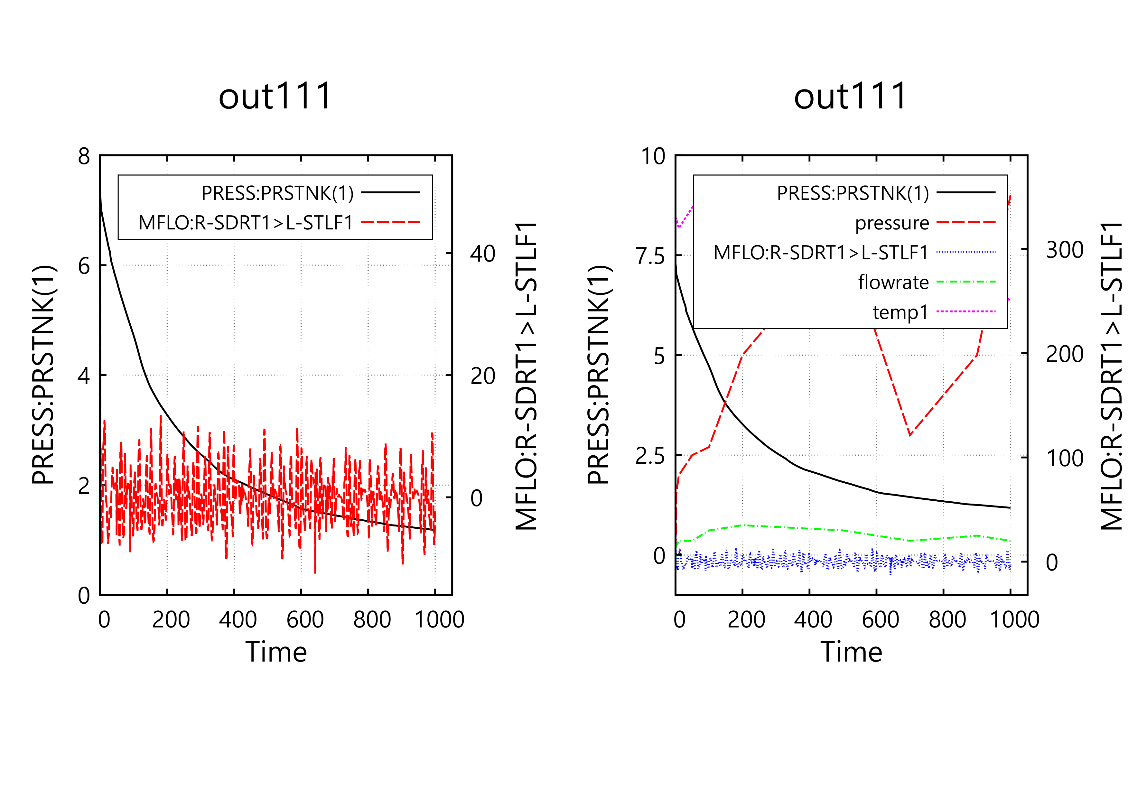
9. M-P, Manual, 2-p: port-EMF: out111(14), press(8), PRESS(9), PRESS(10), PRESS(11)
8/9: 14:35 이후
10. M-P, Manual, 2-p: Land-EMF: out111(14), press(8), PRESS(9), PRESS(10), PRESS(11)
8/9: 14:35 이후

11. M-P, Manual, 2-p: Port-SVG: out111(14), press(8), PRESS(9), PRESS(10), PRESS(11)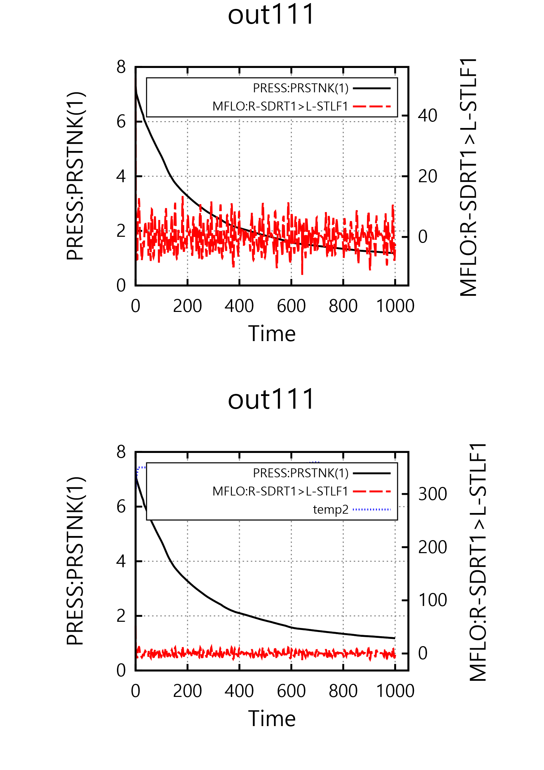
8/9: 14:35 이후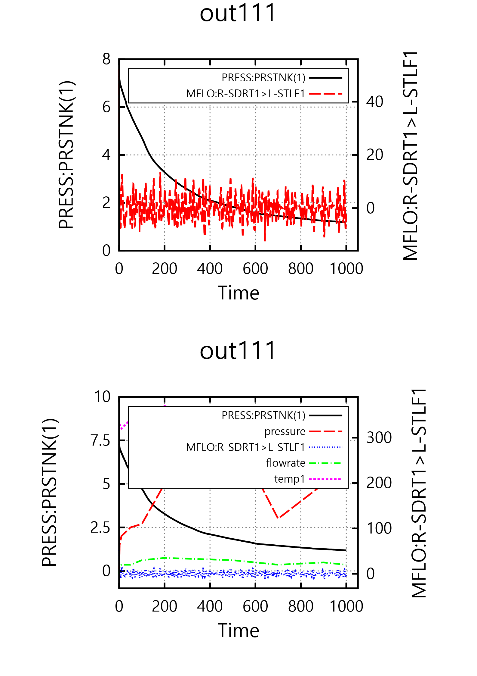
12. M-P, Manual, 2-p: Land-SVG: out111(14), press(8), PRESS(9), PRESS(10), PRESS(11)
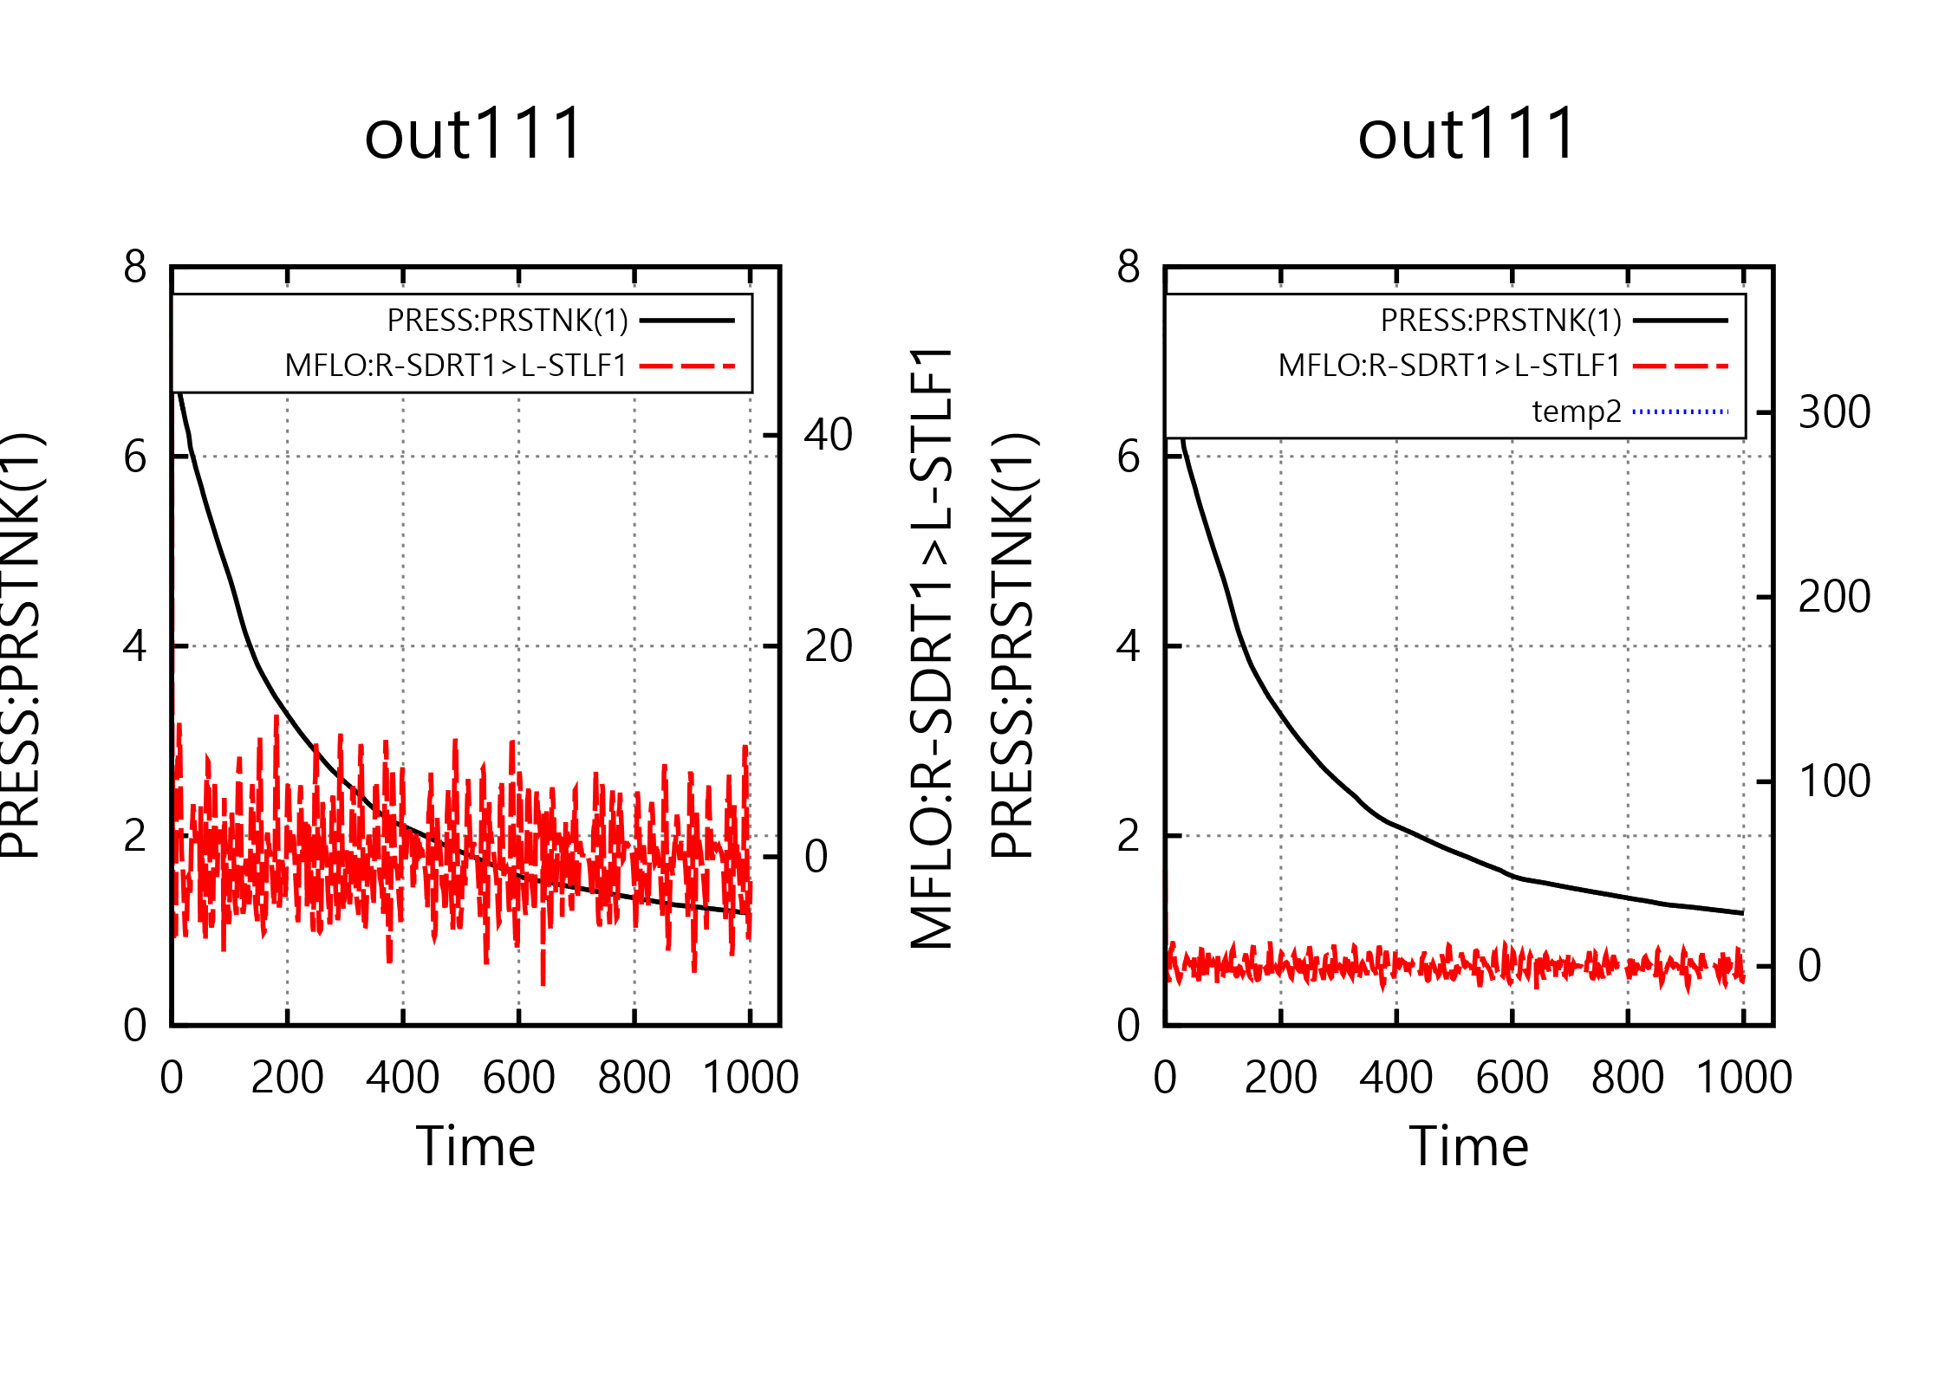
8/9: 14:35 이후

