파일 삽입: PNG(12), PNG(13): out111(14), press(8), PRESS(9), PRESS(10), PRESS(11)
PNG: New
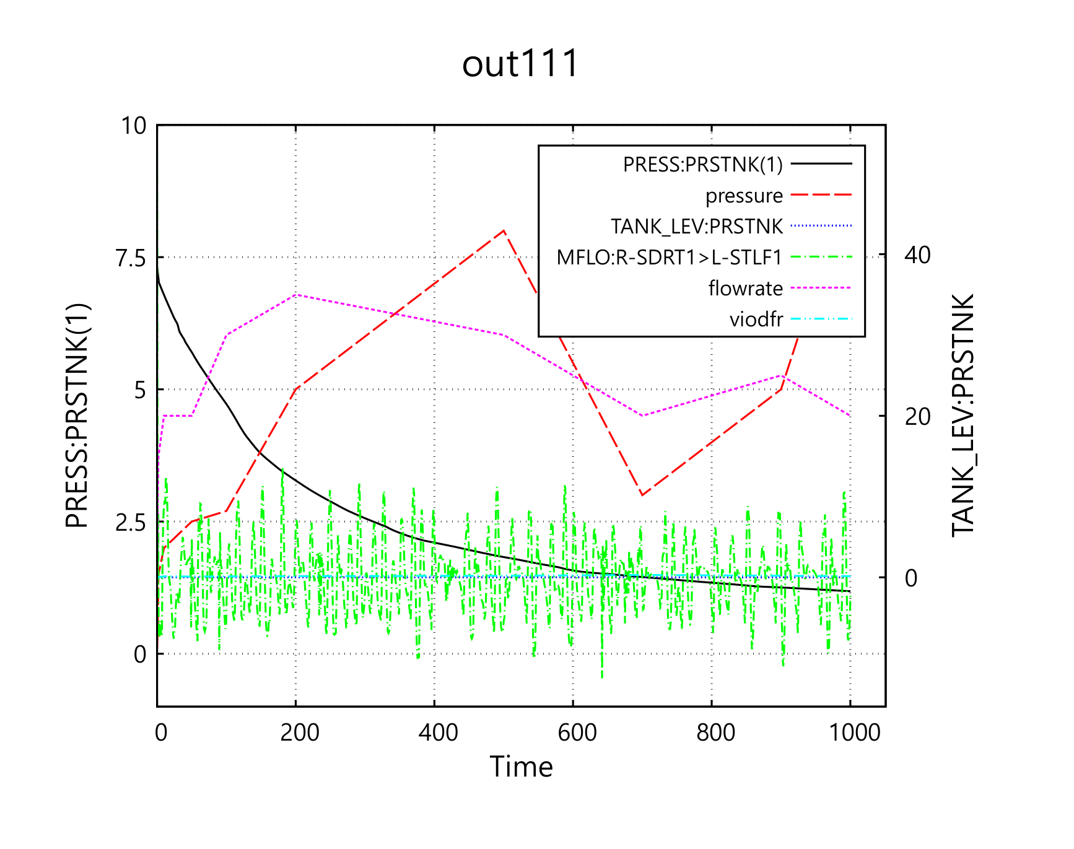
EMF: EMF, out111, PRESS(9), PRESS(11), PRESS(12)
Old:

New
SVG: out111, PRESS(9), PRESS(11), PRESS(12)
old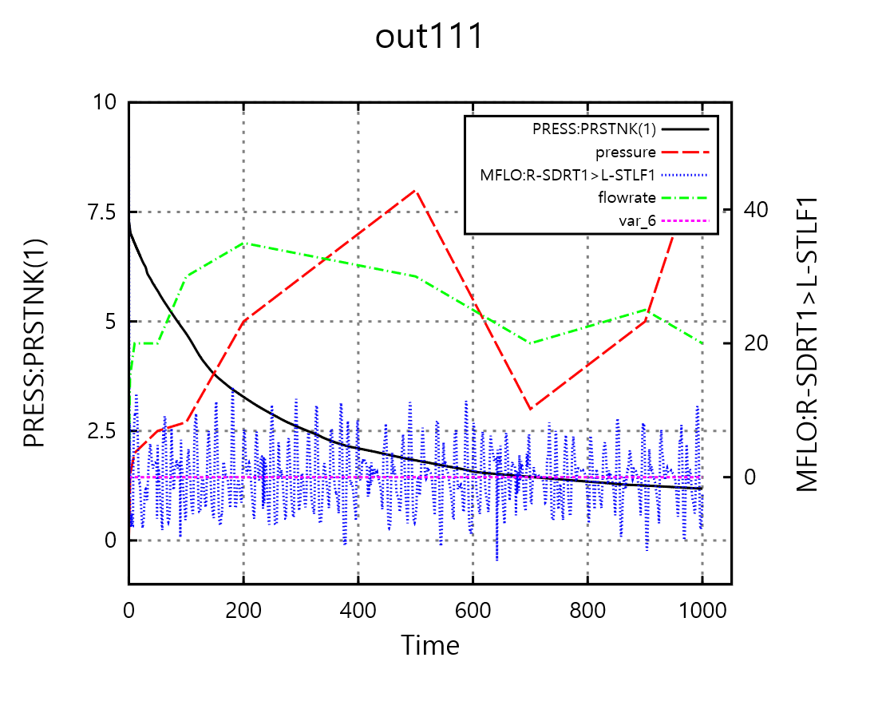

New

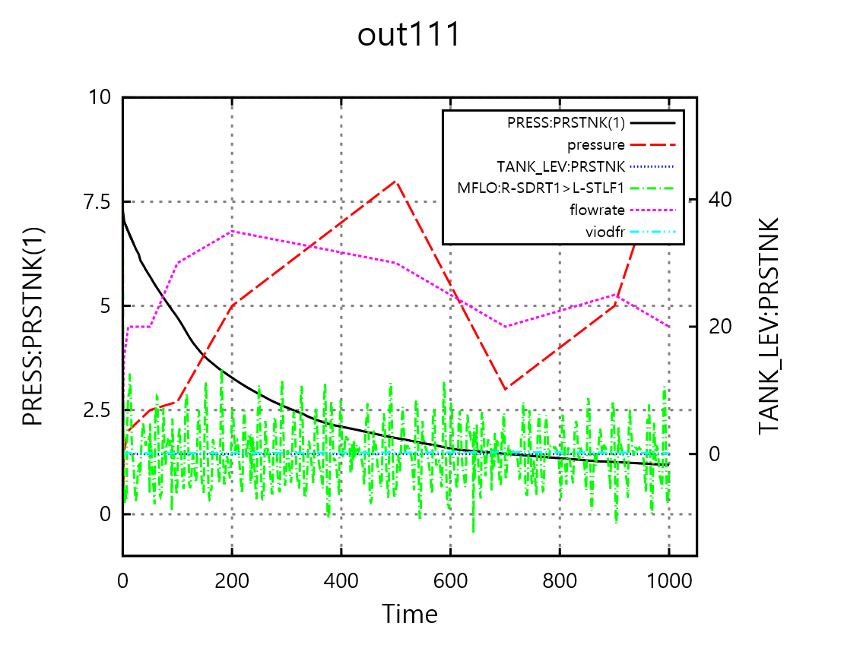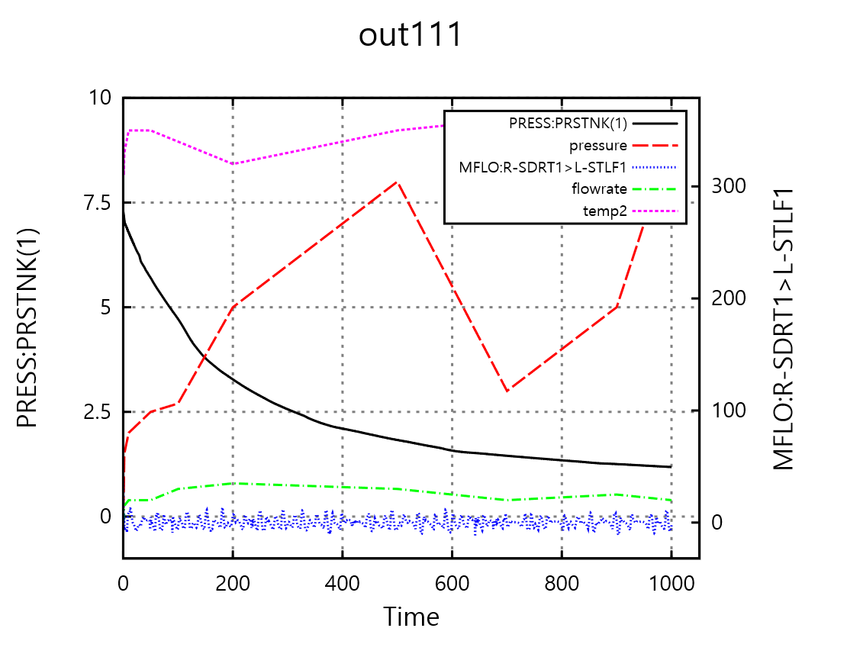

2줄 title 사용했을 때: (PNG)
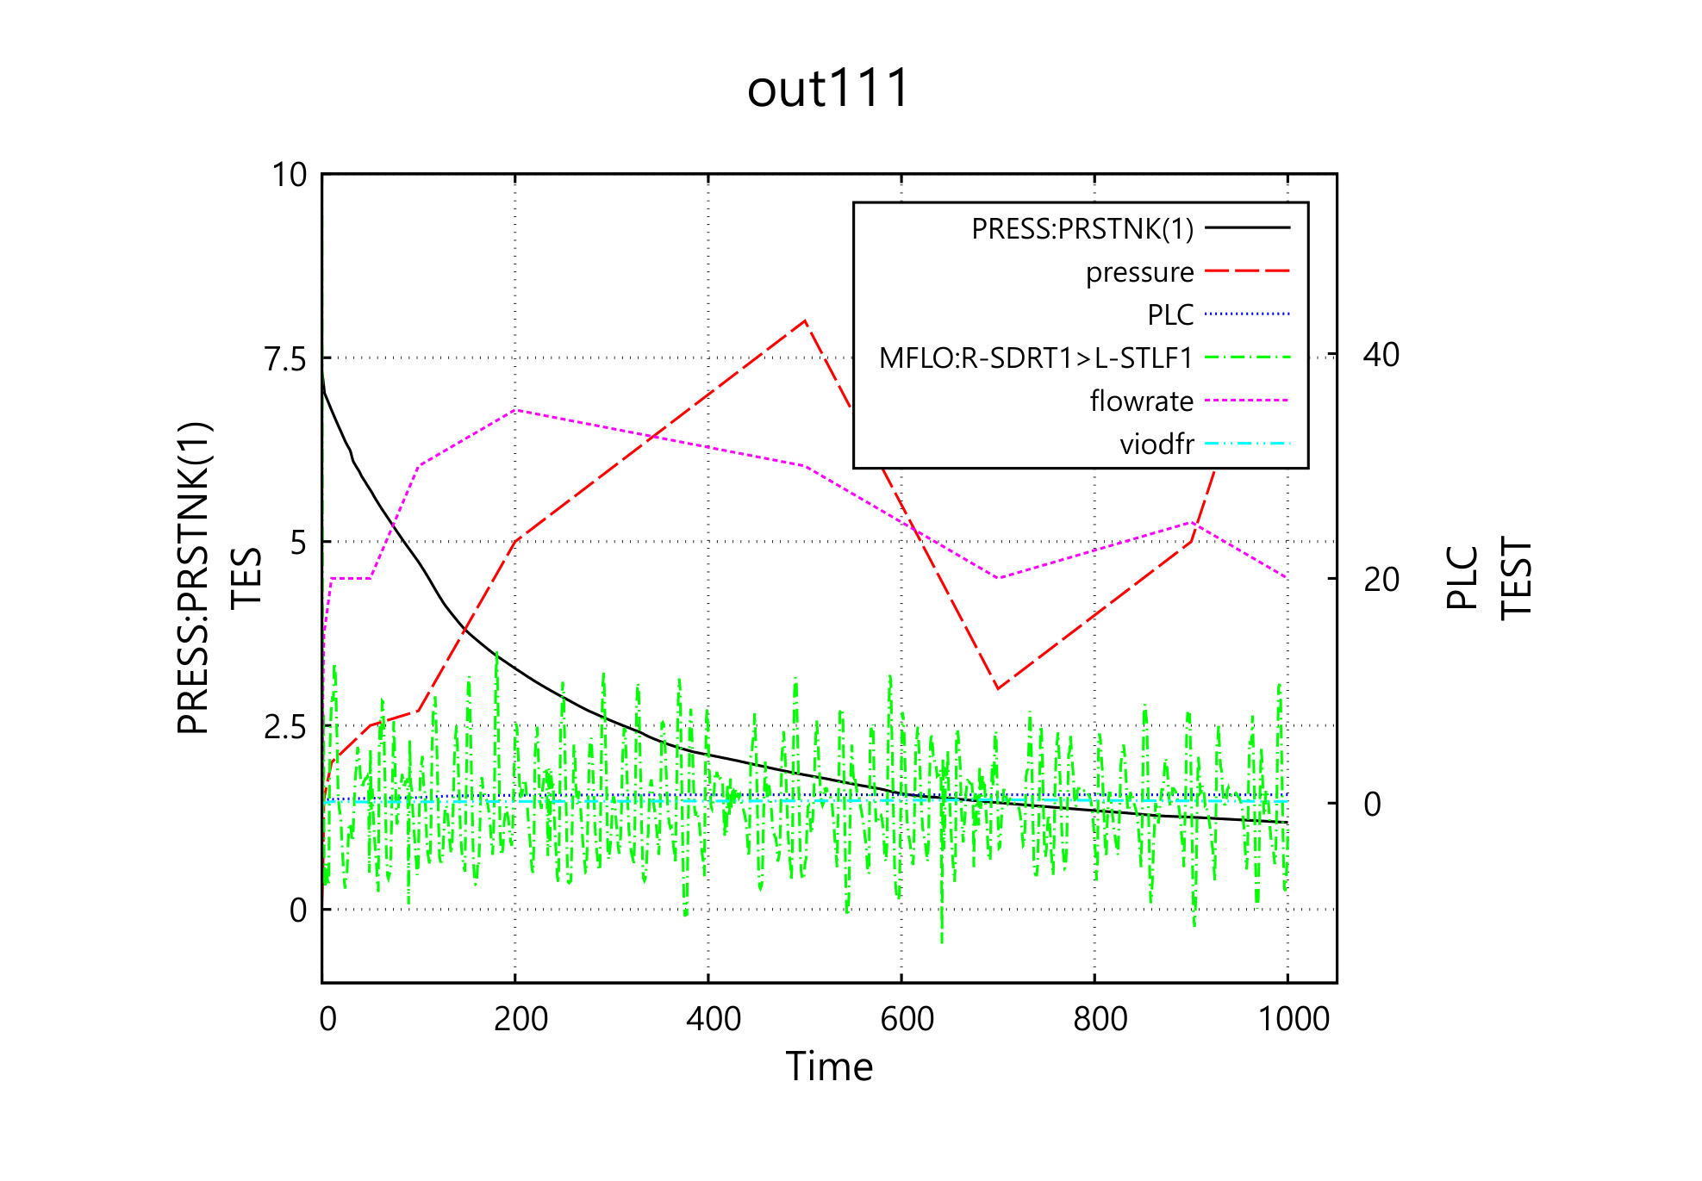
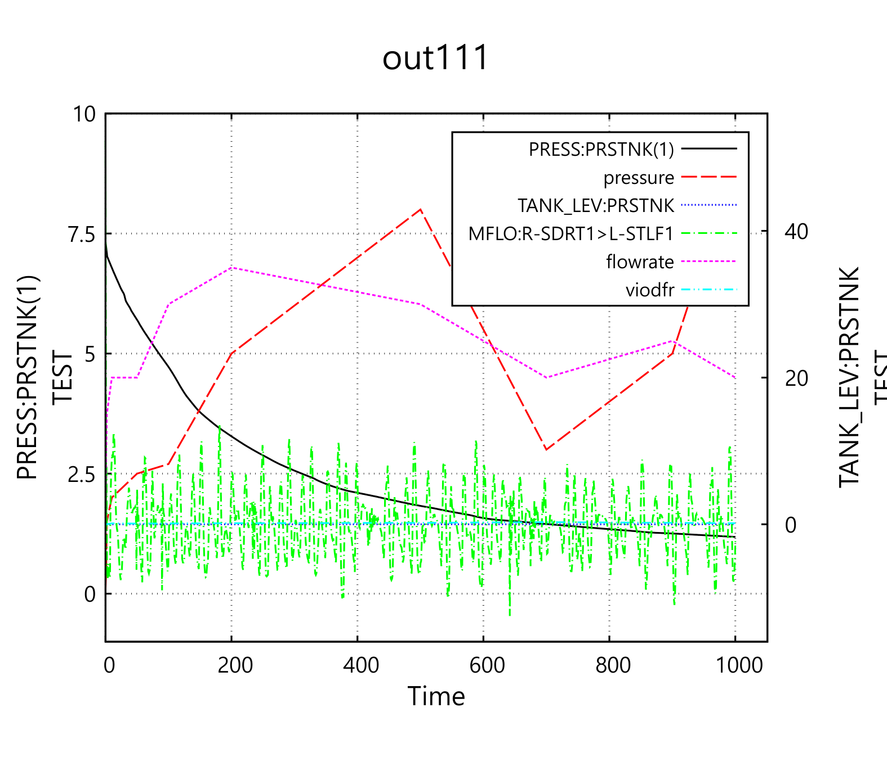
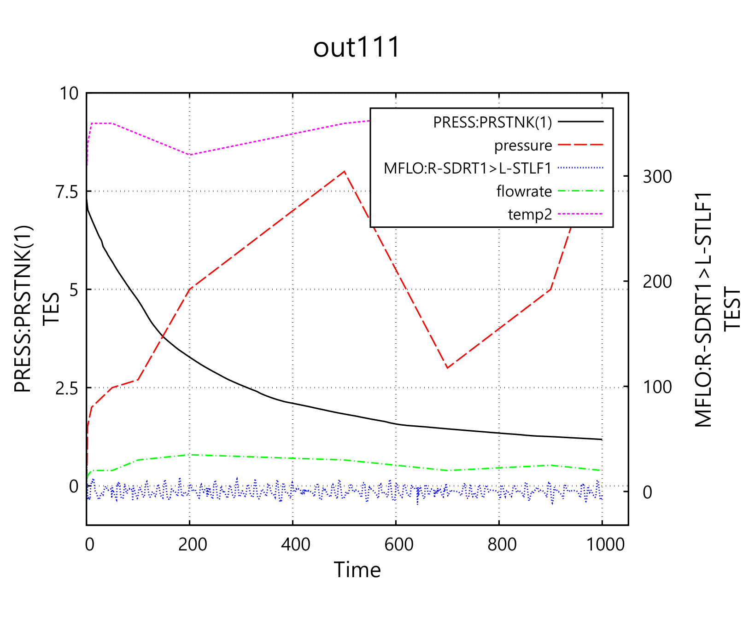

2줄 title 사용했을 때: (EMF)

old
new

2줄 title (SVG):
old
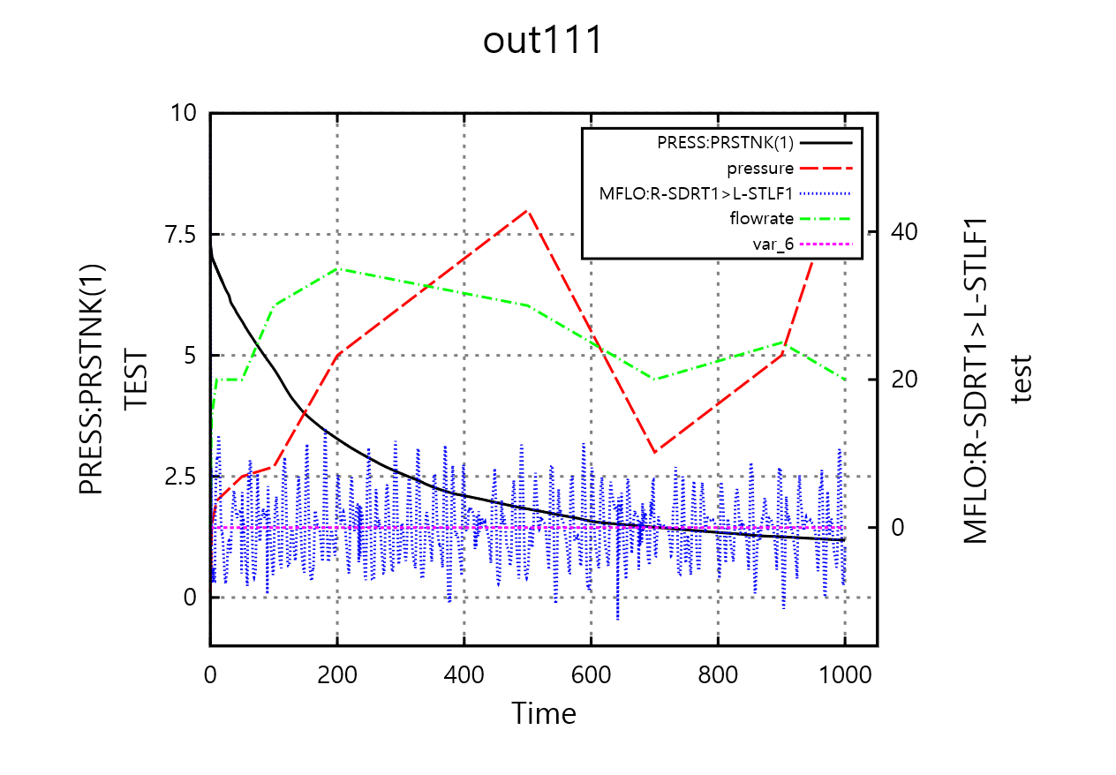

New
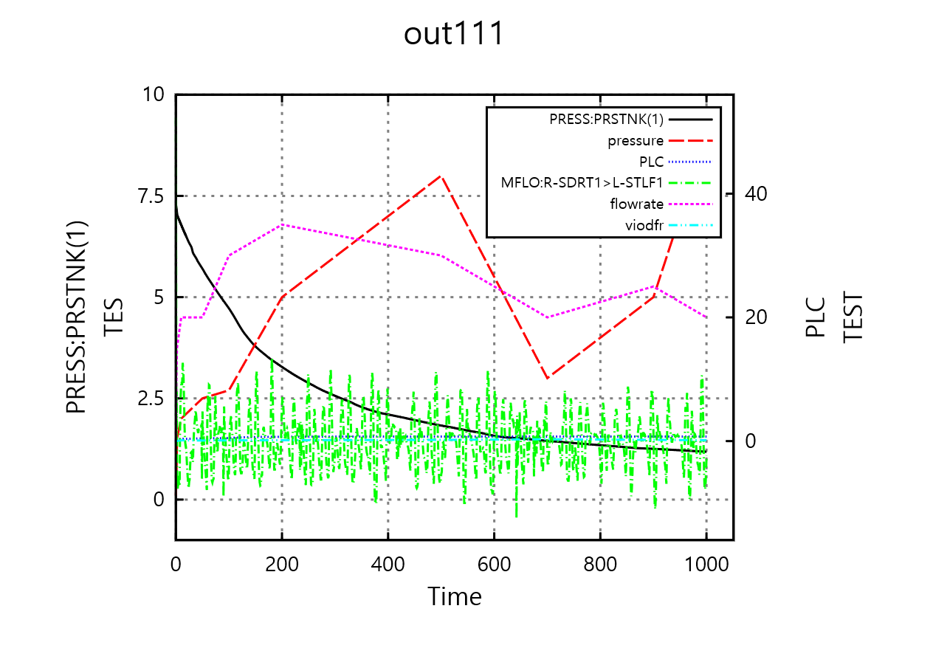
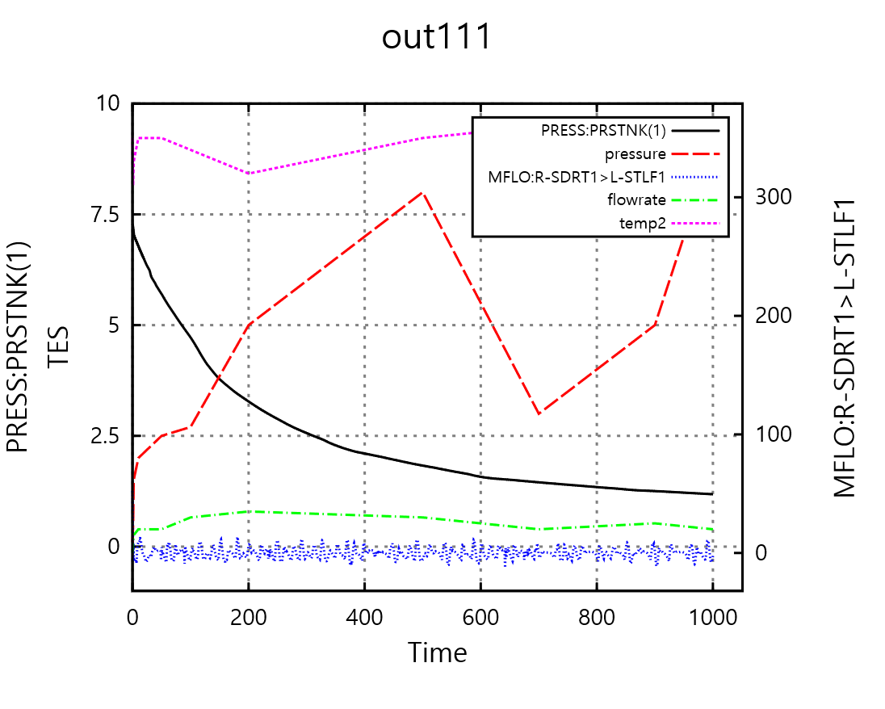

Multi-plot, auto-1plot-land: y1, y2 1줄 title인 경우
png:
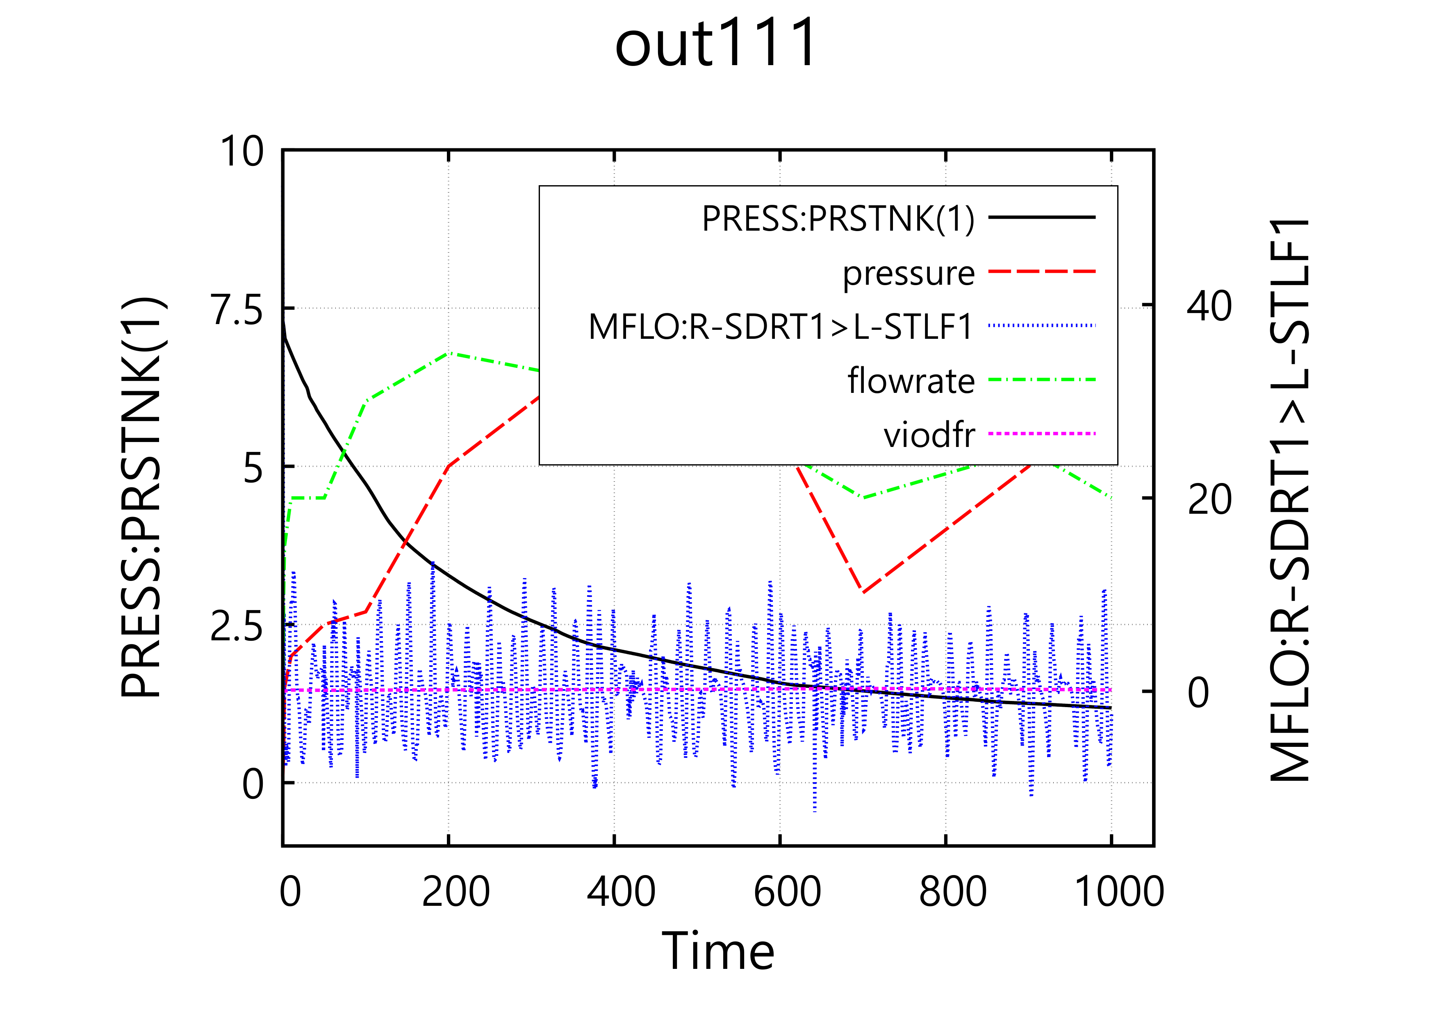

emf:

svg:
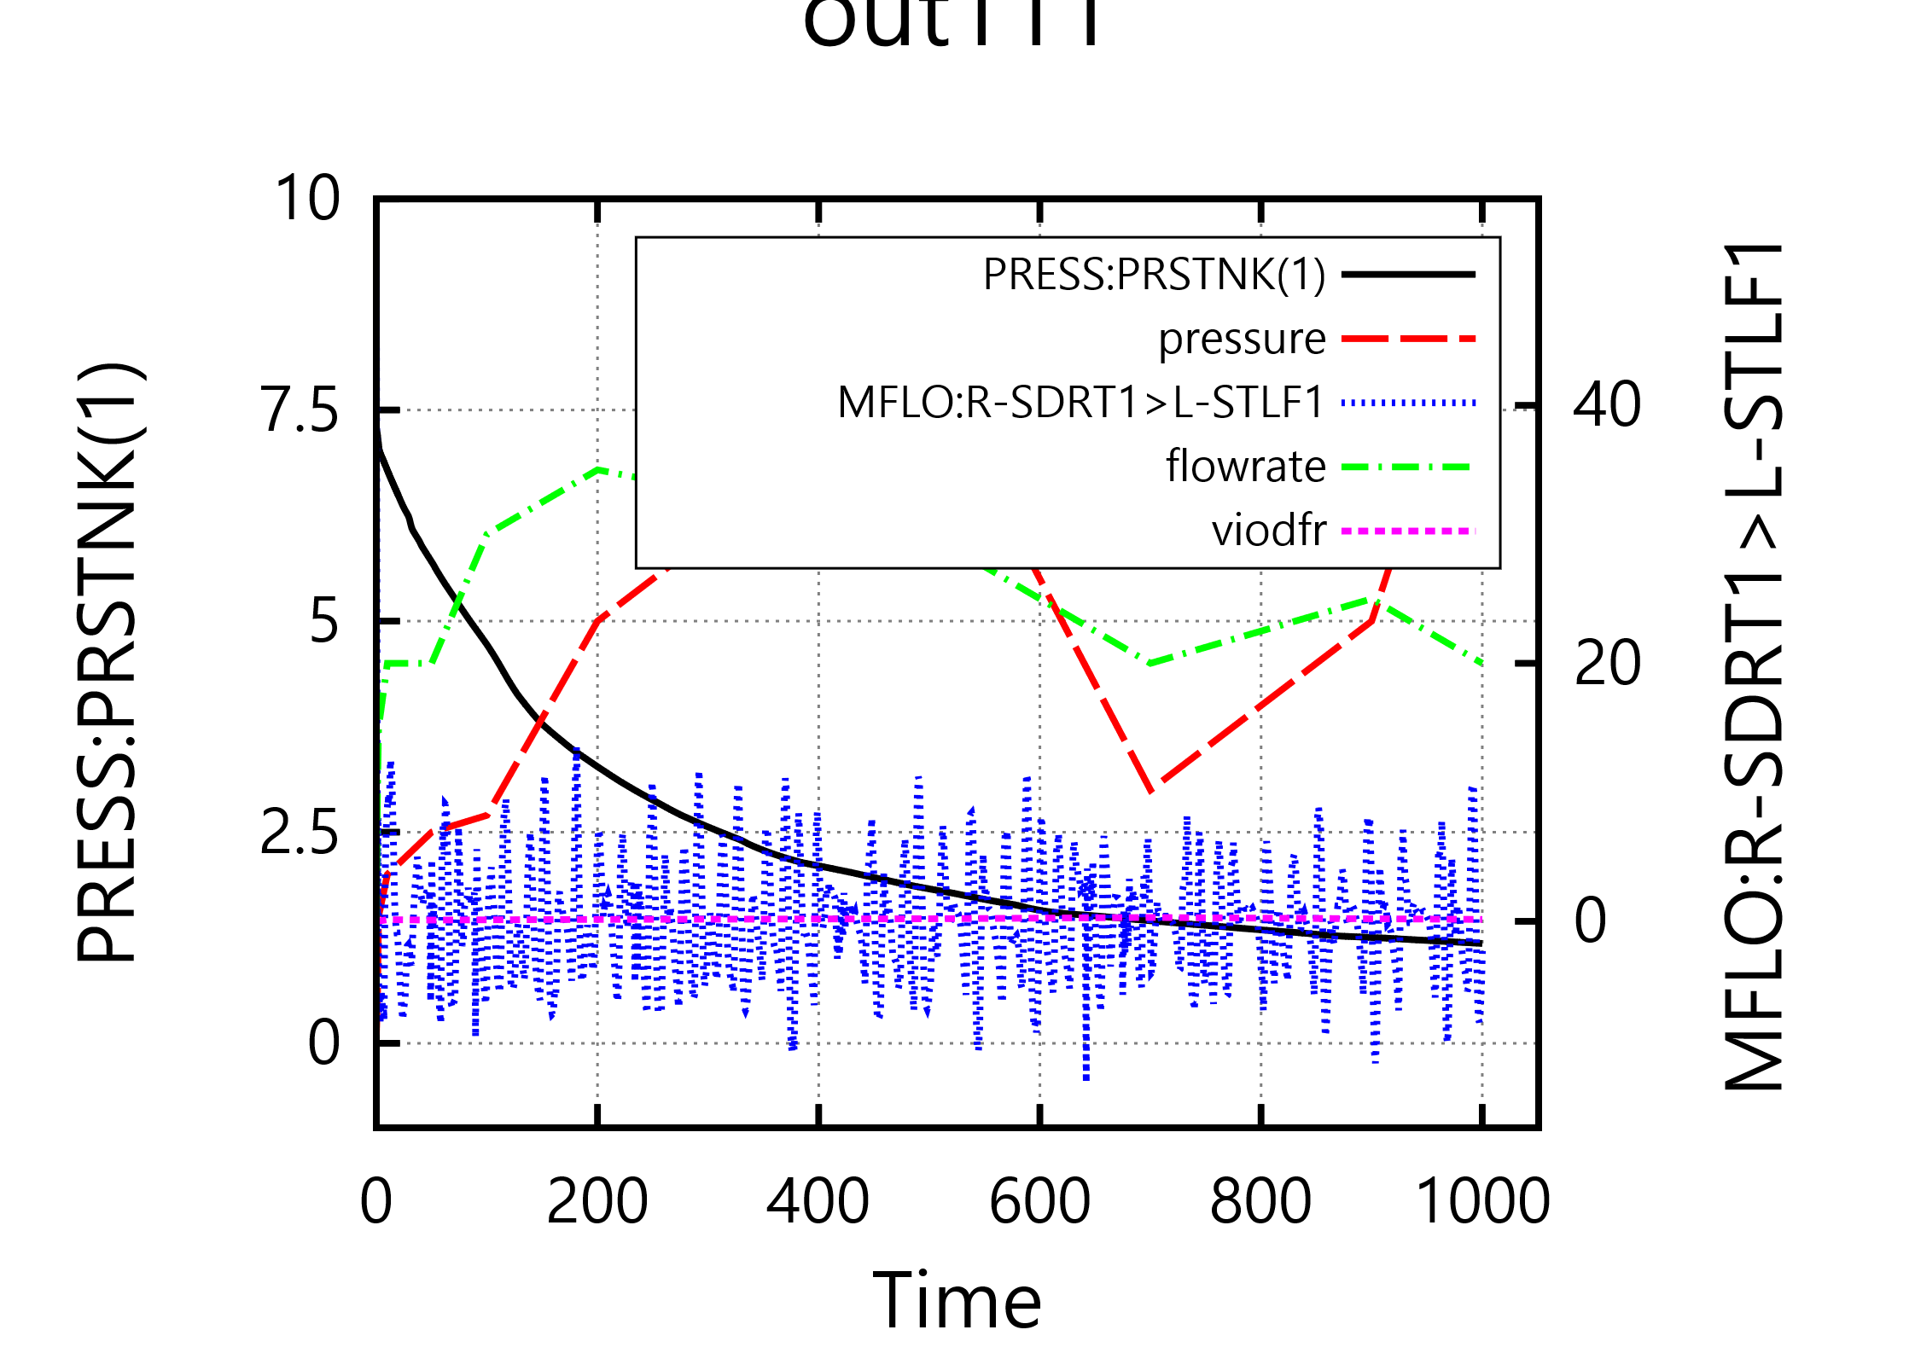

Multi-plot, auto-1plot-land: y1, y2, 2줄 title인 경우
PNG:
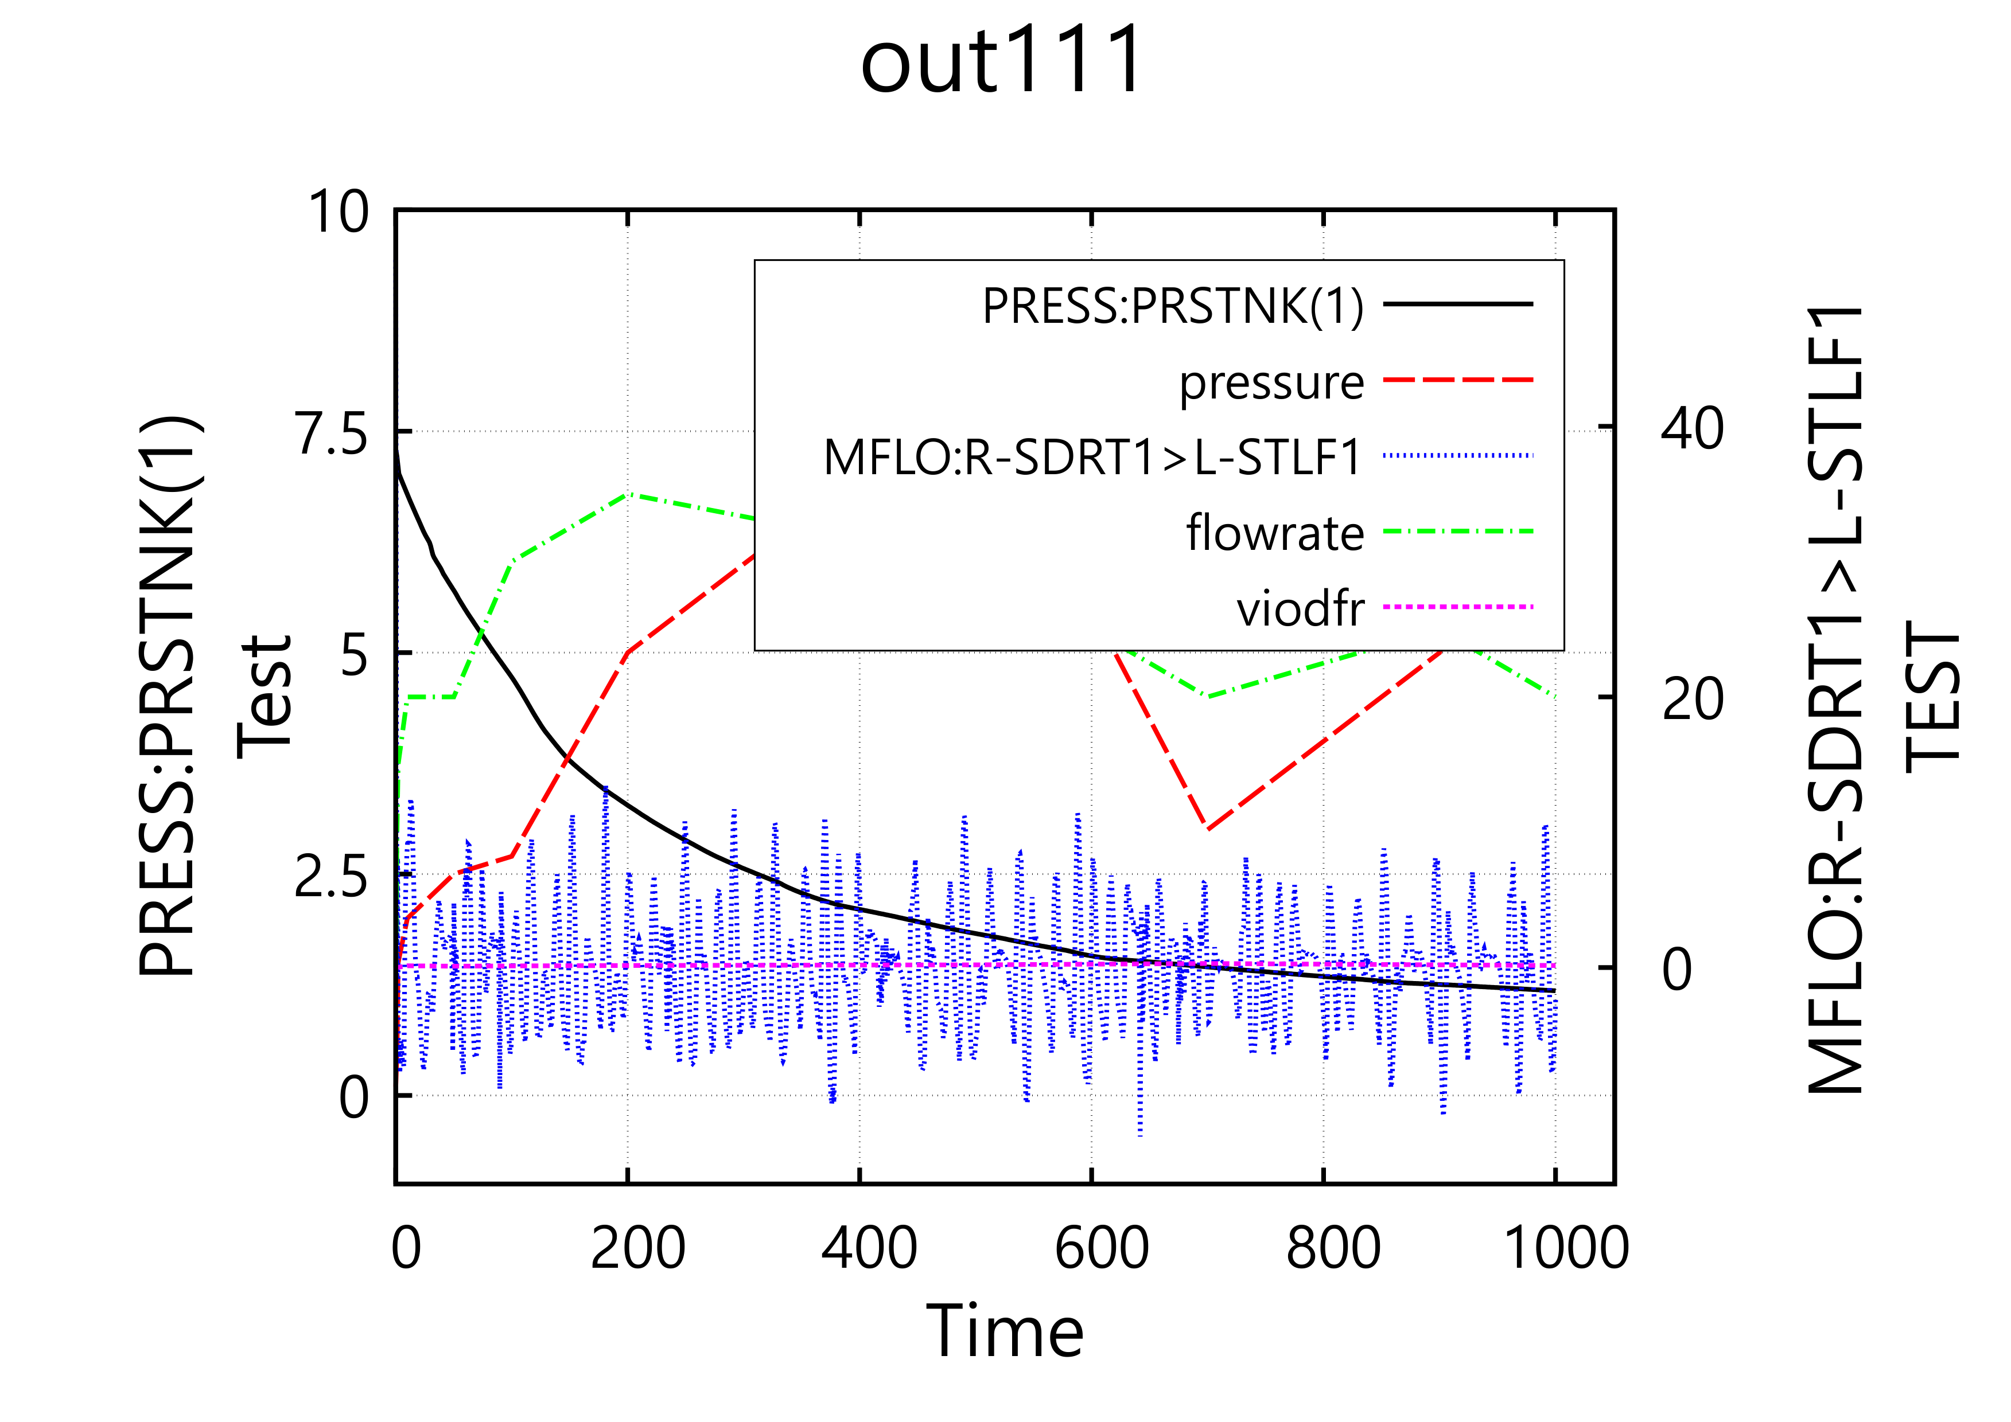

EMF:

SVG:


