Case Western Reserve University

Human Reactions Under Emergent

Behaviors in Driving Safety

Theodore Frohlich

EBME 318: Biomedical Engineering Laboratory I

Dr. Xiong (Bill) Yu | Yang Yang, Ph.D. Student

30 November 2016

***Abstract— Recent studies show that during hand movement, the cortical hemisphere on the contralateral (opposing) side of the body is activated. The μ rhythm (also called the μ wave), traditionally defined as an 8-12 Hz band, is related to the motor information. When brought into the context of driving safety, there are countless implications that can be inferred from observing and analyzing the direct effect on μ waves, as a result of various acute stressors, especially those arising in emergency situations.***

1. **Introduction**

The purpose of this experiment is to study the brainwave frequencies during five different states of mind: a state of relaxation, moving the left hand, *imagining* moving the left hand, moving the right hand, and finally *imagining* moving the right hand. Using all fourteen channels of EEG signals recorded during these tests, the data can be analyzed to explore the difference between the relaxation and moving states.

1. **Methods**

Data acquisition in this experiment was performed via the Brainwear® wireless neuroheadset known as the EMOTIV Epoc+. To ensure a properly conductive interface between the subject’s scalp and the headset, the device’s electrode leads were soaked in a saline solution. With the subject in a seated, relaxed position, the data collection protocol was initiated.

For each aforementioned state of mind, EEG data was recorded in 10-second intervals. Once this baseline was established, the subject performed a sequence of imagined movements (i.e. of the left and right hands) over the course of one long trial, mimicking actions performed by a person while driving.

1. **Results**

The results of this experiment can be visualized thanks to the MATLAB add-on called EEGLAB, a widely used toolbox for processing electrophysiological data. We can analyze the data from each of the five configurational trials mentioned earlier. Now, before continuing, allow me to preface this section by saying that *I was the subject*, and considering how hectic and overwhelming this semester has been for me, it is hardly a surprise that my results are abnormal –or far from “excellent data.” Nevertheless, my results can be observed in both the time and frequency domains, respectively in the subsequent ten figures:

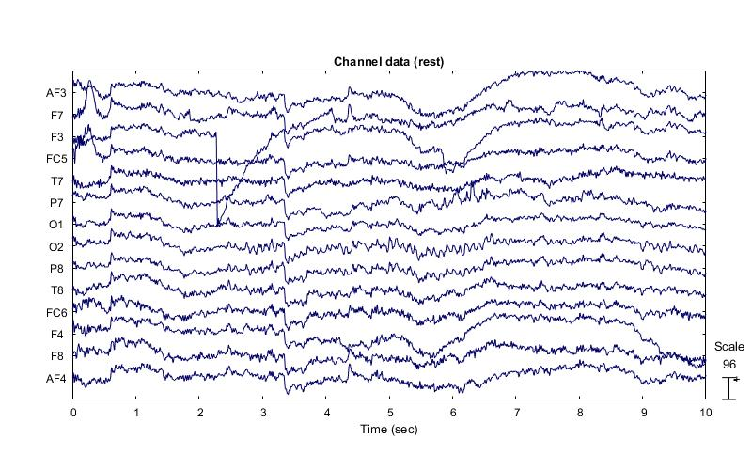

**Fig. 1.** Plot of channel data (scrolling), represented in the time domain, while in a relaxed state of mind. It is interesting that the scale of magnitude of these brainwaves is quite large, as compared to subsequent ‘moving’ states of mind. I believe I recall accidentally blinking during this trial, or perhaps there was someone walking by outside the room, who caught my attention. This could explain sudden unprecedented neural activity at certain points in the 10-second window.

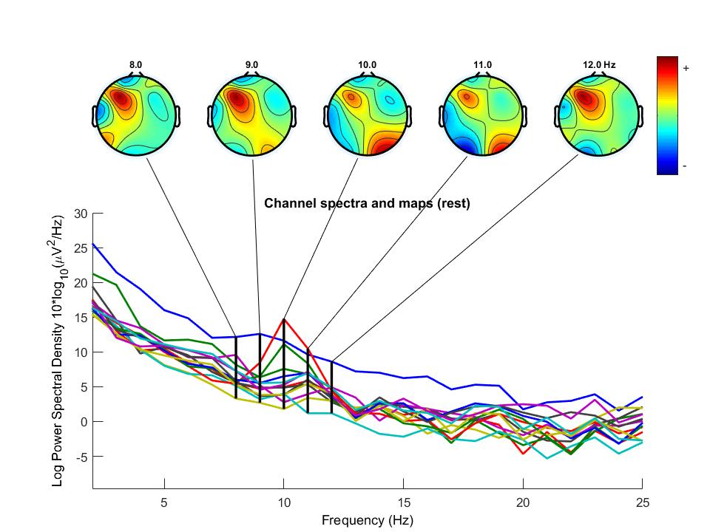

**Fig. 2.** Plot of channel spectra and maps, represented in the frequency domain, while in the state of relaxation.

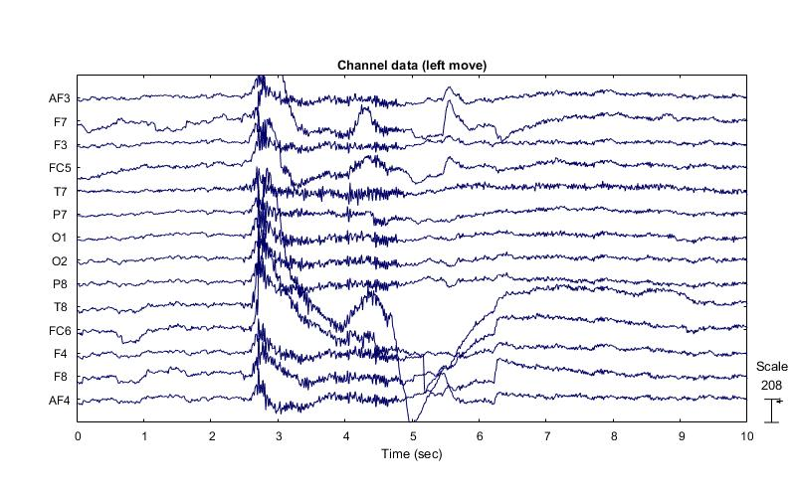

**Fig. 3.** Plot of channel data (scrolling), represented in the time domain, while moving my left hand.

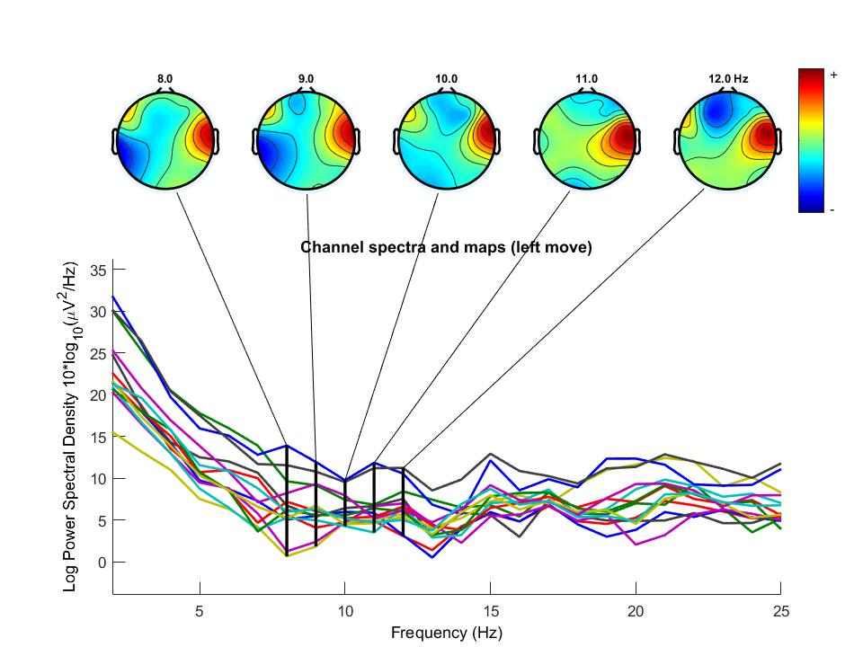

**Fig. 4.** Plot of channel spectra and maps, represented in the frequency domain, while moving my left hand. Note the prevalence of neural activity in the right cortical hemisphere. This instance of contralateral activation supports the recent studies mentioned in the abstract.

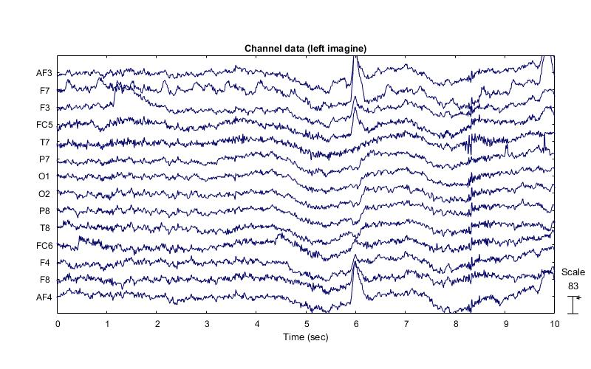

**Fig. 5.** Plot of channel data (scrolling), represented in the time domain, while imagining moving my left hand.

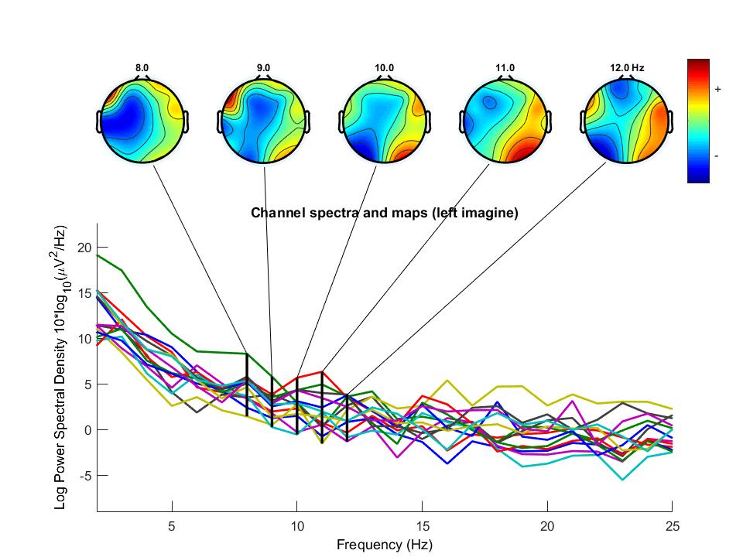

**Fig. 6.** Plot of channel spectra and maps, represented in the frequency domain, while imagining moving my left hand. Note that, although there is a presence of contralateral neural activity, it is hardly comparable to magnitudes observed while actually moving the hand (as seen in Fig. 4).

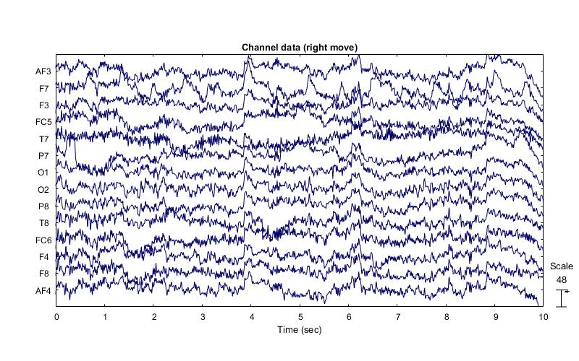

**Fig. 7.** Plot of channel data (scrolling), represented in the time domain, while moving my right hand. Although visibly more erratic, note that the scaling factor here is drastically lower than those in other trials. It is hard to say why this is. Perhaps moving my right hand required less neural activity since I am right-handed, or I had not performed these motions with as much energy as I had while moving my left hand (Fig. 3-4).

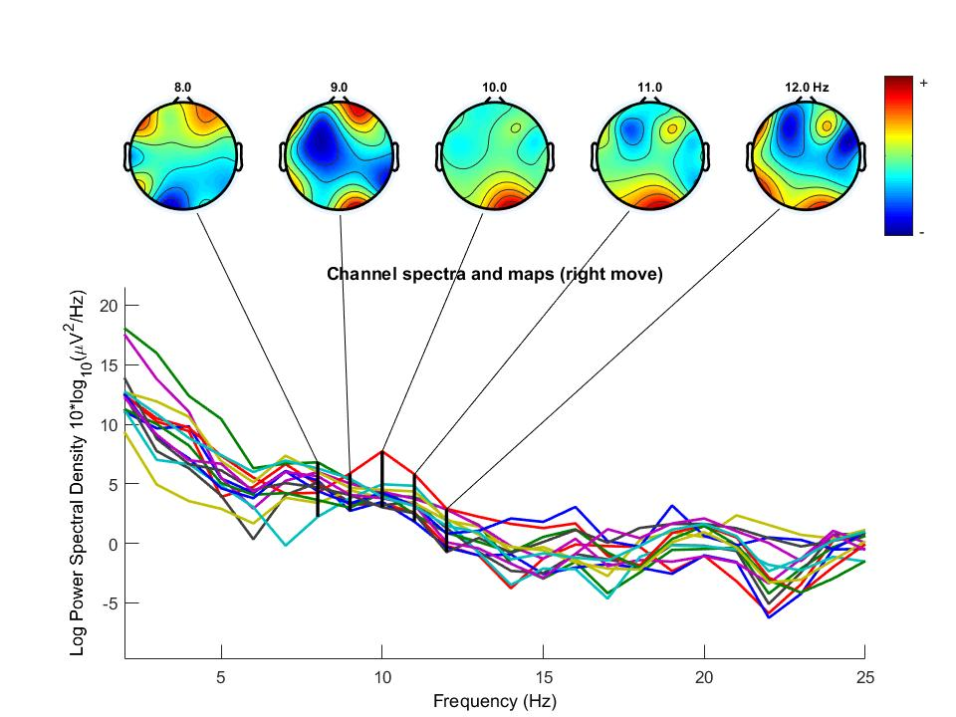

**Fig. 8.** Plot of channel spectra and maps, represented in the frequency domain, while moving my right hand.

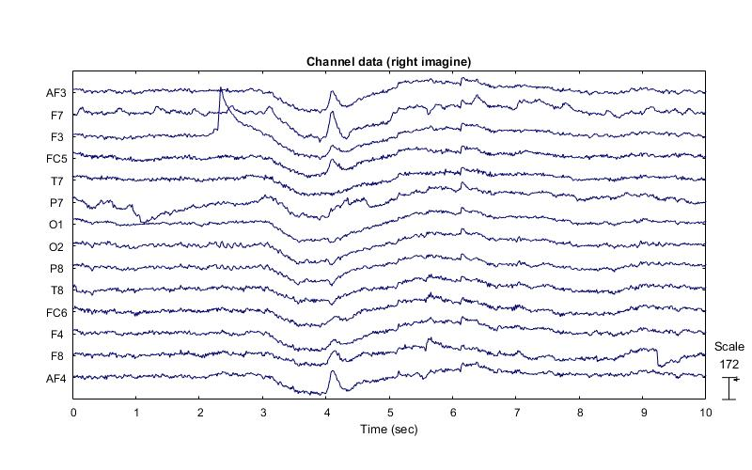

**Fig. 9.** Plot of channel data (scrolling) represented in the time domain, while imagining moving my right hand.

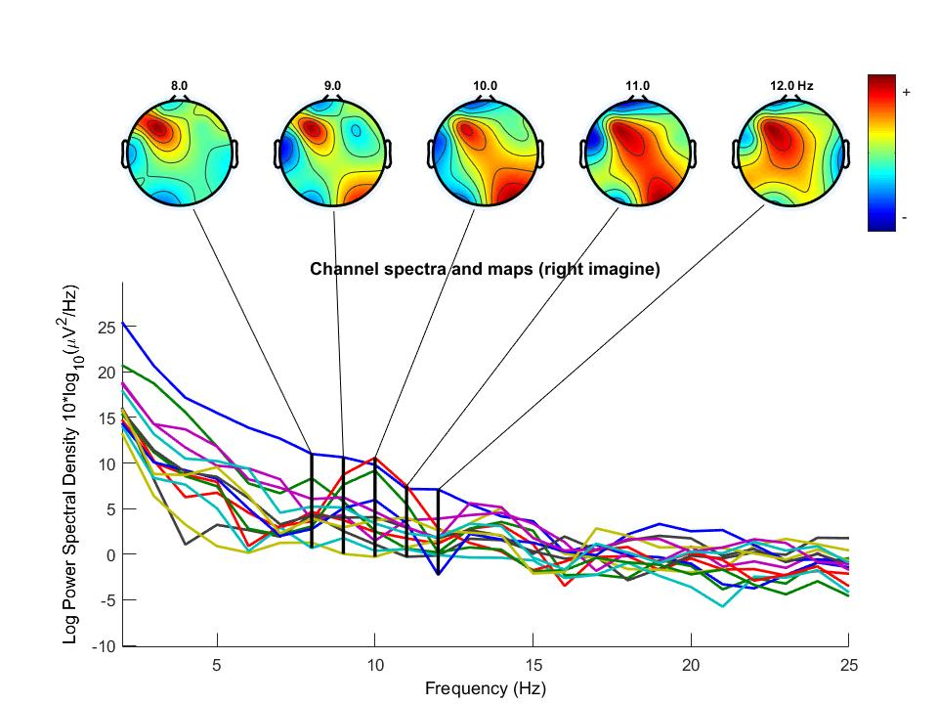

**Fig. 10.** Plot of channel spectra and maps, represented in the frequency domain, while imagining moving the right hand. Note that there is clearly an increase in neural activity in the left cortical hemisphere, which is again in accordance with the studies mentioned in the abstract. However, there is still some peculiar activity in the right caudal region of my brain, noticeable in 9-11 Hz band of the μ rhythm.

1. **Discussion**

Following from the results given in the previous section, showing time-domain and frequency-domain representations of the EEG signals in five tests, collected as scalp potentials from my very own brain, let us now discuss the difference seen in the signals between the relaxation state and the moving states.

As I started to mention in the caption to Fig. 1, there is a possibility that my frenzied mental state at the time of the trials had a pronounced skewing effect on the data acquired. As it took place in a later time in the year, when the atmosphere is colder and drier, I recall having difficulty preventing myself from blinking during the 10-second testing intervals. Executing a blinking motion—or at least having the desire to do so—must be to blame for some of the spikes in the signal seen in Fig. 1. So, unfortunately, we may have to conclude that the control trial of this experiment returned data that is not nearly as helpful as hoped.

From the subsequent four trials, the best example of contralateral neural activity—by far—is seen in Trial 2: moving the left hand. As explained in the caption to Fig. 4, there is a dramatic surge in power spectral density (PSD) in the right-most topographical region of the brain. In accordance with the recent studies mentioned in the abstract, this effect is accounted for by the scientific paradigm concerning the relationship between voluntary movements of the body and the cortical hemisphere *on the opposing side* of the body. As seen in the time-domain plot of this data, the majority of this PSD is amassed between 2.7 and 4.9 seconds; I recall there were a few times throughout the course of this experiment when I either performed *or imagined performing* a hand-clench with greater energy, focus, and determination. I believe, as a result, this was one of those times.

From looking at all the other trials, it is interestingly apparent that there always seems to be some increased neural activity in the right caudal region of my brain. That is, the μ waves produced by my brain were overall higher in energy than the mean brainwave energy dissipated over the course of each 10-second trial. As this is hard to explain, perhaps I can guess that this effect can be attributed to the fact that the computer data acquisition setup was slightly to my left-hand side.

After having performed this experiment once, I have now realized the sensitivity of neural scan technologies and the inherent difficulty of producing good data. To optimize data quality, these tests would have had to be reiterated by the subject until unprecedented activity is rendered statistically insignificant. Additionally, data from a handful of test subjects could be averaged to reveal a minimally biased set of results, leading to an easier and more accurate conclusion surrounding statistical significances present in the data overall.

1. **Conclusion**

In the context of driving safety, the ability to apply knowledge and current, state-of-the-art EEG neuroscan technologies has unprecedented value. Situations in the real world, in which critical human factors such as distraction, inattention, and drowsiness may arise in drivers, could be monitored in real-time to alert and prevent unnecessary danger to the driver, the car, and even the passengers and cargo. Of the many possibilities implied by this technology, this application would undoubtedly save lives and ultimately make the roads a safer place.

**Acknowledgement**

I would like to take a moment to thank both Dr. Yu and Yang for the exciting experience as well as the opportunity to observe and participate in such a fascinating experiment!