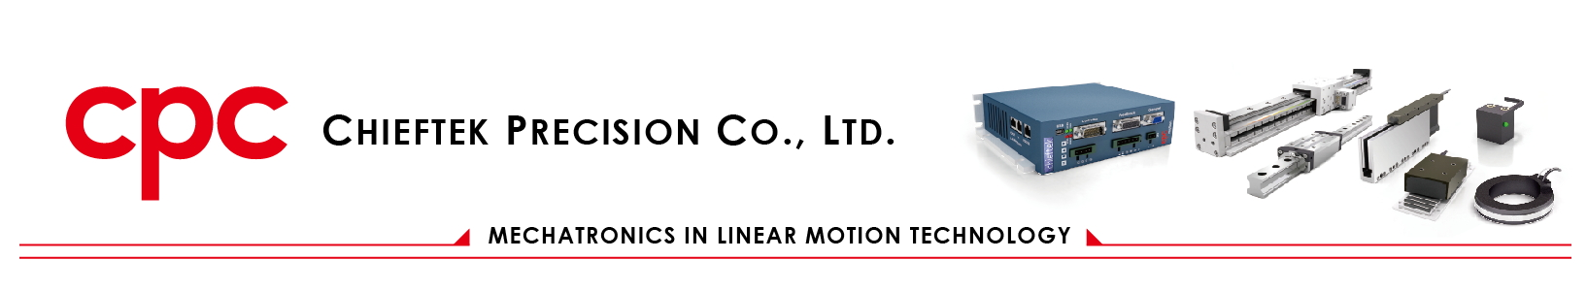

**Quotation**

|  |  |  |  |  |  |  |  |  |  |  |  |
| --- | --- | --- | --- | --- | --- | --- | --- | --- | --- | --- | --- |
| **CONTROL SYSTEMS S.r.l.** | | | | | | | | Page: 1/1 | | | |
| Via del Brolo, 14 | | | | | | | | Customer No.: [$1$] | | | |
| 26100 – Cremona (I) | | | | | | | | Customer inquiry No.: [$6$] | | | |
| Contact: [$2$] | | | | | | | | Person in charge: [$7$] | | | |
| Payment Term: 30 days | | | | | | | | Trade Term: [$9$] | | | |
| Special condition: | | | | | | | | Date: [$5$] | | | |
| Law and court: | | | | | | | | | | | |
| Warranty: | | | | | | | | | | | |
| Item | Article No. / Description | | | L2 | L3 | | Unit | Qty | | Unit Price | Amount |
| [$10$] | [$11$] | | | [$12$] | [$13$] | | [$14$] | [$15$] | | [$16$] | [$17$] |
| **Subtotal** | | [$18$] | **Tax Amount** | | | [$19$] | | | **Total Amount** | | [$20$] |

**CONTROL SYSTEMS S.r.l. Chieftek Precision Co., Ltd.**

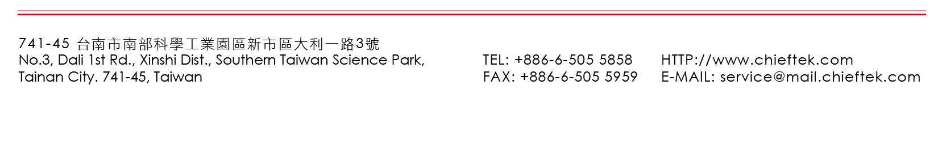

Document No.：1-DS-4-A-011 Rev.: 3

Please confirm and sign back