

**BuggyAI**

**The Complete Manual.**

**Group Members:**

Kyle Brown

Miguel Garnica

Michell Valdivia

Ky Phan

**Advisor**:

Dr. Adriano Cavalcanti

**Table of Content.**

**About BuggyAI…****…………………………………………………………………………………………. 2**

**Getting Started…****…………………………………………………………………………………………. 4**

**The Result…****………………………………………………………………………………………………. 8**

**Special Thanks.**

Special thanks to Mr. Xiaoping Wu for providing us with a large dataset of common pests.

To access the same dataset, go to <https://github.com/xpwu95/IP102>

# About BuggyAI.

BuggyAI is a machine learning image classifier. The application is supposed to classify a given image as one of the following three common pests: aphids, red spider mites, or thrips. The result displayed to the users tells them how confident the program is (in terms of percentage) that the given image is an aphid, or a red spider mite, or a thrips.

A prediction model was created with Python programming language, using Tensorflow / Keras. After the model was properly trained, it was saved to the backend database. User requests made in the [https://buggyai.com](https://buggyai.com/) will be handled on a Flask application on an Ubuntu 18.04 server which is run in production mode. Gunicorn will then act as a gateway server and handle the execution and entry point of the Flask application. Before all of this, an Nginx server is running as a reverse proxy to filter incoming and outgoing requests being made to the website’s IP address. It is also worth noting that the server has valid SSL certification and only accepts requests from other Https domains.

Before using BuggyAI, make sure your device has a web browser (Google Chrome, Mozilla Firefox, Safari, ...), access to the Internet, and a picture for pest identification readied.

# Getting Started.

Here is an example on how to use the BuggyAI application on a computer:

1. On your device, open a web browser (Google Chrome, Mozilla Firefox, Safari, ...).
2. Once inside the browser, type in the URL “[https://buggyai.com](https://buggyai.com/)” without quotation marks, and hit **Enter**. The web browser should now display the BuggyAI’s homepage, which looks like this.

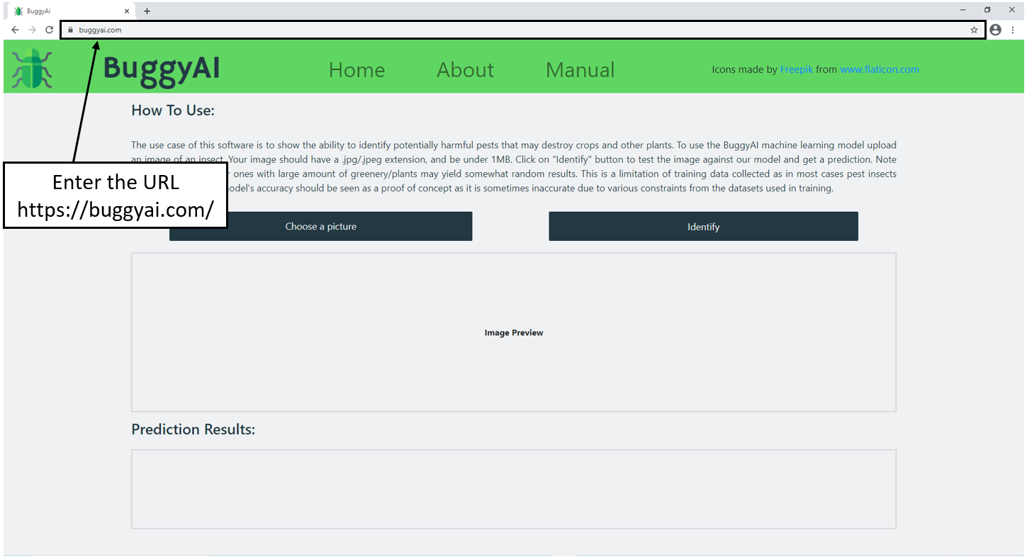

Continue instruction on the next page.

1. Click the **Choose a picture** button. A new window will pop up, and the **Choose a picture** button will turn white, indicating that a picture is needed for the identification.

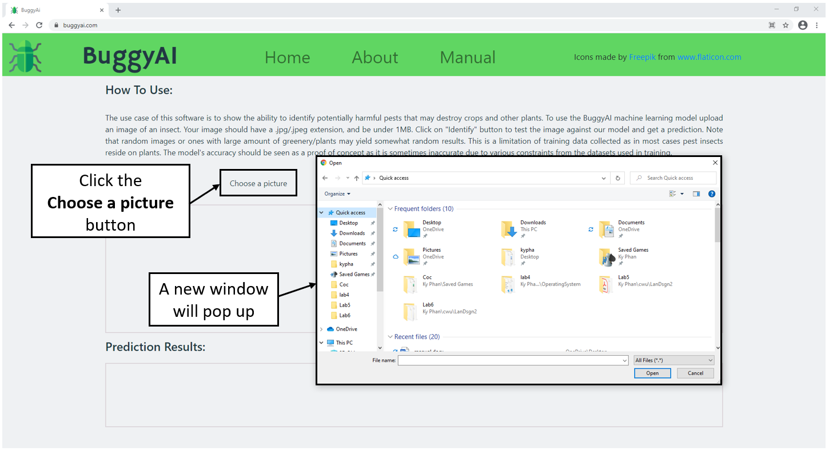

Continue instruction on the next page.

1. From the newly popped up window, navigate to the directory that has the image file you want to identify, double click that image file (for this example, the picture is **aphid01.jpg** inside **Desktop**).

**Important Note**: For now, the application only accepts **.jpg** and **.png** image files.

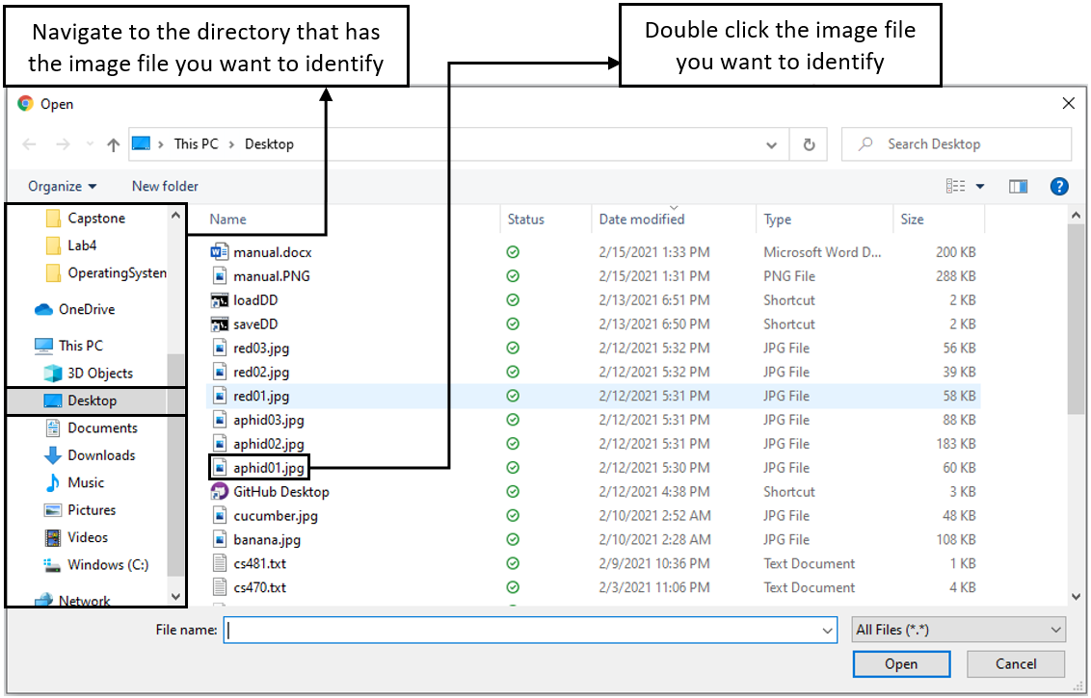

Continue instruction on the next page.

1. If the application can load the selected image file from the previous step 4, it will be shown in the website. Click the **Identify** button to identify.

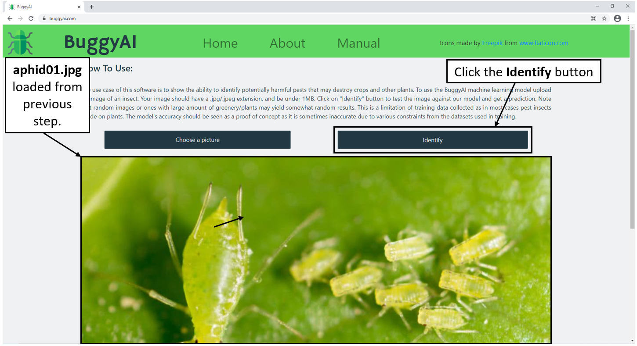

1. Scroll down to see the result, which will be displayed in the **Prediction Results** area.

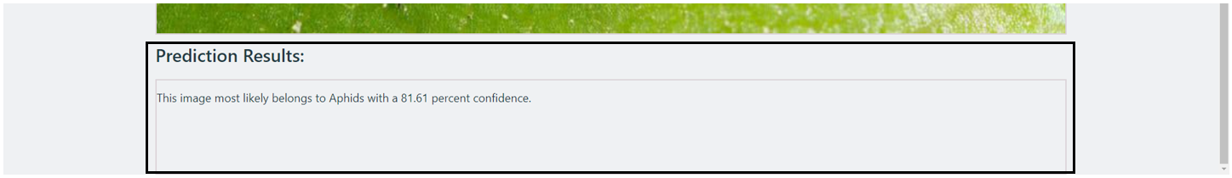

In this example, BuggyAI deemed the provided image to be most likely an image of an aphid, with a level of confidence of 81.61 percent.

# The Result.

**Good results:** If the resulting level of confidence is greater than 66,67 percent (equivalent to the odds of two out of three), then BuggyAI would usually have the correct prediction result.

**Bad results:** If the level of confidence is less than 66,67 percent, then BuggyAI would usually have the wrong prediction result. A low level of confidence means the application was struggling when trying to identify the provided image.