User Manual for MOEKA UI

## Introduction:

MOEKA UI is the User Interface version of the MOEKA software. It provides a visual representation of the Multiple Disk Form (MDF) created by the MOEKA program and the functions contained inside of it. MOEKA UI also allows for creating Functions and Clauses manually during runtime.

## Running the program:

When you run the program, you will get a Window that looks like the one below. Each Node is labeled with a number that corresponds to its description.



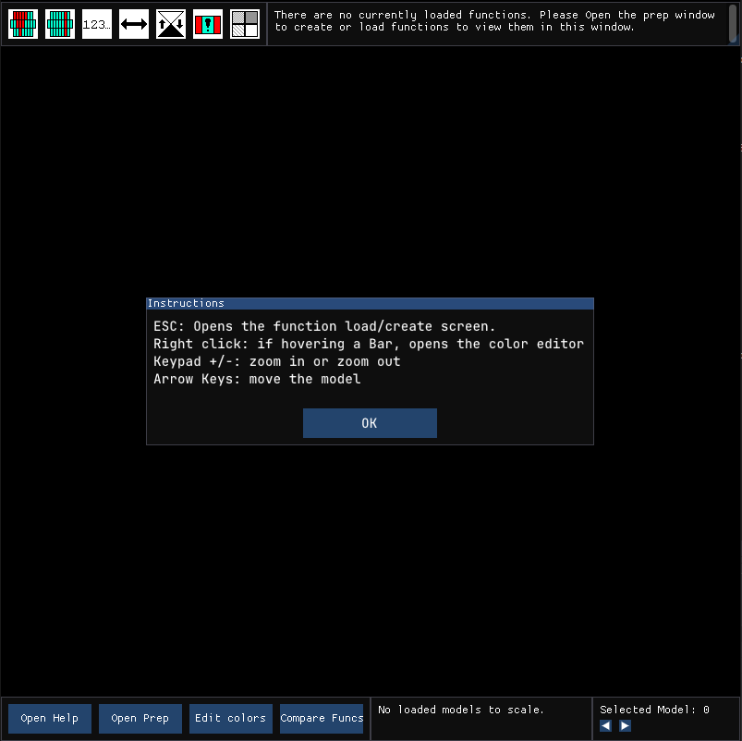



1. A window that contains buttons that manipulate the model, such as “Show bush up” and “Change expanded to real elements”. As of writing, these buttons do not have functionality.
2. When a Function is loaded into memory, a Tree view representation of the function and its sub functions, clauses, and sibling functions will appear below it in the hierarchy. There are also two buttons that will appear under the function when expanded labelled “Math” and “English” that will show the function as expressed through mathematical notation, and plain english.  
   A black screen with white text

   Description automatically generated  
   A black screen with white text

   Description automatically generated
3. An introduction window that appears on first time start up, or by pressing the “Open Help” button. This window shows the keybinds involved in the program.
4. This Window contains buttons to open up some of the commonly accessed windows, such as the Introduction window via “Open Help”, the Preparation Window via “Open Prep”, the Color Editor via “Edit Colors” and comparing two functions via “Compare Funcs”
5. When a model is loaded, some widgets will populate this Window to affect the scaling of the currently focused model.  
   
6. When there are multiple models loaded into memory, we can swap the selected model using the arrow buttons in this Window.

Furthermore, If you hover a particular bar of data in a Model, you will be shown the bars class value, and you can right click to edit the color of the bar and other bars with the same class.

## Prep Window:

When opening the prep window, the program will have a handful of fields pop up:



1. The Functions name
2. Function swapper, for changing the subject of the Prep Window to another function.
3. A slider for the amount of target attributes for the function being created.
4. A slider for the amount of attributes the function has.
5. A number of sliders with an attached attribute name box will appear based on the amount of attributes specified via the Amount of Attributes slider. You can change the name of the attribute using the text box, and the maximum value the attribute can hold with the slider.
6. A scrollable box containing all the attributes.
7. Loads function/s from a file. If successful the program will remove current functions from memory before loading.
8. If we already have a defined function in our program, and we do not wish to define a new function, the user can press Skip to go directly to the Function Screen without creating a new function. This option will be greyed out and unclickable if we do not have any loaded functions.
9. Add func will add the function to the programs memory and move into the Function Screen.
10. If clicked it will use the function created and step into the Interview Screen.

## Function Screen:

When in this screen, we will see the following:

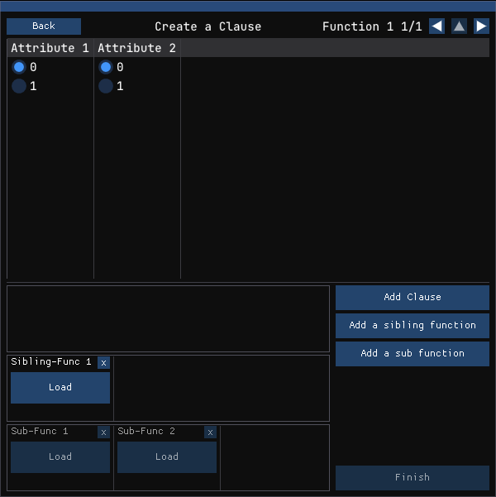



1. A button to go back to the previous screen.
2. If we have multiple loaded functions, pressing the left and right arrow will swap the focus between them here. If we are loaded into a sub-function, we will also gain the use of the up arrow to go into the parent function.
3. Each attribute defined in the previous window using Amount of Attributes will appear in this table, with radio buttons equal to the amount specified in the slider relating to the attribute. The selected values is for the next clause to be added. If a clause was loaded, then that clauses values will be displayed instead.
4. A box that contains all the Clauses that this function contains. Pressing Load will change the focus of the Table above, while pressing X will delete the clause.  
   A black rectangular object with a black border

   Description automatically generated
5. A box that contains all the Sibling functions this function has, which is pre-calculated using the value of “Amount of Target Attributes” minus 1.  
   A black rectangular object with a black border

   Description automatically generated
6. A box that contains all the sub functions this function has, which is pre-calculated using the value of “Amount of Attributes”. The sub functions come undefined until the user defines them.  
   A screen shot of a computer

   Description automatically generated
7. The button to add a clause to the function. This button changes to “Update Clause” when a clause has been loaded into memory, for clarity.
8. Adds a sibling function to the function. This button is not entirely necessary when the sibling functions are already pre-calculated.
9. Attaches a sub function definition to this function at a specified attribute. Select the attribute to add the definition for, then press Select. The program will load into that subfunction automatically.  
   A screenshot of a computer program

   Description automatically generated
10. Finish up the Function screen and create a model of the function. This button is greyed out if there is no defined clauses.

## Interview Screen:

In this screen, the user will be asked questions about the function instead of manually applying values. The user must answer all questions before continuing forwards.

Then, the user will be asked for values of individual datapoints. Once all the answers have been collected a model will generate.

## Color Editor:

In this screen, the user can set the individual colors of each class for a model. They can also instead click the “use gradient instead?” button to create a gradient from one color to another.

Compare Screen:  
In this screen, the user can select two loaded functions. If they can be compared, it will compare the clauses of each function and create a model that highlights the differences.