# Overview

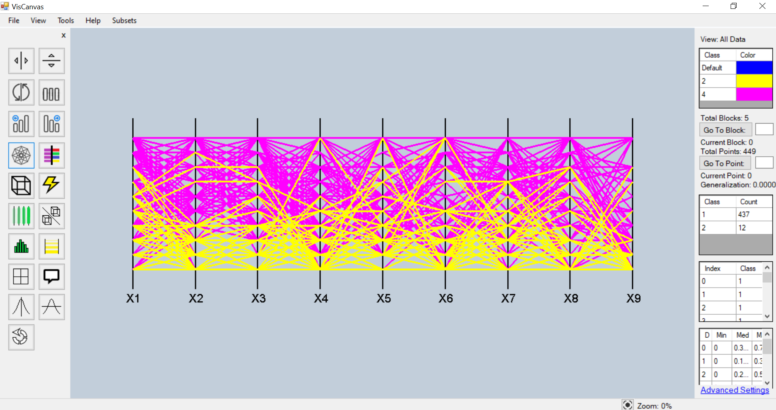

The VisCanvas UI has 5 main areas. The first of which is the menu bar at the top of the screen. The next two are the toolbars on the left and right side of the screens. There is also a small bar at the bottom of the screen that allows for zoom functionality. The main area is the data visualization itself in the center of the screen. The following sections describe these areas in more detail.

# Menu Bar

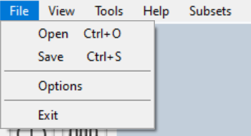

The first drop-down menu in the menu bar is the file menu. This has four options open, save, options, and exit. The open option opens a file explorer window where the user can select a .csv file to load into the software for visualization. The save option also opens a file explorer window where the user can select a destination and name the save file. The save file stores all of the data alongside any hypercubes or hyper-blocks that were made by the user.

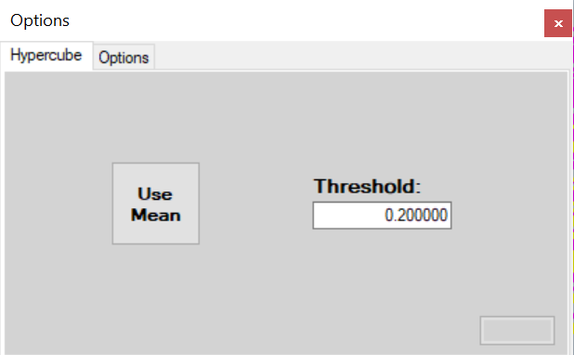

The options option opens an options window where the user can change various settings. There is a tab for hypercube settings where the user can define the threshold value for defining hypercubes and whether or not they want to use the mean of hypercubes. There is also a button for applying these settings.

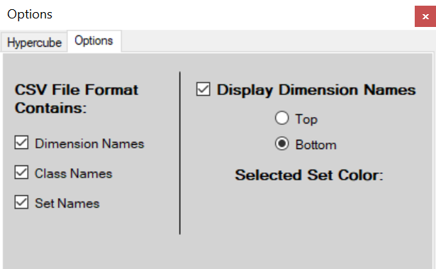

There is also an options tab where the user can define the format of the csv file that they will be loading into the software for visualization. Next to that is an option of whether to display the dimension names and where to display them. There is also space for a color picker to be implemented so that the user can choose what color they want their selector line to be and for a button to apply these changes. The selector line is a line the user can navigate through the data with. If they press the arrow keys they have the capability to select different lines to use with features like hypercube creation.

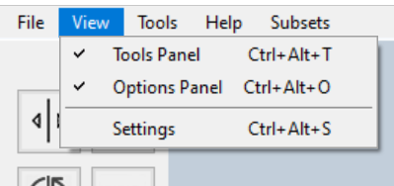

The second drop-down menu is under the view tab. This drop-down has three options. The first of which set whether to display the left and right-side toolbar panels. A checkmark will be displayed if they are currently displayed. The third option is settings which opens a settings window.

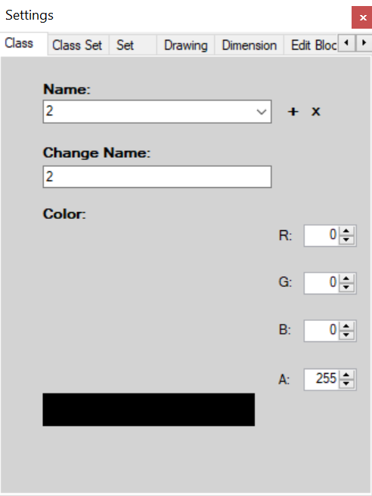

The first tab in the settings window allows the user to modify classes. Classes can be selected via their name in the corresponding dropdown menu. They can then be deleted with the x or have their name changed with the change name field. There are also RGBA selectors to allow the user to define custom colors for different classes. There is also room for an apply button that would set these settings.

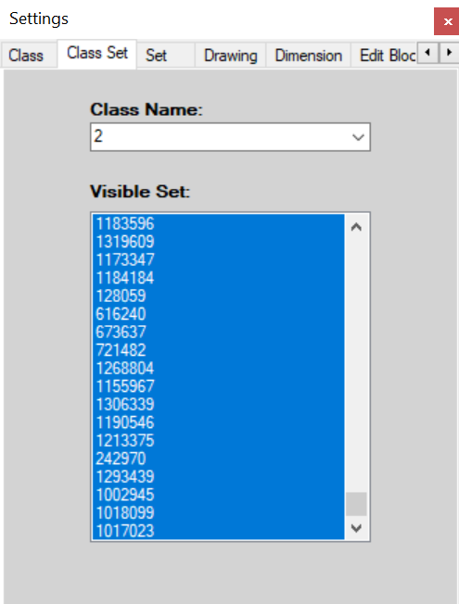

The next tab is the class set tab. This allows the user to select a class by name using the class name drop down. After a class is selected the user can click and drag to select a subset of n-D points to be displayed, rather than displaying all n-D points in that class. This is defined as the visible set of n-D points. There is also room for an apply button that would set these settings.

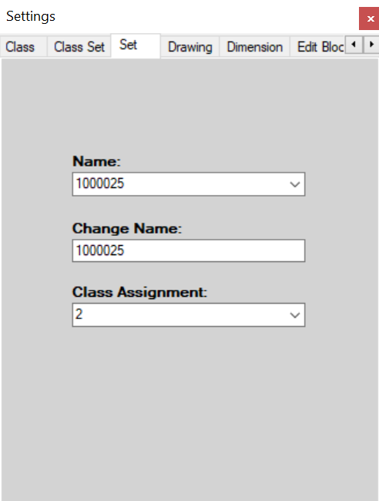

The third tab is the set tab. This tab should be labeled n-D point as it allows the user to select an n-D point by name from the name drop-down. They can change the points name using the change name field or change what class the point belongs to by using the class assignment drop down. There is also room for an apply button that would set these settings.

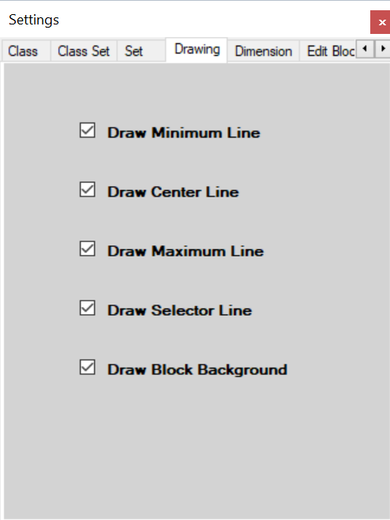

The fourth tab is the drawing tab. This tab controls what is drawn when viewing hyper blocks. Clicking a checkbox will set the relevant item to be displayed or to be hidden. The minimum, center, and maximum lines are the borders and median of the currently selected hyper-block. The selector line is the user-controlled line that is used to navigate the data. The background option controls whether the data is drawn on a white background or not.

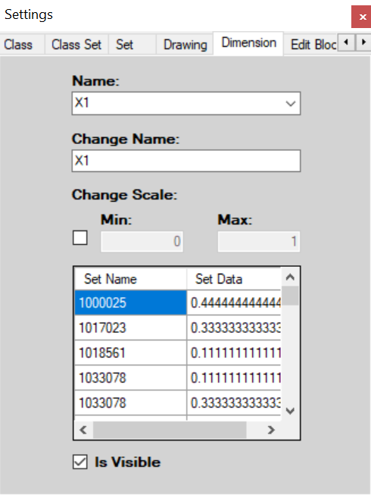

The next tab is the dimension tab. This tab allows the user to change dimensions by selecting them from the name drop down. The dimensions label can be changed from the change name field. There are also options to see all values for each n-D point in this dimension and to alter how it is scaled. Below that is a check box that allows the user to reduce dimensions by removing them from view. There is also room for an apply button that would set these settings.

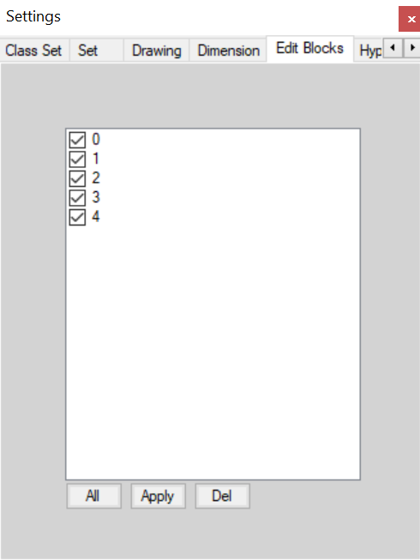

Next to this tab is the edit blocks tab. This tab allows control over hyper-blocks and hypercubes. Any hypercube or hyper-block that is created will be available to view here. Clicking in the white space will load the list of blocks and checking them controls whether they are viewed or not. The all button selects/de-selects all blocks. The apply button makes sets the current check marks. The del button will delete all selected blocks.

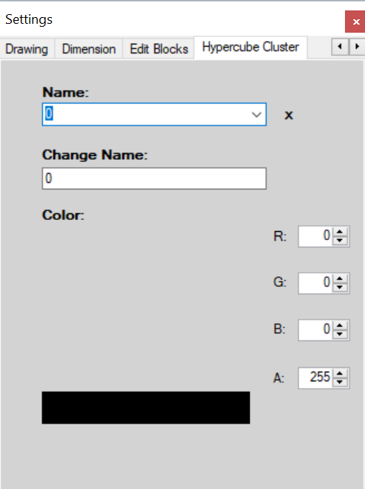

The final tab is the hypercube cluster tab. This tab allows the user to select a hypercube from the name drop down. They can then delete a chosen hypercube by clicking the x. They can also change the name or color of the hypercube using the corresponding fields. There is also room for an apply button that would set these settings.

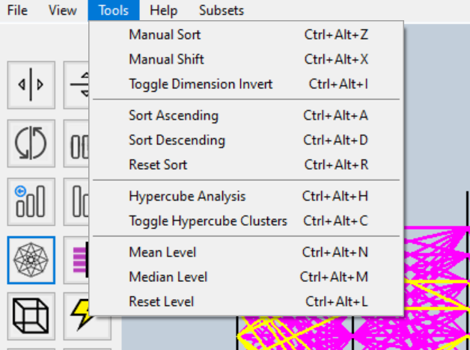

The tools drop-down menu in the bar allows users another route to using the functionality of the program without using the buttons or the hotkeys.

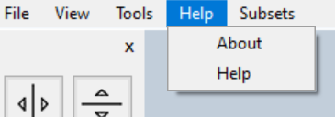

The help drop-down menu has two options where the user can find information about the software. The about option displays the names of the authors and the help function has a link to the pdf manual.

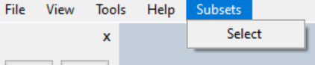

The final option in the menu bar is the subsets option. This option allows the user to gain more insight into the data and to select subsets of it.

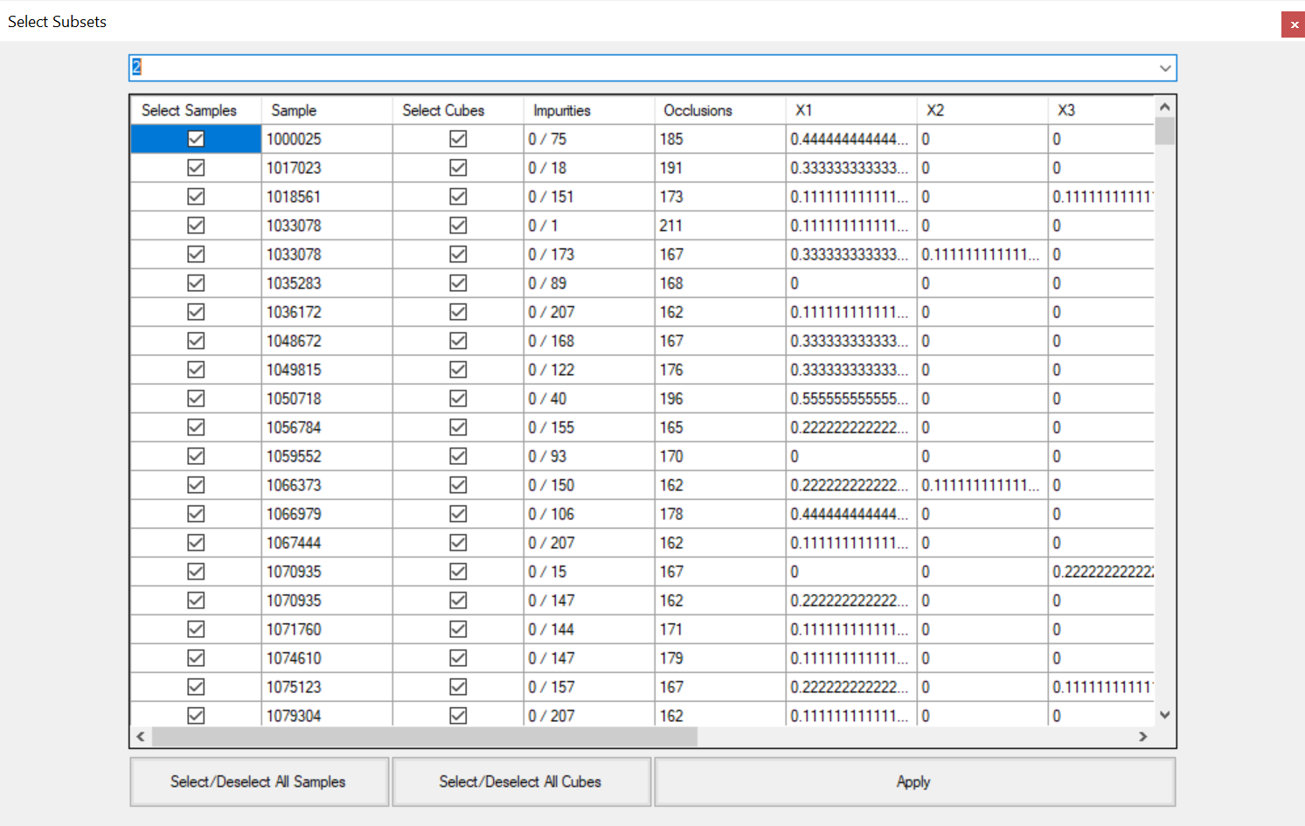

The user can select a class from the dropdown at the top of the window. The select samples column allows users to define a subset of n-D points in the selected class by displaying only those that are checked. The sample column displays the name of the n-D point. The select cubes column allows users to see context around any given point by switching to a context view that displays these cubes. Only those that are checked will be displayed, and this allows users to gain insight into the region around a n-D point of interest. The impurities column displays how many n-D points of opposite classes exist in these context cubes. The occlusion column displays how many other n-D points a given sample visually overlaps. The following columns contain the values of each dimension for each n-D point. The buttons allow for selecting/de-selecting all samples/cubes and to set current selections.

# Function Bar

The function bar on the left side of the software contains buttons that control the main functionality of the software. Each buttons description is listed after its image.



This button toggles a mode that allows the user to move dimensional lines left or right, swapping them.

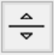

This button toggles a mode that allows the user to move dimensional lines up or down.



This button inverts the values of a dimension.



This button resets all dimensional lines to their default position.

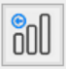

This button sorts dimensional lines in ascending order.

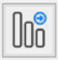

This button sorts dimensional lines descending order.

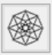

This button toggles the viewing mode to be hypercubes or all of the data.

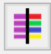

This button toggles which coloring scheme to use when drawing data.

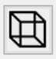

This button creates a hypercube around the currently selected n-D point using the threshold set in the options window.

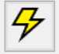

This button automatically creates hyper-blocks.

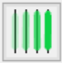

This button compares all hyper-blocks pair wise and highlights areas that separate them in each dimension.

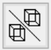

This button reduces the dimensions of two selected hyper-blocks to those where they do not overlap.

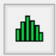

This button toggles a visualization mode that shows histograms based on frequency.

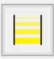

This button toggles a visualization mode that scales line width and alpha based on frequency.

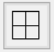

This button creates a new window that displays each hyper-block side by side.



This button creates a window with a linguistic description of the currently viewed data.

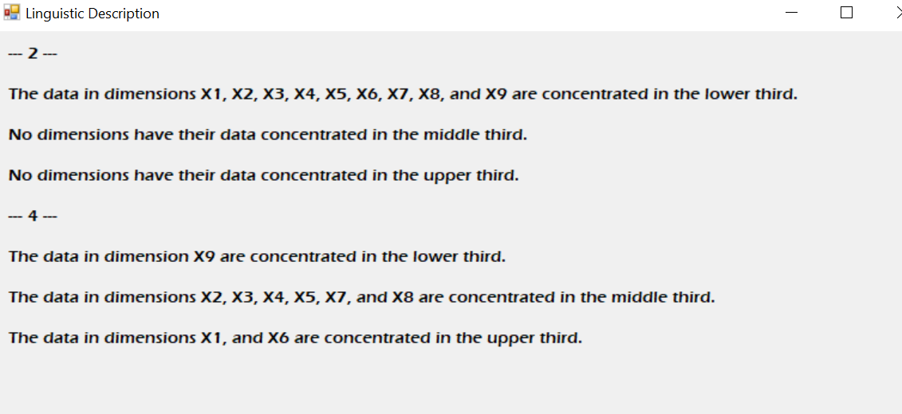

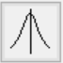

This button shifts the dimensional lines according to the mean of the currently selected line.

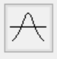

This button shifts the dimensional lines according to the average of the currently selected line.

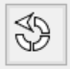

This button resets all shifted lines.

# Data Bar

The data bar on the right side of the software contains tabular data describing the current visualization.



This component shows whether all data or hyper-blocks are being viewed.

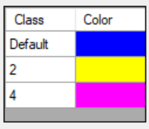

This table shows the color of each class in the data set.

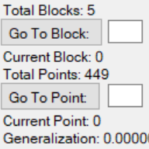

This component shows which point is currently being selected, and how many points there are. It also shows how many hyper-blocks there are, and which one is selected.

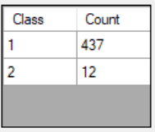

This table shows the distribution of classes within the currently selected hyper-block.

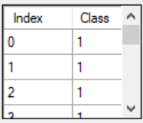

This table shows the index and class of each point within the currently selected hyper-block.

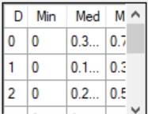

This table shows the minimum, median, and maximum of each dimension for the currently selected hyper-block.



This link opens the settings window.

# Zoom Bar

The zoom bar at the bottom of the screen shows the current zoom level and has a button that resets the zoom level.



# Visualization

There are many different visualization modes within VisCanvas that are viewed in different ways. A description for each follows the image of it.

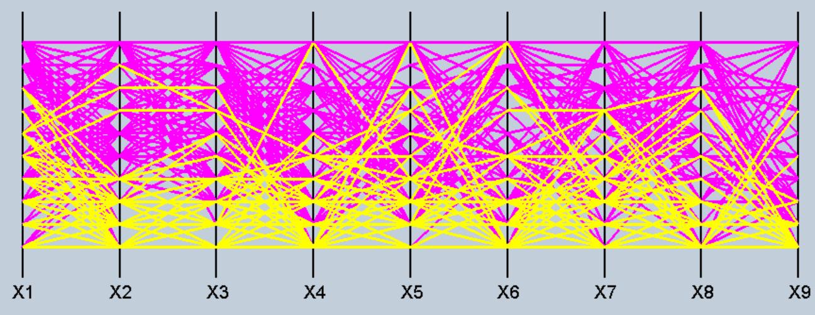

This is the default visualization which shows all n-D points.

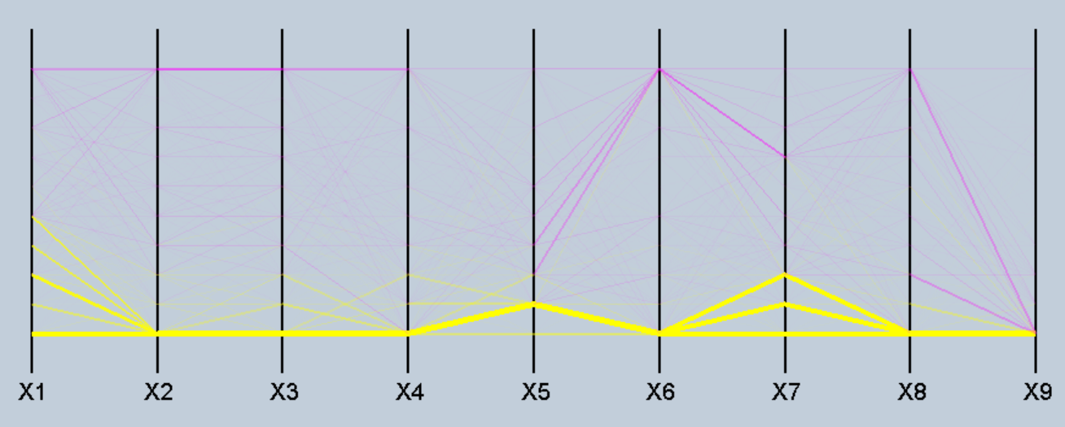

This is a visualization of all data using line width and alpha scaling to illustrate frequency.

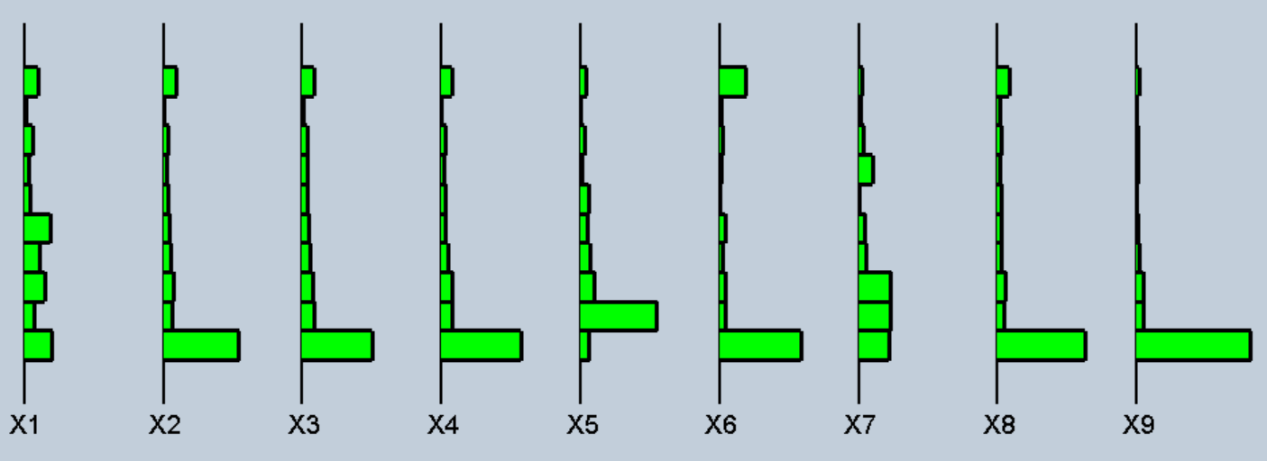

This is a visualization using histograms to view frequency.

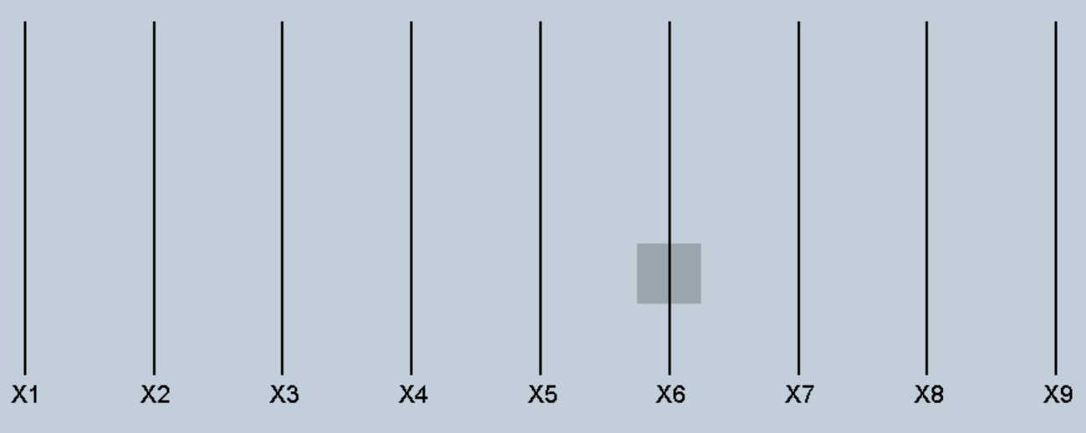

This is a visualization that highlights areas where pairs of hyper-blocks do not overlap.

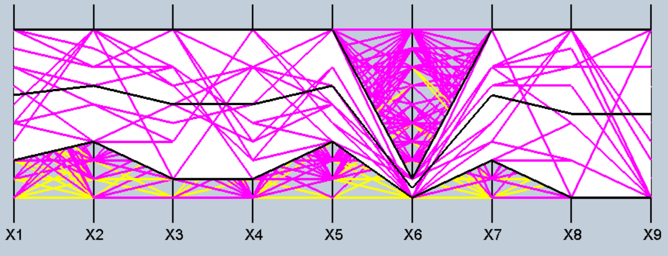

This is a visualization of hyper-blocks using minimum, median, and maximum lines with a background.

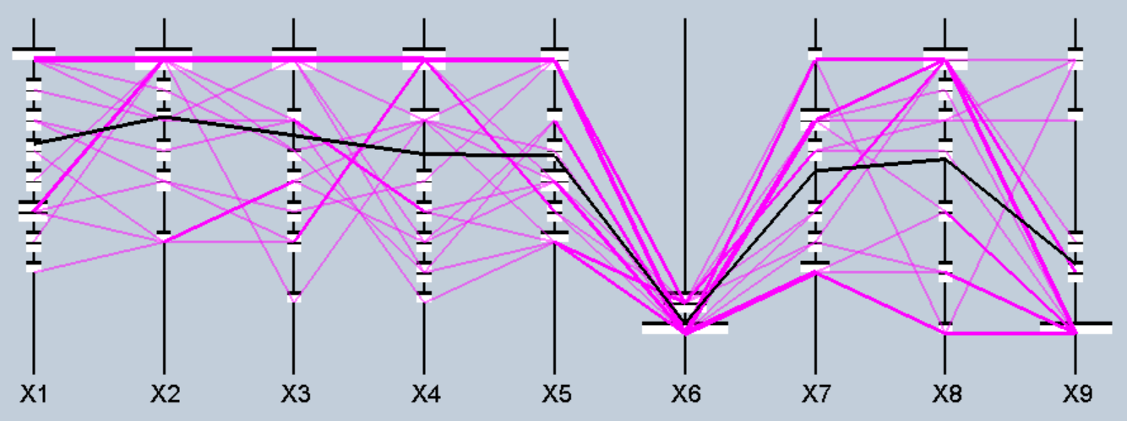

This is a visualization that uses histograms, line width, and line alpha to illustrate frequency of hyper-blocks.

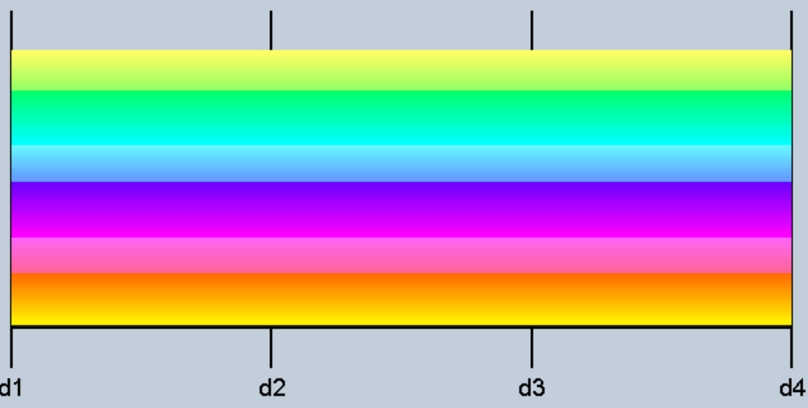

There is a feature that auto colors classes when loaded into the software. The above visualization illustrates this with 100 lines all of a different class.