**Decision Analysis for and Forecasting for Agricultural Development**

**Master Course Outline**

**Taught in … semester (dates: …)**

*(about 60 hours in class [15*4 hour class] and 120 outside class [projects etc.])*

*This from the Uni-Bonn Institute of Computer Science as a model* [*https://cg.cs.uni-bonn.de/en/teaching/ss-2018/lecture-mrfs-for-vision-and-graphics/*](https://cg.cs.uni-bonn.de/en/teaching/ss-2018/lecture-mrfs-for-vision-and-graphics/)

*Andrew Heiss* [*https://datavizm20.classes.andrewheiss.com/*](https://datavizm20.classes.andrewheiss.com/)

**Elevator pitch**

Decisions in agriculture are often risky, meaning that decision makers have uncertainty about how their decision will influence the intended outcomes. Farming systems are dynamic and the impact of any intervention, policy or management decision is likely to be influenced by many factors ranging from soil and crop dynamics to social dynamics such as farmer and community perceptions. In order to provide scientific support for decision making it is important that our models and forecasts attempt to include these interactions. Decision Analysis provides a set of approaches that are aimed at capturing what is known and applying this knowledge to generate forecasts of decision outcomes. The theoretical body of approaches has been formally applied in business and economics for more than 50 years (Howard and Abbas 2015) and somewhat in agriculture since the 70s (Anderson et al. 1978). Our mission is to be a catalyst for making these holistic approaches common place in research, and to move agricultural science from the lab bench and field trials to real world application and decision support for farmers and agricultural decision makers such as those in government ministries and aid organizations.

Class participation **50%**

* Attendance
* Short weekly tests for seeing how up to speed people are
* Track GIT activity

Group work **50%**

* Paper
* Repository
* Code
* All do weekly reading/listening assignments and teams lead short related discussion

# Introduction (Readings and Lectures):

* What? Experiential course. You (students) will be leading discussions and projects.
* So What? Becoming a critical thinker and generating useful forecasts for decision makers in agricultural development.
* Now What? Build a working model of an agricultural development decision
* Introduce idea of group work etc. (choose group / begin to think about a decision).

# Group Project

* Decision Identified
* Collaborate with decision makers on decision model development (qualitative)
* Generate model code from qualitative model and parameterize (quantitative step)
* Git repo with code

# Collaboration (Git, Readings and Lectures):

* STEP 1 Start simple with own repository only and work on it alone.
* STEP 2 start to collaborate on something and learn the complicated parts of that.
* All project work takes place in GIT
* ~ 5,000 word paper (written in RMarkdown, examples of best practices, word counts, spell check, grammar check in github.com/hortibonn/Plotting-High-Dimensional-Data)

**Seminar 1:** Scientific process / publications / careers

**Seminar 2:** Citation management software / Literature sources

**Seminar 3:** Writing style etc.

**Seminar 4:** How to use RStudio, R

**Seminar 5:** How to use GitHub, git, Rmarkdown

# Decision Analysis

* Overview of DA (Hubbard, Anderson, Howard)
* Brief examples (Vietnam…, Uganda, Calluna…)
* Hubbard (selected chapters from ‘How to Measure Anything’)
* Howard (selected chapters from ‘Decision Analysis’ and recorded talks)

# Decision Models (Overview)

* Making a solid business case for the model before programming
* Step1. Start with a skateboard… then move on to other steps

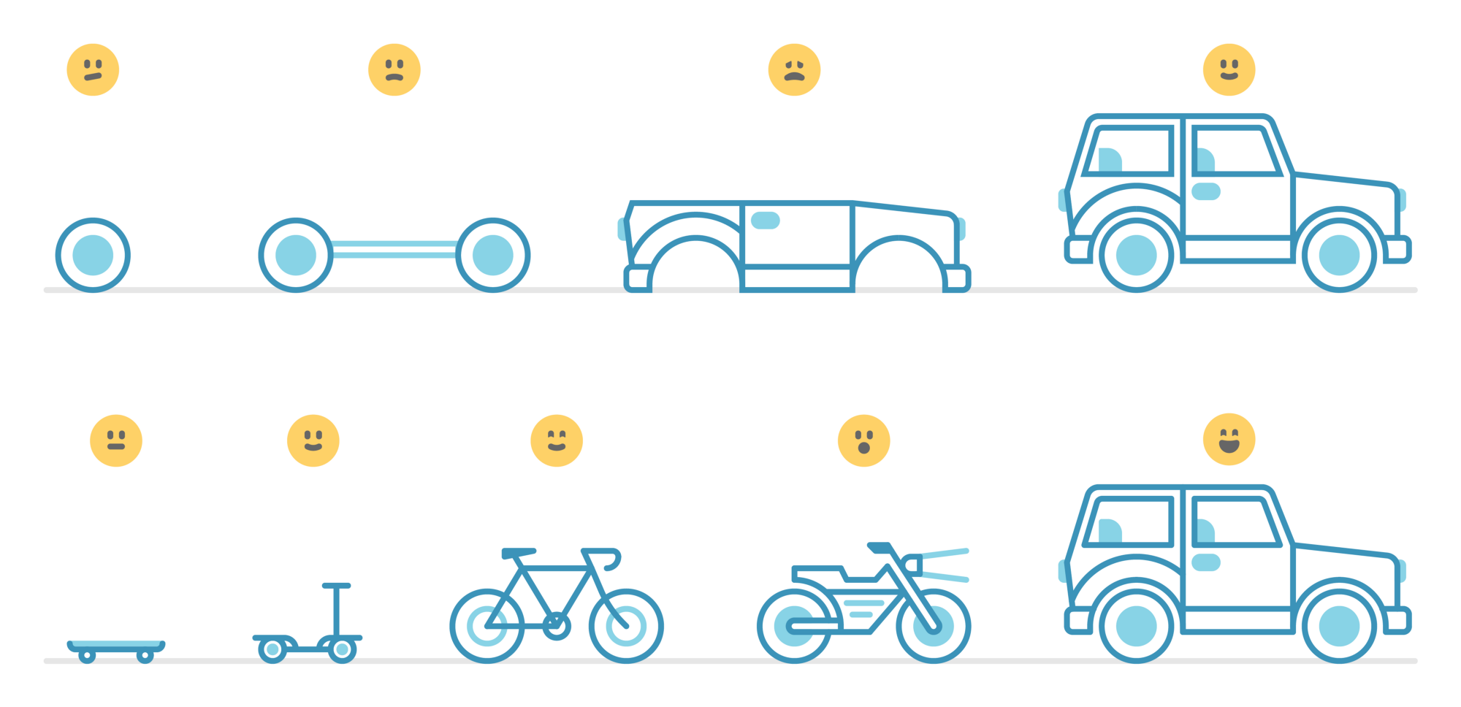

**Seminar:** Causal model / diagram / Impact pathway / Theory of change

# Biases (Readings and Lectures):

* Kahneman (selected work from ‘Thinking Fast and Slow’)
* Rosling (TED Talks / selected work from ‘Factfulness’)
* Ken Robinson (TED Talks / selected work from ‘Out of Our Minds’)

**Seminar:** Calibration Training (lead by team)

# Bayesian thinking

* All follow ‘Learning Bayesian Statistics’ podcast
* Selected reading from ‘The theory that would not die’
* R. McElreath (selected reading from ‘Statistical Rethinking’)
* Betancourt’s work (selected blogs, talks, git repos, Stan, HCMC)

**Assignments:**

1. Greenland, Sander, Judea Pearl, and James M. Robins. “Causal Diagrams for Epidemiologic Research.” *Epidemiology* 10, no. 1 (1999): 37–48*.*
2. *“Yesterday, I gave an easy intro to causal diagrams for some MA students […] bc it contains not a single equation to scare a student with.” – Richard McElreath*
3. NOVA: Prediction by the Numbers. 2018. With the science of forecasting flourishing, this documentary explores how predictions inform our lives and statistics and algorithms' reliability. **52m video** <https://www.dailymotion.com/video/x6fi9b3>

# Model Programming (Coding and programming in R)

* R packages decisionSupport (walk through a vignette or two)
* RSTAN, Other modeling programs - Betancourt’s work (selected blogs, talks, git repos, Stan, HCMC)
* Yihui (markdown etc.)
* **Assignments:**
* 1. “episode 3, with Colin Carroll. He mentions Tom Rainforth's thesis.” – Alex Andorra (about his interview with Colin Carol on the podcast Learning Bayesian Statistics)
* Rainforth, Tom. “Automating Inference, Learning, and Design Using Probabilistic Programming.” Doctor of Philosophy, University of Oxford, 2017.

**References**

Anderson, Jock, John Dillon, and Brian Hardaker. 1978. *Agricultural Decision Analysis*. Ames, Iowa: Iowa State University Press.

Howard, Ronald A., and Ali E. Abbas. 2015. *Foundations of Decision Analysis*. NY, NY: Prentice Hall.