Supporting agricultural development decisions for improved food security - Methods in supporting decisions under uncertainty

Cory Whitney $​^{1}$

Prajna Kasargodu Anebagilu $​^{1}$

Eike Luedeling $​^{1}$

$​^{1}$ University of Bonn, Germany

# Abstract

It is often challenging to make accurate projections about how interventions will affect the real world and to use projections to develop effective implementation plans, monitor progress and evaluate project impacts. This is due to various factors, including lack of data, complex impact pathways, and risks and uncertainties that are difficult to factor into intervention planning. Scientific approaches to produce reliable impact projections are rarely applied in agricultural development, but Decision Analysis techniques commonly used in other fields can potentially improve development decisions. This manual outlines a Decision Analysis approach that can help decision-makers efficiently allocate resources for the most effective agricultural policies that impact food security.

The procedures outlined in this manual feature the construction of causal models – models that describe the mechanisms through which intervention impacts will be delivered –co-developed by experts, stakeholders and analysts through facilitated participatory processes. This manual illustrates the use of participatory workshops that convene experts on the systems, stakeholders involved in ongoing or prospective projects, and analysts. These teams can jointly develop impact pathways for the interventions, which can be formalized into quantitative models. After several rounds of feedback elicitation and including data from experts and other sources, stochastic simulations can be run to determine the likely impacts of the interventions. Results can be presented back to stakeholders for feedback.

Critical uncertainties in the models of intervention impact pathways can be identified through the tools laid out in this manual. These high-value variables can determine uncertainty about project outcomes. Further measurement or disaggregation of these variables could greatly support decision-making processes.

By demonstrating improved intervention decisions with little additional investment and improved tools for intervention decision modeling, we hope this approach will be widely adopted and used to enhance the efficacy of development activities.

# Introduction

The development community faces increasing demand to credibly link research and development activities with progress toward the envisioned outcomes (Shepherd, Luedeling, & Whitney, in preparation). Improved planning tools for interventions targeting complex systems are urgently needed, especially in developing countries where data are scarce and uncertainty about decision outcomes is significant. However, stakeholders are often left guessing about development outcomes, especially when quantitative impact predictions are requested because they lack reliable tools to forecast impacts. Methodologies that address these uncertainties could transform the way development is done and greatly enhance the efficacy of its activities. Such methods could stimulate thorough scrutiny of research priorities and direct resources to where they lead to the greatest impacts (Luedeling & Shepherd, 2016). For this positive effect to materialize, however, the development community needs better approaches for planning for impact. One of the central difficulties in planning for impact is dealing with uncertainty. It is rarely possible to accurately predict the impacts of agriculture on nutrition and other interventions. Many important factors that determine these impacts, such as adoption rates, yield increases, the performance of a particular tree or crop in a new environment and future weather, are highly uncertain. Additionally, many development interventions are implemented in risky environments, where extreme weather events, conflict, poor anticipation of cultural preferences, political interference or other risk factors can dramatically disrupt progress at any time (Luedeling et al., 2015).

Making impact projections in this environment, especially where precise numbers are expected, is very difficult, and researchers and development workers often find themselves in an ethical quagmire, torn between the perceived need to honestly evaluate risks and the temptation to let wishful thinking guide their estimates. The latter may lead to overly optimistic assumptions and high-impact projections that may raise the chance of political and donor support but are essentially unrealistic. This conflict of interest is not only a problem for project proponents – it also compromises the ability of stakeholders to compare impact ‘promises’ across proposals or reported impacts by different projects.

For research that is actually worth doing, results cannot be forecast with certainty (otherwise, the research would not be necessary). However, what is currently lacking is a set of reliable methods to produce robust impact projections that consider the host of uncertainties and risks that research and development activities face. Such methods should be based on quantitative representations of impact pathways that capture the causal mechanisms of impact delivery. This manual aims to provide documentation for disseminating an approach based on probabilistic modeling for impact pathways. It seeks to establish decision analysis as a widely used tool for agricultural development decisions for nutrition and food security.

## Predicting impacts of Agriculture for Nutrition activities

Many agricultural research and development activities aim to improve nutrition, but they are often unable to articulate clearly how nutrition objectives will be achieved and to what degree. Agricultural systems in developing countries are complex, and few agricultural interventions can be expected to impact such systems linearly. Thus, there is a need for new approaches to analyzing the impacts of agricultural interventions on food and nutrition systems.

The success of an intervention will always depend on several factors that interact in ways that would be difficult or impossible to predict with precision. Some examples of these difficult-to-measure factors are the so-called ‘intangible’ factors, such as people’s perceptions of healthy food and food preferences. The nutritional status of a country’s population is determined by many such factors, including, of course, the nutritional value of the food people eat, but also a complex interplay between the food environment, household economics, health, education, and agricultural value chains (Waage, Hawkes, & Turner, 2012). Thus, many pathways may have the potential to improve national nutrition, e.g., through higher nutrient contents in crops (DellaPenna, 1999; Nestel, Bouis, Meenakshi, & Pfeiffer, 2006), greater nutritional diversity (Hoddinott & Yohannes, 2002) or improved awareness about childhood nutrition (Ruel, Alderman, & Maternal, 2013). For any given context, however, it is not easy to decide *a priori* which pathway will be most effective. Some pathways may not produce positive outcomes at all if, for instance, the value chain degrades the nutritional value of the food or if certain foods never reach vulnerable groups (e.g., children or lactating women).

Credible impact pathways regarding agriculture for nutrition should reflect their complexity. However, there is currently a severe shortage of practical methods that allow credible analysis of these complex systems. Most conventional scientific approaches are unable to deal with this complexity. Opportunities for controlled trials are very limited, especially at low cost, and simple statistical tools (regressions, correlations) do not provide much information about the way that drivers of agricultural systems are related to nutritional (and other) outcomes.

Use and analysis of impact pathways have helped to show how interventions function, where they are lacking and what can be done to improve them. For example, Leroy, Ruel, & Verhofstadt (2009) used impact pathway models to review the effect of cash transfer programs on child nutrition outcomes. Olney, Talukder, Iannotti, Ruel, & Quinn (2009) used impact pathway models to evaluate the maternal and child health and nutrition effects of a homestead food production program in Cambodia and found that household-level benefits from the program did not translate into significant improvements in maternal and child health and nutrition. Both studies found a major gap in implementer and stakeholder knowledge about how the programs improve nutrition and identified this as a major obstacle to the interventions.

This manual provides a step-by-step guide to help synthesize expert knowledge and other sources of information into models that provide credible probabilistic projections of the impact of decisions. The methods described can be applied to multiple nutrition outcomes. The resulting models and the participatory process from which they emerge can be used to define useful metrics for monitoring progress toward nutrition outcomes. To achieve this, this manual demonstrates various approaches, which seek to express the current uncertainty on everything that matters to a decision and can help focus the measurement effort on areas that can narrow uncertainty to reduce ambiguity in the decision. Analysts can then update their models based on the new information. Whether a factor is seemingly easy or difficult to measure or has existing data available has no bearing on its inclusion. Omitting an important factor is essentially prescribing it as valueless. This is then complemented with innovative group work techniques for eliciting expert knowledge to construct a logical framework to describe system interactions and outcomes (i.e., an impact pathway). Expert knowledge is thereby used to generate model structures (Bolger & Rowe, 2015; Kuhnert, Martin, & Griffiths, 2010; Papakosta, Xanthopoulos, & Straub, 2017), and these are then integrated into model calculations (cf. Yet et al., 2016).

## Decision Analysis

Decision Analysis provides a framework for development research. Its objective is to facilitate better decisions by gaining insights into what actions could most increase multiple benefits given stakeholder preferences while minimizing costs and risks. Abbas & Howard (2015) illustrate how the foundations of Decision Analysis provide the norms for decision-making. The basic Decision Analysis approach seeks to increase benefits and decrease risks continuously through the intervention planning and implementation process. The insights gained through the Decision Analysis approach include a better understanding of the magnitude of the trade-offs among different development objectives relative to the preferences of different stakeholder groups. The ultimate aim is to lead to clarity of action for decision-makers

The basic steps in the Decision Analysis process (Figure 1) address why and how decisions are formulated, and factors are measured. Hubbard_2014 outlines some of these approaches as part of his Applied Information Economics (AIE), which he calls the ‘Universal Modeling Approach’ since AIE has the fundamental premise that if something has an effect, it must be observable. If it is observable, it must be measurable. Decision Analysis and AIE are a collection of decision theory and risk analysis tools that use:

* calibrated probability assessment (discussed in more detail in the section Calibration training)
* value of additional information calculations applied to uncertain variables in a decision model, the results of which will reveal where to focus efforts to reduce uncertainty (e.g., by model refinement or by making further measurements)
* empirical methods applied according to the information value of the measurement

Figure 1 shows a technical diagram of the Decision Analysis process adapted from Shepherd et al. (20XX). The process outlined is followed in cooperation with key stakeholders and experts to improve the design of policy and interventions and monitor their impacts. The loop in the top half of the diagram describes the process that evaluates different alternatives to the decision goals. In contrast, the lower loop uses the value of information analysis to determine what should be measured to clarify the decision. There are iterative feedback loops throughout the process.

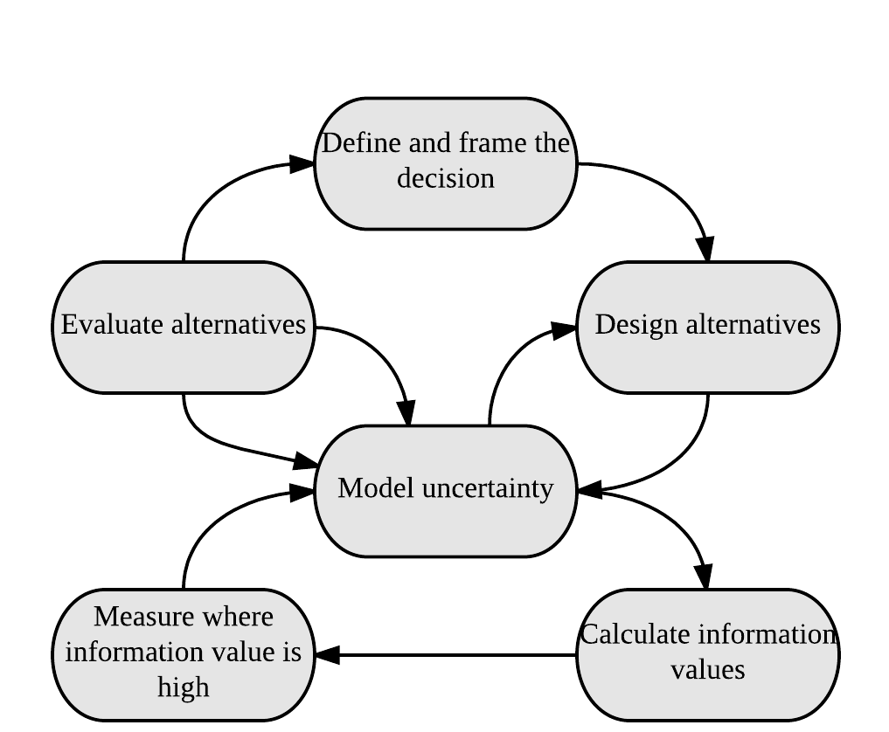

Figure 1 Summary of the decision modeling process; the sequence of activities in the decision modeling approach (adapted from Shepherd et al. 20XX).

The merits of applying the Decision Analysis tools for development decisions have been further described in detail. Luedeling & Shepherd (2016) point out that Decision Analysis solves the problem of data gaps, which has often prevented research from comprehensively and holistically forecasting decision impacts. It also allows explicit consideration of risks and variability.

Decision Analysis tools allow for decision-making that draws on all appropriate sources of evidence rather than rule out intangible and hard-to-measure aspects of a decision. Luedeling & Shepherd (2016) point out that, in Decision Analysis, a model should include all the factors and all the critical decision impacts that experts consider relevant, regardless of data availability. Shepherd et al. (2015) point out that Decision Analysis tools are particularly useful in development contexts, where data are often sparse. One very useful aspect of the approach is that expert knowledge can be used to fill in the knowledge gaps and avoid missing important factors when deciding about development interventions.

# Process for systematic support for development decisions

## Step 1: Decision framing

Decision framing is the first part of the decision analysis process; it determines the boundaries of a decision and is the most important aspect of making a good decision. Decision framing starts by identifying a decision to be modeled and the relevant experts. This is not as simple as it sounds and should be undertaken carefully and with much forethought. Consideration of the criteria that define a decision can help to add structure to this important step in the process:

As Shepherd et al. (20XX) point out, in order to achieve clarity in decision making, each of the above elements and the preferences of the decision-maker, need to be carefully defined. Once the decision has been identified, the decision analysts then identify and convene relevant decision-makers, stakeholders, and any additional experts. We find that around 20 experts make for a manageable workshop, but more can be cumbersome, especially when dealing with model building in plenary.

It is essential to have several different types of knowledge holders involved in developing the impact model. Therefore, expert selection should seek to gather experts with knowledge on as many aspects of the decision as possible. As Fenton & Neil (2012) points out, expert knowledge is often vital in identifying critical, underlying causal factors that affect risks and opportunities that would otherwise have been missed based on available data or statistical models. The experts selected for modeling sustainable agriculture for food security and nutrition decisions should represent a mix of knowledge holders such as academic institutions (e.g., nutritionists and agronomists), government institutions, local villages and development organizations (see Luedeling, 2017).

## Step 2: Generating a graphical model

The next step in the Decision Analysis process is jointly developing a decision model. In the workshop setting, the analyst needs to gather all the variables that the expert group agrees are logically important to describe the impact pathway of the decision and include them in the model. This should be done regardless of the ease of measurement of the individual variables.

Before engaging in this process, the overall context for the model (the identified decision) should be defined explicitly and agreed upon in plenary discussions with the identified experts. Once this has been done, building the graphical model can begin. In our approach, we start from the decision-framing step to the model development by asking experts to work together and peer review each other's work.

Bolger & Rowe (2015) and Bolger & Wright (2017) point out the various challenges in handling expert knowledge, including poor judgment regarding probability and high levels of variation among experts. These problems occur because experts are not trained to formulate reliable representations of uncertainty, many lack experience with probability, and few learn to express their uncertainty as probability distributions. Here, we outline several essential steps that should be taken to aid in collaboratively building model structures and making variable estimates. These will help to ensure accuracy in the process.

### Collaborative approaches

Tools are available to help overcome these problems. According to Bolger & Rowe (2015), it is possible to create better conditions for gathering expert knowledge. These include offering experts experiences in making estimates for well-defined targets, offering tools on which to base their estimates, and offering regular and usable feedback about the accuracy of their estimates. Bolger & Wright (2017) state that experts can be a source of quality data about the future. Ensuring the quality of this data starts by selecting the best experts, training experts in the normative aspects of anticipation and combining judgments from several experts.

Here, we illustrate some useful approaches for combining experts' probability distributions, using the accumulated information from multiple experts. In this approach, a workshop is held, and graphical models are developed by individual experts and then peer reviewed by other experts. These approaches allow analysts to obtain as much information as possible and gather data representing expert opinion summary. Clemen & Winkler (1999) and Bolger & Wright (2017) show more examples of these tools in practice.

Figure 2 has been adapted from Whitney et al. (2018); it illustrates a process that can be used for eliciting graphical representations of decisions from expert groups. In our approach, the process begins with breaking the decision down into several important questions in plenary discussions. Random interchanging working groups of experts are then led through three stages of collaborative thinking for each question that is brought up; these are:

The steps defined above are designed to help experts interact, brainstorm and reach common understanding about impact pathways. Through this approach, experts can explore details of the expected impacts, disaggregate the impact pathway into the intermediate steps and identify all the influencing factors that they consider essential to the decision (i.e., draw a model of nodes and edges; cf. ).

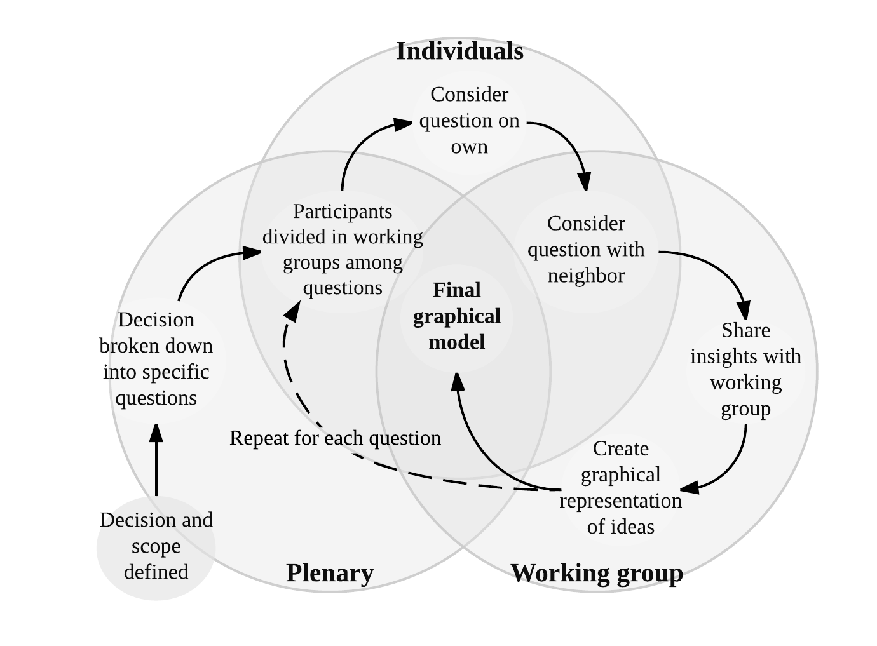

Figure 2. Process used for eliciting graphical representations of decisions from expert groups to be used in developing a Bayesian Network model (Source: Whitney et al., 2018)

The iterative steps shown ensure all experts have worked on each question and are satisfied that all specific relationships have been identified. This iterative process of building a model in the workshop is illustrated conceptually in Figure 2. Participants should be encouraged to discuss any factors they deem essential for the decision, particularly the various costs, benefits, and risks associated with interventions, as well as the objectives and concerns of decision-makers and stakeholders. The model should broadly aim to describe the effects of agricultural decisions on specific nutrition outputs such as hunger (a.k.a. global energy and macronutrient deficiency).

Following this approach, the analysts must have an overview of the process to build a final working model in mind. Analysts should work to guide the experts so that they think about how model parameters interact logically. For example, the work of Whitney et al. (2018) illustrates the use of the expert knowledge elicitation (EKE) approach to build an impact model that aims to deliver the probabilities for different states of malnutrition under a policy decision and to relate this directly to a monetary value for calculating variables of importance.

The resulting models can then be brought before the whole group of experts for plenary discussion and re-drawn, aiming for a common understanding of the relationships in each model. The end result should be one model per question with the contributions of all experts. These can then be combined into one large impact pathway model. Corrections and further feedback can be gathered for model verification as a final stage of model development.

## Step 3: Calibration training

The next modeling step follows procedures, outlined by Hubbard (2014), known as ‘calibration training’. Experts are trained, using well-established ‘calibration’ procedures to estimate their state of uncertainty and thereby increase their capacity to provide accurate estimates by reducing errors of judgment. Through the process, experts learn to improve their ability to estimate their own state of uncertainty and thereby reduce errors of judgment, e.g., under-confidence or overconfidence (i.e., give correct estimates 90% of the time when they have 90% confidence, Hubbard, 2014). As both Hubbard (2014) and O’Hagan et al. (2006) show, the experts learn to minimize potential biases in probability estimation through this training.

Calibration training consists of several exercises aiming to reveal to the participants their personal biases (overconfidence or underconfidence) by assessing their performance on a set of trivia questions. Through these exercises, experts are trained to assess their subjective uncertainty and express it as a Confidence Interval (CI). This interval has a predefined chance (e.g., 90%) of containing the right value. Perfectly calibrated people should get around 90% of answers correct, and any deviation (outside a narrow band of stochastic variation) from this optimal figure indicates estimation bias. Experts are calibrated through repetition and feedback on the exercises. The training is divided into several stages:

The examples given by Hubbard (2014) and Luedeling et al. (2015) show that through the use of these procedures, experts learn to give estimates that are neither too vague (under-confidence) nor too specific (overconfidence). The procedures seek to help participants become accurate estimators. In this context, accuracy does not mean precision but refers to the ability to produce an accurate range of probable estimates of different possible states of the variables of interest. Therefore, the procedures outlined in this approach seek to provide experts with the skills necessary to represent uncertainty explicitly as probabilities of different possible states of the world. More examples of these calibration procedures and instructions on their application are provided in detail by Hubbard (2014).

## Step 4: Model quantification

For final model quantification, the analyst converts the conceptual model into a mathematical model, translating stakeholder inputs into equations as accurately as possible. Following Luedeling et al. (2015), all estimates can then be consolidated into one single distribution for each model parameter.

Once completed and verified with the literature and other sources, the model can be shared with experts again to verify its logical consistency and receive final feedback.

## Step 5: Value of Information Analysis

As mentioned earlier, the analyst needs to gather all the variables that the expert group agrees are logically important to describe the impact pathway of the decision and include them in the model. This should happen for several reasons, the most important of which is that the final development outcomes are generally strongly dependent on highly uncertain variables. These intangible and uncertain variables often include essential factors such as behavioral, institutional and policy factors. They are likely to be brought up by the experts as part of their discussions of impact pathways. Part of the value of the Decision Analysis approach is that it directs attention and performance monitoring to such factors, identified by their high information value.

When a model has been programmed in the appropriate software, and no preferable option emerges from the model results, Value of Information (VoI) analysis is a tool that can be used to reveal what further information is needed to narrow uncertainty and clarify a decision. It is expressed as the amount a rational decision-maker would be willing to pay for that knowledge before making a decision. VoI is a central concept of Decision Analysis; it is used to guide decisions on the level of complexity to be considered in a decision model and the need for further measurement to clarify decision alternatives. VoI can be estimated by analyzing the uncertainties in all the variables that affect a decision. According to Abbas & Howard (2015), VoI could also be called the value of clairvoyance.

VoI analysis can be used to determine whether additional information on certain input variables in the model could increase confidence about the emerging decision recommendation. The examples of Hubbard (2014) show that when the value of information analysis is used to prioritize measurements, it is often found that only a few variables may be relevant. Data collection should focus on those that narrow choices the most. Other examples, such as those of Constantinou, Yet, Fenton, Neil, & Marsh (2016) and Whitney et al. (2017), illustrate how the results of VoI analysis can be used for prioritizing knowledge gaps that should most urgently be narrowed in order to improve certainty about a decision. Constantinou et al. (2016) also show that VoI can help decision-makers learn if a decision outcome is dependent on or independent of any risk factors, thereby helping to focus any necessary follow-up research resources. More follow-up measurements and disaggregation of any identified variables can help inform the design and prioritization of future research and provide guidance about the best pathways for implementing the current decision.

## Step 6: Expected Value of Perfect Information

The Expected Value of Perfect Information (EVPI) is one useful VoI tool. It is the difference between the expected value of a decision made with perfect information and the expected value with current imperfect information (Hubbard, 2014). The many examples presented by Hubbard (2014) and those of Felli & Hazen (2003) show how EVPI can help decision-makers to consider both the probability of changes due to a decision and the resulting difference in the payoff. Constantinou et al. (2016) show how EVPI can be calculated for models to identify a selected subset of important model variables. To achieve this, utility nodes assign monetary value to model outputs (example shown in Table 1).

The Expected Monetary Value (EMV) is a key part of the EVPI calculation. It is the weighted average of the payoffs for a decision alternative, where weights are the probabilities of the different states of nature (). EVPI is the maximum amount one should be willing to pay for additional information about the decision.

$EVPI=EVwithPI–max\left(EMV\right)$

It is the expected value for the decision (payoff) if perfect information is available about the states of nature minus the expected value for the decision if perfect information is not available.



Variables that have large uncertainty and a significant potential impact on outcomes will have high information values. Information values also point decision-makers to places where they could adjust the intervention design to reduce risks and improve outcomes and also where to increase model complexity. With the new information, the model can be rerun, and the process is repeated until decision-makers feel confident they can make a well-informed decision.

Value of information analysis provides an efficient, iterative approach to information collection, as measurements are only made as far as needed and lowest cost options are tried first. As a first step, experts and analysts can work on decomposing model variables into sub-variables that are easier to estimate in an attempt to narrow uncertainty. If there is still residual information value, the analysts may try further literature review or consulting with more experts to narrow the uncertainty.

In this approach, analysts only need to design physical measurements or surveys if the other steps are insufficient. Even if more data needs to be gathered, small sample sizes may be sufficient to reduce uncertainty and reveal a clear decision. The value of information analysis also tells decision-makers how much they should consider spending on these measurements. From applying probabilistic decision modeling on over 80 diverse problems, Hubbard (2014) observed that only a few variables typically had high information value in any given decision, and interestingly, they were rarely variables receiving current measurement effort.

## Case studies

…

# Conclusions

In this manual, we have attempted to outline some tools for adapting and applying Bayesian Networks to agriculture for nutrition development contexts. Decision Analysis is an important paradigm for development research. The approach of conceptual impact pathway models promises to be an effective strategy for dealing with complex systems, multiple impact pathways, uncertain and incomplete information, and other constraints to meaningful quantitative impact projections.

The many factors that determine the nutritional impact of agricultural interventions are interconnected in various ways, and there are often clear causal connections between them. Most traditional research approaches, such as regression analysis, controlled trials etc., fare poorly in complex and multi-factorial situations, and results from modeling exercises that adopt deterministic perspectives on complex systems are often not credible because they rely on a host of simplifying assumptions. However, rational prioritization among ‘agriculture for nutrition’ actions requires an evaluation approach that can accommodate the complex relationships and thereby credibly translate agricultural activities into nutritional outcomes.

We see the potential for significant benefits to arise from an approach such as BNs within the Decision Analysis paradigm. These approaches can integrate existing data with expert opinion and other sources of information. This can considerably improve development research, especially for considering causal relationships in potential intervention impacts. We hope this manual will contribute to the broader application of these tools to agriculture for nutrition decisions.

More information and resources are available through the referenced materials in the decisionSupport package for R (Luedeling & Goehring, 2017) and the AgenaRisk software (Fenton & Neil, 2016), as well as on the Harvard DataVerse (Luedeling, 2017).

# References

Abbas, A. E., & Howard, R. A. (2015). ***Foundations of decision analysis***: 832. NY, NY: Prentice Hall.

Bolger, F., & Rowe, G. 2015. The aggregation of expert judgment: Do good things come to those who weight. ***Risk Analysis***, 35(1): 5–11.

Bolger, F., & Wright, G. 2017. Use of expert knowledge to anticipate the future: Issues, analysis and directions. ***International Journal of Forecasting***, 33(1): 230–243.

Clemen, R. T., & Winkler, R. L. 1999. Combining probability distributions from experts in risk analysis. ***Risk Analysis***, 19(2): 187–203.

Constantinou, A., Yet, B., Fenton, N., Neil, M., & Marsh, W. 2016. Value of information analysis for interventional and counterfactual bayesian networks in forensic medical sciences. ***Artificial Intelligence in Medicine***, 66: 41–52.

DellaPenna, D. 1999. Nutritional genomics: Manipulating plant micronutrients to improve human health. ***Science***, 285(5426): 375–379.

Felli, J. C., & Hazen, G. B. 2003. Sensitivity analysis and the expected value of perfect information. ***Medical Decision Making***, 23(1): 97.

Fenton, N., & Neil, M. 2012. ***Risk assessment and decision analysis with bayesian networks***: 503. Boca Raton, Florida: CRC Press.

Fenton, N., & Neil, M. 2016. AgenaRisk professional version 7.0. ***Revision 3451 VOI***.

Hoddinott, J., & Yohannes, Y. 2002. ***Dietary diversity as a food security indicator***, vol. Discussion Paper 136: 1–2. Washington, DC: International Food Policy Research Institute (IFPRI).

Hubbard, D. W. 2014. ***How to measure anything: Finding the value of intangibles in business***, vol. Second Edition: 301. Hoboken, New Jersey: John Wiley & Sons.

Iqbal, J., & MacLean, D. A. 2010. Prediction of balsam fir sawfly defoliation using a bayesian network model. ***Can. J. For. Res.***, 40(12): 2322–2332.

Kuhnert, P., Martin, T., & Griffiths, S. 2010. A guide to eliciting and using expert knowledge in bayesian ecological models. ***Ecology Letters***, 13(7): 900–914.

Leroy, J. L., Ruel, M., & Verhofstadt, E. 2009. The impact of conditional cash transfer programmes on child nutrition: A review of evidence using a programme theory framework. ***Journal of Development Effectiveness***, 1(2): 103–129.

Luedeling, E. 2017. Probabilistic causal models for nutrition outcomes of agricultural actions - uganda model. ***Harvard Dataverse, World Agroforestry Centre - ICRAF Dataverse, ICRAF Decision Analysis Dataverse***.

Luedeling, E., & Goehring, L. 2017. ***decisionSupport – quantitative support of decision making under uncertainty. Contributed package to the r programming language. Version 1.103.2***.

Luedeling, E., Oord, A. L., Kiteme, B., Ogalleh, S., Malesu, M., et al. 2015. Fresh groundwater for wajir - ex-ante assessment of uncertain benefits for multiple stakeholders in a water supply project in northern kenya. ***Frontiers in Environmental Science***, 3, article 16: 1–18.

Luedeling, E., & Shepherd, K. 2016. Decision-focused agricultural research. ***Solutions***, 7(5): 46–54.

Nestel, P., Bouis, H. E., Meenakshi, J., & Pfeiffer, W. 2006. Biofortification of staple food crops. ***The Journal of Nutrition***, 136(4): 1064–1067.

O’Hagan, A., Buck, C. E., Daneshkhah, A., Eiser, J. R., Garthwaite, P. H., et al. 2006. ***Uncertain judgements: Eliciting experts’ probabilities***. West Sussex: John Wiley & Sons.

Olney, D. K., Talukder, A., Iannotti, L. L., Ruel, M. T., & Quinn, V. 2009. Assessing impact and impact pathways of a homestead food production program on household and child nutrition in cambodia. ***Food and Nutrition Bulletin***, 30(4): 355–369.

Papakosta, P., Xanthopoulos, G., & Straub, D. 2017. Probabilistic prediction of wildfire economic losses to housing in cyprus using bayesian network analysis. ***International Journal of Wildland Fire***, 26(1): 10–23.

Ruel, M., Alderman, H., & Maternal, C. N. S. G. 2013. Nutrition-sensitive interventions and programmes: How can they help to accelerate progress in improving maternal and child nutrition. ***Lancet***, 382(9891): 536–551.

Shepherd, K., Hubbard, D., Fenton, N., Claxton, K., Luedeling, E., et al. 2015. Development goals should enable decision-making. ***Nature***, 523(7559): 152–154.

Shepherd, K., Luedeling, E., & Whitney, C. W. in preparation. ***A decision analysis framework for development planning and performance measurement: Application to land restoration investments***.

Waage, J., Hawkes, C., & Turner, R. 2012. ***Current and planned research on agriculture for improved nutrition: A mapping and a GAP analysis. A report for DFID***: 48. London: Leverhulme Centre for Integrative Research on Agriculture; Health (LCIRAH).

Whitney, C. W., Lanzanova, D., Muchiri, C., Shepherd, K. D., Rosenstock, T. S., et al. in preparation. ***Probabilistic decision tools for determining impacts of agricultural development policy on household nutrition***.

Whitney, C. W., Tabuti, J. R. S., Hensel, O., Yeh, C., Gebauer, J., et al. 2017. Homegardens and the future of food and nutrition security in southwest uganda. ***Agricultural Systems***, 154: 133–144.

Yet, B., Constantinou, A., Fenton, N., Neil, M., Luedeling, E., et al. 2016. A bayesian network framework for project cost, benefit and risk analysis with an agricultural development case study. ***Expert Systems with Applications***, 60: 141–155.