University of Canberra

Faculty of Science and Technology

**Mobile Technologies (8878 & 9076)**

**Week 2 Tutorial**

**Creating Android Projects in Android Studio**

**Tasks:**

* Creating Android Projects in an application for different devices
* Running this application and making some changes on this application

**Implementation:**

1. Run **Android Studio**

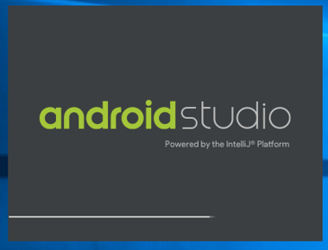 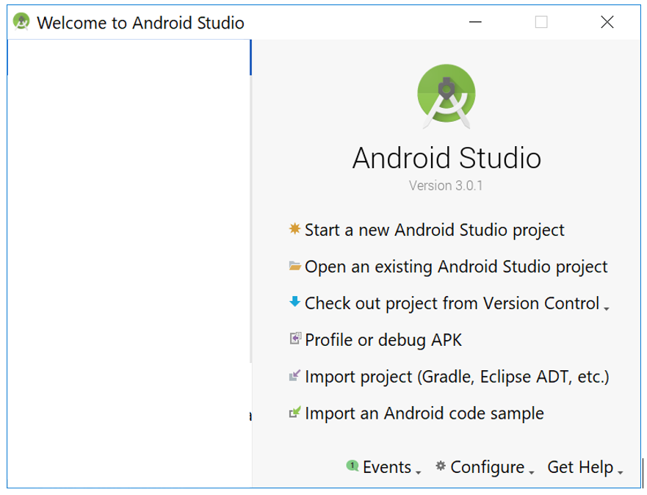

1. Select **Start a new Android Studio project**. Enter the details as shown below (change u123456 to your student ID)

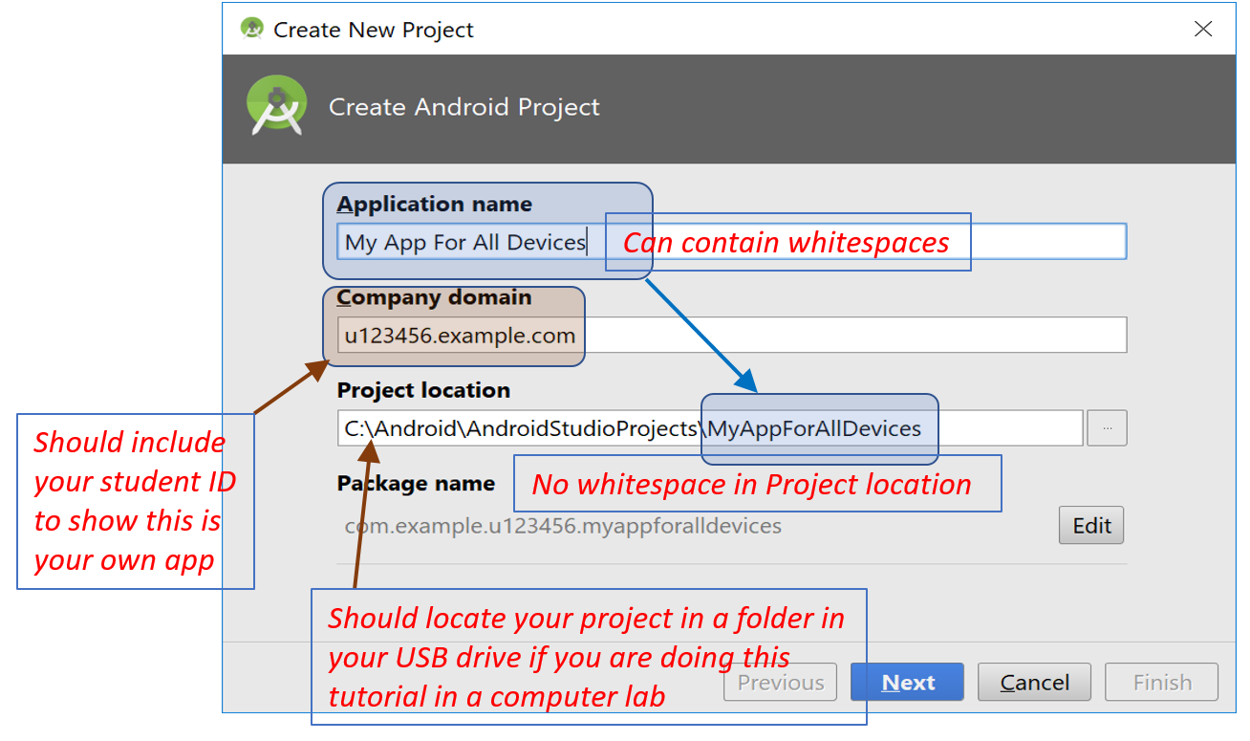

1. Check all the checkboxes and select the latest APIs available on your current computer

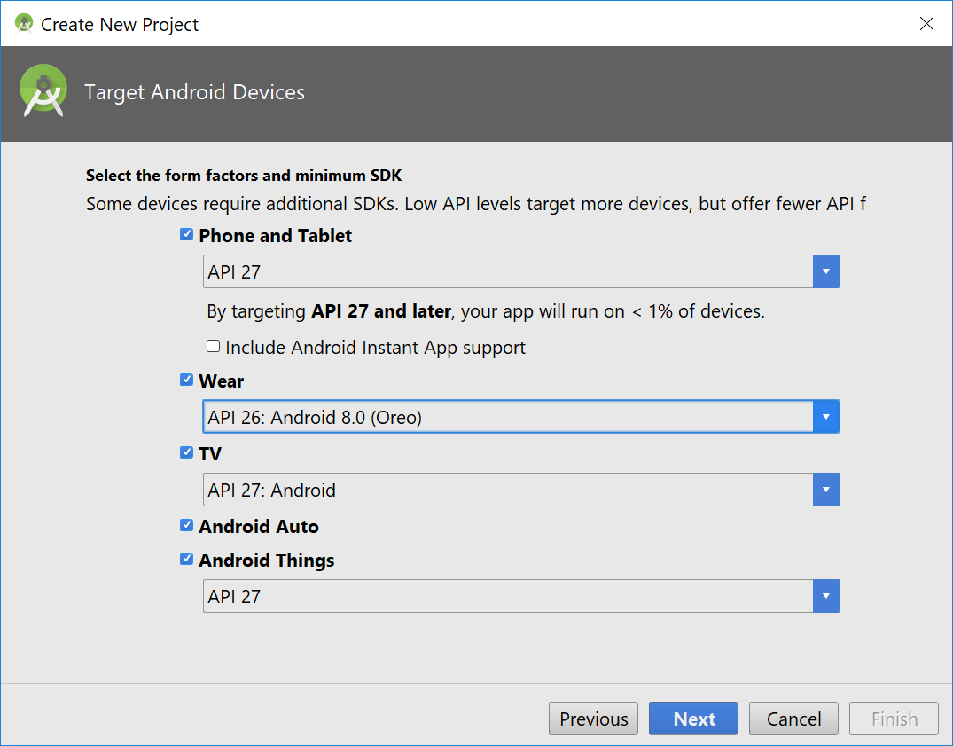

1. Click **Next**. Accept all default settings until **Finish** to create all projects.

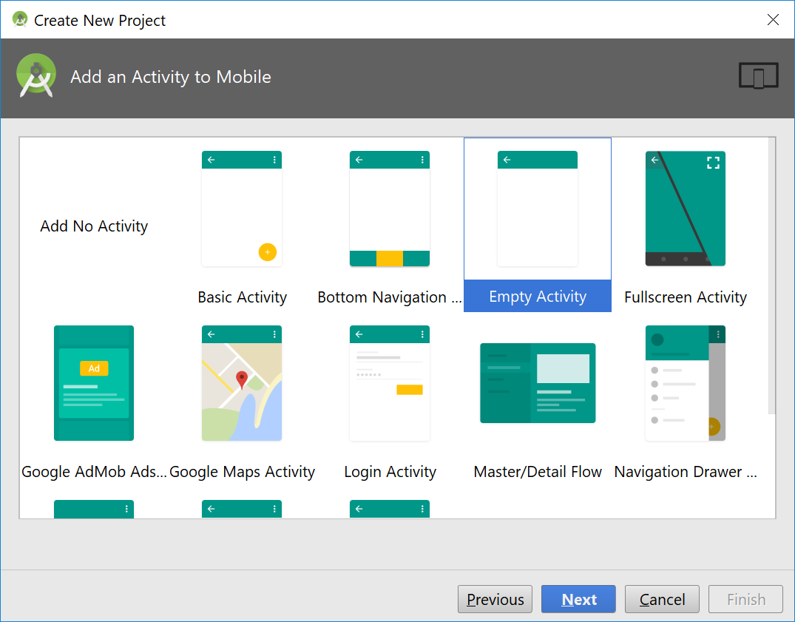 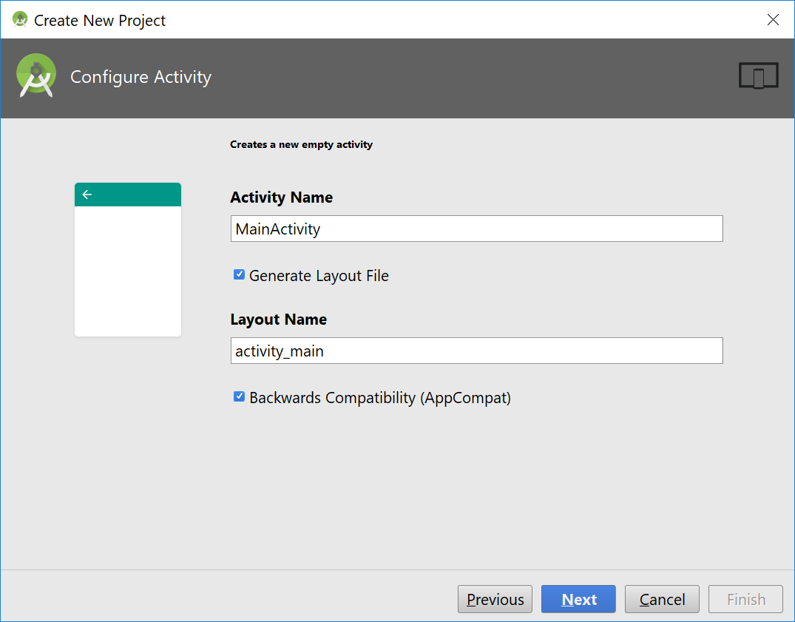

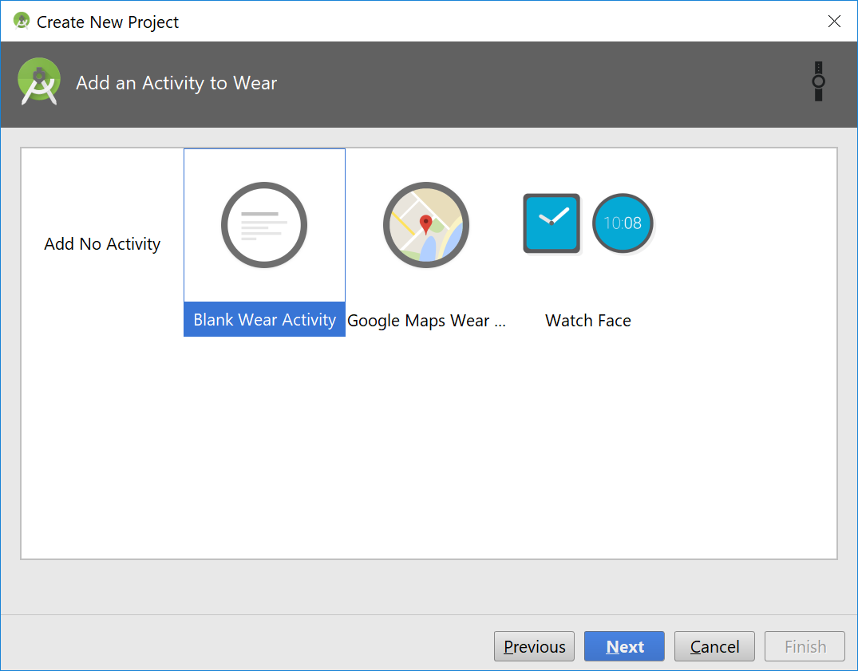 

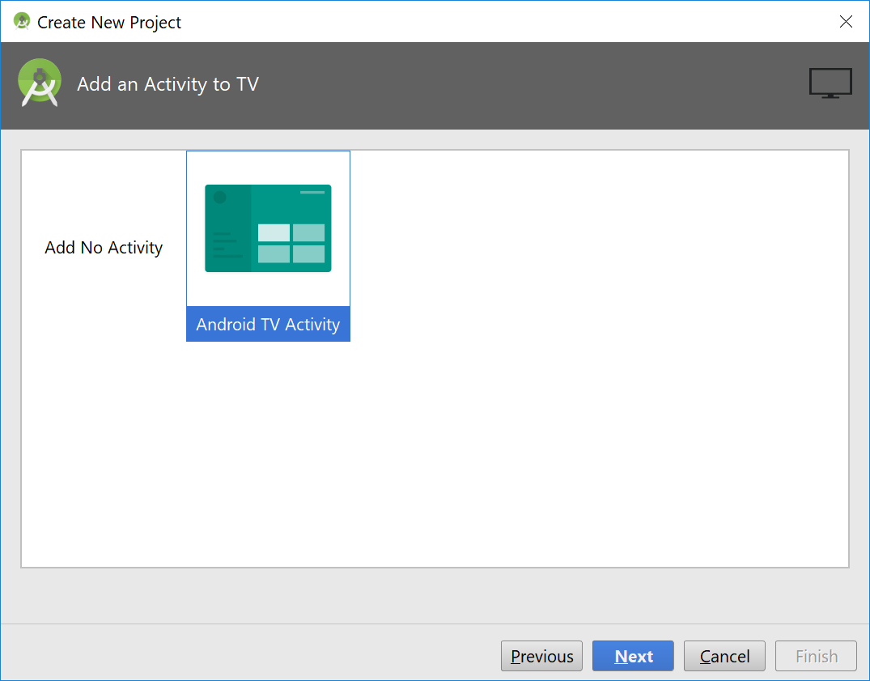 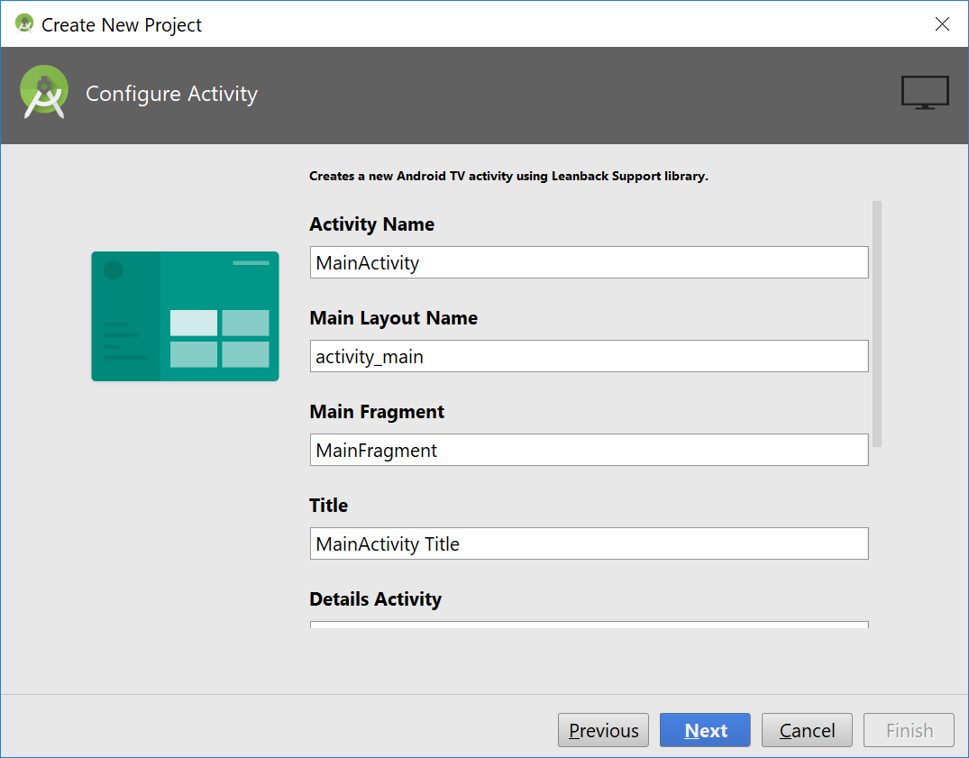

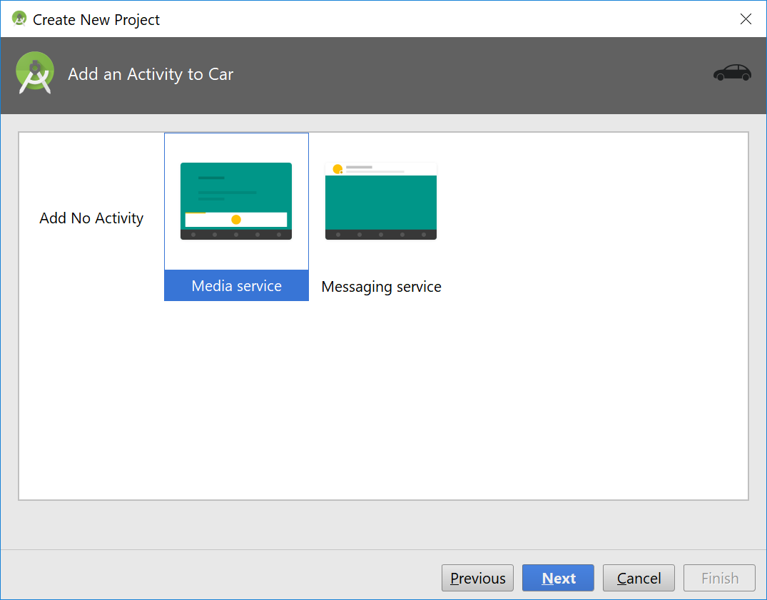 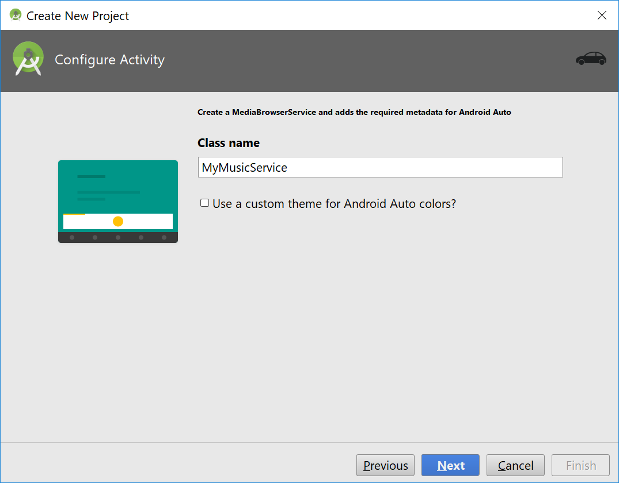

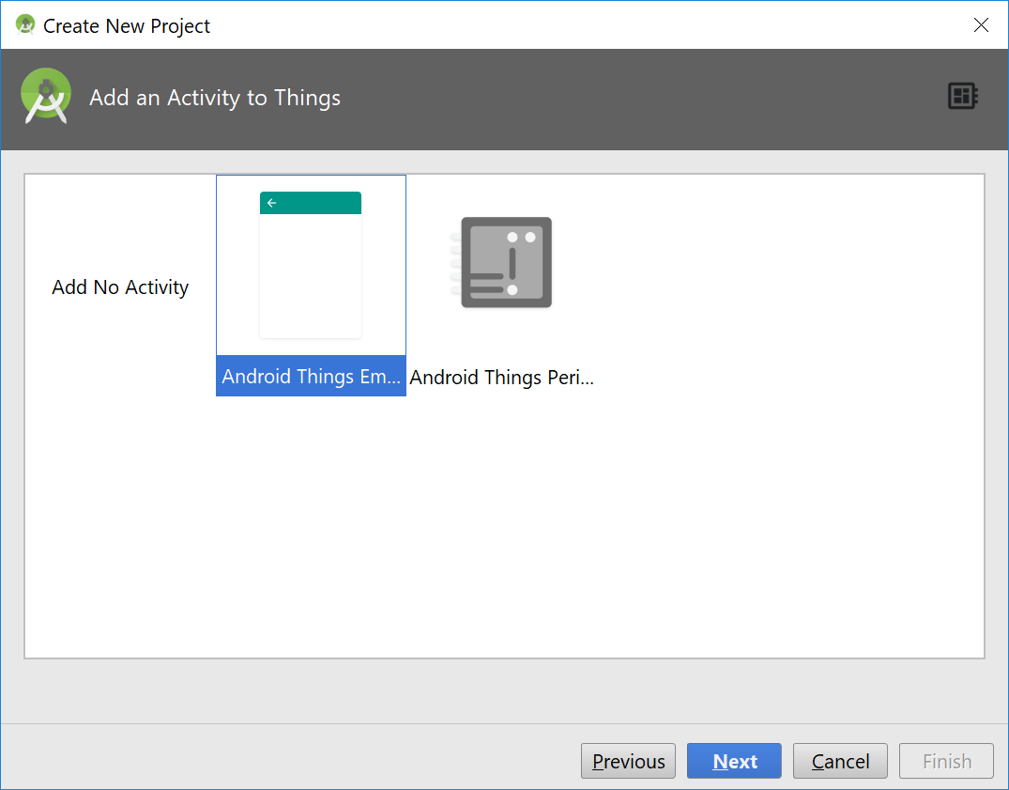 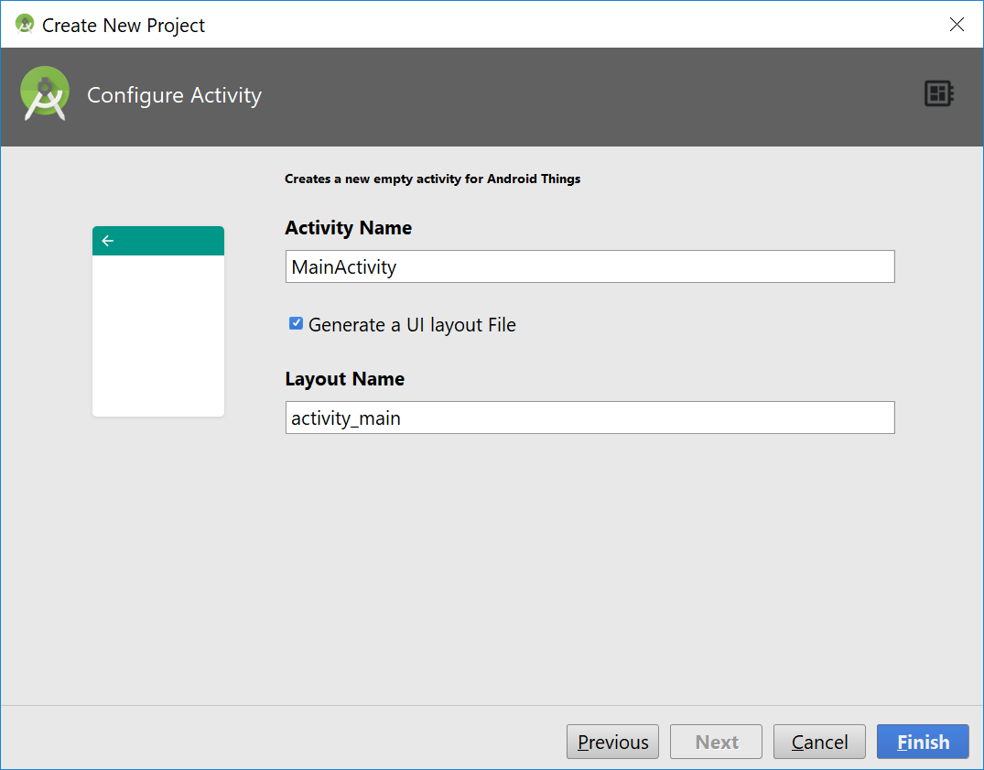

1. You can see 4 projects (mobile, things, tv, and wear) created in Android Studio.

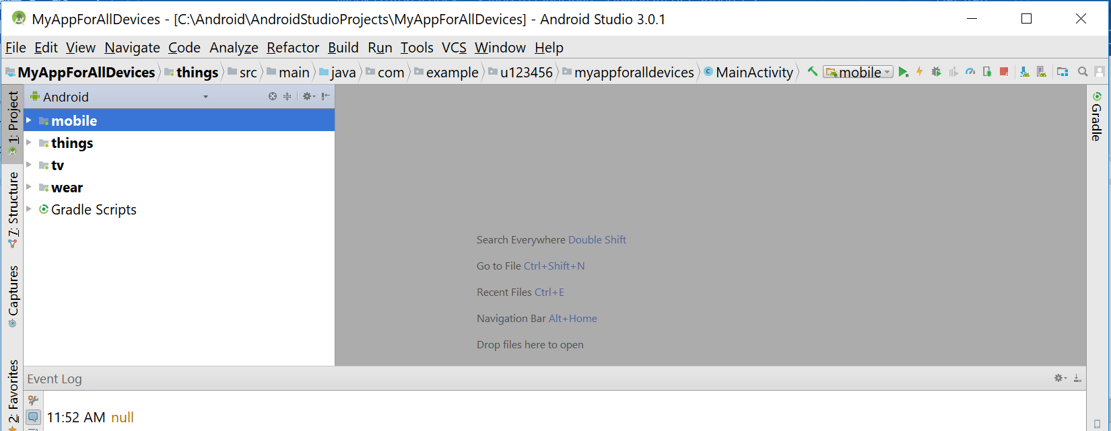

1. Take a moment to have a look at the projects by clicking on each item on the left side.

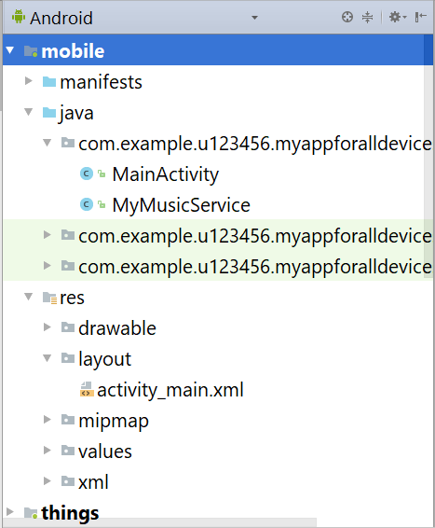 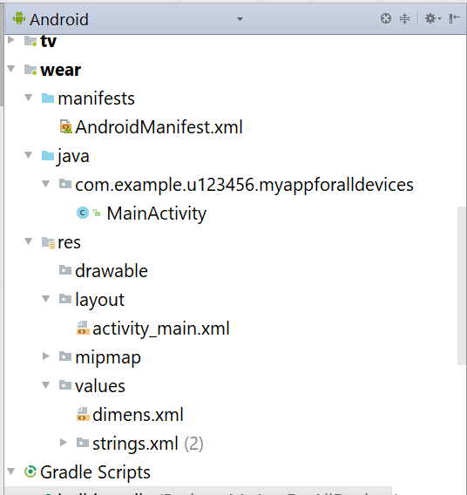 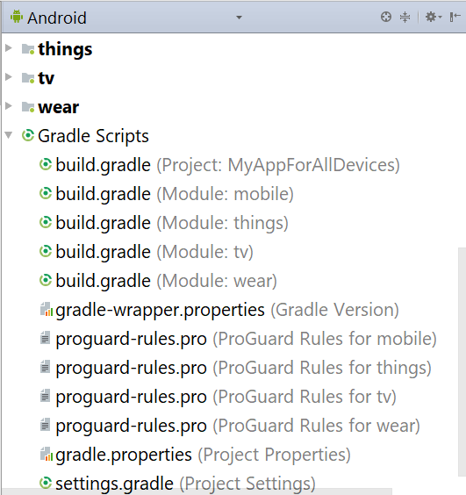

1. Before modifying some projects, you can run all projects to see their output on emulators. Look at the bottom of Android Studio, if you see the message like this "**Gradle build finished in 1m 37s 542ms**", this means the projects are ready to run. It takes a while for the gradle to build and index the project. At the top-right corner of Android Studio, you can see a drop down list as follows

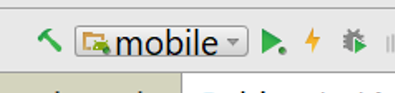

Select mobile if it’s not the current item, then click on the green triangle icon to run the project for mobile/tablet.

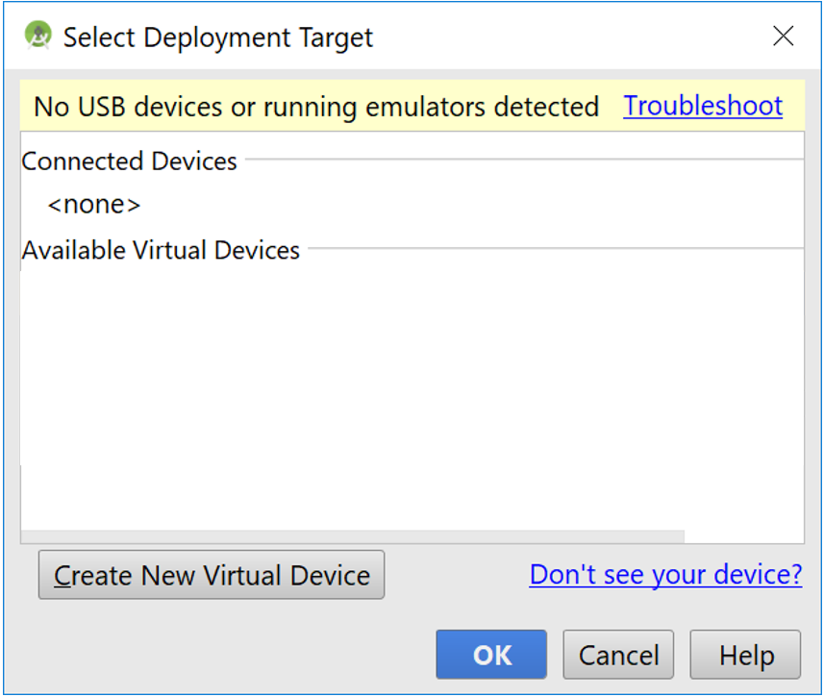

If you don’t see any virtual devices available, you can select **Create New Virtual Device** to create a new device to test your app. On the window below, select Phone then Pixel 2 XL to create a phone emulator. Click Next. If no API is available, select the latest one (API 27) and click download. Accept all default settings until you finish all.

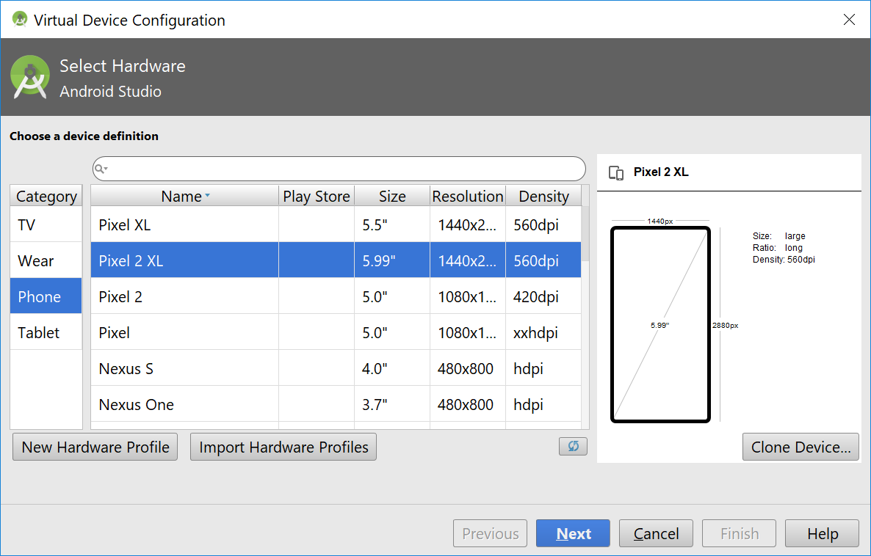 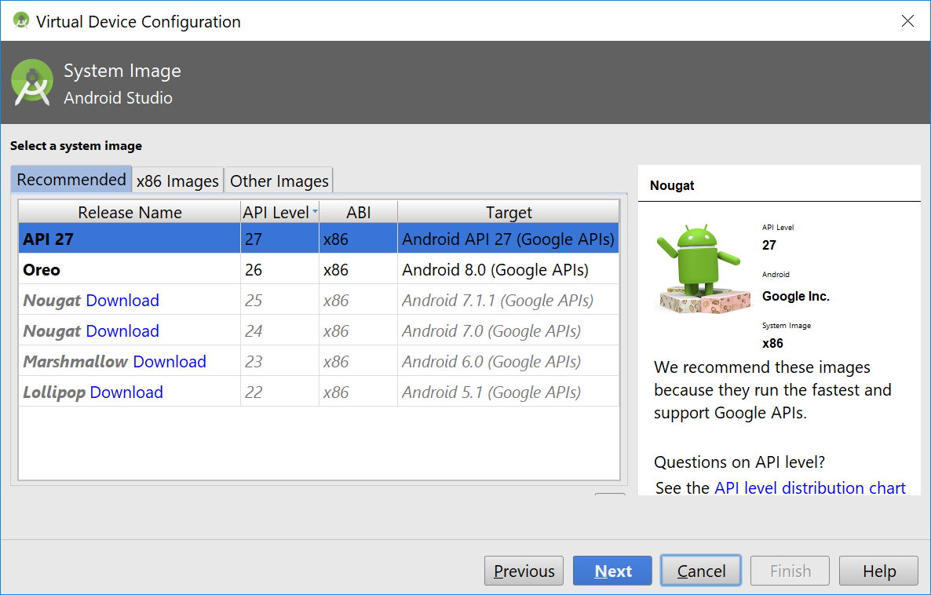

1. Back to the **Select Deployment Target** window, select the Pixel 2 XL emulator then click OK. It takes a while to load the emulator.

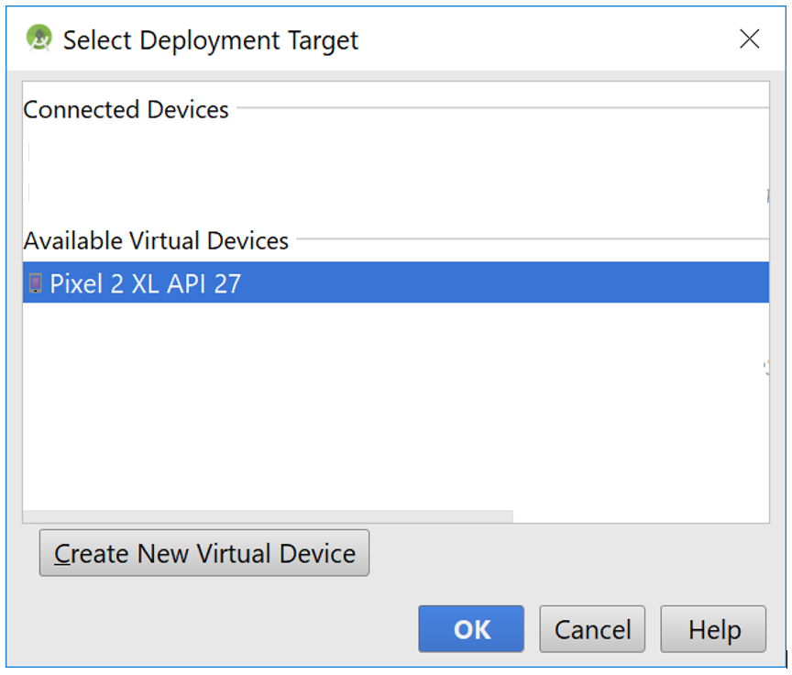 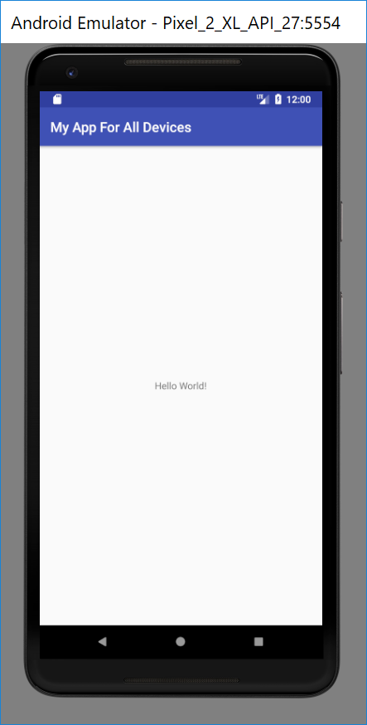

1. Repeat those steps to create emulators for wear and tv then run the projects for wear and tv. There is no emulator for Auto and Things so you cannot test these projects at the moment.

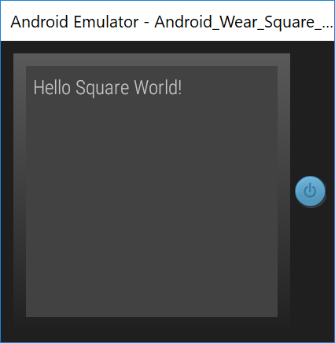 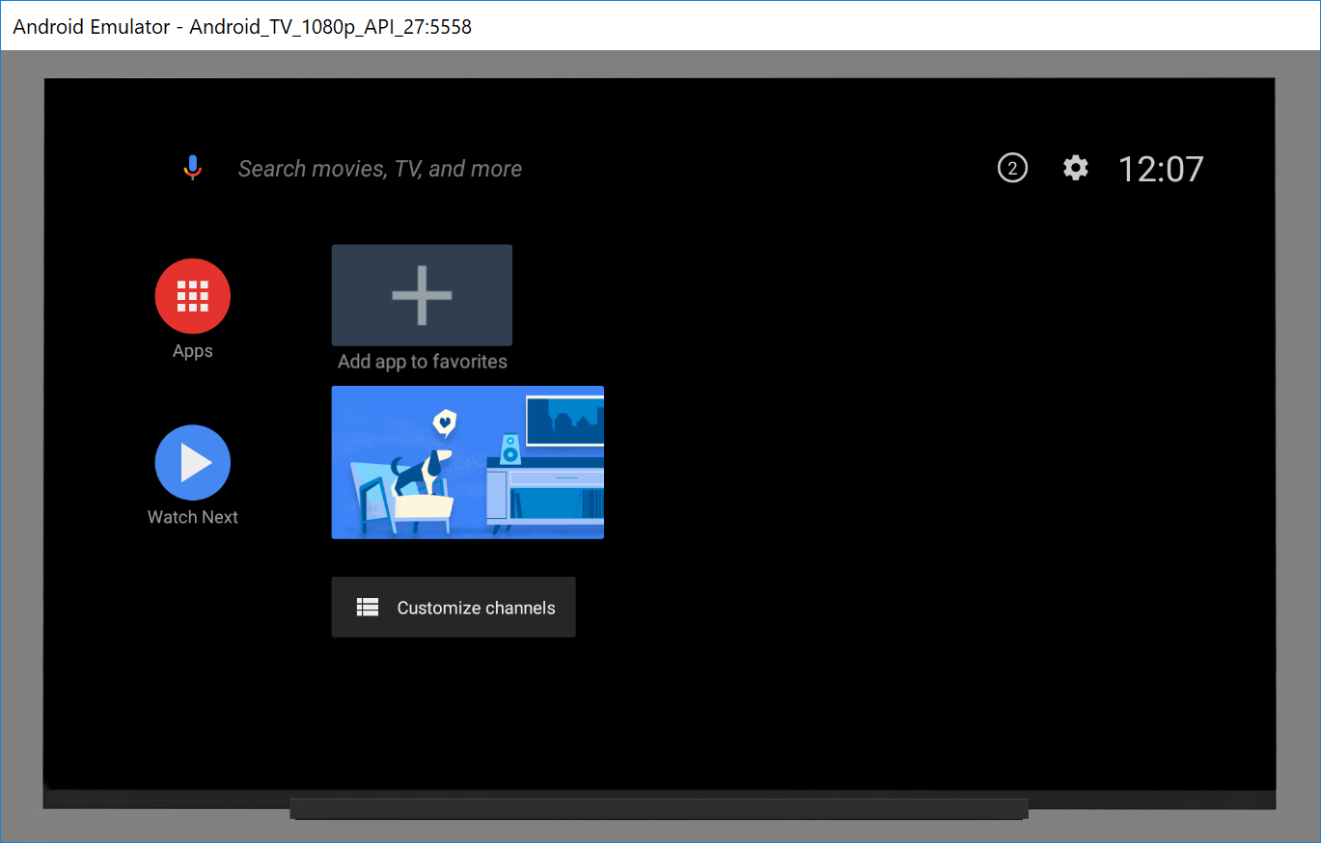

1. The following steps are to modify the mobile/tablet project. Expand the **mobile** tab and click on **activity_main.xml** to open it on the editor. You will see it as follows.

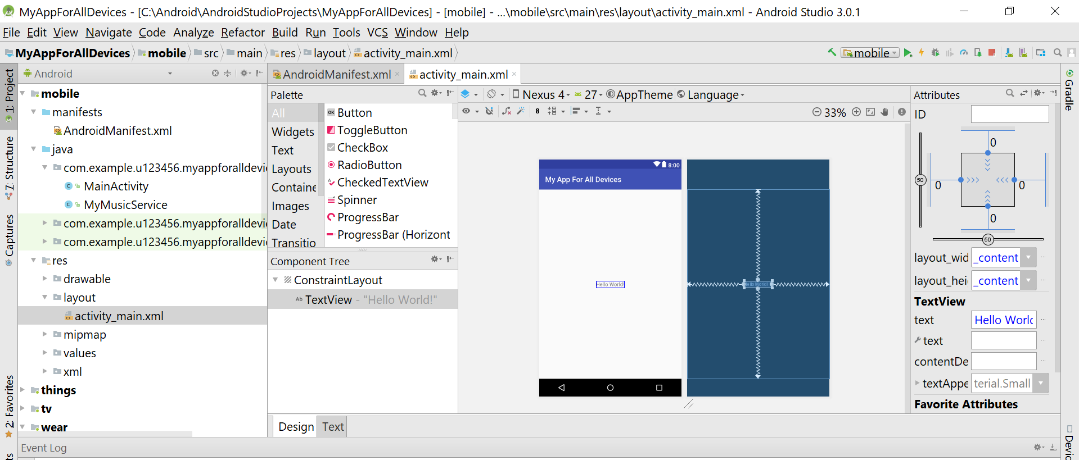

1. Change **Hello World!** in **TextView** element to **Hello, Android 8.0 Oreo!** as follows. Open **activity_main.xml**, select **Design** tab if you don’t see the emulator. Click on **Hello World!** to open the **Properties** panel on the right. Click on the text box to change to **Hello, Android 8.0 Oreo!**

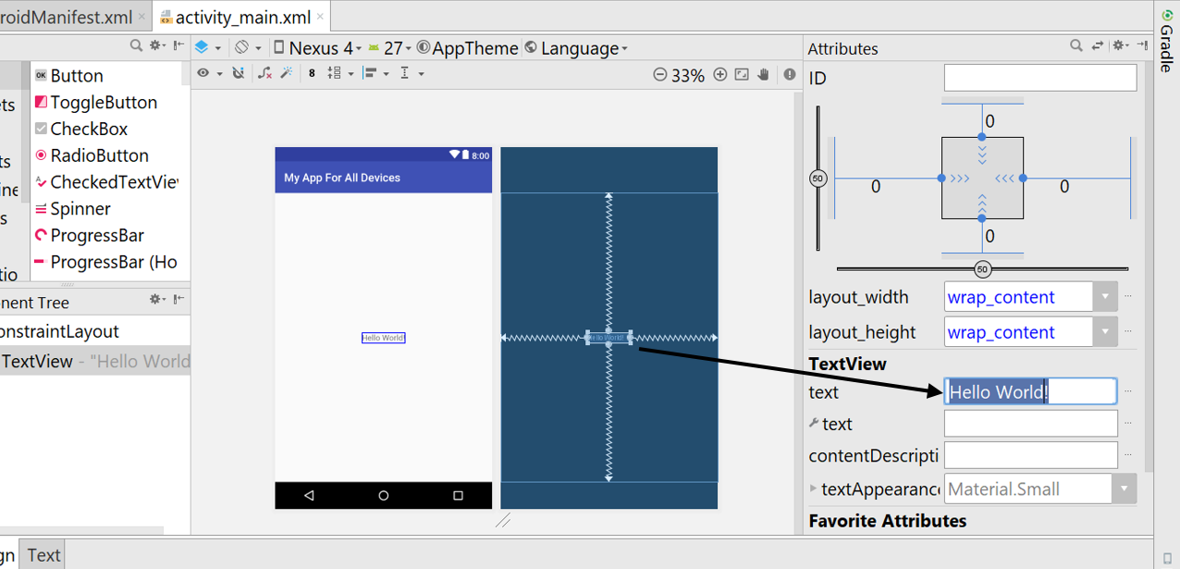

1. Alternatively, you can select **Text** tab to display XML code and find **Hello World!** then change it. See the screen shot below.

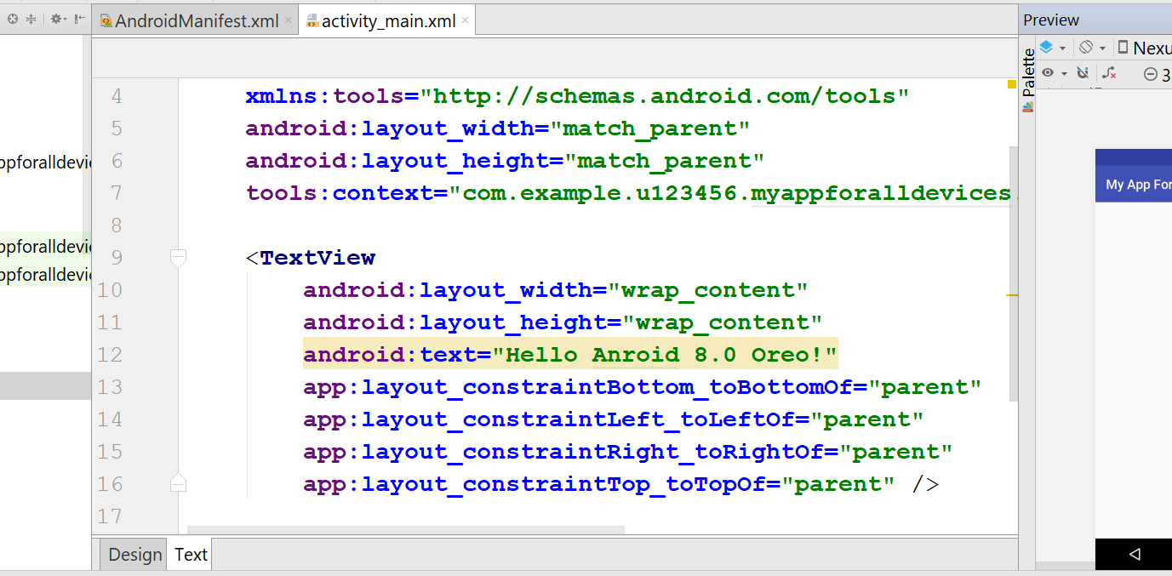

1. You add the line for text size as follows to make the text bigger

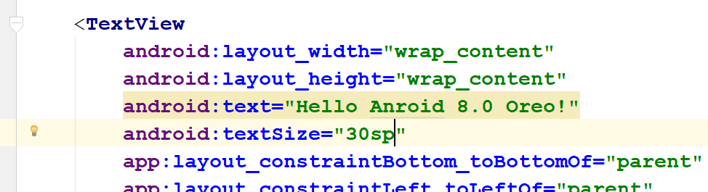

1. Run the project to see your change on the emulator.

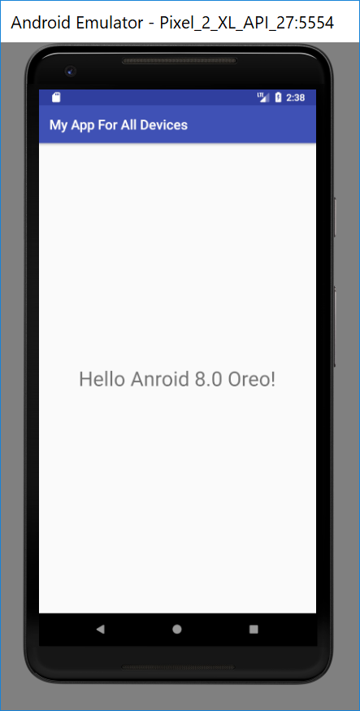

1. Next you change the application name from **My App For All Devices** to **Mobile Technologies App**. Open **strings.xml** and change the application name as seen below. Modify it then run.

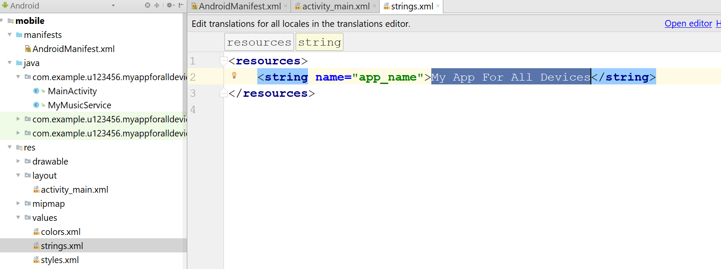

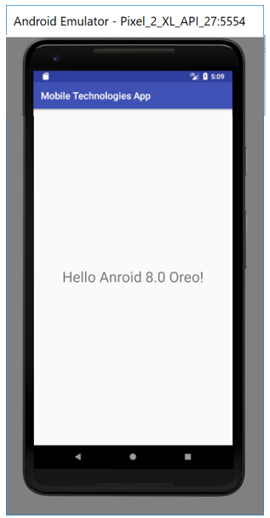

1. Finally, you add a new image to the project and display it. Right click on the image below and select **Save as Picture** and name it **android_oreo.png** (all letters must be lowercase)



1. Place this image to the **drawable** folder in this project (use Windows explorer to find this **drawable** folder then place the image in to this folder)

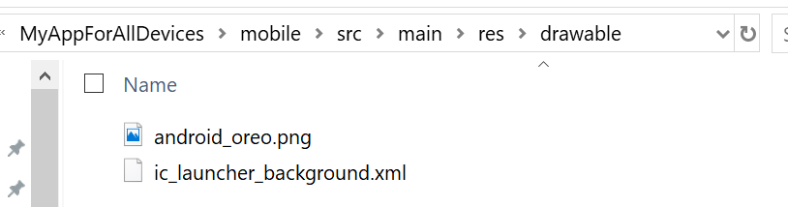 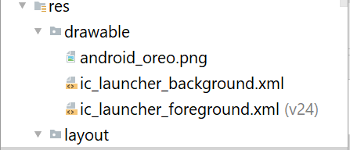

1. Open **activity_main.xml**, move the text view up (use mouse to do it on the Palette (blue) window), drag and drop **ImageView** to the layout and add the image as follows

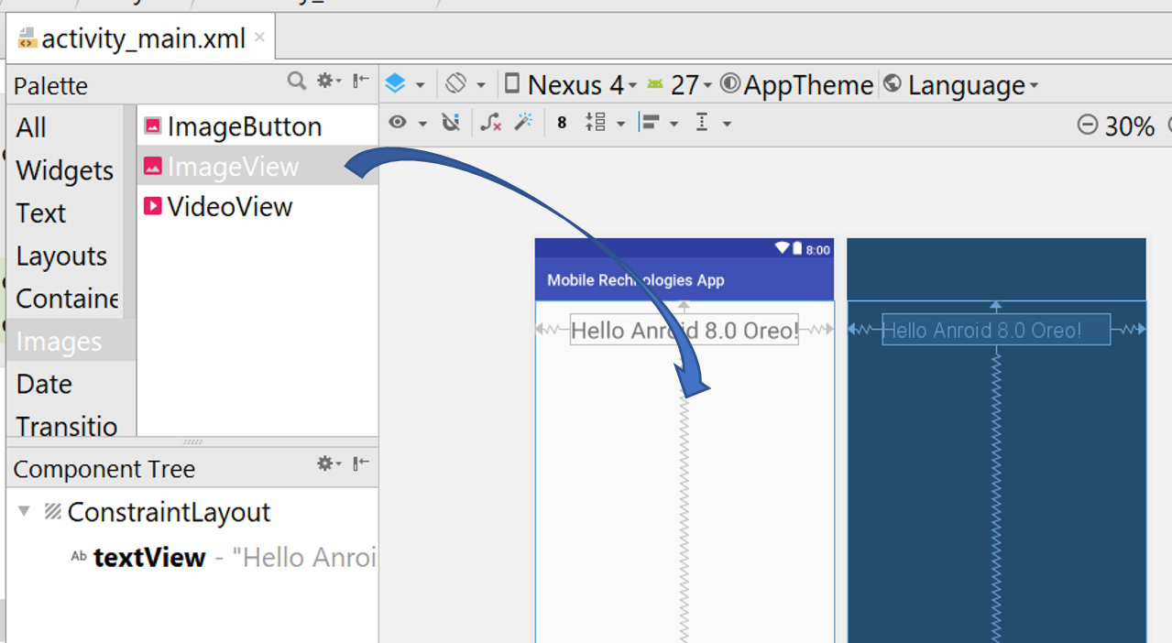

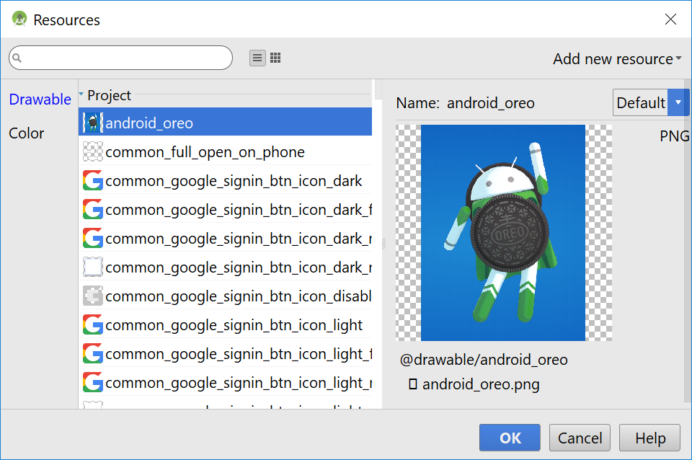

1. Change some properties of the image view for design then run the project.

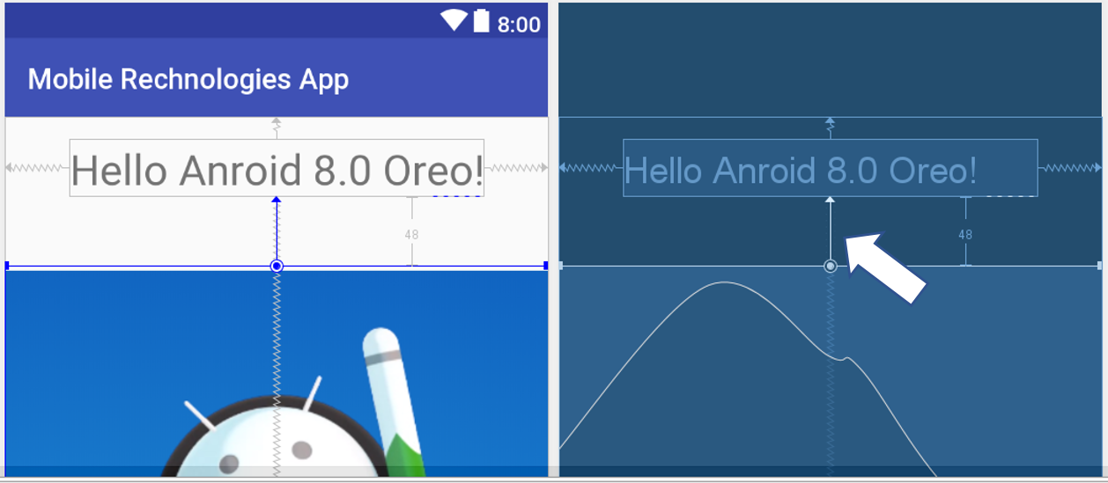 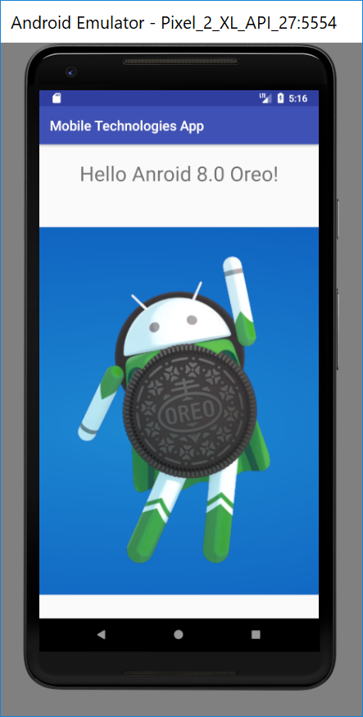

Find the folder of your app in File Explorer (see below). Zip the folder and submit it on Canvas site of this unit. Ask your tutor to see your complete work before you leave the lab. Mark for attendance: 1% and mark for this app: 1%.

