Are we there yet? The impact of reduced composition data on the ability to monitor rebuilding for overfished fish stocks

Chantel R. Wetzel1,2, André Punt2

1Northwest Fisheries Science Center, National Marine Fisheries Service, 2725 Montlake Boulevard East, Seattle, WA 98112, United States

2School of Aquatic and Fishery Sciences, University of Washington, Seattle, WA 98195-5020, United States

ABSTRACT

*Keywords*:

Rebuilding, overfished, simulation, limited data

*Corresponding author*: C.R. Wetzel

*Email:* [Chantel.Wetzel@noaa.gov](mailto:Chantel.Wetzel@noaa.gov)

*Phone*: 1-206-302-1753

*Fax*: 1-206-860-6792

# Introduction

Rebuilding overfished stocks requires a reduction in fishing mortality to a level that allows the stock biomass to increase. In the United States, federally-managed stocks that fall below a minimum stock size threshold are declared overfished and are mandated to be rebuilt to target biomass levels in the shortest amount of time, accounting for biological and environmental conditions (SFA, 1996). This can lead to substantial reductions in fishing effort relative to historical levels. The severity of restrictions during rebuilding can, for some stocks, lead to a situation where the ability to collect data becomes limited over the period when managers are likely most concerned about stock size (i.e. when the stock is under the rebuilding plan).

Data are necessary to determine the extent to which a stock is on track to rebuild. A rebuilding stock should have harvests limited to levels below the replacement yield. However, being able to measure the rate of recovery is still crucial to management, and increased uncertainty due to limited data can impede this. Additionally, biological data are critical to improve estimates of key parameters within stock assessments (e.g. natural mortality, growth, steepness) and can indicate incoming poor or strong year-classes (recruitment), which can impact estimates of relative stock biomass and rebuilding rates. Potential improvements in parameter estimates, and the ability to detect incoming fluctuations in recruitment during rebuilding could be restricted when collection of new biological data is limited due to harvest restrictions.

Overfished rockfish species off the U.S. west coast have experienced large reductions in harvest during rebuilding. One example is yelloweye rockfish (*Sebastes ruberrimus*), which was declared overfished in 2002 (Methot and Piner, 2002). Similar to other rockfish species on the U.S. west coast, catches of yelloweye rockfish were large and unsustainable during the 1980s and early 1990s. The catches were cut dramatically following the overfished declaration relative to the historical catches, where the allowable catch in the first year of rebuilding was reduced to approximately 10% of the catch observed four years earlier (Stewart *et al*., 2009).

Many species of rockfish are not sampled well by main fishery-independent survey off the U.S. west coast either due to the survey’s inability to sample rocky habitat using trawl gear or other restrictions on sampling locations (e.g. rockfish conservation areas or near-shore habitat). Yelloweye rockfish fall into the category of poorly sampled rockfish by the fishery-independent survey, resulting in the majority of historical information (e.g. index of abundance, length, and age data) available for assessment, albeit somewhat limited, coming primarily from recreational and commercial fishery samples. During rebuilding, retention has been prohibited in the recreational fishery, and the limited allowed catch has led to an avoidance behavior by the commercial fishery (Stewart *et al.*, 2009). The most recent assessment cited limited fishery data during rebuilding as a challenge to ‘produce conclusive information about the stock for the foreseeable future’ (Stewart *et al.*, 2009). The limited fishery-independent data, along with the reduction of fishery data during rebuilding presents a challenge for assessment and management.

There have been numerous simulation studies evaluating the impact of data quality and quantity on the performance of stock assessment methods (e.g. Hilborn, 1979; Chen *et al.*, 2003; Yin and Sampson, 2004; Magnusson and Hilborn, 2007; Wetzel and Punt, 2011; Lee *et al.*, 2012). Studies often focus on the ability to estimate either management quantities or biological parameters. However, to date, these studies have not addressed the long-term impact of reduced data on the ability to monitor a stock during rebuilding. This paper simulates an overfished long-lived rockfish stock, such as those that are common to the U.S. west coast, where harvest and the collection of fishery data are restricted during rebuilding. The simulation study addresses three main questions; 1) does limited data result in increased uncertainty impacting the ability to detect when an overfished stock has recovered to management target stock size (i.e. it is rebuilt), 2) are the limited data from the fishery able to detect a change in fishery selectivity resulting from changing fishing behavior during rebuilding, and 3) how are model estimates of stock size and biological parameters affected during periods of limited data?

# Material and Methods

## General approach

A rockfish life-history type common to U.S. west coast was simulated (Table 1), based on the life history and fishery for yelloweye rockfish. Yelloweye rockfish are assumed to have very slow population dynamics based on very low natural mortality and recruitment compensation (steepness). However, the operating model was parameterized using higher natural mortality and steepness values to allow for shorter recovery periods (< 100 years) for computation efficiency while still maintaining the characteristics of a rockfish life history.

Two alternative cases were simulated for the operating model to account for the potential impacts of time-invariant versus time-variation in natural mortality and fishery selectivity. The first state case, “time-invariant”, involved a fixed natural mortality over time and a fixed fishery selectivity curve during the historical period, the overfished period, and after the stock rebuilt to target biomass levels (Fig. 1a). Fishery selectivity shifted during the period when the stock was assessed to be overfished to reflect a change in fisher behavior due to harvest restrictions (e.g. avoidance behavior, closed-areas) (Fig. 1b). The second case, “time-varying”, involved autocorrelated annual deviations in natural mortality and uncorrelated deviations in the parameters on which the fishery selectivity selection pattern is based during the historical, overfished, and rebuilt periods (Fig. 1c and d). To generate annual deviations in the fishery selectivity a standard error of 0.50 was applied annually about the size at maximum selectivity (Fig. 1c) and a standard error of 0.20 was applied for the width at maximum selectivity creating the descending limb (e.g. dome-shaped) while the stock was estimated overfished (Fig. 1d).

The operating model as based on a single-sex age-structured model. An annual index of abundance was observed with error and length and age composition data were collected for selected years, and used by the estimation method to estimate population size and a corresponding catch level. The catches were then applied to the simulated stock. The data generation, catch estimation and stock updating was conducted in an iterative fashion for 100 years (termed the management period), a length of time that would allow for recovery to occur.

## The operating model

The numbers-at-age at the start of the year are computed using the equation:

 (1)

where  is the number of fish of age *a* at the start of the year *t*,  is the number of age-0 animals at the start of year *t*,  is the selectivity during year *t* for animals of age *a*, *A* is the plus group,  is the instantaneous fishing mortality rate during year *t*, and *Mt* is the instantaneous rate of natural mortality during year *t*.

Autocorrelated annual deviations in natural mortality are generated using:

 (4)

where *M* is the mean value of natural mortality,  is the standard error of the annual variations in natural mortality, and  is the auto-correlated lognormal deviation in natural mortality for year:

 (5)

where  is the level of autocorrelation associated with natural mortality and  is the deviation for year *t*. The time-invariant natural mortality case assumed  and .

The number of age-0 fish is related to spawning biomass according to the Beverton-Holt stock recruitment relationship:

 (2)

where *SB0* is the unfished spawning biomass,  is the spawning biomass at the start of the spawning season in year *t*,  is the standard deviation of recruitment in log space, and *h* is steepness.

A non-equilibrium starting condition was created by applying equations (1) and (2) for the number of years equal to the maximum age prior to the start of fishing with variation in recruitment and no fishing. Historical catches for years 1-50 were generated so that the populations were at 0.15*SB*0 in year 50. The relative stock size in year 50 was selected to allow for correct detected by the estimation method that the stocks were overfished, and would require an extended number of years for rebuilding were data could impact the long-term performance of the estimation method. The catch of fish of age *a* during year *t* in numbers determined by:

 . (3)

The observation model was used to generate an index of abundance for the fishery and the survey for each year *t*:



where *Q*is the catchability coefficient, $σ_{s}$ is the standard deviation of catchability in log space (see Table 1), and the  expected vulnerable biomass. The expected biomass index is given by:

 (4)

where *wa* is the weight of a fish at age *a*, and *St,,a* is the selectivity for the survey or the fishery in year *t* for age *a*. The length- and age-composition data for the fishery and survey catch were assumed to be multinomially distributed (see *Data Scenarios* for details). Ageing error was normally distributed with ages subject to a 5% standard deviation by age.

The fishery and survey selectivity during the historical period (years 1-50) were assumed asymptotic (Fig. 1). The fishery selectivity shifted to a domed-shaped (compared to the historical asymptotic) within the operating model during the period that the stock was estimated to be below the target biomass (0.40*SB*0). Once the population was estimated to have recovered to above the target biomass, fishery selectivity reverted to the asymptotic form. The shift in selectivity was designed as a way to mimic a change in fishing behavior resulting from an overfished declaration. The time-varying state of nature applied annual deviations to the peak and descending selectivity (Fig. 1c and 1d).

## The estimation method

Stock synthesis (SS), an integrated statistical catch-at-age model (Methot and Wetzel, 2013), was the estimation method used to assess the simulated stocks. SS was applied for the first time in year 50 and then every 6th year thereafter. Assessment frequency of U.S. west coast groundfish varies based upon commercial importance which is used as an indicator of exploitation, the time since last assessment, and dynamics of the stock (Methot 2015). Long-lived rockfish species generally have slow dynamics, resulting in minimal fluctuations in biomass from year to year (assuming non-extreme harvesting). Assessing the stock every 6th year was selected based upon the slow-dynamics of the stock and to minimize computational time per simulation.

*R0*, steepness, growth, annual recruitment deviations, initial age-structure deviations, the size at maximum selectivity, and the width at the maximum selectivity for the fishery and survey selectivities were estimated. The relative stock biomass in the assessment year was estimated and the forecasted catches were determined using the Pacific Fishery Management Council (PFMC) rockfish harvest control rule. The catches were removed from the operating population without error, index of abundance and composition data were generated for the subsequent six years.

The PFMC harvest control rule applies a linear reduction in catch when a stock is below 0.40*SB*0, with no fishing when the stock falls 0.10*SB*0. The overfishing level (OFL) was set equal to the target spawner-per-recruit harvest rate multiplied by *SBt*. The OFL was reduced by a commonly used management buffer value that accounts for the uncertainty about current biomass for well-assessed stocks (0.956; Ralston *et al.* 2011) to determine the ABC catch level, i.e. ABC = 0.956 OFL. The annual catch limit (ACL) was set equal to the ABC is the stock was above 0.40*SB*0 or reduced according to the harvest control rule when the stock fell below 0.40*SB*0.

One major difference in the simulation and actual management practice on the U.S. west coast was the omission of the rebuilding plans that are implemented when a stock is assessed to have fallen below a minimum stock size threshold (defined as 0.25*SB*­0 for U.S. west coast rockfish). Harvest for stocks below the threshold would no longer be determined based upon the standard harvest control rule, but rather a rebuilding plan would be used to determine catches until it is rebuilt to the target biomass. To reduce simulation complexity a rebuilding plan was not imposed if a simulated stock was assessed to have fallen below the threshold and the catches were determined based on the harvest control rule for all estimated stock sizes.

## Data scenarios

Three data scenarios were created to explore the impact of data availability on the ability to monitor rebuilding of an overfished stock (Fig. 2). The data scenarios were designed to emulate a stock that is infrequently encountered by a survey (e.g. due to depth or habitat) and the majority of the historical data available were from the fishery. The historical sample sizes were generally based on the effective sample sizes observed for yelloweye rockfish. Following the first assessment in year 50, the three data scenarios have different data availability based on stock status. Stock status is defined as the ratio of biomass to unfished biomass (termed relative spawning biomass) in the assessment year relative to the management targets. The simulated stocks were in an overfished state when the first assessment was conducted. The simulated stocks were classified as overfished until the relative spawning biomass surpassed the target biomass (0.40*SB*0) at which time they were classified as rebuilt.

The data quantity available during the management period differed across the three data scenarios based on whether the stock was overfished or rebuilt. The “full data” scenario maintained fishery and survey composition data at the historical levels (prior to the stock being declared overfished in year 50) during rebuilding.

The “reduced data” scenario reduced the amount of data available from the fishery during rebuilding (Fig. 2). The composition data were reduced to 20% of the historical sample sizes during rebuilding. The composition sample sizes revert to historical levels when the stock was estimated to have rebuilt above the target biomass. The fishery CPUE index was eliminated during rebuilding, but is available again when the stock was estimated to be above the target biomass.

The “eliminated data” scenario eliminated new fishery data, both composition and index, during rebuilding. The composition data and fishery CPUE index resumes at historical samples sizes when the stock was estimated to be rebuilt.

## Performance measures

The outcomes of the simulations for each harvest control rule were summarized using the following five metrics that were selected to evaluate the impact of data and estimation of indicators of stock status (e.g. relative spawning biomass) and management quantities (e.g. ACLs):

1. The relative errors (REs) for estimated parameters, calculated as:

 (5)

where E is the estimated quantity of interest and T true value from the operating model.

1. The root mean square error (RMSE), a measure of precision and bias, was calculated to assess the overall level of error given the amount of data available:

 (6)

1. The average (over simulations) of the total catch attain while the stock was recovering to the target biomass.
2. The annual average variability of the catches (abbreviation AAV) defined as:

$AAV=100\frac{\sum_{y}{\left|C_{y}-C_{y+1}\right|}}{\sum_{y}{C_{y}}}$ (7)

where C*y* is the catch during year *y*.

# Results

## Assessment performance with time-invariant parameters

The trends of the relative error about in spawning biomass and relative spawning biomass were generally consistent across the three data scenarios (Figs. 3a-c and 4a-c). The initial assessment in year 50 was median unbiased for both spawning biomass and the relative spawning biomass. However, relative spawning biomass was negatively biased while the stock rebuilt (e.g. assessment years 68-110) for the full and reduced data scenarios (Figs. 3a-b and 4a-b). As expected, the estimates relative spawning biomass for the full data scenario were less variable during the rebuilding period compared to the reduced data and eliminated data scenarios. At the end of the management period, the bias and variance of estimated spawning biomass and relative spawning biomass were similar among the three data scenarios.

The RMSE, a measure of both bias and precision, for estimated relative spawning biomass for each assessment year shows the increased precision of the full data scenario during the rebuilding period compared to the reduced and eliminated data scenarios (Fig. 5a). The reduced data and eliminated data scenarios resulted in similar RMSE patterns over time, indicating that the limited fishery samples had little impact on estimation performance during the recovery period with the assessment results being driven by the historical data and the continuing survey data (Fig. 5a). The final assessments, when the majority of simulated populations were estimated to have recovered and data levels reverted to the historical levels, resulted in similar RMSE across the data scenarios (Fig. 5a).

The AAV of catches (during rebuilding and over all years) was lowest for the full data scenario (Table 2). As the population rebuilds toward the target biomass, estimated catches increase in proportion to the biomass and the AAV over this period would be anticipated to be greater than an AAV measured over the entire management period (e.g. rebuilding and rebuilt years) which was observed across all the data scenarios (Table 2). The AAVs during the rebuilding period were similar among the data scenarios, but the full data scenario resulted in the smallest median value and 90% simulation interval (Table 2). The full data scenario resulted in the highest median average catch during the overfished period (Table 2). However this scenario also estimated the highest positive bias in the median time estimated for the stock to recover relative to the true population (Table 3). The median estimated number of years the stock required to recover to the target biomass for the stocks that successfully rebuilt was the same across data scenarios (Table 3).

Reduction or elimination of data during rebuilding increased the variance of the estimates of the size at maximum fishery selectivity (Fig. 6a-c) and the width at maximum selectivity defining the shape of the dome in selectivity during the overfished period (Fig. 7a-b). The estimates were generally equal to the true value in median terms for all data scenarios. The precision of the estimates for the reduced and eliminated scenarios only improving at the end of the management period when the majority of the stocks has rebuilt and fishery composition sample sizes returned to the higher historical levels (Fig. 6b-c). Each of the data scenarios that were allowed to estimate dome shaped selectivity during the rebuilding period (the eliminated data scenario did not allow for estimation of dome-shaped selectivity due to the absence of fishery composition data) resulted positively biased estimates that were highly variable at start of the management period (Fig. 7a-b). A positively biased median estimate results in the estimation model assuming a less severe dome in selectivity (decreased slope for the selectivity descending limb). The full data scenario resulted in markedly improved estimates of the shape of the dome over the management period, especially compared to the reduced data scenario (Fig. 7a-b).

## The impact of time-varying parameters

The case that assumed time-varying natural mortality and fishery selectivity generally resulted in increased variation in estimates among simulation compared to the time-invariant state of nature. The initial estimates of spawning biomass at the time of the first assessment were positively biased and highly variable (Fig. 3d-f). The variance about spawning biomass decreased markedly for the full data scenario after the first assessment (Fig. 3d). However, the variance of estimated spawning biomass remained high for approximately the first thirty years of the management period for both the reduced data and eliminated data scenarios, until approximately 38-51% of the simulated stocks were estimated recovered and the fishery sample sizes increased to historical levels (Fig. 3e-f). Across data scenarios the median spawning biomass was generally negatively biased, but the median estimated relative spawning biomass levels were typically unbiased (Fig. 4c-f). The RMSE about the estimated relative spawning biomass for the full data scenario was reduced relative to the other data scenarios for the first portion of the management period and across data scenarios, but the RMSE was higher when time-varying parameters were present within the operating model (Fig. 5). Similar to the time-invariant results, the RMSE of relative spawning biomass reached similar levels across data scenarios approximately half way through the management period after a majority of the simulated stocks are estimated recovered.

The inclusion of time-varying parameters resulted in slower estimated recovery of stocks relative to the time-invariant state of nature for all the data scenarios (Fig. 4) with a higher number of stock failing to be estimated recovered to the target biomass (Table 3). Of the stocks that successfully rebuilt, the median number of years for the stock to recover to the target biomass were similar across data scenarios (Table 3). However, the median average catch obtained during the recovery period was the highest for the full data scenario, followed by the eliminate data scenario (Table 2). The eliminated data scenario had the lowest median AAV during the overfished period and the median relative error about the time overfished had only a lower positive bias relative to the full data scenario (Tables 2 and 3). In contrast the full data scenario, resulted in the highest number of stocks that were never estimated to exceed the target biomass (Table 3).

Inclusion of time-varying selectivity resulted in a persistent positive bias for the estimated size at maximum selectivity across all data scenarios (Fig. 6d-f), although the full data scenario resulted in the lowest variation. The full data and the reduced data scenarios which were allowed to estimate a dome in selectivity during the recovery period resulted in highly imprecise estimates at the start of the management period with the precision of the estimates improving earlier over time for the full data scenario (Fig. 7).

# Discussion

# References

Chen, Y., Chen, L., Stergiou, K.I. 2003. Impacts of data quantity on fisheries stock assessment. Aquat. Sci. 65, 92-98.

Hilborn, R. 1979. Comparison of fisheries control systems that utilize catch and effort data. J. Fish. Res. Board. Can. 36: 1477-1489.

Lee, H.H., Maunder, M.N., Piner, K.R., Methot, R.D., 2012. Can steepness of the stock-recruitment relationship be estimated in fishery stock assessment models? Fish. Res. 125-126, 254-261.

Magnusson, A., Hilborn, R. 2007. What makes fisheries data informative? Fish Fish. 8, 337-358.

Methot. Jr., R.D. (editor) 2015. Prioritizing fish stock assessments. U.S. Dep. Commer., NOAA Tech. Memo. NMFS-F/SPO-152, 31 pp.

Methot, R.D., Piner, K., 2002. Rebuilding analysis for yelloweye rockfish: Update to incorporate results of coastwide assessment in 2002. Pacific Fishery Management Council, 7700 Ambassador Place NE, Suite 200, Portland, OR 97220.12 pp.

Methot, R.D., Taylor, I.G., 2011. Adjusting for bias due to variability of estimated recruitments in fishery assessment models. Can. J. Fish. Aquat. Sci. 68, 1744-1760.

Methot, R.D., Wetzel, C.R., 2013. Stock Synthesis: A biological and statistical framework for fish stock assessment and fishery management. Fish. Res. 142, 86-99.

Punt, A.E., Cope, J.M., Haltuch, M.A. 2008. Reference points and decision rules in U.S. federal fisheries: West Coast groundfish experiences. In: J.L. Nielsen, J.J. Doson, K. Friedland, T.R. Hammon, J. Musick and E. Verspoor [Eds.] Reconciling Fisheries with Conservation: Proceedings of the Fourth World Fisheries Congress. American Fisheries Society Symposium 49. p 1343-1356.

Ralston, S., Punt, A.E., Hamel, O.S., DeVore, J.D., Conser, R.J. 2011. A meta-analytic approach to quantifying scientific uncertainty in stock assessments. Fish. Bull. 109, 217-231.

Sustainable Fisheries Act of the Magnuson-Stevens Fishery Conservation and Management Act (SFA). 1996. Silver Spring: U.S. Department of Commerce, National Oceanic and Atmospheric Administration, National Marine Fisheries Service. 170 pp.

Stewart, I.J., Wallace, J.R., McGilliard, C., 2009. Status of the U.S. yelloweye rockfish resource in 2009. Pacific Fishery Management Council, 7700 Ambassador Place NE, Suite 200, Portland, OR 97220. 435 pp.

Taylor, I.G., Methot, R.D. Jr. 2012. Hiding or dead? A computationally efficient model of selective fishing mortality. Fish. Res. 142, 75-85.

Wetzel, C.R., Punt. A.E. 2011. Performance of a fisheries catch-at-age model (Stock Synthesis) in data-limited situations. Mar. Fresh. Res. 62, 927-936.

Yin, Y., Samson, D.B. 2004. Bias and precision of estimates from an age-structured stock assessment program in relation to stock and data characteristics. N.A. Jour. Fish. Manag. 24, 865-879.

# Tables

Table 1. Life-history and observation parameters used in the operating model.

|  |  |  |  |  |
| --- | --- | --- | --- | --- |
| Parameter | Time-invariant | Time-varying | | Treatment in estimation model |
| Natural mortality(*M*) yr-1 | 0.08 | | 0.08 | Fixed |
| Natural mortality standard error (σm) | 0 | | 0.10 |  |
| Natural mortality autocorrelation ( ) | 0 | | 0.707 |  |
| Steepness(*h*) | 0.65 | |  | Estimated |
| Maximum length (*L∞*)(cm) | 64 | |  | Estimated |
| Growth coefficient (*kt*) (yr-1) | 0.05 | |  | Estimated |
| Weight at length $w_{l}=αL^{β}$ (kg) | α =1.50x10-5β = 3 | |  | Fixed |
| Length at 50% maturity (cm) | 37 | |  | Fixed |
| Recruitment variation (σR) | 0.50 | |  | Fixed |
| Survey catchability coefficient (*Qs)* | 1 | |  | Analytically Solved |
| Survey standard error (σs) | 0.40 | |  | Fixed |
| Fishery CPUE standard error (σf) | 0.30 | |  | Fixed |
| Fishery CPUE catchability coefficient (*Qf)* | 0.01 | |  | Analytically Solved |

Table 2. The median and 90% simulation intervals of the average catch during rebuilding, the AAV during rebuilding, and the AAV over all years for each data scenario and state of nature.

|  |  |  |  |  |  |  |  |
| --- | --- | --- | --- | --- | --- | --- | --- |
|  | Average catch during rebuilding | | AAV during rebuilding (%) | | AAV all years (%) | | |
|  | Median | 90% SI | Median | 90% SI | | Median | 90% SI |
| Time-invariant |  |  |  |  | |  |  |
| full data | 40.2 | (17.5 - 72.3) | 6.0 | (3.9 - 9.8) | | 2.9 | (2.3 - 4.1) |
| reduced data | 37.6 | (16.7 - 65.8) | 6.2 | (3.8 - 11.2) | | 3.1 | (2.3 - 4.6) |
| eliminated data | 35.7 | (16.4 - 71.4) | 6.1 | (4.1 - 11.2) | | 3.0 | (2.4 - 4.4) |
| Time-varying |  |  |  |  | |  |  |
| full data | 37.3 | (13.3 - 78.2) | 6.6 | (4.4 - 13.5) | | 3.7 | (2.6 - 5.6) |
| reduced data | 31.0 | (14.0 - 77.8) | 6.9 | (4.3 - 12.5) | | 3.9 | (2.7 - 5.6) |
| eliminated data | 35.2 | (13.9 - 74.3) | 6.3 | (4.0 - 12.2) | | 3.8 | (2.6 - 5.6) |

Table 3. The median and 90% simulation interval of the relative error about the estimated recovery time, the estimated number of years needed to recover to target biomass, the operating model number of years needed to recover, and the number of stocks that failed to rebuild to the target biomass determined by the estimation method (EM) and the operating model (OM) for each data scenario and state of nature. The median recovery times (estimated and operating model) were based on the stocks that successfully rebuilt to the target biomass.

|  |  |  |  |  |  |  |  |  |
| --- | --- | --- | --- | --- | --- | --- | --- | --- |
|  | RE time overfished | | Estimated recovery time | | Operating model recovery time | | Failed to recover | |
|  | Median | 90% SI | Median | 90% SI | Median | 90% SI | EM | OM |
| Time-invariant |  |  |  |  |  |  |  |  |
| full data | 0.22 | (-0.67 - 1.51) | 37 | (19 - 85) | 39 | (18 - 79) | 2 | 2 |
| reduced data | 0.16 | (-0.75 - 1.22) | 37 | (19 - 67) | 38 | (16 - 78) | 0 | 4 |
| eliminated data | 0.19 | (-0.76 - 1.32) | 37 | (18 - 74) | 38.5 | (16 - 84) | 2 | 4 |
| Time-varying |  |  |  |  |  |  |  |  |
| full data | 0.14 | (-0.79 - 1.53) | 31 | (13 - 85) | 41 | (14 - 85) | 15 | 3 |
| reduced data | 0.07 | (0.78 - 1.35) | 31 | (13 - 85) | 39 | (13 - 80) | 9 | 3 |
| eliminated data | 0.07 | (-0.73 – 1.46) | 31 | (13 - 88) | 39 | (13 - 80) | 8 | 3 |

# Figures

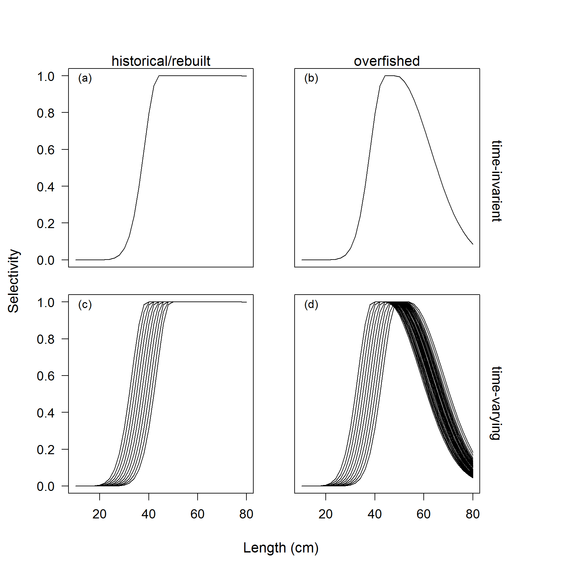

Figure 1. The fishery selectivity for either time-invariant or time-varying selectivity for the historical/rebuilt and overfished periods. The standard error of 0.50 was applied annually about the size at maximum selectivity (c) and (d) and a standard error of 0.20 was applied for the width at maximum selectivity while the stock was estimated overfished (see Methot and Wetzel, 2013 for additional details on double normal selectivity).

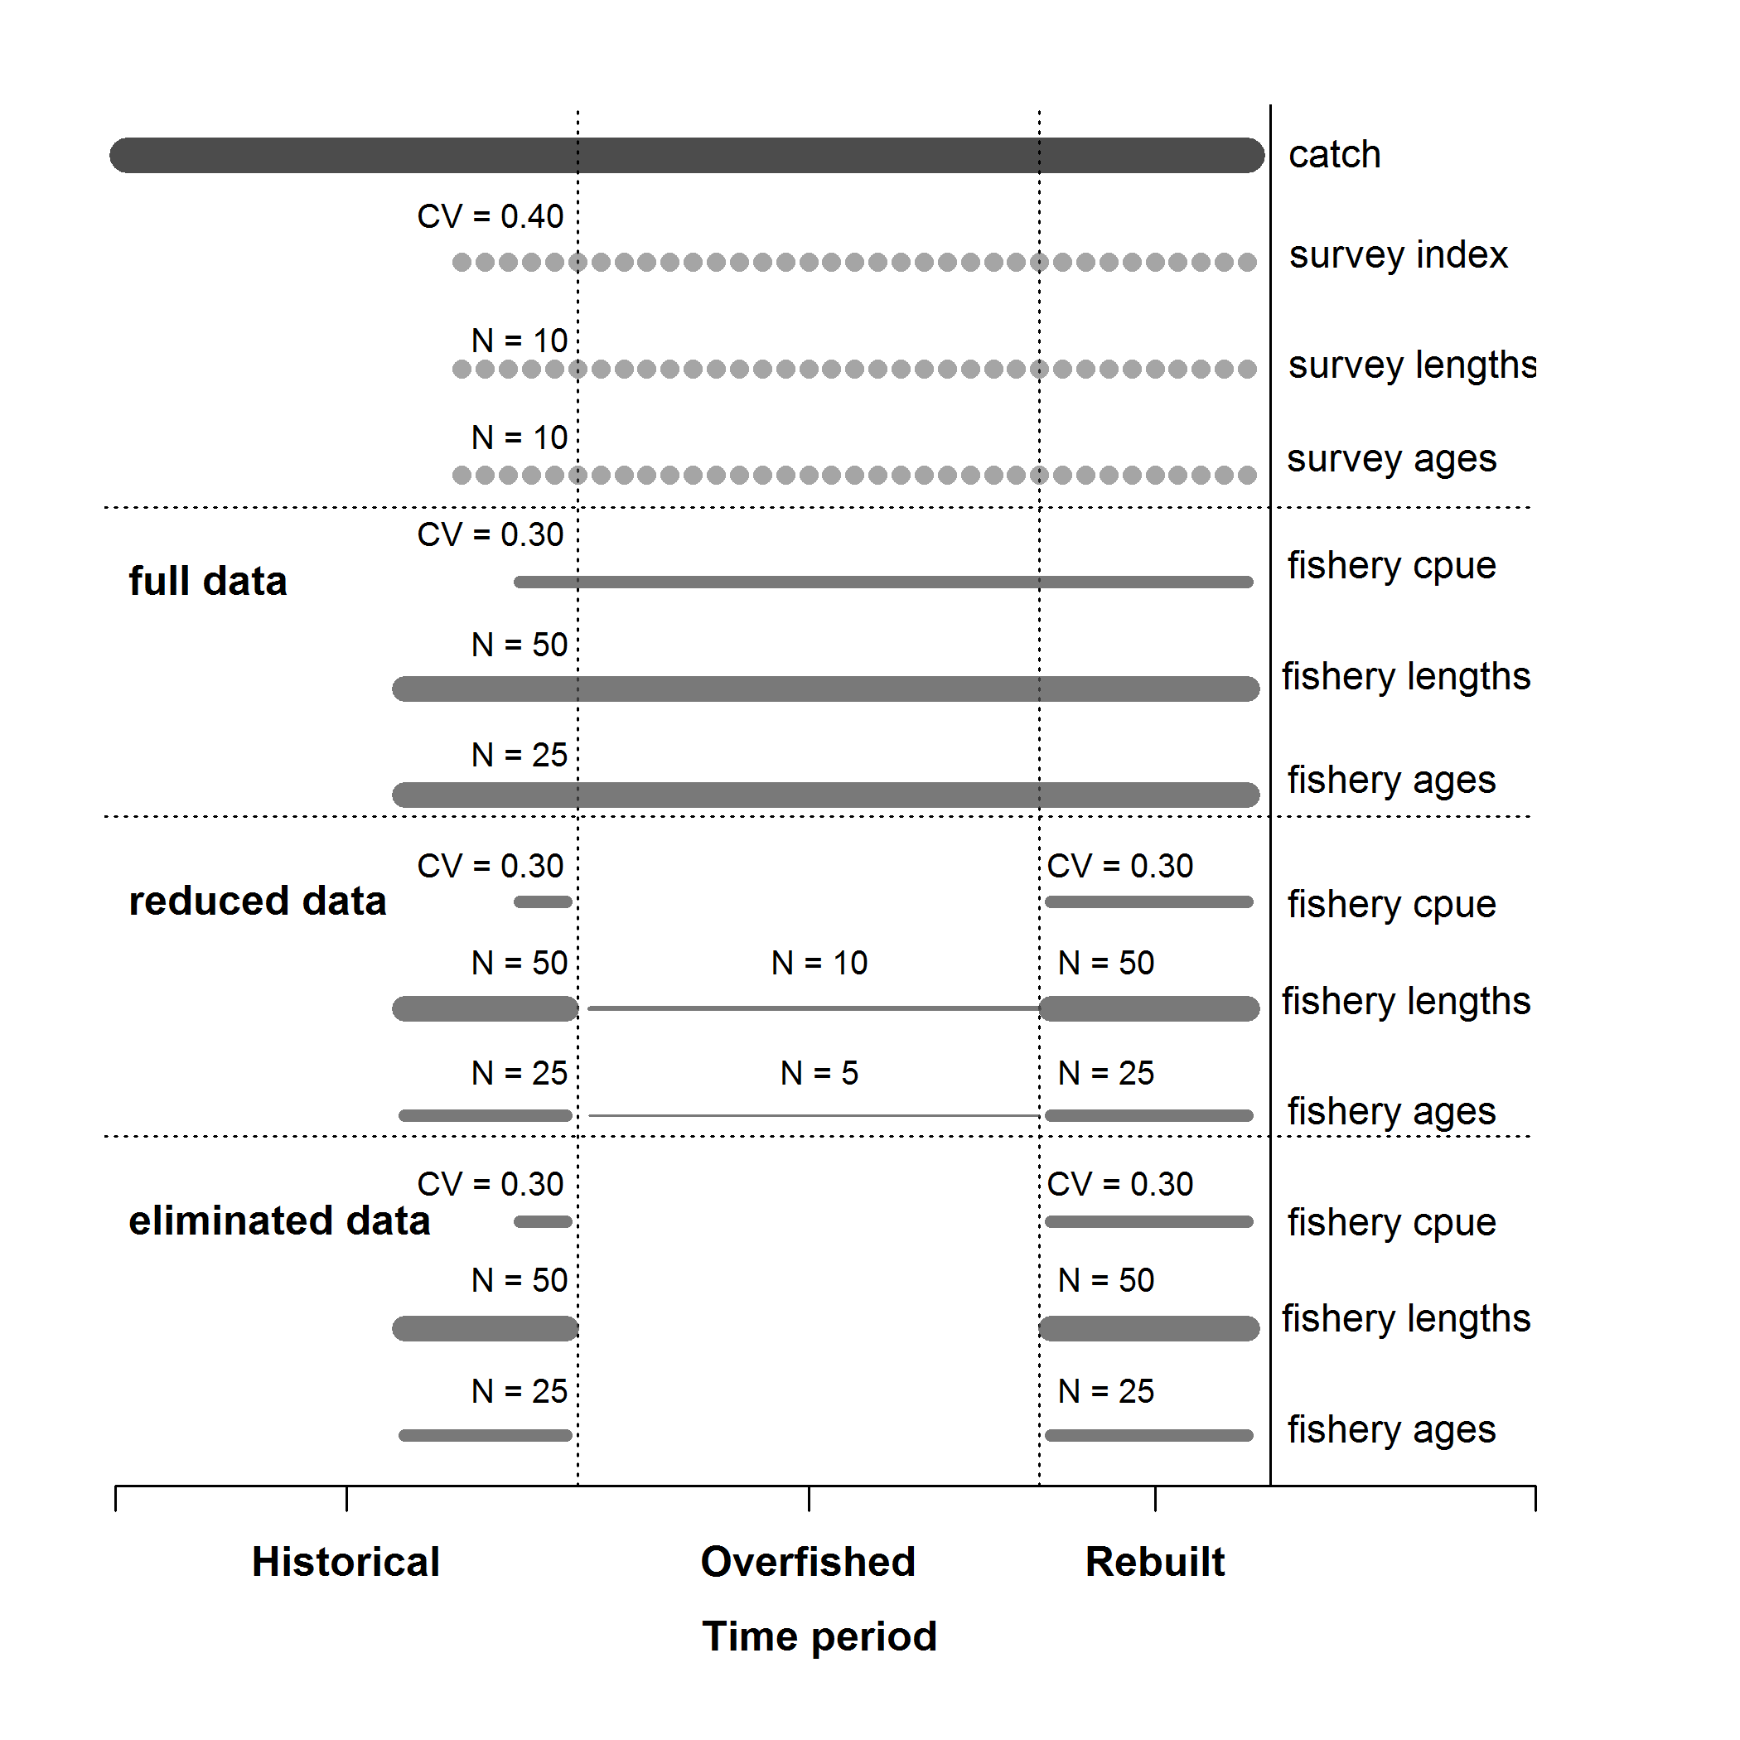

Figure 2. Summary of the data available for each of the data scenarios. Catches, survey index of abundance, survey length- and age-composition were available across all data scenarios.

.

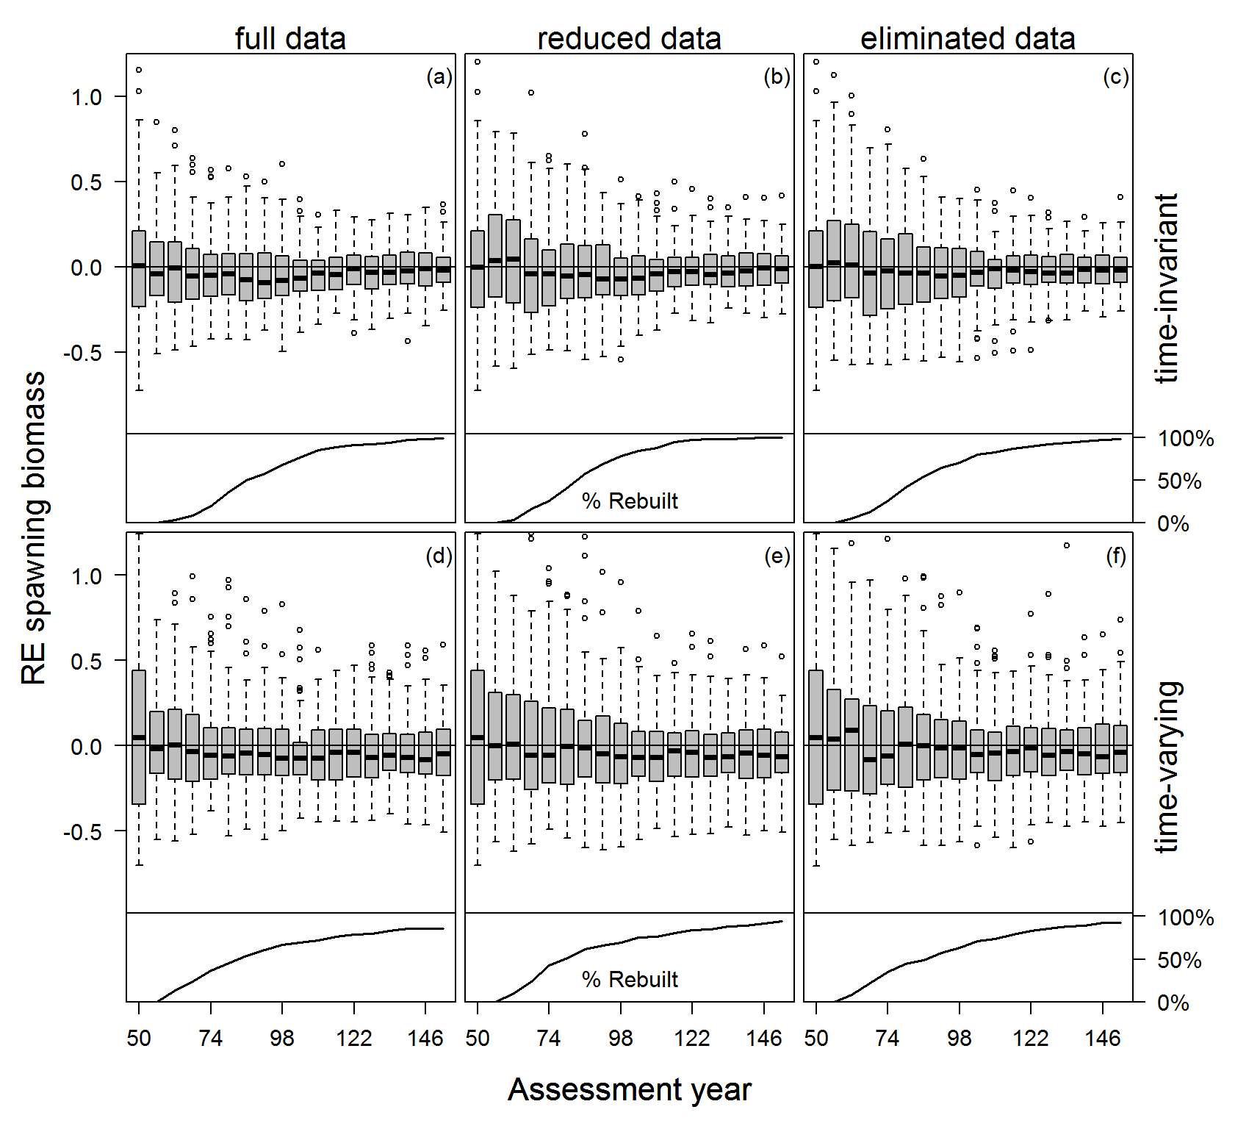

Figure 3. Relative error of spawning biomass in each assessment year for each data scenario and state of nature. The percentage of stocks that had rebuilt over time, with data collection consequently returning to historical levels are shown along the bottom of each panel.

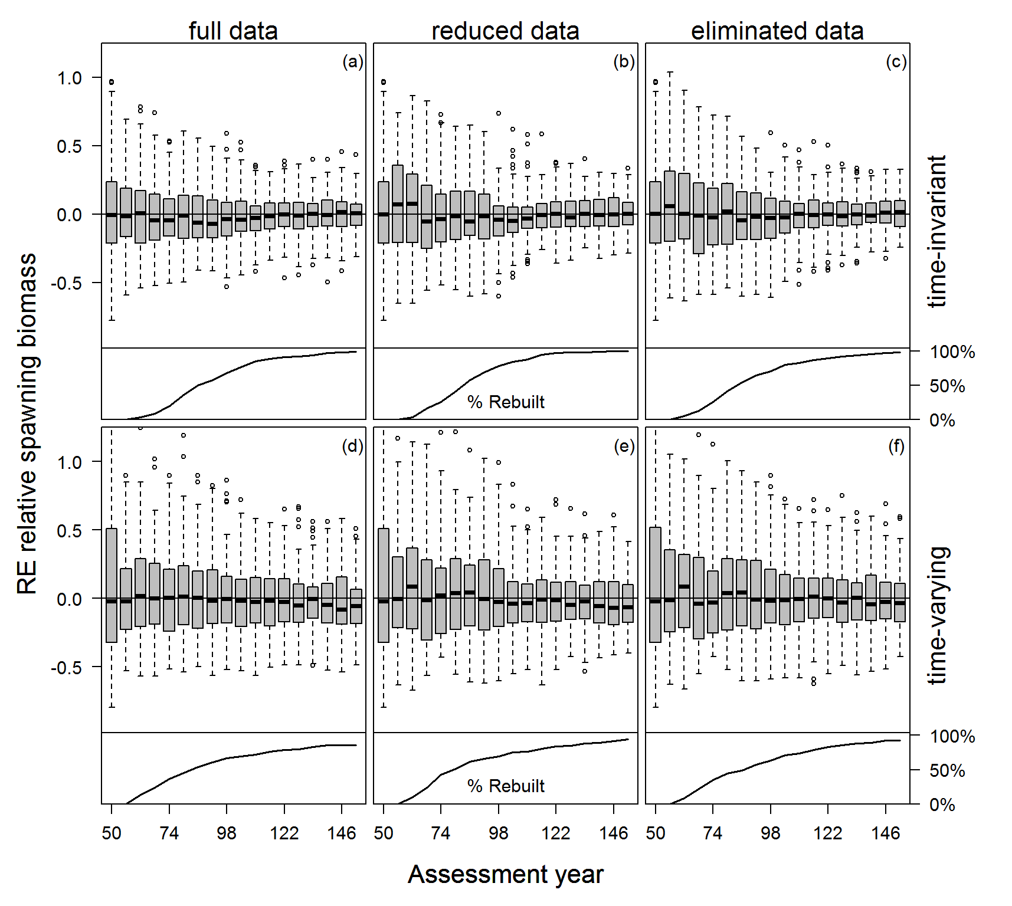

Figure 4. Relative error of relative spawning biomass in each assessment year for each data scenario and state of nature. The percentage of stocks that had rebuilt over time, with data collection consequently returning to historical levels are shown along the bottom of each panel.

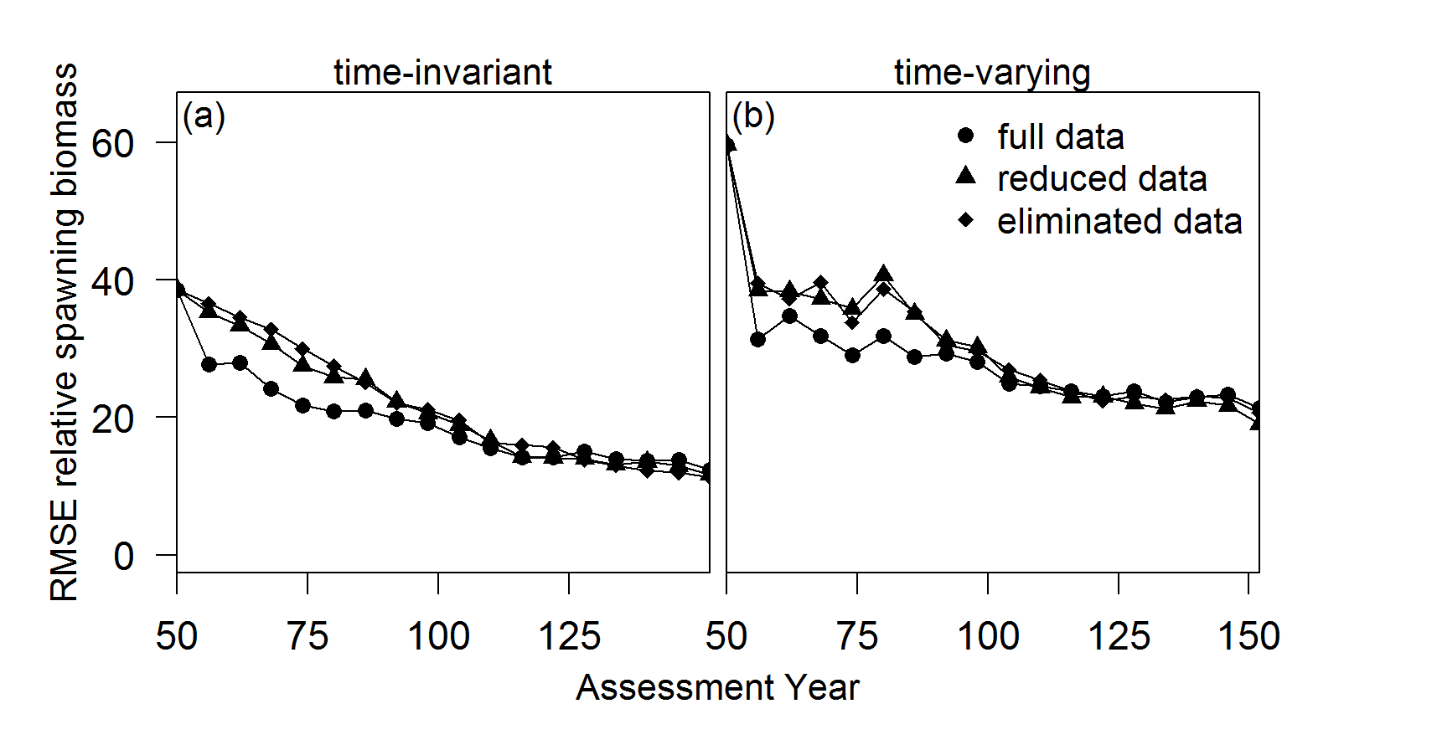

Figure 5. The root mean square error about relative spawning biomass in the assessment year for each data scenario and state of nature.

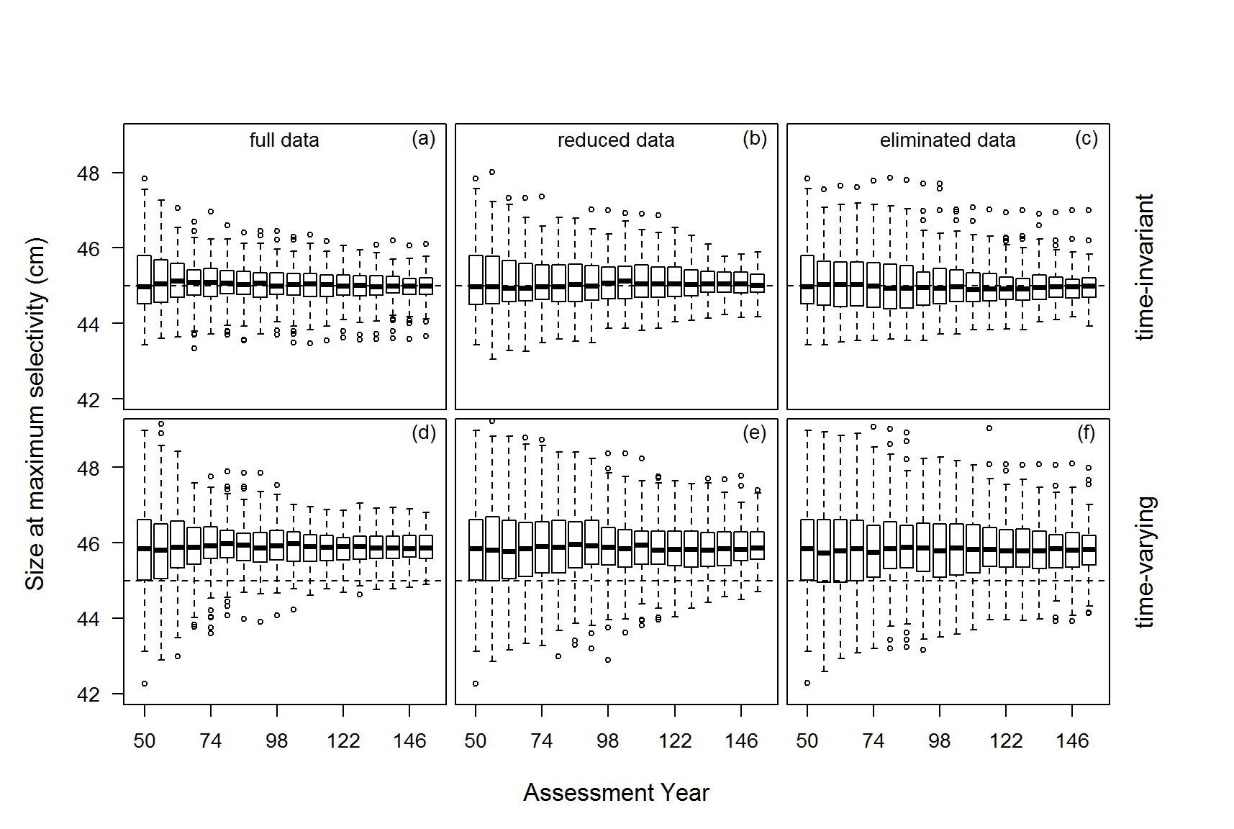

Figure 6. The estimated size at maximum fishery selectivity for each data scenario and state of nature. The time-varying data scenarios were compared against the mean of the distribution for the annual deviations in the size at maximum selectivity.

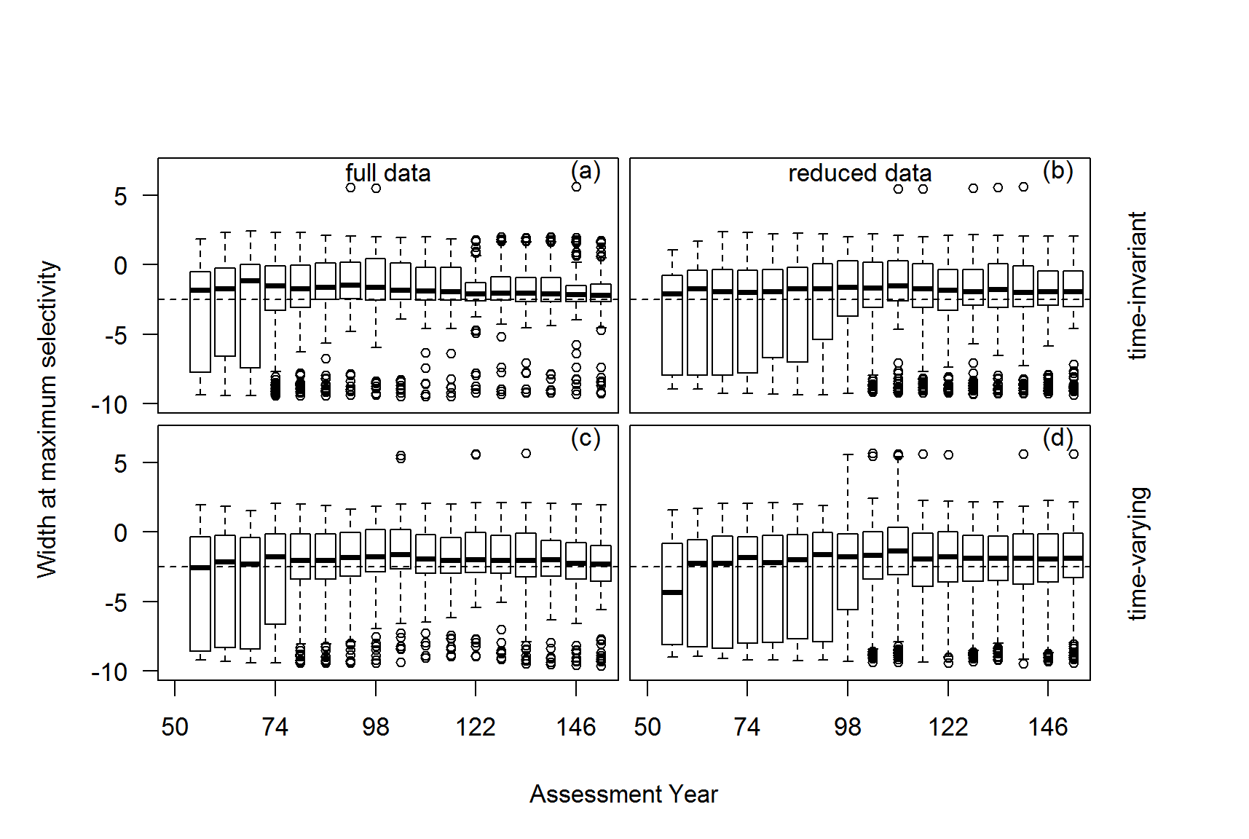

Figure 7. The estimated width at maximum selectivity for the fishery that occurred while the stock was overfished for each data scenario and state of nature. The time-varying data scenarios were compared against the mean of the distribution for the annual deviations in the width at maximum selectivity.