Linear Regression – y = w1x1 + w2x2 + … + b such that minw(y - f(x))^2
Bayes’ Rule – P(J | K) = P(K | J) P(J) / P(K)
Conditional Probability – P (F | G) = P(F,G) / P(G)
Perceptron Weight update for threshold unit - wj^t+1 = wj^t + a ( y – thresh( sumitoN wixi )) xj
Entropy – I (X) = -sumofx P(x)log(P(x))
Probit Distribution – integral from 0 to – inf N (0,1)
Marginalization – P(A,B) = SumcinC P(A,B,C = c)
Mean squared error – 1/N sumitoN (yi – f (xi))^2
Sigmoid – g(x) = 1 / (1 + e^-x)
Maximization step of EM – argmaxtheta sumH P(H|O)P(H,O|theta), hidden, observed
Chain rule of conditional probability - P(A,B,C,D) = P(D|A,B,C) P(C|A,B) P(A,B|A) P(A)
Information Gain – Iparent – sumchild P (child)Ichild
Perceptron Weight update for sigmoid unit - wj^t+1 = wj^t + a ( y – g( sumitoN wixi )) g’(sumitoN wixi) xj
Absolute independence – two separate circles
Gaussian Distribution – N (mu, sig)(x) = 1/(sig sqroot(2pi)) e ^ -(x-mu)^2 / (2 sig^2)
Output of multilayer perceptron – o = g(sumj wj^bc g(sumk wkj^ab ak))
Expectation step of EM – compute P (hidden | observed)
k-means algorithm – vi^* = argmink ||ck-xi||^2
conditional independence – P(X,Y,Z) = P (X|Z) P (Y|Z)
uniform distribution = U (a,b)(x) = 1/b-a, a < x < b or 0 otherwise
The price of tea in china(Guassian). The distribution of genders in a class(Categorical). Whether you buy a car depending on how expensive it is(Probit). Distribution of words in different topics in a topic model(dirichlet).
Vision: Convolution: Method of applying a filter to a signal. Discrete-case equation y(t) = sumn=-inftoinf x(t) h(t-n)
Detecting edges: 1-D. Take first derivative of smoothed signal y=(x*g)’ can be estimated by derivative filter d=[-1 1] y=(x*g)* d. Theorem: derivative of convolved signal is equivalent to convolving signal with derivative of filter y=x*(g’)≈x*(g*d)
Detecting edges: 2-D. Remember: gaussian components independent. G(x,y)=G(x)G(y). How do you find vertical edges? Derivative in x-direction will change Gx(x,y)=G’(x)G(y). Similar derivative in y-direction
Canny edge detection. Smooth with gaussian. Find gradient of image (I.e., derivative in x and y directions) Find edge pixels next to each other that point in similar direction
Cues from prior knowledge Shading: assumes uniform reflectance Contour: assumes minimal curvature Texture: assumes uniform texture Motion: assumes rigid bodies, continuous motion Stereo: assumes solid, contiguous, non- repeating bodies Object recognition First: segment the world Then: put the pieces back together and figure out what’s there Biometric identification: fingerprints, iris scans Content-based image retrieval: • Find a photo with “X” in it Handwriting recognition Audition:Vision: use eyes/camera and extract perceptual information Audition: use ears/microphone and extract perceptual information. Computational Auditory Scene Analysis (CASA) Separate out different sound signals Speech enhancement Similar to CASA, but focused on extracting speech from other signals (noise, other speech) Music analysis Analysis of musical styles Music information retreival
Sounds are vibrations of air molecules at a particular frequency. frequency = 1/wavelength. 1 Hertz (1 Hz) = 1 vibration/sec Often, vibrations occur at multiples of the fundamental frequency. Strength of overtones gives instruments different sounds, for example Pitch is (to a first approximation) the fundamental frequency
You can (usually) find the fundamental frequency by comparing a signal to shifted versions of itself (Autocorrelation) R(j)=∑xnxn-j
Mid-level representations form the basis for segment formation and subsequent grouping processes. Correlogram extracts periodicity information from frequency analysis. Summary correlogram can be used to identify F0 Cross-correlation between adjacent correlogram channels identifies regions that are excited by the same frequency component
Automatic speech recognition: Audition. Automatic Speech Recognition. Natural Language Understanding. Dialogue Management. Planning. Dialogue Planning. Natural Language Generation.Text-to- speech(words-signal-w-logical form-words-signal)
ASR: Feature Calculation. Acoustic Modeling. Pronunciation modeling(cat:k@t). Language Modeling(cat dog:.02). Training ASR Probability Models. Three probability models P(X|Q): acoustic model. P(Q|W): duration/transition/pronunciation model. P(W): language model. language/pronunciation models inferred from prior knowledge Other models learned from data (how?). Get a whole bunch of text data (corpus) Simplest model: Learn P(wt+1|wt) (bigram) P(<the,go,him,leave>|to) = <0.2,0.4,0.2,0.2>. Problem: what’s the probability of P(have|to)? P(<the,go,him,leave>|to) = <0.2,0.4,0.2,0.2> With this model, P(have|to)=0!. Smoothing techniques needed to estimate unseen word pairs. Add small counts for all words (bad idea in practice). Backoff smoothing: use P(have) to help estimate P(have|to). P(have|to) = P(have) BackoffWeight(to). Interpolation: P(have|to)= α P(have|to) + (1-α) P(have)
Determine “state occupancy” probabilities I.e. assign each data vector to a state. Remember: states are hidden variables Calculate new transition probabilities, new means & standard deviations using assignments. HMM Training Algorithm E-step: Compute P(q|xt) for all t. Translation: what is the probability of each phone generating the acoustic vector Viterbi training: only consider the most likely phone. • P(q*|x)=1, P(q|x)=0 for other q. M-step: Calculate P(qt+1|qt), P(xt|qt) to maximize. P(X|Q) (and subsequently P(X|W)). P(qt+1|qt): find which states occurred after other states P(xt|qt): compute new Gaussians for each state
Language Processing:
Given document D & query Q, what is probability that D is relevant? P(r | D,Q) = P(D,Q | r)P(r)/ P(D,Q) = P(Q | D,r)P(D | r)P(r) / P(D,Q) =P(Q|D,r)P(r|D) P(D) / P(D,Q) Compare against P(¬r | D,Q) = P(Q | D,¬r)P(¬r | D) P(D) / P(D,Q) =P(Q|¬r)P(¬r|D) P(D) / P(D,Q)
Instead of maximizing P(r|D,Q), maximize ratio of P(r|D,Q)/P(~r|D,Q). P(r|D,Q)/P(¬r|D,Q) =(P(Q|D,r)/ P(Q|¬r)) ( P(r|D)/P(¬r|D)). Precision: how many documents were relevant? Recall: how many relevant documents were found?
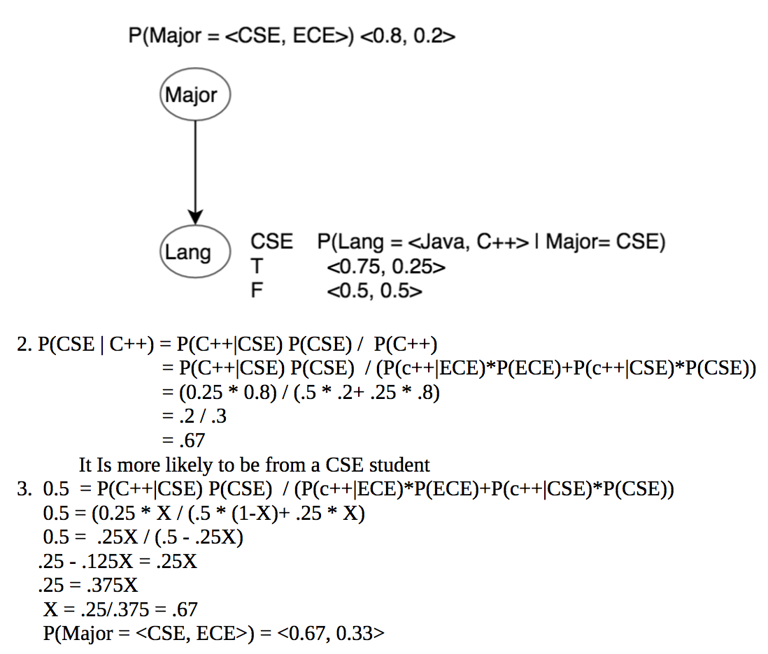
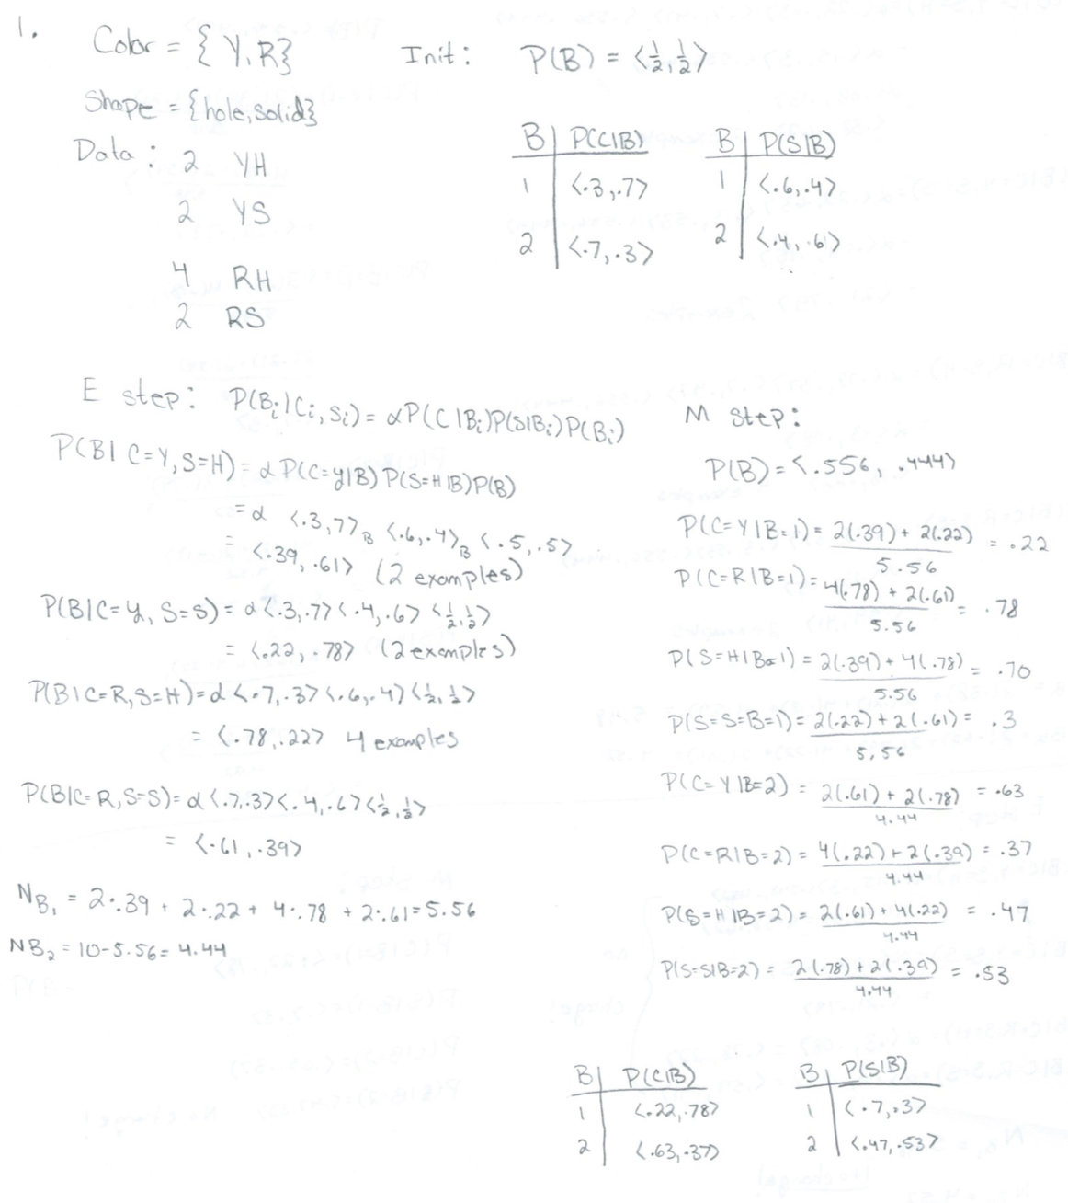
Machine language strategies. Rough translation: get the gist across, clean up afterwards. Restricted source translation: use special domains and formats. Weather reports. Preedited translations: like restricted source, reformat input document into simplified English (or other language). Choose structures that are easy to translate. Literary translation: capture all meanings. Beyond current MT capabilites

