CSE 5522 HW1 Connor Wood

1.
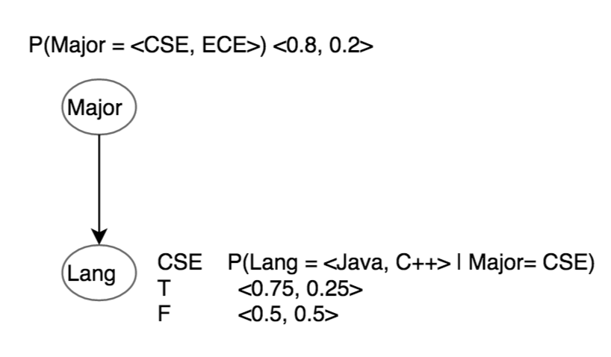
1.
2. P(CSE | C++) = P(C++|CSE) P(CSE) / P(C++)
= P(C++|CSE) P(CSE) / (P(c++|ECE)*P(ECE)+P(c++|CSE)*P(CSE))
= (0.25 * 0.8) / (.5 * .2+ .25 * .8)
= .2 / .3
= .67
It Is more likely to be from a CSE student
3. 0.5 = P(C++|CSE) P(CSE) / (P(c++|ECE)*P(ECE)+P(c++|CSE)*P(CSE))
0.5 = (0.25 * X / (.5 * (1-X)+ .25 * X)
0.5 = .25X / (.5 - .25X)
.25 - .125X = .25X
.25 = .375X
X = .25/.375 = .67
P(Major = <CSE, ECE>) = <0.67, 0.33>

2.
1. P(M|J,K,L,N) = P(M,J,K,L,N) / P(J,K,L,N)
= P(L|J,K,M,N) P(J,K,M,N) / P(J,K,L,N)
= P(L|J,K) P(J,K,M,N) / P(J,K,L,N) * given P(L|J,K,M,N)=P(L|J,K)
= P(L|J,K) P(K|J,M,N) P(J,M,N) / P(J,K,L,N)
= P(L|J,K) P(K|J) P(J,M,N) / P(J,K,L,N) * given P(K|J,M,N)=P(K|J)
= P(L|J,K) P(K|J) P(J|M,N) P(M,N)/ P(J,K,L,N)
= P(L|J,K) P(K|J) P(J|M,N) P(N|M) P(M)/ P(J,K,L,N)
= P(L|J,K) P(K|J) P(J|M,N) P(N) P(M) / P(J,K,L,N) * given P(N|M) = P(N).
= α P(L|J,K) P(K|J) P(J|M,N) P(N) P(M)
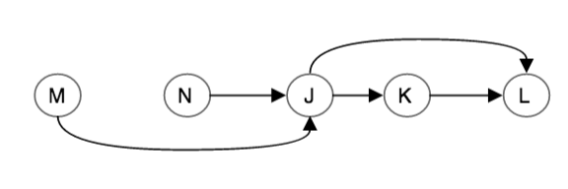
2.
3. L, J
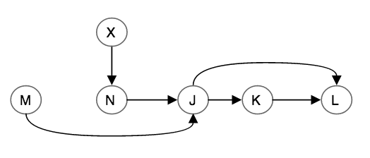
4.

3.

BAR/BAR/BAR pays 25 coins (1/5)^3 = .008
BELL/BELL/BELL pays 10 coins (1/5)^3 = .008
ORANGE/ORANGE/ORANGE pays 5 coins (1/5)^3 = .008
LEMON/LEMON/LEMON pays 4 coins (1/5)^3 = .008
CHERRY/CHERRY/CHERRY pays 3 coins (1/5)^3 = .008
CHERRY/CHERRY/? pays 2 coins (1/5)^2 - .008 = .032
CHERRY/?/? pays 1 coin 1/5 - .032 - .008= .16

1. (25 * .008)+(10*.008)+(5*.008)+(4*.008)+(3*.008)+(2*.032)+(1*.16) = 0.6 coin
2. (X * .008)+(10*.008)+(5*.008)+(4*.008)+(3*.008)+(2*.032)+(1*.16) = 1
.008X = .6
X = .6/.008 = 75 coins
3. P(win) = (.008)*5 + .032 + .16 = 0.232
4. 100000 trials: mean=25.02354, median=15

4. python wood.py agaricus-lepiota.data.train.txt agaricus-lepiota.data.test1.txt

