ScotPHO Profiles QA report - in development

Andy Pulford

06 November 2019

# Profile details

**Indictaor name:** Children registered for free school meals  
**Indicator ID:** 13012  
**Profile:** Children & young people  
**Indicator type:** Percentage  
**Year type:** School year  
**Aggregation:** Single year  
**Trend period:** 2015 to 2018  
**Geographies:** Council area, Health board

# Check OPT file

* Data match the format in the SOP.
* The indicator ID matches the technical document.
* Compare year type in OPT file against technical document:
  + **2015/16 school year** vs. **School year**
* The current published time trend is for **2015 to 2018**:
  + Start year in data: 2015
  + End year in data: 2019
* Aggregation is by Single year
* Check for missing fields:

|  |  |
| --- | --- |
| var | missing |
| code | 0 |
| year | 0 |
| numerator | 0 |
| denominator | 0 |
| rate | 0 |
| lowci | 0 |
| upci | 0 |
| ind_id | 0 |
| trend_axis | 0 |
| def_period | 0 |

* Check aggregation of numerators up to higher geographies:

|  |  |  |  |
| --- | --- | --- | --- |
| year | sc | hb | la |
| 2015 | 82642 | 82642 | 82642 |
| 2016 | 78528 | 78528 | 78528 |
| 2017 | 78041 | 78041 | 78041 |
| 2018 | 38743 | 38743 | 38743 |
| 2019 | 44422 | 44422 | 44422 |

* Check LA to HB aggregation:

|  |  |  |  |
| --- | --- | --- | --- |
| year | code | numerator | hb |
| 2015 | S08000015 | 7049 | 7049 |
| 2016 | S08000015 | 6532 | 6532 |
| 2017 | S08000015 | 6541 | 6541 |
| 2018 | S08000015 | 3280 | 3280 |
| 2019 | S08000015 | 3277 | 3277 |

* rate/percantage calculation check - manual against raw data?
* Minimum and maximum CI ranges:
  + Min: 0.2016609
  + Max: 3.5354108
* Check no rates/percentages sit outside of CI range
  + 0 rows with rate outside of CI range
* Compare Scotland to median LA or HB rate/percentage
* Plot chart as per analysis script:  
  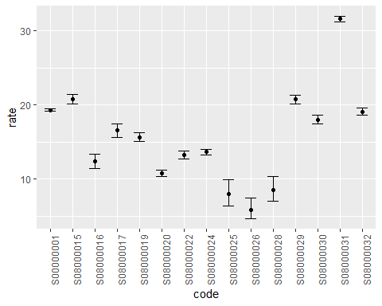

# First person QA notes

# Second person QA notes