学号 2021192010 姓名 王曦

请用英文简要描述该图的基本原理，无需用公式描述

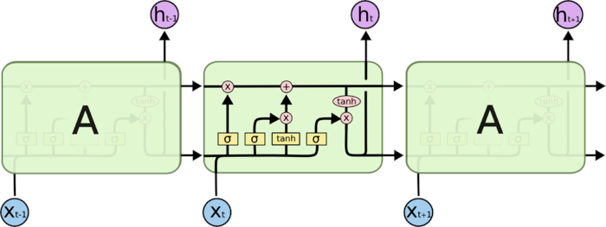

Fig. 1 Architecture of LSTM

Long short-term memory (LSTM) is an artificial neural network used in the fields of artificial intelligence and deep learning. A common LSTM unit is composed of a cell, an input gate, an output gate and a forget gate. The cell remembers values over arbitrary time intervals and the three gates regulate the flow of information into and out of the cell. Each of the gates can be thought as a "standard" neuron in a feed-forward (or multi-layer) neural network: that is, they compute an activation (using an activation function) of a weighted sum.