2021192010 王曦

**3．老师实验课上选取单表查询的难度较高的题目（要有题目语句和运行结果截屏）**

(1) 1.13 **Find all the employees whose last names end with S.**

思路：‘%S’ 表示匹配以S结尾的字符串.

代码：

|  |
| --- |
| SELECT * FROM EMP2021192010  WHERE ENAME LIKE '%S'; |

运行结果：

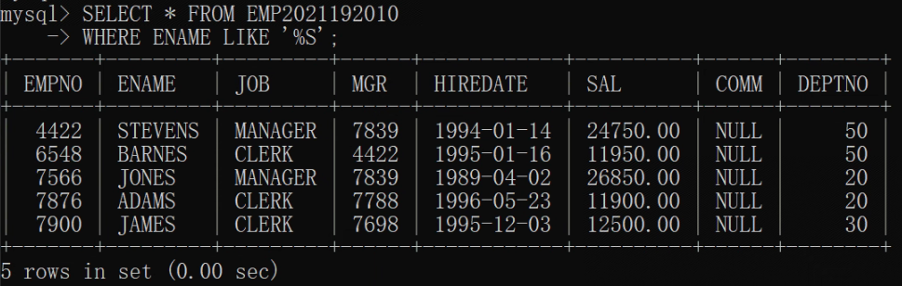

(2) 1.18 **List all salesmen in descending order by commission divided by their salary.**

思路：用WHERE指定选取的JOB为’SALESMAN’，用ORDER BY指定排序规则，用DESC表示降序排列。

代码：

|  |
| --- |
| SELECT * FROM EMP2021192010  WHERE JOB = "SALESMAN"  ORDER BY (COMM / SAL) DESC; |

运行结果：

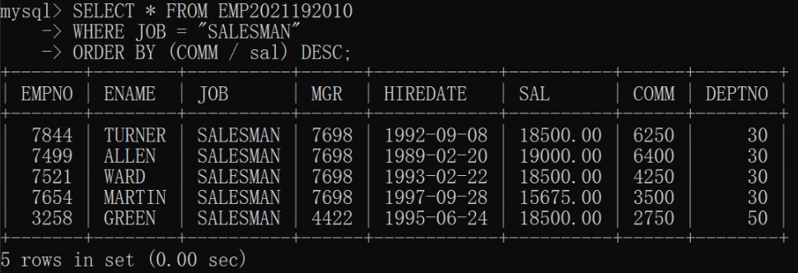

(3) 3.8 **Compute the daily and hourly salary for employees in department 30, round to the nearest penny. Assume there are 22 working days in a month and 8 working hours in a day.**

思路：

1. 表中的 SAL 为月薪（设单位为dollar），求日薪需除以 22 ，求时薪需再除以 8 。
2. ROUND() 函数可实现四舍五入。
3. 为四舍五入到penny，因 1 dollar = 100 penny ，可将数值乘 100 后用 ROUND() 函数取整后再除以 100 。

代码：

|  |
| --- |
| SELECT * FROM  (SELECT (ROUND(SUM(SAL) / COUNT(*) / 22 * 100) / 100) AS 'Daily Salary'  FROM EMP2021192010 WHERE DEPTNO = 30) tmp1, # 别名不可省略, 下同  (SELECT (ROUND(SUM(SAL) / COUNT(*) / 22 / 8 * 100) / 100) AS 'Hourly Salary'  FROM EMP2021192010 WHERE DEPTNO = 30) tmp2; |

运行结果：

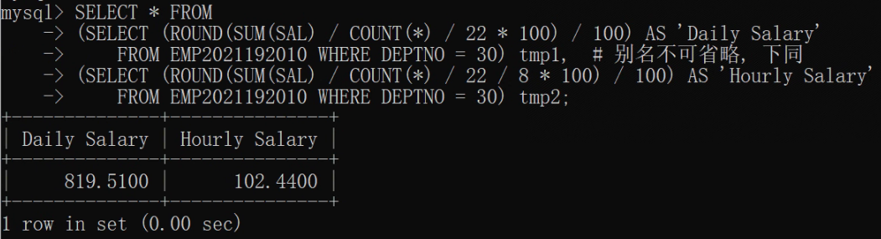

(4) 5.4 **List the average annual salary for all job groups having more than 2 employees in the group.**

思路：

1. COUNT(*) 可统计数据表中非空表项的个数。
2. 因 COUNT(*) > 2 不是表的属性，故查询时需用 HAVING 指定。
3. 用 GROUP BY 指定按 JOB 分组。

代码：

|  |
| --- |
| SELECT JOB, AVG(SAL)  FROM EMP2021192010  GROUP BY JOB  HAVING COUNT(*) > 2; |

运行结果：

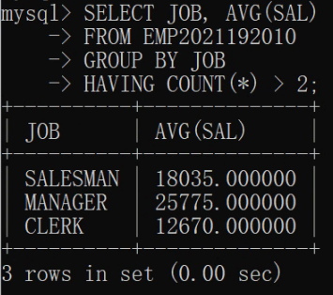

(5) 5.5 **Find all departments with an average commission greater than 25% of average salary.**

思路：AVG() 函数可对指定属性的所有非空值取平均。

代码：

|  |
| --- |
| SELECT DEPTNO  FROM EMP2021192010  GROUP BY DEPTNO  HAVING (AVG(COMM) > 0.25 * AVG(SAL)); |

运行结果：

