2021192010 王曦

(1) 2.5 **For each employee whose salary exceeds his manager's salary, list the employee's name and salary and the manager's name and salary.**

代码：

|  |
| --- |
| SELECT worker.ename 'worker name', worker.sal 'worker salary', manager.ename 'manager name', manager.sal 'manager salary'  FROM emp2021192010 worker, emp2021192010 manager  WHERE worker.mgr = manager.mgr AND worker.sal > manager.sal; |

运行结果：

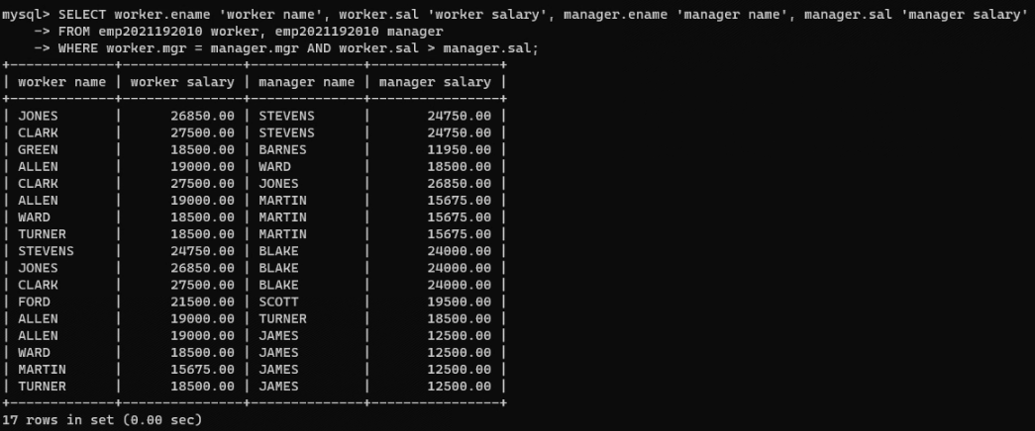

(2) 6.3 **List the name, job, and department of employees who have the same job as Jones or a salary greater than or equal to Ford.**

代码：

|  |
| --- |
| SELECT ename, job, deptno  FROM emp2021192010  WHERE  (job = (SELECT job FROM emp2021192010 WHERE ename = 'JONES') AND ename != 'JONES')  OR (sal >= (SELECT sal FROM emp2021192010 WHERE ename = 'FORD') AND ename != 'FORD'); |

运行结果：

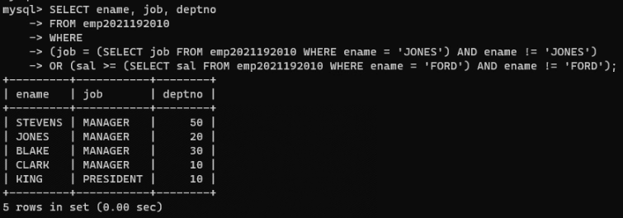

(3) **Find all the employees that earn more than the average salary of employees in their department.**

建表代码：

|  |
| --- |
| CREATE DATABASE exp2;  USE exp2;  CREATE TABLE A2021192010 (  sno VARCHAR(2),  pno VARCHAR(2)  ) ENGINE = InnoDB;  INSERT INTO A2021192010 VALUES  ('s1', 'p1'),  ('s1', 'p2'),  ('s1', 'p3'),  ('s1', 'p4'),  ('s2', 'p1'),  ('s2', 'p2'),  ('s3', 'p2'),  ('s4', 'p2'),  ('s4', 'p4');  SELECT * FROM `A2021192010`;  CREATE TABLE B2021192010 (  pno VARCHAR(2)  ) ENGINE = InnoDB;  INSERT INTO B2021192010 VALUES ('p2');  SELECT * FROM `B2021192010`; |

查询代码：

|  |
| --- |
| SELECT DISTINCT sno FROM A2021192010 seller WHERE NOT EXISTS  (SELECT * FROM B2021192010 part WHERE NOT EXISTS  (SELECT * FROM A2021192010 relation WHERE seller.sno = relation.sno AND part.pno = relation.pno)); |

运行结果：

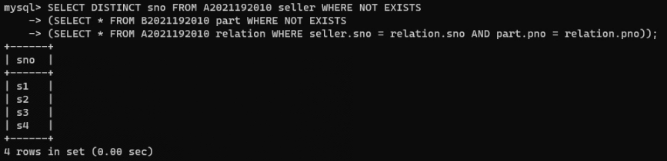

向B表中插入数据 p4 ，再次查询：

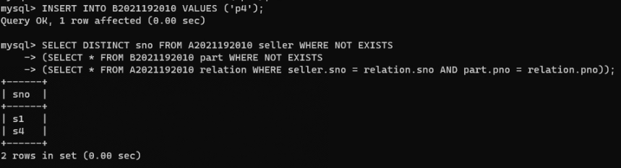

向B表中插入数据 p1 ，再次查询：

