Cynthia Halim

February 23, 2021

Foundation of Programming: Python

Assignment 06

GitHub URL: <https://cxhuw.github.io/ITFdn110-Mod06/>.

Functions and Input/Output (IO)

## Introduction

For this assignment, students are given a task to create a Python script which uses loops as well as Functions and Input/Output. The input data is interactive based on user’s input and the expectation is for user to create a task in a text file and for the script to read it form the text file with a set of options in the script. For this paper, I will go thru the steps that I took to create the script.

## Understanding the Assignment

For this particular assignment, it is an expansion of previous assignment (Assignment05). The intent is to understand the various commands of functions, returns as well as input/output.

## Scripting

I add the title, name, date and change log as well as brief synopsis on what the script does using pseudo-code in comment form.

The assignment contains menu option that requires user’s input (Figure 1). Prof Root has provided majority of the script and we filled out the gaps with scripting.

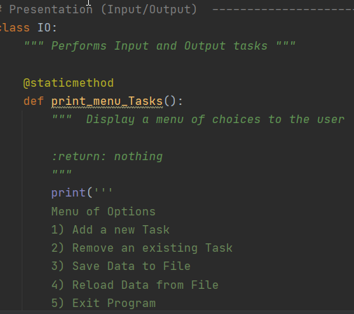

***Figure 1. Menu options***

I basically set up the gaps to be similar to Assignment 05 except some tweaking is needed due to the way the loops are set up. Static methods are used by Prof Root to bind the methods to a class.

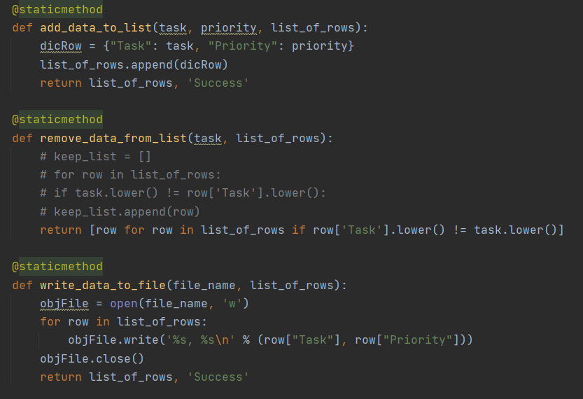

***Figure 2. Setting up the text file for data to be read, removed and written***

The presentation section of the script for the majority is already created by Prof. Root except for the two sections (Figure 3). For this case, I pretty much copied over the script from Assignment05

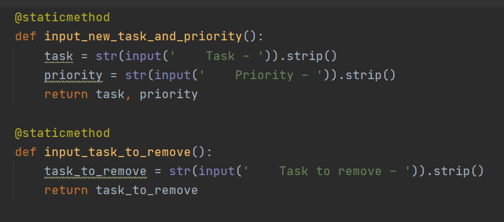

***Figure 3. Setting up functions for adding and removing task***

Next is adding script for the looped functions (Figure 4) by adding input output (IO) scripts that is already defined by Prof. Root.

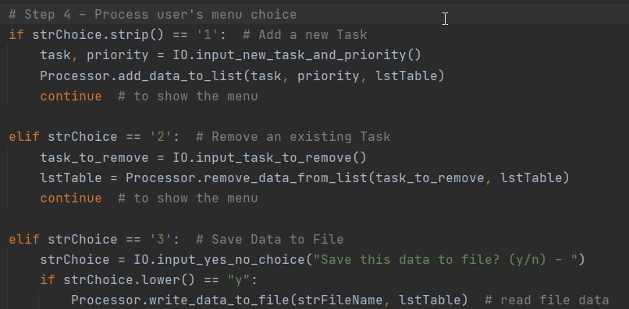

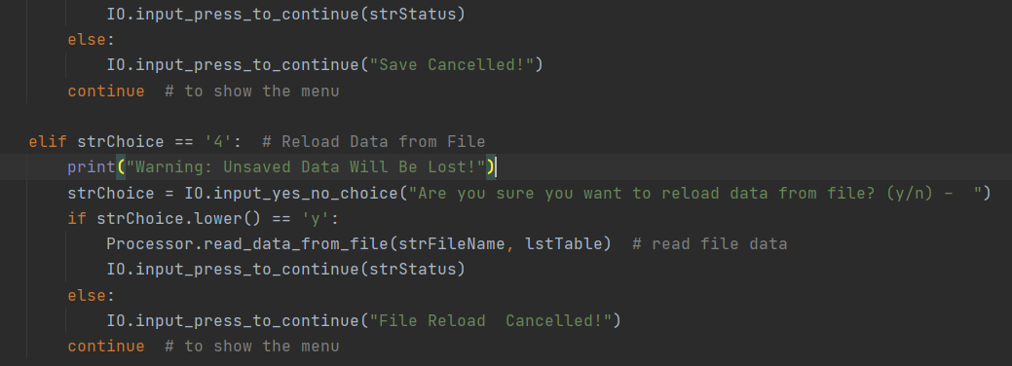

***Figure 4. Adding scripting for input output***

And the last elif is to exit out the program (Figure 5). This is similar to the script used in Assignment05.

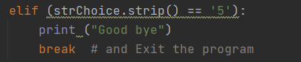

***Figure 5. Exit script***

End of the loop is else loop if user choose an option that is not in the menu (Figure 6).

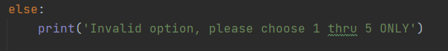

***Figure 6. User feedback if menu option is out of bound***

## Running PyCharm

I run the script in PyCharm by right clicking in the script and hit “run”.

A text file is created and show the data provided by user (Figure 7)

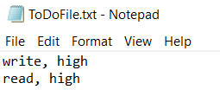

***Figure 7. Text file input***

In addition, I also run the script in the Command prompt to ensure that the codes will work (Figure 8).

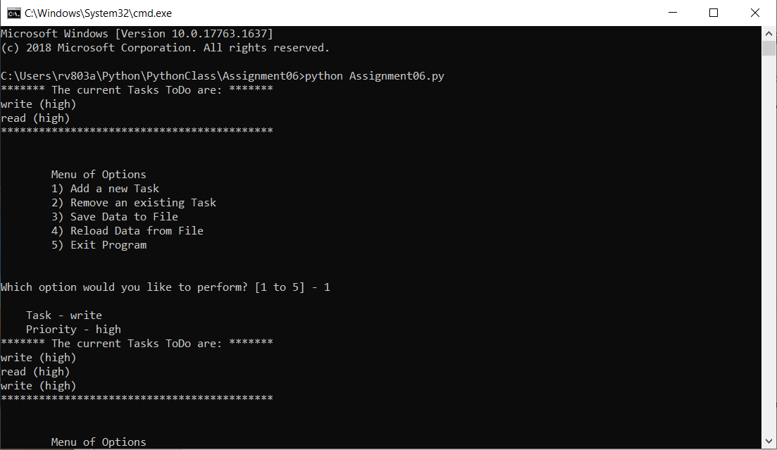

***Figure 8. Input in Command prompt***

## Summary

This assignment is challenging not only because there are multiple functions but also understanding or interpreting someone else’s code. In addition, the length of the script is challenging in that each section has to be broken down for debugging purposes.