Cynthia Halim

February 15, 2021

Foundation of Programming: Python

Assignment 05

List and Dictionary

## Introduction

For this assignment, students are given a task to create a Python script which uses loops as well as Dictionary. The input data is interactive based on user’s input and the expectation is for user to create a task in a text file and for the script to read it form the text file with a set of options in the script. For this paper, I will go thru the steps that I took to create the script.

## Understanding the Assignment

For this particular assignment, it is an expansion of previous assignment (Assignment04). The intent is to understand the difference between list and dictionary and

## Scripting

I add the title, name, date and change log as well as brief synopsis on what the script does using pseudo-code in comment form.

The assignment contains menu option that requires user’s input (Figure 1). From Assignment 04, it’s similar set up except that I did the script for the menu as stringer instead of print in this assignment

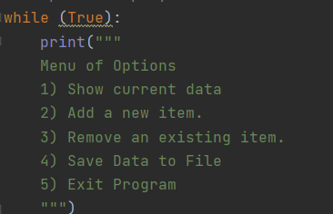

***Figure 1. Menu options***

Prof Root has provided the loop for the students to use and then for students to add the code for each loop.

I set up the text file to read the existing table from by using stringer and dictionary for key (Task) and value (Priority) as well as a list. A list can be modified in an order (Figure 2).

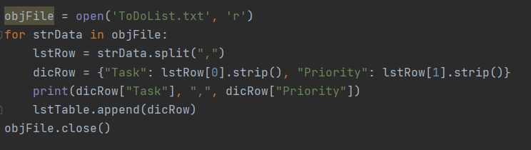

***Figure 2. Setting up the text file for data to be read***

The first loop (a while loop) contains the menu (Figure 1) while the first if loop is to create a loop to show the current data (option 1). For this particular loop, I create a dictionary with key (Task) and value (Priority) in the text file (Figure 3). The dictionary for the loops remained the same throughout.



***Figure 3. Setting up to show current data in the text file***

Next is adding the new item to the text file using stringers for defined key and value so that they can be recalled in the next line by using dictionary function. Last is to add the new item(s) to the table using the list command (Figure 4).

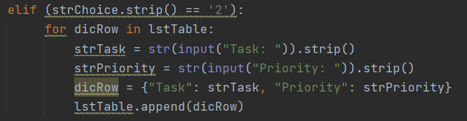

***Figure 4. Adding new item(s) into the list***

Next is to remove a new item from the list. I’m not very clear about this step from the description of the pseudo code. Whether it meant to remove all the new items input or the last new item input in the table. The script written is to remove the last new item input by using the pop() function (Figure 5) as described in the following website *https://www.afterhoursprogramming.com/tutorial/python/page/4/* (external)

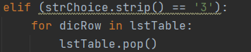

***Figure 5. Removing a new item in the list***

The next elif loop is to save the data in the text file using different File commands (open, write and close) by using the same dictionary function as previous loop (Figure 6).

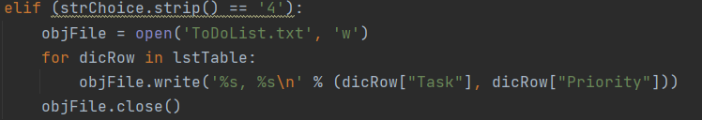

***Figure 6. Saving data into the text file***

And the last elif is to exit out the program (Figure 7).

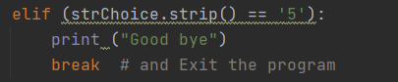

***Figure 7. Exit script***

End of the loop is else loop if user choose an option that is not in the menu (Figure 8).

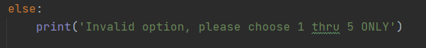

***Figure 8. User feedback if menu option is out of bound***

Each part of the loop describes a separation of concerns which separates the script into distinct sections.

## Running PyCharm

I run the script in PyCharm by right clicking in the script and hit “run”.

A text file is created and show the data provided by user (Figure 8)

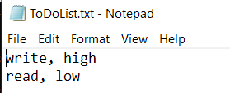

***Figure 8. Text file input***

In addition, I also run the script in the Command prompt to ensure that the codes will work (Figure 9).

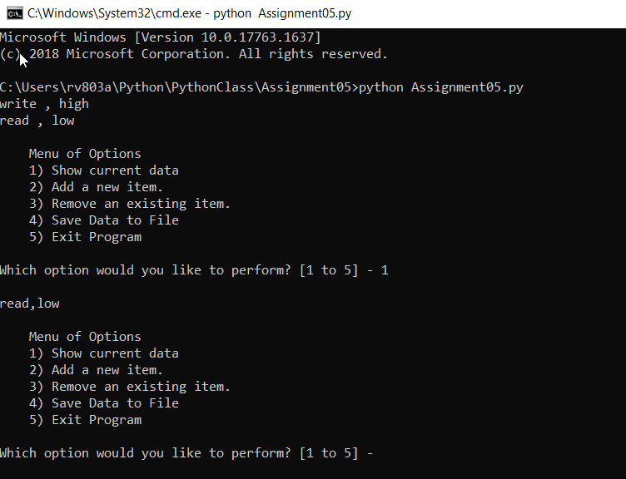

***Figure 9. Input in Command prompt***

## Summary

This assignment is challenging not only because there are multiple loops but also understanding or interpreting someone else’s code. I also learn when to use list and when to use directory as well as new functions (such as strip and pop).