ContMulti-objective optimization model for momentum change based on genetic algorithm
Anonymous Submissions*
Abstract. This paper uses key events in the dataset as indicators of player momentum changes to explore the dynamic changes in momentum during matches. Using genetic algorithm to optimize the momentum change amplitude of different players in key events, forming a multi-objective optimization model. Firstly, process the data and fill in missing values, and test the correlation between the data through correlation analysis. Select key events that affect player status as momentum change events and use them as optimization objectives for genetic algorithms. The accuracy of momentum prediction for the next serve winning rate is about 60%. The cointegration test and Granger causality analysis determined the impact of momentum on game scores. Using the established optimization model, an analysis of a game was conducted, and the results showed that the score and penalty were the most critical factors. A universality test was conducted on a table tennis match, with an accuracy of approximately 65%, but it was affected by a lack of dataset and information. There is a covariance between the score difference and the player's momentum change in the game, but there is no clear causal relationship.
Keywords: Genetic Algorithm, Multi-objective Optimization, Cointegration Test,Granger ,Causality Analysis.
- Introduction
In the 2023 Wimbledon men's singles final, 20-year-old Spanish star Carlos Alcaraz defeated 36-year-old Novak Djokovic. The loss was Djokovic's first at Wimbledon since 2013 and ended an amazing run of Grand Slam tournaments for the tennis star. Before the tournament, people thought Djokovic could continue his myth, which is true if only based on past results, but the results of the tournament often have nothing to do with past results.
In competitive play, the factors that affect an athlete's performance are extremely complex. Age, diet, weather and many other factors influence the course of a match, but we have observed that there seems to be one decisive factor - momentum. Momentum in this context refers to the continuity of wins, losses or scores produced during a game; for example, an athlete or team scoring a point may score consecutive points during a game. We call this continuous scoring "momentum" and it plays an important role in the game.
In sports, momentum is more than a simple reference to consecutive scoring or tactical advantage; it can also be expressed as the mood, energy, and momentum of an athlete or team. The presence of momentum creates a "rush" in a game, allowing an athlete or team to demonstrate a higher level of performance at critical moments. The spread of momentum in a game is significant. Once one team has gained an advantage, this advantage is often transferred to the whole team, generating more motivation and self-confidence. This emotional momentum can allow athletes to perform more tenaciously and courageously during a game, leading to better results.
On the other hand, momentum can also affect the performance of the opponent. When one side consistently gains an advantage, opponents tend to feel pressure and frustration, which can lead to a decrease in their performance. This psychological momentum can allow a side to gain a greater advantage in the game and thus win.
In addition to the emotional and psychological aspects, momentum can also affect the technical and tactical aspects of the game. When a side is consistently gaining an advantage, they tend to be able to execute their tactics more comfortably and show a higher level of technical skill. This technical momentum can further solidify a side's dominant position, thus ensuring victory in the game.
Momentum is therefore a multi-dimensional presence in sports, which is not only reflected in scoring and tactics, but also involves emotional, psychological, and technical aspects. Understanding and mastering the use of momentum is crucial to achieving success in the game. In order to study momentum changes, this paper chooses the real match of 2023 Wimbledon Men's Open Tennis Tournament as the training set, and the data of the match between Guido Pella and Roman Safiulin and the real data of the table tennis match on February 4, 2024 as the test set.
The aim of this study is to examine the dynamic changes of athletes' momentum during the match and to use the changes of key events in the dataset as an index to quantify the momentum. We used an improved genetic algorithm to optimize the magnitude of momentum changes of different players during the key events of the match and constructed an optimization model (GMCM) [1]. Specifically, we selected the key events that have a significant impact on the player's state as the momentum change events, and used the momentum change values of these events as the optimization objective of the genetic algorithm. The score of the next serve is predicted by predicting the player's momentum so that the player with more momentum is expected to win the next serve. In this study, we used real match data, including the data of the match between Guido Pella and Roman Safiulin [2] and the data of a table tennis match on February 4, 2024 [3] as the test set, which achieved 64.7% and 65% correctness rates, respectively. In this paper, we only consider "momentum", and the dataset used is based on the game data of the two sides with equal strengths, instead of the traditional feature-based prediction of machine learning. The focus of this paper is to study the effect of momentum on winning and losing [4], rather than momentum determining winning and losing, so the prediction accuracy is not the primary goal of this paper. The research in this paper provides a new idea for the prediction of sports games.
In the introduction of this paper, we provide an overview of the overall framework of the study and the content of each chapter. Chapter 2 will review relevant prior work that provides a theoretical and practical foundation for our study. Chapter 3 will explain the dataset we use, including its sources, and data characteristics. In Chapter 4, we will detail our proposed methodology, including the model design and optimization process. Next, Chapter 5 will show our experimental results and analysis to verify the effectiveness and performance of the proposed method. Chapter 6 will summarize our research results and discuss their applications in practice and future directions. Finally, in Chapter 7, we will extend our sincere thanks to all those who have provided support and help for this research and make the dataset and code publicly available. Together, these chapters will form the structure and content of this paper, providing a comprehensive exposition and explanation of our research.
- Related work
In this paper's research, we worked to investigate the effects of in-play events on changes in athlete momentum in order to improve athlete performance and the accuracy of predicting game outcomes. We employed multiple data processing and analysis methods to ensure data integrity and reliability. First, we utilized longitudinal forward padding to populate the NA values in the dataset to ensure the continuity of the race data. For categorical variables containing NA values, we chose to populate the data using the mean of the data to maintain data uniformity and comparability. In the data exploration stage, we set the momentum in the race as a dynamic variable, which provided an important reference for our subsequent analysis. By using a genetic algorithm for multi-objective optimization, we were able to predict the winning percentage of the next goal and use the player's status as an indicator of the winning percentage. At the same time, we used prediction accuracy as a fitness function [5] and cross-entropy [6] as a loss function [7] to evaluate the accuracy and effectiveness of our model. This integrated approach allows us to understand more comprehensively the impact of in-race events on athlete momentum and provides an effective tool and guide for optimizing the prediction model. Momentum analysis is one of the key components of our study. By using the changing values of momentum to predict the probability of each athlete scoring the next shot, we are able to more accurately assess the athlete's condition and performance. At the same time, we record the total correct rate to assess the predictive accuracy of our model. Considering the game data as a time series and applying the cointegration test [8] and Granger causality test [9] to show the correlation between momentum and the difference in players' opening scores provides us with deeper insights and analytical perspectives to help us better understand the role and impact of momentum in the game. In terms of momentum factor identification, we use visualizations to process momentum data to identify the factors that are most relevant to momentum. By identifying the key factors that affect a player's momentum, we are able to target improvements to enhance player performance and athleticism. This integrated approach to data analysis and visualization allowed us to more accurately grasp the patterns and trends of momentum changes, providing a solid foundation and basis for our research. Finally, this paper also explored the application of this study on other ball players' data to expand the practical value and scope of application of the study. By applying the research results to other fields and datasets, we were able to validate our methods and conclusions more comprehensively and provide more scientific and effective support for athletes' training and playing strategies. This cross-disciplinary application and promotion helps to improve the practicality and generalization of our research, and provides new ideas and methods for data analysis and prediction research in the field of sports.
- Description of the data set
In this paper, we choose the real match of 2023 Wimbledon Men's Open Tennis Tournament as the training set, and the data of the match between Guido Pella and Roman Safiulin and the real data of the table tennis match on February 4, 2024 as the test set.
  - Characteristics and attributes of the dataset
Large datasets with precise annotations are becoming more and more important for training models, however, in tennis, as each athlete's feelings about special events in the match are subjective, they have different sensitivity to the special events, which also greatly increases the complexity of the calculation.We intercept and analyze the real matches of the Men's Open Tennis Championships at Wimbledon in 2023, and integrate the We intercepted and analyzed the real match situation of Wimbledon Men's Open 2023, and integrated the expressions of the athletes to predict their psychology, and finally intercepted the more representative events to be listed, as shown in the Table 1.
Table1.Description of the data set
Column(s) | Value(s) | Description
match id | “2023-wimbledon-1301” | The 3 in"1301"indicates a round 3 match and the “01”indicates the first match listed from that round
elapsed_time | “0:01:31” | The point begins with a serve 1 minute and thirty-one seconds after the start of the first point of the match.
point no,game no,set no("no"is an abbreviation for number) | 411 | The point played is the 4 point of the 1"game of the Ist set of the match
pl_sets,p2_sets,pl_games,  p2 games | 0 | Since this is the first game of the match neither player has won a game or set yet.
pl_score,p2 score | 1,530 | The score when the point is played is 15 (player 1),to 30 (player 2).Thus,player 1 won one of theprevious points and player 2 won two points.
server | 1 | Player 1(Alcaraz)is serving on this point.
serve no | 1 | The point was played on the first serve meaning Alcaraz hit his first serve in play
point victor | 1 | Alcaraz wins this point (player 1)

These data are explanations about tennis matches: "match_id" identifies the round and order of the match." elapsed_time" indicates the time since the start of the match." point_no, game_no, set_no" describes the course of the match." p1_sets , p2_sets , p1_games , p2_games "Indicates the scores of both teams." p1_score , p2_score" shows the current score." server" identifies the current server." serve_no" indicates the number of serves." point_victor "Shows the winner." p1_points_won , p2_points_won "Shows the points of both players." game_victor, set_victor "Indicates the winner of the set and board." p1_winner" and "winner_shot_type" describe how points are scored." p2_net_pt" and "p2_net_pt_won" indicate Jarry's actions and results.
- Methodologies
Algorithm 1: 算法的数据训练
Require: 生成模型
1: Input: point_victor，consecutive_wins，consecutive_losses- momentum_player1，momentum_player2，server，rally_count
2: Output: Player Momentum Value
3:If point_victor is equal to 1,
then consecutive_wins is incremented by 1 and consecutive_losses is set to 0.
4:If point_victor is equal to 2,
then executive_losses is incremented by 1 and executive_wins is set to 0.
5:If consecutive_losses is equal to 2, then momentum_player1 plus a
6:If consecutive_wins equals 2, then momentum_player2 plus b
7:If consecutive_wins is equal to 3, then momentum_player1 plus c
8:If executive_losses is equal to 3, then momentum_player2 plus d
9:If server equals 1, then momentum_player1 plus e
10:If server equals 2, then momentum_player2 plus f
11:If server is equal to 1, and rally_count is equal to 0, and point_victor is equal to 1, then momentum_player1 minus g
12:If server is equal to 2, and rally_count is equal to 0, and point_victor is equal to 1, then momentum_player2 subtracts h
13:end
This paper converted the player information into numerical identifiers, then cleaned the dataset, filled in the missing values, discrete analyzed and normalized the data, viewed the basics of the data by browsing through the data, set momentum as a dynamic variable and used a genetic algorithm, used multi-objective optimization, used the player's momentum value as the probability of winning the next ball, and used the prediction accuracy as the fitness function, the cross-entropy function as the loss function, the main events affecting the players during the game as the optimization objective, using the momentum change as an indicator to predict the probability of each athlete's next score and record their momentum values, this paper used the cointegration test and Granger causality test to analyze the matched data and the correlation analysis of the momentum score values with the athletes' scores, and the momentum visualization to Plot the momentum and momentum difference between athletes to predict whether a player will score the next goal or not, and identify the factors that have the highest correlation with momentum.The research idea of this paper is shown in the Figure 1.
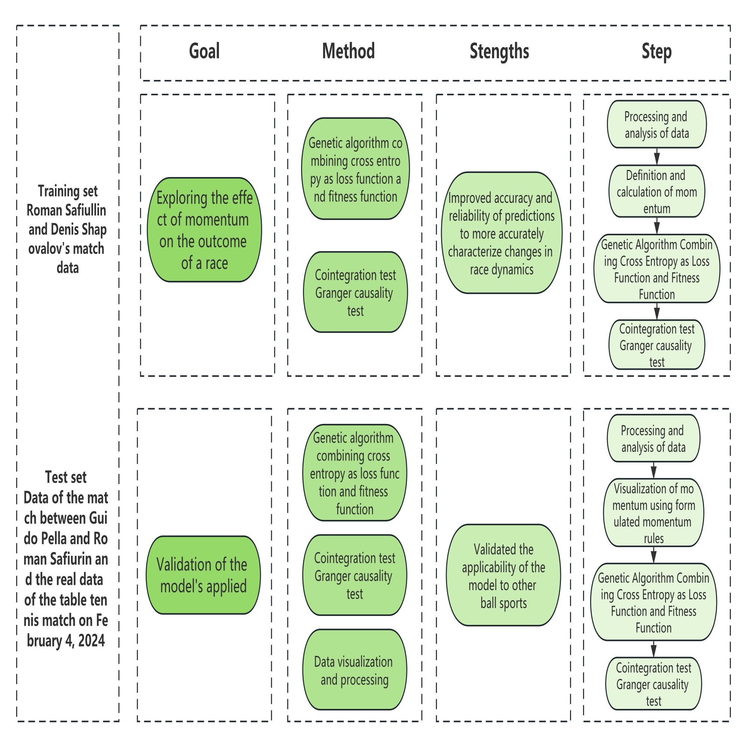
Figure1. Research process
  - Momentum
By analyzing the dataset and correlating the value of the momentum change for each athlete with the scoring, this paper developed rules for the momentum change by analyzing the momentum of the match in terms of win/loss, serve side, number of consecutive wins/losses, breaks of serve, points scored, points won, and points that landed on the side of the net.
  - Strategy Rule Set
This paper developed the above rules for the momentum values of the two tennis players, and the code uses the letters $[a, b, c,... v]$ as constants to represent the change in momentum in different situations. For example, when player 1 serves, their momentum increases, considering that the serving player has a higher win rate. If player 1 wins 2 points in a row, player 1's momentum value increases, if player 2 loses 3 points in a row, player 1's momentum value increases by c, and so on. The purpose of this code is to update the momentum values of both players based on the outcome of each point. This quantifies the player's momentum value, reflecting the player's state and trend in the game. This quantifies the player's momentum value, reflecting their status and trends in the game. The higher the momentum value, the more dominant the player is and the more likely they are to win the game. This quantifies the player's momentum value, reflecting their position and trend in the game. Conversely, a lower momentum value indicates that the player is at a disadvantage and the more likely they are to lose the game. Based on the provided code, a player's momentum value during a game can be calculated and incorporated into the game data for further analysis. Using the given code, it is possible to visualize the player's momentum changes, but manual optimization is difficult due to the presence of many variables, including the dynamic variables of the player's momentum, so this paper optimized the player's momentum changes in various game scenarios using a genetic algorithm.
  - Genetic Algorithm Optimization
Genetic algorithms [10] are computational models that simulate Darwin's biological evolutionary process of genetic selection and natural elimination. In the late 1960s and early 1970s, a more complete theory and methodology of genetic algorithms was developed mainly by Prof. John Holland of the University of Michigan, USA, and his colleagues and students.
When training neural networks, the loss function is usually used to measure the difference between the probability distribution of the model output and the actual label distribution, by minimizing the cross-entropy loss can make the output probability distribution of the model as close as possible to the actual probability distribution, so as to improve the classification performance of the model, and the cross-entropy function is very important in Bayesian inference [11] for the model selection, integrated learning and decision-making.
Hp,q=Ep−lnqx=−x​pxlnqxω (1)
where $p\left(x\right)$ is the true probability distribution, $q\left(x\right)$is the probability distribution predicted by the model, and $E_{p}\left[−lnq\left(x\right)\right] is the expectation of p\left(x\right) true distribution$, denotes the complex sum of the probabilities for each time, and the sum of the negative terms of the probability distribution predicted by the model under the true distribution is also understood to be the weighted sum of the negative terms of the probability distribution.−x​pxdenotes the complex sum over time probabilities, and the sum of the negative terms of the probability distribution predicted by the model under the true distribution is also understood as the weighted sum of the negative terms of the probability distribution.
In the model in this paper, the cross-entropy between predicted and actual match results is minimized to fine-tune the model parameters and enhance the match dynamics representation, which involves calculating the model probability z-distribution for each win/loss point, comparing it to the actual results and iteratively optimizing the parametric model to improve the prediction accuracy, which significantly improves the accuracy and reliability of the prediction, and employing a combination of a fitness function and a cross-entropy loss function in a A genetic algorithm combining the fitness function and the cross-entropy loss function is used to more accurately characterize the dynamics of the game.
To ensure that the model accurately reflects the momentum changes in a tennis match, this paper uses the fitness function in combination with a genetic algorithm to evaluate and select the best configuration of model parameters. Thanks to the involvement of the fitness function and the cross-entropy loss function, the genetic algorithm is able to most accurately characterize changes in match dynamics. On the contrary, the loss function measures the discrepancy between the model prediction and the actual race result, which is a crucial metric during the model training process. In order to enhance the model's predictive ability in capturing momentum changes during the race, this paper introduced the fitness function and loss function to further optimize the genetic algorithm.
- Experimentation
In order to study the effect of momentum on the result of the game, based on the dataset, we first preprocess the data, analyze the discrete data, the missing value processing and the dataset normalization, set the momentum as a dynamic variable, combine the genetic algorithm with the fitness function and the loss function, and use the multi-objective optimization to take the state of the player as the probability of winning the next goal, take the prediction accuracy as the fitness function, and take the cross entropy as the loss function, and analyze the image changes of loss function and fitness function to further predict the results. To make our model more convincing, this paper used the cointegration test and Granger causality test to determine whether there is a cointegration and causality between the change in momentum and the difference in scores. To demonstrate the generalizability of our model, we will visualize a random round of matches from the dataset and collect data from a table tennis match to further ensure the model's adaptability to various sports.
  - Data preprocessing
Data preprocessing is a crucial step in data analysis which includes discrete data analysis, missing value handling and data normalization, after analyzing the dataset, in the case of Wimbledon Championships, this paper observed the presence of missing values, which were due to discontinuous points in time recorded in the data collection, and so we used longitudinal forward padding to fill in the vacant values. For $speed_{m}ph$ columns, we used data averaging to improve the quality of the data, and in reviewing the attached data, we found no significant outliers, except in a few cases where the contest was conducted over a 24-hour period and therefore required minimal processing. This methodology ensured the consistency and completeness of the data and provided a reliable basis for further analysis.
The dataset included 31 matches, and to simplify the model, we assumed that all athletes were equally strong and that all indicators in the dataset were meaningful. We first analyze the metrics using the Spearman rank correlation coefficient [12], which ranges from -1 to 1. A higher correlation coefficient indicates a stronger correlation between the two variables, and a lower coefficient indicates a weaker correlation. Assuming that the two variables $X$ and $Y$ and are represented as $X=\left[X1,X2,−−−,Xn\right]$and$Y=\left[Y1,Y2,−−−,Yn\right]$ by n-dimensional vectors, we calculate Spearman rank correlation by arranging the sums in ascending or descending order and taking the order of the elements to form $x=\left[x1,x2,−−,xn\right]$ and$y=\left[y1,y2,−−−,yn\right]$ , which is given in the following equation.

$ρ_{\left(X,Y\right)}=\frac{\sum_{i=1}^{n}{\left(x_{i}−\overline{x}\right)}\left(x_{i}−\overline{y}\right)}{\sqrt{\sum_{i=1}^{n}{{\left(x_{i}−\overline{x}\right)}^{2}}\sum_{i=1}^{n}{{\left(x_{i}−\overline{y}\right)}^{2}}}}$ (2)
where $x$ and $y$ represent the mean values of the $n$-dimensional vectors $x$ and $y$, $n$ is the number of samples in the data, (X, Y) is the correlation coefficient of the variables X , Y . The value of Spearman's correlation coefficient ranges from -1 to 1. The closer the value is to 1 or -1, the stronger the hierarchical relationship between the variables; while the value close to 0 indicates a weaker hierarchical relationship between the variables, obtaining the one-hot [13] as shown in Figure 2 .


Figure 2. Heatmap
The heatmap shows the correlation between different variables and uses shades of color to indicate the magnitude of the correlation coefficient. The correlation coefficient takes on a range of values from -1 to 1. Values close to 1 or -1 indicate that the variables are strongly positively or negatively correlated, whereas values close to 0 indicate that the variables have little or no linear correlation with one another. indicates a stronger positive correlation, colors close to blue indicate a stronger negative correlation, and the shade of the color indicates the strength of the correlation.
After analyzing the graphs, it can be seen that there is a negative correlation between speed and the number of matches (-0.183), which suggests that more matches may lead to a decrease in the player's speed due to potential fatigue, furthermore, there is a strong positive correlation between the number of matches and the distance covered by the player, with a correlation of -0.885 and -0.887 for athlete 1 and athlete 2, which suggests that more matches leads to an increase in player movement. However, there was no significant correlation between players' scores and the distance they covered, suggesting that high scores are not necessarily related to the distance covered, and we concluded that the scoring of matches is influenced by factors such as strategy, technique, and details of the game.
Upon further analysis, we found a high positive correlation coefficient of 0.974 between the scores of Player 1 and Player 2, suggesting that scoring would be balanced across high-intensity matches.
  - Experimental Procedure
To further explore the effect of momentum on the game, we introduce the fitness function and use the magnitude of momentum as the probability of a player winning the next ball, which are formulated as follows
$\text{Loss=−}\sum_{i=1}^{n}{\left(y_{i}log\left(p_{i}\right)+\left(1−y_{i}\right)log\left(1−p_{i}\right)\right)}$ (3)
$Accuracy=\frac{CorrectPredictions}{TotalPredictions}$ (4)
Using Equation 2 as the fitness function and Equation 3 as the loss function, the genetic algorithm has a variance rate of 0.01, a crossover rate of 0.1, a population size of 500, and 10 iterations to obtain the table
Table 2. Variable assignment table
a =(5,10) | 1=20,30) | g =(5,10) | r=(5,10)
b=(5,10) | m =(10,20) | h=(5,10) | s =(0,5)
c =(10,20) | n =(10,20) | i=10,20) | t =0,5)
d=(10,20) | o =(10,20) | j=(10,20) | u =(10,20)
e =(10,20) | p=(10,20) | k=(20,30) | v=(10,20)
f=(10,20) | q=(5,10)

By analyzing the Table 2, for consecutive and direct serve points, the range of values was set lower, specifically (5, 10). In the case of large differences in the number of sets, the value was set even lower at (0, 5). This is because the player is unable to reverse the set number quickly, and setting the value too high would result in an unreasonable increase in the player's momentum after gaining a set advantage. The higher range of (10, 20) is used when a player is serving and the set is tied. If a player completes a break serve, the value is taken from the range of (20, 30) due to the higher difficulty, the audience cheering and celebrating will also have a more positive impact on the player's momentum, and due to the difference in the player's personality, IQ, and other factors, the player in the same situation will produce different changes in momentum.
The final correct rate of the genetic algorithm was 65.2%, this paper used the algorithm to calculate the momentum change based on the player's previous matches, and then predicted the winning percentage of the player's next serve, although the correct rate may not seem high, but it is very impressive for the prediction of the score's result, momentum is a dynamic metric that changes as the match progresses. Momentum is an objective measure, conceding a match point or set piece can significantly reduce momentum, negative emotions can occur and this can significantly reduce the value of momentum and decrease the win percentage. Based on this evidence, it can be concluded that players with higher momentum values perform better at that stage of the game. In addition, it seems that the level of performance increases as the momentum value increases. Figures 3 and 4 show the results of the calculations.
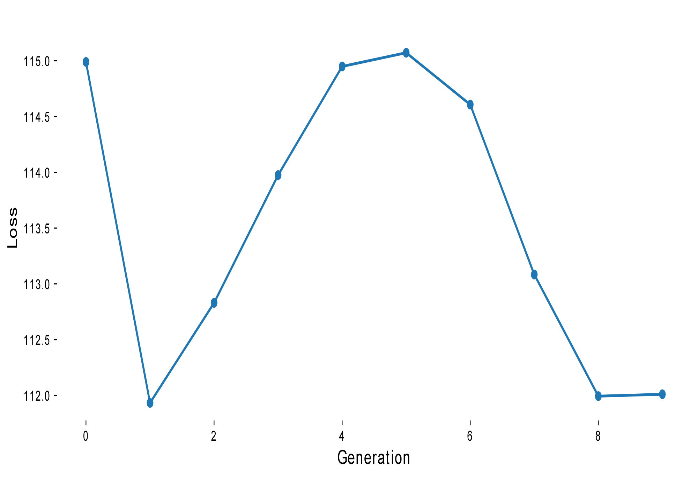
Figure 3. Loss function

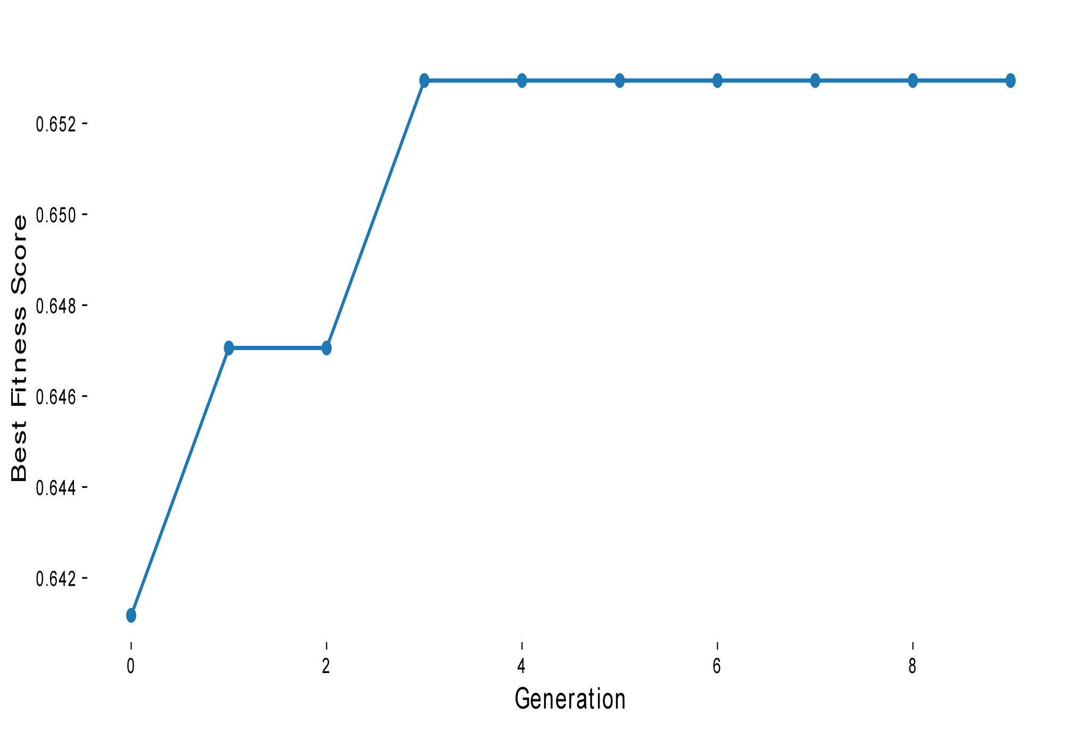
Figure 4.Fitness function
Importing the race data into python yields the results:
Best Parameters: [ 5.08138474 8.7738534 13.67879637 11.9921135 12.49863652 17.64623069 6.70703776 9.89588152 11.59778834 17.51481846 27.39170142 28.36993115 18.28763803 19.96600647 10.13291699 18.83278349 8.63671372 7.74432822 4.23697062 2.91672762 14.00070127 16.86162989]
best_fitness_scores: 0.6529411764705882
Final Loss: 115.0721736193098
We plotted the momentum change curves of Roman Safiullin and Denis Shapovalov using their match data as a training set, as shown in Fig.
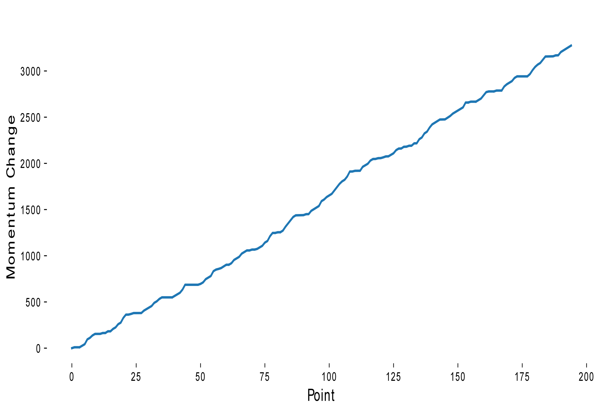
Figure 5.Momentum change of Roman and Denis
In the Figure 5, we can see that although the momentum values of both Roman Safiullin and Denis Shapovalov are gradually increasing, which indicates that both players are in the state of getting more and more excited, which indicates that Roman Safiullin's state is better than Denis Shapovalov's. The momentum values of both players are increasing gradually, which indicates that both players are in the state of getting more and more excited, which indicates that both players are in the state of getting more and more excited. And as the distance between the momentum curves is getting bigger and bigger, it means that Roman's state is getting better and better than Denis's state.
In order to explore the weights of the factors affecting the momentum of the two players, we made a weighting diagram, which is shown in the figure, to better analyze the effect of each factor on the player's momentum change.
By analyzing the Figure 6, it can be observed that the players' dynamics changed significantly during the match point, which suggests that they were very sensitive to the game. Overall, Roman's sensitivity to changes in momentum is greater than Denis', which suggests that Roman may possess a superior mindset and tactics, which is true in terms of the match results.

Figure 6.Weight map
The difference in momentum change is calculated as the difference in momentum change values between two neighboring points. And we use the 75th percentile as a categorization criterion for significant momentum change, specifically, a point in time is considered a strong performer if the difference in momentum change exceeds the 75th percentile of the difference in the change in all variables for that player, as can be seen in the Figure 7 and Figure 8. Roman performs better on scores from 102 to 116 and 130 to 135, while Denis performs better on scores from 10 to 29.


Figure 7. Denis’s stellar performance

Figure 8.Roman’s stellar performance
  - experimental verification
Because there is a strong link between players' scoring and their momentum changes and both variables fluctuate throughout the course of the game, for further validation, this paper used cointegration tests [8] and Granger Causality Tests [9] to determine their relationship to confirm the causality between players' momentum changes and scoring differences.

Cointegration test

Cointegration is the existence of a stable long-run relationship between two or more variables in time series analysis. This means that if two time series variables have a cointegrating relationship, their linear combination will be smooth, indicating the existence of a long-run equilibrium relationship between them. The main purpose of the cointegration test is to establish that there is a long-run equilibrium relationship between the variables to explain the variation in the scores of both players.
As the game progressed, we utilized the cointegration test for linear trends, which is given by the formula:
$Y_{t}=α+βX_{t}+ϵ_{t}$ (5)
Where $Y_{t}$ denotes the time series of the dependent variable, $X_{t}$ denotes the time series of the independent variable, $α$ denotes the intercept, $β$ denotes the slope function, and $ϵ_{t}$ denotes the error term. The formula for the final prediction error is:
$FPE=\frac{1}{n−k}\left(\frac{SSE}{{\hat{σ}}^{2}}\right)⋅e^{\left(n+2k\right)/n}$ (6)
The AIC [14] (Akaike Information Criterion) is used to measure the quality and complexity of the fit of the model and is calculated as
$AIC=2k−2 ln\left(\hat{L}\right)$ (7)
where $k$ is the number of parameters in the model and $\hat{L}$ is the maximum likelihood estimate of the model.
The SC [15] (Schwarz Criterion) is formulated as:
$SC=ln\left(n\right)k−2 ln\left(\hat{L}\right)$ (8)
Where $n$ is the sample size, $k$ is the number of parameters in the model, and $\hat{L}$ is the maximum likelihood estimate of the model.
HQ [16] (Hannan-Quinn Criterion) is formulated as:
$HQ=2 ln\left(ln\left(n\right)\right)k−2 ln\left(\hat{L}\right)$ (9)
where $n$ is the sample size and $k$ is the number of parameters in the model and $\hat{L}$ is the maximum likelihood estimate of the model. The first step is to normalize the athlete's momentum difference data and innings score data, and for a given data point, its normalized value in Z-score can be calculated using the following formula Z
$z=\frac{x−μ}{σ}$ (10)
where denotes the normalized value (z-score), denotes the value of the momentum difference data and the local score data, and denotes the mean of the momentum difference data and the local score data. denotes the standard deviation of the momentum difference data and the bureau split data. Based on the results of the evaluation of the FPE,AIC,SC,HQ equations, the lag order was chosen to be second order, which means that a model with second order lags may be the most appropriate for modeling and predicting the data in this case. This choice was made by considering multiple informative criteria to ensure that the chosen lag order provided the best balance and predictive power in the model. After analyzing the scenarios included in our specified momentum rule, we obtained a final table of covariance detection results. As shown in Table 3.
Table 3.Cointegration test results
Null hypothesis | Characteristic root | Trace  (Max Root) | 10% cut-off | 5% cut-off | 1% cut-off
No cointegration relationship | 0.231 | 46.678 | 16.162 | 18.398 | 23.148
Up to 1 cointegration | 0.016 | 2.774 | 2.705 | 3.841 | 6.635

The metrics analyzed by this paper included standardized momentum differences and standardized score differences, and second-order lags were chosen for the analysis; based on the results of our cointegration tests, it is reasonable to assume a stable correlation between these two metrics over time in the dataset we studied. In addition, we performed other correlation analyses, such as the smoothing test of the variables and the selection of the optimal lag order, steps that are essential to ensure the accuracy of the cointegration test results.
In order to consider the strength of the monotonic relationship between the variables when determining the long-run stability relationship, we used Spearman correlation coefficients, Spearman rank correlation coefficients can be used to measure the monotonic relationship between two variables, and these coefficients take a value ranging from -1 to 1. Based on this, we also provide a way to quantify the strength of the relationship between the variables, which is particularly important when interpreting dependence between the variables particularly important when interpreting dependencies between variables.
If trace > 5% critical value, the original hypothesis is rejected, indicating the existence of at least 1 covariance relationship
Up to 1 covariate: if trace > 5% critical value, it means that the original hypothesis is rejected, i.e. it means that there is more than 1 covariate; and
Up to 2 covariates: if trace> 5% critical value, it means that the original hypothesis is rejected, i.e. it means that there are more than 2 covariates; and
Based on the results of the above covariance test, it can be proved that there is a covariance between score difference and momentum difference, i.e. momentum is related to the effect of winning and losing the game.

Granger causality test

In this study, Granger causality tests are used to examine whether one set of time series is responsible for another set of time series, focusing on the standardized momentum difference and the standardized score difference, and ADF is used to assess the smoothness of the time series. This step is crucial because non-smoothed time series can lead to spurious regression problems, and next we will analyze a data table containing 31 races.
Table 4.ADF test
variable | t | P | Threshold
variable | t | P | 1% | 5% | 10%
momentum_diff | -6.884 | 0.000*** | -3.47 | -2.879 | -2.576
score_diff | 1.957 | 0.999 | -3.471 | -2.879 | -2.576

As shown in the Table 4.For scorediff. the test statistic of -6.884 produces a very low p-value of 0.000 at 1% significance level (p<0.05) indicating that the series is smooth with stable mean and variance over time. On the other hand, for momentum_diff, the test statistic "t" is 1.957, resulting in a high p-value of 0.999 over the 5% significance level (p>0.05). This indicates that momentum_diff is a non-smooth series with unstable mean and variance over time.
These analyses are critical for future time series analysis and modeling because smoothing of time series data is critical for effective modeling and forecasting, non-smooth series may require additional processing or transformation to meet modeling requirements, and ADF test results guide the selection of appropriate variables for subsequent analysis and modeling.
To make the study more convincing, Hungry Oh we chose second order lag for Granger causality test, the mathematical expression for Granger causality test is
$Y_{t}=α+\sum_{i=1}^{n}{β_{i}}Y_{t−i}+\sum_{i=1}^{m}{γ_{i}}X_{t−i}+ϵ_{t}$ (11)
where $Y_{t}$ and $X_{t}$ denote the observations at time $t$, $m$ and $n$ denote the number of autoregressive and lagged terms, $α$denotes the intercept term, $β_{i}$ and $γ_{i}$ denote the regression coefficients, and denote the error term, and based on the mathematical expressions, and combining the 31 sets of matched data, we produced the following Table 5.
Table 5. Granger causality test results table
Pair sampels |  | F | P
score_diff | momentum_diff | 18.895 | 0.000***
momentum_diff | signed_score_diff | 0.457 | 0.634

The table above shows the results of the Granger causality test, including paired samples, example sentences, and significance p-values. If the p is less than 0.05, the original hypothesis is rejected, indicating that the left-hand side variable can cause changes in the right-hand side variable with Granger causality, and vice versa, there is no Granger causality. For the variables momentum_diff and score_diff, the significance p-value is 0.000***,indicating that momentum_diff causes changes in score_diff. However, based on score_diff and momentum_diff, the significance p-value is 0.643, score_diff is not able to cause a change in momentum_diff, which indicates that the change in momentum is not solely determined by the difference in scores, but is also interfered by other factors, such as broken serve and non-contactable serve, which also significantly affects the player's momentum, which also supports our view and proves that momentum has a great influence on winning or losing a match.
  - Experimental applications
Visualization

In order to demonstrate the applicability of this study, we used the data of the match between Guido Pella and Roman Safiulin and the real data of the table tennis match on February 4, 2024 as a test set. In order to make the meaning and trend of the data given to us easier to understand and thus provide a more intuitive interpretation, we first extracted the data of the match between Guido Pella and Roman Safiurin to analyze and derive their momentum change curve and momentum difference curve.
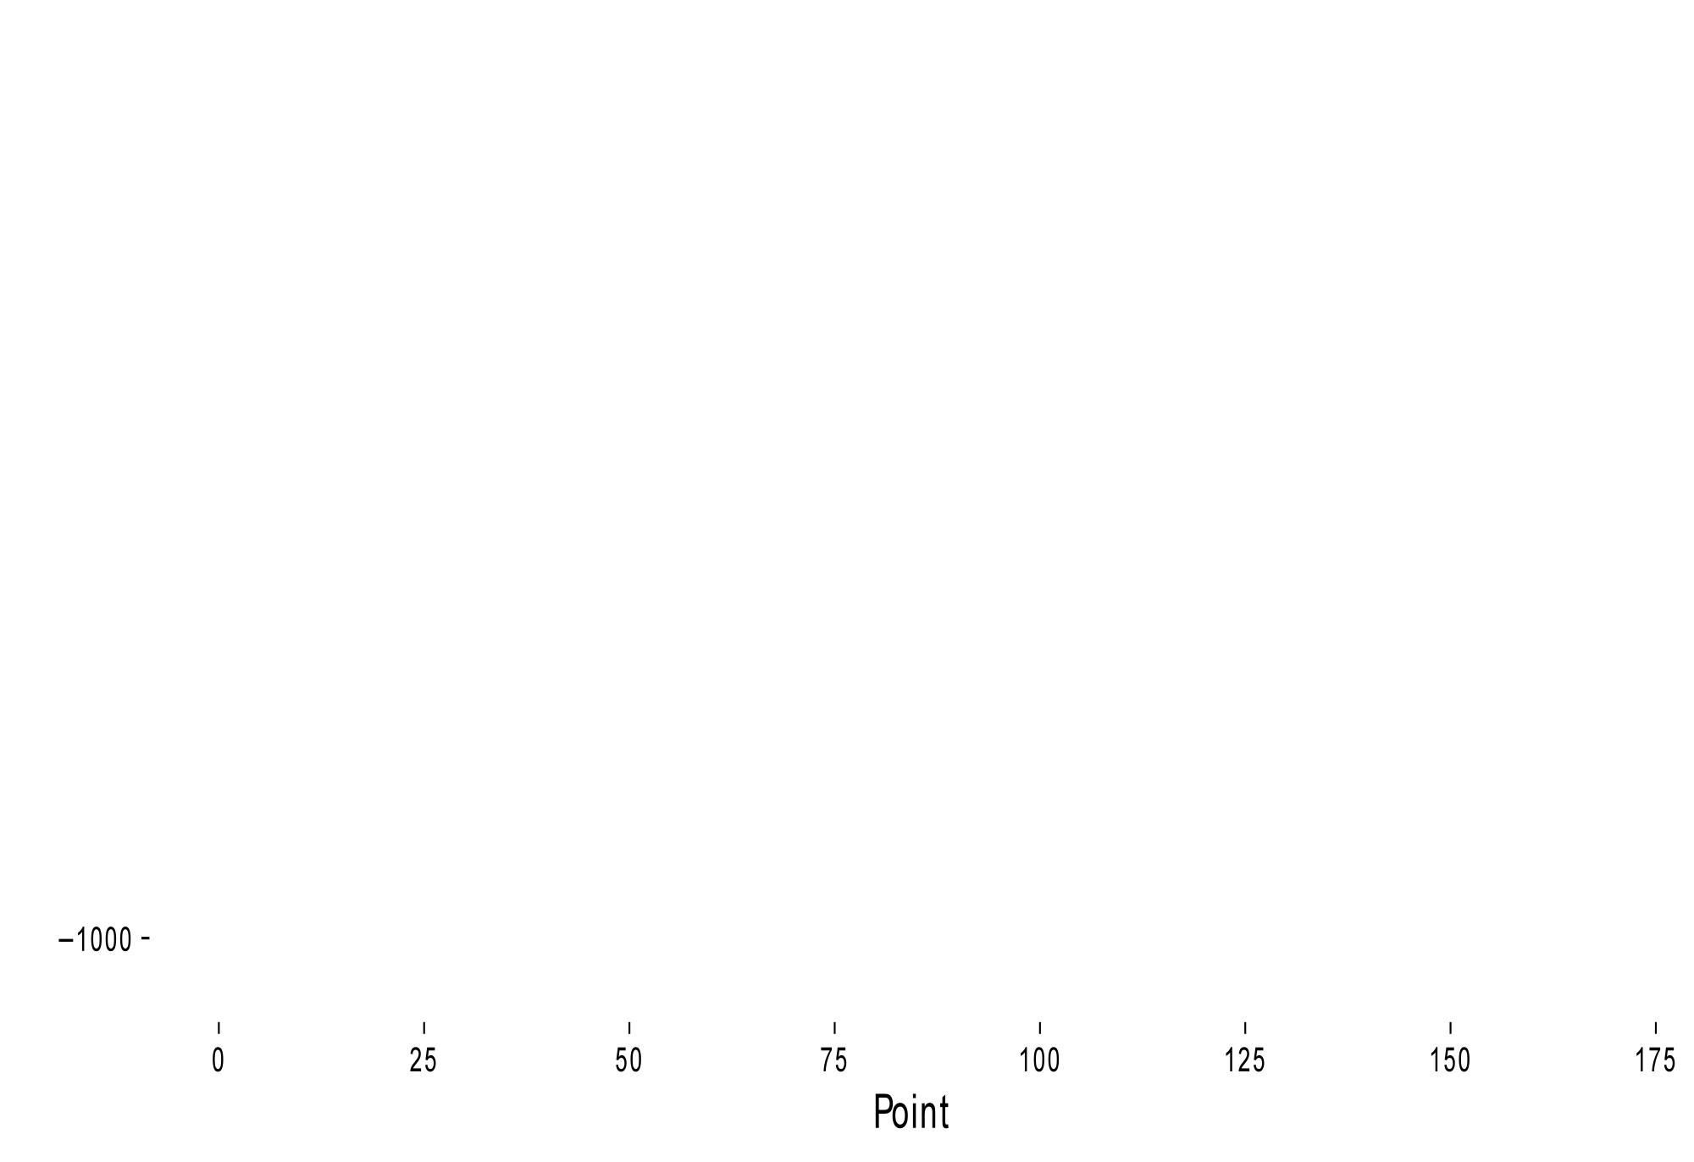
Figure 9. Guido and Roman Momentum Difference
As can be seen from the Figure 9, Guido Pella's momentum consistently exceeds that of Roman Safiulin, and in order to highlight the difference in their momentum changes, this paper plotted their momentum difference changes. In order to effectively reflect the momentum changes during tennis matches, evaluate and select the optimal model parameter configurations, test the utility of the model and predict the deviation from the actual match results, we developed the fitness function and the loss function and plotted their images.
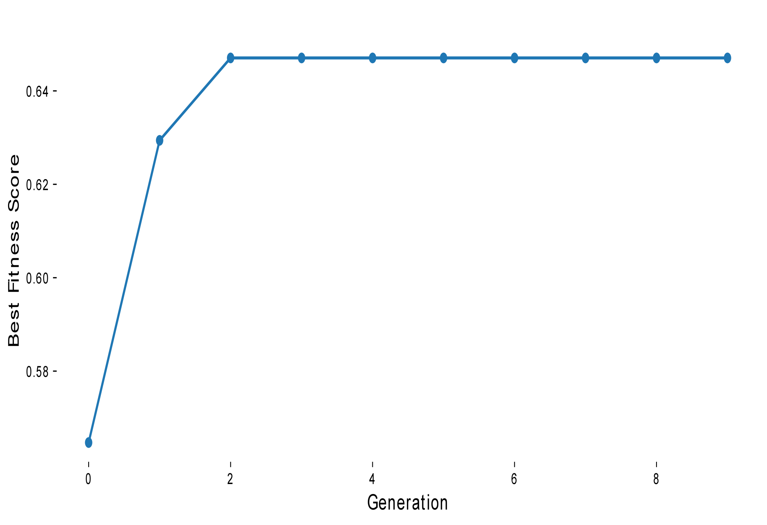
Figure 10. Fitness function

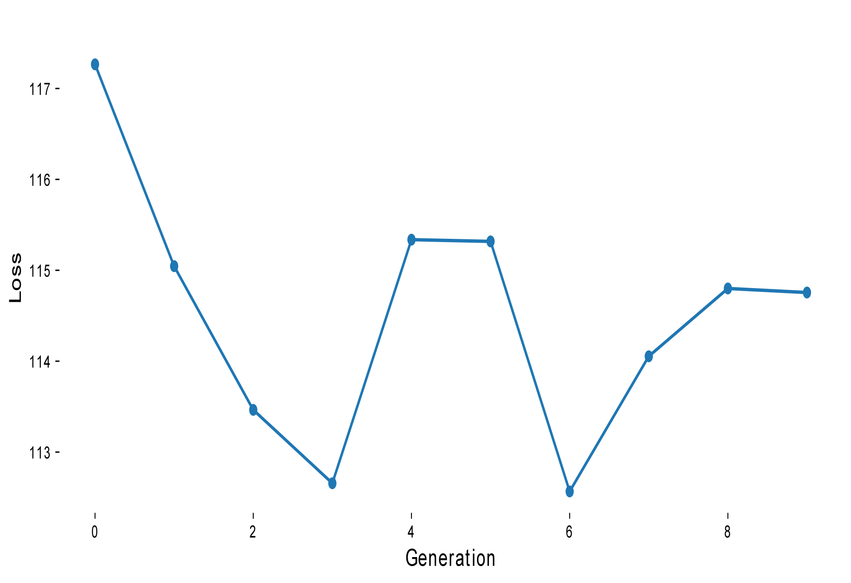
Figure 11. Loss function
By analyzing Figure 10 and Figure 11, we can clearly see the dynamics of the match between Guido Pella and Roman Safiulin and conclude that Guido Pella's form in the match is significantly higher than that of Roman Safiulin, which means that he is more competitive and has a higher probability of winning in the match, of course, the result of the match is also affected by a number of factors, but statistically speaking Guido Pella has a higher probability of winning. Pella has a higher probability of winning, so it can be predicted that Guido Pella has a higher probability of winning the match against Roman Safiulin, these data analyses provide a better understanding of the player's condition and potential performance, and provide important clues and support for predicting the outcome of the match.
In order to determine the most important factors influencing a player's momentum change, the team calculated the magnitude of the momentum change in each situation using the rules developed along with it, allowing for a more intuitive comparison of the degree of influence between them.
Best Parameters: [0.35514315 0.64822797 0.20250662 1.86324285 0.01749878 0.79889203 0.52925115 0.45127423 0.26909532 0.6048418 0.05688508 2.90088369 0.27216234 0.92832007 0.97012719 0.17537693 2.68230694 0.99943985]
best_fitness_scores: 0.6506024096385542
Final Loss: 90.74534470442833

Momentum fluctuations can vary significantly from situation to situation or occasion to occasion. However, a player's skill level and chosen tactics usually remain consistent. Players can analyze a player's playing condition by examining the values of momentum fluctuations in different situations prior to a match to identify the factors that have the greatest impact on a player's condition. This information can be used to develop tactics that are appropriate for the player and to stabilize their mental state in different situations of the match. The team analysis showed that the momentum values of the players changed significantly when they lost match points and positional points, lost two consecutive points, or made serving errors. Therefore, during a match, if players encounter situations that result in significant changes in momentum values, they should take timely measures to stabilize their mental state, which will help them enter the next match with a more stable and combative mindset. By analyzing players' momentum value changes in different situations, coping strategies can be developed to better deal with the pressure and challenges of the game and improve individual competitive performance.
In the following, we will extract real data from a table tennis match on February 4, 2024 for analysis. This analysis will ensure the adaptability of this study for various sports and enhance its reliability for real-world use.
By combining rule-specified parameters with subjective observations, we can quantify the data into specific metrics for a more objective assessment of the players’ momentum changes. This method of quantitative analysis integrates both subjective and objective data, providing a more comprehensive understanding of the momentum changes of Chasselin P and Partyka N.. This, in turn, provides a more reliable basis for model validation and improvement. The use of this thorough analysis method will aid in comprehending the state and performance of the players during the game, providing a more precise and dependable database. We plotted the momentum changes of the players in Figure 12 and created the variable assignment Table 6.
Table 6. Variable assignment table
a =(0，1) | g =(0，1) | m =(10,20)
b=(0，1) | h=(5,10) | n =(10,20)
c =(1，2) | i=10,20) | o =(10,20)
d=(1，2) | j=(10,20) | p=(10,20)
e =(1，2) | k =(20,30) | q=(5,10)
f=(1，2) | 1=（0，1) | r=(5,10)

To improve clarity, the team plotted momentum change and momentum difference images for two players, Chasselin P and Partyka N, in order to better visualize the difference between the two players' performances during the course of the match, and thus predict the probability that one of the players will win the next ball.We made their momentum change curves and momentum difference curves, as shown in Figure 13 and Figure 14.
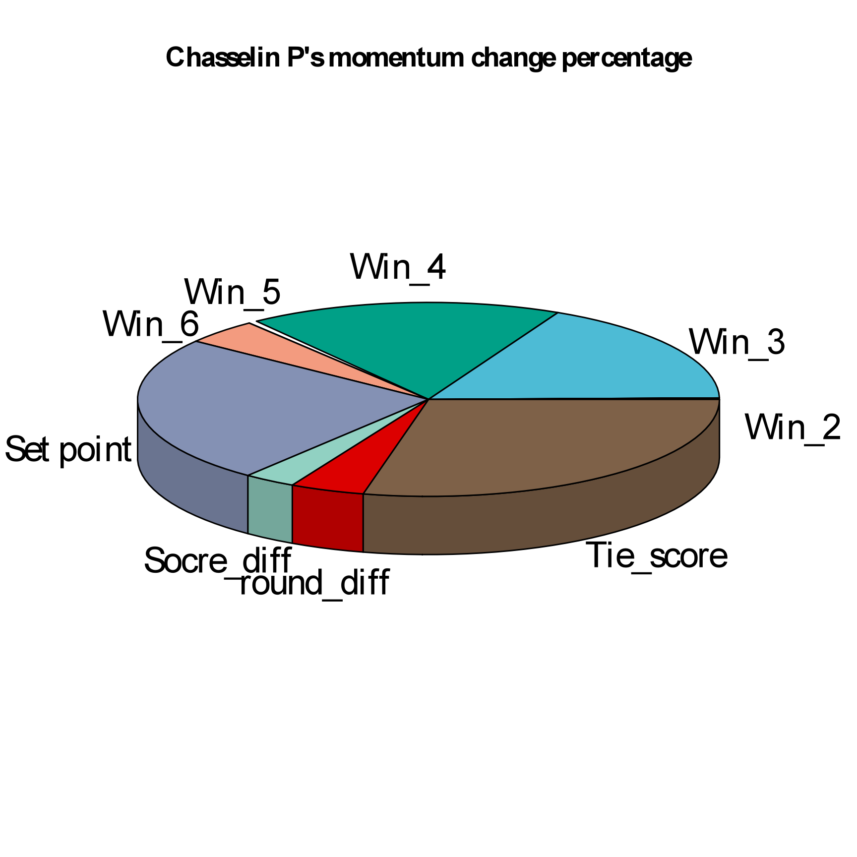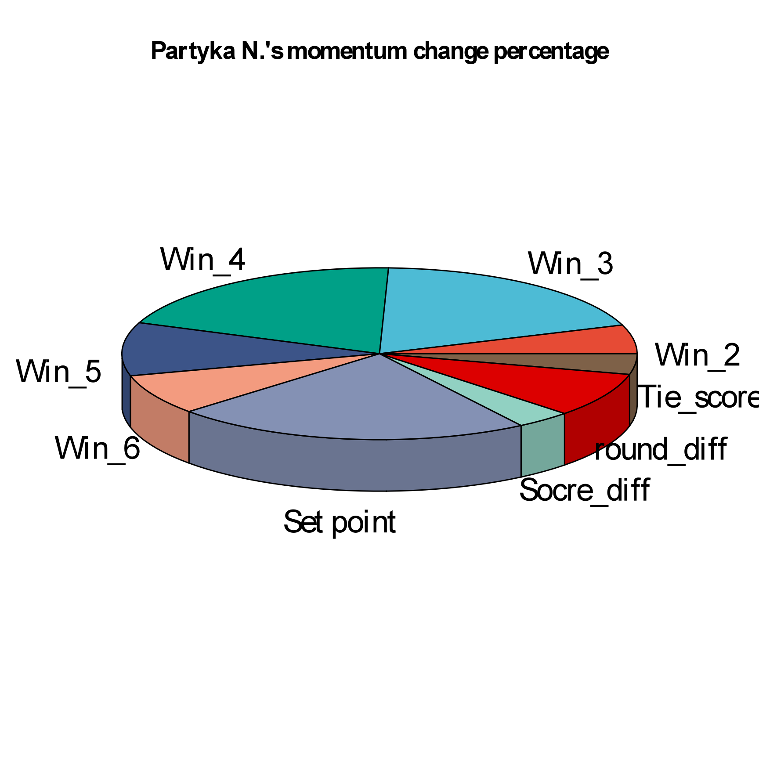
Figure 12. Chasselin P and Parka N Momentum

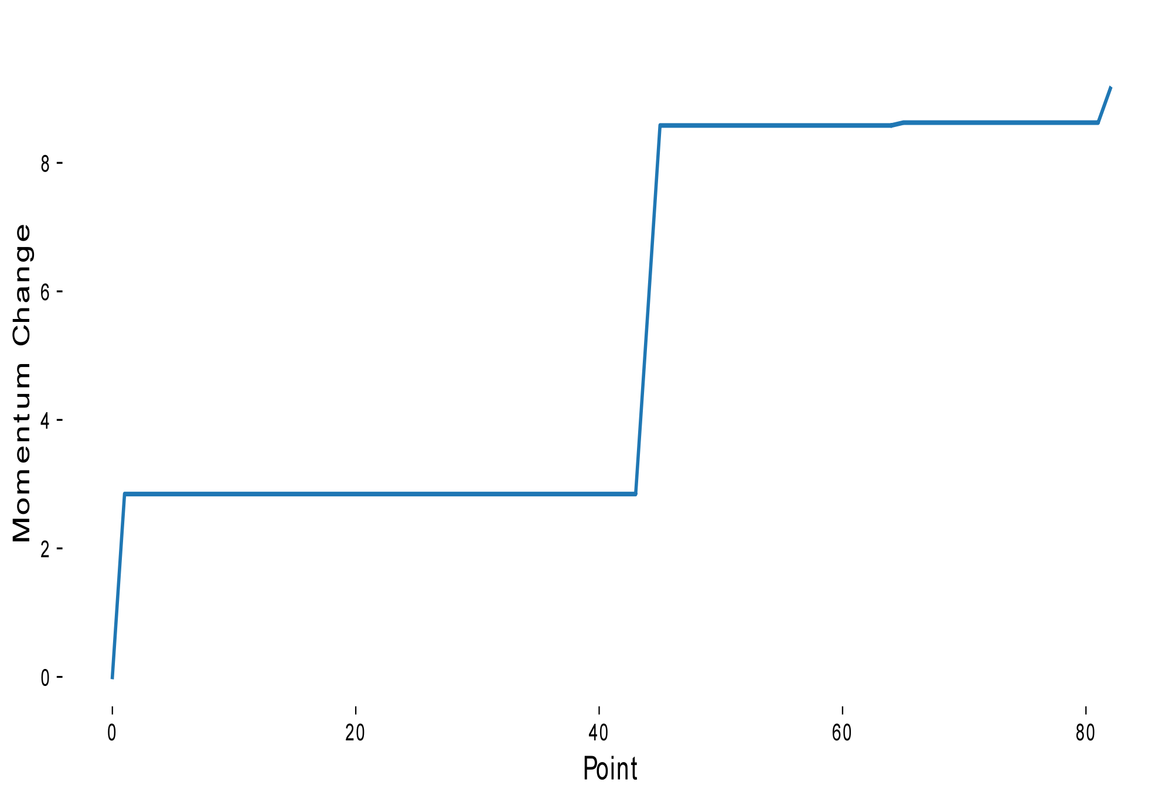
Figure 13. Momentum Change plot
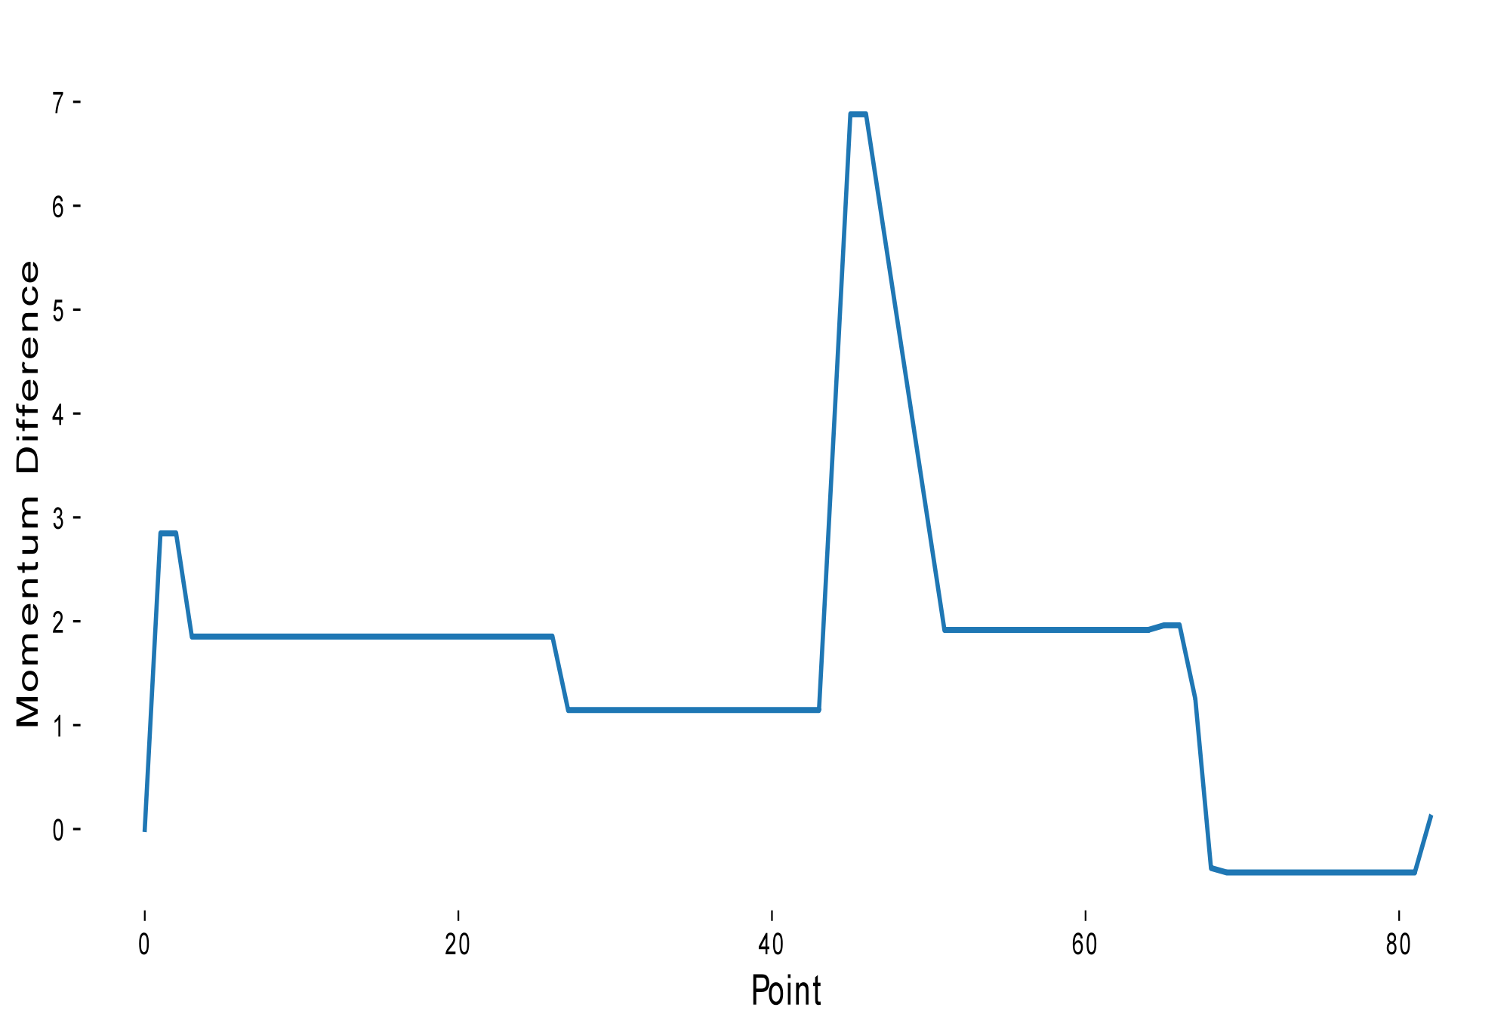
Figure 14. Momentum Difference
The loss function is an important metric for assessing the predictive accuracy of a model. A smaller loss function value indicates that the model has a strong predictive ability because the difference between the predicted and actual values is small. To improve the credibility of the model in predicting other matches, we need to analyze the fitness function and loss function. By studying the fitness function and loss function, which are shown in Figure15 and Figure 16 ,in the graphs and plots, we can better understand the performance of the model and evaluate and improve the predictive ability of the model.
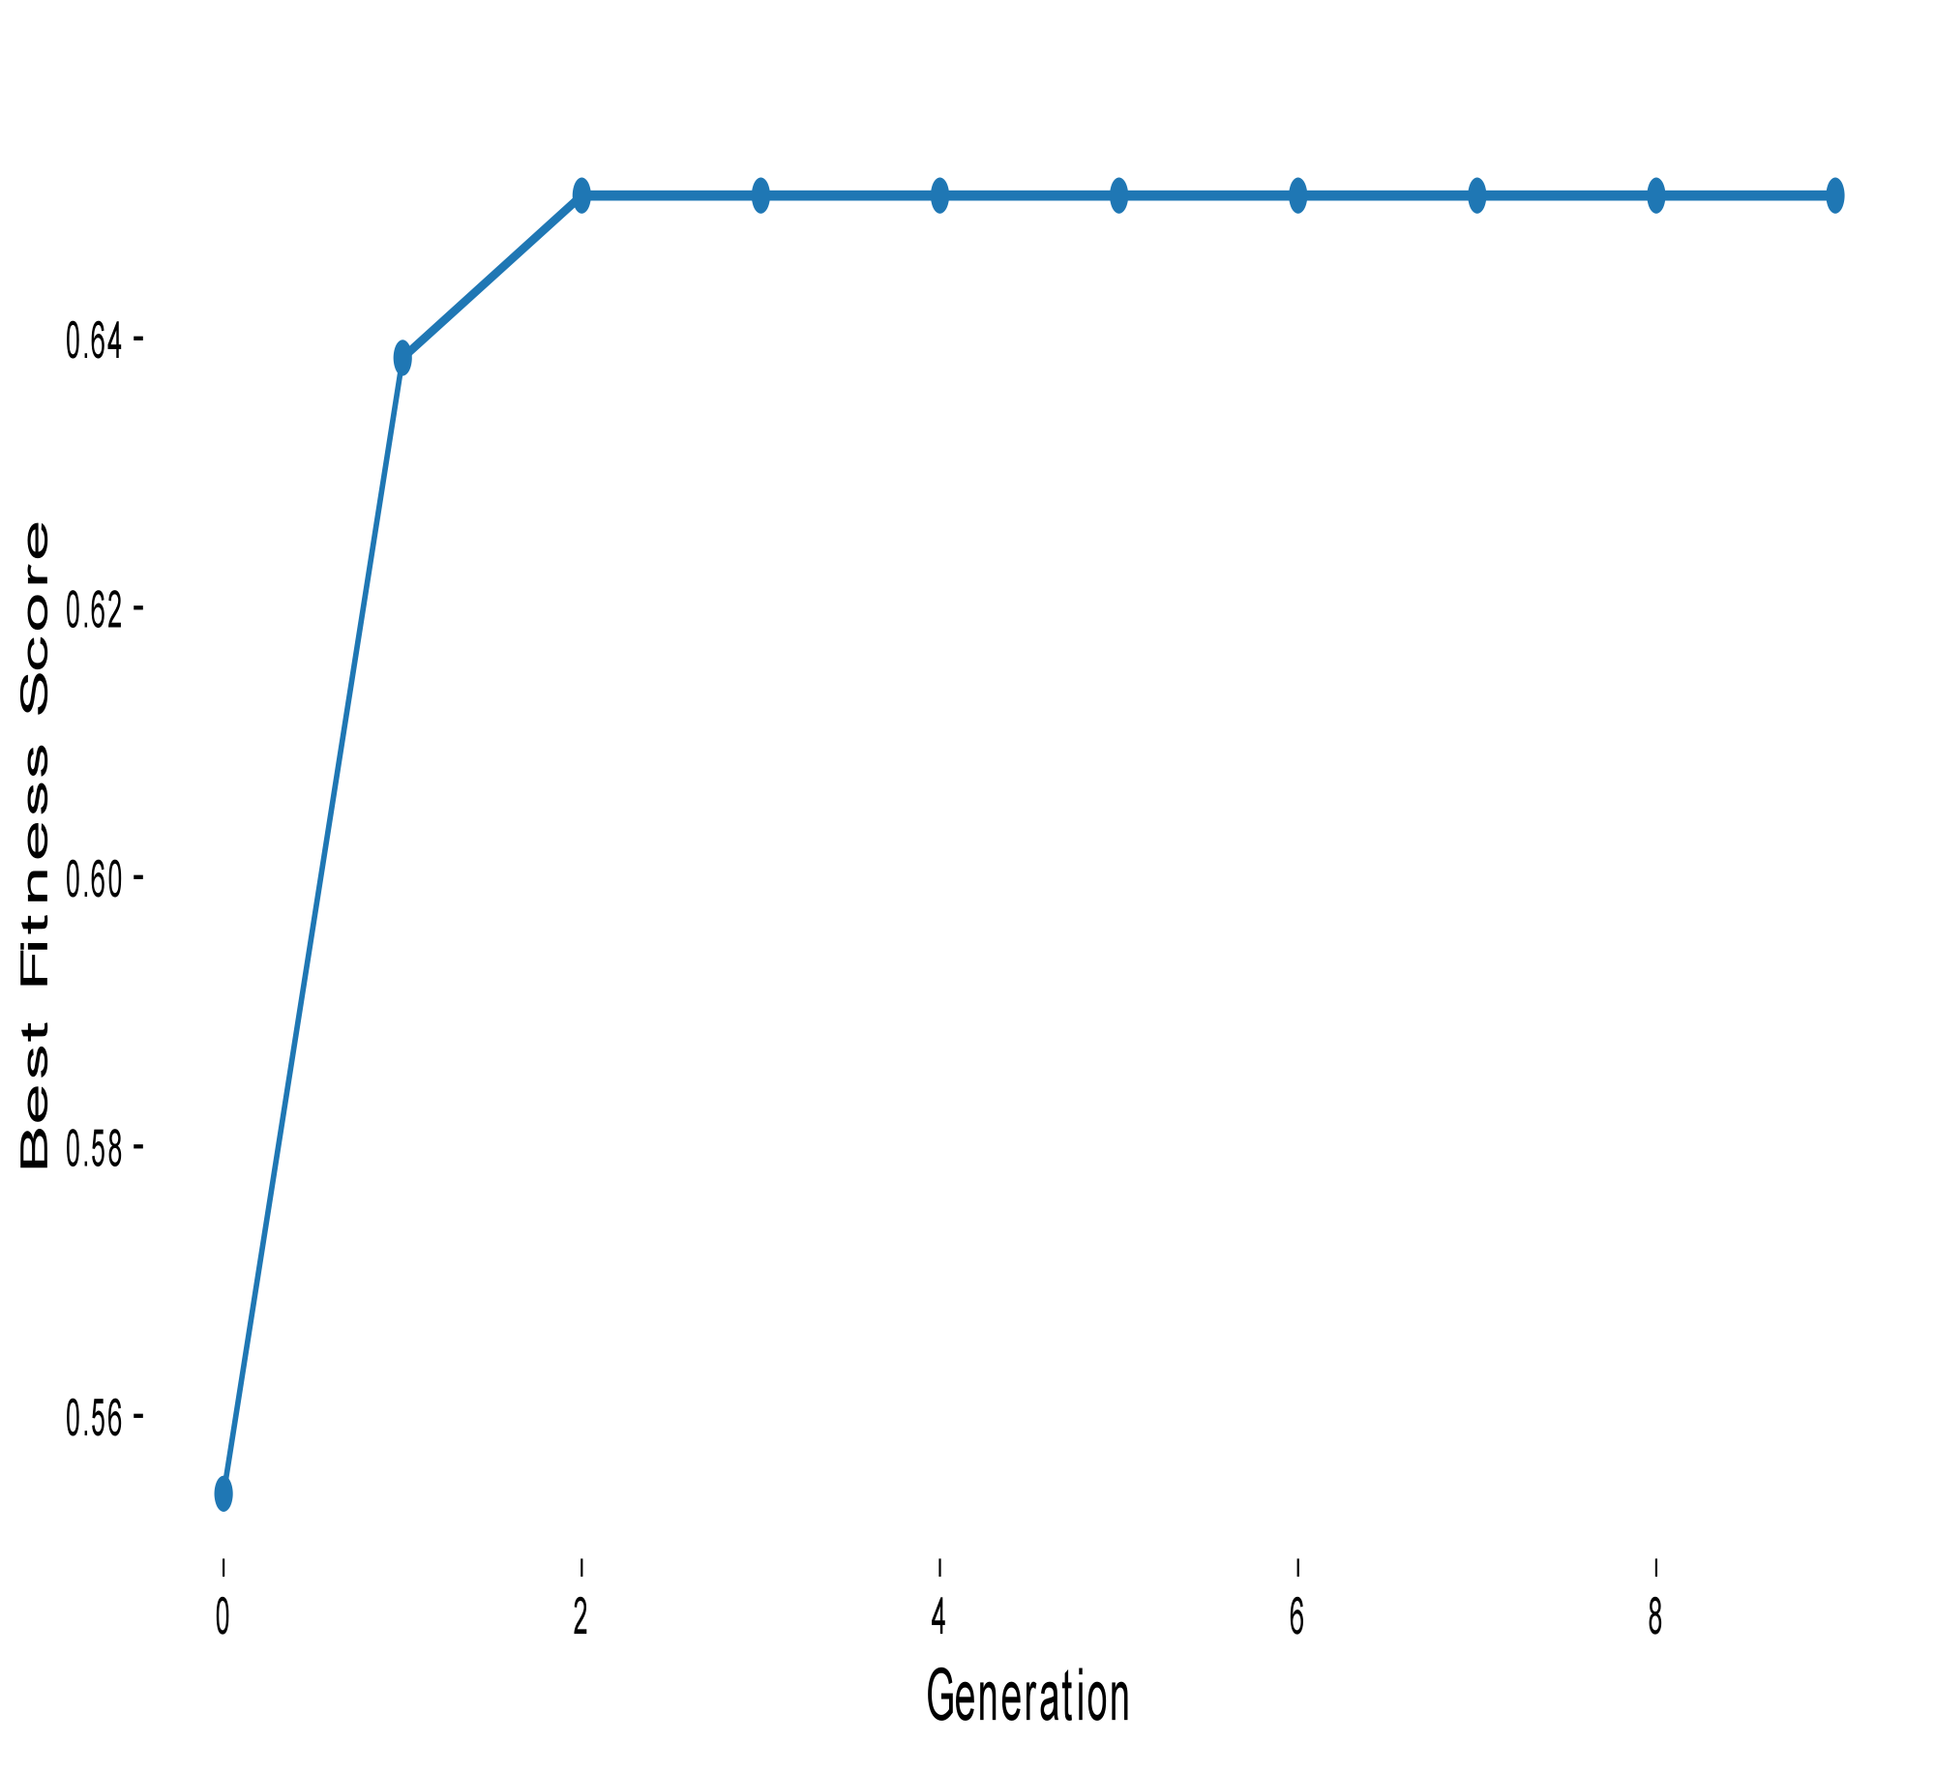
Figure 15. Fitness function
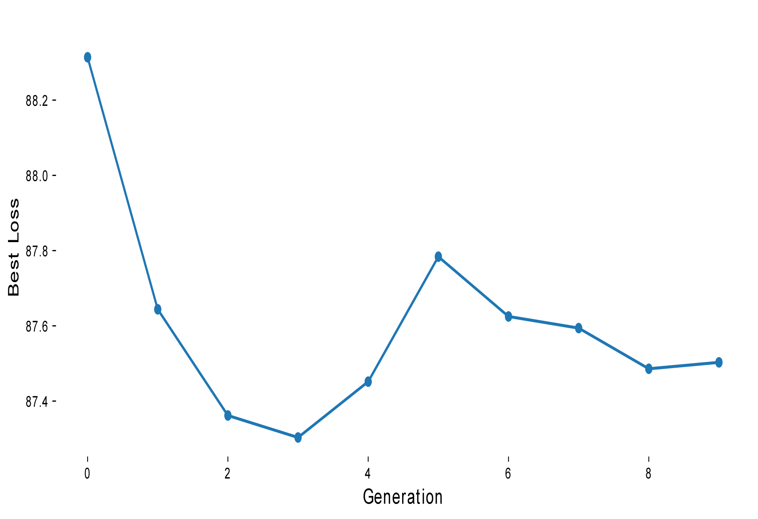
Figure 16. Loss function
By analyzing the momentum change curves of both participants, it can be found that in most cases the momentum change of Chasselin P is significantly larger than that of Partyka N, which means that the probability of Chasselin P winning the game is larger than that of Partyka N. The game data was imported into python to produce the results:
Best Parameters: [0.35514315 0.64822797 0.20250662 1.86324285 0.01749878 0.79889203 0.52925115 0.45127423 0.26909532 0.6048418 0.05688508 2.90088369 0.27216234 0.92832007 0.97012719 0.17537693 2.68230694 0.99943985]
best_fitness_scores: 0.6506024096385542
Final Loss: 90.74534470442833

By analyzing the code and combining it with this paper's model, we quantified the momentum of both players and predicted the probability of a player winning the next ball with 65% accuracy. This is a good proof that this study can be generalized to other ball, sports.
- Conclusion
This study has been developed using a multi-objective optimization framework based on genetic algorithm. It utilizes prediction accuracy as a loss function and cross entropy as another loss function. It effectively designs the magnitude of momentum changes to allow participants to accurately calculate their momentum changes in different situations. This allowed it to make strong predictions about the outcome of the next game and the participants' momentum changes. The validity of the model was confirmed by cointegration and Granger causality tests. Given a sufficient dataset, the model can intelligently formulate rules for momentum changes for different players based on the specific rules of each game, showing a high degree of generalizability and strongly demonstrating the impact of momentum on winning and losing a game.
- Acknowledgements
We sincerely thank the reviewers of this study for their careful review and valuable comments on this paper. The reviewers' professional suggestions and in-depth evaluations played a vital role in the improvement of this paper. Their guidance and suggestions helped us to better understand the research questions and enhanced the quality and credibility of this paper.
We are particularly grateful to the reviewers for their review of the methodology and results of this paper, as well as their critical thinking about the ideas and conclusions presented in the paper. We would like to express our sincerest gratitude to the reviewers for their time and effort in the anonymous review process. Without their careful guidance and professional advice, the completion of this paper would have been much more difficult. Once again, we thank the reviewers for their hard work!
In addition, we would like to thank all the members of the research team who participated in the data collection, processing, and analysis, and whose hard work provided a solid foundation for the study. We anonymously provide the code and datasets here to indicate the reproducibility of the methods, and the anonymized repository is located at the following address:
Finally, we would like to thank all of our family, friends, and coworkers who provided support and encouragement in this study. Their understanding, support and encouragement have been a source of motivation along the way.
Thank you again to all of you for your support and help!

References
- Shenshen Gu,Hanmei Yao. Pointer Network Based Deep Learning Algorithm for the Maximum Clique Problem. International Journal on Artificial Intelligence Tools. 2021;30 (01):2140004-2140004.
- https://www.sofascore.com/safiullin-pella/tNjsFYZ#id:11390639
- https://www.sofascore.com/chasselin-partyka/uNFstoMb#id:12039993
- Jun Ueda, K. Shirase, Y. Matsumoto, S. Oda and T. Ogasawa, ”Momentum compensation for fast dynamic walking of humanoids based on pelvic rotation of contact sport athletes,” 4th IEEE/RAS International Conference on Humanoid Robots, 2004., Santa Monica, CA, USA, 2004, pp. 592- 607
- Thomas Weise,Zhize Wu,Xinlu Li, et al. Frequency Fitness Assignment: Making Optimization Algorithms Invariant Under Bijective Transformations of the Objective Function Value. IEEE Transactions on Evolutionary Computation. 2021;25 (2):307-319.
- Shekoufeh Gorgi Zadeh,Matthias Schmid. Bias in Cross-Entropy-Based Training of Deep Survival Networks. IEEE Transactions on Pattern Analysis and Machine Intelligence. 2021;43 (9):3126-3137.
- James R. Clough,Nick Byrne,Ilkay Oksuz, et al. A Topological Loss Function for Deep-Learning Based Image Segmentation Using Persistent Homology. IEEE Transactions on Pattern Analysis and Machine Intelligence. 2022;44 (12):8766-8778.
- Robert McNown,Chung Yan Sam,Soo Khoon Goh. Bootstrapping the autoregressive distributed lag test for cointegration. Applied Economics. 2017;50 (13):1509-1521.
- Maciej Rosoł,Marcel Młyńczak,Gerard Cybulski. Granger causality test with nonlinear neural-network-based methods: Python package and simulation study. Computer Methods and Programs in Biomedicine. 2022;216 (0):106669-106669.
- Zhihua Cui,Zhaoyu Xue,Tian Fan, et al. A many-objective evolutionary algorithm based on constraints for collaborative computation offloading. Swarm and evolutionary computation. 2023;77 (0):101244-101244. doi:10.1016/j.swevo.2023.101244
- Yea-Seul Kim,Paula Kayongo,Madeleine Grunde-McLaughlin, et al. Bayesian-Assisted Inference from Visualized Data. IEEE Transactions on Visualization and Computer Graphics. 2021;27 (2):989-999.
- .Spearman's rank correlation coefficient. BMJ. 2014;349 (dec05 1):g7528-g7528.
- Cencheng Shen,Qizhe Wang,Carey E. Priebe. One-Hot Graph Encoder Embedding. IEEE Transactions on Pattern Analysis and Machine Intelligence. 2023;45 (6):7933-7938.
- Haoda Li,Zhensheng Yang,Wei Yan. An improved AIC onset-time picking method based on regression convolutional neural network. Mechanical Systems and Signal Processing. 2022;171 (0):108867-108867.
- Shokrya Saleh. Robust Variable Selection Based on Schwarz Information Criterion for Linear Regression Models. The Philippine statistician (Quezon City). 2022;71 (1):54-68.
- Maïnassara, Y.B., Kokonendji, C.C. Modified Schwarz and Hannan–Quinn information criteria for weak VARMA models. Stat Inference Stoch Process 19, 199–217 (2016).

