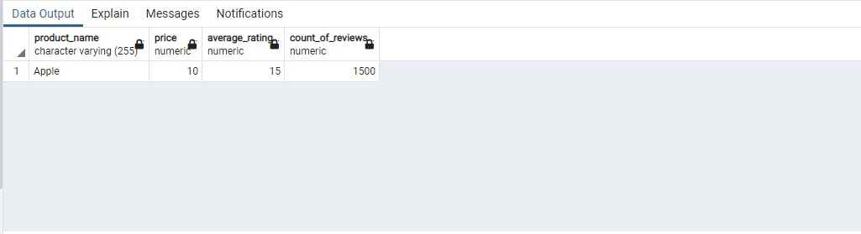Product of one company

CREATE TABLE product (product_name varchar (255), price numeric,

average_rating numeric, count_of_reviews numeric)

INSERT INTO product ("product_name", "price", "average_rating", "count_of_reviews")

VALUES ('Apple', '10', '15', '1500');

CREATE VIEW company_product AS SELECT "product_name", "price", "average_rating", "count_of_reviews"

FROM product

SELECT * FROM company_product

Sum of the cart of a single user

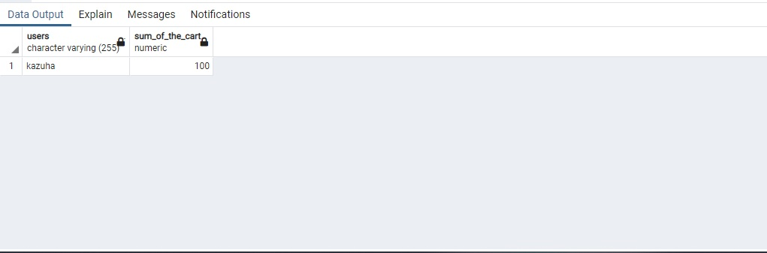

CREATE TABLE sums (users varchar(255), sum_of_the_cart numeric)

INSERT INTO sums ("users", "sum_of_the_cart")

VALUES ('kazuha', '100');

CREATE VIEW user_sum AS SELECT "users", "sum_of_the_cart"

FROM sums

SELECT * FROM user_sum

3. Yearly orders of one company

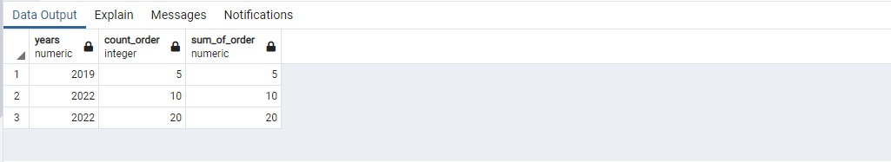

CREATE TABLE product_year (years numeric, count_order int, sum_of_order numeric)

INSERT INTO product_year ("years", "count_order", "sum_of_order")

VALUES ('2019', '5', '5');

INSERT INTO product_year ("years", "count_order", "sum_of_order")

VALUES ('2022', '10', '10');

INSERT INTO product_year ("years", "count_order", "sum_of_order")

VALUES ('2022', '20', '20');

CREATE VIEW count_year AS SELECT "years", "count_order", "sum_of_order"

FROM product_year

SELECT * FROM count_year

4. New user

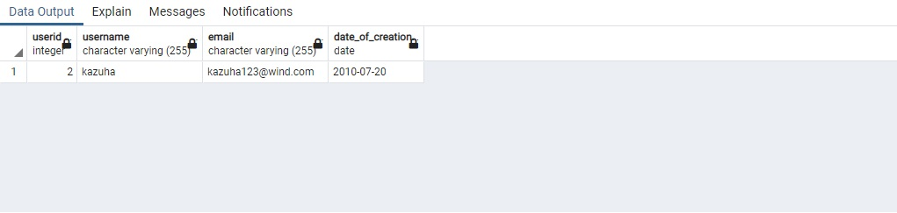

CREATE TABLE new_user (userID int, Username varchar(255), Email varchar(255), Date_of_creation date);

INSERT INTO new_user ("userid", "username", "email", "date_of_creation")

VALUES ('1', 'ayato', 'ayato08@wind.com', '2010-07-10');

INSERT INTO new_user ("userid", "username", "email", "date_of_creation")

VALUES ('2', 'kazuha', 'kazuha123@wind.com', '2010-07-20');

CREATE VIEW newuser AS SELECT "userid", "username", "email", "date_of_creation"

FROM new_user

SELECT * FROM new_user

5. Banned user

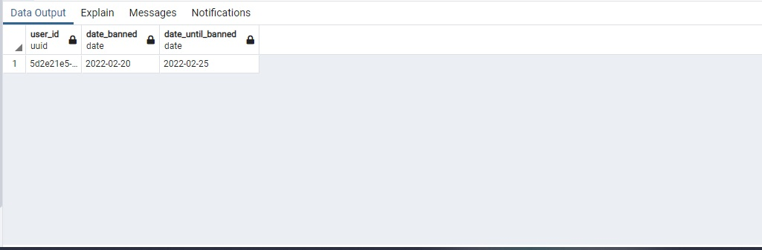

INSERT INTO banneduser ("date_banned", "date_until_banned")

VALUES ('02-20-2022', '02-25-2022');

CREATE VIEW banned_user AS SELECT "date_banned", "date_until_banned"

FROM banneduser

SELECT * FROM banned_user

6. Discount sale 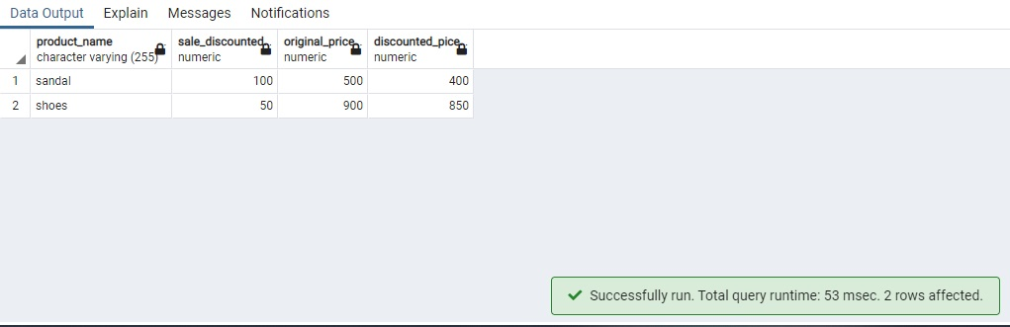

CREATE TABLE sales (product_name varchar(255), sale_discounted numeric, original_price numeric,

discounted_pice numeric)

INSERT INTO sales ("product_name", "sale_discounted", "original_price", "discounted_pice")

VALUES ('sandal', '100', '500', '400');

INSERT INTO sales ("product_name", "sale_discounted", "original_price", "discounted_pice")

VALUES ('shoes', '50', '900', '850');

CREATE VIEW sale AS SELECT "product_name", "sale_discounted", "original_price", "discounted_pice"

FROM sales

ORDER BY "sale_discounted" DESC, "discounted_pice" DESC

SELECT * FROM sale

7. Deletes user with special characters

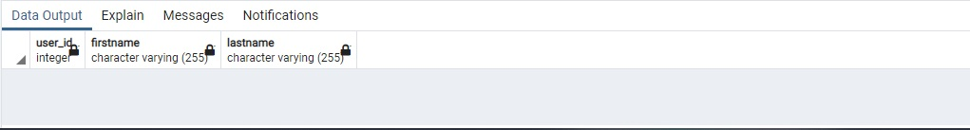

CREATE TABLE users (user_id int, firstname varchar(255), lastname varchar(255))

INSERT INTO users ("user_id", "firstname", "lastname")

VALUES ('1','armin@', 'aclo');

INSERT INTO users ("user_id", "firstname", "lastname")

VALUES ('2','eren%', 'yeger');

INSERT INTO users ("user_id", "firstname", "lastname")

VALUES ('3','famela!', 'yeger');

INSERT INTO users ("user_id", "firstname", "lastname")

VALUES ('4','marites$', 'kamisato');

DELETE FROM users WHERE firstname Like '%@%';

DELETE FROM users WHERE firstname Like '%%%';

DELETE FROM users WHERE firstname Like '%!%';

DELETE FROM users WHERE firstname Like '%$%';

SELECT * FROM users

8. Shows the cart



CREATE TABLE show_cart (user_id int, user_fullname varchar(255), product_id int, product_name varchar(255),

product_price numeric, product_discount numeric, product_original_price numeric,

product_vendorid int, product_vendor_name varchar, quantity numeric, subtotal numeric)

INSERT INTO show_cart ("user_id", "user_fullname", "product_id", "product_name", "product_price", "product_discount",

"product_original_price", "product_vendorid", "product_vendor_name", "quantity","subtotal")

VALUES ('1','kazuha ayato', '1', 'ring', '650', '50', '700', '1', 'aether raiden', '5','3250');

CREATE VIEW cart AS SELECT "user_id", "user_fullname", "product_id", "product_name", "product_price", "product_discount",

"product_original_price", "product_vendorid", "product_vendor_name", "quantity","subtotal"

FROM show_cart

SELECT * FROM cart