***NewChess Manual***

**Content**

**I. Download and Instalation……………………………….…2**

**II. Terms & Conditions……………………………………….2**

**III. Main Menu………………………………………………..3**

**IV. Game Section……………………………………………...5**

**V. Archives…………………………………………………….8**

**VI. Moving Pieces……………………………………………..8**

**VII. Special Keys………………………………………………9**

**I. Download and Installation**

Download the files from <https://github.com/masterkey2314124/Black-White.git>.After the files have been downloaded, go to the directory where you downloaded the files, then **bin / Debug** and there you will see the file *NewChess.exe*.

Right-Click the file mentioned above and select **Send To > Desktop(create shortcut )**. Close the directories and just double-click the shortcut to start the application.

**II. Terms & Conditions**

The software is **Open Source**, meaning anyone can make changes to it. By using the software in any way you agree to credit DBN for its original version.

**III. Main Menu**

After you opened the application , you will see the *Main Menu*. ( Fig 1.0 )

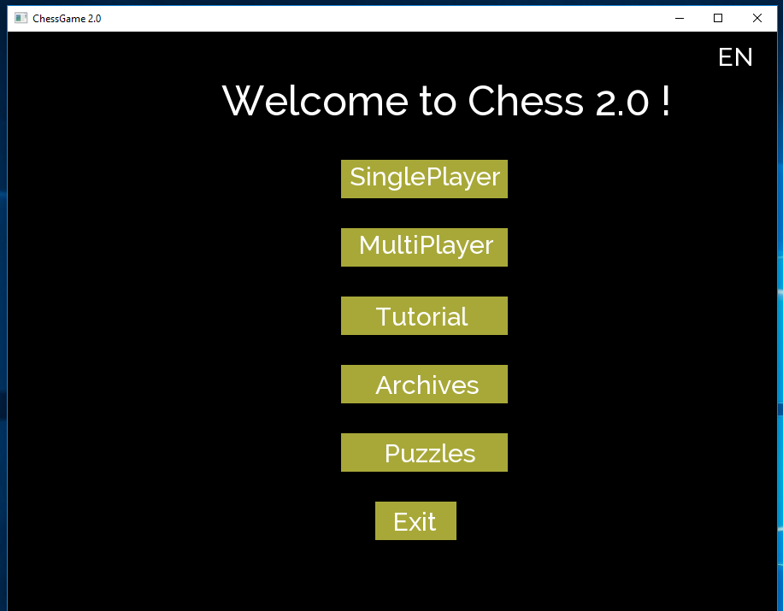

Fig. 1.0

Each button will lead you to a different section of the app.

The first button, labeled *Singleplayer* will start a new game where you play Chess against the Computer. Before starting the game itself, you will have to pick a side and a difficulty.

The second button, labeled *Multiplayer* will start a game of Chess where you play against another person, but on the same device.

The third one, will get you to the tutorial section, where the basic rules of chess are explained.

The *Archives* button will lead you to a section where you can replay any game you’ve completed this far. Last but not least, the *Puzzles* button will allow you to play a series of puzzles made to

improve your board-analysis skills and help you take better decisions in your future games.

In the top right corner you can see a label with the current language of the application. Clicking on it will toggle the language and translate the application in an instant. ( Fig 1.1 )

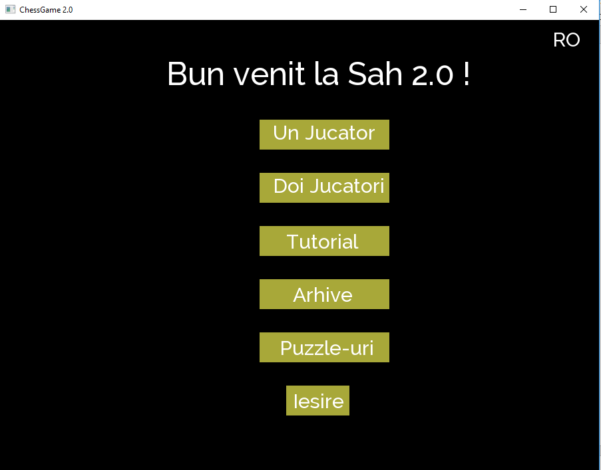

Fig. 1.1

Currently, the application has two languages : Romanian and English.

**IV. Game Section**

After you have started a game, you will see the chess board with the pieces on it, alongside with two buttons *Resign* / *Propose Draw*, and a label ( in Multiplayer games only ) telling who’s turn it is. ( Fig. 1.2 )

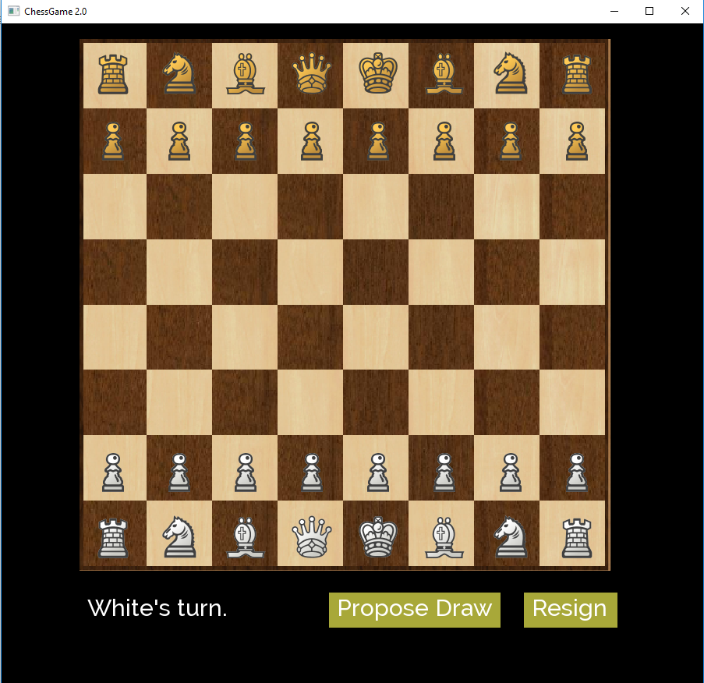

Fig. 1.2

The first button will offer draw, and, in Multiplayer games, the other player will be able the accept via the same button ( Fig. 1.3 )

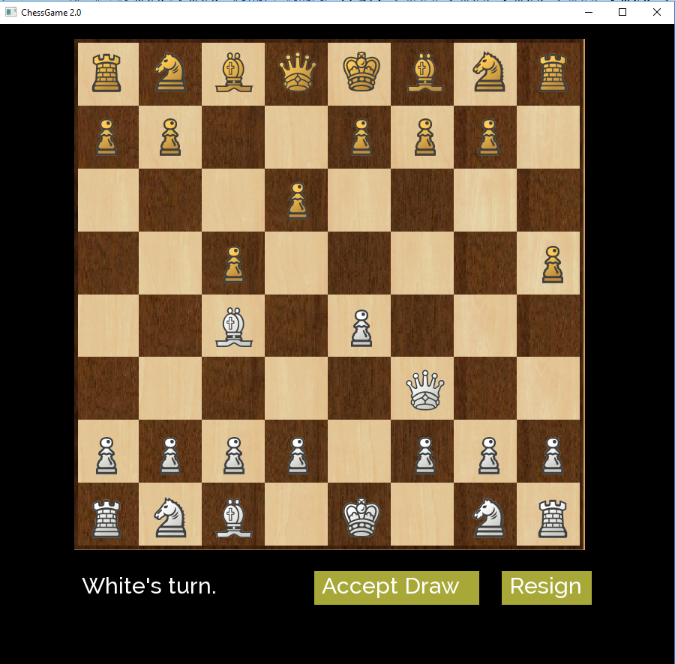

Fig. 1.3

In order to propose a draw, all you have to do is click the button and make your move to end your turn. On the other player’s turn he can accept your offer by clicking the same button or he can reject the draw offer by making his own move, thus ending his turn.

The *Resign* button will end the game, the player who pressed it being the looser.

At the end of any game, you will have the label show the winner ( In both Singleplayer and Multiplayer modes ) and two buttons *Review Match / Exit*. ( Fig. 1.4 )

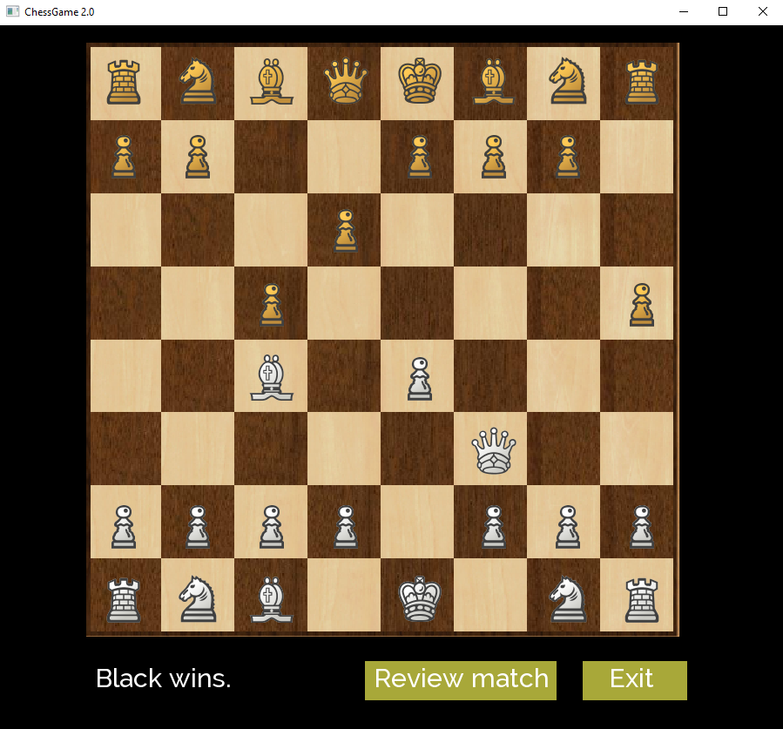

Fig. 1.4

The first button will lead you to the review screen, where buttons *Back* and *Continue* will allow you to see the game move by move.

The second button will return you to the main menu.

**V. Archives**

Inside the archives, you will see the number of saved games and will be asked which game to load. Simply type in the number you want to load ( from 1 to maximum number ) and you will be able to review that game. ( Fig. 1.5 )

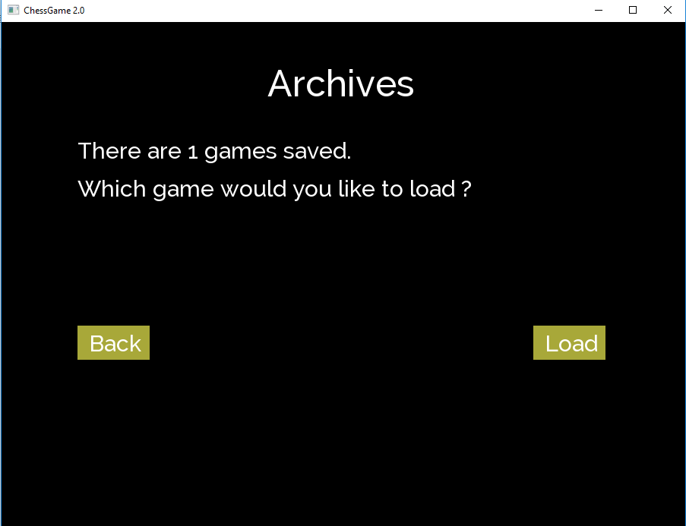

Fig. 1.5

To avoid breaking the application, you can only type in numbers. So, don’t try writing words please 😊

**VI. Moving Pieces**

In order to move pieces simply drag and drop the pieces. If nothing happens, check if the move is valid and if it is, try picking the piece from its center.

**VII. Special Keys**

There are three special keys :

* Z : Undo last move
* X : Undo last set of moves ( 1 white – 1 black )
* ESCAPE : Closes the application