**Michine Learning-Homework2**

資訊碩一 11177016 董承宥

1. **Using linear kernel and RGB color feature**

**(400 × 3 dims for each image)**

1. use to_svm.py to convert the raw data into svm file format.
2. Use svm-scale.exe to scale the converted files and data to [0,1].



1. Training with tuned data to generate models.

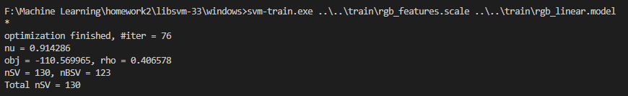

1. The accuracy of the prediction using the trained model is 71.4286%.



1. **Using RBF kernel and RGB color feature**
2. Use to_svm.py to convert the raw data into svm file format.
3. Use svm-scale.exe to scale the converted files and data to [0,1].



1. Use grip.py to find the best arguments.

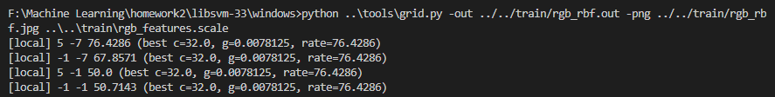



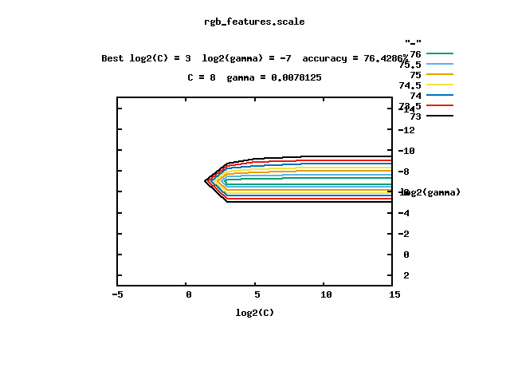

1. Model training using parameters obtained from grip.py.

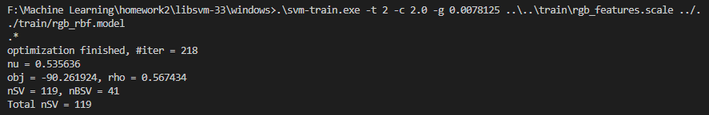

1. The accuracy of the prediction using the trained model is 83.5714%.



1. **Using linear kernel and gradient feature**

**(400 × 2 dims for each image)**

1. Use to_svm.py to convert the raw data into svm file format.
2. Use svm-scale.exe to scale the converted files and data to [0,1].



1. Training with tuned data to generate models.

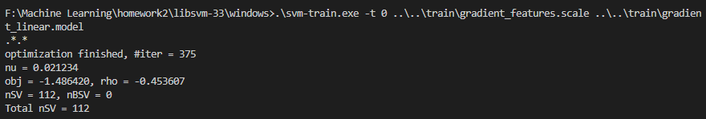

1. The accuracy of the prediction using the trained model is 80.7143%.



1. **Using RBF kernel and gradient feature**
2. Use to_svm.py to convert the raw data into svm file format.
3. Use svm-scale.exe to scale the converted files and data to [0,1].



1. Use grip.py to find the best arguments.

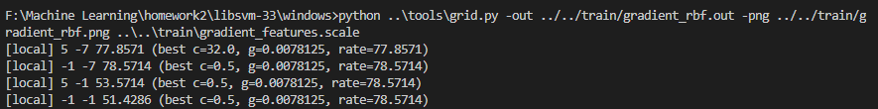



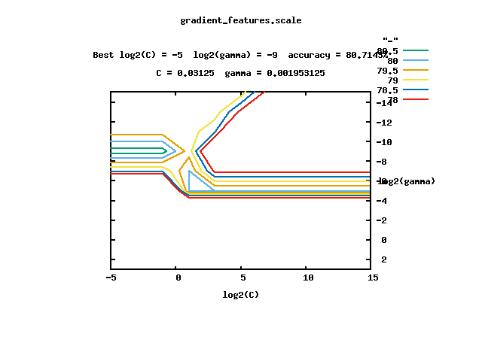

1. Model training using parameters obtained from grip.py.

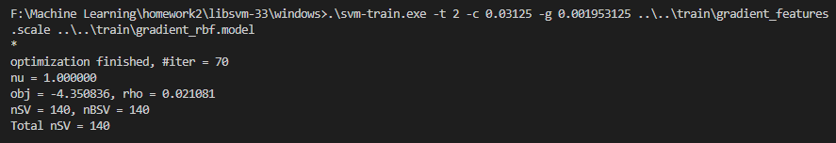

1. The accuracy of the prediction using the trained model is 85.7143%.



1. **Using linear kernel and color+gradient feature**

**(400 × 5 dims for each image)**

1. Use to_svm.py to convert the raw data into svm file format.
2. Use svm-scale.exe to scale the converted files and data to [0,1].



1. Training with tuned data to generate models.

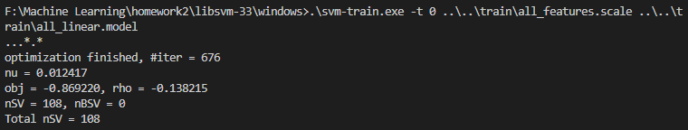

1. The accuracy of the prediction using the trained model is 84.2857%.



1. **Using RBF kernel and color+gradient feature**
2. Use to_svm.py to convert the raw data into svm file format.
3. Use svm-scale.exe to scale the converted files and data to [0,1].



1. Use grip.py to find the best arguments.

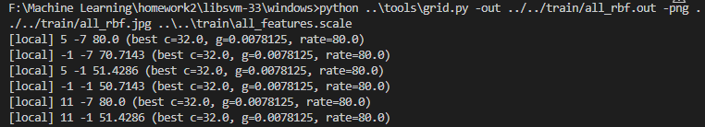



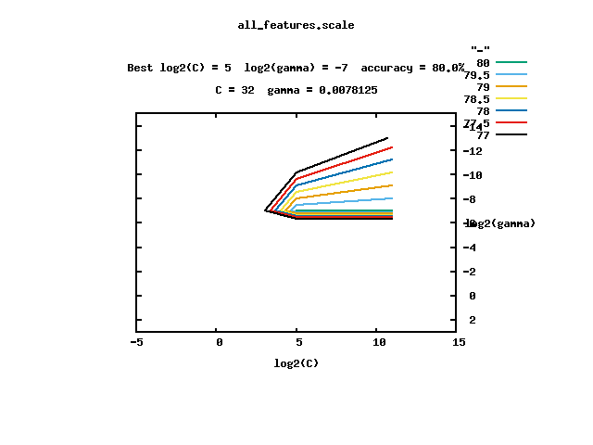

1. Model training using parameters obtained from grip.py.

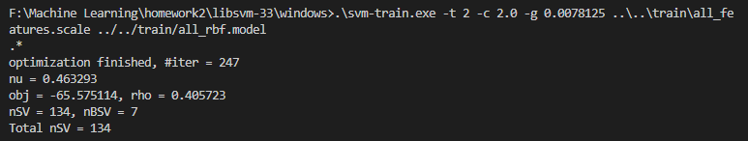

1. The accuracy of the prediction using the trained model is 85%.



**Conclusion**

For both training schemes, RBF kernel is more accurate than linear kernel.

In terms of feature selection, the color+gradient feature trained model has the highest accuracy when using the linear kernel, but the color+gradient feature trained model does not have the best accuracy when using the RBF kernel.