# **Bench introduction: Case western reserve university (CWRU) bearing dataset**

## **Dataset overview**

This is a well-known dataset in the field of bearing fault diagnosis, with experimental data from the CWRU bearing data center. The test bench and dataset are described below.

## **Bench information**

The bench for the CWRU dataset consists of a 2 hp motor, a torque transducer/translator, a dynamometer, and an electronic controller. An acceleration sensor is placed at the fan end of the motor housing and at the drive end to collect the acceleration signal from the bearings. A 16-channel data logger collects the vibration signals. To quantify the influence of fault location on the bearing vibration response, the outer ring fault was placed at three different locations, at 3 o’clock (directly in the load zone), 6 o’clock (orthogonal to the load zone), and 12 o’clock. 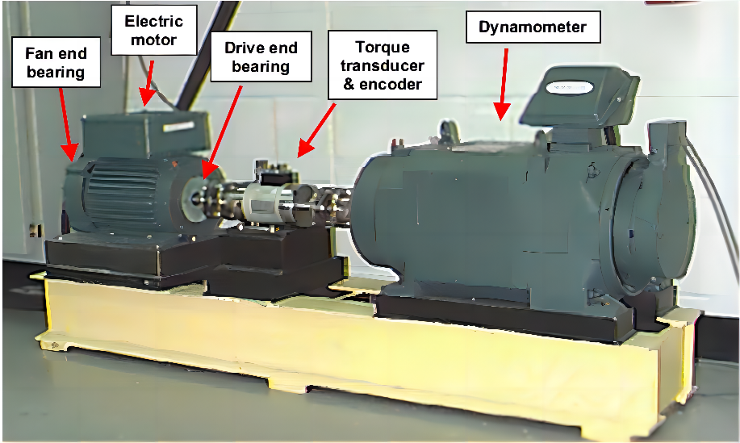

Figure 1: Overview of CWRU [1]

## **Characteristics of tested bearings**

There are two types of bearings on the bench, the bearing SKF-6205-2RS JEM located at the drive end with sampling frequencies of 12 kHz and 48 kHz, and the bearing SKF-6203-2RS JEM located at the fan end with the sampling frequency of 12 kHz. The specific parameters of the two types of bearings are shown in Tables 1 and 2 [2].

Table 1: Specifications of bearing SKF-6205-2RS JEM [2]

Table 2: Specifications of bearing SKF-6203-2RS JEM [2]

## **Operating conditions**

The data from CWRU dataset is the acceleration signal of a bearing fault with three single points (inner ring fault, outer ring fault, and rolling element fault). There are four fault diameters, 0.007 inches, 0.014 inches, 0.021 inches, and 0.028 inches, respectively. The damage to the bearings is introduced by electro-discharge machining (EDM), so this dataset can only be used for fault diagnosis rather than RUL prediction. The bearings in each condition are also operated at 0 hp, 1 hp, 2 hp, and 3 hp load, corresponding to motor speeds of 1797 rpm, 1772 rpm, 1750 rpm, and 1730 rpm. Table 3 lists the four operating conditions. Tables 4-7 present the details of the four operating conditions.

Table 3: Conditions of CWRU [3]

Table 4: CWRU normal baseline data [3]

Table 5: CWRU 12 kHz drive end bearing fault data [3]

Table 6: CWRU 48 kHz drive end bearing fault data [3]

Table 7: CWRU 12 kHz fan end bearing fault data [3]

# **Reference**

[1] Wade A Smith and Robert B Randall. Rolling element bearing diagnostics using  
the case western reserve university data: A benchmark study. *Mechanical systems  
and signal processing*, 64:100–131, 2015.

[2] HAKAN ÇALI¸S, ABDÜLKADIR Cakir, and Emre Dandil. Artificial immunity- ˙  
based induction motor bearing fault diagnosis. *Turkish Journal of Electrical Engineering and Computer Sciences*, 21(1):1–25, 2013.

[3] Case Western Reserve University. *Case Western Reserve University Bearing Data* *Center Website*. <http://csegroups.case.edu/bearingdatacenter/home>. Oct. 2016.