# Bench introduction

## Dataset overview

The Paderborn bearing dataset was designed and provided by the Paderborn University. The data set contains a total of 128 sets of experimental data for 32 bearings under 4 working conditions. All of the data can be used for bearing fault diagnosis. Generating Real Bearing Damage data enables remaining useful life prediction.

## Bench information

### Artificial damage and healthy (undamaged) bearings

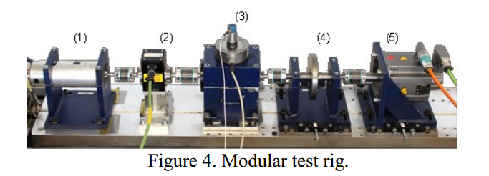

**Figure 1. Modular test rig.[1]**

The test rig consists of several modules: an electric motor (1), a torque-measurement shaft (2), a rolling bearing test module (3), a flywheel (4) and a load motor (5). [1]

The motor (1) is a 425 W Permanent Magnet Synchronous Motor (PMSM) with a nominal torque of T = 1.35 Nm, a nominal speed of n = 3,000 rpm, a nominal current of I = 2.3 A and a pole pair number p = 4 (Type SD4CDu8S-009, Hanning Elektro-Werke GmbH & Co. KG). It is operated by a frequency inverter (KEB Combivert 07F5E 1D-2B0A) with a switching frequency of 16 kHz. [1]

### Generating real bearing damage

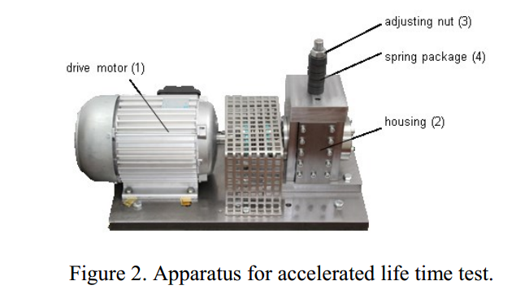

**Figure 2. Apparatus for accelerated life time test. [1]**

## Bearing parameters and category of bearing damage

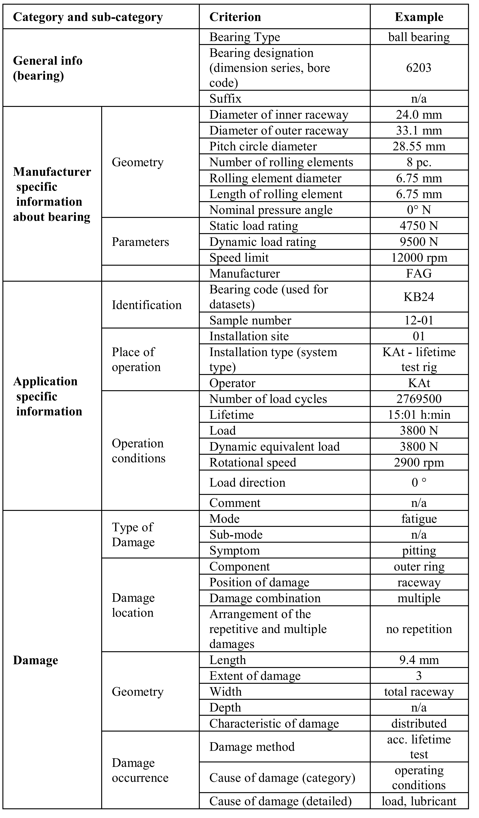

**Table 1 . Categorization of bearing damage. [1]**

## Operating conditions

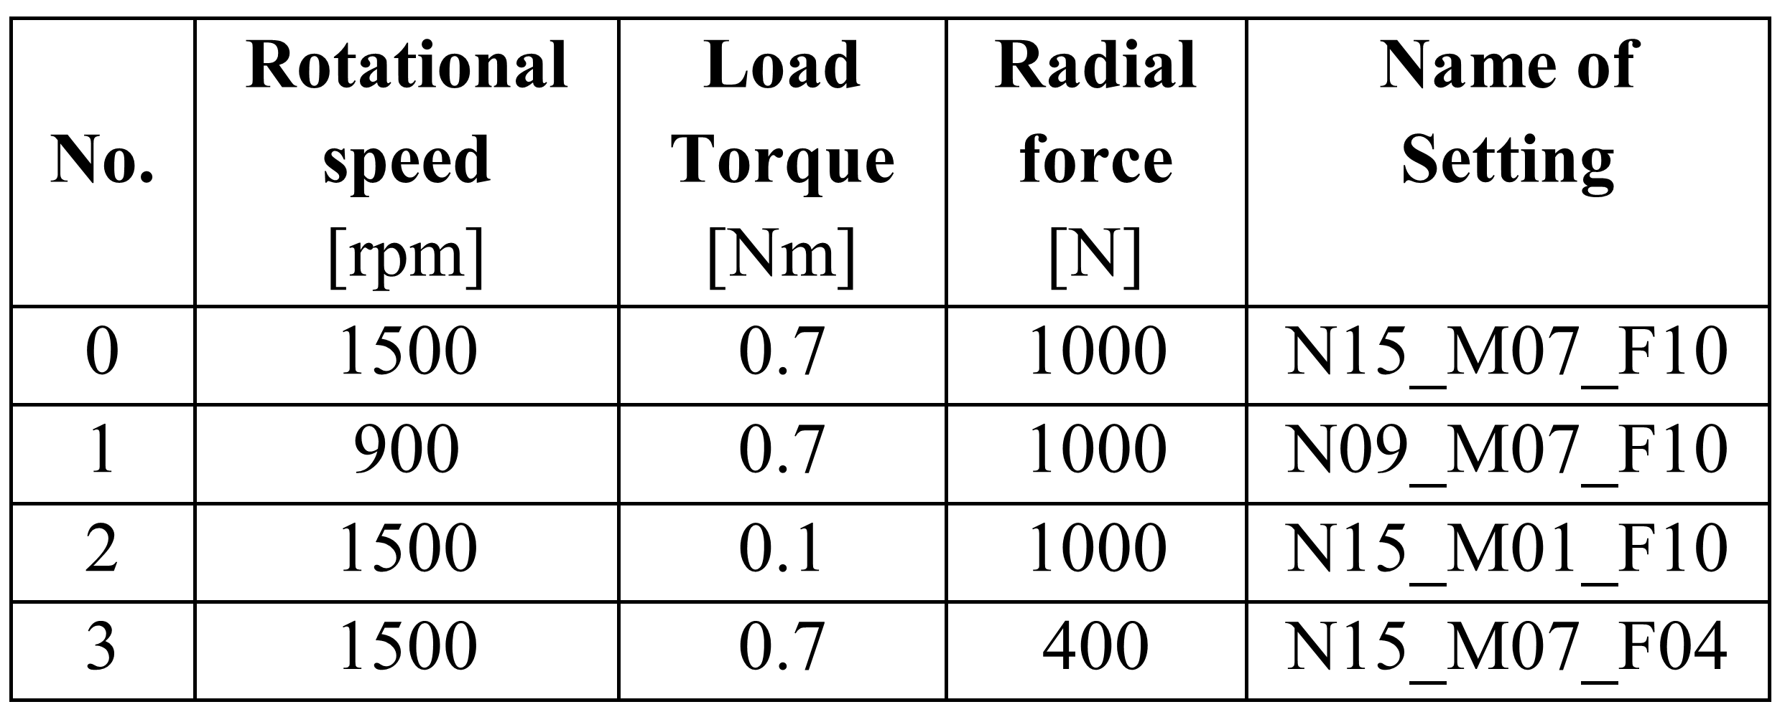

**Table 2. Operating parameters. [1]**

## Data collection

### Sampling rate

|  |  |
| --- | --- |
| Vibration signal: | 64kHz |
| Mechanical signal: | **4kHz** |
| Temperature signal: | **1Hz** |
| Motor current signal: | **64kHz** |

## Data introduction

### Artificial damage

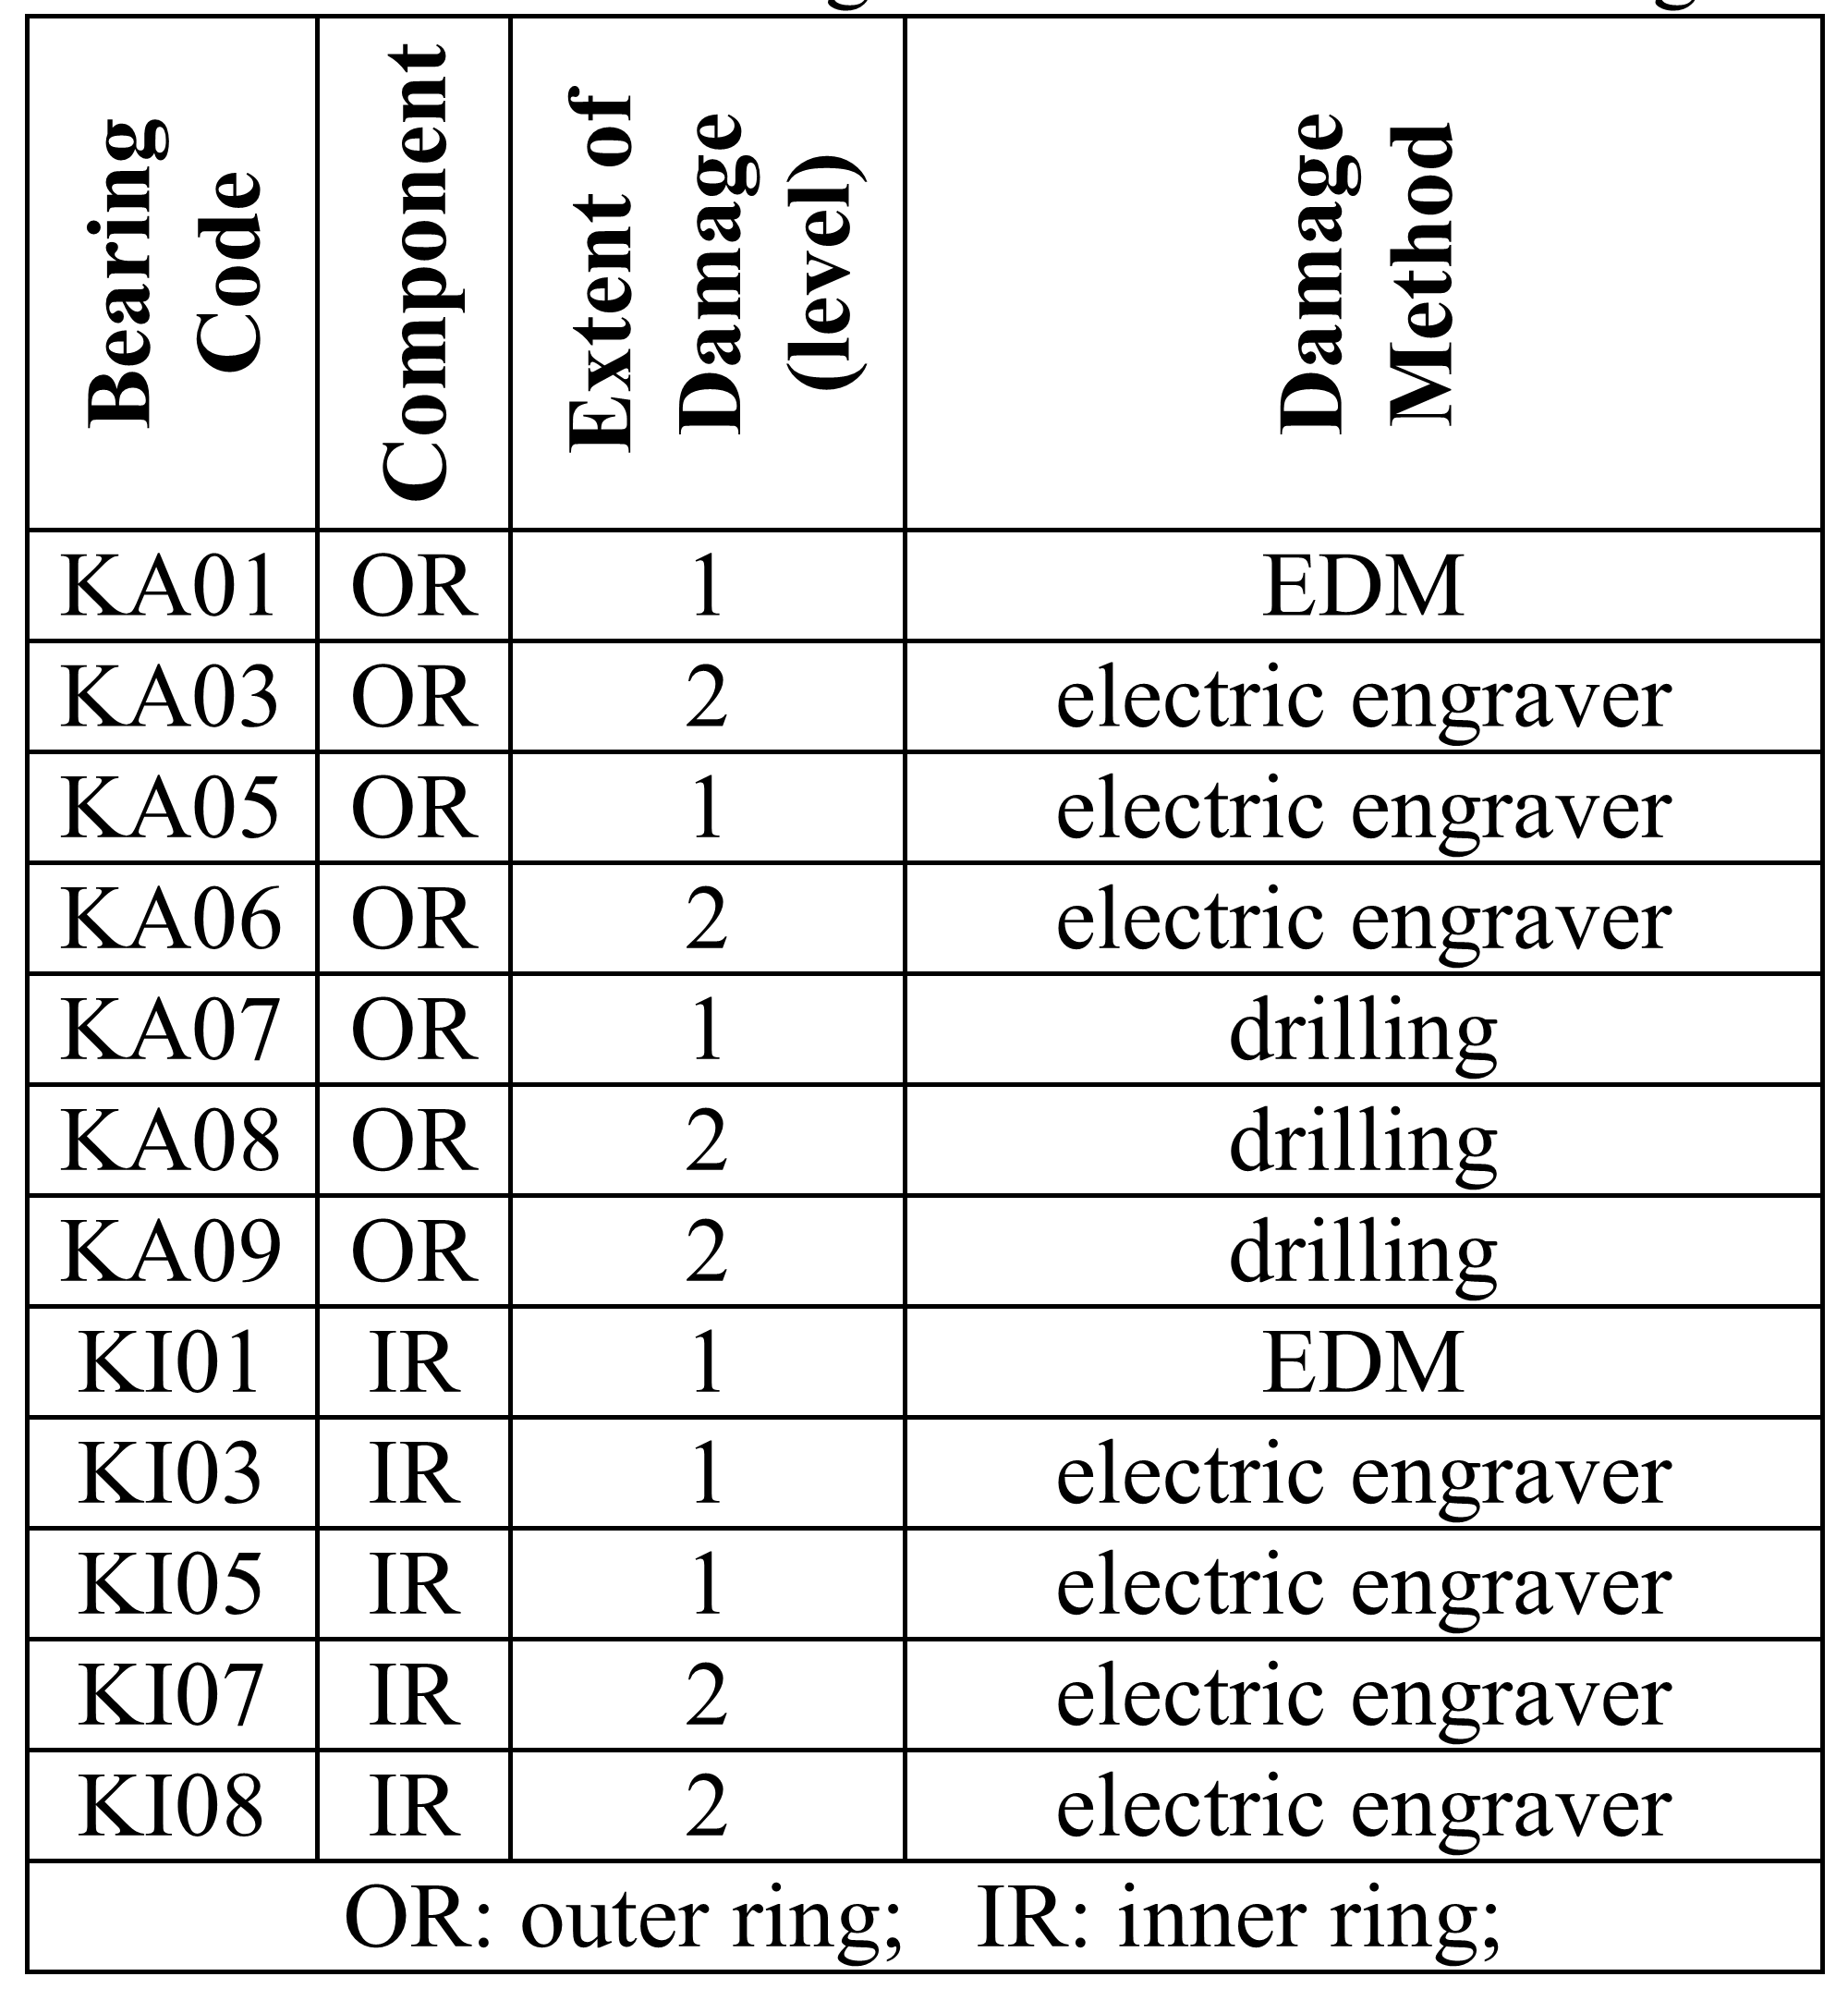

**Table 3. Test bearings with artificial damage. [1]**

### Healthy (undamaged) bearings

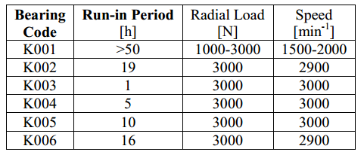

**Table 4. Operating parameter of healthy (undamaged) bearings during run-in period. [1]**

### Generating real bearing damage

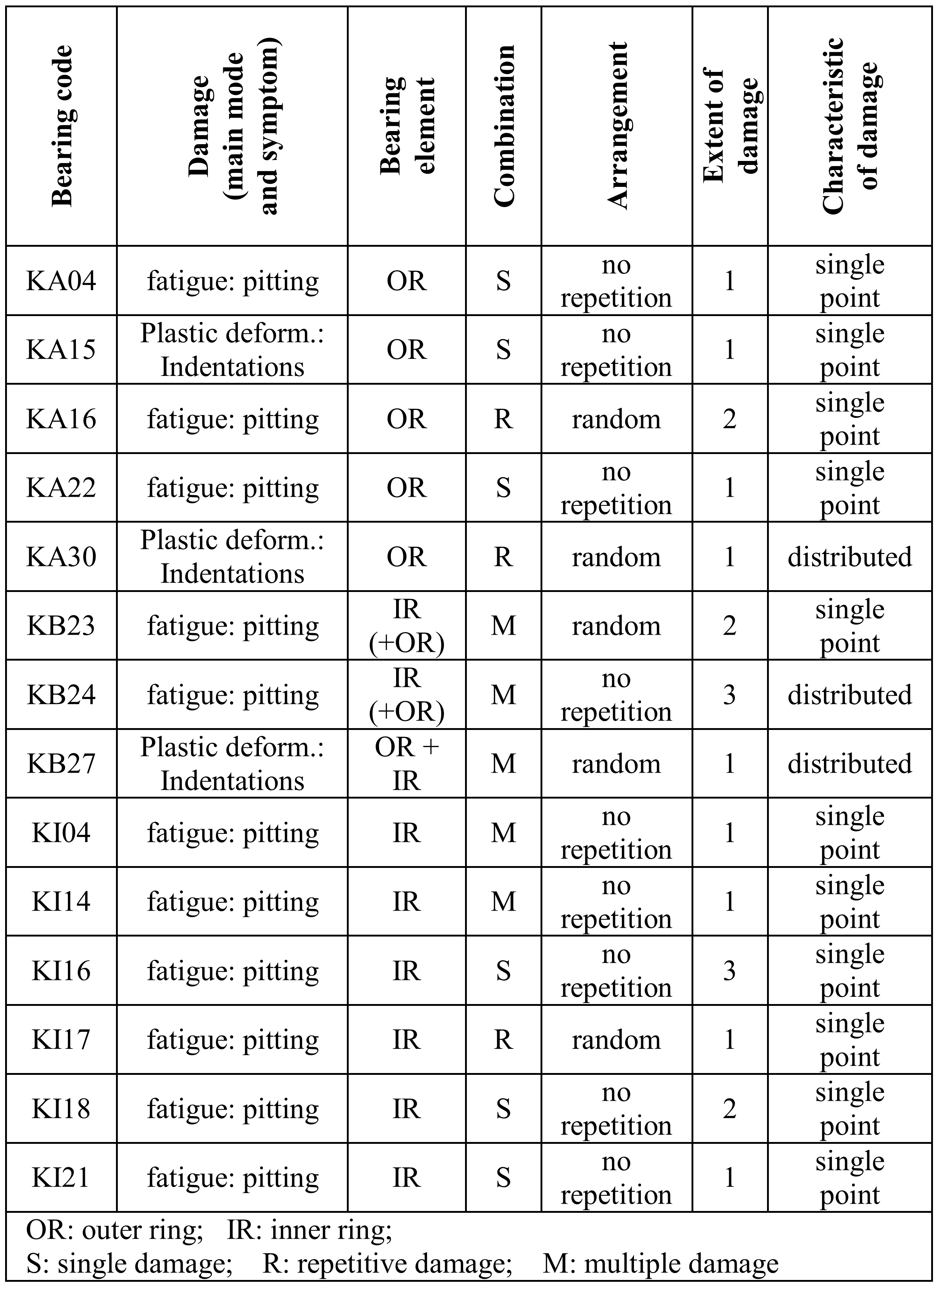

**Table 5. Test bearings with real damages caused by accelerated lifetime test.[1]**

### Damage levels to determine the extent of damage

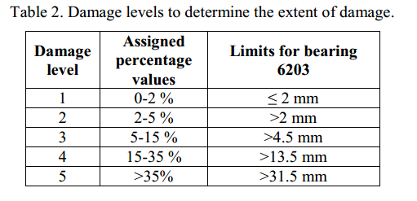

**Table 6. Damage levels to determine the extent of damage.[1]**

# Reference

[1] Patrick Nectoux, Rafael Gouriveau, Kamal Medjaher, Emmanuel Ramasso, Brigitte Morello, Nourredine Zerhouni, Christophe Varnier. PRONOSTIA: An Experimental Platform for Bearings Accelarated Life Test. IEEE International Conference on Prognostics and Health Management, Denver, CO, USA, 2012.