XJTU-SY Bearing Datasets1. Dataset overview

XJTU-SY bearing datasets are provided by the Institute of Design Science and Basic  
Component at Xi’an Jiaotong University (XJTU), Shaanxi, P.R. China and the Changxing Sumyoung Technology Co., Ltd. (SY), Zhejiang, P.R. China. The datasets  
contain complete run-to-failure data of 15 rolling element bearings that were acquired  
by conducting many accelerated degradation experiments.

2. Dataset introduction

**2.1. Bearing testbed**

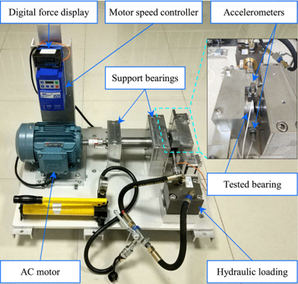

Figure shows this bearing testbed, a record of degradation data throughout the

entire aging cycle of the bearing. The bearing test bench is mainly composed of an alternating current (AC) motor, a digital force display, a motor speed controller, a tested bearing, a hydraulic loading, support bearings and accelerometers.

**2.2. Tested bearing**The type of tested bearings is LDK UER204. and the detailed parameters are given.

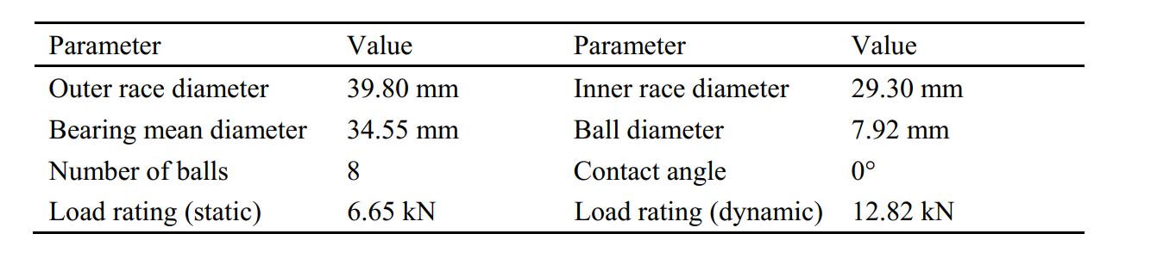

**2.3. Operating condition**A total of 3 different operating conditions were set in the accelerated degradation  
experiments:

1) 2100 rpm (35 Hz) and 12 kN;  
2) 2250 rpm (37.5 Hz) and 11 kN;  
3) 2400 rpm (40 Hz) and 10 kN.

**2.4. Sampling setting**

To collect run-to-failure data from the bearings, two PCB 352C33 accelerometers are placed on the housing of the bearings being tested. The accelerometers are positioned at 90° to each other, that is, one is placed on the vertical axis and the other is placed on the horizontal axis. The sampling frequency is 25.6kHz to record 32 768 samples (i.e., 1.28 s) every 1 minute

**3. Dataset details**

Table lists the detailed information of each  
tested bearing, including number of CSV files, bearing lifetime and fault element.

