# Function of Random Forest (RF)

Fault diagnosis and remaining useful life (RUL) prediction based on Random Forest (RF)

## Description

Result = RF (Function‚ Optimization Algorithm‚ Hyper-Parameter) returns a confusion matrix. In "File Upload" is used to load the required data set. In "Function" a method is selected. When the optimization algorithm is not used, "Optimization Algorithm" should be selected as "None" and the required parameters should be set in the "Parameter".

Result = RF (Function‚ Optimization Algorithm‚ Hyper-Parameter) returns a confusion matrix. In "File Upload" is used to load the required data set. In "Function" a method is selected. When the optimization algorithm is used, the required algorithm is selected in "Optimization Algorithm" and parameters such as the number of iterations can also be set here.

## Parameter introduction

Parameters of RF:

* Max depth: The maximum depth of the tree. (data type: int)
* Max leaf nodes: Grow a tree with “Max leaf nodes“ in best-first fashion. (data type: int)
* N of Estimators: The number of trees in the forest. (data type: int)

Parameters of optimization algorithms:

* Pop size: Number of particles or chromosomes. (In particle swarm optimization (PSO) and Genetic algorithm (GA)). (data type: float)
* Maximum iterations: Number of iterations. (data type: int)
* α: Cooling factor. (In simulated annealing (SA)). (data type: float)

**Functional description of the main components**

The overall view of function of RF is divided into File Upload, Function, Optimization Algorithm, Parameter and Result.

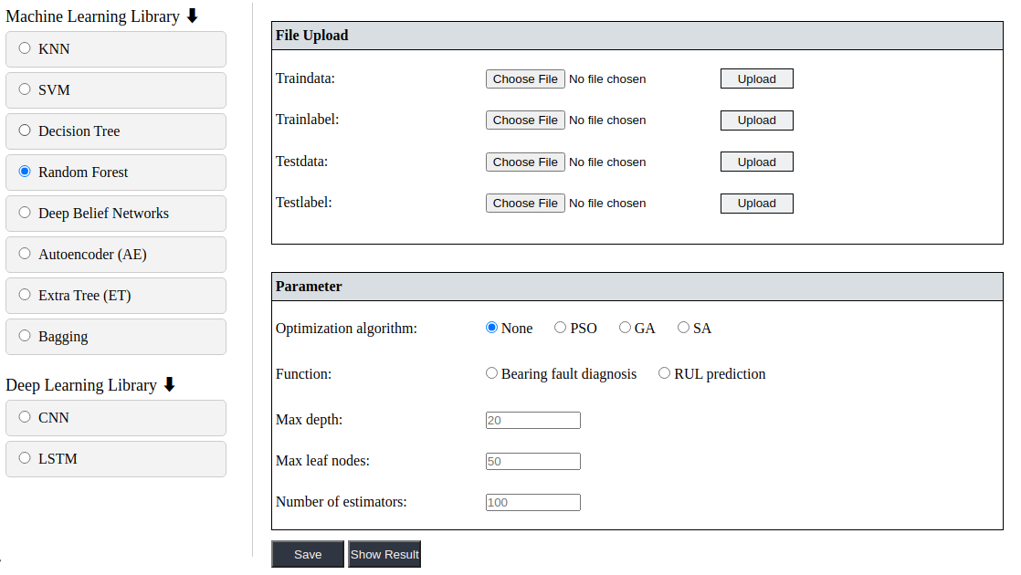

### File Upload

In the “File Upload” component, the user loads data and labels by clicking on the “Choose File” buttons, and the file names of the data and labels are displayed in the boxes. Finally, click the button “Upload“ to upload the file successfully. Upload data files support .mat, .txt, .csv, .xls, .npy format files.

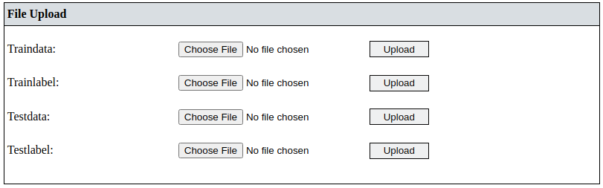

* Train data or test data: Each row of train label or test lebelrepresents the classification or RUL of the corresponding row of train data or test data. (data type: float)
* Train label or test label: Each row corresponds to one observation (also known as an instance or example), and each column corresponds to one predictor variable (also known as a feature). (data type: float)

### Function

Fault diagnosis and RUL prediction are provided as methods.



### Optimization Algorithm

In this component, the user can select the optimization algorithm they wish to use. If the user does not want to use the optimization algorithm to optimize the parameters, simply select “None“.



If the user needs to use the optimization algorithm, the default parameters of the optimization algorithm can be changed.

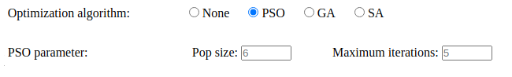

### Hyper-parameter

When ”None” is selected in the “Opt Algorithm” component, it means that the optimization algorithm is not used to find the optimal parameters. Therefore, the user has to set the hyper-parameter values himself. Each hyper-parameter is provided with a default value, but the user can also change the value of the hyper-parameter if required, if the user does not change it, the software will run with the default value.

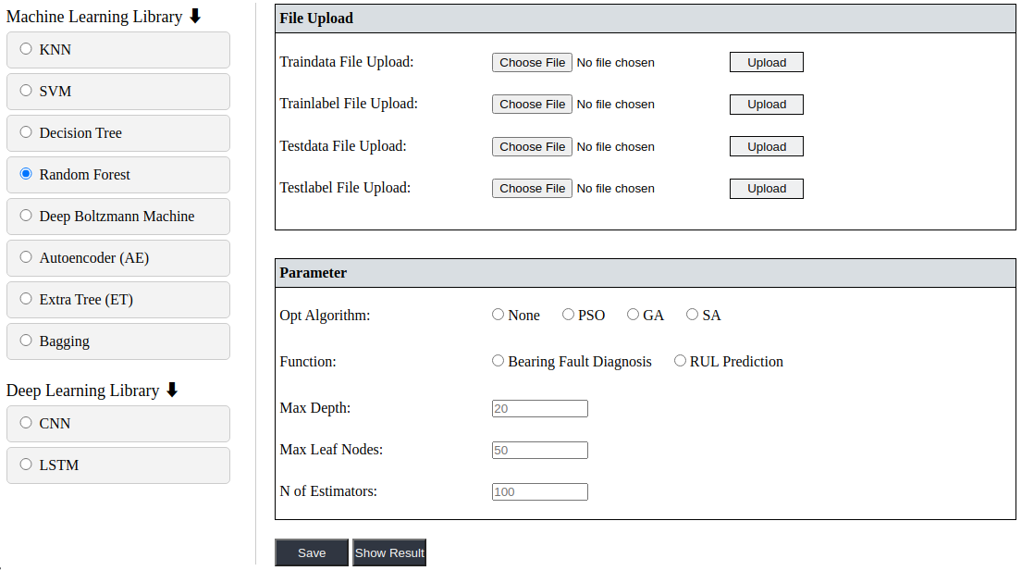

### Result

After the software has been run, click the “Show Result“ button to display the confusion matrix.

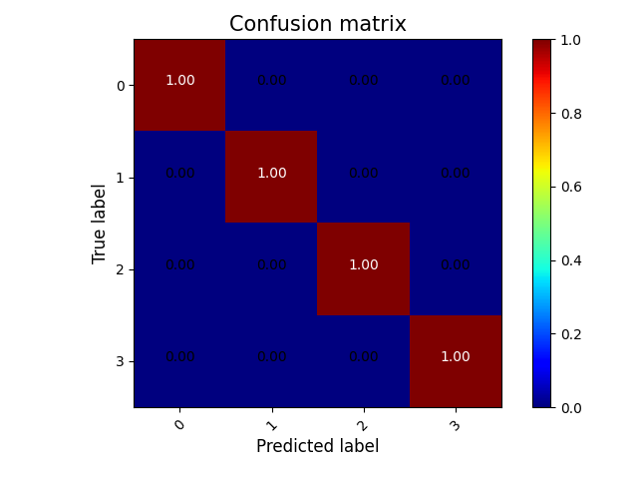

If the function is “RUL Prediction“ and an optimization algorithm is used, it will display a drawn curve.

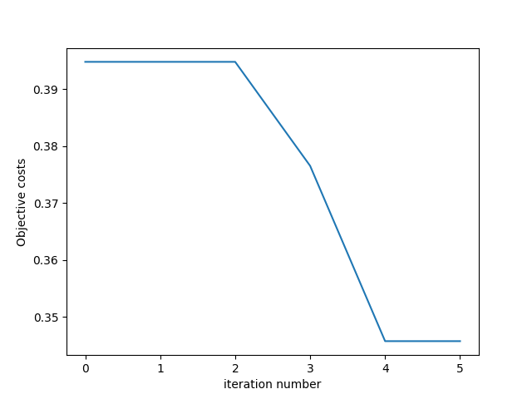

The “Download“ button downloads relevant result images, data, and reports.

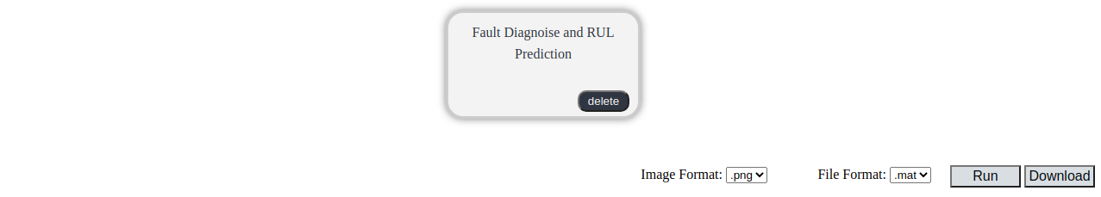

**Examples**

The process of finding the optimal hyper-parameters of RF using the PSO algorithm in fault diagnosis.

**Step 1: Configuration procedure**

To select “Fault diagnosis and RUL prediction“ from the process bar on the left side of the web page.



**Step 2: Select function**

To select the procedure that needs to be configured from the process display area.

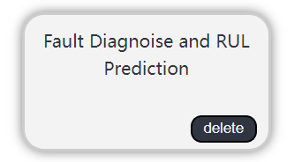

The RF function is chosen for fault diagnosis and RUL prediction.

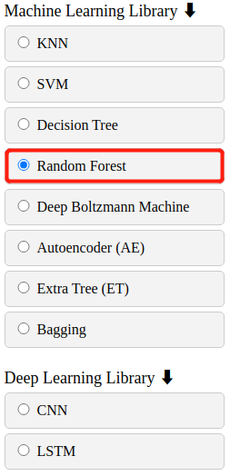

**Step 3: Data file upload**

Select the data file to be applied from the local path.

After successfully selecting the upload data file, click ”Upload”. Complete the uploading of training data and test data.



**Step 4: Set and save parameter**

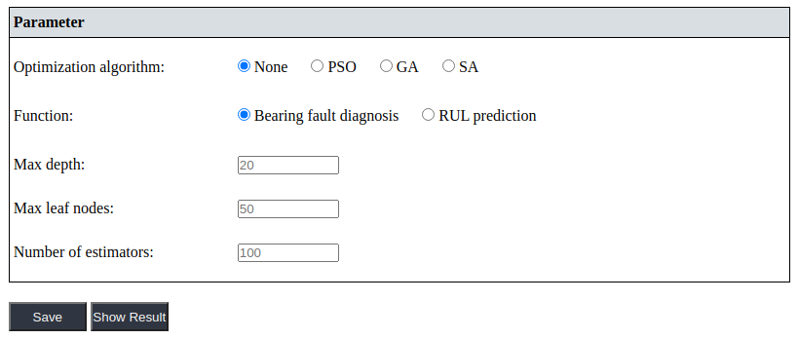

First, choose whether to use the optimization algorithm to optimize the hyper-parameters of the machine learning model.

To select a different optimization algorithm, the user needs to configure additional optimization algorithm parameters. For details about the parameters of the optimization algorithm, see "Parameter introduction".

Then the user needs to choose the application method of the RF model. Optional bearing fault diagnosis or remaining life prediction.

Finally, click "Save" after all parameters are configured.

**Step 5: Execute the configured procedure**

Before executing the configured function, the user also needs to set the selected output image and file format.



Finally, select "Run".

**Step 6: Show result**

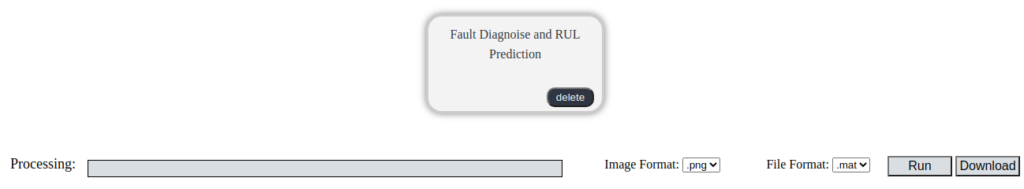

When the progress bar reaches the end, the task is completed.



The graphical results of the function can be easily viewed by selecting "Show Result".



The displayed result graph is the confusion matrix.

**Step 7: Download**

To download the compressed file of the trained model, the predicted labels, and the detailed results of the process, the user can click the "Download" button.

