# FEMTO-ST Bearing Dataset

Open dataset FEMTO-ST bearing dataset as data source

## Description

Result = FEMTO-ST (Data selection, Data segmentation) returns a two-dimensional data (sample number, sample length). In the "Data selection" area, select the bearing data. Set the parameters for the data segmentation in the "Data segmentation" area.

## Parameter introduction

Parameters of data segmentation:

* Shift: Length of overlapping samples between data segmentation samples. (data type: int)
* Sample length: Sample length after data segmentation. (data type: int)
* Save data: Whether to save the data after data segmentation.
* Function option: Uses of sample data, fault diagnosis, or RUL prediction. This option will affect the generated sample labels. If the user selects fault diagnosis, the user will use the labels set above; if the user selects RUL prediction, the user will set the labels to a floating point between 0 and 1. 0 means the bearing is completely damaged, and 1 means the bearing is healthy.

**Functional description of the main components**

The overall view of function of FEMTO-ST bearing dataset is divided into Data selection, Data segmentation and Result.

### Data selection

In the data selection component, the user retrieves the required bearing data by means of a query form. The table contains information on the sampling rate, radial load, rotational frequency, fault type, default label, and bearing number of the data set. By entering the specified number in the input box, the corresponding bearing data can be retrieved. The numbers are separated from each other using commas, as shown in the figure with the default parameters.

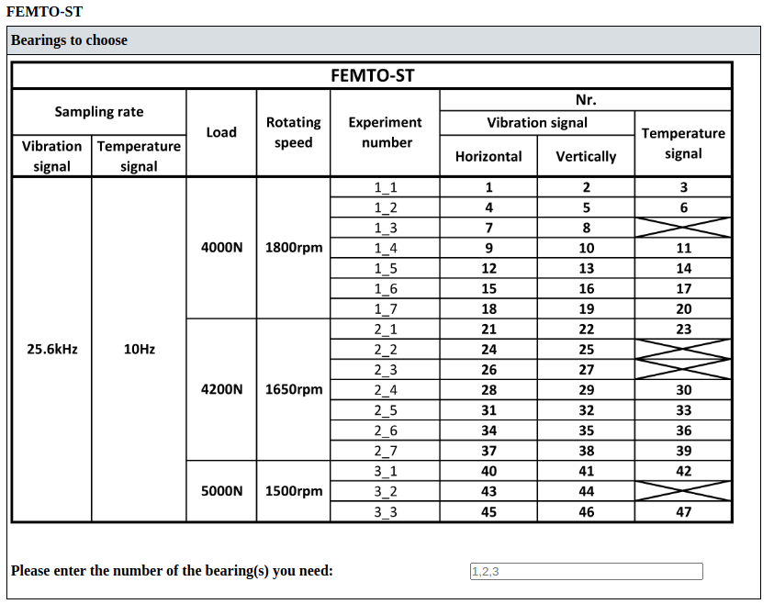

### Data segmentation

The number of samples can be increased and the length of the samples can be standardized through data segmentation. The data segmentation parameters can be configured in this area, as shown in the figure.

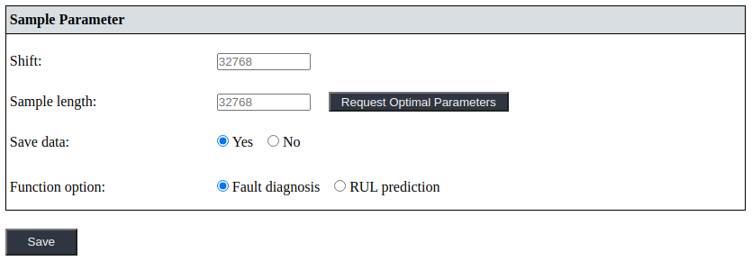

The user can obtain an optimised sample length by clicking on the "Request Optimal Parameters" button. The optimised sample length depends on the selected bearing number.

The "Save data" and "Function option" parameters can be configured in detail in the "Parameters introduction" section.

### Result

If the user has set "Save data" to "Yes", the saved data file can be downloaded by clicking on the "Download" button. The "File Format" parameter can be configured prior to the process to determine the format of the resulting data file.

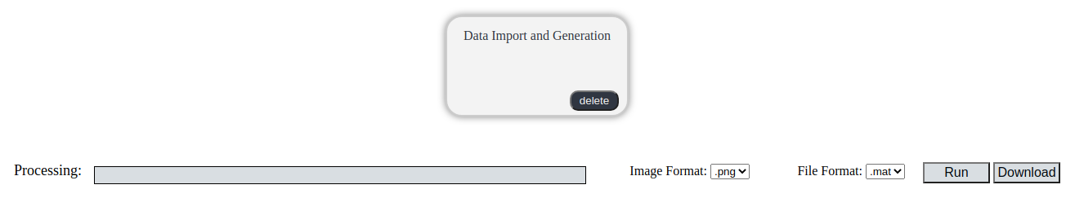

**Examples**

The process of preparing sample data using the FEMTO-ST bearing dataset as a data source.

**Step 1: Configuration procedure**

To select “Data Generation” from the process bar on the left side of the web page.



**Step 2: Select function**

To select the procedure that needs to be configured from the procedure display area.

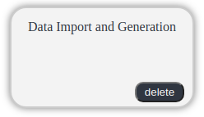

Select FEMTO-ST Dataset to generate sample data.

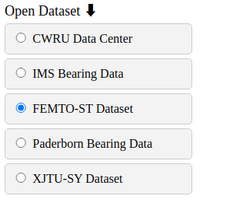

**Step 3: Set and save parameter**

Query the table and select the desired bearing data. Afterwards, set the labels manually for the selected data.



Set the data segmentation parameters, along with other parameters.

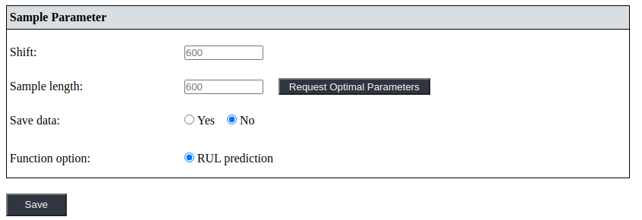

Finally, click "Save" after all parameters are configured.

**Step 4: Execute the configured procedure**

Before executing the configured function, the user also needs to set the selected file format.

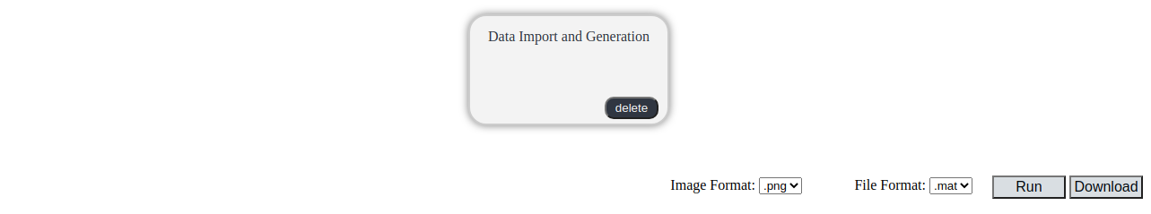

Finally, select "Run".

**Step 5: Download**

When the progress bar reaches the end, the task is completed.



To download the saved sample data, the user can click on the "Download" button.