**Bearing Simulation Based on Physical Dynamics Model**

Bearing vibration signal generation based on the physical dynamics model

## Description

To generate the bearing vibration data with or without defects, users should define three parameter types. If the user does not want to define them, they can also just click the Save button to run with the software's default parameters.

For parameter, definitions refer to the following parameter introduction.

## Parameter introduction

Parameters of the ball:

* D: Ball diameter (data type: float);
* Di: Diameter of the inner ring (data type: float);
* Do: Diameter of the outer ring (data type: float);
* Kb: Stiffness of balls (data type: float);
* Nb: Number of balls (data type: int);
* Alpha: Contact angle (data type: float);

Parameters of the system:

* Ms: Mass of the shaft (data type: float);
* Mp: Mass of the pedestal (data type: float);
* Mr: Mass of the sprung mass system (data type: float);
* Ks: Stiffness of the shaft (data type: float);
* Kp: Stiffness of the pedestal (data type: float);
* Kr: Stiffness of the sprung mass system (data type: float);
* Cs: Damping of the shaft (data type: float);
* Cp: Damping of the pedestal (data type: float);
* Cr: Damping of the sprung mass system (data type: float);

Parameters of defect definition:

* L: Length of the defect (data type: float);
* B: Width of the defect (data type: float);
* H: Height of the defect (data type: float);
* Outer ring switch: Enable switch to simulate outer ring defect, 0-disable, 1-enable (data type: int);
* Inner ring switch: Enable switch to simulate inner ring defect, 0-disable, 1-enable (data type: int);
* Ball switch: Enable switch to simulate ball defect, 0-disable, 1-enable (data type: int);
* Number: The number of defects to simulate (data type: int);
* Position: Local angular position arrays for defects, e.g.: [20,40,60] stand for three defects at 20deg,40deg and 60deg respectively;
* Identifier: The flag number of the fault ball, 1≤i≤Nb;
* Fr: Radial external force (data type: float);
* Fa: Axial external force (data type: float);
* Ω_shaft: The speed of the shaft (data type: float);
* Duration: Simulation duration (data type: float);
* Step size: The step size for time (data type: float);
* Mutation percentage: Sliding percentage, 0.01-0.02 rad (data type: float);
* Initial angular position: Initial angular position of the cage (data type: float);

**Functional description of the main components**

The parameter settings are divided into three parts: Ball parameter, system parameter and defect definition. Click to display the parameter settings for the corresponding part.

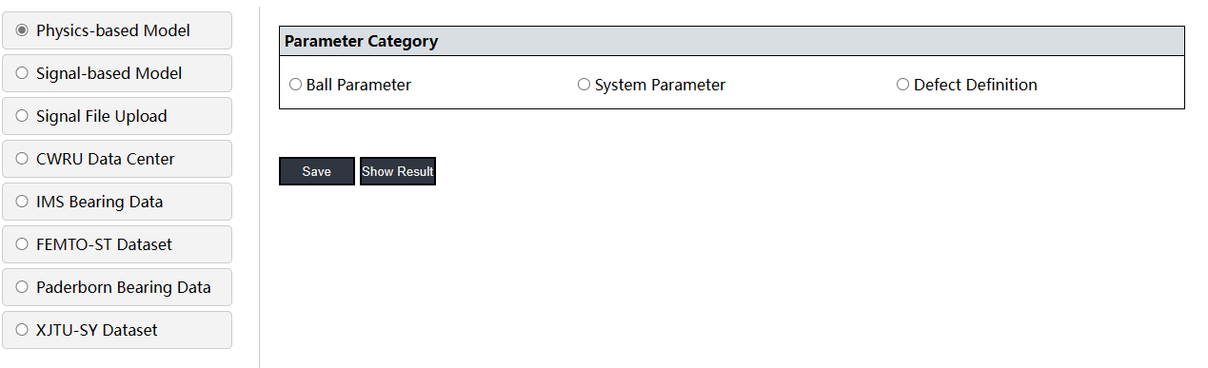

### Ball parameter

In this part, to define the bearing the user has to manually enter the bearing parameters. To use the software’s default parameters the user can also just click on the save button.

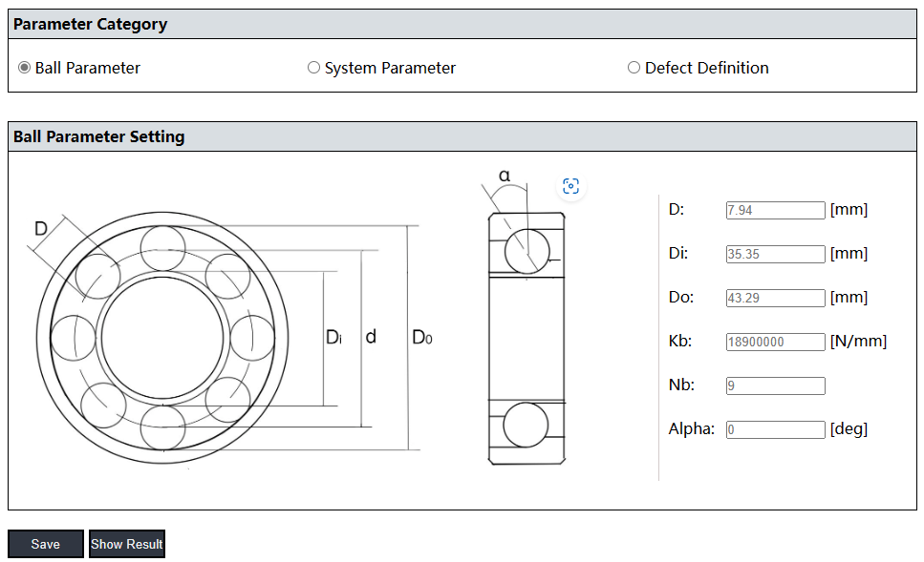

### System parameter

In this part, the user has to define the parameters of the bearing dynamics system. When the settings are complete, click the Save button to save the settings.

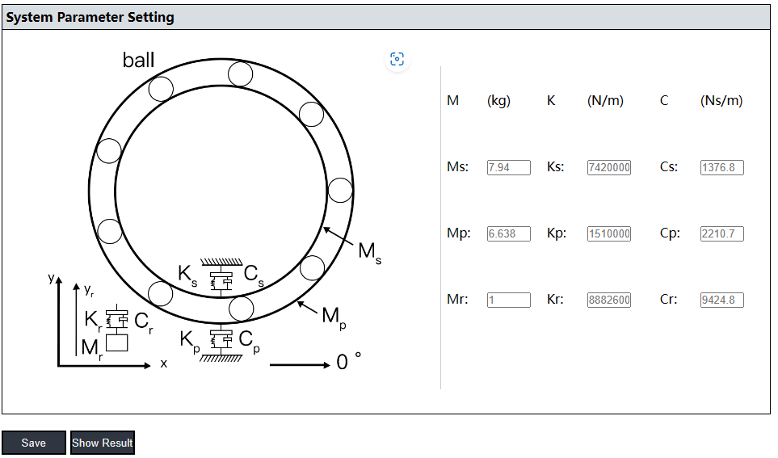

### Defect definition

This part of the parameter consists of four sections: Definition of the defect, definition of working condition, parameters of the simulation and parameters special for the 5-degree freedom bearing model. When the settings are complete, click the Save button to save the settings.

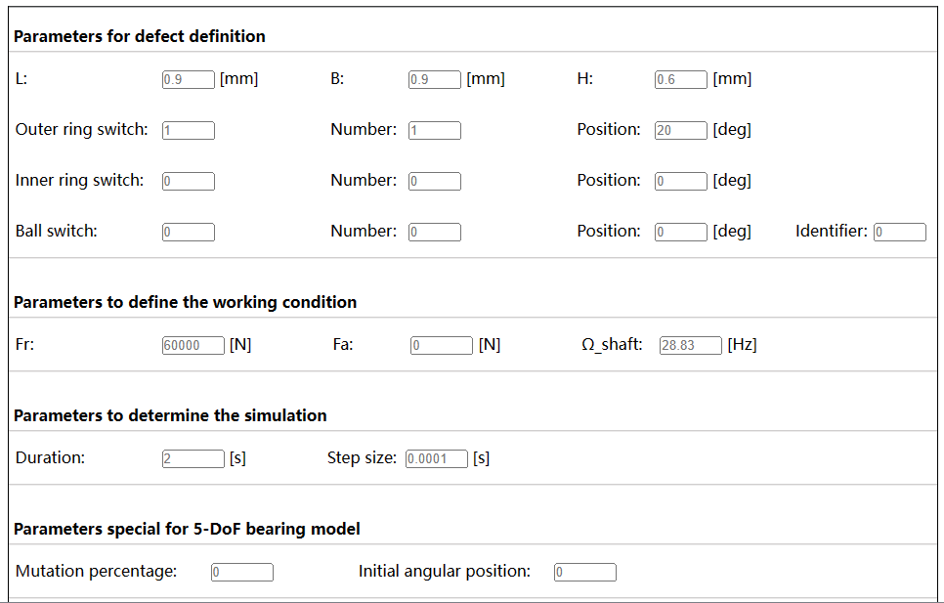

To save all the settings the user must click the Save button once more. Then click on the "Run" button to run the program.

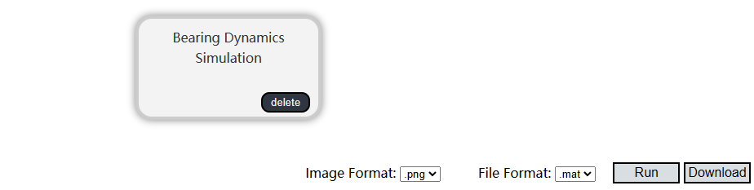

### Result

After the software has been run, click the “Show Result” button to display the simulation result.

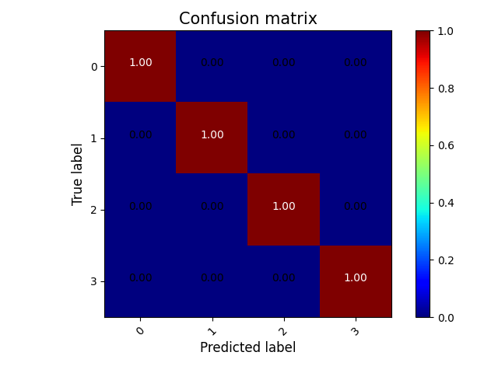

To download the result the user has to click the “Download” button.



**Examples**

The process is run using the software’s default parameters.

**Step 1: Configuration procedure**

Select the “Bearing dynamics simulation” module from the process column on the left side of the web page.



**Step 2: Select the function**

Click on the corresponding module to bring up the function selection field

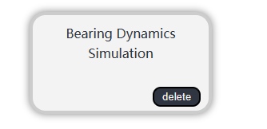

Click “Physical-based model” to display the parameter settings.

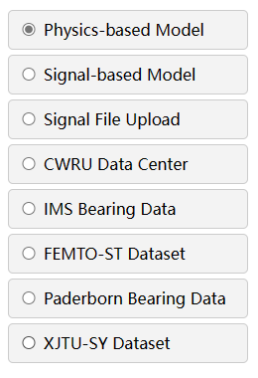

**Step 3: Set and save parameters**

Click the Save button directly because here all parameters are the default parameters.



The module border will turn green after the parameters have been saved successfully

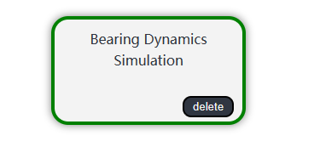

**Step 4: Execute the configured procedure**

Before executing the configured function, the user also needs to set the selected output image and file format. Finally, click "Run".

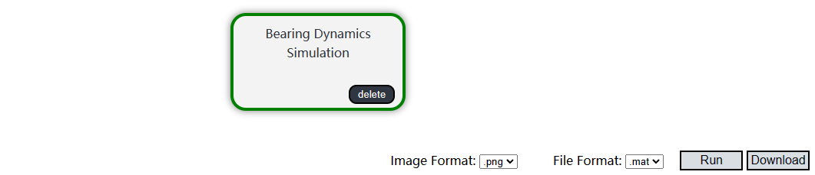

**Step 5: Show the result**

When the progress bar reaches the end, the task is completed. The graphical results of the function can be easily viewed by clicking "Show Results".



The displayed result graph is the confusion matrix.

**Step 6: Download**

Click on the “Download” button to download a zip file with all the results.