**Bearing Simulation Based on Signal Model**

Bearing vibration signal generation based on the signal model

## Description

To generate the bearing vibration data with or without defects, users should define four parameter types. If the user does not want to define them, they can also just click the Save button to run with the software's default parameters.

For parameter, definitions refer to the following parameter introduction.

## Parameter introduction

Parameters of the bearing:

* D: Ball diameter (data type: float);
* Di: Inner ring raceway contact diameter (data type: float);
* Do: Outer ring raceway contact diameter (data type: float);
* Z: Number of balls (data type: int);
* Type Factor: bearing type parameter, 3/2 for ball bearings, and 10/9 for roller bearings (data type: float);
* Alpha: Initial contact angle (data type: float);

Parameters of the working condition:

* Load Max: Maximum of external radial load (data type: float);
* Load Proportional Factor: Modification coefficient of load (data type: float);
* Speed: Shaft speed (data type: float);
* Resonance Frequency: Resonance frequency of bearing (data type: float);
* Phi Limit: Extent of load zone (data type: float);
* Load Distribution: Load distribution parameter (data type: float);

Parameters of defect definition:

* Defect Type: Outer ring defect, inner ring defect, ball defect;
* B: The decay parameter B in exponential decaying function, larger value brings faster decay rate (data type: float);
* Defect Initial Position: Initial angular position of the defect (data type: float);

Parameters of simulation:

* Step Size: Simulation step size (data type: float);
* Duration: Simulation duration (data type: float);

**Functional description of the main components**

The parameter settings are divided into four parts: Bearing parameter, condition parameter, defect parameter and simulation parameter.

### Bearing parameter

In this part, to define the bearing the user has to manually enter the bearing parameters. To use the software’s default parameters the user can also just click on the save button.

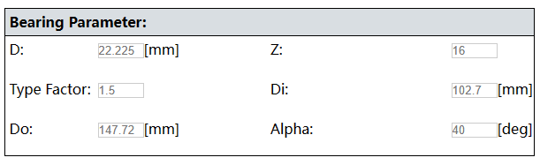

### Condition parameter

In this part, the user has to define the parameters of the system condition. When the settings are complete, click the Save button to save the settings.

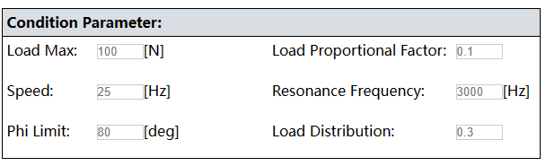

### Defect parameter

When the settings are complete, click the Save button to save the settings.

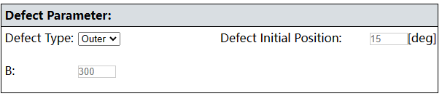

Then click on the "Run" button to run the program.

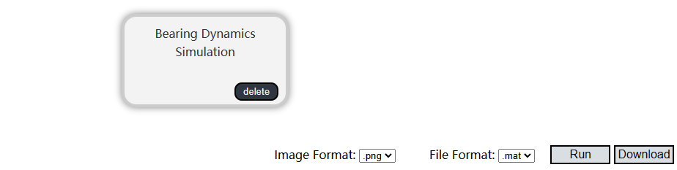

### Result

After the software has been run, click the “Show Result” button to display the simulation result.

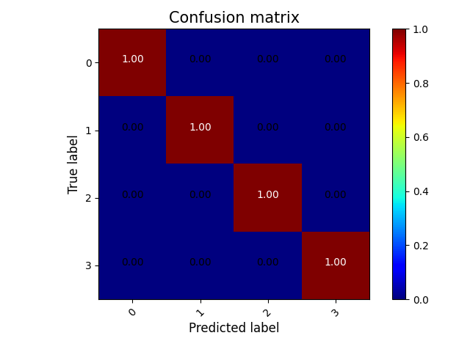

To download the result the user has to click the “Download” button.



**Examples**

The process is run using the software’s default parameters.

**Step 1: Configuration procedure**

Select the “Bearing dynamics simulation” module from the process column on the left side of the web page.



**Step 2: Select the function**

Click on the corresponding module to bring up the function selection field.

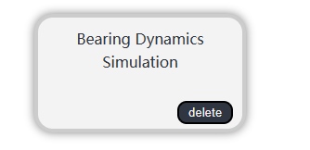

Click “Signal-based model” to display the parameter settings.

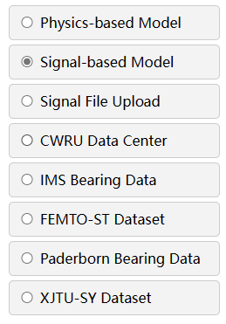

**Step 3: Set and save parameters**

Click the Save button directly because here all parameters are the default parameters.



The module border will turn green after the parameters have been saved successfully.

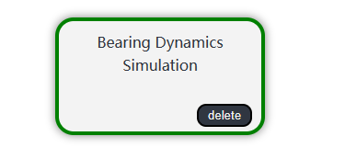

**Step 4: Execute the configured procedure**

Before executing the configured function, the user also needs to set the selected output image and file format. Finally, click "Run".

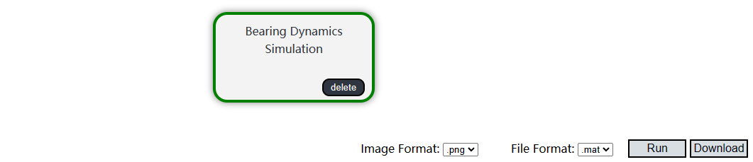

**Step 5: Show the result**

When the progress bar reaches the end, the task is completed. The graphical results of the function can be easily viewed by clicking "Show Results".



The displayed result graph is the vibration signal of bearing.

**Step 7: Download**

Click on the “Download” button to download a zip file with all the results.