# The Function of Generative Adversarial Network (GAN)

Data augmentation based on GAN.

## Description

GAN consists of a generator and a discriminator. The generator is responsible for generating samples, and the discriminator is responsible for distinguishing the authenticity of the samples. It returns the signals after augmentation. "File Upload" is used to load the required data set, and the required parameters should be set in the "Parameter" field.

## Parameter introduction

Parameters of GAN:

~~Sample parameter:~~

* ~~Fault Type: Type of bearing failure: BPFO (Ball Passing Frequency of Outer Race), BPFI (Ball Passing Frequency of Inner Race), FTF (Fundamental Train Frequency).~~

~~Bearing parameter:~~

* ~~Rot Fre: Rotation frequency of the bearing. (data type: float)~~
* ~~Z_dim: Size of input noise, which is used to generate new data. (data type: float)~~
* ~~N_ball: Number of balls. (data type: int)~~
* ~~D_ball: Diameter of balls. (data type: float)~~
* ~~D_pitch: Pitch diameter. (data type: float)~~
* ~~Alpha: Initial contact angle. (data type: float)~~

Function parameters:

* Num: The number of the increased dataset. (data type: int)
* ~~Num Epochs: The number of iterations in GAN training. (data type: int)~~
* Input noise size: Size of input noise, which is used to generate new data. (data type: float)

**Functional description of the main components**

The overall view of the function of GAN is divided into "File Upload", "Parameter" and "Result".

### File Upload

The uploaded data files and label files support ".mat", ".txt", ".csv", ".xls", and ".npy" format files.



### Parameter

The user can set the parameters here.

### Result

After the software has been run, click the "Show Result" button to display only one signal diagram after augmentation.

After the software has been run, click the "Download" button to download the relevant result data, the original signal diagram, and the signal diagrams after augmentation:

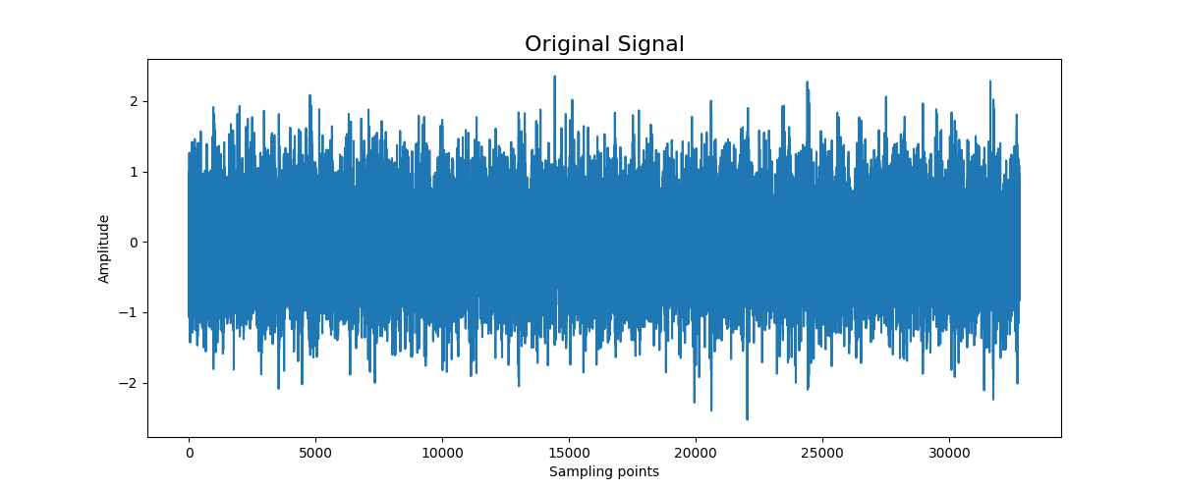

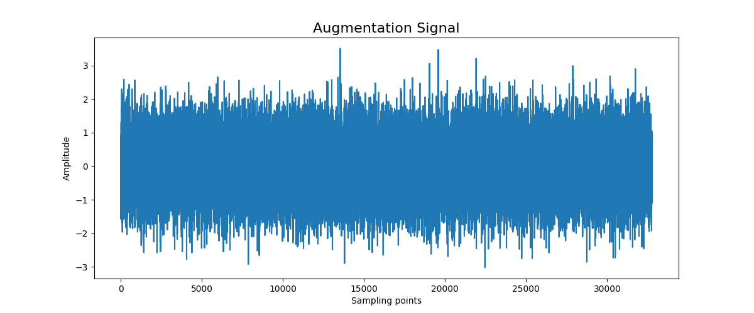

**Examples**

The process of using GAN in data augmentation.

**Step 1: Configure the procedure**

Select "Data Augmentation & Sample Generation" from the process bar on the left side of the web page.



**Step 2: Select the function**

Select the procedure that needs to be configured from the process display area.

The ''Generative Adversarial Network'' function is chosen for data augmentation.

**Step 3: Upload the data file**

Select the data file and label file to be applied from the local path.



Click "Upload" after successfully selecting the upload data file, and then click "Save".

**Step 4: Set and save the parameters**

The user needs to set the parameters in the blank box. For details about the parameters of the function, see "Parameter introduction".

Then click "Save" after all parameters are configured.

**Step 5: Execute the configured procedure**

Before executing the configured function, the user also needs to set the selected output file format.

Finally, select "Run".

**Step 6: Show the result**

When the progress bar reaches the end, the task is completed.

When the signal is augmented *N* times, 1 original signal diagram and *N* signal diagrams after augmentation will be generated.

文本

Select "Show Result" to simply view only one signal diagram after augmentation, and the remaining images can be downloaded and viewed.

**Step 7: Download**

Click "Download" to download the file of data and images.

