**CTF Write-up**

ssh [bandit@bandit.labs.overthewire.org](mailto:bandit@bandit.labs.overthewire.org) -p 2220

Table of Contents

OverTheWire – Bandit 3

Bandit0 3

Bandit1 3

Bandit2 3

Bandit3 4

Bandit4 5

Bandit5 6

Bandit6 7

Bandit7 8

Bandit8 9

Bandit9 10

Bandit10 11

Bandit11 12

Bandit12 13

# OverTheWire – Bandit

## Bandit0

After ssh with bandit0 and password bandit0, I used ‘ls’ command and saw a ‘readme’ file. I used ‘cat’ command to see info in ‘readme’ file, and it shows a line of character. That will be the password to bandit1, which is NH2SXQwcBdpmTEzi3bvBHMM9H66vVXjL

## Bandit1

In bandit1, I used ‘ls’ command and saw a file named ‘-‘. I used ‘./’ and followed the filename and successfully open the file, then I got the password, which is rRGizSaX8Mk1RTb1CNQoXTcYZWU6lgzi

## Bandit2

I used ‘ls’ command and saw the file named with spaces. So, when I cat the file, I used back slash ‘\’ at behind of the file before the spaces. But we also can first type spaces then press “Tab” to let it finish by itself, it’s extremely useful. aBZ0W5EmUfAf7kHTQeOwd8bauFJ2lAiG

## Bandit3

The questions said the password stored inside the ‘inhere’ folder. After cd in, I used ‘ls -a’ to see all files including hidden file. Then I ‘cat’ to get the password. 2EW7BBsr6aMMoJ2HjW067dm8EgX26xNe

## Bandit4

Its not a good idea to check them one by one, but luckily there just 10 files, I probably should use find command.

Up: I got a new solution, using “file ./*” can check the info in all of the file. lrIWWI6bB37kxfiCQZqUdOIYfr6eEeqR

## Bandit5



Used ‘ls’ command and saw too much of directory in it, I got a hint from the question, it said maybe can use find command, and go to google and someone said man the find. After searching, I used ‘find’ command with ‘-readable’ to filter out human-readable file, ‘-size 1033c’ to find the file size with 1033 bytes. And I got a file named ‘-file2’.

And I got a long line of human-readable characters. In case it’s wrong I opened another file

And it’s not readable…So -file2 should be storing password.

P4L4vucdmLnm8I7Vl7jG1ApGSfjYKqJU

## Bandit6

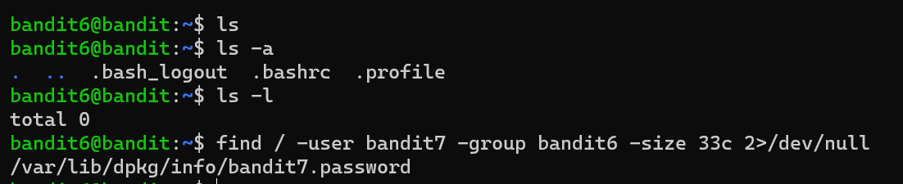

After using series of ls commands, there’s no file or directory to do. After doing some research on Medium, I got this command. “/” after find is to let find command search the entire file system from root. “2>/dev/null” is to prevent ‘permission denied” error display in the screen.



z7WtoNQU2XfjmMtWA8u5rN4vzqu4v99S

## Bandit7

Used “ls – l” to check the size of the text file. Used “grep” to know the password TESKZC0XvTetK0S9xNwm25STk5iWrBvP is beside the word that said in the question.

## Bandit8

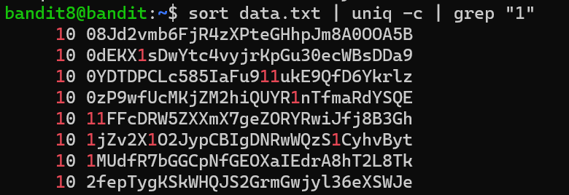

Using “sort” command to sort data.txt, and “uniq -c” command to count the repeated lines. Then used grap “1” to get that have 1. But we need to write with “grep “1 “ “ to ensure it’s 1 not everything that has 1.



EN632PlfYiZbn3PhVK3XOGSlNInNE00t

## Bandit9

Used “strings” command to show the data, and grep to filter with several “=”. G7w8LIi6J3kTb8A7j9LgrywtEUlyyp6s

## Bandit10

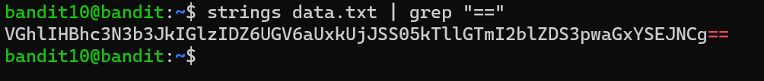

Usually, Base64 encrypt will include double equal sign at the last of the cipher text.

Use cyberchef to decrypt the cipher text to plain text. 6zPeziLdR2RKNdNYFNb6nVCKzphlXHBM

## Bandit11



ROT13 encrypt is to change the first 13 alphabet to last 13 alphabet.

JVNBBFSmZwKKOP0XbFXOoW8chDz5yVRv

## Bandit12