

AMERICAN INTERNATIONAL UNIVERSITY–BANGLADESH (AIUB)
Dept. of Computer Science
Faculty of Science and Technology
CSC2210: OBJECT ORIENTED PROGRAMMING 2
Spring 2025-2026
Section: [A]
Group No: 02

Project Report On
Project Name:
PeerSync
Connect, Collaborate, Succeed

Supervised By
Tofayet Sultan

Submitted By:

Name | Id
Sajal Mollick | 22-49653-3
Azraful Alam | 24-57476-2
Azizul Alam | 22-47521-2
Sabrina Islam

CO2: Display and verify the mean of a real-life Project using the concepts of C# Graphical User Interface based environment with database integration to depict a desktop-based application.
Assessment  Criteria | Not Attended/ Incorrect (0) | Inadequate  (1-2) | Average  (3) | Good  (4) | Excellent  (5)
Evaluation Criteria | Evaluation Definition |  |  |  | Total =
Requirement fulfillment | Properly demonstrate a real-life scenario-based project with proper functional requirement identification for the Object-Oriented Programming project development activities.
Validation | Ensuring the ability of students’ proper demonstration on validation forms in their system in terms of dealing with the data.
Verification | Identifying if the students can verify the system data along with proper functional requirements in terms of data flow.

1. Introduction
PeerSync is a smart peer-matching and team management system developed for university students to help them find suitable teammates for group projects and collaborative assignments. In modern education, group work has become an essential part of academic learning, especially in technical and engineering fields. However, students often face difficulties in choosing reliable and skilled teammates. Many teams are formed randomly or through personal friendships, which can lead to communication problems, uneven workload distribution, lack of accountability, and poor project outcomes. PeerSync was designed to solve these common issues by creating a structured platform where students can connect based on skills, interests, work styles, and reputation.

The main idea behind PeerSync is inspired by social matching applications, where users can browse student profiles and decide whether they want to connect or pass. The system uses a swipe-based matching mechanism that only creates a connection when both students show mutual interest. This process helps students form teams more comfortably and efficiently. Along with matching, the platform also provides reputation tracking through peer ratings, allowing students to evaluate teammates based on contribution, communication, reliability, and punctuality. These features encourage accountability and help users make informed decisions before forming project groups.

PeerSync was developed using C# Windows Forms for the frontend interface, ADO.NET for database connectivity, and Microsoft SQL Server for secure data storage. The application supports both student and admin roles. Students can create profiles, manage skills and work preferences, form project groups, and rate teammates after completing projects. Administrators can monitor user activities, manage accounts, and maintain platform integrity through a dedicated admin dashboard. The database was designed using normalization techniques to ensure data consistency, eliminate redundancy, and support efficient operations.

The project aims to improve collaboration among university students by simplifying team formation and promoting professional behavior in academic projects. By introducing intelligent matching, centralized group management, and a transparent feedback system, PeerSync provides a practical solution to many challenges faced in group-based learning environments. The system not only benefits students by saving time and improving teamwork quality but also supports universities in encouraging better peer collaboration and accountability.

2. ER Diagram
The Entity Relationship (ER) Diagram below illustrates the data model of PeerSync, showing the entities, their attributes, and the relationships between them. The diagram captures the core tables including USER, SKILL, WORK_STYLE, SWIPE, MATCH, PROJECT_GROUP, GROUP_MEMBER, and RATING, along with their associations.

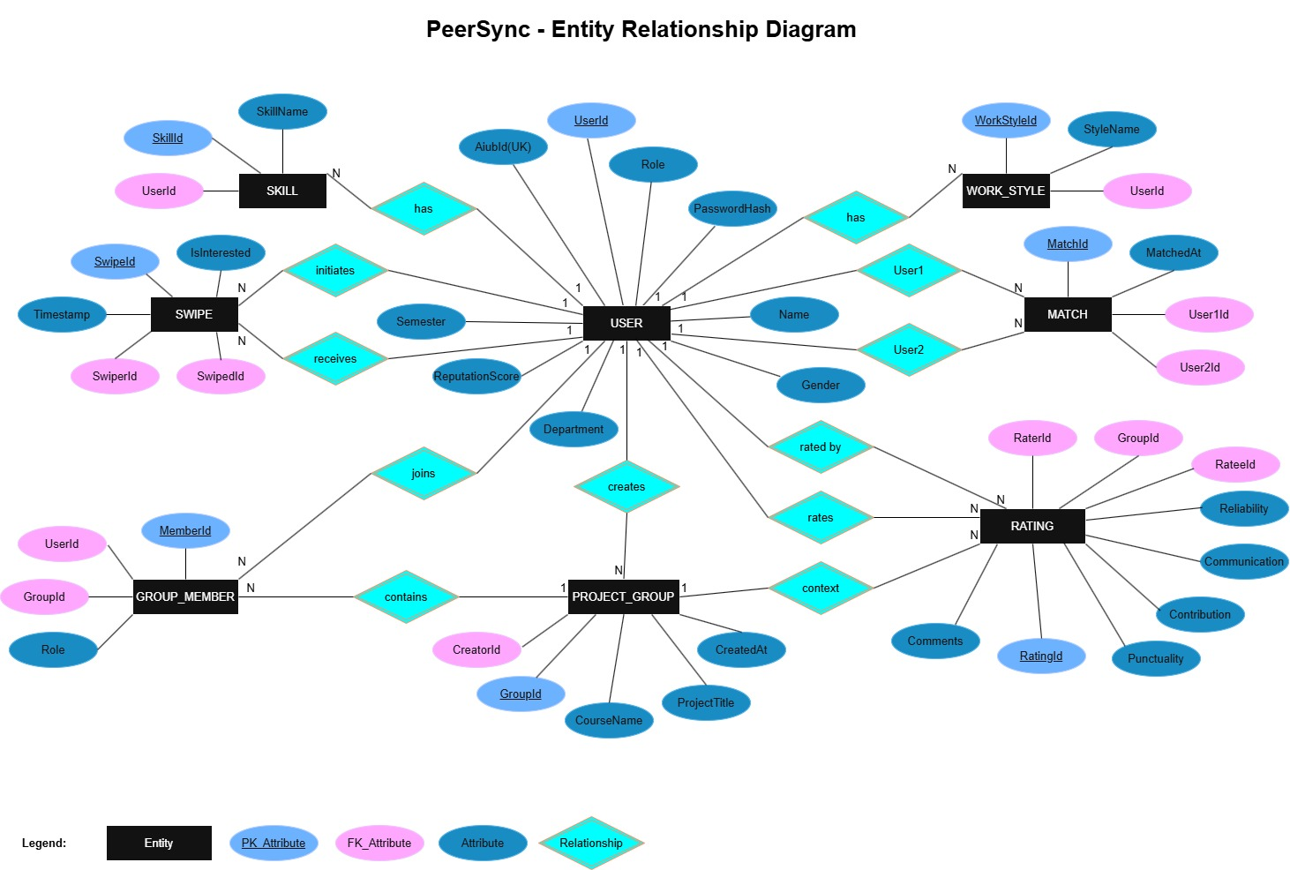

Figure 1: PeerSync ER Diagram

3. Normalization – Final Table Structure
The PeerSync database follows Third Normal Form (3NF). Primary Keys (PK) are underlined and bold. Foreign Keys (FK) are shown in bold dark blue. All tables are free from partial and transitive dependencies.

Table 1: USER
S/N | Attribute | Data Type / Constraint
1 | UserId (PK) | INT, IDENTITY, PRIMARY KEY
2 | AiubId (UK) | NVARCHAR(20), UNIQUE NOT NULL
3 | PasswordHash | NVARCHAR(255), NOT NULL
4 | Name | NVARCHAR(100), NOT NULL
5 | Gender | NVARCHAR(10)
6 | Department | NVARCHAR(50)
7 | Semester | NVARCHAR(10)
8 | Role | NVARCHAR(20), DEFAULT 'Student'
9 | ReputationScore | INT, DEFAULT 0

Table 2: SKILL
S/N | Attribute | Data Type / Constraint
1 | SkillId (PK) | INT, IDENTITY, PRIMARY KEY
2 | UserId (FK) | INT, FOREIGN KEY REFERENCES USER(UserId)
3 | SkillName | NVARCHAR(100), NOT NULL

Table 3: WORK_STYLE
S/N | Attribute | Data Type / Constraint
1 | WorkStyleId (PK) | INT, IDENTITY, PRIMARY KEY
2 | UserId (FK) | INT, FOREIGN KEY REFERENCES USER(UserId)
3 | StyleName | NVARCHAR(100), NOT NULL

Table 4: SWIPE
S/N | Attribute | Data Type / Constraint
1 | SwipeId (PK) | INT, IDENTITY, PRIMARY KEY
2 | SwiperId (FK) | INT, FOREIGN KEY REFERENCES USER(UserId)
3 | SwipedId (FK) | INT, FOREIGN KEY REFERENCES USER(UserId)
4 | IsInterested | BIT, NOT NULL
5 | Timestamp | DATETIME, DEFAULT GETDATE()

Table 5: MATCH
S/N | Attribute | Data Type / Constraint
1 | MatchId (PK) | INT, IDENTITY, PRIMARY KEY
2 | User1Id (FK) | INT, FOREIGN KEY REFERENCES USER(UserId)
3 | User2Id (FK) | INT, FOREIGN KEY REFERENCES USER(UserId)
4 | MatchedAt | DATETIME, DEFAULT GETDATE()

Table 6: PROJECT_GROUP
S/N | Attribute | Data Type / Constraint
1 | GroupId (PK) | INT, IDENTITY, PRIMARY KEY
2 | CourseName | NVARCHAR(100)
3 | ProjectTitle | NVARCHAR(200)
4 | CreatorId (FK) | INT, FOREIGN KEY REFERENCES USER(UserId)
5 | CreatedAt | DATETIME, DEFAULT GETDATE()

Table 7: GROUP_MEMBER
S/N | Attribute | Data Type / Constraint
1 | MemberId (PK) | INT, IDENTITY, PRIMARY KEY
2 | GroupId (FK) | INT, FOREIGN KEY REFERENCES PROJECT_GROUP(GroupId)
3 | UserId (FK) | INT, FOREIGN KEY REFERENCES USER(UserId)
4 | Role | NVARCHAR(50)

Table 8: RATING
S/N | Attribute | Data Type / Constraint
1 | RatingId (PK) | INT, IDENTITY, PRIMARY KEY
2 | RaterId (FK) | INT, FOREIGN KEY REFERENCES USER(UserId)
3 | RateeId (FK) | INT, FOREIGN KEY REFERENCES USER(UserId)
4 | GroupId (FK) | INT, FOREIGN KEY REFERENCES PROJECT_GROUP(GroupId)
5 | Contribution | INT (1-5)
6 | Communication | INT (1-5)
7 | Reliability | INT (1-5)
8 | Punctuality | INT (1-5)
9 | Comments | NVARCHAR(500)

4. Table Data
The following screenshots show sample data inserted into each of the eight PeerSync database tables to verify functionality and demonstrate realistic usage scenarios.

4.1 USER Table
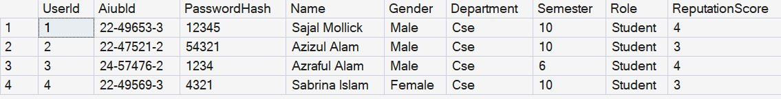
Figure 2: USER Table – Sample Data

4.2 SKILL Table
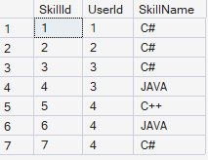
Figure 3: SKILL Table – Sample Data

4.3 WORK_STYLE Table
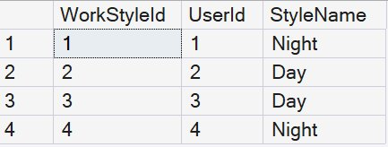
Figure 4: WORK_STYLE Table – Sample Data

4.4 SWIPE Table
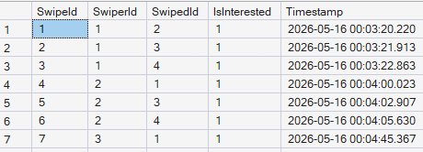
Figure 5: SWIPE Table – Sample Data

4.5 MATCH Table
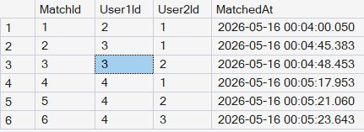
Figure 6: MATCH Table – Sample Data

4.6 PROJECT_GROUP Table
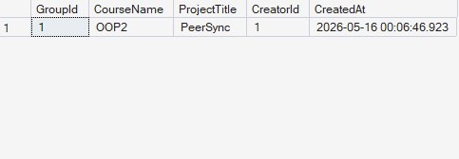
Figure 7: PROJECT_GROUP Table – Sample Data

4.7 GROUP_MEMBER Table
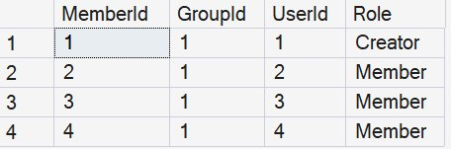
Figure 8: GROUP_MEMBER Table – Sample Data

4.8 RATING Table
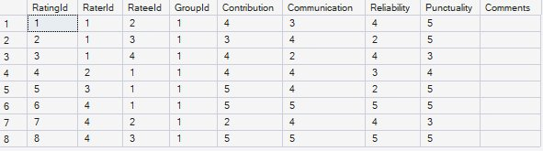
Figure 9: RATING Table – Sample Data

5. Features
PeerSync provides a comprehensive set of features designed to improve academic group collaboration:

5.1 Mutual Swiping
Students can browse candidate profiles on the Home Feed and either CONNECT or PASS. A match is only created when both students mutually express interest, ensuring team formations are always consensual and based on shared intent.

5.2 AIUB Student ID Verification
During registration, students must provide their valid AIUB Student ID. The system enforces uniqueness of the AIUB ID in the database, preventing duplicate or fake accounts and ensuring that only legitimate AIUB students can access the platform.

5.3 Anonymous Post-Project Ratings
After completing a project, group creators can rate their teammates across four dimensions: Contribution, Communication, Reliability, and Punctuality. Ratings encourage honest and fair feedback without fear of social repercussions.

5.4 Reputation Score System
Each student maintains a Reputation Score automatically calculated as the average of all ratings received across past projects. This score is visible on student profiles and the Home Feed, helping peers make informed decisions when selecting teammates.

5.5 Group Creation
Matched students can create project groups directly within the platform by specifying a course name, project title, and selecting matched peers as members. Group data is stored using a database transaction to ensure atomicity and data integrity.

5.6 Admin Dashboard
The Admin Dashboard provides full control over the student user base. Admins can search for students by name or AIUB ID, add new students, update existing records, and delete accounts using a cascaded transaction that safely removes all associated data.

6. Forms
The following screenshots illustrate the user interface forms of PeerSync. Each form serves a specific functional purpose within the application workflow.

6.1 Welcome Form

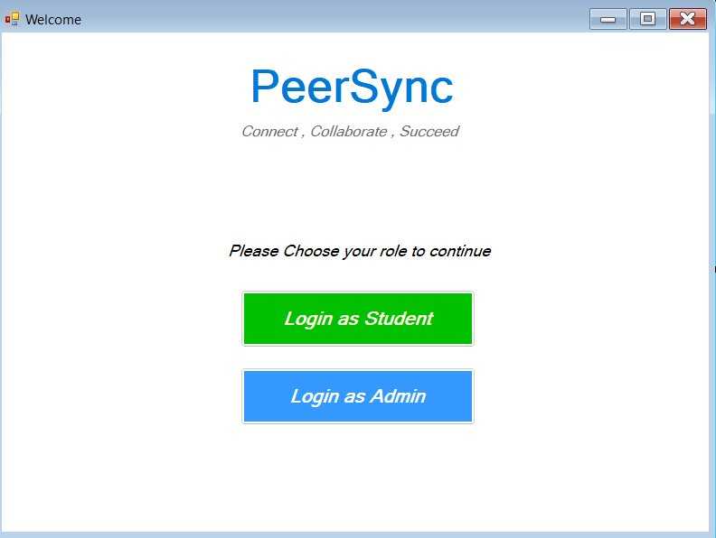
Figure 10: Welcome Form – Role Selection

6.2 Student Login Form

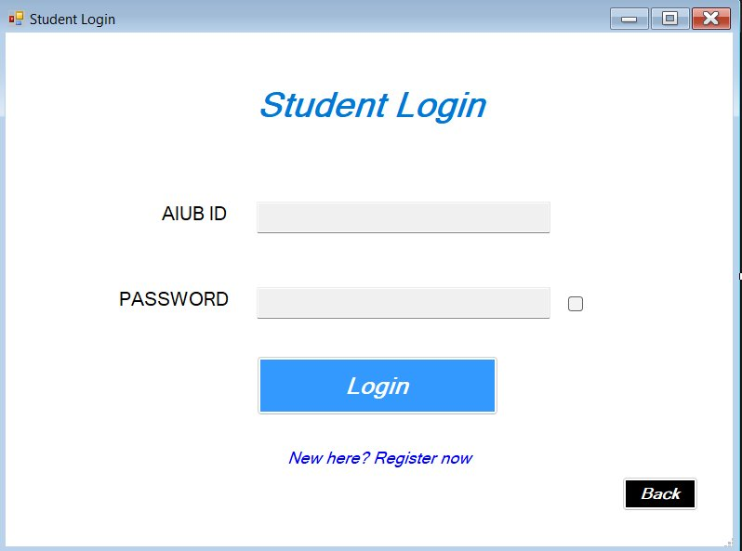
Figure 11: Student Login Form

6.3 Registration Form

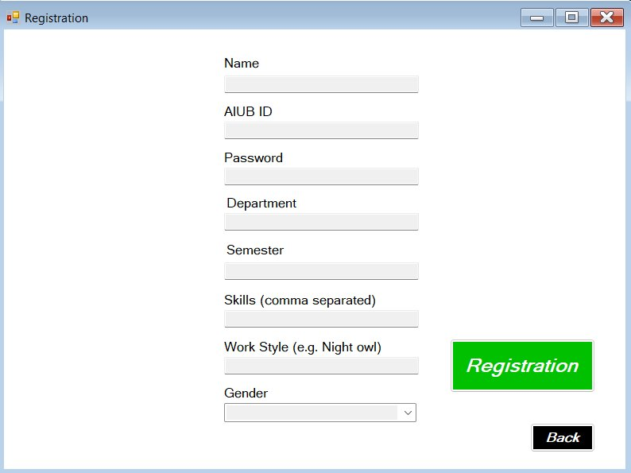
Figure 12: Student Registration Form

6.4 Home Feed Form

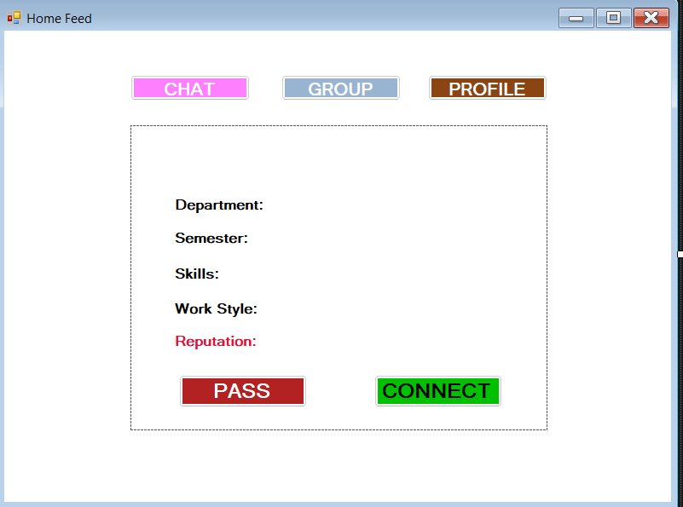
Figure 13: Home Feed – Swipe Interface

6.5 Group Form

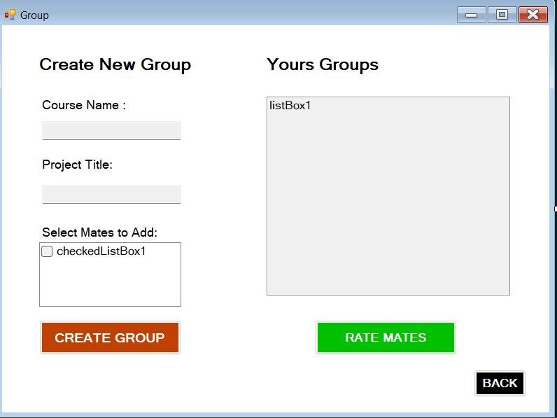
Figure 14: Group Creation and Management Form

6.6 Rate Team Mate Form

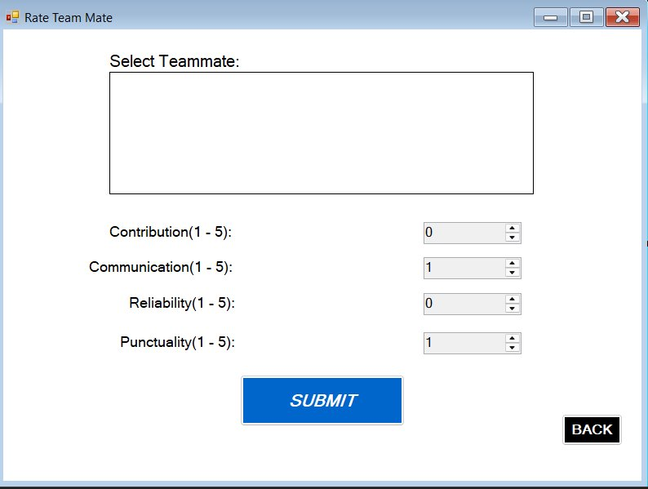
Figure 15: Rate Team Mate Form

6.7 My Profile Form
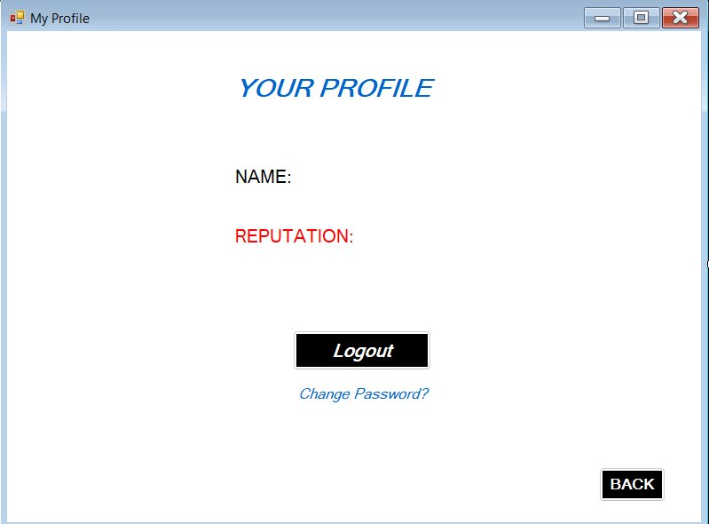
Figure 16: My Profile Form

6.8 Change Password Form

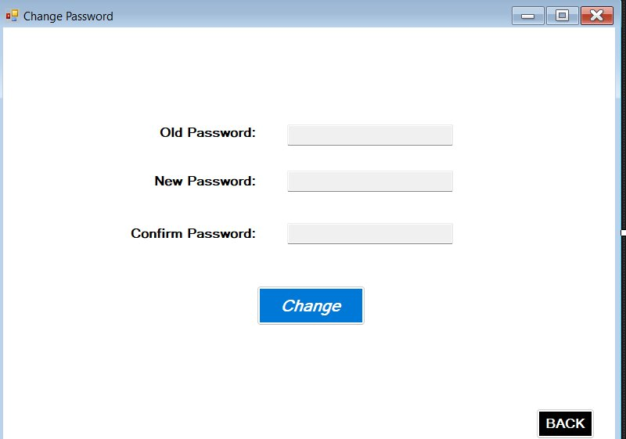
Figure 17: Change Password Form

6.9 Connection / Chat Form

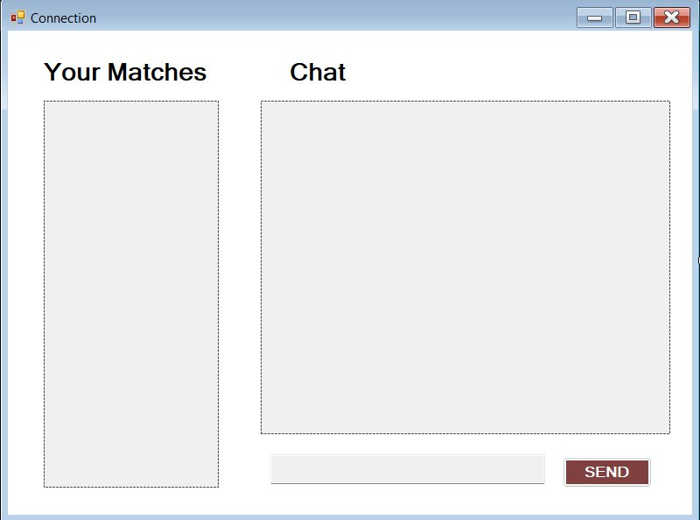
Figure 18: Connection and Chat Form

6.10 Admin Login Form

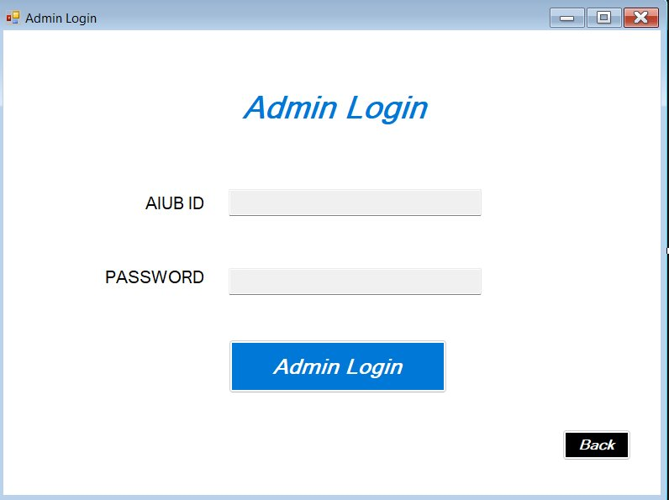
Figure 19: Admin Login Form

6.11 Admin Dashboard Form

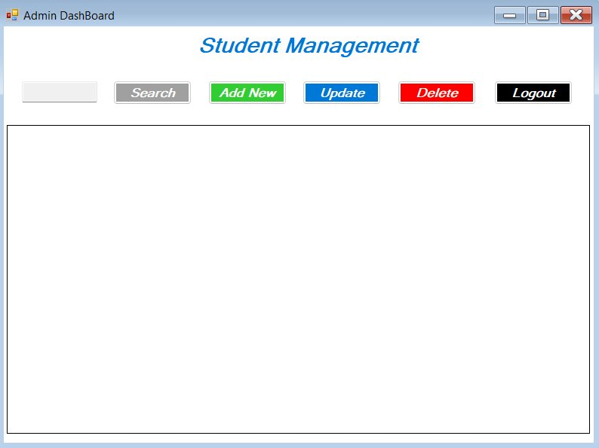
Figure 20: Admin Dashboard – Student Management

6.12 Update Form

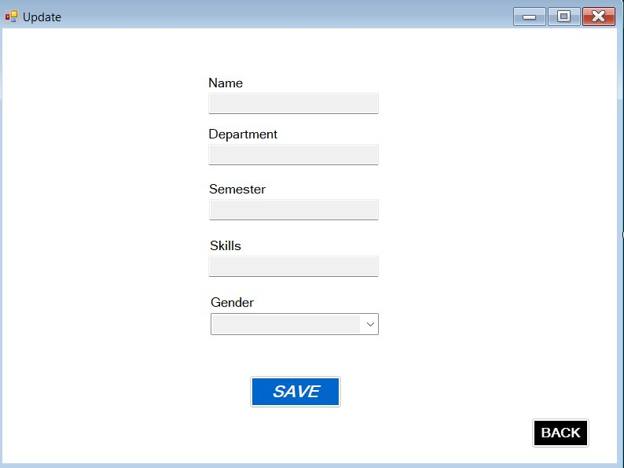
Figure 21: Update Student Information Form

7. Schema Diagram
The database schema diagram below presents the complete relational structure of the PeerSync database, showing all eight tables, their columns with data types, and the foreign key relationships that enforce referential integrity across the system.

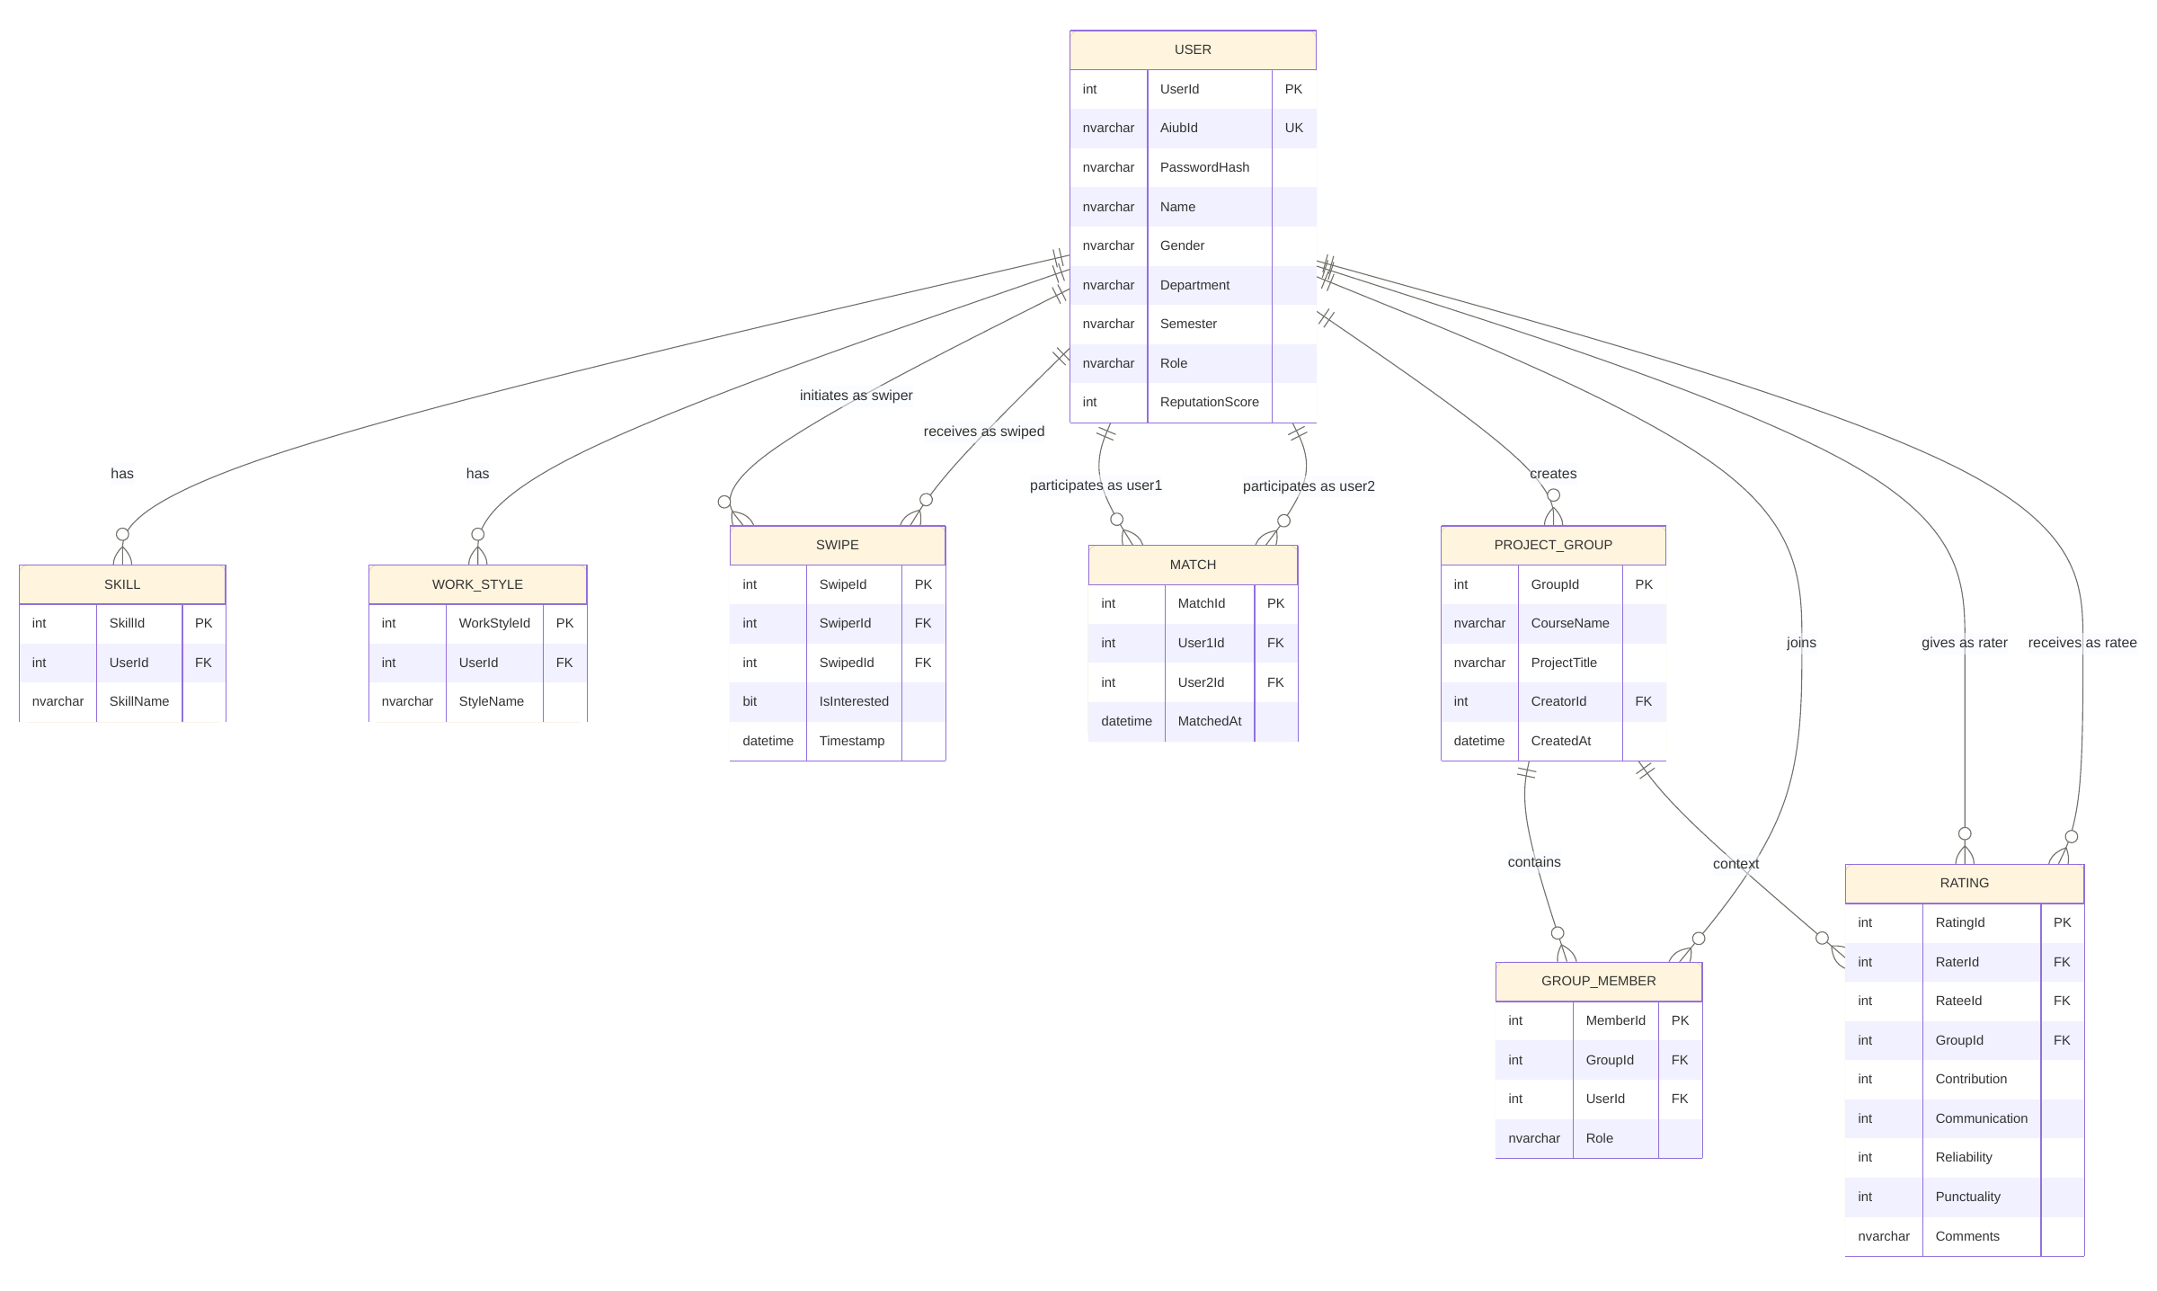
Figure 22: PeerSync Database Schema Diagram

8. Activity Diagrams
The following activity diagrams model the key workflows of the PeerSync application, illustrating the sequence of actions, decision points, and outcomes for each major process.

8.1 Student Registration

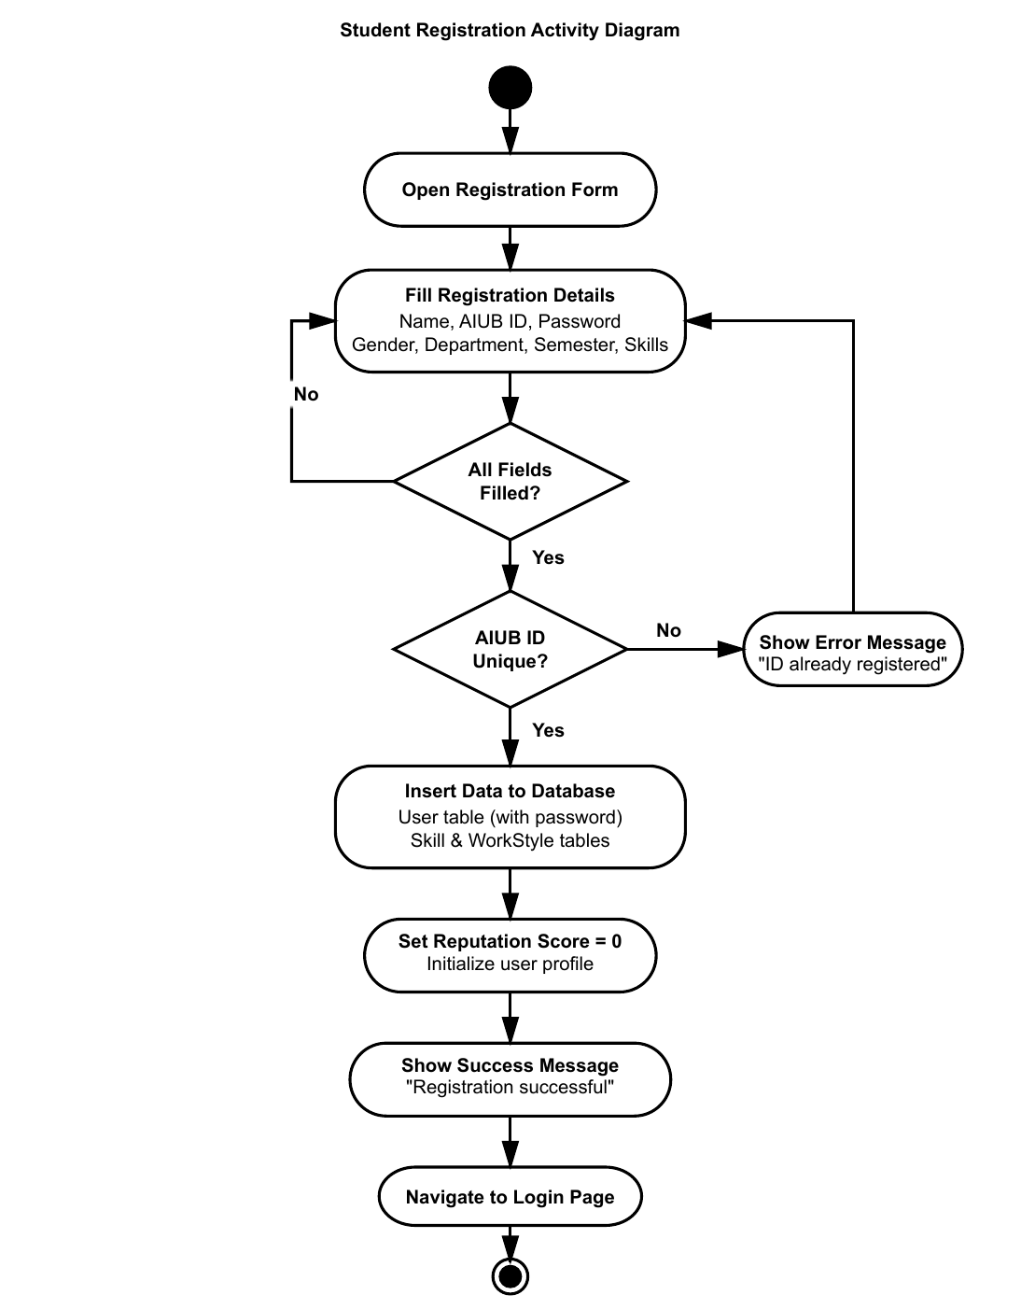
Figure 23: Student Registration Activity Diagram

8.2 Admin User Management

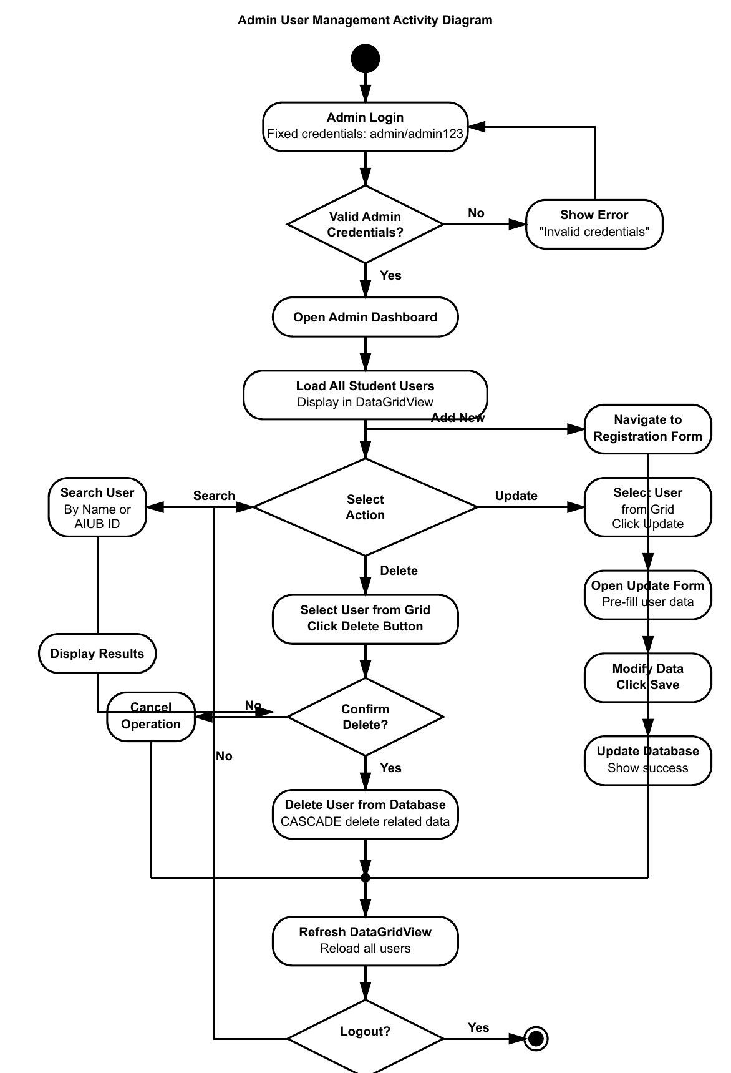
Figure 24: Admin User Management Activity Diagram

8.3 Project Group Creation

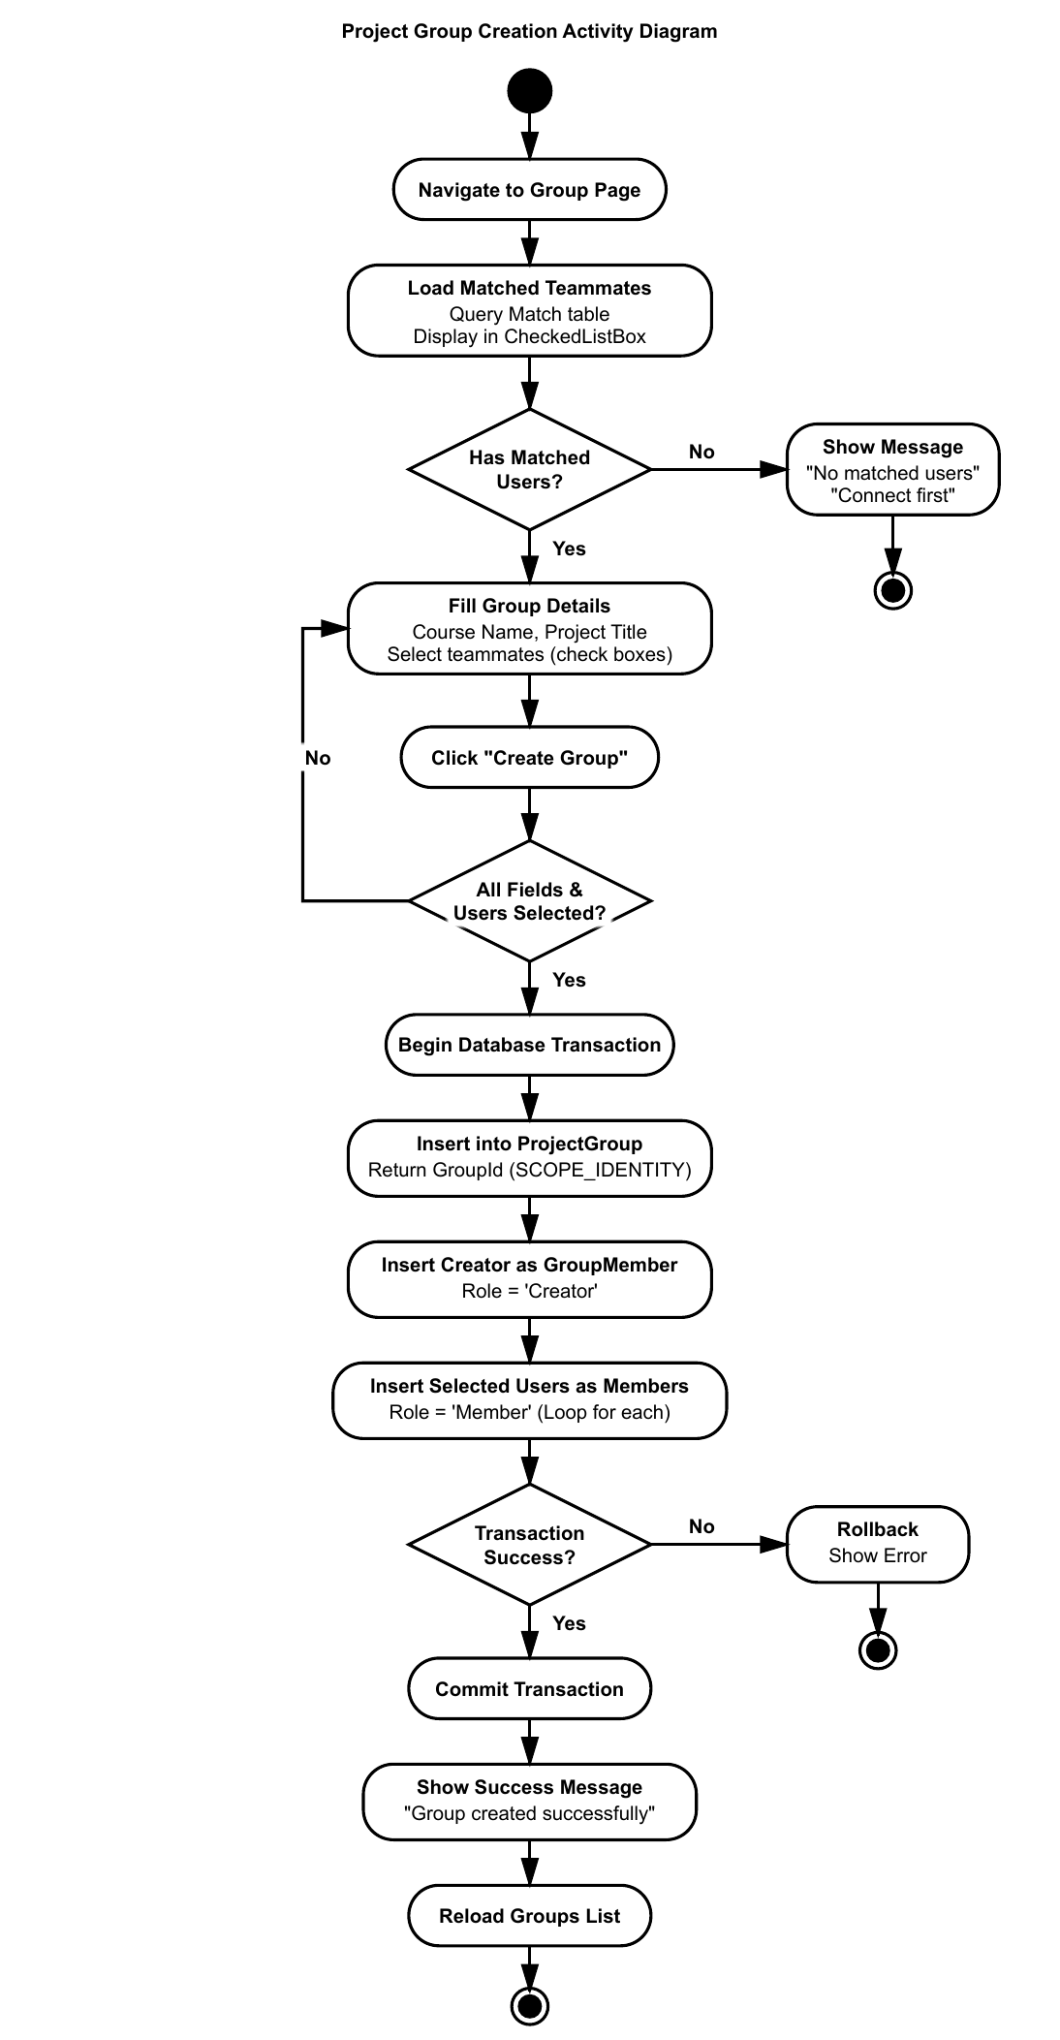
Figure 25: Project Group Creation Activity Diagram

8.4 Student Login & Swipe Matching

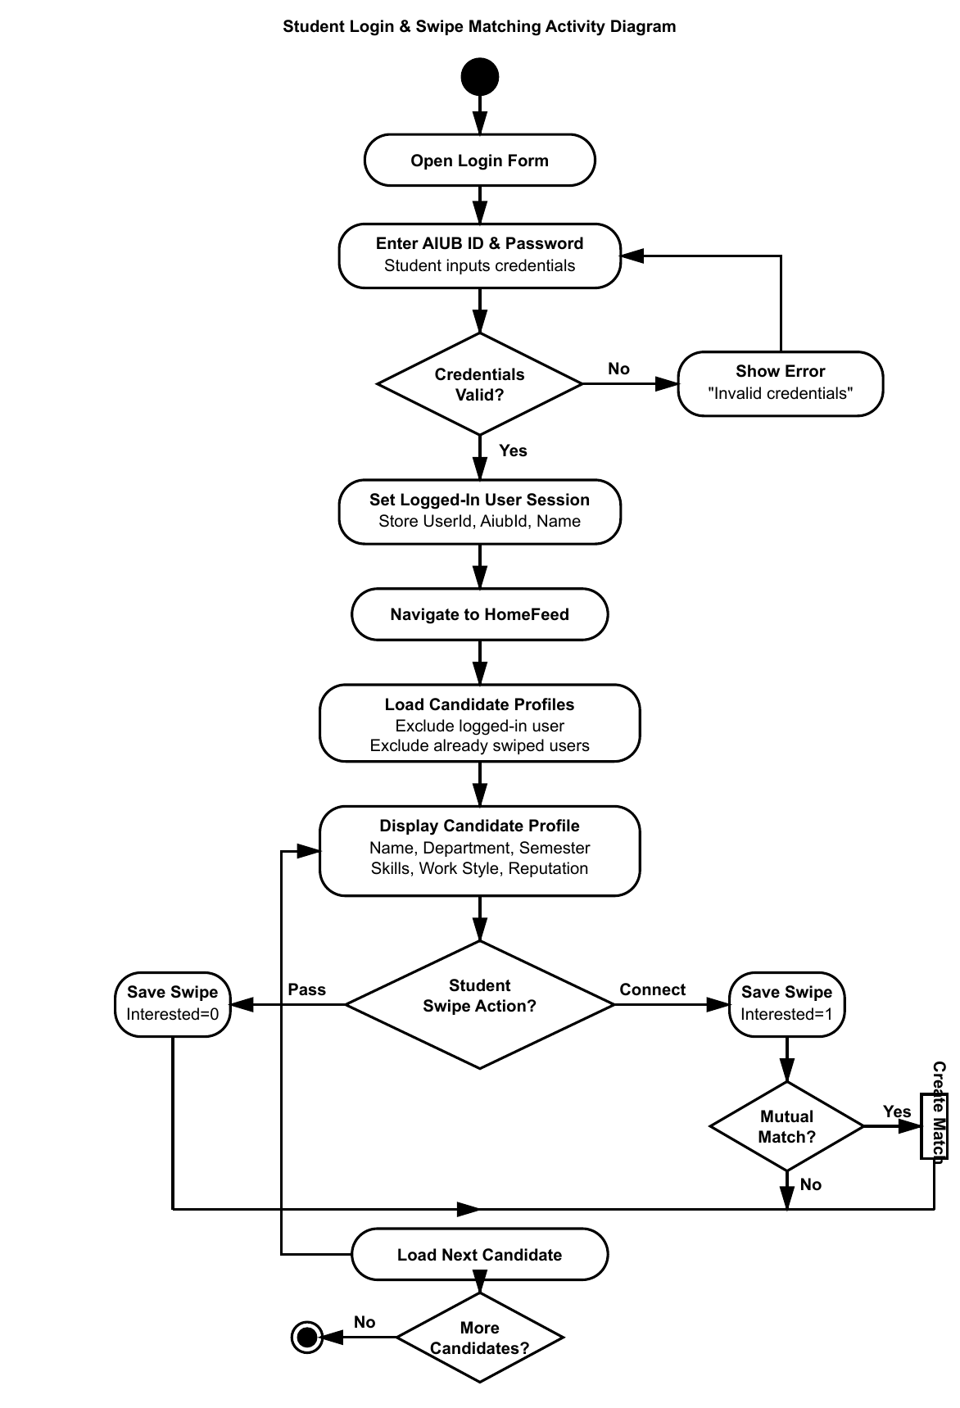
Figure 26: Student Login & Swipe Matching Activity Diagram

8.5 Teammate Rating

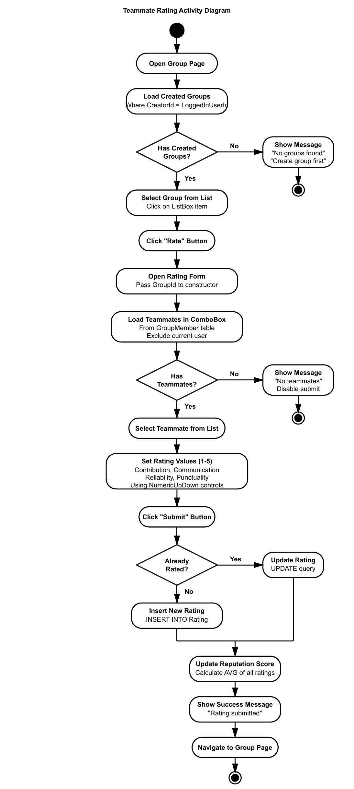
Figure 27: Teammate Rating Activity Diagram

9. Implementation
This section presents the core implementation of PeerSync. Each C# source file is shown with its filename as a header, formatted in a double-column layout. The system is built with C# .NET Windows Forms and ADO.NET for SQL Server database connectivity.

9.1 StudentRegistration.cs
StudentRegistration.cs
﻿using System;  using System.Collections.Generic;  using System.ComponentModel;  using System.Data;  using System.Data.SqlClient;  using System.Drawing;  using System.Linq;  using System.Text;  using System.Threading.Tasks;  using System.Windows.Forms;  namespace WindowsFormsApp1  {  public partial class Registration : Form  {  public Registration()  {  InitializeComponent();  genderComboBox.Items.Add("Male");  genderComboBox.Items.Add("Female");  genderComboBox.Items.Add("Other");  }  private void RegistrationButton_Click(object sender, EventArgs e)  {  string connectionString = "data source=DESKTOP-MJTHEPS\\SQLEXPRESS;  string name = nameTextBox.Text.Trim();  string aiubId = aiubIdTextBox.Text.Trim();  string password = passwordTextBox.Text.Trim();  string gender = genderComboBox.SelectedItem?.ToString();  string department = departmentTextBox.Text.Trim();  string semester = semesterTextBox.Text.Trim();  string skills = skillsTextBox.Text.Trim();  string workStyle = workStyleTextBox.Text.Trim();  if (string.IsNullOrWhiteSpace(name) || string.IsNullOrWhiteSpace(aiu  string.IsNullOrWhiteSpace(password) || string.IsNullOrWhiteSpace  string.IsNullOrWhiteSpace(department) || string.IsNullOrWhiteSpa  {  MessageBox.Show("Please fill all required fields!", "Validation  return;  }  using (SqlConnection connection = new SqlConnection(connectionString  {  try  {  connection.Open();  string checkQuery = "SELECT COUNT(*) FROM [User] WHERE AiubI  using (SqlCommand checkCmd = new SqlCommand(checkQuery, conn  {  checkCmd.Parameters.AddWithValue("@AiubId", aiubId);  int count = (int)checkCmd.ExecuteScalar();  if (count > 0)  {  MessageBox.Show("This AIUB ID is already registered!  return;  }  }  string insertUserQuery = @"INSERT INTO [User] (AiubId, Passw  VALUES (@AiubId, @Password, @Name,  SELECT SCOPE_IDENTITY();";  int newUserId;  using (SqlCommand command = new SqlCommand(insertUserQuery,  { | command.Parameters.AddWithValue("@AiubId", aiubId);  command.Parameters.AddWithValue("@Password", password);  command.Parameters.AddWithValue("@Name", name);  command.Parameters.AddWithValue("@Gender", gender);  command.Parameters.AddWithValue("@Department", departmen  command.Parameters.AddWithValue("@Semester", semester);  newUserId = Convert.ToInt32(command.ExecuteScalar());  }  if (!string.IsNullOrWhiteSpace(skills))  {  string[] skillArray = skills.Split(',');  foreach (string skill in skillArray)  {  string skillTrimmed = skill.Trim();  if (!string.IsNullOrWhiteSpace(skillTrimmed))  {  string insertSkillQuery = "INSERT INTO Skill (Us  using (SqlCommand skillCmd = new SqlCommand(inse  {  skillCmd.Parameters.AddWithValue("@UserId",  skillCmd.Parameters.AddWithValue("@SkillName  skillCmd.ExecuteNonQuery();  }  }  }  }  if (!string.IsNullOrWhiteSpace(workStyle))  {  string[] styleArray = workStyle.Split(',');  foreach (string style in styleArray)  {  string styleTrimmed = style.Trim();  if (!string.IsNullOrWhiteSpace(styleTrimmed))  {  string insertStyleQuery = "INSERT INTO WorkStyle  using (SqlCommand styleCmd = new SqlCommand(inse  {  styleCmd.Parameters.AddWithValue("@UserId",  styleCmd.Parameters.AddWithValue("@StyleName  styleCmd.ExecuteNonQuery();  }  }  }  }  MessageBox.Show("Registration successful! Please login.", "S  this.Hide();  StudentLogin studentLogin = new StudentLogin();  studentLogin.Show();  }  catch (Exception ex)  {  MessageBox.Show("Error: " + ex.Message, "Database Error", Me  }  }  }  private void backButton_Click(object sender, EventArgs e)  {  this.Hide();  StudentLogin s1 = new StudentLogin();  s1.Show();  }  }  }

9.2 StudentLogin.cs
StudentLogin.cs
﻿using System;  using System.Collections.Generic;  using System.ComponentModel;  using System.Data;  using System.Data.SqlClient;  using System.Drawing;  using System.Linq;  using System.Text;  using System.Threading.Tasks;  using System.Windows.Forms;  using static System.Windows.Forms.VisualStyles.VisualStyleElement;  namespace WindowsFormsApp1  {  public partial class StudentLogin : Form  {  public static int LoggedInUserId = 0;  public static string LoggedInAiubId = "";  public static string LoggedInUserName = "";  private string connectionString = "data source=DESKTOP-MJTHEPS\\SQLEXPRE  public StudentLogin()  {  InitializeComponent();  }  private void loginButton_Click(object sender, EventArgs e)  {  string aiubId = aiubIDTextBox.Text.Trim();  string password = PasswordTextBox.Text.Trim();  if (string.IsNullOrWhiteSpace(aiubId) || string.IsNullOrWhiteSpace(p  {  MessageBox.Show("Please fill all fields!", "Validation Error", M  return;  }  string query = "SELECT UserId, Name FROM [User] WHERE AiubId = @Aiub  try  {  using (SqlConnection connection = new SqlConnection(connectionSt  using (SqlCommand command = new SqlCommand(query, connection))  {  command.Parameters.AddWithValue("@AiubId", aiubId); | command.Parameters.AddWithValue("@Password", password);  connection.Open();  SqlDataReader reader = command.ExecuteReader();  if (reader.Read())  {  LoggedInUserId = Convert.ToInt32(reader["UserId"]);  LoggedInAiubId = aiubId;  LoggedInUserName = reader["Name"].ToString();  MessageBox.Show("Login successful!", "Success", MessageB  this.Hide();  HomeFeed homeFeed = new HomeFeed();  homeFeed.Show();  }  else  {  MessageBox.Show("Invalid credentials!", "Login Failed",  }  }  }  catch (Exception ex)  {  MessageBox.Show("Error: " + ex.Message, "Database Error", Messag  }  }  private void backButton_Click(object sender, EventArgs e)  {  this.Hide();  Welcome welcome = new Welcome();  welcome.Show();  }  private void registrationLabel_Click(object sender, EventArgs e)  {  this.Hide();  Registration registration = new Registration();  registration.Show();  }  }  }

9.3 Dashboard.cs – LoadAllUsers & Search
Dashboard.cs – LoadAllUsers & searchButton_Click
using System;  using System.Data;  using System.Data.SqlClient;  using System.Windows.Forms;  namespace WindowsFormsApp1  {  public partial class Dashboard : Form  {  LoadAllUsers();  }  private void LoadAllUsers()  {  string query =  "SELECT UserId, AiubId, Name, Gender, Department, Semester, Repu  "FROM [User] WHERE Role='Student'";  using (SqlConnection connection =  new SqlConnection(connectionString))  {  try  {  SqlDataAdapter adapter =  new SqlDataAdapter(query, connection);  DataTable dt = new DataTable();  adapter.Fill(dt);  dataGridView1.DataSource = dt;  }  catch (Exception ex)  {  MessageBox.Show(  "Error loading data: " + ex.Message,  "Database Error",  MessageBoxButtons.OK,  MessageBoxIcon.Error);  }  }  }  private void searchButton_Click_1(object sender, EventArgs e)  {  string searchText =  searchTextBox.Text.Trim();  if (string.IsNullOrWhiteSpace(searchText))  { | LoadAllUsers();  return;  }  string query =  @"SELECT UserId, AiubId, Name, Gender,  Department, Semester, ReputationScore  FROM [User]  WHERE Role='Student'  AND (Name LIKE @Search  OR AiubId LIKE @Search)";  using (SqlConnection connection =  new SqlConnection(connectionString))  {  try  {  SqlDataAdapter adapter =  new SqlDataAdapter(query, connection);  adapter.SelectCommand.Parameters.AddWithValue(  "@Search",  "%" + searchText + "%");  DataTable dt = new DataTable();  adapter.Fill(dt);  dataGridView1.DataSource = dt;  if (dt.Rows.Count == 0)  {  MessageBox.Show(  "No users found!",  "Search Result",  MessageBoxButtons.OK,  MessageBoxIcon.Information);  }  }  catch (Exception ex)  {  MessageBox.Show(  "Error: " + ex.Message,  "Database Error",  MessageBoxButtons.OK,  MessageBoxIcon.Error);  }  }  }  }

9.4 Dashboard.cs – deleteButton_Click
Dashboard.cs – deleteButton_Click
private void deleteButton_Click_1(object sender, EventArgs e)  {  if (dataGridView1.SelectedRows.Count == 0)  {  MessageBox.Show(  "Please select a user to delete!",  "Selection Error",  MessageBoxButtons.OK,  MessageBoxIcon.Warning);  return;  }  int userId =  Convert.ToInt32(  dataGridView1.SelectedRows[0]  .Cells["UserId"].Value);  string userName =  dataGridView1.SelectedRows[0]  .Cells["Name"].Value.ToString();  DialogResult result =  MessageBox.Show(  "Are you sure you want to delete " +  userName + "?",  "Confirm Delete",  MessageBoxButtons.YesNo,  MessageBoxIcon.Question);  if (result == DialogResult.Yes)  {  using (SqlConnection connection =  new SqlConnection(connectionString))  {  connection.Open();  SqlTransaction transaction =  connection.BeginTransaction();  try  {  string deleteSwipeQuery =  "DELETE FROM Swipe " +  "WHERE SwiperId=@UserId " +  "OR SwipedId=@UserId";  SqlCommand swipeCommand =  new SqlCommand(  deleteSwipeQuery,  connection,  transaction);  swipeCommand.Parameters.AddWithValue(  "@UserId",  userId);  swipeCommand.ExecuteNonQuery();  string deleteMatchQuery =  "DELETE FROM Match " +  "WHERE User1Id=@UserId " +  "OR User2Id=@UserId";  SqlCommand matchCommand =  new SqlCommand(  deleteMatchQuery,  connection,  transaction);  matchCommand.Parameters.AddWithValue(  "@UserId",  userId);  matchCommand.ExecuteNonQuery();  string deleteGroupMemberQuery =  "DELETE FROM GroupMember " +  "WHERE UserId=@UserId";  SqlCommand gmCommand =  new SqlCommand(  deleteGroupMemberQuery,  connection,  transaction);  gmCommand.Parameters.AddWithValue(  "@UserId",  userId);  gmCommand.ExecuteNonQuery();  string deleteRatingQuery =  "DELETE FROM Rating " +  "WHERE GroupId IN " +  "(SELECT GroupId FROM ProjectGroup WHERE CreatorId=@  "OR RaterId=@UserId " +  "OR RateeId=@UserId";  SqlCommand ratingCommand =  new SqlCommand(  deleteRatingQuery,  connection,  transaction); | ratingCommand.Parameters.AddWithValue(  "@UserId",  userId);  ratingCommand.ExecuteNonQuery();  string deleteProjectQuery =  "DELETE FROM ProjectGroup " +  "WHERE CreatorId=@UserId";  SqlCommand pgCommand =  new SqlCommand(  deleteProjectQuery,  connection,  transaction);  pgCommand.Parameters.AddWithValue(  "@UserId",  userId);  pgCommand.ExecuteNonQuery();  string deleteSkillQuery =  "DELETE FROM Skill " +  "WHERE UserId=@UserId";  SqlCommand skillCommand =  new SqlCommand(  deleteSkillQuery,  connection,  transaction);  skillCommand.Parameters.AddWithValue(  "@UserId",  userId);  skillCommand.ExecuteNonQuery();  string deleteWorkStyleQuery =  "DELETE FROM WorkStyle " +  "WHERE UserId=@UserId";  SqlCommand wsCommand =  new SqlCommand(  deleteWorkStyleQuery,  connection,  transaction);  wsCommand.Parameters.AddWithValue(  "@UserId",  userId);  wsCommand.ExecuteNonQuery();  string deleteUserQuery =  "DELETE FROM [User] " +  "WHERE UserId=@UserId";  SqlCommand userCommand =  new SqlCommand(  deleteUserQuery,  connection,  transaction);  userCommand.Parameters.AddWithValue(  "@UserId",  userId);  int rowsAffected =  userCommand.ExecuteNonQuery();  transaction.Commit();  if (rowsAffected > 0)  {  MessageBox.Show(  "User deleted successfully!",  "Success",  MessageBoxButtons.OK,  MessageBoxIcon.Information);  LoadAllUsers();  }  else  {  MessageBox.Show(  "Failed to delete user!",  "Error",  MessageBoxButtons.OK,  MessageBoxIcon.Error);  }  }  catch (Exception ex)  {  transaction.Rollback();  MessageBox.Show(  "Error: " + ex.Message,  "Database Error",  MessageBoxButtons.OK,  MessageBoxIcon.Error);  }  }  }  }

9.5 Update.cs
Update.cs
﻿using System;  using System.Collections.Generic;  using System.ComponentModel;  using System.Data;  using System.Data.SqlClient;  using System.Drawing;  using System.Linq;  using System.Text;  using System.Threading.Tasks;  using System.Windows.Forms;  namespace WindowsFormsApp1  {  public partial class Update : Form  {  private string connectionString = "data source=DESKTOP-MJTHEPS\\SQLEXPRE  private int userId;  public Update(int userId)  {  InitializeComponent();  this.userId = userId;  comboBox1.Items.Add("Male");  comboBox1.Items.Add("Female");  comboBox1.Items.Add("Other");  }  private void Update_Load(object sender, EventArgs e)  {  LoadUserData();  }  private void LoadUserData()  {  string query = "SELECT * FROM [User] WHERE UserId = @UserId";  using (SqlConnection connection = new SqlConnection(connectionString  using (SqlCommand command = new SqlCommand(query, connection))  {  command.Parameters.AddWithValue("@UserId", userId);  try  {  connection.Open();  SqlDataReader reader = command.ExecuteReader();  if (reader.Read())  {  nameTextBox.Text = reader["Name"].ToString();  departmentTextBox.Text = reader["Department"].ToString()  semesterTextBox.Text = reader["Semester"].ToString();  comboBox1.SelectedItem = reader["Gender"].ToString();  }  }  catch (Exception ex)  {  MessageBox.Show("Error: " + ex.Message);  } | }  }  private void saveButton_Click_1(object sender, EventArgs e)  {  string name = nameTextBox.Text.Trim();  string department = departmentTextBox.Text.Trim();  string semester = semesterTextBox.Text.Trim();  string gender = comboBox1.Text;  string query = @"UPDATE [User] SET  Name = @Name,  Gender = @Gender,  Department = @Department,  Semester = @Semester  WHERE UserId = @UserId";  using (SqlConnection connection = new SqlConnection(connectionString  using (SqlCommand command = new SqlCommand(query, connection))  {  command.Parameters.AddWithValue("@Name", name);  command.Parameters.AddWithValue("@Gender", gender);  command.Parameters.AddWithValue("@Department", department);  command.Parameters.AddWithValue("@Semester", semester);  command.Parameters.AddWithValue("@UserId", userId);  try  {  connection.Open();  int rows = command.ExecuteNonQuery();  if (rows > 0)  {  MessageBox.Show("User updated successfully!");  this.Hide();  Dashboard dashboard = new Dashboard();  dashboard.Show();  }  else  {  MessageBox.Show("Update failed!");  }  }  catch (Exception ex)  {  MessageBox.Show("Error: " + ex.Message);  }  }  }  private void backButton_Click(object sender, EventArgs e)  {  this.Hide();  Dashboard dashboard = new Dashboard();  dashboard.Show();  }  }  }

9.6 HomeFeed.cs – SwipeUser, CheckMutualMatch & CreateMatch
HomeFeed.cs – Core Swipe/Match Logic
using System;  using System.Collections.Generic;  using System.ComponentModel;  using System.Data;  using System.Data.Common;  using System.Data.SqlClient;  using System.Drawing;  using System.Linq;  using System.Text;  using System.Threading.Tasks;  using System.Windows.Forms;  using static System.Windows.Forms.VisualStyles.VisualStyleElement;  namespace WindowsFormsApp1  {  public partial class HomeFeed : Form  {  private void SwipeUser(bool isInterested)  {  if (candidatesTable == null || currentIndex >= candidatesTable.Rows.  return;  int swipedUserId = Convert.ToInt32(candidatesTable.Rows[currentIndex  SaveSwipe(StudentLogin.LoggedInUserId, swipedUserId, isInterested);  currentIndex++;  ShowCurrentCandidate();  }  private bool CheckMutualMatch(int user1, int user2)  {  string query = @"  SELECT COUNT(*) FROM Swipe  WHERE SwiperId = @u2 AND SwipedId = @u1 AND IsInterested = 1";  using (SqlConnection con = new SqlConnection(connectionString))  using (SqlCommand cmd = new SqlCommand(query, con))  {  cmd.Parameters.AddWithValue("@u1", user1);  cmd.Parameters.AddWithValue("@u2", user2);  con.Open();  return (int)cmd.ExecuteScalar() > 0; | }  }  private void CreateMatch(int user1, int user2)  {  string query = "INSERT INTO [Match] (User1Id, User2Id) VALUES (@u1,  try  {  using (SqlConnection con = new SqlConnection(connectionString))  using (SqlCommand cmd = new SqlCommand(query, con))  {  cmd.Parameters.AddWithValue("@u1", user1);  cmd.Parameters.AddWithValue("@u2", user2);  con.Open();  cmd.ExecuteNonQuery();  }  }  catch (Exception ex)  {  MessageBox.Show("Match Error: " + ex.Message);  }  }  private void connectButton_Click_1(object sender, EventArgs e)  {  if (candidatesTable == null || currentIndex >= candidatesTable.Rows.  return;  int swipedUserId = Convert.ToInt32(candidatesTable.Rows[currentIndex  SaveSwipe(StudentLogin.LoggedInUserId, swipedUserId, true);  if (CheckMutualMatch(StudentLogin.LoggedInUserId, swipedUserId))  {  CreateMatch(StudentLogin.LoggedInUserId, swipedUserId);  MessageBox.Show("It's a Match!");  }  currentIndex++;  ShowCurrentCandidate();  }  }

10. Conclusion
PeerSync has been successfully developed as a complete peer-matching and project team management system for university students. The application effectively addresses major problems related to group project collaboration, such as finding compatible teammates, maintaining accountability, and organizing team activities. By combining a user-friendly swipe-based interface with a reputation management system and secure database architecture, PeerSync provides a practical and efficient platform for academic teamwork.

Throughout the development process, all major objectives of the project were achieved successfully. The system allows students to create profiles, showcase skills and work preferences, connect with suitable teammates through mutual matching, create project groups, and provide peer ratings after project completion. The reputation system helps build trust among users by displaying performance scores based on previous teamwork experiences. In addition, the admin dashboard enables proper user management and platform monitoring, ensuring smooth operation and security.

The project also provided valuable learning experiences in software engineering, database design, and application development. Important concepts such as database normalization, object-oriented programming, SQL query management, error handling, and user interface design were applied in a real-world scenario. Several technical challenges were encountered, including reputation score calculation, match detection logic, and displaying multiple skills without duplication. These were resolved through proper database structure, optimized queries, and improved application logic.

Overall, PeerSync demonstrates how technology can improve collaboration and teamwork in university environments. The project successfully combines social networking concepts with educational needs to create a meaningful solution for students. By encouraging skill-based matching, accountability, and constructive feedback, PeerSync contributes positively to academic collaboration. The successful implementation of OOP2 concepts using C# Windows Forms and SQL Server integration demonstrates practical mastery of the course objectives.

11. GitHub Link
The complete source code for PeerSync is available on GitHub at the following repository:

Repository URL: [GitHub Repository Link – To Be Added]

12. References
[1] Microsoft, "C# Language Documentation," Microsoft Docs, 2024. [Online]. Available: https://docs.microsoft.com/en-us/dotnet/csharp/

[2] Microsoft, "SQL Server Technical Documentation," Microsoft Docs, 2024. [Online]. Available: https://docs.microsoft.com/en-us/sql/

[3] Microsoft, "ADO.NET Overview," Microsoft Docs, 2024. [Online]. Available: https://docs.microsoft.com/en-us/dotnet/framework/data/adonet/

[4] A. Silberschatz, H. F. Korth, and S. Sudarshan, Database System Concepts, 7th ed. New York, NY, USA: McGraw-Hill, 2020.

[5] M. Fowler, UML Distilled: A Brief Guide to the Standard Object Modeling Language, 3rd ed. Boston, MA, USA: Addison-Wesley, 2018.

[6] American International University-Bangladesh, "CSC2210 Object Oriented Programming 2 Course Materials," Faculty of Science and Technology, AIUB, Dhaka, Bangladesh, 2025.

