Selection of Process Model
We chose the Agile Scrum model for the PeerSync project due to its flexibility, iterative development approach, and strong support for changing requirements. As the system involves multiple user roles such as students, professors, researchers, industry partners, and administrators, their needs and requirements may evolve during development. Scrum’s sprint-based approach allows the team to deliver working features incrementally, enabling early feedback and continuous improvement. Key functionalities such as user registration and verification, profile management, collaborator search, project posting, messaging, research collaboration, and administrative features can be developed, tested, and refined across multiple sprints. Scrum also promotes effective communication through regular ceremonies such as Sprint Planning, Daily Scrum, Sprint Reviews, and Sprint Retrospectives, which is suitable for our team working within limited academic time and resources.
Visualization:
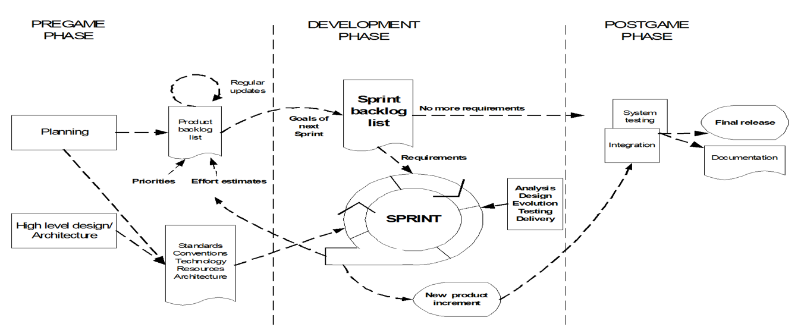
We did not use other models due to:
Waterfall Model: The Waterfall model follows a rigid, sequential approach with fixed requirements. It was not chosen because PeerSync contains multiple user roles and numerous features, and requirements may change based on user and supervisor feedback. Its limited support for early feedback makes it less suitable for the dynamic development of PeerSync.
V-Model: The V-Model emphasizes verification and validation and requires extensive upfront planning and documentation. This rigidity makes it less suitable for PeerSync, where features can be improved through continuous feedback and iterative development.
Extreme Programming (XP): XP focuses heavily on coding practices such as pair programming, test-driven development, continuous integration, and refactoring. However, PeerSync requires stronger project coordination and management of many user stories and user roles. Scrum provides more structured sprint planning and progress monitoring, making it more suitable for this project.
Dynamic Systems Development Method (DSDM): DSDM provides strong governance and prioritization but involves additional roles, processes, and documentation. This overhead is not practical for a small academic team working with limited time and resources.
Feature Driven Development (FDD): FDD is more appropriate for larger development teams and complex systems with specialized feature ownership. Its formal feature-driven structure is less suitable for PeerSync, where flexible teamwork and continuous feedback are important.
Scrum is an agile framework that delivers software incrementally through time-boxed sprints, allowing continuous feedback and adaptation. For the PeerSync project, Scrum provides an effective balance between structure and flexibility, enabling the team to prioritize important features early while continuously developing, testing, and improving the system based on user and stakeholder feedback. This makes Scrum suitable for developing a flexible and high-quality multi-university academic collaboration platform.

