
AMERICAN INTERNATIONAL UNIVERSITY-BANGLADESH
Faculty of Science and Technology
Department of Computer Science
CSC 3215: Web Technologies

Semester: Fall 25-26 | Group No: 06 | Section: | BB

Group Members:
SL. | Student ID | Name | Role | Signature
1 | 24-57476-2 | Md. Azraful Alam | Group Leader
2 | 23-52293-2 | Imtiaze Hossain Nahin | Member
3 | 23-54657-3 | Sumaiya Binte Kamal | Member
4 | 23-51187-1 | Chayon Kumar Roy | Member

Project Title
PawNest: An Online Pet Shop and Marketplace
Short Description
PawNest is a web application for buying and selling pets and pet supplies. Customers browse and search listings, add items to a cart and place orders with home delivery or shop pickup. Sellers publish pet and product listings, an administrator approves listings and manages users and orders, and delivery riders update the status of the deliveries assigned to them.
Introduction
Buying a pet or pet supplies often means scrolling through social media groups, calling shops or visiting stores in person. Listings are scattered, prices and ages are not always clear, and there is rarely a record of the order or its delivery.
PawNest brings this into one web application for four types of users: customers, sellers, delivery riders and an administrator. Customers can search and filter pets and supplies, order them and follow the delivery. Sellers list what they offer, and every new listing is checked by the administrator before it appears in the shop. Because live animals need extra care, the system limits live-pet orders to local delivery or pickup, and riders can see which orders contain a pet.
This proposal covers the implementation of PawNest as a web application for the Web Technologies course. It presents the database design, the use case diagram, the tentative user interface and the features of each user type. The front end will be built with HTML, CSS and JavaScript.
Background Study
Several existing options cover part of this need, but none covers all of it.
Social media groups and pages (for example Facebook groups) – make it easy to post and reach buyers, but listings are not verified, search and filtering are limited, and there is no order record or delivery tracking.
General classified and marketplace sites – have a wide audience, but pets and supplies are mixed with every other kind of goods, and nothing is designed around the care that live animals need.
Pet supply online stores – handle products and checkout well, but usually do not support listings of live pets with details such as breed and age.
Local pet shop websites – often work as a simple catalog or contact page, without seller accounts, an approval step or order tracking.
Pet adoption and sale boards – list animals so that people can contact the owner, but do not provide a cart, checkout or delivery.
PawNest combines what is missing: structured pet and product listings with search and filters, seller accounts with administrator approval, a cart and checkout with delivery or pickup options, and order tracking from placement to delivery. This comparison is based on general knowledge of these kinds of services and not on a formal survey.
ER Diagram
The database is organized around the USERS table, which stores every account regardless of role (customer, seller, rider or administrator). PRODUCTS holds both pets and supplies, separated by a type column, and each product belongs to a seller and a category. CART_ITEMS, ORDERS and ORDER_ITEMS record what each customer buys, and every order can be assigned to a rider through the rider_id column, which also points to USERS.
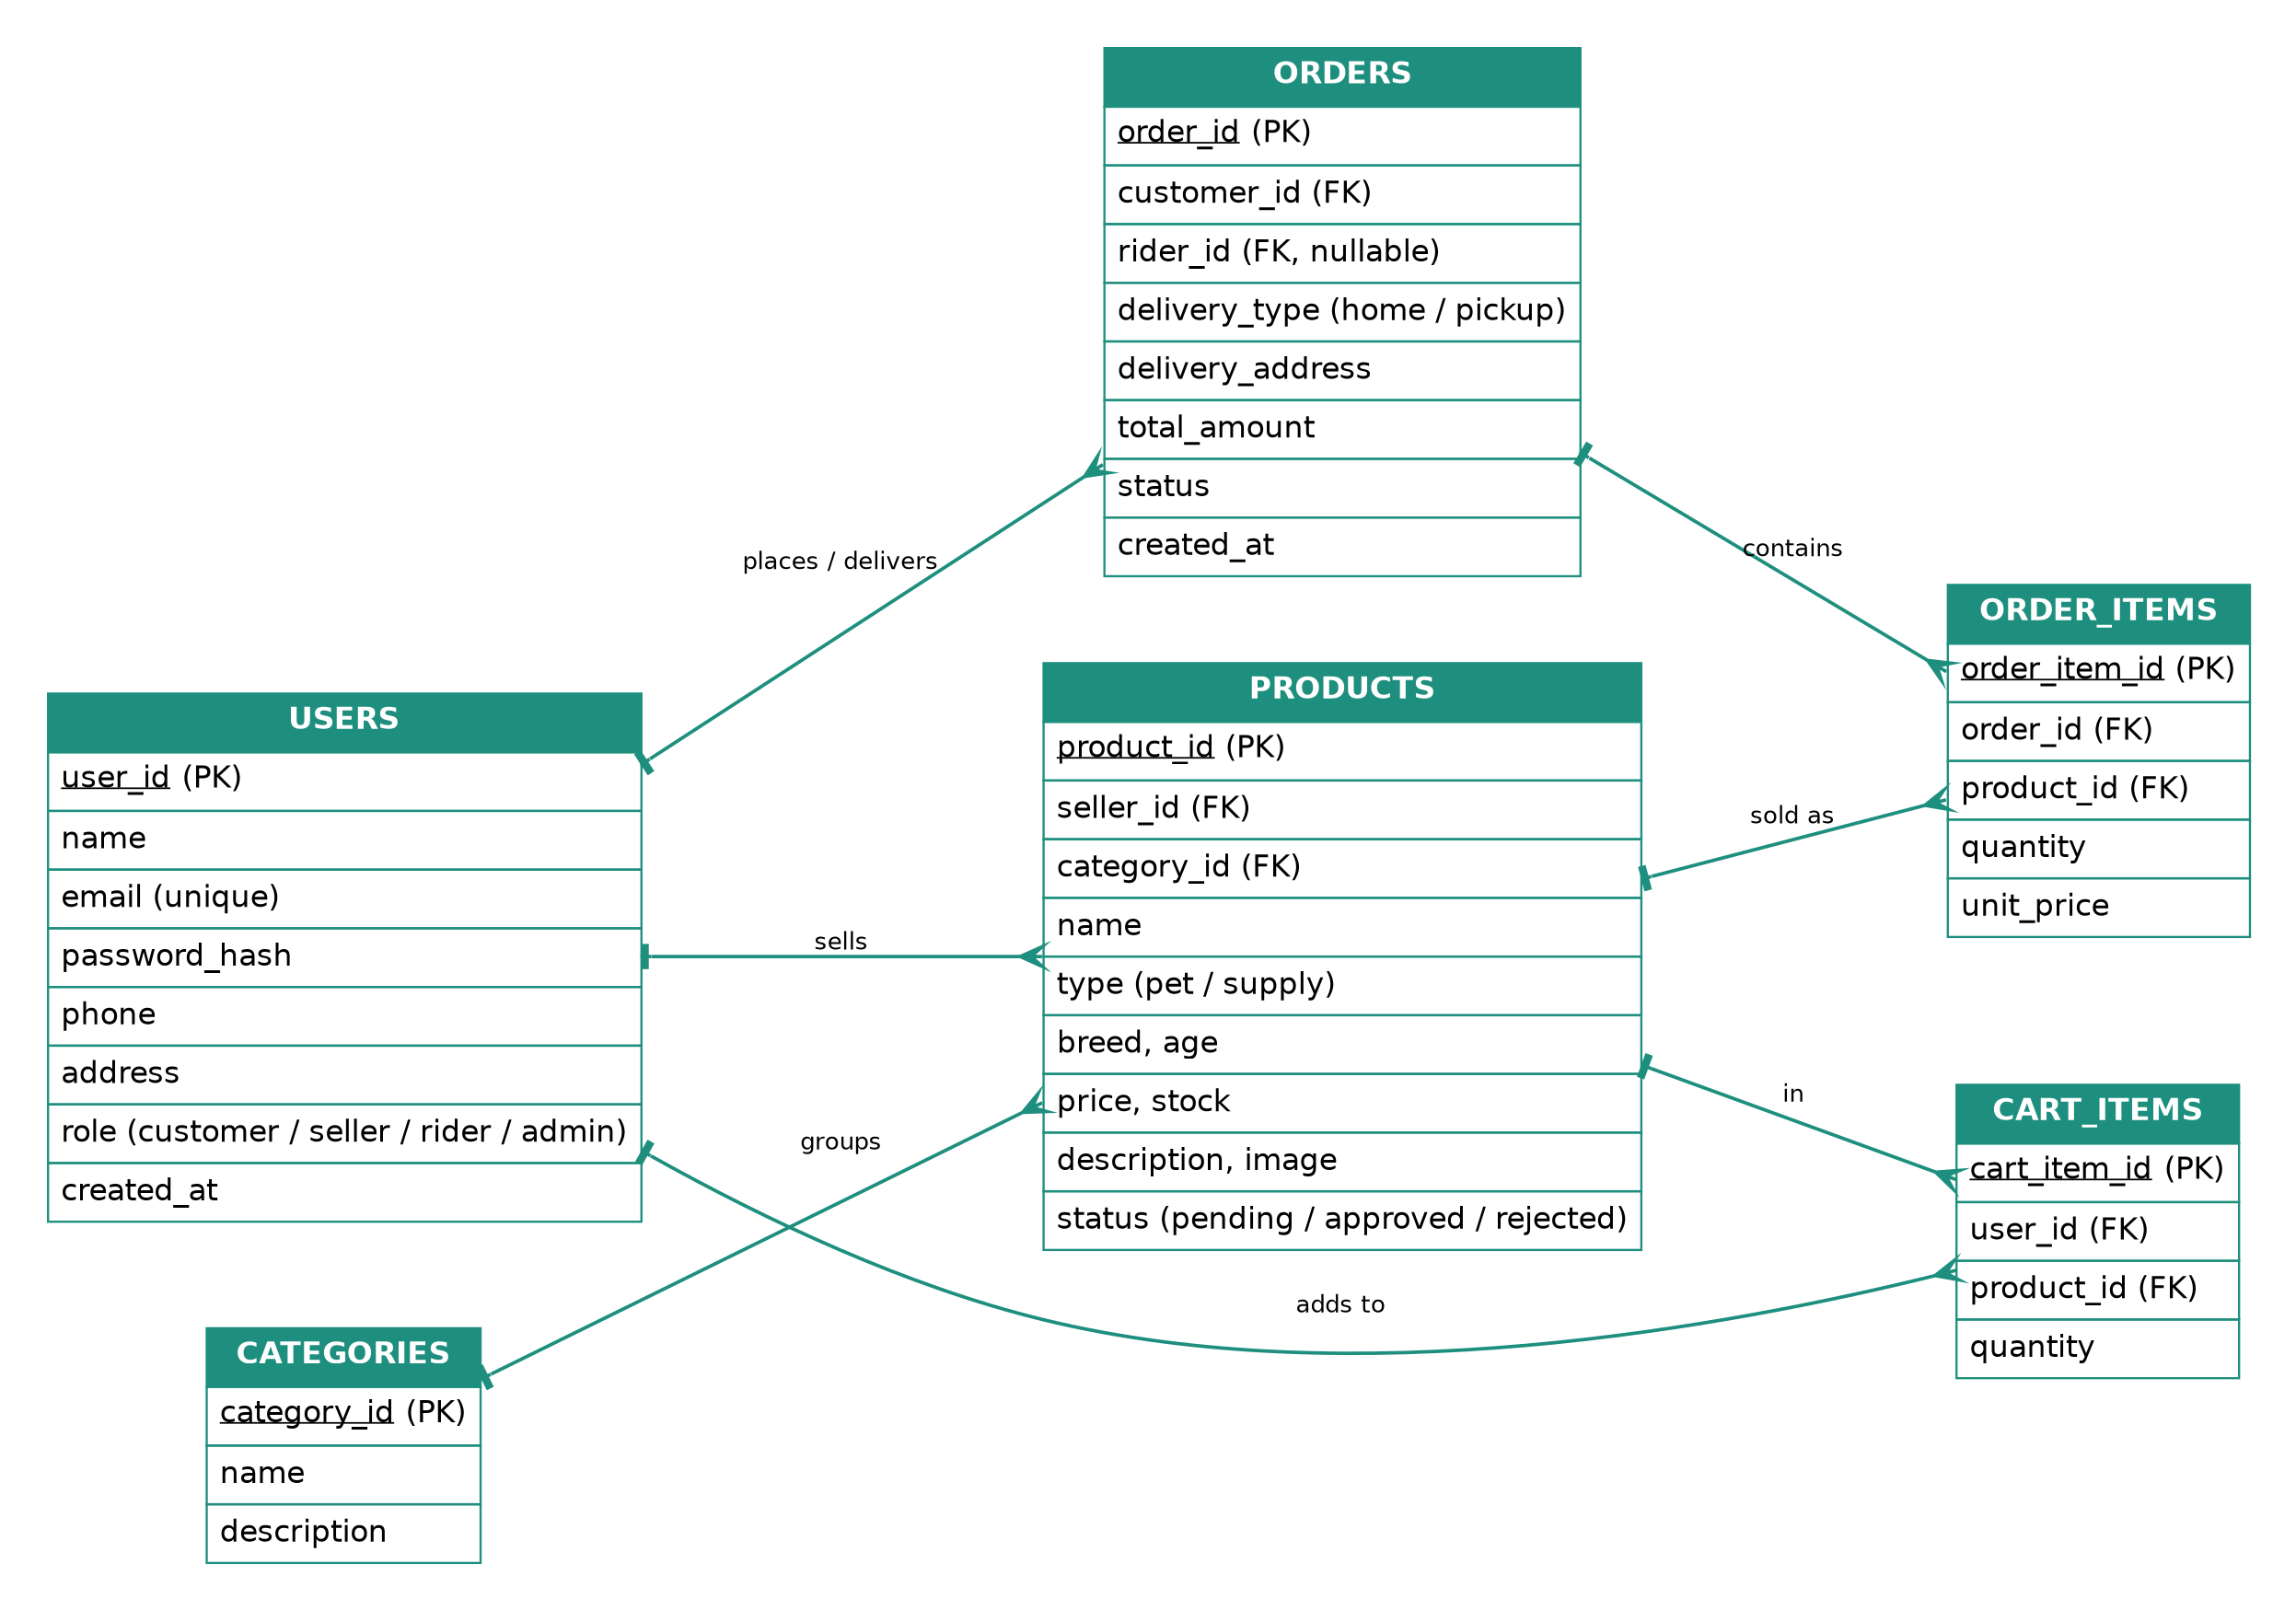
Figure 1: Entity-Relationship (ER) diagram of PawNest
Use Case Diagram
The use case diagram shows the PawNest system boundary, its four actors (Customer, Seller, Administrator and Delivery Rider) and the use cases each actor can perform, with include and extend relationships marked.
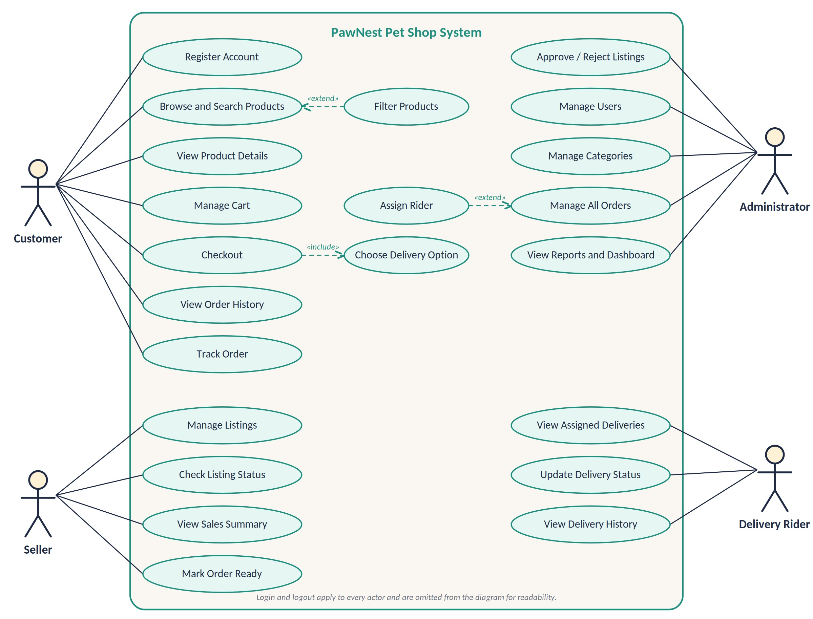
Figure 2: Use case diagram of PawNest
UI (Figma/Sketch)
The tentative design covers seven desktop screens: home, shop, cart and checkout, login and register, and the seller, administrator and delivery rider dashboards. It uses a warm background with teal and amber accents and a cat and dog mascot, and the screens will be implemented as responsive web pages.
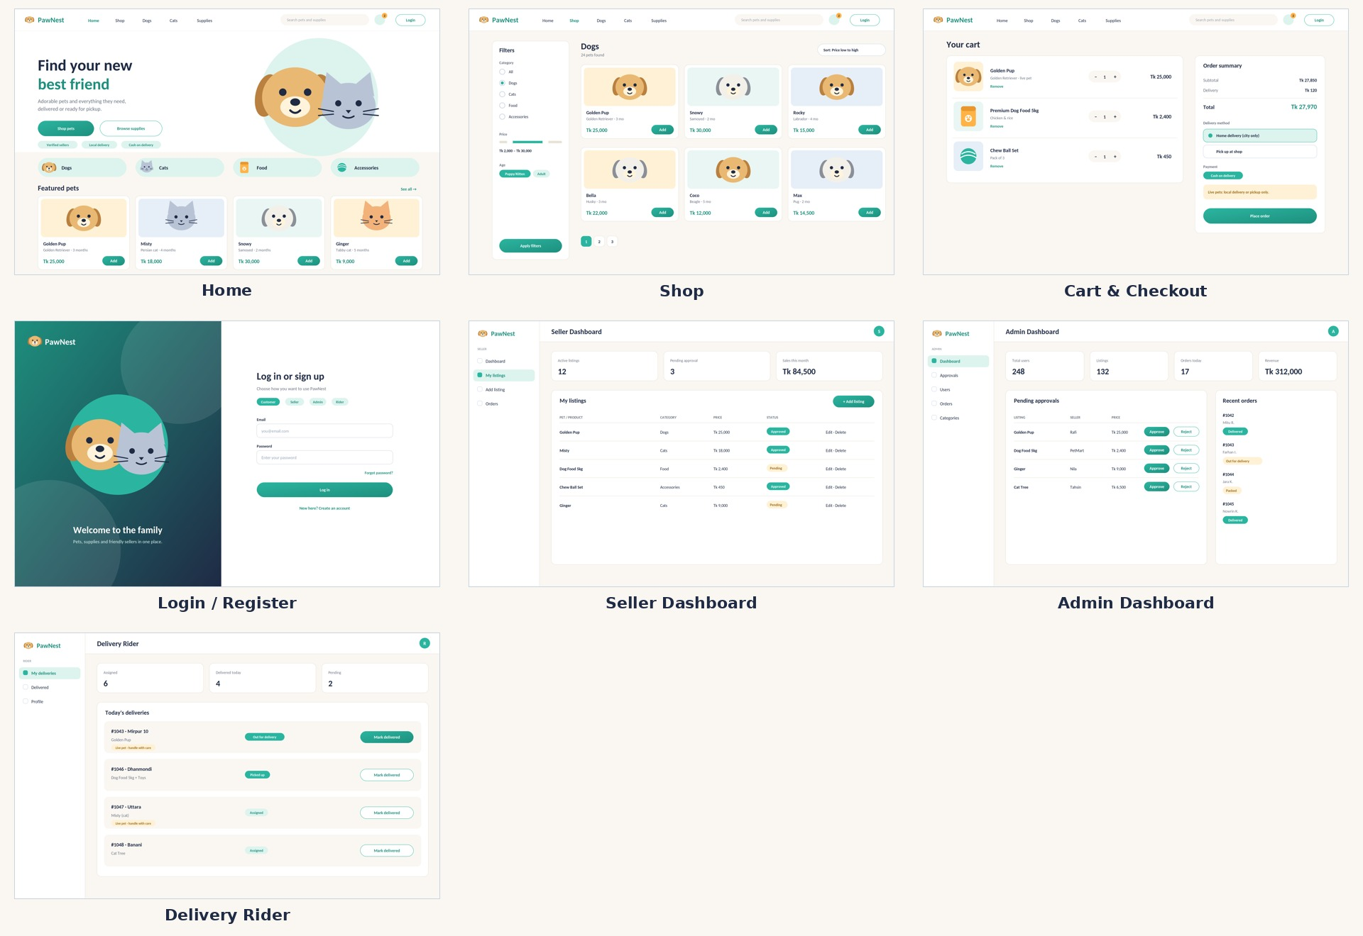
Figure 3: Tentative desktop UI design of PawNest

Types of Users (Roles):
- Customer
- Seller
- Delivery Rider
- Administrator
Common Features (Available to All Types of Users)
- Authentication
- Login to the system
- Logout from the system
- User registration (Account Creation)
- Account Management
- Change and reset password
- Manage profile information (view, edit, delete, including profile picture)
- Dashboard
- Access a personalized dashboard after login (each type of user must land on their own dashboard after login)
Specific Features by User Type
- Features of Customer
- Browse and Search Pets and Supplies – browse by category (dogs, cats, food and accessories), search by keyword and filter by price, breed and age.
- Shopping Cart – add pets and supplies to a cart, change quantities and remove items before checkout.
- Checkout with Delivery Option – place an order with home delivery or shop pickup; live pets are limited to local delivery or pickup, and payment is cash on delivery.
- Order History and Tracking – view past orders and follow the status of each order from placed to delivered.
- Features of Seller
- Manage Listings – add, edit and delete pet and product listings with photos, breed, age, price and stock.
- Listing Approval Status – see whether each listing is pending, approved or rejected by the administrator, and update and resubmit a rejected listing.
- Order Handling – see incoming orders that include the seller's items and mark them as ready for handover to the rider or for pickup.
- Sales Summary – view total sales and the number of items sold for a chosen period.
- Features of Delivery Rider
- Assigned Deliveries – see the orders assigned by the administrator with the delivery address and contact number.
- Delivery Status Updates – mark each order as picked up, out for delivery or delivered.
- Live Pet Handling Notes – see which orders contain live animals so they can be handled and delivered with care.
- Delivery History – view completed deliveries with their date and order total.
- Features of Administrator
- Listing Approval – review new listings and approve or reject them before they appear in the shop.
- User Management – view, suspend or remove customer, seller and rider accounts.
- Category Management – add or edit product categories and remove inappropriate listings.
- Order Management and Rider Assignment – view all orders, change their status and assign a rider to each delivery order.
- Dashboard and Sales Reports – view totals for users, listings, orders and revenue.

