
NEW USER TRAINING
Engaging Local 801
A practical guide to signing in, organizing your work, recording outreach, and protecting member information
Start here: Use the first half of this guide for everyday work. Role-specific administration begins later and is clearly marked.
Training edition • August 2026
Private Local 801 workspace — for authorized users only

How to use this guide
You do not need to memorize the whole application on day one. Learn the basic rhythm first: open your work, make the contact, record what happened, and set the next step. The pages available to you will depend on your assigned role.

Your first-day checklist
- Confirm which Microsoft account was invited and complete MFA.
- Open the account menu and check that the role shown matches your assignment.
- Find Home, Member outreach, Follow-ups, To Do, Documents, and Support.
- Open one assigned outreach record and review the contact and work details.
- Practice recording a conversation in the approved training or Preview environment before entering live work.
Good habit: When a page says a change was not confirmed, stop and check the current record before trying again. Never assume a second click is harmless.

What the labels mean
Item | What it means
Protected PII | The page contains personal or member information. Use it only for approved Local 801 work.
Preview environment | A synthetic training space. It does not create Production accounts or connect to Production records.
Audited operation | The application records who performed the action and when.
Unavailable | CAT withheld the information because it could not load or verify it safely. Do not fill the gap with guesses.

1. Sign in safely
CAT is invitation-only. Microsoft confirms your identity and MFA; CAT separately checks that your account is active and has one assigned role. A successful Microsoft password screen, by itself, does not grant access.
- Use the invited account — Choose the exact Microsoft account named in your Local 801 invitation. For most users this is a personal Microsoft account created with, or linked to, the invited email address.
- Complete MFA — Finish the Microsoft verification prompt in the same browser window.
- Check your CAT role — After sign-in, open the account menu. If the role is wrong, sign out and contact an administrator rather than working under the wrong access.
- Reset a stuck sign-in — Use Sign out and reset sign-in when Microsoft keeps returning the wrong account or an older attempt.
Never share: Your password, MFA code, recovery code, or a screenshot containing protected member information.

What the sign-in page checks
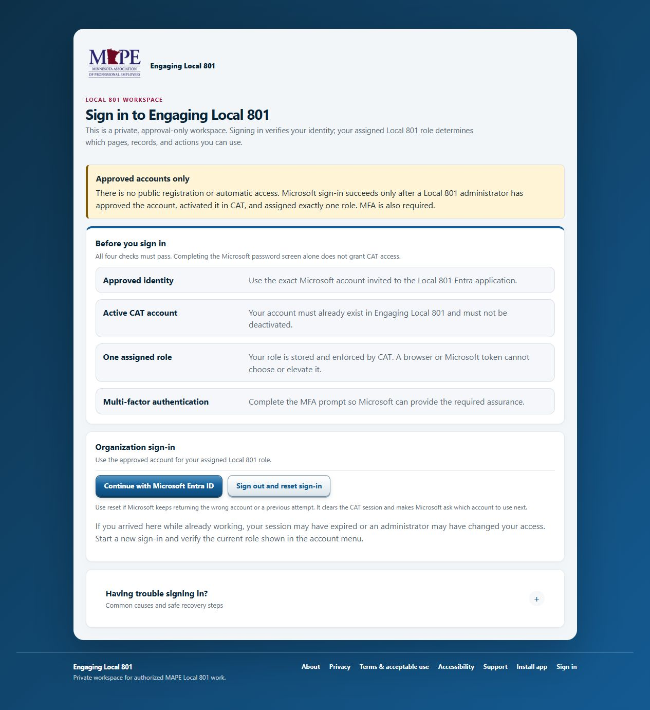
The Production sign-in page lists the four checks that must pass.

2. Find your way around
On a desktop, the main areas are grouped in the left navigation. On a phone, your most-used pages appear along the bottom and the rest are under More. The list changes by role, so it is normal for two users to see different menus.
Item | What it means
Overview | Home and the work that needs attention now.
People | Membership, Directory, and New hires, when your role allows them.
My work | Member outreach, Work planner, Follow-ups, and To Do.
Programs | Action catalog, Campaigns, and CAT Actions.
Operations | Data imports, Data issues, Contact updates, and Documents.
Insights | Reports available to your role.
Administration | Audit Activity, Team & Access, and Settings for administrators.
If a link is missing: Your role probably does not include that function. Do not use another person’s account to reach it; ask an administrator to review your role.

Navigation example
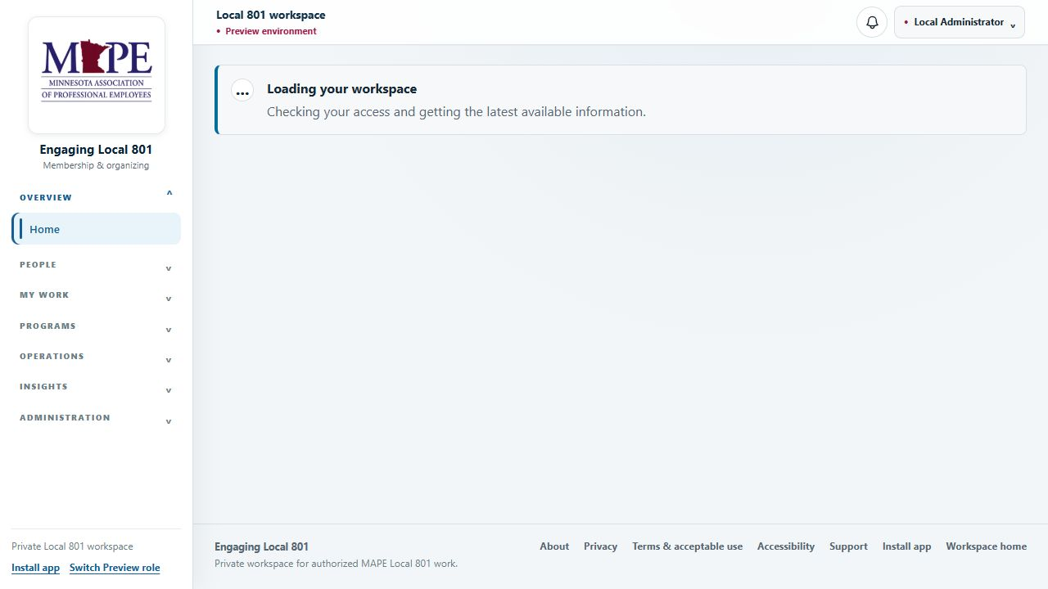
Synthetic Preview example. The role appears in the top-right account menu; navigation groups appear on the left.

3. The everyday outreach rhythm
Most CAT and LCAT work follows the same five-part rhythm. If you keep this sequence, the next person can understand the record without chasing you for context.
- Start with your list — Open Member outreach. Overdue follow-ups and people who need attention rise toward the top.
- Review before contacting — Open the person’s outreach record. Check assignment context, recent conversations, open follow-ups, and current action readiness.
- Use the available contact method — Open Contact info. Call, text, or email only through details available to you.
- Record what happened — Choose the contact method, outcome, time, context, and an appropriate note visibility. Keep notes factual.
- Set the next step — Update action readiness when it changed and create a follow-up when another contact is needed.
A useful note: Briefly record the result and what the next organizer needs to know. Leave out medical, family, disciplinary, or other personal detail unless it is genuinely necessary for the authorized work.

Use Directory and Outreach for different jobs
Item | What it means
Directory | Find a person by name, workplace, classification, membership status, or work email. Open a record when you are allowed to work with that person.
Member outreach | Work the people currently assigned or visible in your scope, ordered around follow-ups and attention.

4. Record a conversation
Open the member’s outreach record and choose Record conversation. The form is designed to capture the result without turning the note into a transcript.
Item | What it means
Contact method | In person, phone, text message, email, video call, or other.
What happened? | Contacted, no answer, left message, declined conversation, wrong contact information, or not available.
When | Leave blank to use the current time, or choose the correct date and time. Entered times use your device time zone.
Context | Choose the assignment or general outreach context that explains why the contact occurred.
Note | Optional. Keep it factual, brief, and useful.
Who can see this note? | Choose the narrowest visibility that still supports the work.

Follow-up suggestions are suggestions
Some outcomes may suggest a reasonable next contact date. Nothing is scheduled until you accept the suggestion and save the conversation. You can also set a different date and assignee.
Wrong contact information: Record the outcome, then use Contact info to propose the corrected phone, email, or address for Membership Data review. Do not replace the official contact information yourself.

5. Keep action readiness current
Action readiness describes the member’s current response to an organizing action. Earlier responses remain in history, so updating the current response does not erase what was recorded before.
Item | What it means
Willing | The member is willing to take the action.
Considering | The member has not decided and may need follow-up.
Declined | The member declined this specific action.
Completed | The member completed the action.
Declines all actions | Use only when the member currently declines every organizing action. CAT keeps earlier history.
When possible, save the conversation first and then update action readiness. CAT can link the readiness change to the conversation you just recorded.
Use the catalog as written: If the needed action is missing, add or request a catalog item. Do not repurpose an unrelated action just to make the form submit.

6. Work the next step

Follow-ups
Start with overdue items and those due today. Depending on your role, you may be able to move the due date, reassign the follow-up, or mark it complete. Open the member record before closing an item if you need to confirm what happened.

To Do
To Do combines current reminders, review requests, and saved work views. It is ordered by urgency. Browser notifications, when enabled, stay generic and do not include member names or protected details.

Work planner
The planner puts follow-ups and other due work in one place. It helps you plan your time; it does not change assignments and it is not a performance score.
Before marking complete: Make sure the conversation or result is recorded. A completed reminder without a usable record leaves the next organizer guessing.

7. Mobile field view
On a phone-sized screen, Member outreach automatically opens in Field view unless you previously chose the standard view during that session. Field view keeps the next actions close: contact the member, record what happened, update readiness, add a follow-up, and return to the refreshed list.

You are still in control
- Choose Use standard view whenever you want the full list layout.
- Choose Start field view to return to the focused mobile workflow.
- The preference is respected for the rest of the browser session.
- Field view stays online. It does not store member contact details for offline use.
Connection trouble: If a save is interrupted, reconnect and verify the record before entering it again. Do not assume the first attempt failed or succeeded.

8. Documents
Documents are encrypted and shown only to roles and audiences allowed to see them. Use the Documents page to open approved material, and use the upload area only when your role and the document’s audience are clear.
- Choose the audience — Select the narrowest audience that needs the file.
- Upload the correct file — Check the filename and content before choosing Upload. Files must pass malware scanning before encrypted storage.
- Wait for approval when required — An uploaded file may not be available to its audience until the approval step is complete.
- Use metadata carefully — Titles, descriptions, dates, and relationships should help users find the right document without exposing protected detail.
- Delete only with authority — Deletion is an administrative action. Confirm the exact document and verify the result.
Do not use personal storage: Do not copy Local 801 documents to a personal drive, personal email, or unapproved messaging service.

Install the app shortcut
The Install app page explains the available option for the current device. Installing adds a convenient shortcut; it does not remove the need for a secure connection or an approved CAT account.
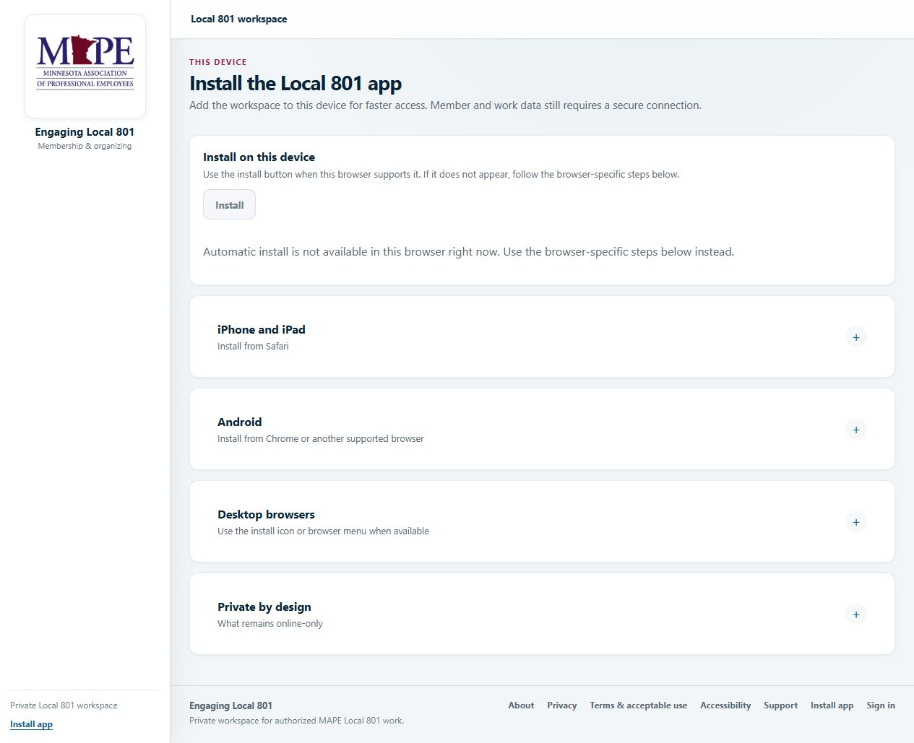
The install page provides device-specific instructions and explains what remains online-only.

9. Protect member information
CAT limits access by role, assignment, and record scope. Those controls help, but good judgment still matters once information is on your screen.
- Use CAT only for approved Local 801 work.
- Do not share your account or work under another person’s account.
- Use the narrowest note visibility and document audience that will do the job.
- Keep screenshots, rosters, contact details, and documents out of support messages unless an approved process specifically requires them.
- Lock your device when you step away, especially in the field.
- Report a lost device, suspicious sign-in, or unexpected role promptly.

If a page says information is unavailable
CAT fails closed when it cannot safely verify access or load protected data. Retry once after checking your connection. If the problem continues, record the non-sensitive support reference and contact support. Do not substitute old spreadsheets or guess at the missing information.

Role-specific administration
Skip this section if it is not your job: These pages are shown only to roles that have the related permission. Having a link does not remove the need to verify the record and the requested change.

Programs: Action catalog, Campaigns, and CAT Actions
- Action catalog: maintain the ordered list of organizing actions used on outreach records. Custom items become available across employee outreach pages.
- Campaigns: define the participant population, assign organizers, track contact and completion, and connect the work to CAT Actions.
- CAT Actions: create action work records, assign tasks, manage due dates, and monitor completion.
Create programs in draft when the participant list, assignments, or timing still needs review. Archive or close work only after checking what will disappear from active views.

Membership operations
- Membership shows current totals, recent additions and drops, and breakdowns from the latest approved snapshot.
- Data issues lets you fix an employee record, attach an import row to an existing employee, create a new employee after review, or remove the row from the import.
- An exact active work-email match always wins and cannot be overridden. When there is no exact match, CAT ranks possible employees using names and workplace details; an administrator confirms the attachment.
- Contact updates are proposals. Reviewers approve or reject them before the official contact data changes.
- Data imports require validation, review decisions, and an exact execution plan before authorized roster changes are applied.
Import safety: Uploading or reviewing a file does not change the roster. Apply only the exact reviewed changes, and do not treat absence from a file as a drop, separation, archive, or deletion.

Team & Access
System Owners and Local Administrators use Team & Access to add users, assign roles, deactivate or reactivate accounts, and revoke sessions. Access changes should match a confirmed Local 801 responsibility.
- Check the email — Use the exact personal Microsoft account the user will sign in with. Confirm spelling before creating the invitation.
- Choose one role — Assign the least-privileged role that fits the person’s current work.
- Send the invitation — When Entra provisioning is available, CAT creates the guest, assigns the enterprise application, and asks Microsoft to send the customized invitation.
- Verify sign-in — Have the user accept the invitation, complete MFA, and confirm the role shown in CAT.
- Change access deliberately — Role changes, deactivation, and session revocation affect active access. Confirm the current state after the action.
Protected accounts: Follow the hierarchy and System Owner protections shown by CAT. Do not remove or downgrade a protected owner account as a shortcut.

Reports, audit, and settings
- Reports show only the totals, trends, and person-level detail allowed to your role. If a report is unavailable, CAT does not substitute plausible numbers.
- Audit Activity records administrative and sensitive operations. Use the non-sensitive event details to confirm what happened.
- Settings shows environment and security posture without exposing secrets. A locked control is a real boundary, not a suggestion to bypass it.

Get help without exposing data
Most access problems can be resolved with the exact account name, device type, time of the problem, and the support reference shown by CAT. Support does not need a member roster or a screenshot of protected contact information.
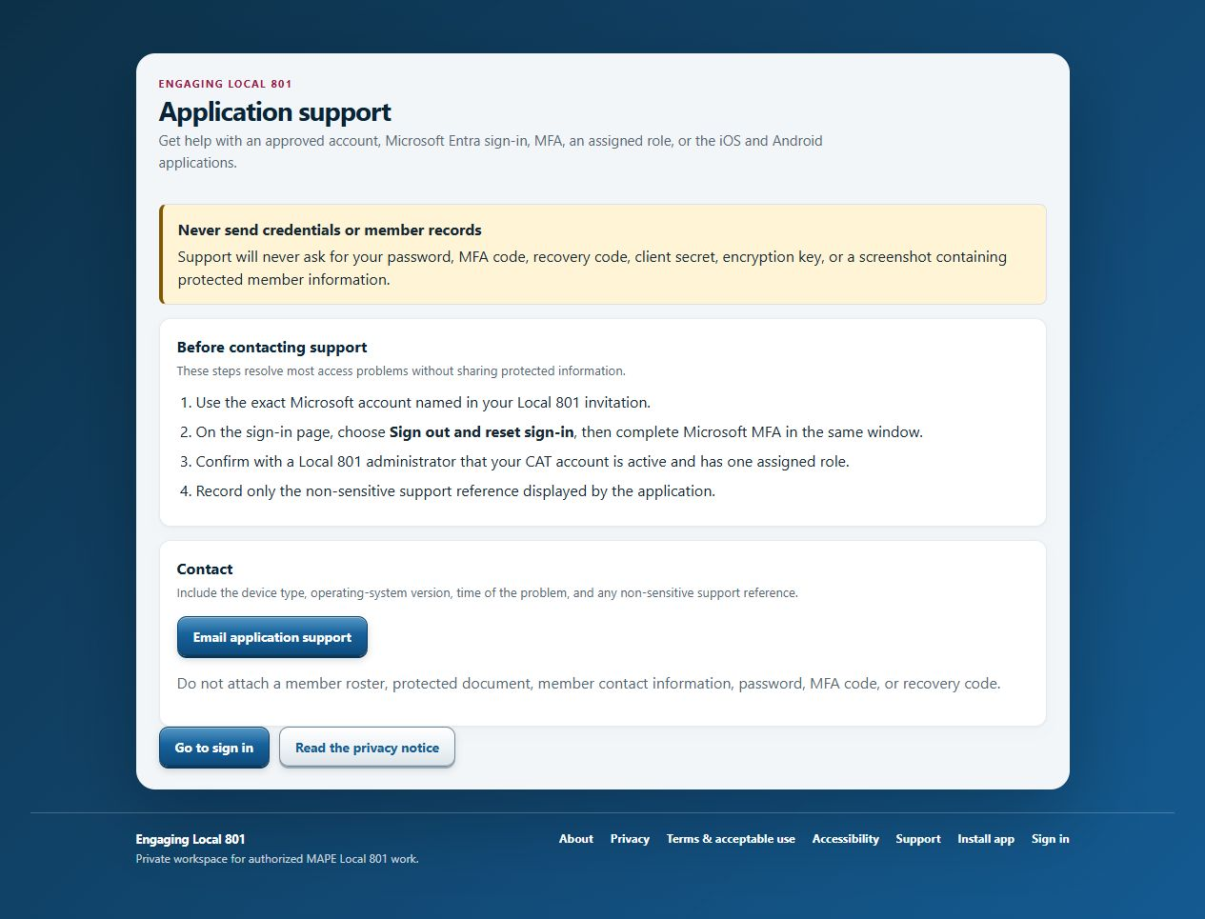
The Support page lists safe recovery steps and the information to include.

Troubleshooting quick reference
Item | What it means
Microsoft keeps choosing the wrong account | Return to CAT sign-in and choose Sign out and reset sign-in. Then select the exact invited account.
Microsoft sign-in finishes, but CAT denies access | Ask an administrator to confirm that the CAT account is active and has exactly one role, and that the invited identity is the one you used.
MFA does not move forward | Finish security-info registration for the invited account, close older sign-in tabs, and begin a new CAT sign-in.
A save produced an error | Check the record first. Retry only if the current state shows the change was not saved.
The page is unavailable | Check your connection and role. Use the non-sensitive support reference if the problem continues.
A menu item is missing | The page may not be available to your role. Ask an administrator to review access.
You found incorrect contact data | Record the wrong-contact outcome, then propose a contact update for Membership Data review.

Before you contact support
- Write down the exact non-sensitive support reference.
- Note the device, browser or app, and approximate time.
- Explain what you expected and what happened in one or two sentences.
- Remove member names, contact details, passwords, MFA codes, and recovery codes.

Practice: one clean outreach record
Use a synthetic training record and work through this scenario with your trainer.
- Open Member outreach — Choose a synthetic person who has an open follow-up.
- Review the record — Identify the assignment context, last contact, current action readiness, and follow-up due date.
- Open Contact info — Identify which contact methods are available to your role.
- Record the conversation — Choose Phone, Contacted, the current time, a short factual note, and Assigned outreach team visibility.
- Update readiness — Record Considering for one training action and link it to the conversation.
- Create the next follow-up — Assign it to yourself for a trainer-approved date and time.
- Verify the record — Refresh the page and confirm the conversation, readiness change, and follow-up each appear once.
Trainer check: The learner should be able to explain what was saved, who can see it, and what they would do if the save result were unclear.

Quick glossary
Item | What it means
CAT | A user who works assigned people, follow-ups, and shared documents.
LCAT | A lead who manages team assignments, follow-ups, documents, and authorized reports.
Action readiness | A member’s current response to a defined organizing action.
Assignment scope | The people or work a user is authorized to see and manage.
Protected PII | Personal information that receives additional access and storage protection.
Support reference | A non-sensitive code that helps administrators identify a failed operation.

Ready for live work
Before a new user begins live work, the trainer or administrator should confirm the items below. This is a practical readiness check, not a test of memorization.
- The user can sign in with the invited Microsoft account and complete MFA.
- The role shown in CAT matches the approved assignment.
- The user can find Member outreach, Follow-ups, To Do, Documents, and Support when those pages belong to the role.
- The user can record one synthetic conversation, update action readiness, and create a follow-up.
- The user understands note visibility, protected information, and safe support practices.
- The user knows to verify the current record after any uncertain save or error.
Last reminder: Work from the current CAT record, keep notes useful and restrained, and ask before using protected information in a new way.

