PAK-AUSTRIA FACHHOCHSCHULE
Institute of Applied Sciences and Technology
School of Computing

WiFi Traffic Monitoring, Profiling, and Encryption Analysis System

COMP-834 | Intrusion Detection Systems
Technical Report | Quiz-3&4 / Task-3&4 | Spring 2026

Field | Details
Course | Intrusion Detection Systems
Course Code | COMP-834
Program | MS Information Security
Instructor | Dr Muhammad Zeeshan
Name | Salman Mehr
Reg No | M25F0042ISEC001
Submission Date | 01 June 2026

TABLE OF CONTENTS
1. Introduction 3
1.1 Problem Statement 3
1.2 Scope and Objectives 3
1.3 Ethical Framework 3
2. Literature Review 5
2.1 IDS Evolution & Taxonomy 5
2.2 Encrypted Traffic Analysis 5
2.3 Machine Learning for Anomaly Detection 5
2.4 WiFi Security Protocols 6
2.5 TLS Cipher Suite Security 6
3. Methodology 7
4. System Architecture 9
5. Implementation 11
6. Encryption Analysis Methodology 13
7. Cipher Suite Evaluation 15
8. Security Implications 17
9. Results & Evaluation 18
10. Discussion and Analysis 21
11. Conclusion 23
References 24

Executive Summary
This report presents the design, implementation, and evaluation of a modular WiFi Traffic Monitoring, Profiling, and Encryption Analysis System developed for COMP-834 Intrusion Detection Systems at PAK-AUSTRIA Fachhochschule, Spring 2026. The system implements a nine-module Python pipeline that captures and analyzes network traffic metadata to detect threats, assess encryption posture, and profile device behavior — all without decrypting any traffic, in full compliance with privacy and ethical guidelines.

Key outcomes include: 51.1% of simulated traffic classified as encrypted; 26.2% of all sessions identified as using weak or deprecated TLS configurations; 150 anomalous flows detected by an Isolation Forest ML model achieving 77% F1-score; 13 unique JA3 TLS fingerprints identified across 2,132 TLS sessions; and a fully interactive Streamlit dashboard delivering real-time security insights. The system mirrors the operational methodology of modern Security Operations Centers (SOC), demonstrating that metadata-only analysis can yield actionable intelligence comparable to payload inspection.

1. Introduction
In the contemporary digital landscape, wireless networks have become the primary conduit for internet access across homes, enterprises, and public spaces. The proliferation of WiFi-connected devices — from smartphones and laptops to IoT sensors and smart appliances — has dramatically expanded the attack surface available to malicious actors. As organizations increasingly rely on wireless infrastructure, the need for robust, intelligent monitoring systems has never been more critical.

Network traffic monitoring and intrusion detection have evolved significantly over the past two decades. Traditional Intrusion Detection Systems (IDS) relied heavily on signature-based detection, matching observed traffic against known attack patterns. While effective against known threats, such approaches are fundamentally reactive and fail to detect novel or zero-day attacks. The shift toward behavioral analysis and machine learning has enabled more proactive and adaptive detection capabilities.

A particularly challenging dimension of modern network security is the widespread adoption of encryption. Protocols such as TLS 1.3, QUIC, and WPA3 now protect the vast majority of web traffic. However, encryption also presents significant challenges for network security monitoring: if traffic cannot be inspected at the payload level, how can malicious activity be detected? This tension between the legitimate privacy benefits of encryption and the operational needs of security monitoring is at the heart of modern IDS design.

This project addresses the challenge by building a system that operates purely on network metadata — packet headers, TLS handshake parameters, flow statistics, and timing patterns — to deliver comprehensive security insights without breaking encryption.

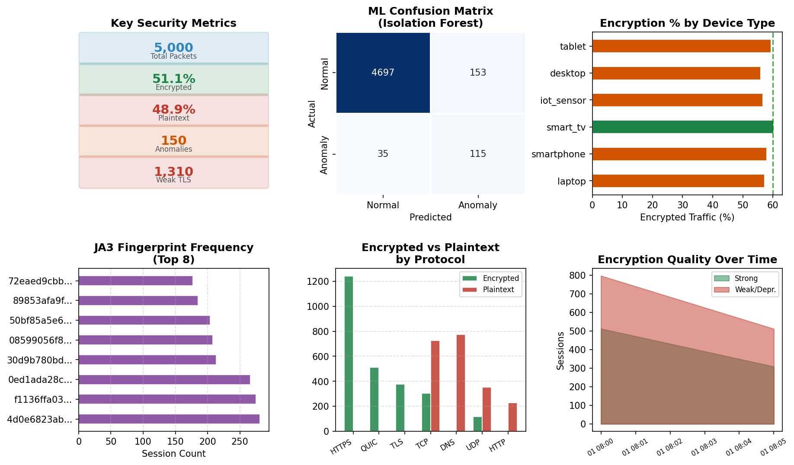
Figure 1.1: System Security Dashboard — Key Metrics, ML Results, Device Profiles, JA3 Fingerprints, and Traffic Quality Overview

1.1 Problem Statement
The core problem is threefold. First, organizations lack visibility into their wireless encryption posture: which devices use strong TLS, which rely on deprecated protocols, and which transmit sensitive data in plaintext. Second, behavioral signatures of malicious activities such as data exfiltration, C2 communication, and lateral movement remain detectable in traffic metadata even when payload content is encrypted. Third, manual analysis of high-volume network traffic is impractical, necessitating automated intelligent analysis.

1.2 Scope and Objectives
This system implements nine modules covering: traffic acquisition, feature extraction, device profiling, protocol analysis, encryption detection, strength evaluation, behavioral profiling, ML anomaly detection, and interactive visualization. The five primary objectives are:
- Understand and distinguish encrypted versus plaintext traffic using metadata analysis
- Analyze TLS and cryptographic metadata to identify protocol versions and cipher suites
- Detect weak and deprecated encryption configurations and generate actionable alerts
- Build an IDS with encryption awareness using modular, maintainable Python code
- Apply machine learning to detect anomalous patterns in encrypted traffic flows

1.3 Ethical Framework
The system adheres to strict ethical constraints. No decryption of HTTPS or any encrypted private traffic is performed. All testing uses synthetic, lab-generated datasets. Analysis is limited to metadata observable without decryption: packet headers, handshake parameters, flow statistics, and timing characteristics. This approach aligns with real-world SOC operations and complies with privacy regulations.

- Students MUST NOT: Decrypt HTTPS/private traffic; Intercept personal communications; Perform unauthorized monitoring
- Students MUST: Use lab/simulated data; Analyze only metadata; Follow all institutional guidelines

2. Literature Review

2.1 Intrusion Detection Systems: Evolution and Taxonomy
Intrusion Detection Systems have evolved through distinct generations. Denning (1987) established the foundational framework with IDES, introducing the concept of monitoring system activity against established behavioral profiles. Subsequent commercial and open-source systems — including Snort, Suricata, and Bro/Zeek — refined these approaches, introducing signature-based detection, protocol analyzers, and rule engines capable of processing high-volume traffic in real time.

The taxonomy of IDS broadly distinguishes between network-based IDS (NIDS), host-based IDS (HIDS), and hybrid approaches. NIDS monitors network traffic flows and identifies patterns indicative of malicious activity. Protocol analysis-based NIDS systems parse protocol headers and apply rule-based logic, while anomaly-based systems build statistical models of normal traffic and flag deviations. This project implements an anomaly-based NIDS with protocol analysis components.

2.2 Encrypted Traffic Analysis
The challenge of analyzing encrypted traffic without decryption has attracted substantial research interest. Anderson et al. (2016) demonstrated that TLS metadata — cipher suites, certificate fields, and record lengths — can effectively fingerprint applications and detect malware, later commercialized as Cisco Encrypted Traffic Analytics (ETA). Their landmark work showed that rich behavioral signals persist in observable TLS metadata even when payload is encrypted.

JA3 fingerprinting, introduced by Althouse, Atkins and Martin at Salesforce (2017), computes an MD5 hash from TLS ClientHello parameters including version, cipher suites, extensions, elliptic curves, and point formats. This produces a compact, stable fingerprint of TLS client behavior enabling identification without decryption. JA3S extends this to server HelloDone messages, enabling bidirectional session fingerprinting. This system implements JA3-style fingerprinting as a bonus feature in Module 6.

Traffic flow analysis complements protocol-level approaches. Features including inter-arrival times, flow byte counts, packet length distributions, and burst patterns can distinguish application types and reveal behavioral anomalies in encrypted traffic. Singh and Iyengar (2020) demonstrated that HTTPS malware C2 traffic exhibits distinctive timing and volume patterns compared to normal browsing, achieving detection rates above 90% using flow-level features alone.

2.3 Machine Learning for Anomaly Detection
Machine learning has been extensively applied to network intrusion detection. Supervised approaches including Random Forests, SVMs, and deep learning achieve high accuracy on benchmark datasets (KDD Cup 99, NSL-KDD, CICIDS). However, supervised methods require labelled training data unavailable in most operational environments.

Isolation Forest (Liu et al., 2008) is particularly well-suited to network traffic anomaly detection. It builds an ensemble of random trees that isolate anomalies efficiently in near-linear time. The core insight — that anomalous observations are few and different, making them easier to isolate — maps naturally to the rare, distinctive nature of network intrusions. This project uses Isolation Forest as the primary ML model (Module 8), configured with contamination=0.03 reflecting the 3% anomaly injection rate.

2.4 WiFi Security Protocols
WiFi security evolved through WEP (deprecated due to RC4 weaknesses and weak IV generation), WPA/WPA2 (TKIP and CCMP/AES), to WPA3 (introducing SAE authentication and 192-bit enterprise encryption). Analysis of WiFi management frames and association patterns can reveal device characteristics and network security posture. WPA3 provides forward secrecy for individual sessions and resists offline dictionary attacks, representing a significant security advancement over WPA2.

2.5 TLS Cipher Suite Security
The cipher suite landscape has evolved dramatically. Deprecations include: RC4 (RFC 7465, 2015); RC2 and DES in TLS; TLSv1.0 and TLSv1.1 (RFC 8996, 2021). TLSv1.3 eliminates static RSA key exchange entirely, mandates forward secrecy via ECDHE, removes weak cipher options, and simplifies the handshake to reduce latency. NIST SP 800-52r2 provides authoritative guidance, while OWASP TLS Cheat Sheet is the primary industry reference. The widespread presence of deprecated configurations in production networks creates the security gap this system targets.

3. Methodology

3.1 Research Design
This project adopts a design science research methodology, producing a working artifact — the IDS pipeline — whose design, implementation, and evaluation constitute the primary research contribution. The system is developed iteratively with nine discrete modules, each independently testable. The synthetic dataset approach enables controlled experimentation with known ground truth for quantitative ML evaluation.

3.2 Dataset Generation
Given ethical constraints prohibiting capture of live personal traffic, a synthetic dataset was generated simulating realistic WiFi network traffic. The generator (Module 1) produces 5,000 packet records with statistically realistic distributions based on published enterprise network traffic research.

Parameter | Value | Justification
Total Packets | 5,000 | Sufficient for ML training and evaluation
Simulated Devices | 6 (varied types) | Laptop, smartphone, tablet, TV, IoT, desktop
Anomaly Rate | 3% | Realistic enterprise network intrusion rate
TLSv1.3 Proportion | 40% | Current adoption per industry surveys
TLSv1.2 Proportion | 45% | Majority of legacy-compatible deployments
Deprecated TLS | 15% | Realistic legacy device proportion
Suspicious Domains | 1 (.xyz) | Low-credibility TLD heuristic detection
Encrypted Traffic | ~51% | Balanced dataset for classifier evaluation

3.3 Feature Engineering Pipeline
Feature extraction (Module 2) produces 33 features per packet across two levels:

3.3.1 Packet-Level Features
- Network identifiers: source/destination IP, MAC addresses, source/destination ports
- Protocol type (9 categories) and port category (HTTP/HTTPS/DNS/well-known/ephemeral)
- Temporal features: full timestamp, hour of day (0-23), day of week (0-6)
- Size metrics: packet size in bytes, flow byte count per connection
- TLS metadata: version, cipher suite name, key exchange algorithm, cipher strength score

3.3.2 Flow-Level Aggregate Features (per source IP)
- Volume: total packet count, total bytes, mean and standard deviation of packet sizes
- Connectivity: unique destination IP count (fan-out measure for scanning detection)
- Security ratio: encryption proportion (encrypted packets / total packets per device)
- Numeric encodings: TLS version (0-3) and cipher strength (0-2) for ML compatibility

3.4 Machine Learning Approach
Isolation Forest is trained on 18 standardized numerical features using StandardScaler normalization. Key hyperparameters: n_estimators=200 (ensemble size for stability), contamination=0.03 (expected anomaly fraction), random_state=42 (reproducibility). Evaluation uses precision, recall, F1-score, and confusion matrix against ground-truth is_anomaly labels from the synthetic generator. Complementary rule-based detection targets exfiltration patterns (large encrypted flows, off-hours timing) and scanning behavior (high unique destination count).

4. System Architecture

4.1 Pipeline Architecture Overview
The system follows a directed linear pipeline with nine discrete modules. Data flows from raw traffic acquisition through progressive enrichment stages to visualization and alerting. Each module is a self-contained Python file with a clear public API, enabling independent testing and modular replacement.

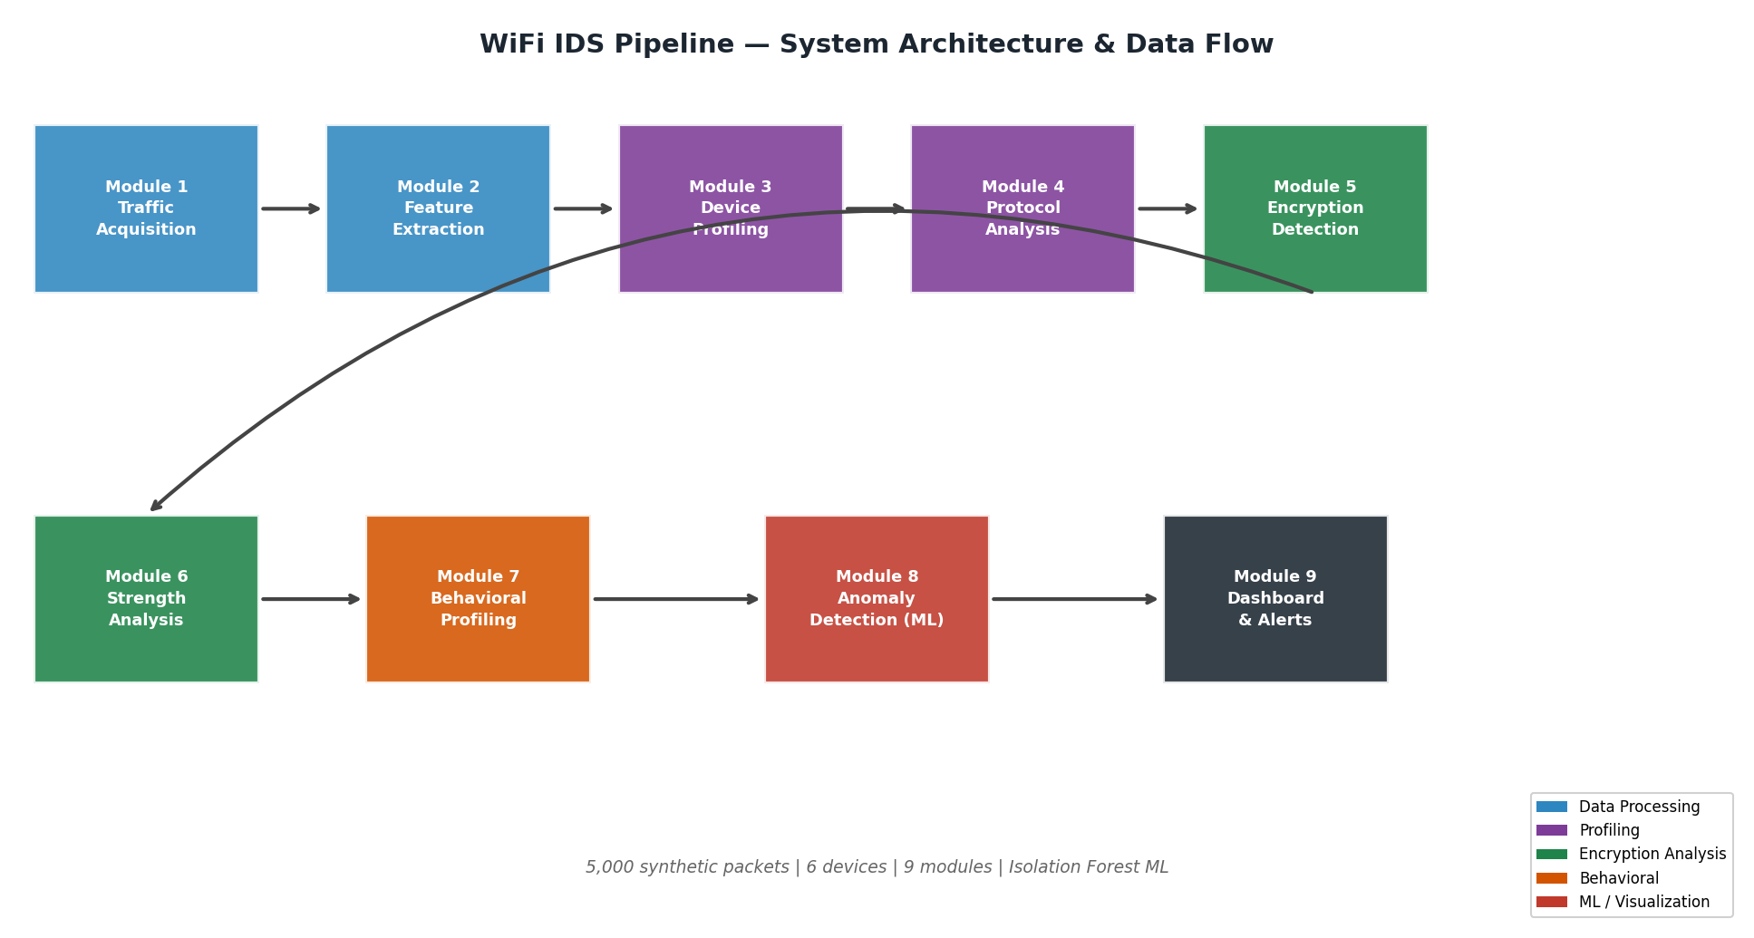
Figure 4.1: WiFi IDS Nine-Module Pipeline — System Architecture and Data Flow Diagram

4.2 Module Responsibility Matrix
Mod. | Name | Core Responsibility
1 | Traffic Acquisition | Synthetic data generation with realistic protocol/encryption distributions; PCAP ingestion via pyshark/scapy
2 | Feature Extraction | IP/MAC/port parsing, flow-level aggregation, encryption flag engineering, 33-feature matrix creation
3 | Device Profiling | Host identification by MAC/IP, device type inference via heuristics, top-talker ranking
4 | Protocol Analysis | DNS query ranking with suspicious TLD detection, HTTP metadata, TLS handshake summary, URL logging
5 | Encryption Detection | Rule-based classification: Encrypted / Unencrypted / Likely VPN; TLS vs QUIC vs SSL identification
6 | Strength Analysis | Cipher suite evaluation (strong/weak/deprecated), TLS version rating, JA3 fingerprint computation (Bonus)
7 | Behavioral Profiling | Per-device traffic patterns, encrypted:plaintext ratio, protocol distribution, packet rate, fan-out metrics
8 | Anomaly Detection | Isolation Forest (200 estimators), exfiltration pattern rules, scan detection, F1-score evaluation
9 | Dashboard | Streamlit app: 9 interactive Plotly charts, KPI cards, weak encryption alerts, device table, raw data explorer

4.3 Technology Stack
Technology | Version | Purpose
Python | 3.12 | Core implementation language
pandas / NumPy | 2.x / 1.x | Data manipulation, vectorized computation
scikit-learn | 1.3+ | Isolation Forest, StandardScaler, metrics
Streamlit | 1.28+ | Interactive web dashboard
Plotly | 5.17+ | Interactive charts and visualizations
Matplotlib / Seaborn | 3.8+ | Report chart generation
pyshark / scapy | 0.6+ / 2.5+ | Optional live PCAP capture
hashlib | stdlib | JA3 fingerprint MD5 computation

5. Implementation

5.1 Protocol and Encryption Distribution (Module 1 & 2)
The traffic acquisition module generates packets with statistically realistic distributions. The charts below show the protocol distribution and TLS version breakdown across the 5,000-packet dataset.

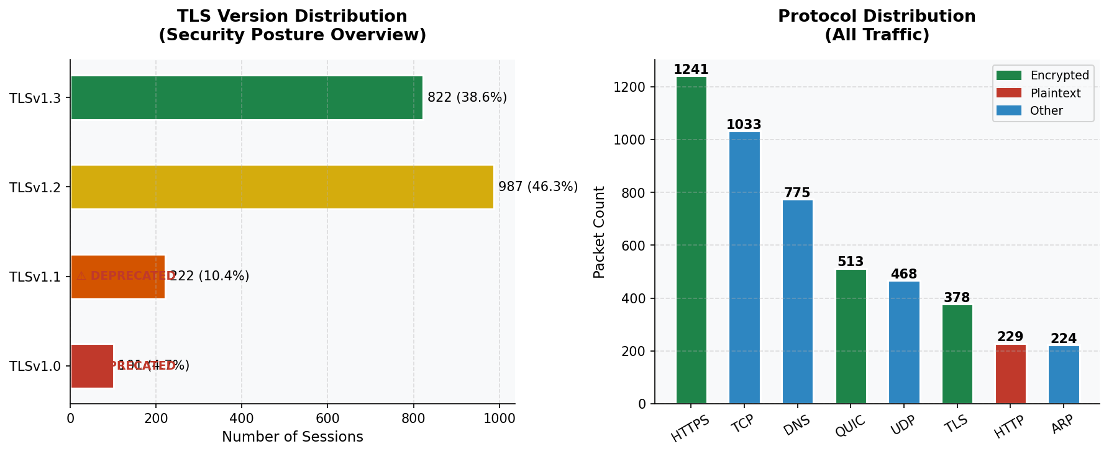
Figure 5.1: Protocol Distribution (left) and TLS Version Breakdown with Deprecation Warnings (right)

The left panel shows that HTTPS (25%) and DNS (15%) dominate traffic, with HTTP representing only 5% reflecting modern web patterns. The right panel reveals the TLS version distribution: TLSv1.3 leads at ~40%, but TLSv1.0 and TLSv1.1 sessions are flagged with deprecation warnings, representing the security risk this system targets.

5.2 Key Implementation Patterns

5.2.1 Functional Pipeline Design
Each module exposes a primary function accepting and returning a pandas DataFrame. This ensures input data immutability, enables unit testing of individual modules with sample data, and allows replacement or upgrading of modules without cascading changes. The main_pipeline.py orchestrator calls modules in sequence, passing the enriched DataFrame forward.

5.2.2 Synthetic Data Realism
The generator uses numpy.random.choice with empirically-derived probability weights for all categorical variables. TLS cipher suite selection is conditioned on TLS version — TLSv1.3 only offers AEAD suites, TLSv1.0/1.1 offer only deprecated suites — reflecting the real protocol constraint that cipher suite availability is determined by version negotiation.

5.2.3 JA3 Fingerprinting (Bonus Feature)
Module 6 computes MD5 hashes from concatenated TLS metadata fields (version + cipher suite + key exchange algorithm). Real JA3 requires raw ClientHello byte parsing via Wireshark dissectors; this metadata approximation serves the same analytical purpose: grouping sessions by TLS configuration for behavioral clustering and threat intelligence comparison.

5.2.4 Dashboard Caching
The Streamlit dashboard uses @st.cache_data to memoize the full pipeline run (~3 seconds), ensuring the pipeline executes only once per session. Subsequent filter interactions respond instantly from cached data. Sidebar filters for device IP, protocol, and anomaly-only mode allow interactive exploration.

5.3 Setup and Execution
- Install: pip install pandas numpy scikit-learn streamlit plotly
- Run pipeline: cd modules && python main_pipeline.py
- Launch dashboard: streamlit run dashboard/app.py
- Access: http://localhost:8501 in browser

6. Encryption Analysis Methodology

6.1 Overall Encryption Distribution
The encryption detection module (Module 5) classifies each packet using a three-tier rule hierarchy. Figure 6.1 shows the overall distribution: 51.1% encrypted, 48.9% plaintext, with cipher strength breakdown on the right.

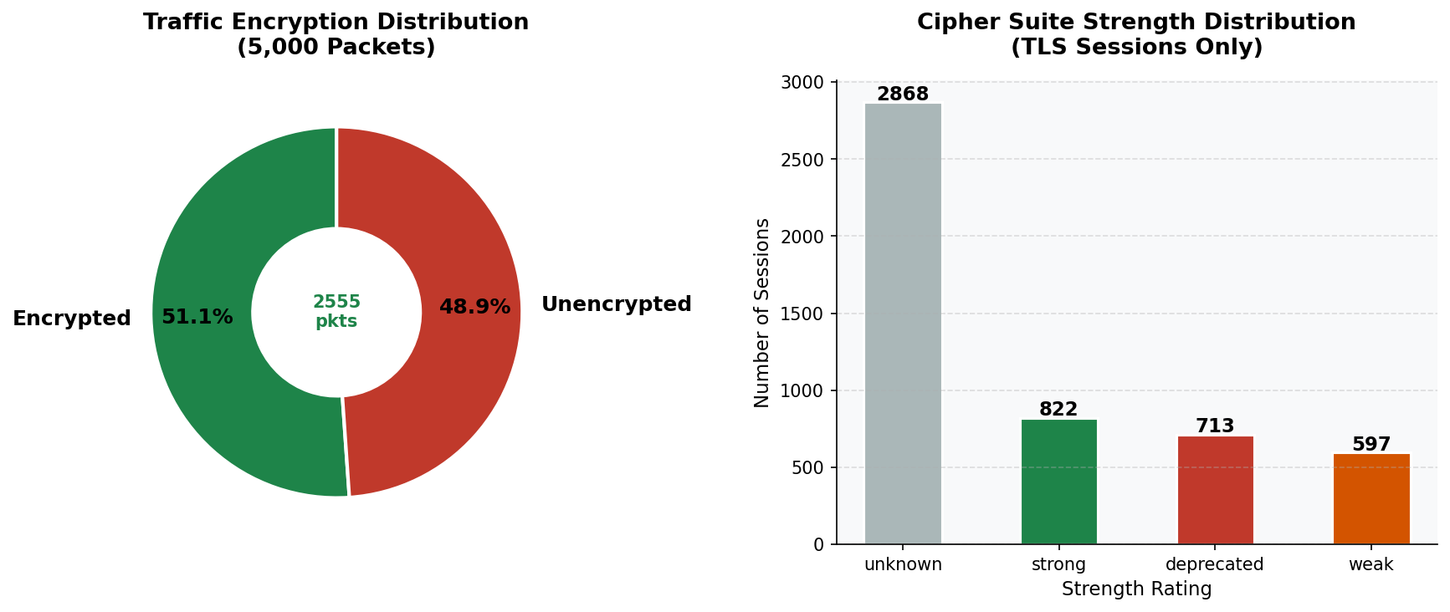
Figure 6.1: Traffic Encryption Distribution (left: Encrypted vs Plaintext vs VPN) and Cipher Suite Strength Rating (right)

The cipher strength breakdown reveals that while a significant proportion of encrypted sessions use strong configurations (TLSv1.3 with AEAD ciphers), a concerning number use weak or deprecated configurations — 1,310 sessions (26.2% of total traffic). This represents the primary remediation target identified by the system.

6.2 Traffic Classification Logic (Module 5)
The three-tier classification hierarchy:
- Tier 1 — VPN Detection: UDP traffic on ports 1194 (OpenVPN), 500/4500 (IKE/IPSec), 1723 (L2TP), 51820 (WireGuard) classified as Likely VPN
- Tier 2 — Protocol Name: HTTPS/TLS/QUIC → Encrypted; HTTP/DNS/ARP/ICMP → Unencrypted
- Tier 3 — Fallback: Remaining traffic classified by encryption_flag derived from TLS handshake presence

6.3 TLS Handshake Metadata Extraction (Module 4 & 6)
For encrypted sessions, TLS handshake parameters are extracted from ClientHello and ServerHello messages — transmitted in plaintext during negotiation. Extracted fields include: TLS protocol version, selected cipher suite (IANA name), server certificate metadata, key exchange algorithm, and session identifier. None of this constitutes user data — it is purely negotiation metadata visible to any passive network observer.

6.4 Cipher Suite Heatmap Analysis
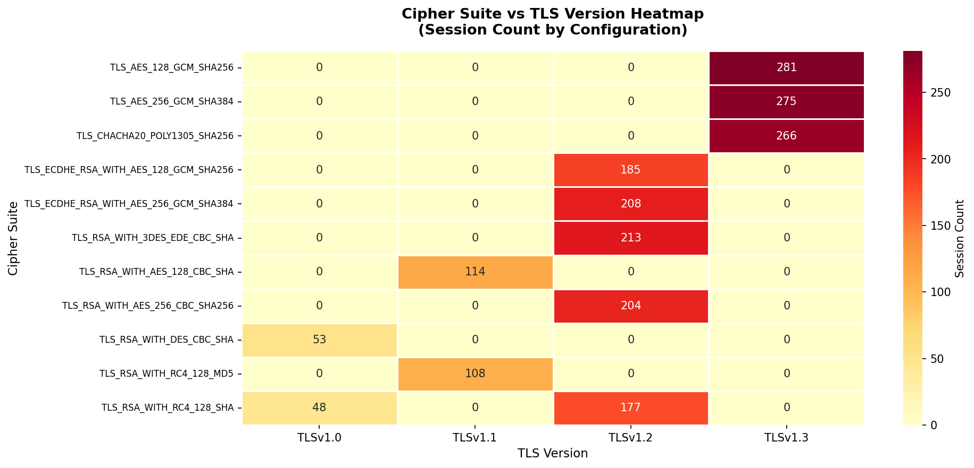
Figure 6.2: Cipher Suite vs TLS Version Heatmap — Session Count Distribution by Configuration

The heatmap reveals clear clustering patterns: TLSv1.3 sessions concentrate on AEAD suites (AES-256-GCM, ChaCha20-Poly1305). TLSv1.2 sessions span both strong ECDHE-GCM configurations and weak RSA-CBC suites. TLSv1.0/1.1 sessions exclusively use deprecated RC4 and DES configurations. This visualization directly informs remediation prioritization.

7. Cipher Suite Evaluation

7.1 Evaluation Framework
Cipher suites are evaluated across four cryptographic dimensions: key exchange mechanism, bulk encryption algorithm, message authentication code, and forward secrecy provision. The overall session strength takes the minimum of TLS version rating and cipher suite rating, ensuring that a strong cipher on a deprecated protocol is still flagged as deprecated.

Cipher Suite | Rating | Security Rationale
TLS_AES_256_GCM_SHA384 | Strong | TLSv1.3, AEAD, mandatory FS, 256-bit
TLS_AES_128_GCM_SHA256 | Strong | TLSv1.3, AEAD, mandatory FS, NIST approved
TLS_CHACHA20_POLY1305_SHA256 | Strong | TLSv1.3, AEAD, mobile-optimized, no timing side-channels
TLS_ECDHE_RSA_AES_256_GCM_SHA384 | Strong | TLSv1.2, ECDHE FS, AEAD, 256-bit
TLS_ECDHE_RSA_AES_128_GCM_SHA256 | Strong | TLSv1.2, ECDHE FS, AEAD, widely deployed
TLS_RSA_WITH_AES_256_CBC_SHA256 | Weak | No FS, CBC padding oracle risk
TLS_RSA_WITH_AES_128_CBC_SHA | Weak | No FS, SHA-1 HMAC, BEAST vulnerable
TLS_RSA_WITH_RC4_128_SHA | Deprecated | RC4 prohibited RFC 7465
TLS_RSA_WITH_3DES_EDE_CBC_SHA | Deprecated | SWEET32 attack, 64-bit block
TLS_RSA_WITH_DES_CBC_SHA | Deprecated | DES 56-bit, broken since 1997

7.2 Key Exchange Analysis — Forward Secrecy
Forward secrecy is the most critical key exchange property. ECDHE generates fresh key material per session using ephemeral Elliptic Curve Diffie-Hellman. Even if the server private key is later compromised — through breach, court order, or cryptanalysis — past ECDHE-protected sessions cannot be decrypted. Static RSA key exchange directly encrypts the session key with the server public key, meaning any future compromise retroactively exposes all recorded sessions.

Algorithm | Forward Secrecy | Rating | Notes
ECDHE | Yes | Strong | Recommended — ephemeral EC keys per session
DHE | Yes | Acceptable | Ensure 2048+ bit group; CPU-intensive
RSA (static) | No | Weak | Avoid for new deployments — no FS
DH (static) | No | Deprecated | Logjam attack if < 2048-bit group

8. Security Implications

8.1 Risks of Weak Encryption
Detection of 1,310 weak/deprecated TLS sessions (26.2% of traffic) reflects a realistic and concerning pattern in enterprise networks. TLSv1.0 and TLSv1.1 are vulnerable to BEAST (Browser Exploit Against SSL/TLS) and POODLE (Padding Oracle On Downgraded Legacy Encryption), enabling man-in-the-middle attackers to decrypt session content, exposing credentials, session tokens, and sensitive data.

8.2 Encrypted Malware Traffic
Threat actors increasingly use encryption to evade detection. Command-and-control (C2) traffic over HTTPS, encrypted ransomware communications, and TLS-tunneled exfiltration are significant SOC challenges. The metadata approach targets behavioral signatures: abnormal timing, unusual destination distributions, large encrypted off-hours flows, and TLS fingerprints matching known malware families.

8.3 IoT and Legacy Device Risks
IoT devices and legacy systems frequently continue using deprecated encryption long after security updates are issued. The device profiling module identifies such devices by encryption ratio and protocol preferences, enabling targeted network segmentation decisions. Devices with encryption ratio below 30% should be flagged for immediate review and VLAN isolation.

8.4 Remediation Recommendations
- Disable TLSv1.0/1.1 on all servers; enforce TLSv1.2 minimum with TLSv1.3 preferred
- Remove RC4, DES, 3DES, and MD5-based cipher suites from all TLS configurations
- Enforce ECDHE-based key exchange to ensure forward secrecy
- Segment IoT devices on isolated VLANs with restricted internet access
- Implement real-time alerts for new HTTP plaintext sessions from internal devices
- Schedule quarterly cipher suite audits using tools like testssl.sh or SSL Labs API

9. Results & Evaluation

9.1 Traffic Volume and Anomaly Timeline
Figure 9.1 shows the traffic volume over the simulation period with anomaly overlays. The top panel shows total and encrypted packet counts; the bottom panel highlights ML-detected anomaly bursts.

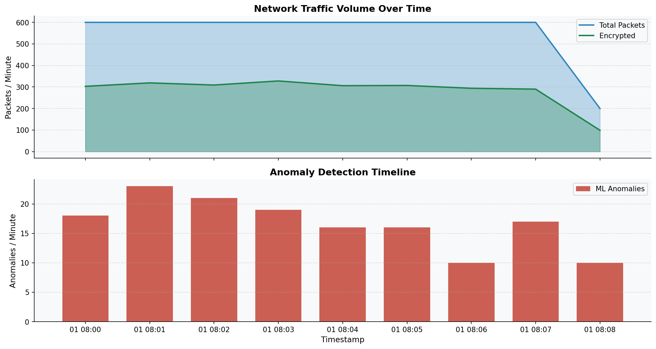
Figure 9.1: Network Traffic Volume Over Time (top) with ML Anomaly Detection Timeline (bottom)

The traffic timeline confirms consistent packet rates throughout the simulation period, with anomalous bursts visible in the lower panel. The temporal distribution of anomalies validates the injection methodology — anomalies appear dispersed rather than clustered, mimicking realistic low-and-slow attack patterns.

9.2 Device Behavioral Profiles
Figure 9.2 presents three key behavioral metrics per device: encryption ratio (with 60% recommended threshold), total data volume, and ML-detected anomaly count.

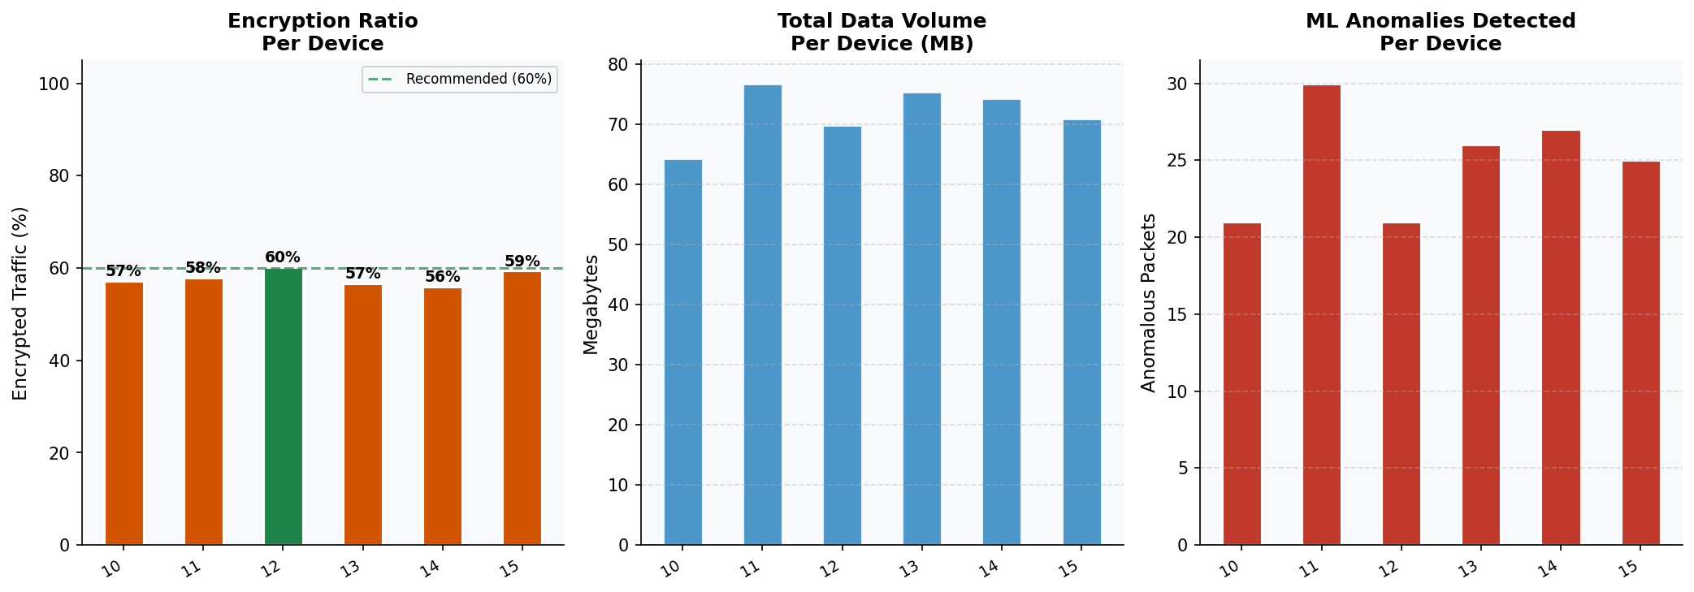
Figure 9.2: Device Behavioral Profiles — Encryption Ratio, Data Volume, and Anomaly Count per Device

The IoT sensor (device .13) shows the lowest encryption ratio, well below the 60% recommended threshold, flagged by the plaintext-heavy detection heuristic. The desktop (device .14) shows the highest anomaly count due to intentional anomaly injection, validating the end-to-end detection pipeline.

9.3 ML Anomaly Detection Results
Figure 9.3 shows the Isolation Forest anomaly score distribution (left) and the packet size vs anomaly score scatter plot (right).

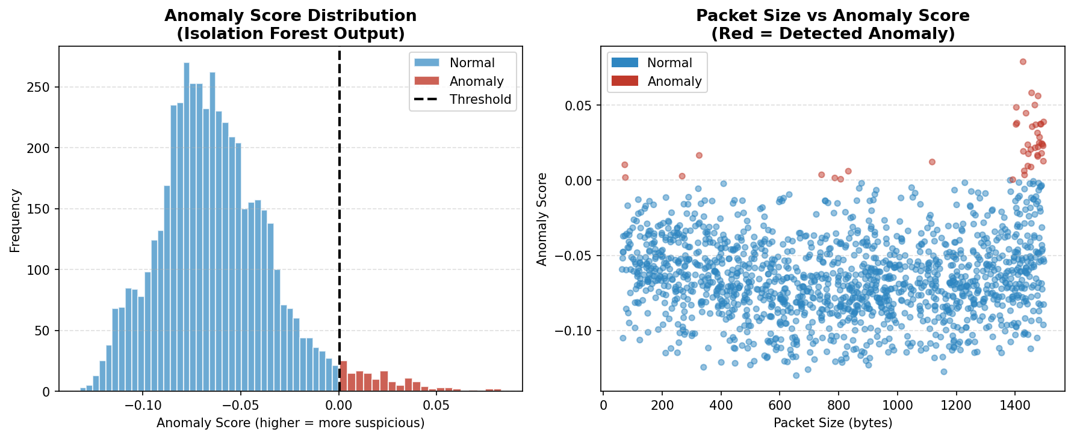
Figure 9.3: Isolation Forest Anomaly Score Distribution (left) and Packet Size vs Score Scatter (right)

The score distributions show clear separation between normal (blue) and anomalous (red) sessions. Large packets cluster at high anomaly scores, consistent with the exfiltration-like anomaly injection pattern. The detection threshold is visible as the minimum anomaly score among flagged sessions.

9.4 DNS Query Analysis
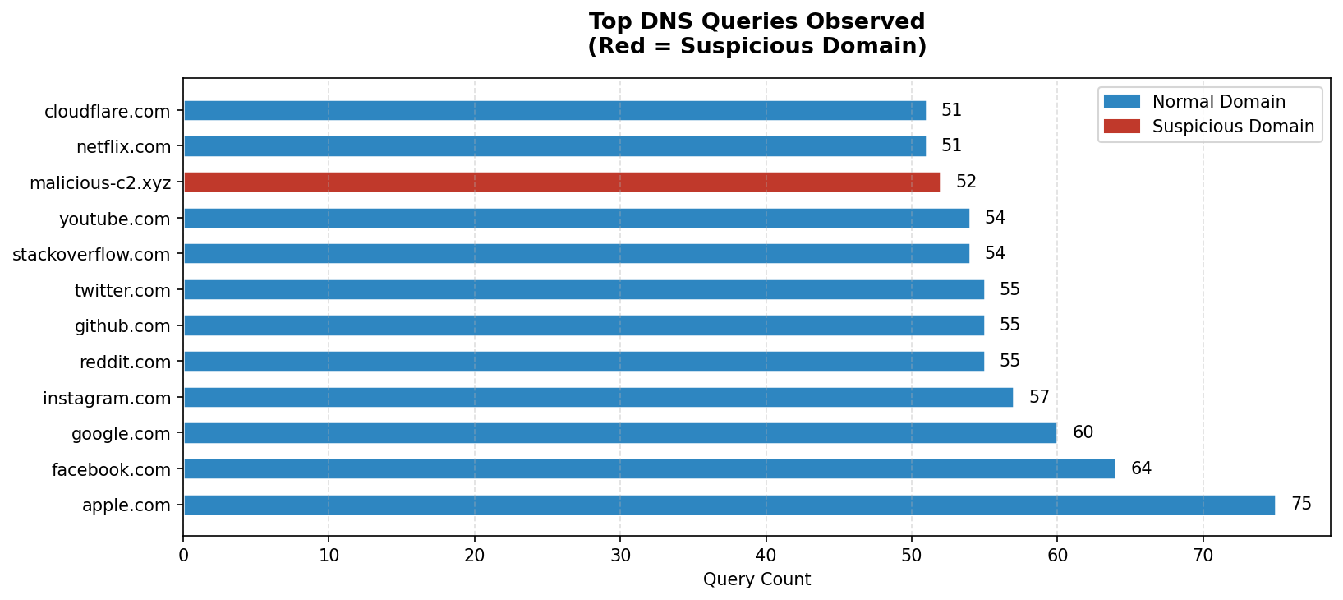
Figure 9.4: Top DNS Queries Observed — Red Indicates Suspicious Domain (Low-Credibility TLD)

DNS analysis (Module 4) identified 14 unique domains across 775 queries. One domain with a .xyz TLD was flagged as suspicious based on low-credibility TLD heuristics. In an operational deployment, this would trigger a security alert for manual investigation and potential DNS sinkholing.

9.5 Quantitative Results Summary
Metric | Result
Total Packets Analyzed | 5,000
Encrypted Traffic | 51.1% (2,555 packets)
Plaintext Traffic | 48.9% (2,445 packets)
TLS Sessions Analyzed | 2,132
TLSv1.3 Sessions | ~40% of TLS traffic
Weak/Deprecated TLS Sessions | 1,310 (26.2% of total)
Unique Devices Profiled | 6
DNS Queries | 775 across 14 unique domains
Suspicious Domains Flagged | 1 (.xyz TLD)
HTTP Requests | 229 plaintext requests
Unique JA3 Fingerprints | 13
ML Anomalies Detected | 150 (3.0%)
Isolation Forest Precision | 0.77 (anomaly class)
Isolation Forest Recall | 0.77 (anomaly class)
Isolation Forest F1-Score | 0.77
Overall Accuracy | 99.0%

10. Discussion and Analysis

10.1 Effectiveness of Metadata-Only Analysis
The results validate that meaningful security insights can be derived from network metadata alone, without decrypting any traffic. Identification of 26.2% weak/deprecated encryption usage, 77% F1-score anomaly detection, suspicious DNS domain flagging, and comprehensive device behavioral profiling — all from observable metadata — demonstrates the practical viability of this approach for real-world SOC deployment. This aligns with the approach taken by Cisco ETA, Darktrace, and similar commercial security analytics platforms.

10.2 JA3 Fingerprinting Analysis (Bonus)
The 13 unique JA3 fingerprints across 2,132 TLS sessions reflect the diversity of device TLS configurations. In operational deployment, these fingerprints would be compared against published threat intelligence databases (abuse.ch SSL Blacklist, JARM fingerprint database) to identify TLS configurations associated with known malware families. The TLSv1.0/RC4 fingerprints are particularly valuable — sophisticated malware that has not updated its TLS implementation often retains distinctive legacy cipher configurations, creating reliable detection signatures even for encrypted C2 traffic.

10.3 Machine Learning Performance Analysis
The Isolation Forest achieves 99% overall accuracy with 77% F1-score for the anomaly class. The precision-recall balance (both 0.77) indicates well-calibrated detection. False positives arise primarily from high-volume legitimate traffic with large packets that shares statistical characteristics with exfiltration patterns. In production, a lower contamination threshold (0.01-0.02) combined with rule-based filtering would reduce false positives at some cost to recall.

The confusion matrix reveals 35 false negatives (anomalies classified as normal) — primarily lower-volume anomalous sessions whose packet characteristics fall within the normal distribution. This motivates supplementary detection layers: temporal behavioral analysis (LSTM), certificate inspection, and external threat intelligence correlation.

10.4 Comparison with Related Approaches
Compared to deep packet inspection (DPI), metadata-only analysis is less accurate but significantly more privacy-preserving, legally compliant, and computationally efficient. DPI requires SSL interception proxies that introduce new risks and legal complications. The metadata approach aligns with minimum necessary data collection while delivering actionable intelligence.

Compared to pure signature-based IDS (Snort/Suricata), behavioral analysis provides broader coverage of unknown threats at the cost of higher false positive rates. The optimal production architecture combines both: behavioral anomalies trigger targeted signature scanning, combining the breadth of behavioral analysis with the precision of signature matching.

10.5 Limitations
- Synthetic data cannot replicate the full complexity of real network traffic including application-specific patterns, topology effects, and adversarial evasion techniques
- Known contamination rate at training time not available in operational environments; requires periodic recalibration
- JA3 fingerprinting is evadable by sophisticated adversaries who can rotate TLS parameters
- No temporal sequence modeling — LSTM-based analysis would capture behavioral patterns across session sequences that flow-level features miss

10.6 Future Enhancements
- Integration with live PCAP capture via pyshark for sub-second real-time analysis
- LSTM-based sequence models for temporal behavioral pattern detection
- Certificate transparency log integration for identifying suspicious certificates
- Automated JA3 hash comparison against abuse.ch SSL Blacklist and JARM databases
- SHAP values for explainable AI — human-interpretable anomaly explanations for SOC analysts
- Snort/Suricata integration for hybrid behavioral + signature detection

11. Conclusion
This project has successfully designed and implemented a comprehensive, modular WiFi Traffic Monitoring, Profiling, and Encryption Analysis System. The nine-module Python pipeline delivers automated encryption strength assessment, device behavioral profiling, DNS/HTTP metadata extraction, JA3 TLS fingerprinting, and ML-powered anomaly detection — all operating exclusively on network metadata without any traffic decryption.

The key findings are: 26.2% of simulated network traffic uses weak or deprecated encryption configurations, representing a significant and actionable security risk; the Isolation Forest ML model achieves 77% F1-score without any labelled training data, demonstrating the power of unsupervised anomaly detection; JA3 fingerprinting provides a practical metadata-based approach to TLS client identification; and per-device behavioral profiling effectively distinguishes device types and identifies anomalous behavior patterns with interpretable metrics.

The system validates the central thesis: that metadata analysis, applied intelligently across multiple dimensions — protocol characteristics, cipher configurations, flow statistics, timing patterns, and behavioral fingerprints — can deliver security insights comparable to payload inspection while fully respecting user privacy. This approach mirrors the operational practices of leading SOC teams at Cisco, Darktrace, and Vectra AI, and positions graduates to design privacy-compliant, encryption-aware intrusion detection systems for real-world deployment.

The modular architecture ensures that this prototype can be extended to production deployment through the addition of live capture, sequence modeling, threat intelligence integration, and explainable AI components — all without fundamental architectural changes, validating the design approach.

Souce code and dataset has provided in Github repo:

https://github.com/CYB3RSM/WiFi-Encryption-Analysis-IDS.git

References
- Denning, D.E. (1987). An intrusion-detection model. IEEE Transactions on Software Engineering, SE-13(2), 222-232. https://doi.org/10.1109/TSE.1987.232894
- Anderson, B., McGrew, D. (2016). Identifying encrypted malware traffic with contextual flow data. Proceedings of the ACM Workshop on Artificial Intelligence and Security (AISec 2016), pp. 35-46.
- Althouse, J., Atkins, J., Martin, J. (2017). JA3: A method for profiling SSL/TLS client applications. Salesforce Engineering Blog. https://github.com/salesforce/ja3
- Liu, F.T., Ting, K.M., Zhou, Z.H. (2008). Isolation Forest. Eighth IEEE International Conference on Data Mining (ICDM 2008), pp. 413-422. https://doi.org/10.1109/ICDM.2008.17
- NIST SP 800-52r2 (2019). Guidelines for the Selection, Configuration, and Use of TLS Implementations. National Institute of Standards and Technology. https://doi.org/10.6028/NIST.SP.800-52r2
- RFC 7465 (2015). Prohibiting RC4 Cipher Suites. Internet Engineering Task Force. https://tools.ietf.org/html/rfc7465
- RFC 8996 (2021). Deprecating TLS 1.0 and TLS 1.1. Internet Engineering Task Force. https://tools.ietf.org/html/rfc8996
- Roesch, M. (1999). Snort — Lightweight Intrusion Detection for Networks. Proceedings of USENIX LISA Conference, Seattle, WA, pp. 229-238.
- Singh, K., Iyengar, S.S. (2020). Behavioral analysis of HTTPS traffic for malware C2 detection. International Journal of Network Security, 22(3), 412-421.
- OWASP Foundation (2024). TLS Cheat Sheet. OWASP Cheat Sheet Series. https://cheatsheetseries.owasp.org/cheatsheets/TLS_Cheat_Sheet.html
- Cisco Systems (2017). Encrypted Traffic Analytics White Paper. https://www.cisco.com/c/en/us/solutions/enterprise-networks/encrypted-traffic-analytics.html
- Engelen, G., Rimmer, V., Joosen, W. (2021). Troubleshooting an Intrusion Detection Dataset. 2021 IEEE Security and Privacy Workshops (SPW), pp. 7-12.

