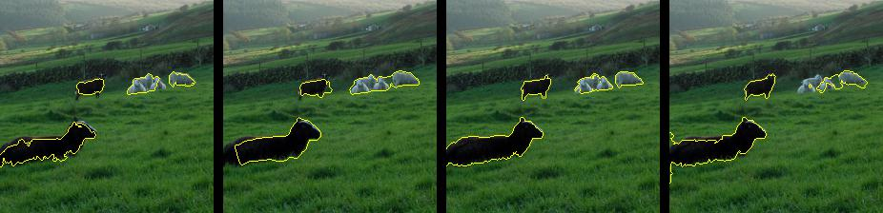

DISPARTING

FZ SLIC QUICK WATERSHED

CLUSTERING

DEEPLAB V3

IMAGE