Page Entry ---🡪 Registration/ Login--🡪 Entry into dashboard profile section

Dashboard Section--🡪 3 pages

1. Normal page greeting like the introduction to the placement portal
2. 2nd page showing the profile details
3. 3rd page showing the details of certificate

Greeting Page

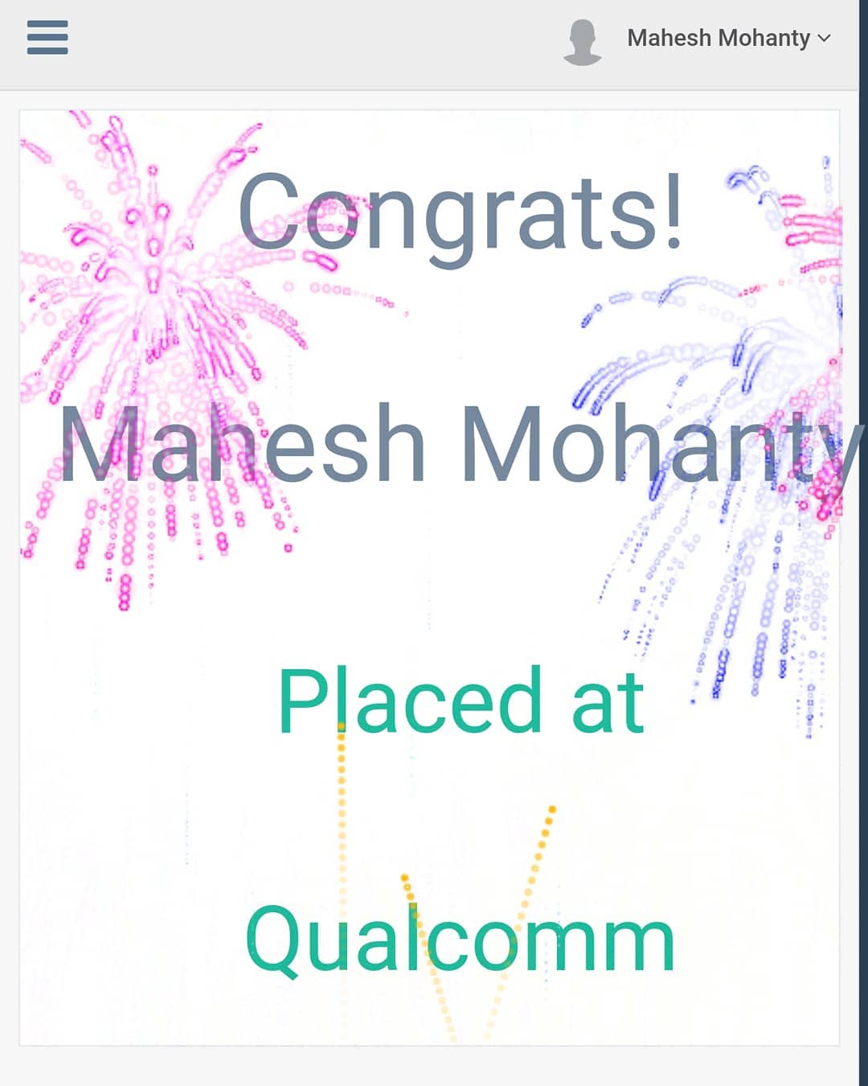

We can replace it like Hello Swagat

Congratutions on completing xyzzy glorious years with cyborg.

2. Profile Pages

Here we will give the option also to update the profile accordingly.

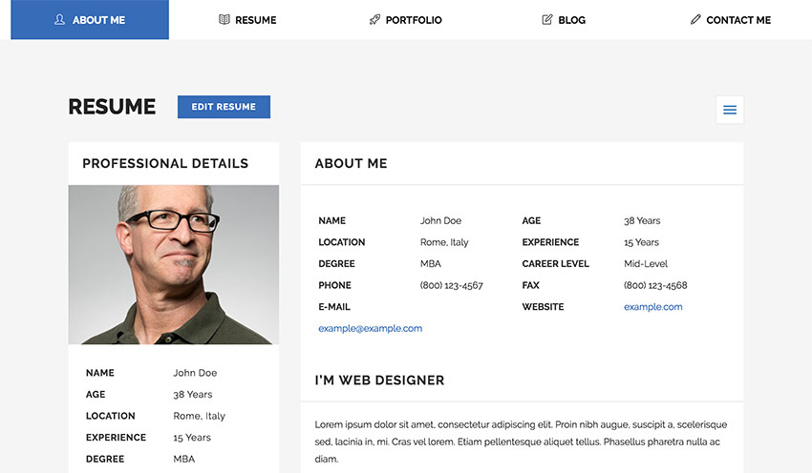The design we can keep same but we can update those features like in place of resume we can put profile.

Rest all details under About Me will be same like degree, name, experience and whatever we accept during registration.

An edit option we can put the top just as we had here so that one can change features like image, location(current), phone number and some specific details.

1. 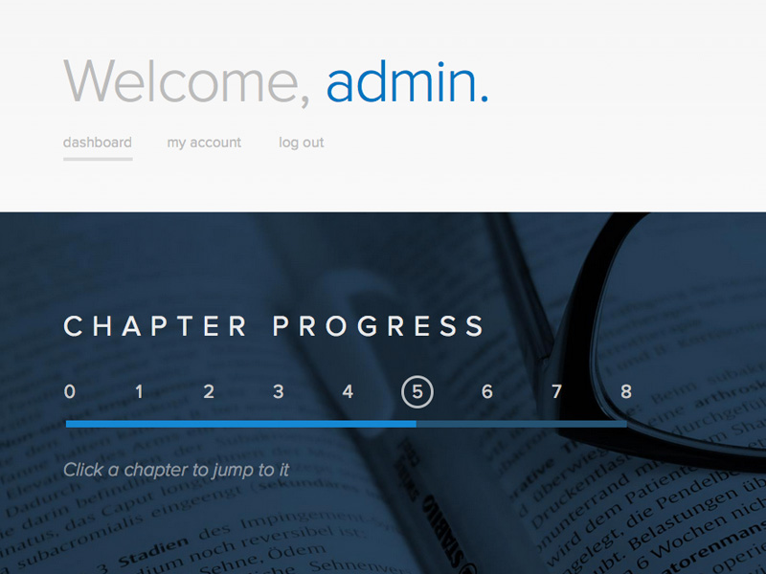

For the certificate generation we can use this.

I.e. A progress bar to show how much stage left to get the certificate

Like 1. For just applied

2. conveyed to Faculty Advisor

3. Download ready

In place of welcome admin, we can use the name of the person.

A download button will be there at end that will be highlighted only when the certificate is up for download.

Backend part

While registration we are going to accept details.

But use some details to store and check.

Like details of

1. Name(30)
2. Roll Number (Legitimate ones like 116 or 715 starting with valid codes of branch like BT, BM, AR, MN, EC, EE, EI, CS….)(9)
3. Date and Time of Registration. so that we can know at what time the user has registered
4. A picture option to upload a picture(.jpg,.png,)
5. Year of joining info (means 1st or 2nd)
6. Zimbra email id.
7. A password and confirm password so that the user authentication can be done again.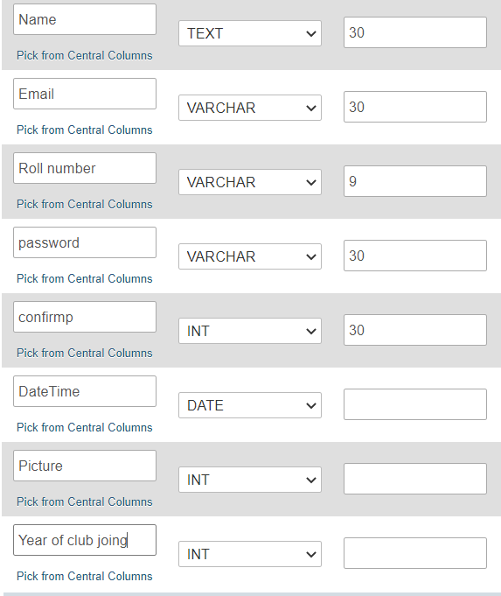

While logging in we can ask for Zimbra mail and password.