Employee policy violation
Gilberto F Alvarez
Aurora University
CYB-4620-01
Lorie Hermesdorf
12/10/2024

Executive Summary
An employee asks about getting a raise, but his request was declined. Their behavior became abnormal and different during work. The security team of the company received an alert about illegal networking activity from the employee’s computer system. Shortly after notification, the company’s Incident response team managed to respond and took a forensic image of the employee’s computer. The employee doesn’t have any hacking experience so there is a reason another person is helping them.
Evidence
I was assign this case and received this file as evidence. The file name is, “4orensics.case2.7z”. It is a zipped file containing the forensic image inside. It has a MD5 hash
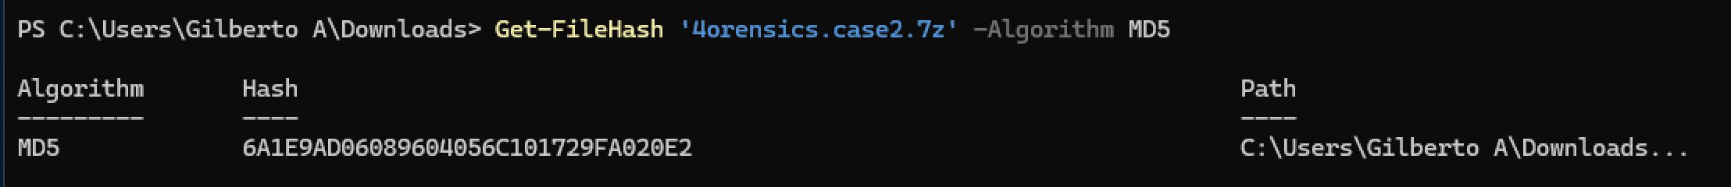
Figure 1 | contains the 4orensics.case2.7z MD5 hash
The file size for the 4orensics.case2.7z is 6,473,598 KB.

The forensic image that is inside the file is called 4orensics.001. File size is 25,853,952 KB and the MD5 hash is,
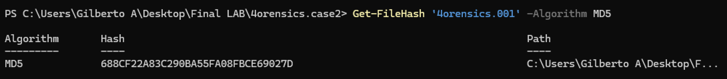
Figure 2 | contains the 4orensics.001 MD5 hash
Forensic Environment
Workstation environment when performing the analyzation of the evidence
| Device specifications
------------------------------
Device name WINDOWS-4RR6371
Processor virt-7.2 1.00 GHz
Installed RAM 8.00 GB
Device ID EB30FE21-FAB2-4286-BE1D-036AF18221B4
Product ID 00326-10000-00000-AA405
System type 64-bit operating system, ARM-based processor
Pen and touch No pen or touch input is available for this display

| Windows specifications
------------------------------
Edition Windows 11 Home
Version 23H2
Installed on ‎10/‎23/‎2024
OS build 22631.4391
Experience Windows Feature Experience Pack 1000.22700.1047.0

| Additional software
------------------------------
Axiom cyber 7.8.0.38310
7-Zip 24.8.0.0

| PowerShell Version
-------------------------------
PS Version 5.1.22621.4391
PS BuildVersion 10.0.22621.4391
CLR Version 4.0.30319.42000
WSManStackVersion 3.0
PSRemotingVersion 2.3
SerializationVersion 1.1.0.1

| Browser Version
------------------------------
Microsoft edge 130.0.02849.52
Safari 18.0.1

The workstation is a windows virtual machine, so here is the platform of it
| VM platform
-------------------------
UTM 4.4.5(94)

| Computer Used
--------------------------
Model MacBook Pro 2021
Device name Not Your Life Saver
Processor Apple M1 Pro
RAM 16 GB

| Computer specifications
--------------------------------
MacOS Sequoia 15.1.1

Analysis
The suspect’s original computer is a windows operating system, a Windows 8.1 Enterprise version. The computer was owned by an individual named Hunter. Hunter is the person suspected of exfiltration. The company’s incident response team gathered a Forensic image of the computer, which is a file that holds all the data of Hunter’s computer. The tool use to analyze the forensic image is called Magnet Axiom, a digital investigation platform that is highly credited in the Forensic community and utilized by many credited examiners. I loaded the evidence in Magnet Axiom and began analyzing on November 6, 2024. The process starts in the user accounts.
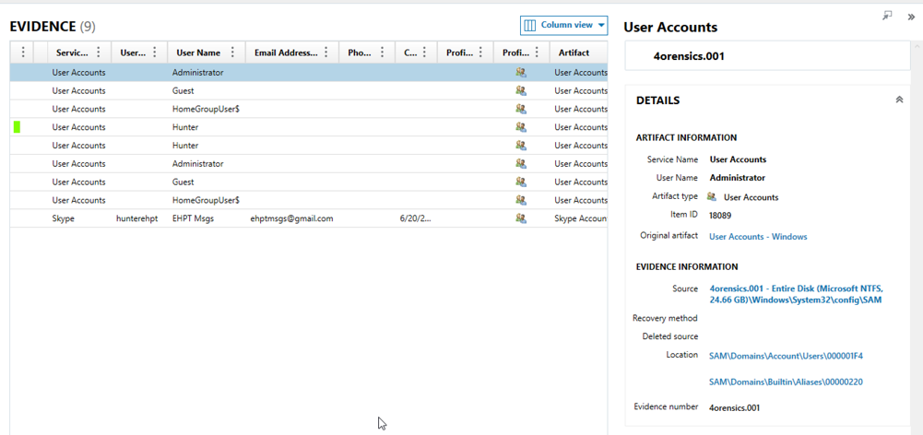
Figure 3 | This evidence shows 9 user accounts registered by the computer.
Path: 4orensics.001 - Entire Disk (Microsoft NTFS, 24.66 GB)\Windows\System32\config\SAM

Figure 3. confirms that the suspects name is Hunter and Hunter has a Skype account with the name, hunterghpt, and with the gmail, ehptmsgs@gmail.com. The creation date of it is 6/20/2016 at 11:07 PM. Another account, “HomeGroupUser$,” is a network user that can view shared files. Figure 3 was collected on December 9, 2024, at 5:21 PM. The evidence follows into Google chrome,
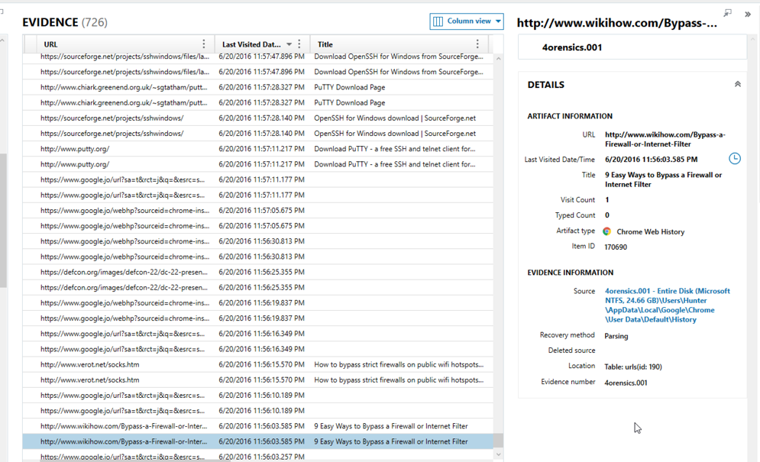
Figure 4 | Google chrome searches history of Hunter
Path: 4orensics.001 - Entire Disk (Microsoft NTFS, 24.66 GB)\Users\Hunter\AppData\Local\Google\Chrome\User Data\Default\History

Figure 4. shows that on 6/20/2016 at 11:56 PM Hunter began to search for ways to bypass the firewall and internet filters. A book by Opplinger (2023) write about Network rules and practices, and mentions about Firewalls, “firewalls are used to restrict or at least control…end-to-end connectivity” (Oppliner, 2023, pg.189). This means firewalls restrict computers from connecting to each other if the rules don’t let them connect. That is what Hunter is searching about, the internet filters. Hunter finds further, PuTTY and OpenSSH which are applications that are used for networks. Collected on 12/9/2024 at 7:50 PM. His Google chrome bookmarks also show the same interest.
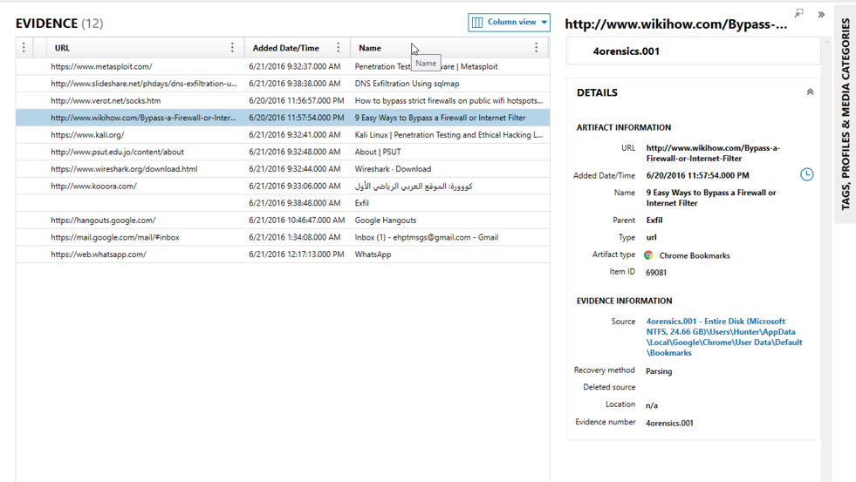
Figure 5 | Hunter’s Goggle Chrome Bookmarks
Path: 4orensics.001 - Entire Disk (Microsoft NTFS, 24.66 GB)\Users\Hunter\AppData\Local\Google\Chrome\UserData\Default\Bookmarks

Figure 5. shows Hunter’s bookmarks containing network related bookmarks like kali linux, Wireshark, and SQL map. All of these are networking tools. Collected on 11/21/2024 at 2:46 PM. The next day, Hunter begins his operations.
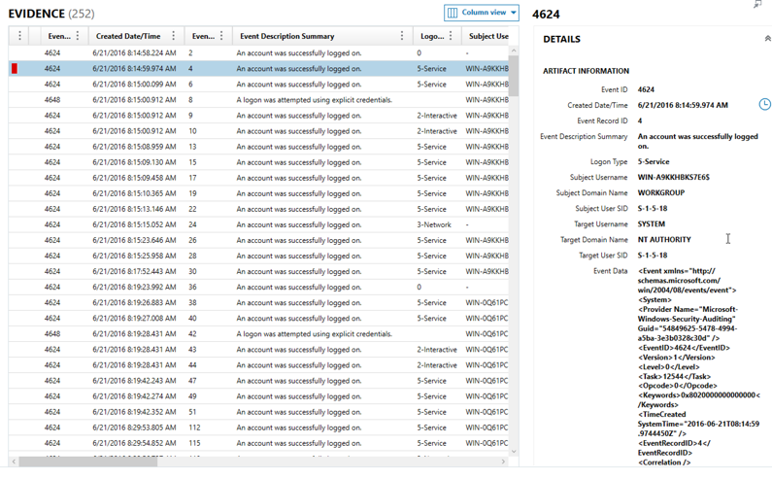
Figure 6 | The user event log shows. The highlighted file is when Hunter logs on to a work account
Path: 4orensics.001 - Entire Disk (Microsoft NTFS, 24.66 GB)\Windows\System32\winevt\Logs\Security.evtx

Figure 6. Shows that Hunter logs on at 6/21/2016, 8:14 AM. This account has admin privileges that gives him the ability to change network settings. Collected on 12/6/2024 at 3:33 PM. This follows next,
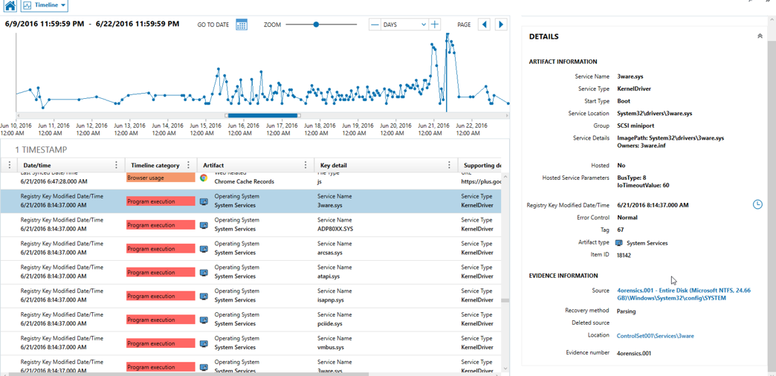
Figure 7 | A timeline picture with a graph that illustrates how much activity happened that day. The red bars indicate code execution
Path: 4orensics.001 - Entire Disk (Microsoft NTFS, 24.66 GB)\Windows\System32\config\SYSTEM

Figure 7. Shows that code execution takes place on 6/21/2016 at 8:14 AM. At the same exact time hunter changes account to admin. Files like 3ware.sys, is a file that is associated with a storage server. Collected on 12/4/2024 at 8:24 PM. Right after code execution happens, there are USBs involved.
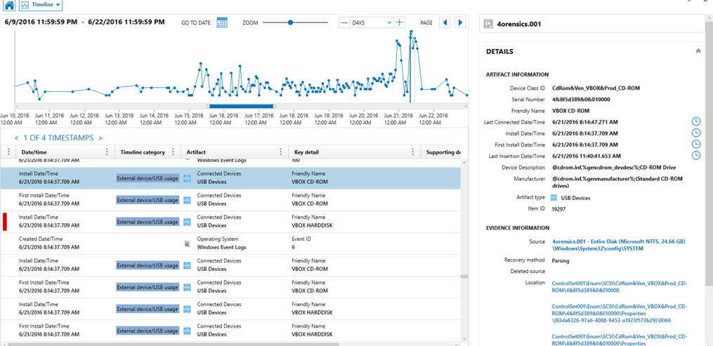
Figure 8 | Usage of external USB drives. The blue vertical bars are the number of USBs.
Path: 4orensics.001 - Entire Disk (Microsoft NTFS, 24.66 GB)\Windows\System32\config\SYSTEM

Figure 8. Shows that on 6/21/2016 at 8:14 AM, the computer system recognized a batch of USBs were connected to the computer. This happens almost instantly; the code execution happens. The evidence was collected on 12/4/2024 at 8:46 PM. Shortly after, there are file opening.
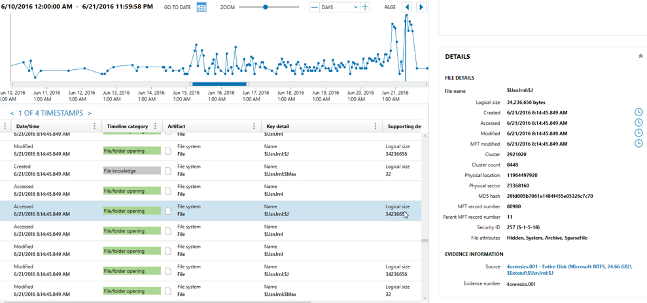
Figure 9 | Files are being open that are very large in file size.
Path: 4orensics.001 - Entire Disk (Microsoft NTFS, 24.66 GB)\$Extend\$UsnJrnl:$J

Figure 9. Shows a very large file being opened multiple times on 6/21/2016 at 8:14 AM. The file, “$UsnJrnl:$J” has a lot of data and is being accessed. This shows Hunter showing interest on a file. The evidence is collected on 12/10/2024 at 7:10 PM. Moving to the firewall event log.
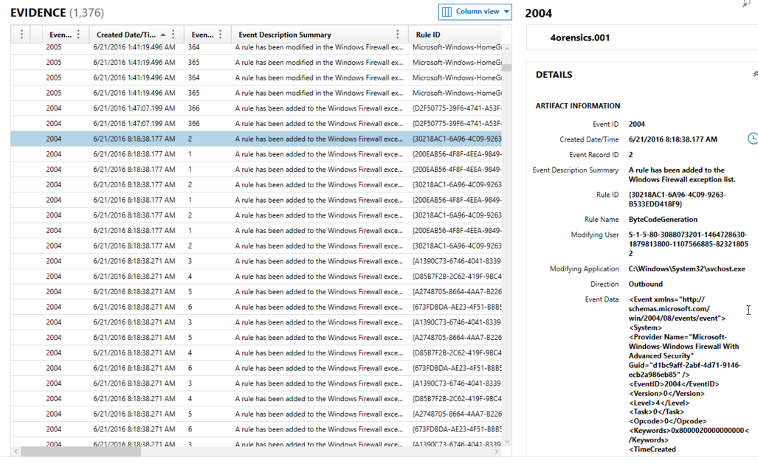
Figure 10 | Firewall event logs indicate the addition of new rules.
Path: 4orensics.001 - Entire Disk (Microsoft NTFS, 24.66 GB)\Windows\System32\winevt\Logs\Microsoft-Windows-Windows Firewall With Advanced Security%4Firewall.evtx

Figure 10. Shows, on 6/21/2016 at 8:18 AM the firewall event logs states that multiple new rules were added to it. An article by Mingze Ma (2024) writes about the firewall logs, “They safeguard the network system by documenting firewall system access and network activity” (Mingze, 2024, 3.1). The firewall logs are similar to the windows firewall logs. They indicate that someone has changed the rules and the changes shown are changed in quick succession. This means that the network settings were changed via code execution. The Figure was collected on 12/6/2024 at 3:20 PM. Moving forward a few hours,
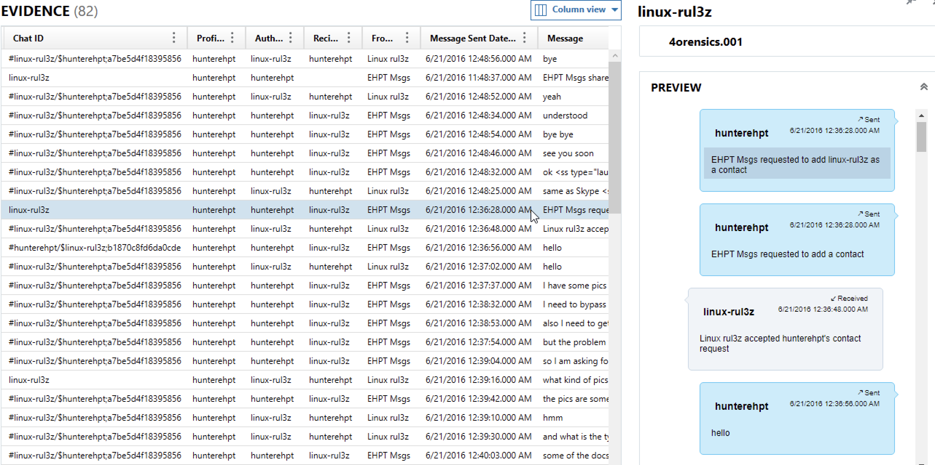
Figure 11 | The highlighted file shows messages between Hunter and someone.
Path: 4orensics.001 - Entire Disk (Microsoft NTFS, 24.66 GB)\Users\Hunter\AppData\Roaming\Skype\hunterehpt\main.db

Figure 11. Shows Hunter Requesting to speak to someone on Skype. The other person accepts. The person is named, “linux-rul3z” and a conversation begins on 6/21/2016 at 12:36 AM. Collected on 12/10/2024 at 7:34 PM. The messages continue,
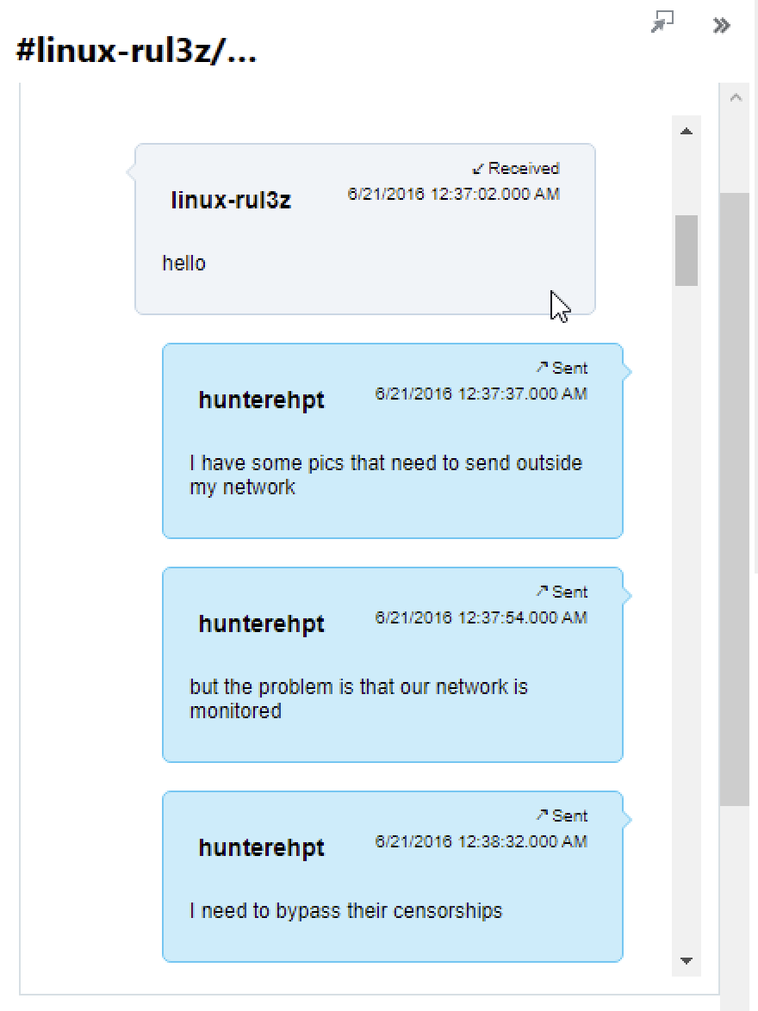
Figure 12 | The messages continue with Hunter and Linux.
Path: 4orensics.001 - Entire Disk (Microsoft NTFS, 24.66 GB)\Users\Hunter\AppData\Roaming\Skype\hunterehpt\main.db

Figure 12. Shows the continued messages between Hunter and linux on 6/21/2016 at 12:37 AM. Hunter wants “send” some files outside his network. Hunter adds that his network is being monitored and need to bypass it. This shows Hunter wanting to exfiltrate the collected data. This figure was collected on 12/2/2024 at 10:48 PM. The messages continue a little further.
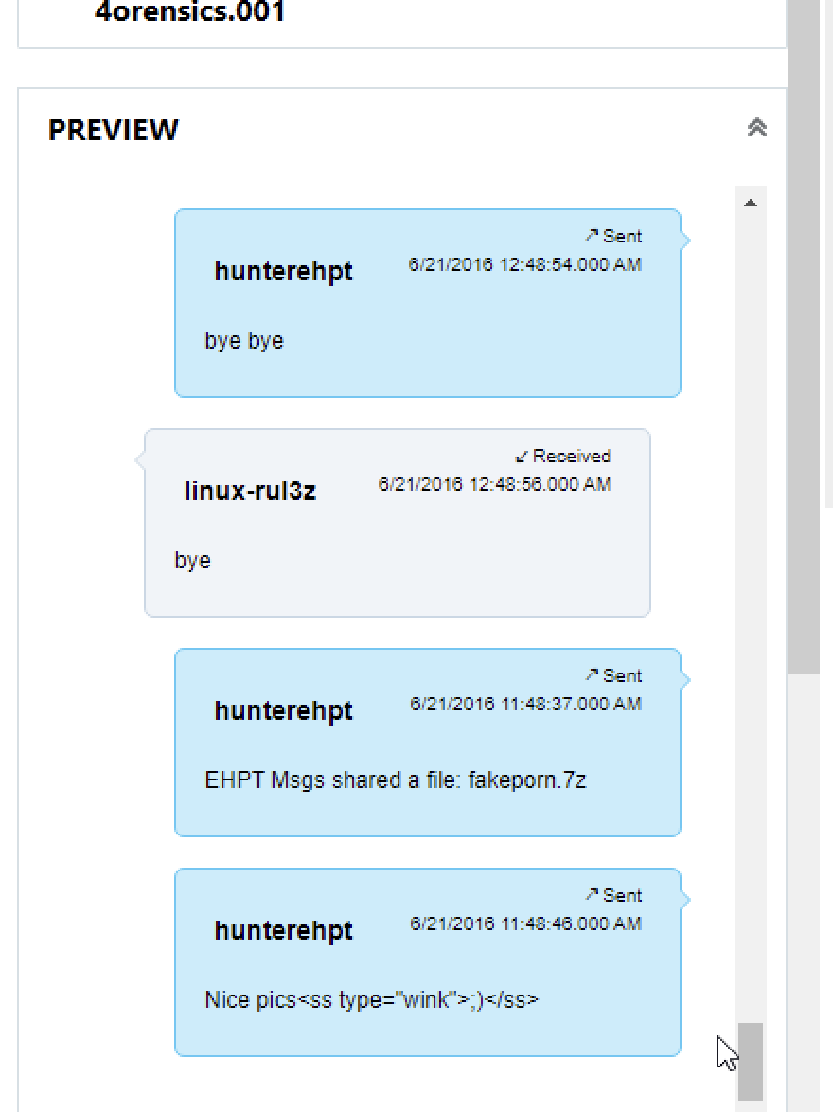
Figure 13 | The messages continue on skype
Path: 4orensics.001 - Entire Disk (Microsoft NTFS, 24.66 GB)\Users\Hunter\AppData\Roaming\Skype\hunterehpt\main.db

Figure 13. Shows Linux and Hunter saying their goodbyes on 6/21/2016 at 12:48 AM. The date then moves back to 6/21/2016 at 11:43 PM with Hunter sharing a file called, “fakeporn.7z”, with the added, ‘Nice pics <SS Type=”Wink”>:)</SS>’. The date change and the file sharing indicate that Hunter didn’t want anyone to know the actual date it happens, this must be the data being exfiltrated. Fakeporn.7z is allegedly the data exfiltration. According to the official website of 7zip (2024) Pavlov write about the 7z, “7z is the new archive format, providing high compression ratio” (Pavlov, 2024). This mean that the .7z file contains compressed data that Hunter allegedly exfiltrated. The figure was collected on 12/2/2024 at 10:55 PM. Let look at Hunter’s installed applications.
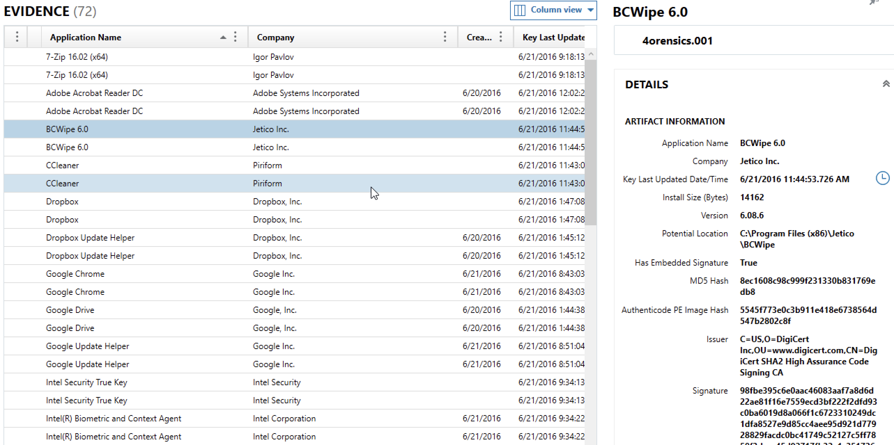
Figure 14 | Installed apps on the computer.
Path: 4orensics.001 - Entire Disk (Microsoft NTFS, 24.66 GB)\Program Files (x86)\Jetico\BCWipe\BCWipeTM.exe

Figure 14. Shows the applications installed on Hunter’s computer. The presence of “BCWipe 6.0”, a file shredder tool and, “CCleaner”, another file shredding tool indicates that the tools were used during hunter’s operation which can be used to modify files. This figure was collected on 12/10/2024 at 8:24 PM. Moving to Hunter’s desktop.
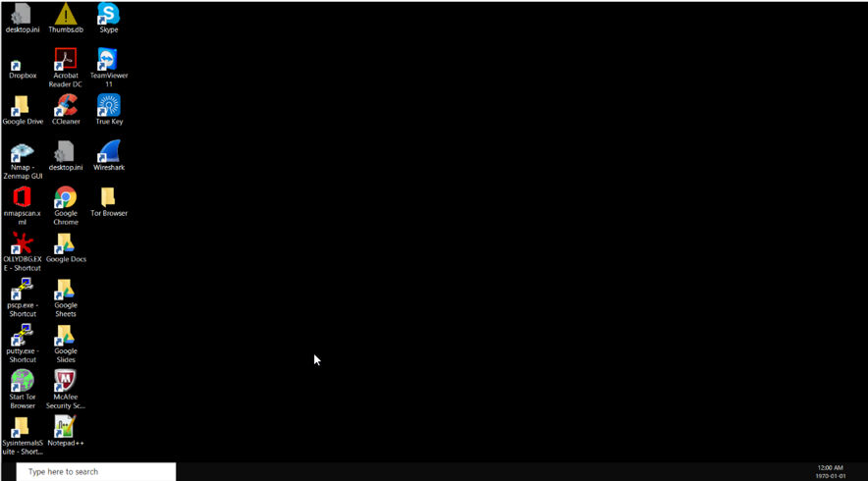
Figure 15 | The desktop of Hunter’s computer
Path: 4orensics.001 - Entire Disk (Microsoft NTFS, 24.66 GB)\Users\Hunter\NTUSER.DAT

Figure 15. Shows the desktop of Hunter’s computer. Many of his installed applications are applications used by coders and networks. CCleaner is in the desktop, so Hunter had some interest in having it on the desktop. The date and time are off on the left bottom corner of the figure. That may have some correlation with the last Skype messages that had the time set back 1 hour. This last figure was collected on 12/10/2024 at 9:11 PM.
Conclusion
In conclusion, Hunter has executed code, installed networking applications, spoke with someone about data exfiltration, accessed files after doing code execution and allegedly exfiltrated the data from his company to the user in Skype. This examination is a success. The recommendations I recommend to the company are to have all user not able to download applications by default, implement USB blockers so that employees don’t stick USBs inside the computer and access them and have more stricter access controls. Hunter should also be required to give the USBs used on his operations as evidence for further analyzation of the case.

References
Oppliger, R. (2023). SSL and TLS : Theory and Practice, Third Edition (Third edition.). ARTECH HOUSE. Source
Mingze, M. (2024). Research and Application of Firewall Log and Intrusion Detection Log Data Visualization systems. IET Software. Source
Pavlov, I. (2024). 7z Format. 7zip. Source

