Ransomware_Case

June 28, 2026 11:05 AM | I started the Ransomware_Case. Zip file downloaded from a start page from stark4n6. Their evidence locker contains many forensic images along with additional information like pcap files.
June 28, 2026 11:08 AM | file name is “Ransomware Case.zip”.
Sha256 is f64d6c1228febd4cb6f3fcfe28aef86166d785a34855ee49bc90bb6e343746d0 for the file without unziping
June 28, 2026 11:15 AM | there are two files in the unzipped ransomware folder.
Sha256 is aefcd3bfba4da3f3f097012f32459ad1e438f9d25824514b7c412e1c7e2e238c for the “merdian_workstation.e01”
The other file is a pcap file, “meridian_incident.pcap”
2d87f551665021d0b2d940e5c5bb824d7a338a9f90a4d0cdc9b14fe969b508af is the hash for it
June 28, 2026 11:22 AM | the website has questions to answer.
- What was the initial access vector and when did it occur?
- How long after the lure was opened did the C2 beacon start?
- Which internal host did the attacker pivot to?
- Where was data exfiltrated before encryption?
- What Windows security feature did the attacker disable first?
- What anti-forensics technique was used, and at what time?
- What is the victim ID from the ransom note?
- What does ID Ransomware identify the malware family as?
June 28, 2026 11:40 AM | the pcap file, “meridian_incident.pcap” from the original ransomware case seems corrupted. Wireshark couldn’t open it, so I had to fix it using pcapfix tool
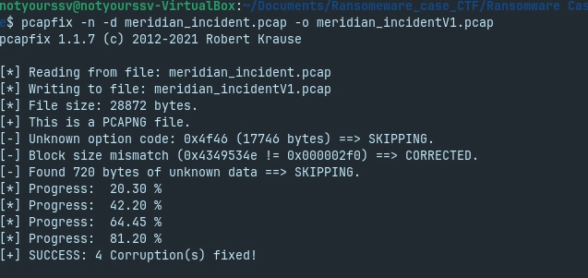
The new file name is, “meridian_incidentV1.pcap”
85dd8010d87342014e365501d22e30cd24f5ba6e2e9ae8f91971e51ad57dfc9f is the new hash
June 28, 2026 11:48 AM | Wireshark can now open the new file, “meridian_incidentV1.pcap”
June 28, 2026 12:26 PM | Question 1, the initial access was from a HTTP request for a file name, “Invoice_March2024.docm” from IP, 185.220.101.47
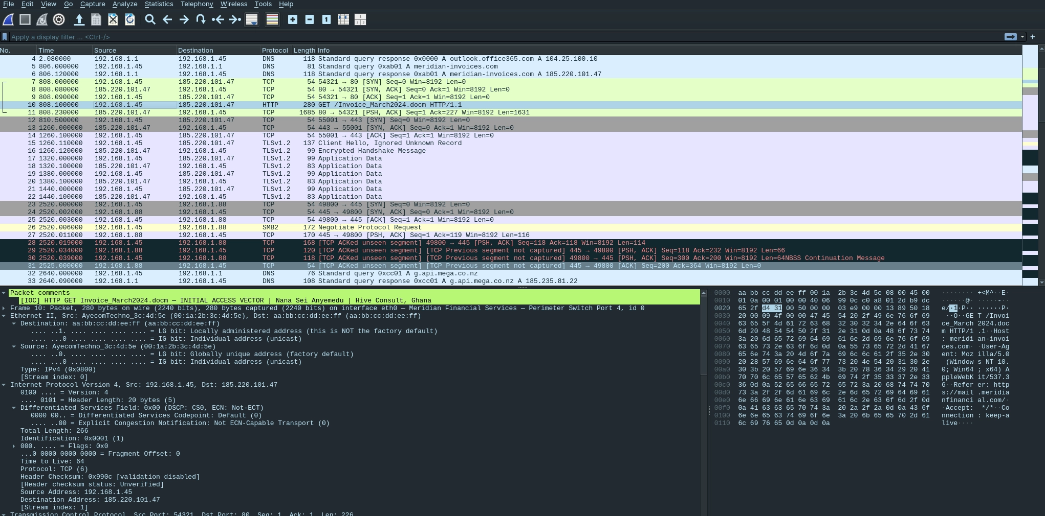
it occurred on March 14, 2024 03:33:28.100000 CDT
June 28, 2026 12:47 PM | Question 2, The lure was executed at 3:33:30.500000 CDT
The C2 beaconing started at 3:41:00.110 CDT
June 28, 2026 12:51 PM | I have to go, no need for sha256 since I am using pcap
June 29, 2026 3:37 PM | The hunt begins
June 29, 2026 3:38 PM | Question 3, The internal attacker pivoted to the Philip.Green
Philip’s IP is 192.168.1.88
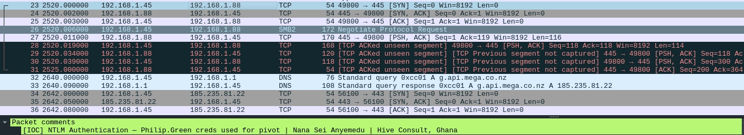
June 29, 2026 3:54 PM | Question 4, data was exfiltrated to mega, a cloud storage used for privacy.
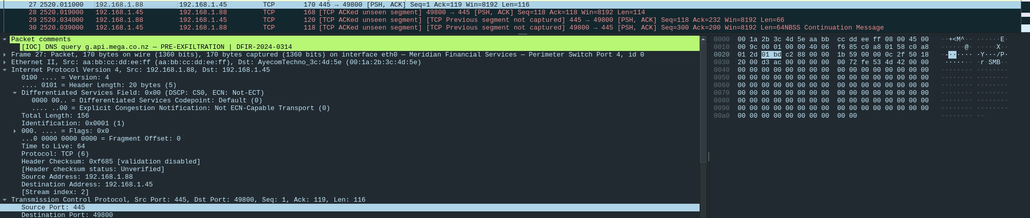
June 29, 2026 4:03 PM | Now to the Eo1 (forensic image) file
June 29, 2026 4:07 PM | The forensic file sha256 is, aefcd3bfba4da3f3f097012f32459ad1e438f9d25824514b7c412e1c7e2e238c which is still the same as the top sha256 so it still good and unmodified
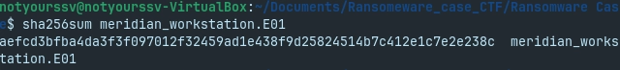
June 29, 2026 4:33 PM | Question 5, The attacker disabled real time monitoring on windows defender
Artifact path: /img_meridian_workstation.EO1/Windows/System32/winevt/Logs
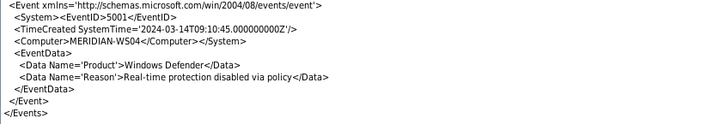
June 29, 2026 4:43 PM | Question 6, The attacker uses vssadmin in cmd, which deletes all shadow copies. Created on 03/14/2024 at 09:14:01.0 CDT
Artifact path: /img_meridian_workstation.EO1/Windows/System32/winevt/Logs
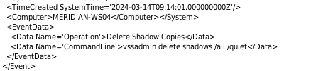
June 29, 2026 4:52 PM | Question 7 The victim ID is
4A9F2E8B-7C31-4D56-A091-F3E28C107B44
Artifact path: /img_meridian_workstation.EO1/Windows/Temp/Restore-My-Files.txt
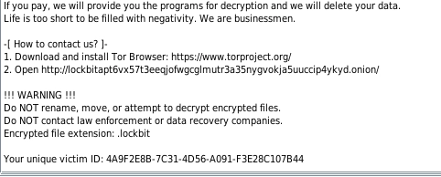
located in Restore-My-Files.txt
June 29, 2026 5:07 PM | Question 8, ID ransomware is a website that is free online tool that helps victims identify the specific ransomware variant.
ID ransomware states that this is a LockBit 3.0 or Lockbit ransomware variant
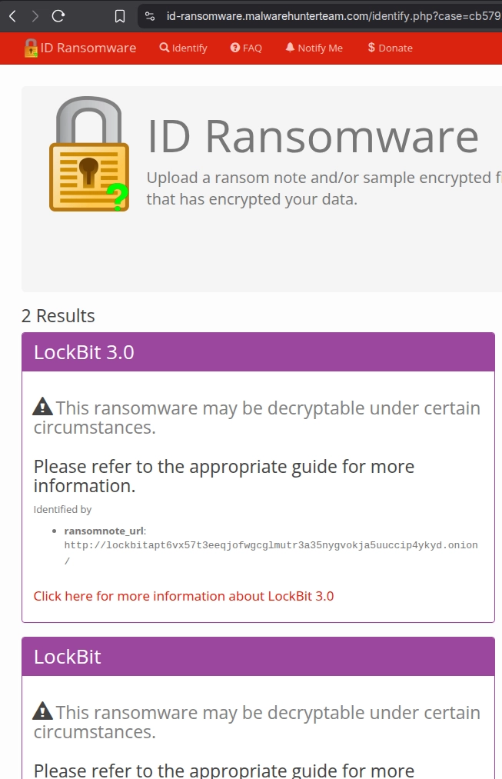
June 29, 2026 5:13 PM | My work here is done
here is the final hash for “meridian_workstation.E01”
aefcd3bfba4da3f3f097012f32459ad1e438f9d25824514b7c412e1c7e2e238c
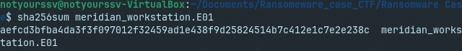

Final thoughts: this was a relatively short CTF. I learned new things on Wireshark and how ransomware and initial access looks like on the network. I used the notes format I used when I was in school. I enjoyed this CTF.

